WEEK 1 REPORT
Financial Analytics Orientation
and Python Environment Setup
  - Research • Environment Configuration • Strategic Analysis Plan

Prepared by | Sommay Dewat
Project | Financial_Analytics_Week_1
Project Path | S:\Projects\Financial_Analytics_Week_1
Environment | Python 3.10.11 • VS Code • Jupyter Notebook
Report Date | 12 September 2026

Submission-ready Word report
Technical evidence is based on the Python/VS Code environment configured during Week 1.

1. Executive Summary
This Week 1 report documents an orientation to financial analytics and the setup of a Python-based environment for future financial data-analysis tasks. The work combines foundational financial concepts, a practical development environment, and a structured strategy for approaching financial datasets. The report covers financial statements, core financial indicators, trend and ratio analysis, data-quality considerations, and the role of Python in transforming financial data into interpretable insights.
The technical environment was configured in a dedicated project directory at S:\Projects\Financial_Analytics_Week_1. Python 3.10.11 was verified, a project-specific virtual environment was created and activated, pip was upgraded, and NumPy, Pandas, Matplotlib, Seaborn, SciPy, and Jupyter were installed. The libraries were subsequently imported successfully from a VS Code Jupyter notebook, and the notebook kernel was verified to use the project's .venv interpreter. A browser-based JupyterLab launch issue was encountered and documented; the workflow was moved to VS Code's integrated Jupyter notebook environment.
The strategic plan in this report establishes a repeatable workflow: define the financial problem, formulate research questions, identify and validate data, clean and transform it, perform exploratory and financial analysis, visualize results, interpret findings, document limitations, and communicate the results. This approach is designed to support future work in financial reporting, business analysis, KPI monitoring, risk-oriented analysis, and data-driven decision support.
2. Objective and Expected Deliverables
Objective
The primary objective of Week 1 is to build a practical foundation in financial analytics while establishing a reliable Python environment for financial data analysis. The work is intended to develop familiarity with financial terminology, common indicators, analytical methods, and the Python libraries required to manipulate, summarize, and visualize financial data.
Expected Deliverables
- A detailed Word report documenting financial-analytics research and the Python environment setup.
- A structured plan for mastering financial analytics using Python.
- A summary of key financial concepts, indicators, trends, and analysis methods.
- Technical evidence showing the installed environment and successful library verification.
- A GitHub-ready project structure for the technical work and supporting documentation.
3. Financial Analytics: Concepts and Foundations
3.1 What is Financial Analytics?
Financial analytics is the systematic use of financial data, quantitative methods, and analytical tools to understand financial performance, financial position, trends, risks, and operational outcomes. It connects accounting and finance concepts with data-analysis techniques so that raw financial records can be transformed into measurable indicators and decision-support information.
For publicly reporting U.S. companies, the SEC's Investor.gov explains that Form 10-K provides a detailed picture of a company's business and financial condition and includes audited financial statements. These statements include the income statement, balance sheet, and statement of cash flows, while the MD&A section provides management's discussion of results, liquidity, capital resources, trends, and uncertainties. [1]
3.2 Major Financial Statements
Statement | Primary purpose | Examples of information
Income Statement | Measures financial performance over a period. | Revenue, expenses, operating income, net income
Balance Sheet | Shows financial position at a point in time. | Assets, liabilities, equity
Cash Flow Statement | Explains changes in cash and cash equivalents. | Operating, investing, financing cash flows
Statement of Equity | Shows changes in shareholders' equity. | Share capital, retained earnings, distributions

These statements should be read together rather than treated as isolated datasets. The SEC notes that financial statements are accompanied by notes that explain the information presented, which is important when interpreting accounting classifications, assumptions, and unusual changes. [1]
3.3 Key Financial Terms
Concept | Meaning | Analytical relevance
Revenue | Income generated from business activities before expenses. | Used for growth and operating-performance analysis.
Expenses | Costs incurred in operating the business. | Helps evaluate cost structure and margin pressure.
Profit / Net Income | Amount remaining after relevant expenses. | Core measure of profitability.
Assets | Economic resources controlled by an organization. | Used in liquidity, efficiency, and return measures.
Liabilities | Financial obligations owed by the organization. | Important for leverage and solvency analysis.
Equity | Residual interest after liabilities are deducted from assets. | Used in capital-structure and return analysis.
Liquidity | Ability to meet short-term obligations. | Supports short-term financial-risk assessment.
Profitability | Ability to generate earnings relative to a financial base. | Used to evaluate financial performance.
Leverage | Use of debt and other fixed financial obligations. | Helps assess capital-structure exposure.
Cash Flow | Movement of cash into and out of an organization. | Supports liquidity and cash-generation analysis.

3.4 Common Financial Indicators
Indicator | Formula / basis | Purpose
Revenue Growth | (Current Revenue − Previous Revenue) / Previous Revenue × 100 | Measures period-over-period revenue change.
Net Profit Margin | Net Income / Revenue × 100 | Shows profit generated per unit of revenue.
Current Ratio | Current Assets / Current Liabilities | Indicates short-term liquidity relative to obligations.
Debt-to-Equity | Total Debt / Shareholders' Equity | Examines debt relative to equity financing.
ROA | Net Income / Average Total Assets | Relates profit generation to the asset base.
ROE | Net Income / Average Shareholders' Equity | Relates earnings to shareholders' equity.
Asset Turnover | Net Sales / Average Total Assets | Assesses sales generated from the asset base.
EPS | Earnings attributable to common shareholders / weighted-average common shares | Measures earnings attributable per common share.

Financial ratios are most useful when interpreted with context, including prior periods, business characteristics, peer comparisons, accounting policies, and the purpose of the analysis. A single ratio should not be treated as a complete measure of financial health. [1][2]
3.5 Financial Trends
- Revenue growth or contraction across reporting periods.
- Changes in operating expenses and expense-to-revenue relationships.
- Movement in gross, operating, or net profit margins.
- Changes in debt, equity, and capital structure.
- Changes in liquidity and cash-flow patterns.
- Changes in asset utilization and operating efficiency.
- Variances between actual results and budgets or forecasts.
- Time-series patterns that may require deeper investigation or forecasting.
3.6 Common Analysis Methods
Method | How it is used
Horizontal Analysis | Compares financial values across periods to identify absolute and percentage changes.
Vertical Analysis | Expresses financial-statement items relative to a base figure, such as revenue or total assets.
Ratio Analysis | Uses financial ratios to assess liquidity, profitability, leverage, and efficiency.
Variance Analysis | Compares actual performance with a budget, forecast, target, or prior period.
Cash-Flow Analysis | Examines operating, investing, and financing cash movements.
Descriptive Statistics | Uses measures such as mean, median, dispersion, and percentiles to summarize data.
Correlation Analysis | Examines the strength and direction of association between numerical variables.
Time-Series Analysis | Studies observations ordered over time to identify trends, changes, and recurring patterns.

4. Python for Financial Analytics
Python provides a flexible environment for financial analytics because financial datasets often require repeated data cleaning, transformation, calculation, statistical analysis, and visualization. The selected Week 1 stack is designed around those tasks.
Library / Tool | Verified version | Role in this project
Python | 3.10.11 | Core programming language and project runtime.
NumPy | 2.2.6 | Numerical arrays and mathematical operations.
Pandas | 2.3.3 | Tabular data manipulation, cleaning, grouping, and time-series work.
Matplotlib | 3.10.9 | Charts and static visualizations.
Seaborn | 0.13.2 | Statistical and analytical visualizations.
SciPy | 1.15.3 | Scientific and statistical computing.
Jupyter | 1.1.1 | Interactive notebook-based analysis.
VS Code | IDE | Project workspace and integrated notebook development.

Pandas provides labeled data structures such as Series and DataFrame and is explicitly designed for tabular and time-series data, making it particularly relevant to financial datasets. [3] NumPy provides multidimensional array structures and numerical functions, while Matplotlib provides facilities for creating static, animated, and interactive visualizations. [4][5]
5. Environment Setup and Technical Evidence
5.1 Project Directory
The project was created in the dedicated workspace S:\Projects\Financial_Analytics_Week_1. Keeping the work in a separate project directory makes the environment easier to reproduce, document, version-control, and maintain.
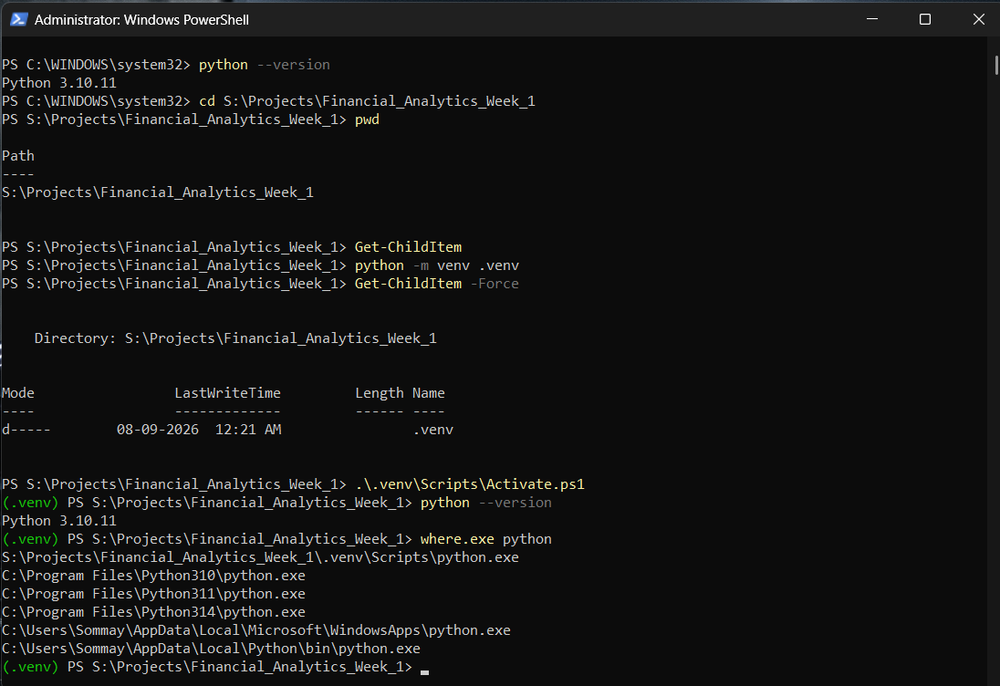
Figure 1. Python 3.10.11 verification and project directory navigation.
5.2 Virtual Environment
A project-specific virtual environment named .venv was created using Python's built-in venv module. The environment was activated before installing project dependencies. This isolates the Week 1 packages from other Python projects on the computer.
Commands used:
python -m venv .venv
.\.venv\Scripts\Activate.ps1
python --version
where.exe python
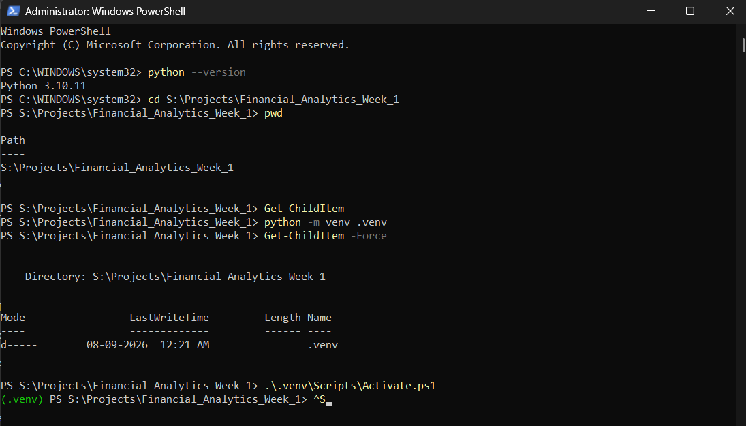
Figure 2. Virtual environment creation, activation, and interpreter verification.
5.3 pip Upgrade
The pip package manager was upgraded inside the virtual environment before installing the analytics stack. The verified project environment reported pip 26.2.1 after the upgrade.
python -m pip install --upgrade pip
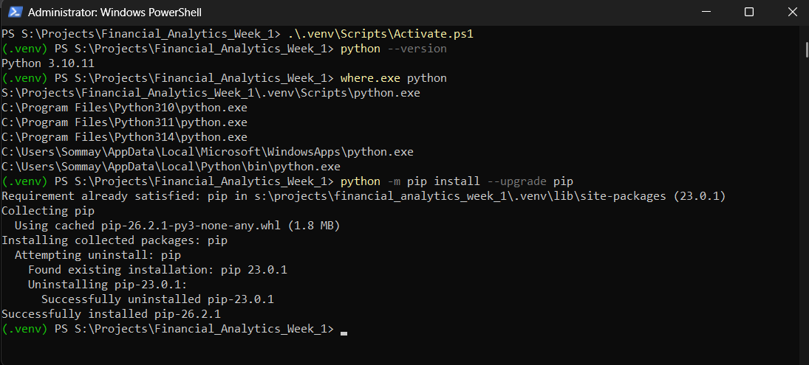
Figure 3. pip successfully upgraded inside the project virtual environment.
5.4 Package Installation
The core financial-analytics packages were installed with one reproducible command:
python -m pip install numpy pandas matplotlib seaborn scipy jupyter
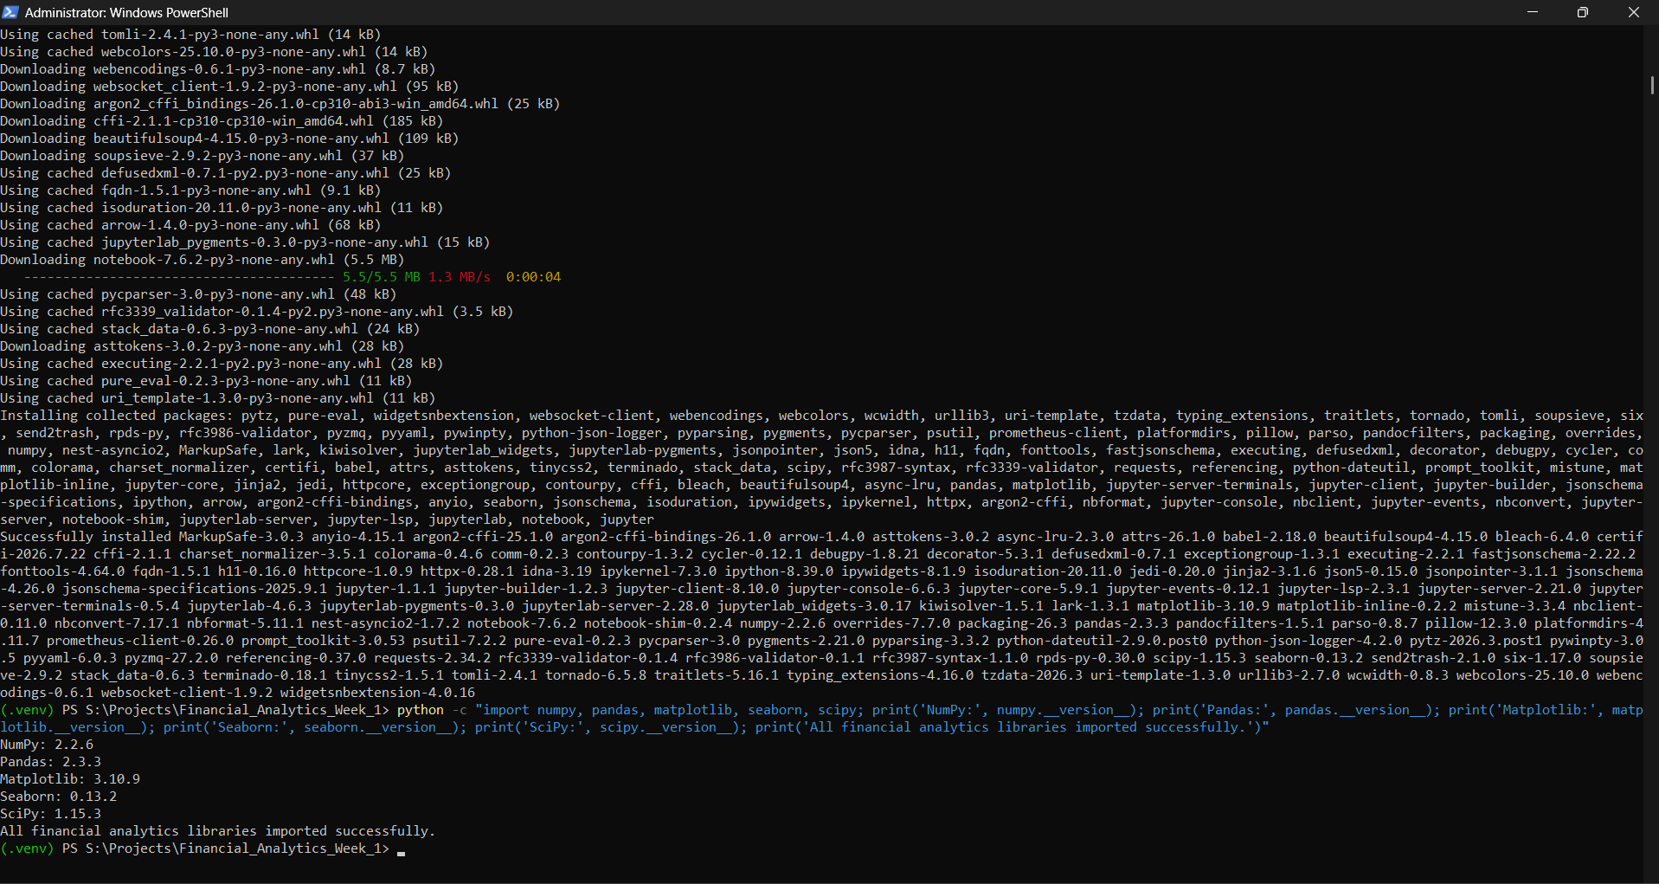
Figure 4. Analytics libraries and Jupyter packages installed successfully.
5.5 Project Structure
The project was organized using the following structure:
Financial_Analytics_Week_1/
├── .venv/
├── data/
│ └── raw/
├── notebooks/
├── outputs/
│ ├── charts/
│ └── reports/
├── screenshots/
└── scripts/
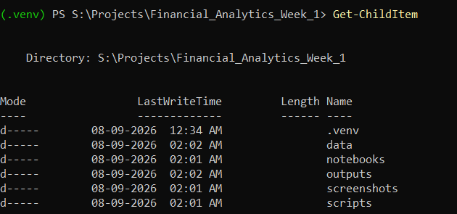
Figure 5. Organized Week 1 project directory.
5.6 Jupyter and VS Code Workflow
Jupyter was installed and its components were verified. A browser-based JupyterLab launch was attempted; the server started successfully but the browser opened an ERR_FILE_NOT_FOUND page for the generated local runtime launch file. Rather than reinstalling the environment, the project workflow was moved to VS Code's integrated Jupyter notebook experience.
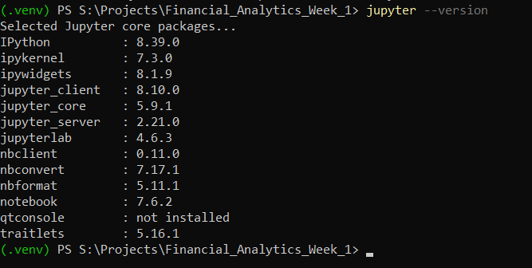
Figure 6. Jupyter component versions verified from the project environment.
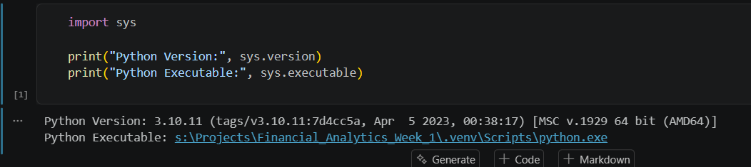
Figure 7. VS Code notebook confirms Python 3.10.11 and the project .venv interpreter.
5.7 Library Import Verification
The installed libraries were imported from the actual VS Code notebook kernel. This provided an end-to-end check that the packages were not only installed but also accessible to the notebook used for analysis.
import numpy as np
import pandas as pd
import matplotlib.pyplot as plt
import seaborn as sns
import scipy
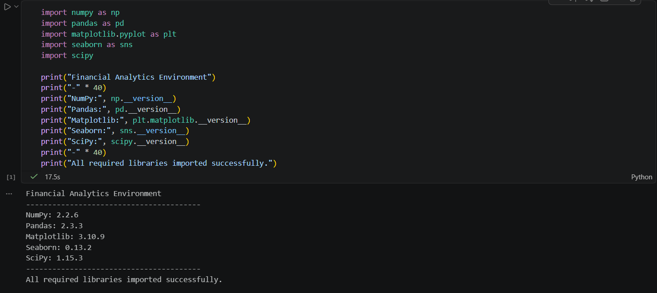
Figure 8. Successful import and version verification inside the notebook.
6. Challenges Encountered and Resolutions
Challenge | Resolution | Outcome
Multiple Python versions were installed on the system. | Created and activated a project-specific .venv using Python 3.10.11; verified the interpreter path with where.exe python. | The .venv interpreter was first in the active project path.
JupyterLab browser launch returned ERR_FILE_NOT_FOUND. | Kept the Jupyter installation and moved the notebook workflow to VS Code after verifying the project kernel. | Stable notebook execution was achieved inside VS Code.
Need for reproducible package management. | Upgraded pip and installed the required analytics stack inside .venv. | Project dependencies are isolated from other environments.

7. Strategic Plan for Financial Data Analysis
The following workflow will be used as the standard approach for future financial analytics tasks. It is designed to be repeatable and to keep financial interpretation connected to data quality and business context.
1. Define the problem — Translate the business or financial need into a clear analytical problem statement.
2. Formulate research questions — Create measurable questions that specify the period, population, metrics, and comparison required.
3. Identify data requirements — List required variables, time periods, units, sources, and any relevant financial statements or market data.
4. Acquire and document data — Collect data from appropriate sources and record source, period, definitions, and assumptions.
5. Validate the data — Check dimensions, data types, dates, missing values, duplicates, units, and obvious inconsistencies.
6. Clean and transform — Handle missing/duplicate records, standardize dates and units, and create analytical variables.
7. Explore the data — Use descriptive statistics, distributions, trends, and grouped summaries to understand the dataset.
8. Apply financial analysis — Calculate relevant growth rates, margins, ratios, variances, returns, or other KPIs.
9. Investigate relationships — Use correlation, time-series comparisons, segmentation, or other suitable methods.
10. Visualize results — Use clear charts with titles, labels, units, and appropriate scales to communicate patterns.
11. Interpret findings — Explain what the results mean in financial/business terms without overstating causality.
12. Document limitations — Record data limitations, assumptions, definitions, missing information, and analytical constraints.
13. Communicate results — Present conclusions in a concise report, notebook, dashboard, or other decision-support format.
7.1 Example Problem Statements
- Analyze historical revenue, expenses, and profitability to identify changes in financial performance over time.
- Evaluate short-term financial position using liquidity indicators and historical trends.
- Examine relationships among revenue, expenses, assets, liabilities, and profit to identify areas requiring further investigation.
- Compare actual performance with a budget, target, or previous period to understand material variances.
7.2 Research Questions
- How has revenue changed across the selected reporting periods?
- How have expenses changed relative to revenue?
- How has profitability changed over time?
- What do the selected liquidity indicators suggest about short-term financial position?
- How has financial leverage changed during the analysis period?
- Which financial metrics show the largest period-to-period changes?
- Are meaningful relationships visible among major financial variables?
- Which trends or anomalies warrant deeper investigation?
7.3 Anticipated Analytical Methods
Analytical need | Method | Python tools
Data preparation | Cleaning, type conversion, filtering, feature creation | Pandas
Numerical calculations | Vectorized calculations and mathematical transformations | NumPy
Financial KPIs | Growth, margin, liquidity, leverage, efficiency calculations | Pandas / NumPy
Historical comparison | Horizontal and trend analysis | Pandas
Data summary | Mean, median, standard deviation, percentiles | Pandas / SciPy
Relationships | Correlation and statistical exploration | Pandas / SciPy
Visualization | Line, bar, scatter, distribution and comparison charts | Matplotlib / Seaborn
Notebook reporting | Narrative, code, output, and interpretation in one document | Jupyter / VS Code

8. Python-Based Financial Analytics Learning Roadmap
Stage | Focus areas | Expected outcome
Stage 1 — Foundations | Financial statements, terminology, Python, NumPy, Pandas basics. | Ability to understand and prepare financial datasets.
Stage 2 — Applied Analysis | Cleaning, EDA, ratios, KPI calculations, visualization. | Ability to produce interpretable financial analysis.
Stage 3 — Time-Series & Risk | Returns, volatility, trend analysis, time-series concepts, statistical methods. | Ability to investigate financial patterns and risk-related measures.
Stage 4 — Business Intelligence | SQL, Excel, Power BI, automated reporting, dashboards. | Ability to communicate financial insights to business stakeholders.
Stage 5 — Advanced Analytics | Forecasting, predictive modeling, scenario analysis where appropriate. | Ability to extend descriptive analysis into forward-looking analytical work.

9. GitHub and Project Documentation Plan
Because the task is technical/software related and the submission instructions state that a GitHub URL is compulsory for certificate issuance in that case, the project will be version-controlled and uploaded after the local report and notebook structure are finalized.
Planned repository structure:
Financial-Analytics-with-Python/
│
├── Week_1/
│ ├── report/
│ │ └── Week_1_Report.docx
│ ├── notebooks/
│ │ └── Week_1_Orientation.ipynb
│ └── screenshots/
│
├── Week_2/
│ ├── data/
│ │ ├── raw/
│ │ └── cleaned/
│ ├── notebooks/
│ │ └── Week_2_Data_Cleaning.ipynb
│ ├── report/
│ │ └── Week_2_Report.docx
│ └── screenshots/
│
├── Week_3/
│ ├── notebooks/
│ │ └── Week_3_EDA.ipynb
│ ├── outputs/
│ │ └── charts/
│ ├── report/
│ │ └── Week_3_Report.docx
│ └── screenshots/
│
├── Week_4/
│ ├── notebooks/
│ │ └── Week_4_Forecasting.ipynb
│ ├── models/
│ ├── outputs/
│ ├── report/
│ │ └── Week_4_Report.docx
│ └── screenshots/
│
├── Week_5/
│ ├── notebooks/
│ │ └── Week_5_Final_Analysis.ipynb
│ ├── outputs/
│ ├── report/
│ │ └── Final_Financial_Analytics_Report.docx
│ └── screenshots/
│
├── README.md
├── requirements.txt
└── .gitignore
- The .venv directory will not be committed to GitHub.
- A requirements.txt file will record the project's Python dependencies.
- The README will describe the objective, setup, project structure, and learning outcomes.
- The final GitHub URL will be inserted into the submission portal after repository creation.
10. Alignment with Evaluation Criteria
Evaluation criterion | How this report addresses it
Clarity and depth of research | Defines financial analytics, financial statements, indicators, trends, and common analytical methods.
Environment setup completeness | Documents Python, .venv, pip, package installation, Jupyter, VS Code kernel selection, and import verification.
Strategic plan quality | Provides a repeatable 13-step financial data-analysis workflow with problem statements, research questions, and methods.
Presentation and structure | Uses numbered sections, tables, bullet points, technical evidence, references, and a consistent report format.
Length and completeness | Provides substantially more than the required 200 words and covers objective, deliverables, steps, and evaluation criteria.

11. Conclusion
Week 1 established both conceptual and technical foundations for financial analytics. The research introduced the role of financial statements, key financial concepts, common indicators, trends, and analytical methods. In parallel, a dedicated Python environment was configured using Python 3.10.11, a project-specific virtual environment, and a core analytics stack consisting of NumPy, Pandas, Matplotlib, Seaborn, SciPy, and Jupyter.
The environment was validated from within a VS Code Jupyter notebook, confirming that the correct .venv interpreter was being used and that the required libraries could be imported successfully. The documented JupyterLab browser issue also demonstrated the importance of troubleshooting while preserving reproducibility rather than repeatedly rebuilding a working environment.
The next phase will build on this foundation by applying the documented analytical workflow to real financial data. The intended progression is from data acquisition and validation to exploratory analysis, financial KPI calculation, visualization, interpretation, and professional reporting. The same workflow will support the development of a GitHub portfolio artifact that demonstrates both financial-analytics understanding and practical Python skills.
12. Submission Checklist
Item | Status | Notes
Word report (.docx) | Ready | This document.
Financial concepts research | Ready | Included in Sections 3–4.
Environment setup evidence | Ready | Included in Section 5.
Challenges and resolutions | Ready | Included in Section 6.
Strategic plan | Ready | Included in Section 7.
Learning roadmap | Ready | Included in Section 8.
GitHub repository | Next step | To be created together.
GitHub URL in portal | Next step | Insert after repository creation.
200+ word portal description | Next step | Prepared after final GitHub/report review.

13. References and Research Sources
[1] U.S. Securities and Exchange Commission / Investor.gov. “How to Read a 10-K.” https://www.investor.gov/introduction-investing/getting-started/researching-investments/how-read-10-k
[2] U.S. Securities and Exchange Commission / Investor.gov. “How to Read a 10-K/10-Q.” https://www.investor.gov/introduction-investing/general-resources/news-alerts/alerts-bulletins/investor-bulletins/how-read
[3] Pandas Documentation. “Package overview” and “Getting started tutorials.” https://pandas.pydata.org/docs/getting_started/overview.html
[4] NumPy Documentation. “NumPy User Guide.” https://numpy.org/doc/stable/numpy-user.pdf
[5] Matplotlib Documentation. “Matplotlib documentation / Getting started.” https://matplotlib.org/stable/

End of Week 1 Report

