COMPREHENSIVE FINANCIAL
ANALYTICS REPORT
WEEK 5 | FINAL SYNTHESIS & RECOMMENDATIONS
Prepared by Sommay Dewat
Junior Data Analyst – Financial Analytics with Python
Project scope: Weeks 1–4 | Dataset: Simulated stock-market data
Educational analysis only • Synthetic data • Not investment advice

1. Executive Summary
This report consolidates the four completed analytical stages of the Financial Analytics with Python project and translates the documented findings into practical recommendations for a future analytics workflow. The work progressed from financial-analytics orientation and Python environment setup to data cleaning, exploratory data analysis (EDA), visualization, and a next-day closing-price forecasting experiment. The objective was to demonstrate a traceable, structured analytical process—not to produce a real-world trading signal. The underlying stock-market dataset is simulated, and all numerical findings are specific to that dataset.
The raw dataset contained 503 rows. Following quality checks and cleaning, the analysis-ready dataset contained 499 rows. EDA reported a mean closing price of approximately 123.05, a median of 122.30, and a range of 87.28–166.35. Average daily return was approximately 0.094%, with observed returns ranging from approximately −3.893% to 5.246%. The exploration also found strong relationships among OHLC price fields, a weak linear relationship between volume and closing price, and potential return outliers identified through the IQR method.
For forecasting, a next-observation closing-price target was created and a chronological split produced 397 training rows and 100 test rows. The Naive Baseline achieved MAE 1.2784, RMSE 1.5876, and R² 0.8718. Linear Regression achieved MAE 1.3218, RMSE 1.6241, and R² 0.8658. The baseline slightly outperformed Linear Regression on this test set. Priority improvements include validating feature availability at prediction time, expanding time-aware validation, documenting outlier thresholds, and testing only on reliable real-world data before considering any operational use.

2. Project Scope, Data Sources, and Preparation
The project was organized as a progressive five-week learning pathway. Week 1 established the financial-analytics context and a reproducible development setup using Python 3.10.11, a project-specific virtual environment, VS Code, and Jupyter Notebook. Weeks 2–4 then applied this environment to a simulated stock-market dataset. The core fields were Date, Open, High, Low, Close, and Volume; derived fields included Price_Change and Daily_Return_Pct. The dataset was intended for practice and does not represent a real listed company, exchange, or live market feed.
The raw data contained 503 rows with deliberately introduced quality issues. The preparation workflow inspected data types, missing values, duplicate records, date validity, volume values, and OHLC consistency. Fields were converted to suitable types, duplicate rows were removed, invalid or missing entries were addressed, and validation checks were applied. After cleaning, the analysis-ready dataset contained 499 rows. These steps matter because uncorrected errors can distort descriptive statistics, charts, and model evaluation. The cleaning workflow also created price-change and daily-return features for later analysis.
For the forecasting task, the cleaned dataset was checked again, including remaining missing values in derived columns. The target `Target_Next_Day_Close` was generated by shifting `Close` forward by one row. The resulting modeling table contained 497 usable rows after excluding rows without a valid target or required values. This report preserves the recorded counts and methods from the project documentation. It does not infer additional data-source metadata, sampling frequency, market identity, or cleaning counts that were not documented in the available project results.

3. Exploratory Data Analysis: Trends, Relationships, and Outliers
The EDA stage examined the dataset's structure, coverage, descriptive statistics, relationships, and potential unusual observations. Analysis included mean, median, standard deviation, quartiles, minimum, and maximum; correlation checks among OHLC prices, volume, price changes, and daily returns; and IQR-based screening of closing prices and returns. Visualizations produced during the project included a closing-price time series, distribution histograms, volume trends, a volume-versus-close scatter plot, box plots, and a correlation heatmap. Together, these views provide complementary ways to inspect central tendency, spread, temporal movement, and relationships.
The reported closing-price mean was approximately 123.05 and the median was 122.30, with values ranging from 87.28 to 166.35. The average daily return was approximately 0.094%; observed returns ranged from about −3.893% to 5.246%. OHLC variables were very strongly correlated, which is plausible because open, high, low, and close describe related price measures. Trading volume had a weak linear relationship with closing price in this sample. These are descriptive observations and do not establish causality or imply that the features have reliable predictive power.
The IQR procedure flagged several daily-return observations outside its calculated bounds. Such observations should be treated as candidates for investigation, not automatically removed or labeled as erroneous. A professional outlier review should record the exact quartiles, IQR, lower and upper fences, number and dates of flagged records, and a reasoned decision for each treatment. Those exact bounds and record-level details are not present in the summarized project results available for this report, so no thresholds or counts are invented here. Because the dataset is synthetic, its trends and anomalies cannot be generalized to real market behavior.

4. Forecasting Methodology and Model Evaluation
The forecasting experiment estimated the next observation's closing price. The target `Target_Next_Day_Close` was created by shifting the Close column by one row. To respect the chronological nature of the data, the split was ordered by time rather than randomized: 397 rows were used for training and 100 rows for testing. The evaluated feature set for Linear Regression included Open, High, Low, Close, Volume, Price_Change, and Daily_Return_Pct. The experiment compared a simple naive estimate with a linear regression model to determine whether the additional model structure improved held-out performance.
The Naive Baseline used the current Close value as the estimate for the next-day close. Linear Regression used the seven listed input features. The evaluation metrics were Mean Absolute Error (MAE), Root Mean Squared Error (RMSE), and R-squared (R²). The baseline results were MAE 1.2784, RMSE 1.5876, and R² 0.8718. Linear Regression results were MAE 1.3218, RMSE 1.6241, and R² 0.8658. The baseline therefore had slightly lower error values and a slightly higher R² on this particular test set.
The result is an important analytical checkpoint: a more complex model should not be assumed to be better without evidence from a fair comparison. The experiment generated prediction and metrics CSV files, an actual-versus-predicted visualization, and a residual visualization. The reported metrics are tied to this synthetic dataset, feature construction, and single holdout split. They do not establish forecast accuracy on live prices. Feature timing is also material: same-day High, Low, Close, and return-related fields may not be known at every intended prediction time, so the forecast timestamp and allowed inputs must be defined before interpreting the scores operationally.
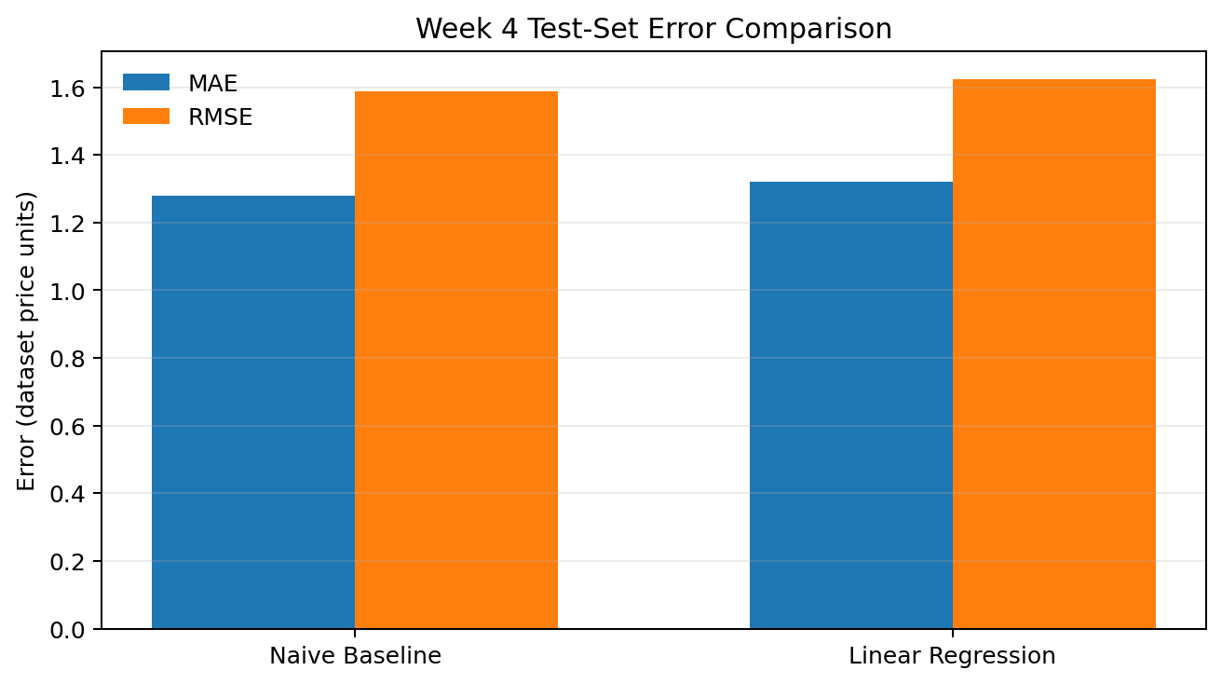
Figure 1. MAE and RMSE comparison for the two evaluated approaches on the documented test set.

Model Evaluation Summary
Model | MAE | RMSE | R²
Naive Baseline (current close) | 1.2784 | 1.5876 | 0.8718
Linear Regression | 1.3218 | 1.6241 | 0.8658

5. Strategic Recommendations for a Financial Analytics Workflow
A financial institution considering a similar analytical workflow should begin with data governance and traceability. Use a documented, appropriately licensed source with clear timestamps, consistent units, and defined quality rules. Validate missingness, duplicates, invalid dates, volume constraints, and OHLC consistency at ingestion. Preserve raw data separately from cleaned data, record each transformation, and maintain versioned datasets and code. These practices improve auditability and help analysts investigate unexpected outputs. Synthetic data is useful for learning and software testing, but decisions involving capital, customers, or risk require validated data and formal review.
Second, strengthen the evaluation design. A single chronological holdout is a useful starting point, but rolling-origin or expanding-window validation can reveal whether results are stable across multiple periods. Keep a naive baseline in the comparison and report metrics consistently across models and test windows. Candidate models may include regularized regression or suitable time-series approaches, but additional complexity should be retained only when it delivers repeatable out-of-sample improvement. Where appropriate, add error distributions, prediction intervals, and subgroup or regime-level diagnostics rather than relying on one aggregate score.
Third, define the forecast timestamp and eliminate feature-timing leakage. Only inputs available at that moment should be used. For example, if a prediction is issued before the close, same-day Close, High, Low, or features derived from them may be unavailable. Document the intended decision use, forecast horizon, data cut-off, and assumptions. Finally, communicate uncertainty clearly and treat model outputs as decision support rather than a guarantee. For a regulated or institutional setting, involve risk, compliance, and domain experts, test robustness, and establish monitoring and retraining criteria before any production deployment.

6. Limitations, Risk Considerations, and Responsible Use
Several limitations constrain the conclusions. First, the dataset is synthetic; its distribution, relationships, and evaluation scores do not describe actual financial markets. Second, the modeling sample is limited and the reported evaluation uses one chronological train-test split. A single split cannot establish stability across market conditions or time periods. Third, the model comparison is narrow, covering a naive baseline and Linear Regression only. The project does not evaluate transaction costs, slippage, liquidity constraints, portfolio construction, risk-adjusted returns, or a trading strategy. These omissions mean that predictive error metrics should not be interpreted as evidence of financial profitability.
Feature timing is a further concern. The input features include current-row OHLC values and derived measures. Depending on when a forecast is intended to be generated, some of these values may not yet be observable. A production-oriented experiment would define a prediction timestamp, use only information available by that time, and test the complete pipeline without leakage. The outlier review also needs a more explicit audit trail containing the IQR thresholds, flagged observations, and documented handling decisions. Those details should be added from the underlying notebook or data rather than estimated after the fact.
Responsible use requires communicating uncertainty and limitations prominently. The results in this report are educational and should not be used to recommend purchases, sales, or other investment decisions. Before any real-world application, the workflow would need reliable data, stronger validation, feature-timing checks, domain review, risk controls, and monitoring. These limitations do not negate the learning value of the project; they define the boundary between a reproducible learning exercise and a validated financial analytics system.

7. Conclusion and Next-Step Plan
Across Weeks 1–4, the project developed a connected workflow for financial data analysis: environment setup, data quality assessment, cleaning, feature creation, exploratory analysis, visualization, and forecasting evaluation. The cleaned dataset contained 499 rows, and EDA summarized price and return distributions, correlations, and potential outliers. The forecasting exercise used a chronological split of 397 training and 100 test observations. On that test set, the Naive Baseline slightly outperformed Linear Regression across the reported MAE, RMSE, and R² values. This is a useful reminder that benchmarks and disciplined evaluation are essential parts of analytical work.
The recommended next steps are to preserve the original data and scripts, document exact outlier thresholds and flagged records, verify that all model inputs are available at the prediction timestamp, and introduce rolling or expanding-window validation. If the project is extended beyond synthetic data, the next stage should use a suitable real-world dataset with documented provenance and permissions, while keeping the same reproducible cleaning and evaluation process. Additional models should be tested against the naive benchmark and assessed on multiple time windows, with uncertainty and limitations clearly reported.
The final outcome is a documented educational project that demonstrates core data analyst practices: asking a defined question, checking data quality, using descriptive and visual analysis, comparing a model with a benchmark, interpreting metrics carefully, and translating findings into practical process improvements. The project does not claim to provide a reliable market forecast. Its main value is the repeatable analytical workflow and the lessons identified for improving data quality, validation, communication, and responsible model use.

8. Project Artifacts and Reproducibility
The repository is organized by week and includes datasets, notebooks, outputs, visualizations, and reports. Week 4 artifacts include the cleaned dataset copy, forecasting notebook, prediction results, model evaluation metrics, actual-versus-predicted chart, residual chart, and the Week 4 Word report. The project is version-controlled with Git and hosted on GitHub. To reproduce the analysis, clone the repository, create and activate a Python virtual environment, install dependencies from the requirements file if current, and run notebooks in sequence while checking their relative paths. Exact results depend on the data and environment used. The final report consolidates the documented findings and highlights where further evidence—such as detailed outlier records or multi-window validation—would be needed.

Appendix A — Key Recorded Statistics
Item | Recorded value
Raw dataset size | 503 rows
Cleaned dataset size | 499 rows
Forecasting modeling rows | 497 rows
Training / test rows | 397 / 100
Closing price mean / median | 123.05 / 122.30 (approx.)
Closing price range | 87.28–166.35
Average daily return | 0.094% (approx.)
Observed daily return range | −3.893% to 5.246% (approx.)

Sommay Dewat | Financial Analytics with Python | Week 5

