Real-World Dataset Analysis Project
Seoul Bike Sharing Demand — YuvaIntern Task 3

1. Dataset and Objective
This project explores the Seoul Bike Sharing Demand dataset from the UCI Machine Learning Repository. The objective is to inspect data quality, analyse hourly and seasonal demand, examine weather relationships, and communicate findings.
Source: https://archive.ics.uci.edu/dataset/560/seoul%2Bbike%2Bsharing%2Bdemand
The dataset includes rental counts, date, hour, weather measurements, season, holiday status, and system functioning status. The source dataset is distributed under CC BY 4.0; attribution should be retained.

2. Data Quality
Records: 8,760
Missing values: 0
Exact duplicate rows: 0
Duplicate date-hour keys: 0

3. Key Findings
Total rentals: 6,172,314
Average hourly rentals: 704.60
Median hourly rentals: 504.50
Maximum observed rentals: 3,556 on 2018-06-19 at 18:00.
Highest average demand hour: 18:00 (1502.93 rentals/hour).

Average Rentals by Season
Season | Average rentals/hour
Summer | 1034.07
Autumn | 819.60
Spring | 730.03
Winter | 225.54

4. Charts
Average demand by hour
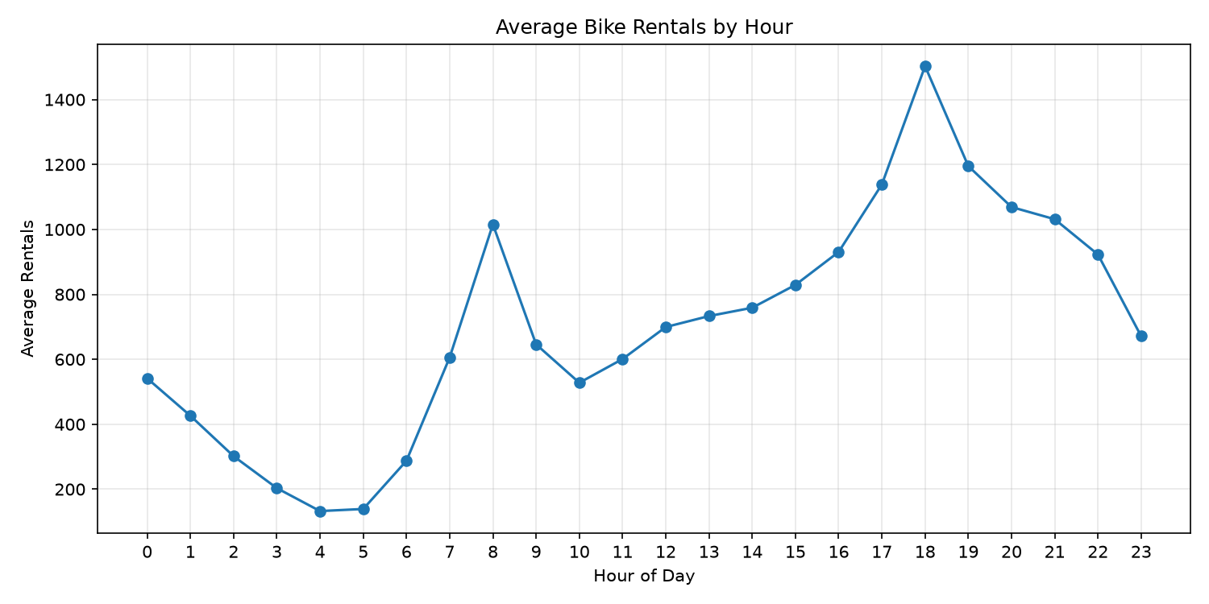
Average demand by season
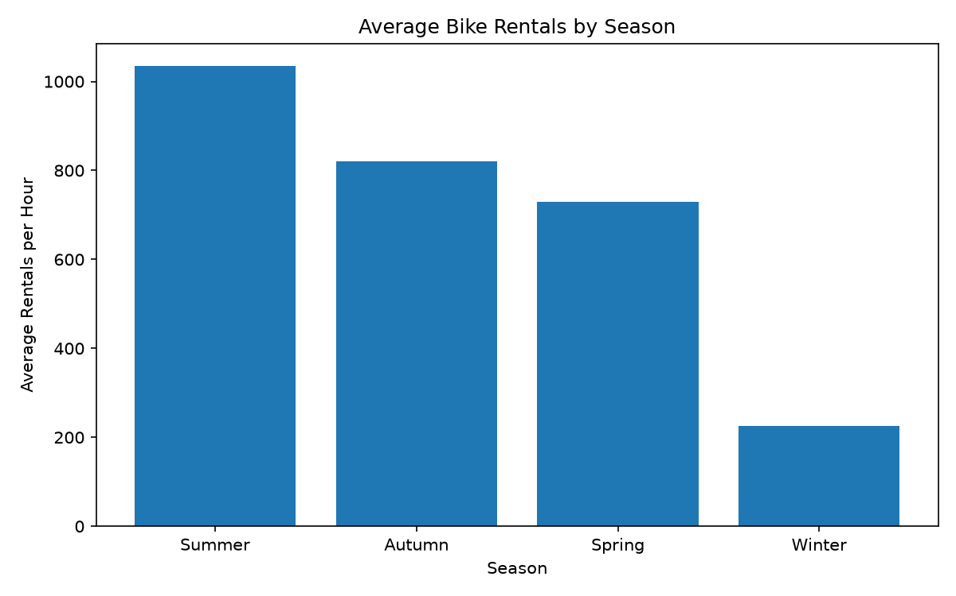
Rental-count distribution
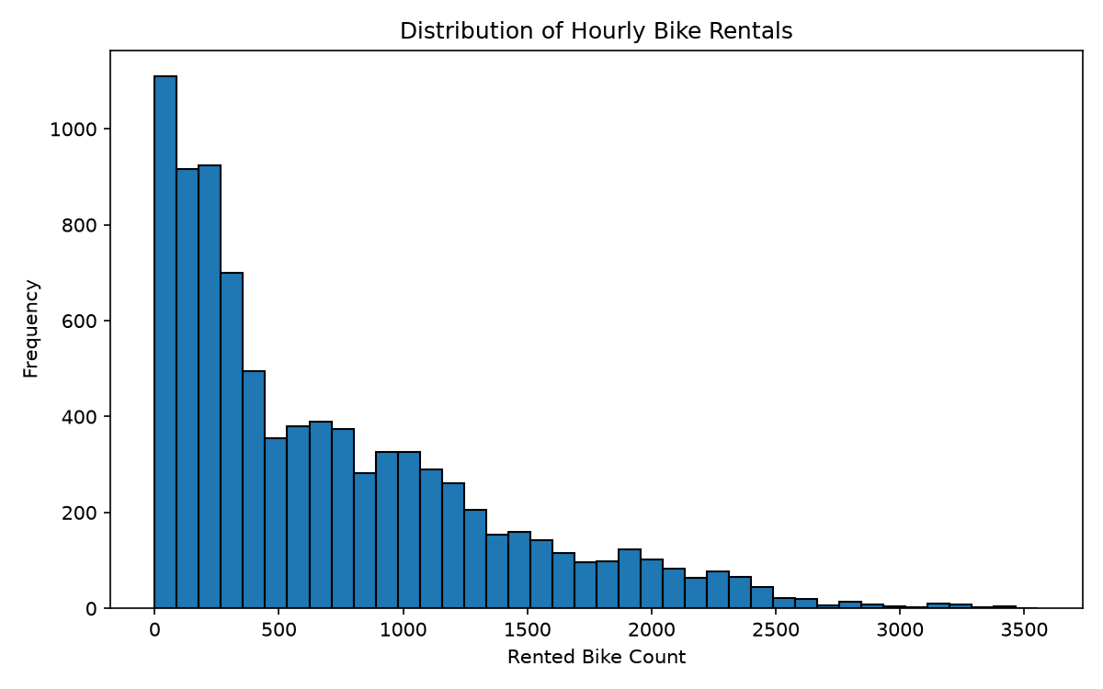
Temperature versus rentals
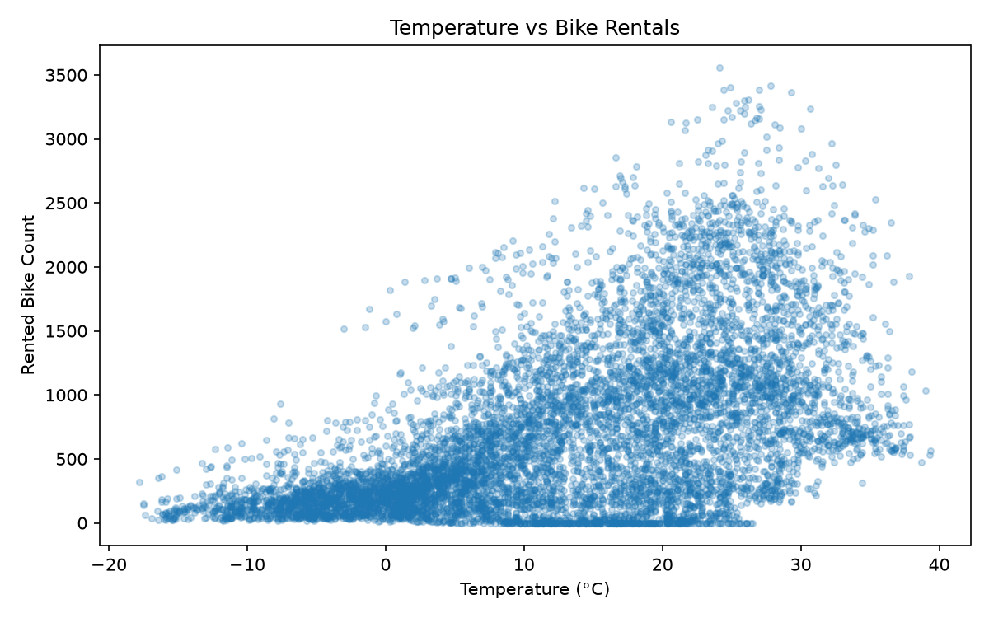
Correlation heatmap
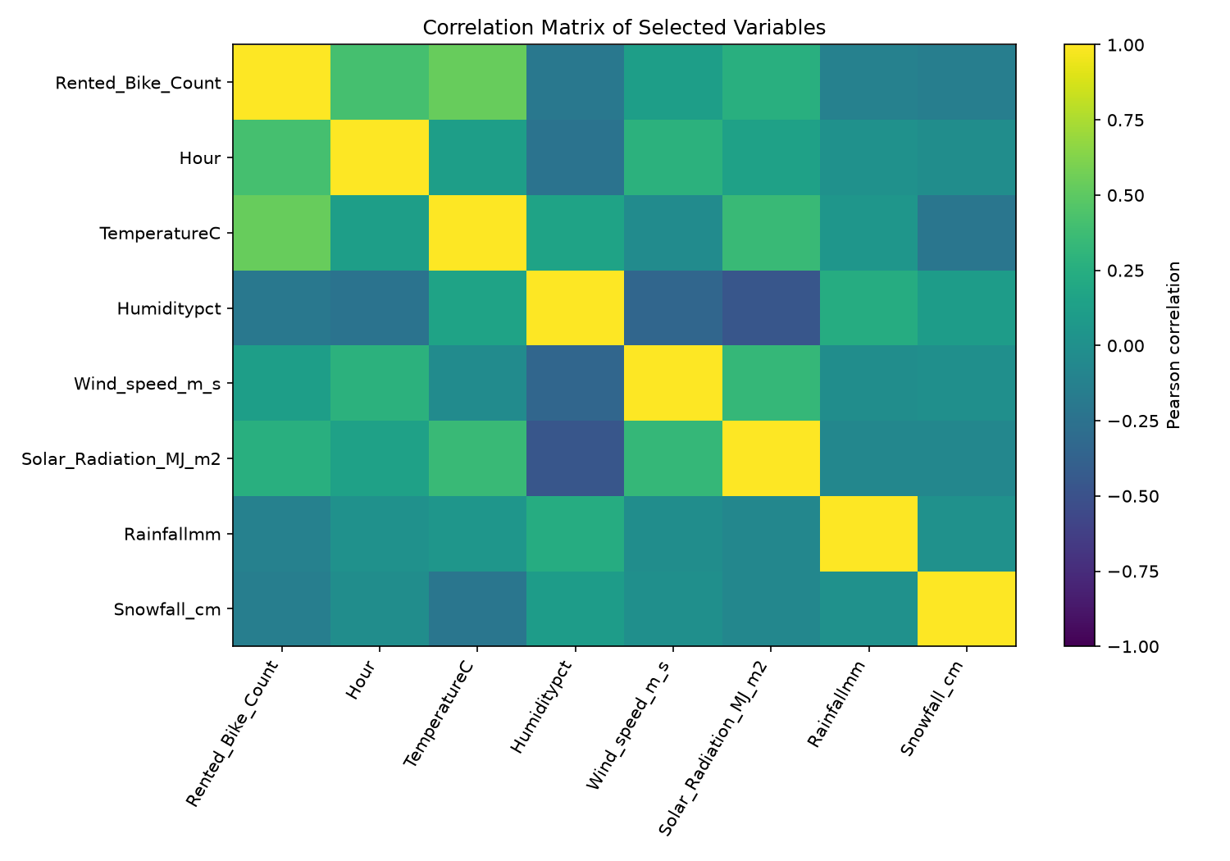

5. Interpretation and Limitations
Hourly and seasonal demand differ substantially. Temperature is positively associated with rentals, but correlation does not prove causation. Potential outliers should be reviewed in context before deciding whether to remove any observations. Results from this dataset may not generalise to other cities or periods.

Reference
UCI Machine Learning Repository, Seoul Bike Sharing Demand. https://archive.ics.uci.edu/dataset/560/seoul%2Bbike%2Bsharing%2Bdemand

