Data Science Tool Mastery Project
Exploratory Data Analysis and Visualization using Python
Prepared by: Sommay Dewat
Project Type: Data Science Tools Practical Project

1. Executive Summary
This project demonstrates practical use of Python data science libraries for dataset inspection, cleaning, statistical analysis, feature engineering, and visualization. The Seaborn restaurant tips dataset was used to study bill amounts, tips, party sizes, days, and meal times. The original dataset contained 244 records and 7 columns. One exact duplicate record was removed, leaving 243 records for analysis.

2. Project Objectives
- Inspect dataset structure, data types, distributions, and quality.
- Use Pandas to clean and transform data.
- Apply NumPy for numerical and statistical calculations.
- Create visualizations using Matplotlib and Seaborn.
- Communicate analytical findings and limitations.
- Practice reproducible analysis using Jupyter Notebook.

3. Tools and Technologies
- Python 3.11
- Pandas for data manipulation and grouping
- NumPy for numerical calculations
- Matplotlib and Seaborn for visualizations
- Jupyter Notebook for documented analysis
- python-docx for report generation

4. Dataset Description
The dataset is Seaborn's built-in tips dataset, intended here for educational analysis. Its seven fields are total_bill, tip, sex, smoker, day, time, and size. The dataset describes restaurant bill and tip observations along with customer and meal attributes. Its small size makes it suitable for learning common data analysis workflows, but it should not be treated as representative of all restaurants or customers.

5. Data Inspection and Cleaning
The original dataset had 244 rows and 7 columns. Inspection found 0 missing values across the original columns and 1 exact duplicate row. The duplicate was removed. No rows were removed for missing numeric values or invalid numeric records. The final cleaned dataset contains 243 rows.
A derived feature, tip_percentage, was calculated as the tip divided by the total bill multiplied by 100. Unusual values were not automatically removed solely because they appeared extreme.

6. Statistical Analysis
- Average total bill: 19.81
- Median total bill: 17.81
- Standard deviation of total bill: 8.89
- Average tip: 3.00
- Median tip: 2.92
- Overall tip-to-bill ratio: 15.15%
Among the recorded days, Sun had the highest average tip (3.26), while Fri had the lowest average tip (2.73).

7. Visualizations
Histogram showing the distribution of restaurant bill amounts.
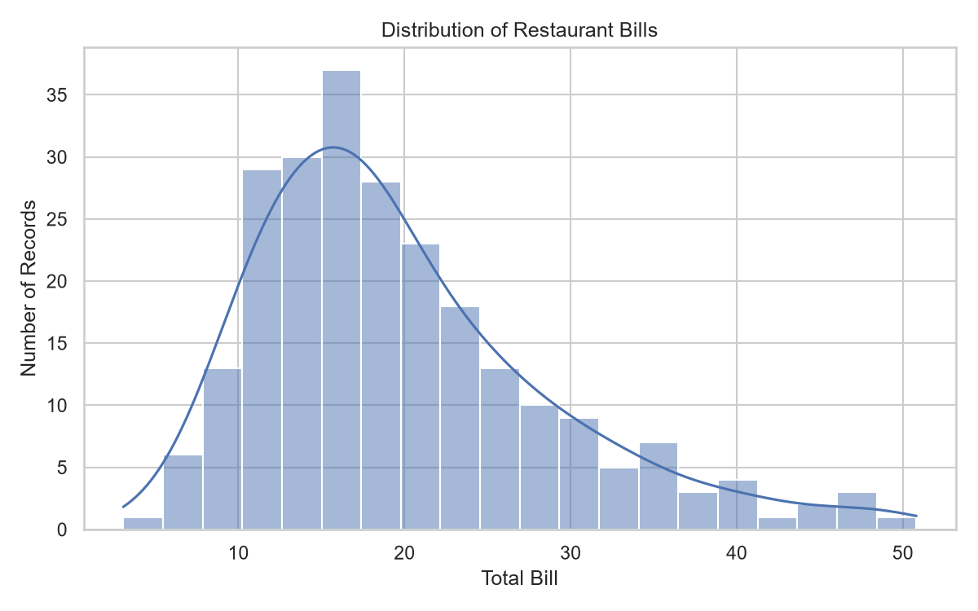
Comparison of average tip amounts across recorded days.
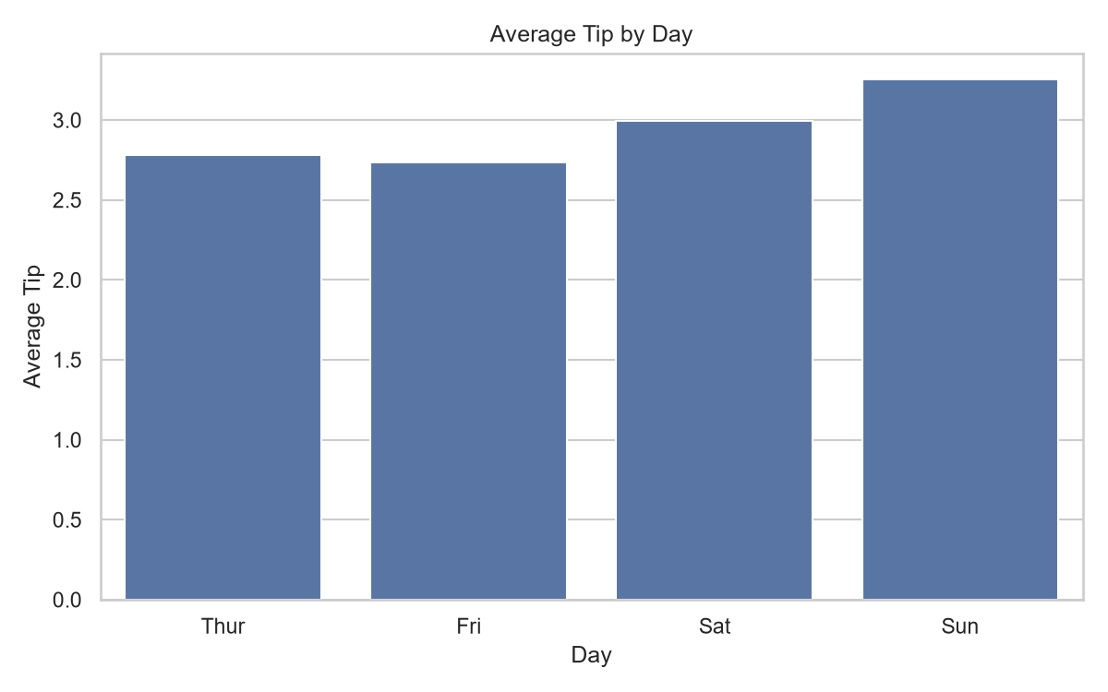
Scatter plot exploring the relationship between bills and tips.
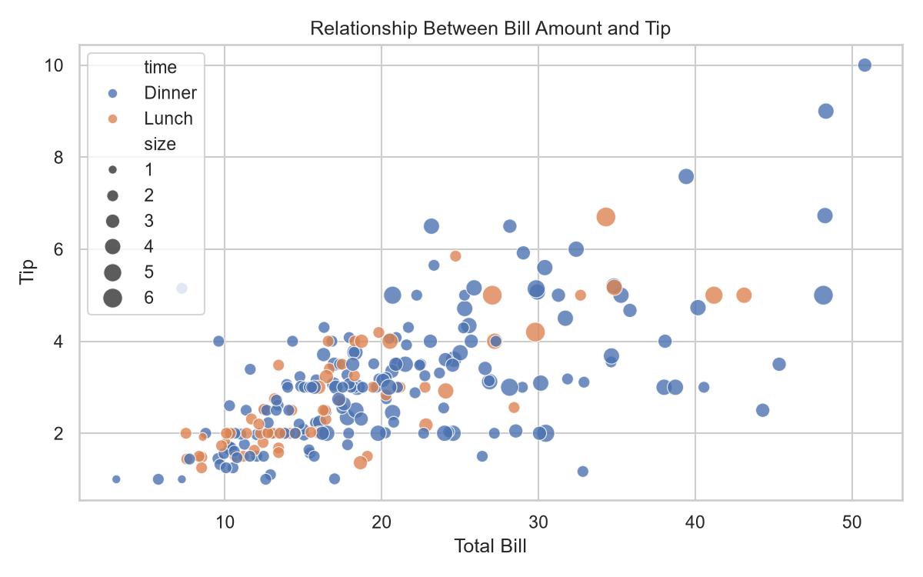
Comparison of average tip percentage across meal times.
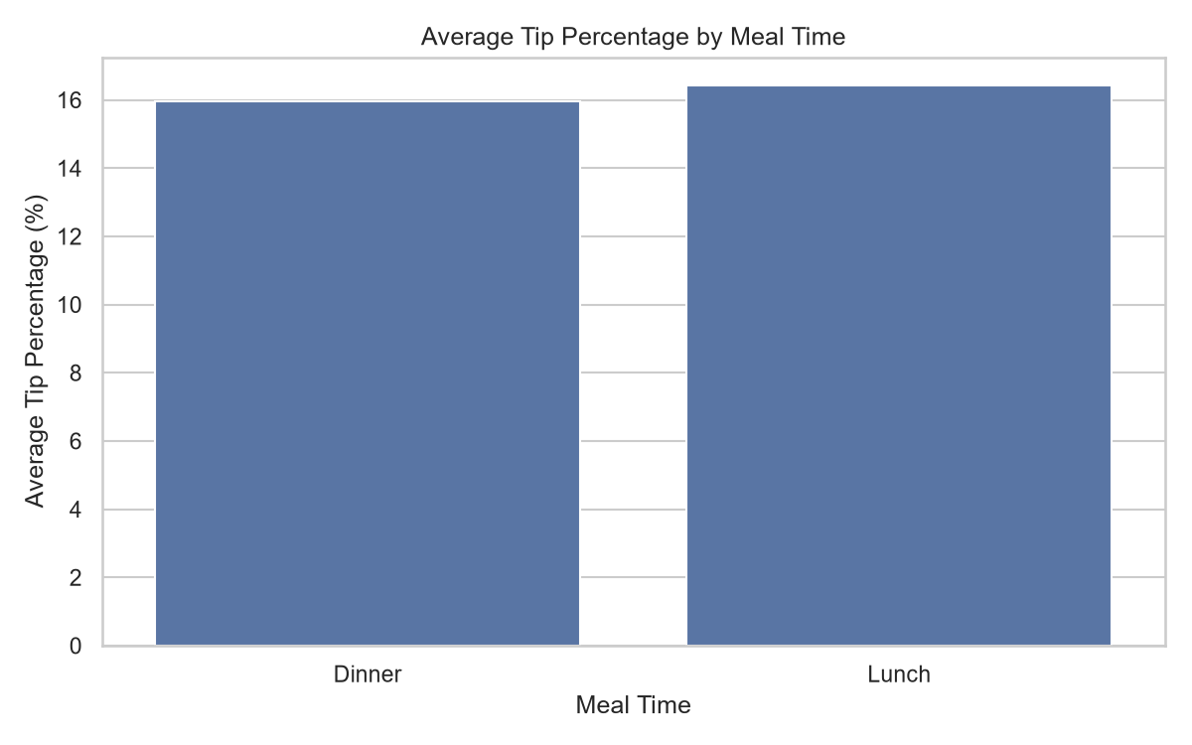
Heatmap showing pairwise correlations among numerical variables.
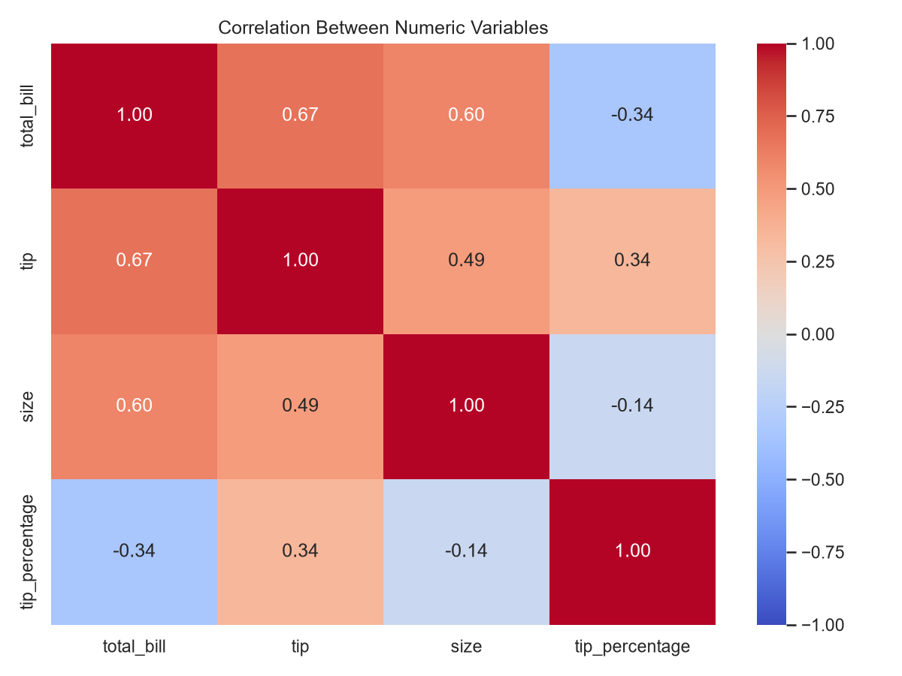

8. Key Findings and Business Interpretation
- The cleaned sample has an average bill of 19.81 and an average tip of 3.00.
- The aggregate tip-to-bill ratio is 15.15%. This is a ratio of total tips to total bills, not the mean of individual percentages.
- The daily average-tip comparison can help demonstrate how grouped summaries support exploratory business analysis.
- The bill-versus-tip scatter plot helps inspect whether larger bills tend to accompany larger tips; a visible association does not prove that bill size causes a particular tip.

9. Recommendations
- Use larger and more representative datasets before making operational decisions.
- Explore tip percentage by party size, day, and meal time.
- Investigate unusual observations before deciding whether they are errors.
- Use clear charts and descriptive statistics to communicate findings.
- Keep the notebook, source code, cleaned data, and outputs together for reproducibility.

10. Limitations
This is a small educational dataset, so results cannot automatically be generalized to all restaurants. The analysis is descriptive and does not establish causality. The dataset's currency and collection context are not established in this report, so monetary values are reported in dataset units. The analysis does not establish statistical significance or support causal claims.

11. Conclusion
The project demonstrates an end-to-end introductory data science workflow: inspecting data, checking quality, removing an exact duplicate, calculating numerical summaries, engineering a feature, creating visualizations, and documenting findings. These exercises provide a practical foundation for further work with larger datasets and more advanced statistical methods.

12. Project Outputs
- data/restaurant_tips.csv
- data/restaurant_tips_cleaned.csv
- results/dataset_inspection.txt
- results/analysis_summary.json
- results/charts/
- notebooks/01_data_science_tool_mastery.ipynb
- src/

