RETAIL SALES PERFORMANCE
Business Analytics Report & Insights Documentation

Sample Superstore Dataset
Prepared as part of the Data Analyst Internship

Focus: Sales | Profitability | Regional Performance | Business Recommendations

1. Executive Summary
This report presents an analysis of retail sales performance using the Sample Superstore dataset. The objective is to understand sales trends, profitability, category performance, regional results, customer segments, and discount patterns to identify potential business improvement areas.
The dataset records 5,009 distinct orders from 793 customers. Total sales were $2,297,200.86, generating a total profit of $286,397.02. The overall profit margin was 12.47%.
Technology was the leading category by total profit, while Furniture recorded a comparatively low profit margin. The West region generated the highest sales and profit among the four regions. Several high-discount bands recorded negative aggregate profit, indicating an area that merits further investigation.

2. Business Objectives
The analysis was designed to support business decision-making through the following objectives:
- Measure overall sales, profit, order volume, and customer activity.
- Evaluate sales and profitability across product categories and sub-categories.
- Compare performance across geographic regions.
- Examine monthly sales patterns and customer segment performance.
- Explore the relationship between discount levels and profitability.
- Develop practical recommendations based on the observed results.

3. Dataset Overview
The analysis uses the Sample Superstore retail dataset. It contains transaction-level information about orders, customers, products, geographic regions, sales, quantity, discount, and profit.
Dataset Attribute | Value
Original records | 9,994
Original columns | 21
Cleaned columns | 25
Distinct orders | 5,009
Distinct customers | 793
Total quantity sold | 37,873

4. Data Cleaning and Preparation
The dataset was inspected and prepared using Python and Pandas. Column names were standardized, date fields were converted into datetime format, and numeric fields were checked for valid values.
- Checked missing values and duplicate records.
- Removed duplicate records and rows with missing essential fields where applicable.
- Validated sales, quantity, and discount values.
- Created order year, order month, and month name features.
- Calculated profit margin as an additional analytical feature.
- Saved the cleaned dataset for subsequent analysis.
Data Quality Check | Result
Original rows | 9994
Cleaned rows | 9994
Exact duplicates before cleaning | 0
Rows removed for missing essential fields | 0
Invalid business records removed | 0
Remaining missing values | 0
Remaining duplicates | 0

5. Key Performance Indicators
KPI | Value
Total Sales | $2,297,200.86
Total Profit | $286,397.02
Total Orders | 5,009
Total Customers | 793
Quantity Sold | 37,873
Average Order Value | $458.61
Profit Margin | 12.47%
Average Discount | 15.62%

Average order value is calculated as total sales divided by distinct order IDs. Average discount is the arithmetic mean of transaction-level discount values and is not weighted by sales.

6. Product Category Performance
Category | Sales | Profit | Profit Margin
Technology | $836,154.03 | $145,454.95 | 17.40%
Furniture | $741,999.80 | $18,451.27 | 2.49%
Office Supplies | $719,047.03 | $122,490.80 | 17.04%

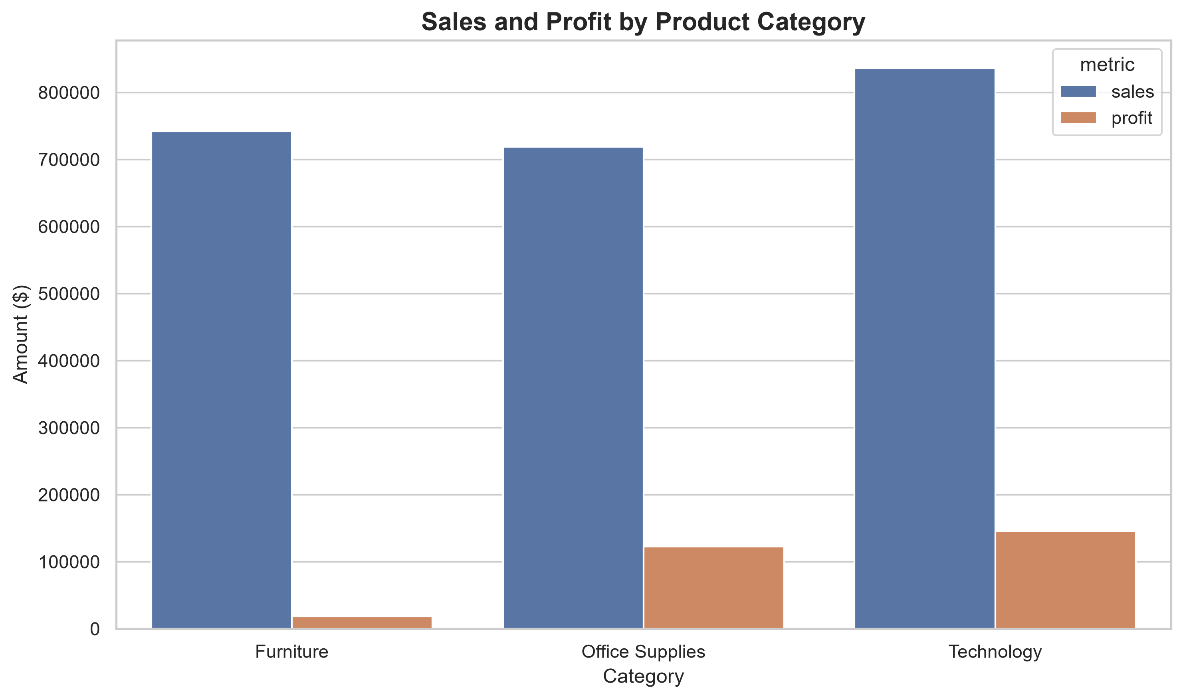
Figure 1. Sales and profit comparison across product categories.
Technology generated the highest total profit, followed by Office Supplies. Furniture generated substantial sales but had a much lower profit margin of 2.49%. This suggests that Furniture profitability deserves closer review.

7. Regional Performance
Region | Sales | Profit | Profit Margin
Central | $501,239.89 | $39,706.36 | 7.92%
East | $678,781.24 | $91,522.78 | 13.48%
South | $391,721.91 | $46,749.43 | 11.93%
West | $725,457.82 | $108,418.45 | 14.94%

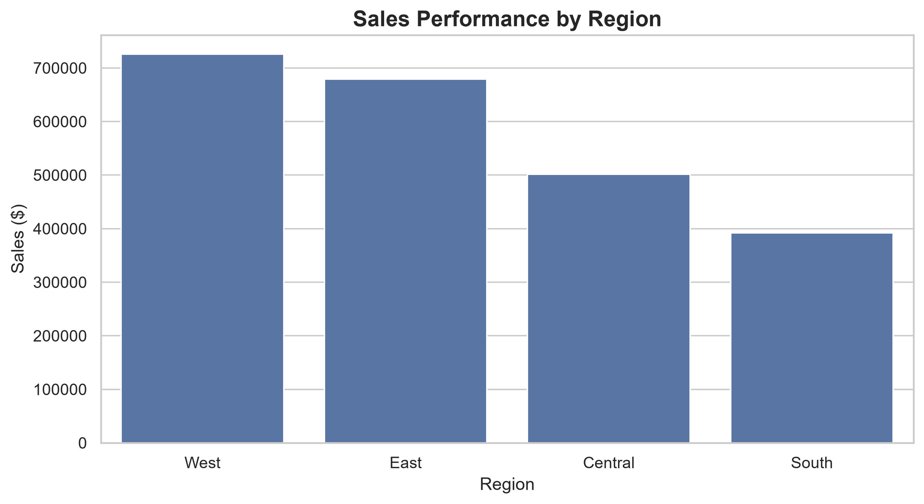
Figure 2. Total sales across the four geographic regions.
The West region recorded the highest sales and total profit, with a profit margin of 14.94%. The Central region had the lowest profit margin at 7.92%. Regional differences may reflect variations in product mix, discounting, customer demand, and operating conditions.

8. Monthly Sales Trend
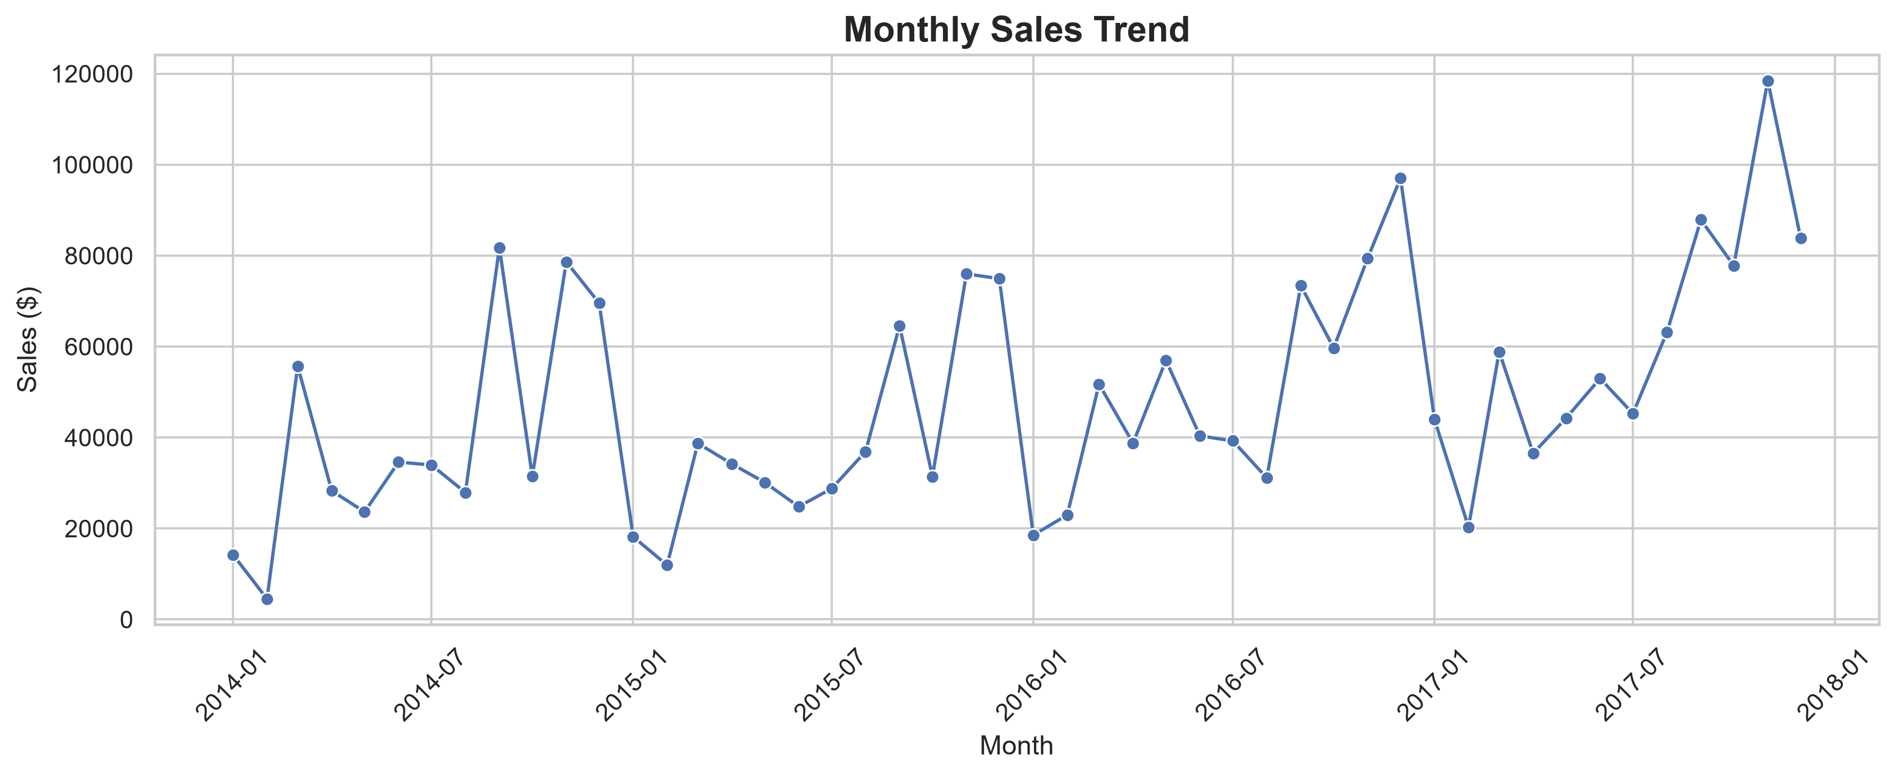
Figure 3. Monthly sales trend over the available dataset period.
The monthly sales visualization helps identify changes in sales volume over time and potential seasonal patterns. Monthly performance should be reviewed alongside profit to distinguish revenue growth from profitable growth.

9. Sub-Category Profitability
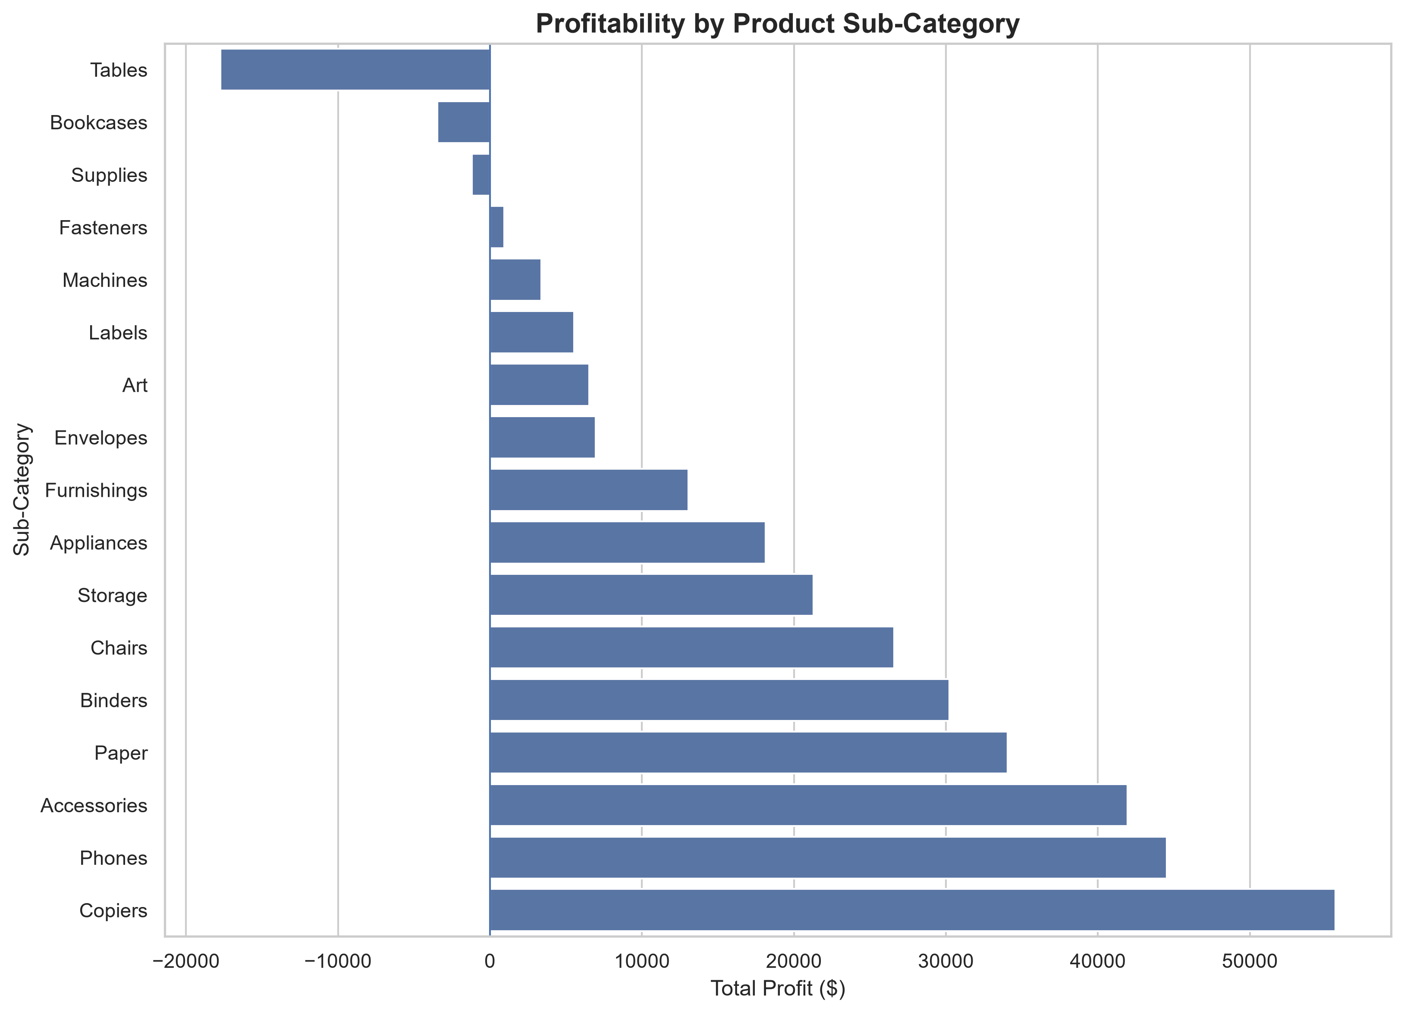
Figure 4. Profit and loss performance across product sub-categories.
Sub-Category | Sales | Profit
Tables | $206,965.53 | $-17,725.48
Bookcases | $114,880.00 | $-3,472.56
Supplies | $46,673.54 | $-1,189.10
Fasteners | $3,024.28 | $949.52
Machines | $189,238.63 | $3,384.76

Tables recorded the largest loss among the listed sub-categories, at $17,725.48. Bookcases and Supplies also recorded negative profit. These products should be investigated for pricing, discounting, product cost, and fulfillment-related issues.

10. Discount and Profitability Analysis
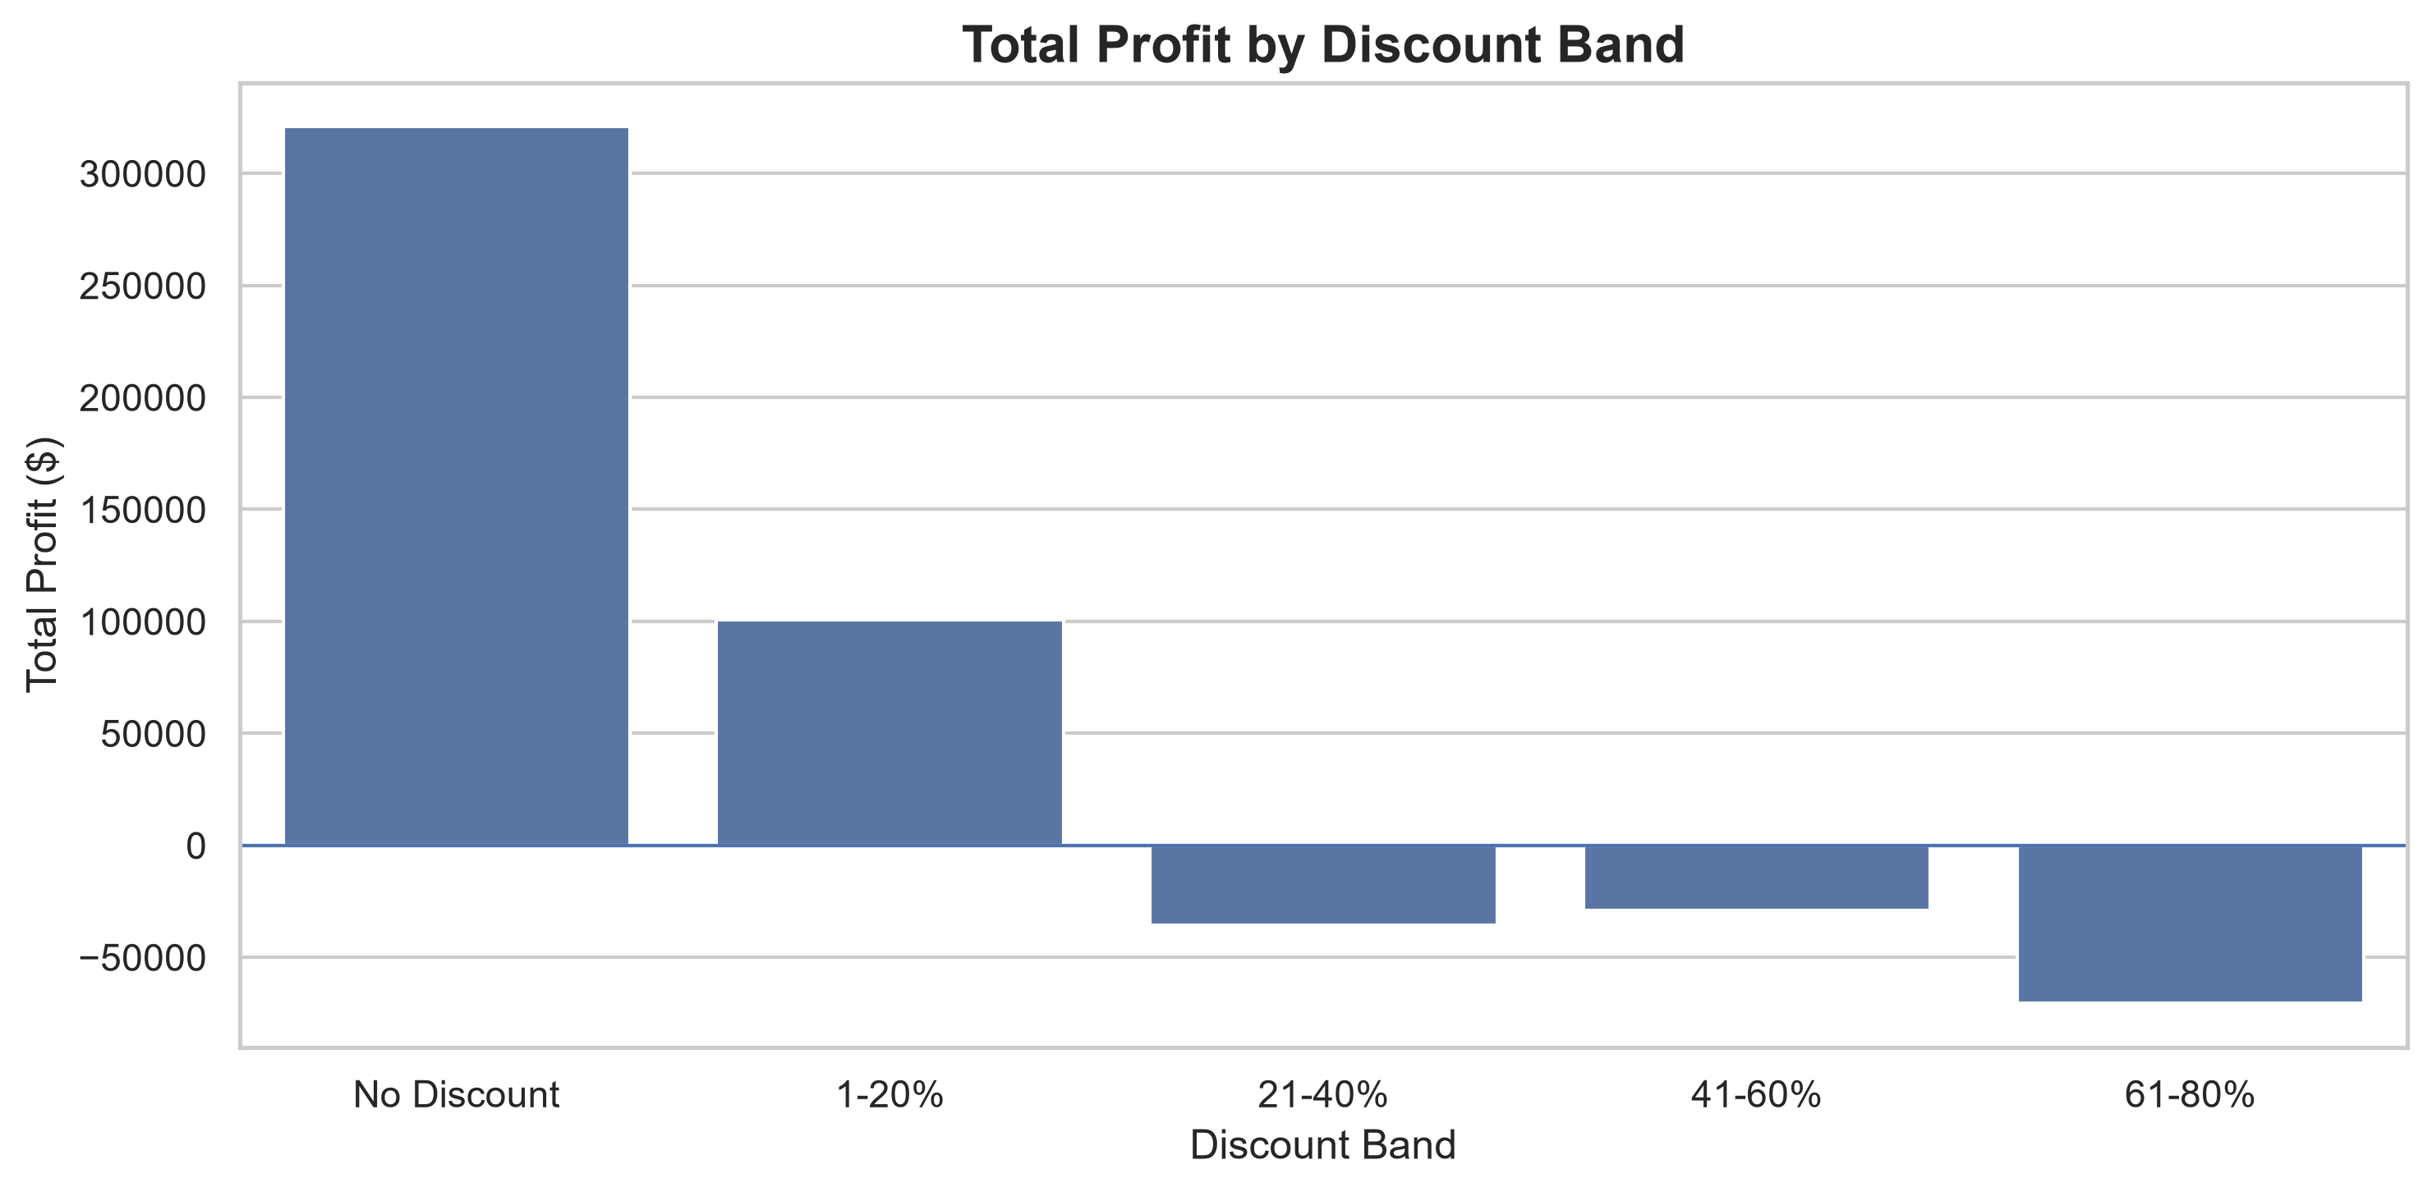
Figure 5. Total profit across discount bands.
Discount Band | Records | Avg. Sales | Avg. Profit | Total Profit
No Discount | 4,798 | $226.74 | $66.90 | $320,987.60
1-20% | 3,803 | $222.59 | $26.50 | $100,785.47
21-40% | 460 | $509.00 | $-77.86 | $-35,817.47
41-60% | 215 | $330.46 | $-134.62 | $-28,944.19
61-80% | 718 | $80.20 | $-98.35 | $-70,614.40

The no-discount and 1–20% discount groups generated positive aggregate profit. The higher discount bands recorded negative total profit. This is an observed association in the dataset and does not, by itself, establish that discounting caused the losses.

11. Customer Segment Performance
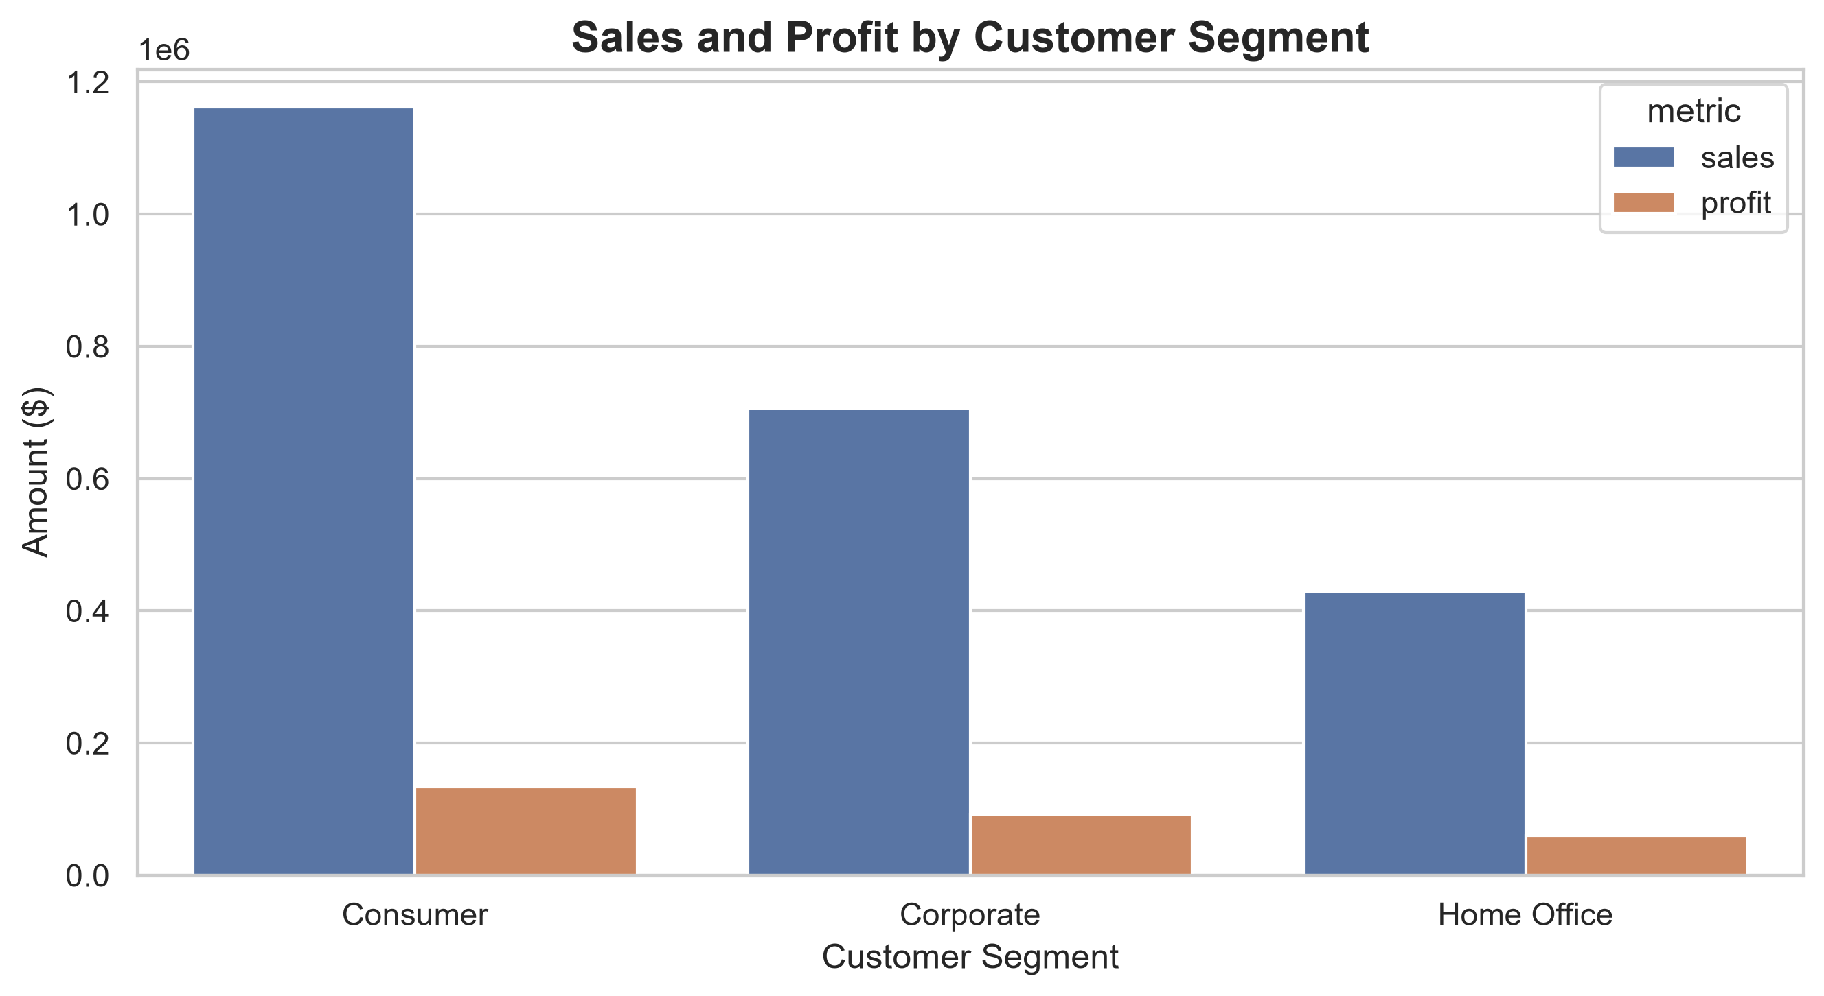
Figure 6. Sales and profit by customer segment.
The customer segment visualization compares sales and profit across the available customer groups. Segment-level results can help guide marketing priorities and customer retention strategies.

12. Key Business Insights
- Overall sales reached $2.30 million, with total profit of approximately $286,397.
- Technology generated the highest category profit at $145,454.95.
- Furniture had a low profit margin of 2.49% despite generating approximately $742,000 in sales.
- The West region led in both sales and total profit.
- The Central region recorded the lowest regional profit margin at 7.92%.
- Tables recorded a loss of $17,725.48, making it the weakest sub-category by profit.
- Discount bands above 20% recorded negative total profit in this dataset.

13. Actionable Business Recommendations

Review Furniture pricing and costs
Investigate the low Furniture margin by reviewing supplier costs, pricing, shipping expenses, and discount practices.

Investigate loss-making sub-categories
Review Tables, Bookcases, and Supplies at product level to identify items with consistently negative margins.

Introduce discount guardrails
Evaluate approval thresholds for high discounts and assess whether promotional offers generate enough incremental profit.

Study Central region performance
Compare the Central region's product mix, discount levels, and order economics with stronger-performing regions.

Learn from the West region
Investigate the West region's product and customer mix to identify practices that may be applicable elsewhere.

Monitor profitable growth
Track sales and profit together through a recurring KPI dashboard rather than evaluating revenue alone.

14. Analysis Limitations
- The findings describe the available Sample Superstore dataset and should not automatically be generalized to all retail businesses.
- The analysis is primarily descriptive and does not establish causal relationships.
- The dataset may not contain all operating costs needed for a complete assessment of business profitability.
- Further analysis would be required to test the statistical significance of observed patterns and evaluate future performance.

15. Conclusion
The analysis provides an overview of retail sales and profitability across products, regions, customer segments, and discount levels. The business generated substantial sales and positive overall profit, but performance varied across categories and regions.
The findings highlight opportunities to review low-margin Furniture products, investigate loss-making sub-categories, evaluate high-discount transactions, and study practices in stronger-performing regions. Regular monitoring of sales, profit, and margin KPIs can help support more informed business decisions.

