**Buying into a Good School?***The Link Between House Cost and School Ratings*

When you’re shopping for a house, you don’t just consider the four walls you’ll be purchasing. In effect, you’re buying into an entire community and everything that comes with it– including the schools.

Through personal experience, we agreed that you have to spend more money on a house if you want a place in a high-rated school zone. But could we prove that personal experience with the data? Is there actually a correlation between property value in a ZIP code and the quality of the schools in that same area?

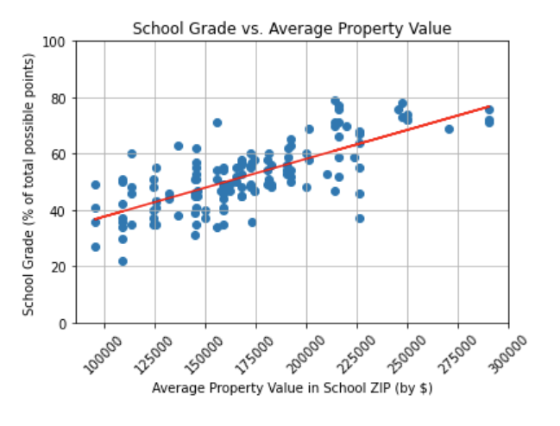**The Link Between Housing Values and School Rating**

From our data set of non-charter, public elementary schools in Hillsborough County, we saw a moderate correlation of school ratings and average property values in the same geographic area (Fig 1).

The r- value for this graph is 0.54 (rounded) and is enough to reject the null hypothesis that property value and school rating bear no correlation.

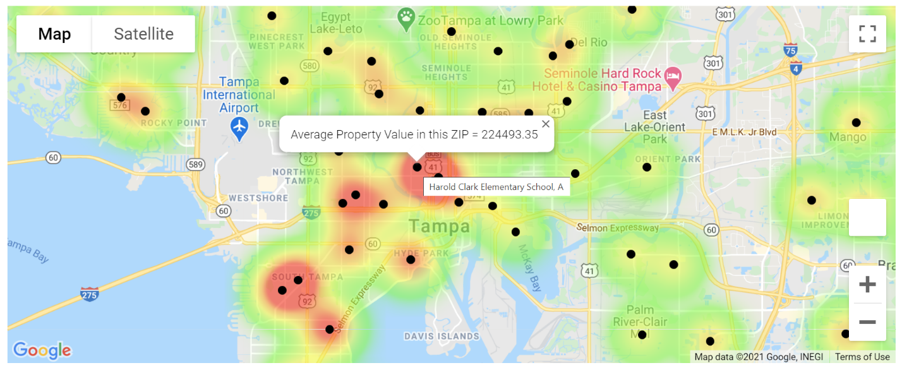The numbers give an idea about how much money a person might need to spend on a home in order to get zoned into a school with a certain rating. For A-rated schools, the average property value of the surrounding area is $234,863 while the average for an area with F-rated schools is $116,343. That’s a $118,520 difference from the average propety value in an area with F rated schools, and a fairly significant difference to consider when budgeting for a home purchase.

**Fig 1**

**Fig 2**: Heatmap of schools giving school rating and average property value in an area.

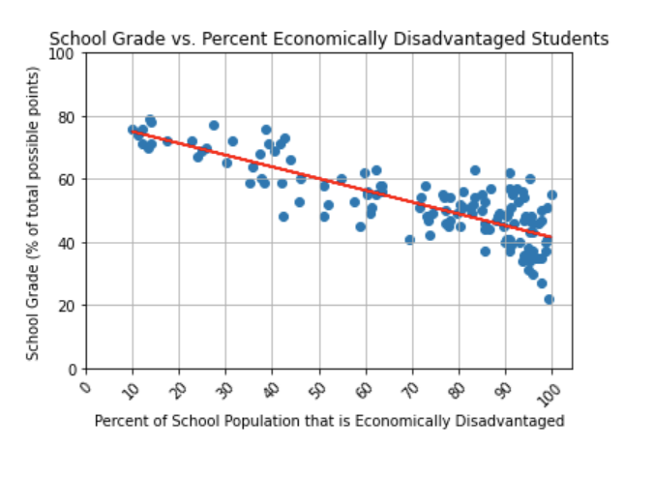**Factoring in the Percentage of Economically Disadvantaged Students**

When investigating the housing value/school rating link, I noticed that the Florida Department of Education also tracks a school’s percentage of economically disadvantaged students, which is the percentage of a school’s population that is made up of students who qualify for free or reduced lunch.

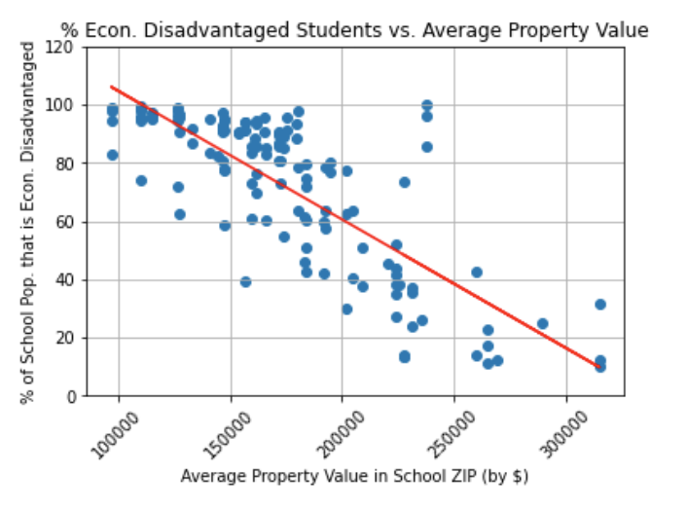The r- value for this graph (Fig 3) is 0.67 (rounded), and is enough to reject the null hypothesis that the percentage of economically disadvantaged students in a school and school rating bear no correlation.

**Fig 3**

We do not know if the economically disadvantaged students represent residents of the neighborhoods with lower average property values, but there is a correlation between the schools with higher percentage of economically disadvantaged students and the average property value in an area (Fig 4). The r- value for this graph is 0.63 (rounded).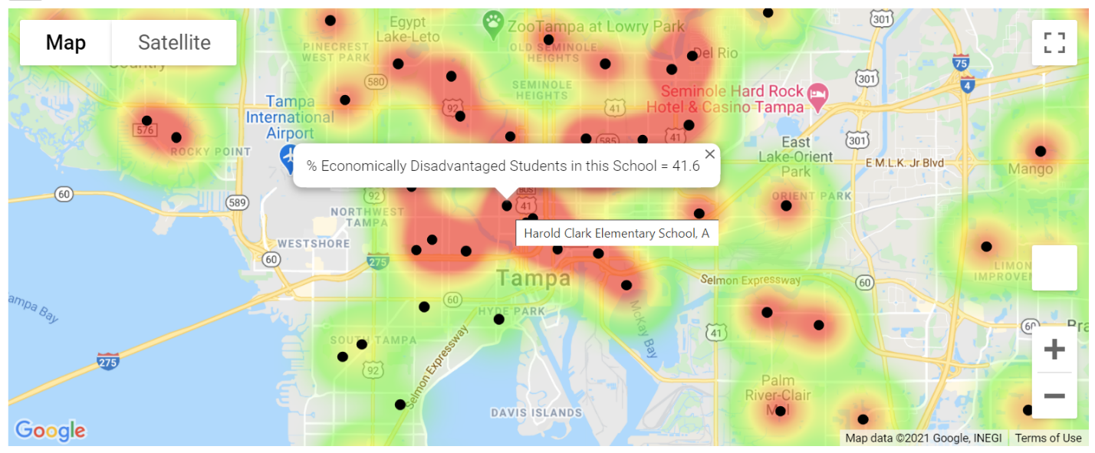 However, according to Figure 4, here do appear to be a few schools with very high percentages of economically disadvantaged students in areas with relatively high average property values ($200k to $250k range).

**Fig 5**: Heatmap of schools giving school rating and percentage of economically disadvantaged students per school.

**Fig 4**

The other thing that we wanted to consider and to observe if it has any effect on the outcome of this project, was the crimes and if it is a factor that could decrease or increase the value of residential properties in a certain neighborhood/zip/city or county.

So, we started by choosing two different zip codes, that were remarkably similar in real estate size, and population count with a distinct difference in the ethnicity of residents.

One being majorly populated by what is the US census identify as minority groups and the other less diverse.

**How are our 2 zip codes doing with respect to crime?**

Based on crime data we have collected, we found out that crime rate is 5x higher in the most diverse zip code then the rest, even though crime count had been on the decline

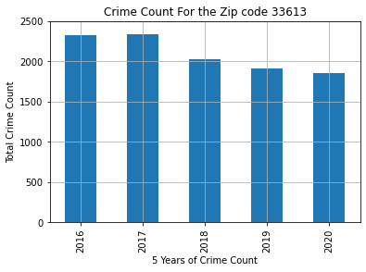  
  
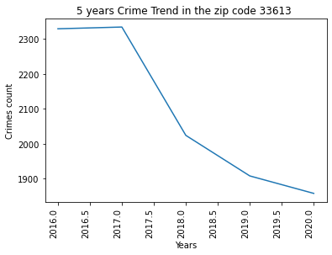

Even though there is a similar trend in the crime count between both zip codes, our less diverse zip code (33556) was faring better in the number of crimes

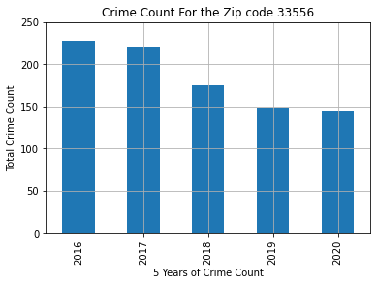

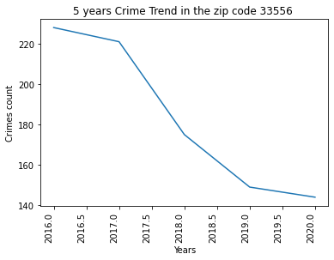

Based on these initial findings, we started to investigate what correlation between property values and crime can we establish and if crime does have a direct effect on the value of a property thus reflecting in return on the schools in its surrounding.

**Is there a real effect of crimes on property values?**

This graph shows the impact of crime on property values by neighborhood code.  
It is evident that in neighborhoods with low crime count have higher property values than those with high crime counts.

We did notice that during that one period when there was a spike in crime rate, average property value has affected in a negative way and the average value had depreciated during that period. As shown below. This proving that there is a real link between crimes and its effect on property value and what kind of impact that trickles onto schools as well.

