CT Intensity Segmentation of Lungs

*using python*

Namdev Parth Deendayal, Soham Vijaykumar Faldu, Manas Sahu

*School of Computer Science and Engineering, Vellore Institute of Technology, Vellore*

*Address*

parthdeendayal.namdev2019@vitstudent.ac.in

[sohamvijaykumar.faldu2019@vitstudent.ac.in](mailto:sohamvijaykumar.faldu2019@vitstudent.ac.in)

manas.sahu2020@vitstudent.ac.in

***Abstract*— The early diagnosis and treatment of lung diseases is a very critical procedure and it requires the use of Computed Tomography (CT) imaging for the segmentation of lungs. Segmentation of the lung helps in the analysis of the lesions. The paper proposes a CT lung and vessel segmentation model without any labels which is based on medical image processing using Python. Medical Image Analysis is basically 3D image processing. This paper provides, i) CT data visualization, ii) lung segmentation based on intensity values iii) the complete methodology of the proposed system iv)analysis and improvements in the result of segmentation. This leads to interesting results which helps the medical-practitioners and scientists who are working in the field of CT intensity segmentation of lungs.**

***Keywords***— **CT Intensity, Python, Segmentation of Lungs, Segmentation and Enhancement, Area-Wise Detection, Web-App - Data Visualization, Lung Contours and Vessels Overlayed.**

1. Introduction

Computed Tomography (CT) is an X-ray based procedure which obtains the 3D image of the body by distinguishing the density differences. CT uses a cathode with high temperature which releases highly energised electrons which further release their energy as X-ray radiations. When the X-rays pass through the human body it is either absorbed by the dense tissues (i.e. bones) and soft tissues (i.e. fat) or else passes without absorption (i.e. it passes through the air region inside the body). So when the X-rays reach the detector on the other side of the body we see dense tissues are depicted as white as it absorbs more radiation while soft tissues absorb less radiation and are depicted as somewhat greyish color and the air is seen in black color in the detector. X-ray absorption is measured on an absolute scale called the Hounsfield scale, where the air intensity is fixed to -1000 and the water intensity is fixed to 0. The intensity value of the lung area is around -500 HU (Hounsfield Unit), for fats it is around -200 to -100 HU. Similarly for soft tissue and bone area it is 30 to 45 HU and greater than 500 HU respectively.

After this, the segmentation of lungs is performed according to the intensity values. For this, initially, the pixel dimension is extracted from the NIFTI file. Find the pixel dimension to compute the area of the lungs. Then the image is binarized by clipping the image range from -1000 to -300 to bring the lungs in the Hounsfield unit range and then again binarize it to 1s and 0s. After this, detect the lung contour and convert the contour to a binary mask. The contour describes the area of the lung which is a closed set. It represents the lungs with a minimum volume of 2000 pixels. The vessel area is found, denoised and an overlay is created with the original CT image and denoised mask of vessels. Finally, the paper provides information about how our project can be useful for the convenience of doctors and patients.

The web app or website is outlined using the Django framework that is based on Python. Image Processing modules are also implemented using Python.

1. Literature Survey

Paper [1] use the adaptive mean shift method to estimate the bandwidth parameter. They also use an optimization algorithm to optimize the parameter by fixed bandwidth estimation. Because of the close dependency of the kernel density estimation method to the bandwidth parameter, the Particle Swarm Optimization algorithm is used to optimize this parameter. This method is achieved better segmentation that can carry out small lung nodules and detect regions within a CT image.

Many accurate methods are now available. Advancement in image processing has led to many more accurate algorithms and methods.

In Paper [2], they have developed models using Gray level co-occurrence matrix (GLCM) based texture image analysis and Statistical parametric approach for helping doctors to detect lung cancer stages. Our approach involves image acquisition, preprocessing, feature extraction, and finally classification. Converting CT scanned images into graycomatrix to calculate the growth of nodules in lungs. They have also used statistical methods. The accuracy gained by this is only 77%. A greater chance of manipulating the image.

Paper [3] presents an application of lung segmentation of an internal organ from computed tomography scan images using an artificial intelligence development approach. The deep convolution neural network technique was used to perform semantic segmentation of an internal organ by training our framework through different computed tomography scan image slices with a medical dataset that has abnormal physiology. This paper shows the best deep learning model available till date.

1. Flow Diagram

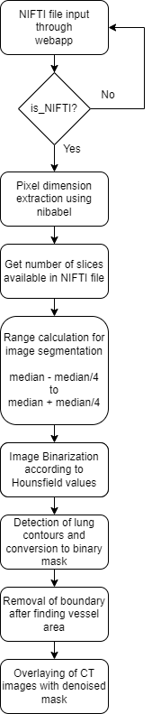

1. Methodology Of The Proposed System
2. *Extract pixel dimension*

In this step, the pixel dimension is extracted from the NIFTI file provided. The header of the NIFTI file consists of all the information associated with the image. The nibabel library is used for the same.

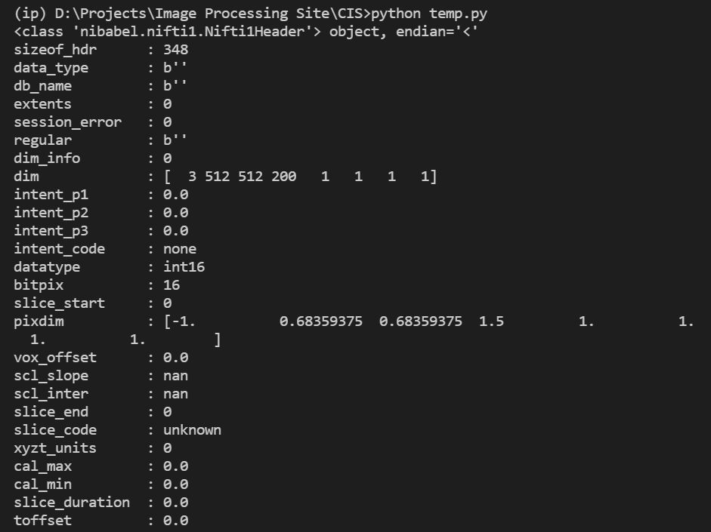

Fig. 1 header of NIFTI

1. *Binarize the image using intensity thresholding*

CT scanned images are present in Hounsfield values. These values stay constant for particular areas on the basis of their intensity. Here the range is taken as [-1000,-300].

max=level+window/2

min=level−window/2

|  |  |  |
| --- | --- | --- |
| **Region/Tissue** | **Window** | **Level** |
| Brain | 80 | 40 |
| Lungs | 1500 | -600 |
| Liver | 150 | 30 |
| Bone | 1800 | 400 |
| Soft Tissues | 250 | 50 |

Table 1. Hounsfield Values

1. *Detecting lung contours*

Here, the area of two lungs is detected and isolated. The algorithm used here is the marching squares method. It identifies the closed set of points that make a contour. Skimage library is used to do the same.

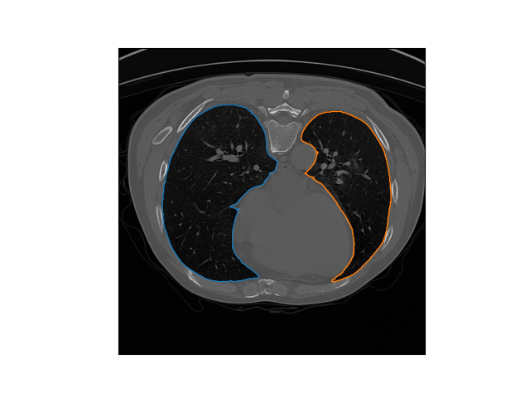

Fig. 2 Contour

1. *Convert contour to Binary mask*

Now, the previous image is converted into a binary mask using the pillow library. Pillow library draws a polygon and a binary mask is created.

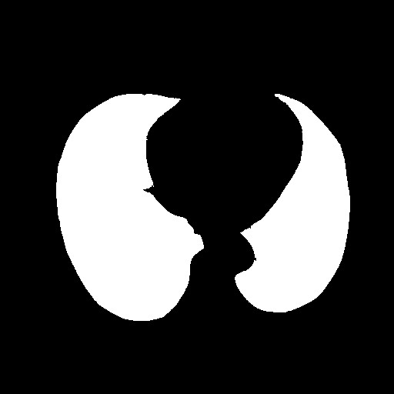

Fig. 3 binary mask

1. *Finding the vessel area.*

In this step element-wise multiplication between the CT image and the lung mask is done to get only the lungs.Then, Intensity thresholding is performed again and all intensities greater than -500 are kept as vessels (Binary thresholding).

1. *Denoising and improving the result*

A denoising function is created that considers the distance of the mask to all contour points. If distance is below 0.1 then it is set to 0. This function removes the border pixels that are redundant.

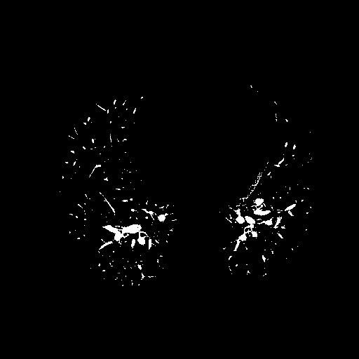

Fig. 4 denoised mask

1. *Create an Overlay*

Finally, the original CT image is overlayed with the denoised mask of vessels.

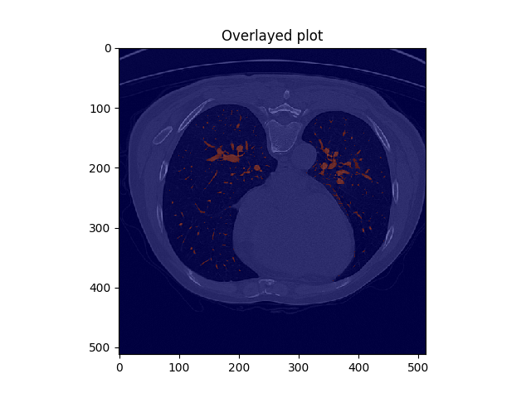

Fig. 5 inverted overlayed CT image

1. Results

After image segmentation and enhancement, the results are visualised on the web app. Results include image carousels of lung contours and vessel overlayed lungs. It also shows detailed and slice-wise infection percentage using a bar graph. The mean infection percentage is displayed on the top of all results. The webapp also allows users to generate PDF reports of the results.

Fig. 6 Web app index page

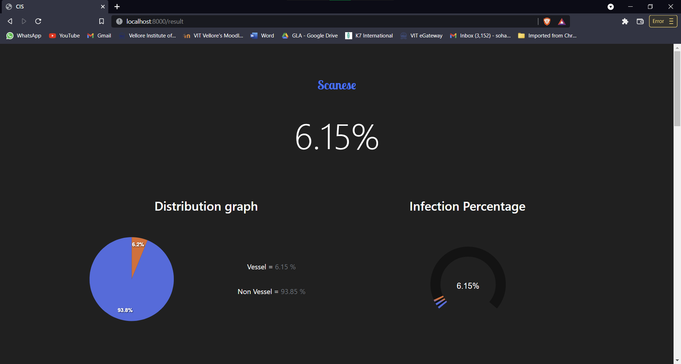

Fig. 7 result page - mean percentage and pie chart

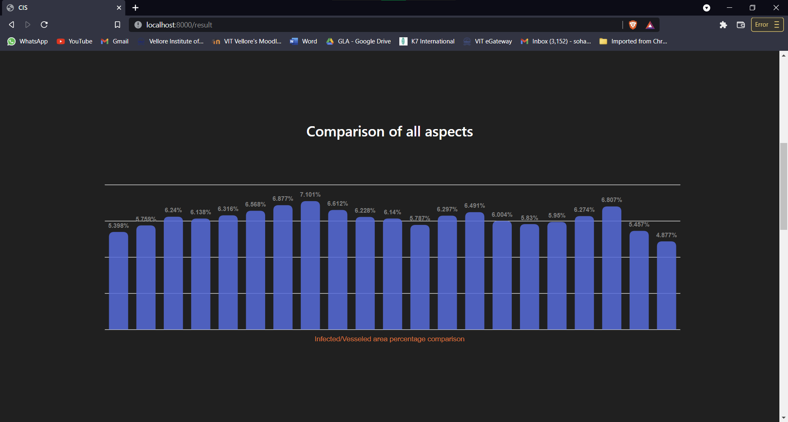

Fig. 8 result page - slice-wise percentage using bar graph

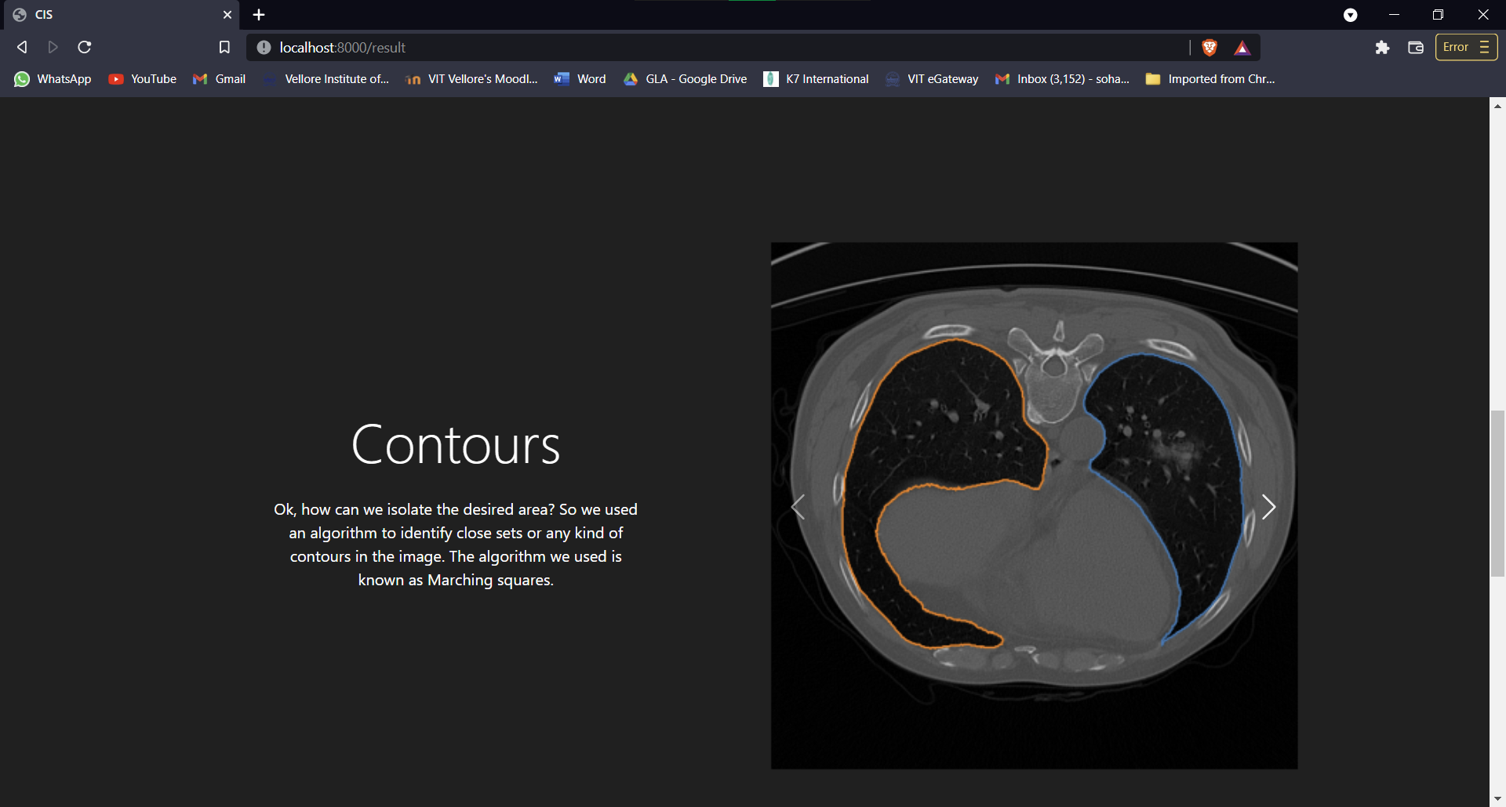

Fig. 9 result page - lung contours carousel

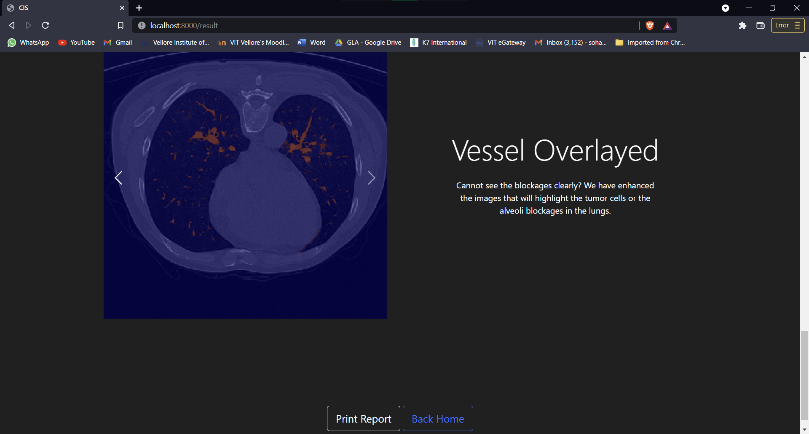

Fig. 10 result page - vessel overlayed carousel

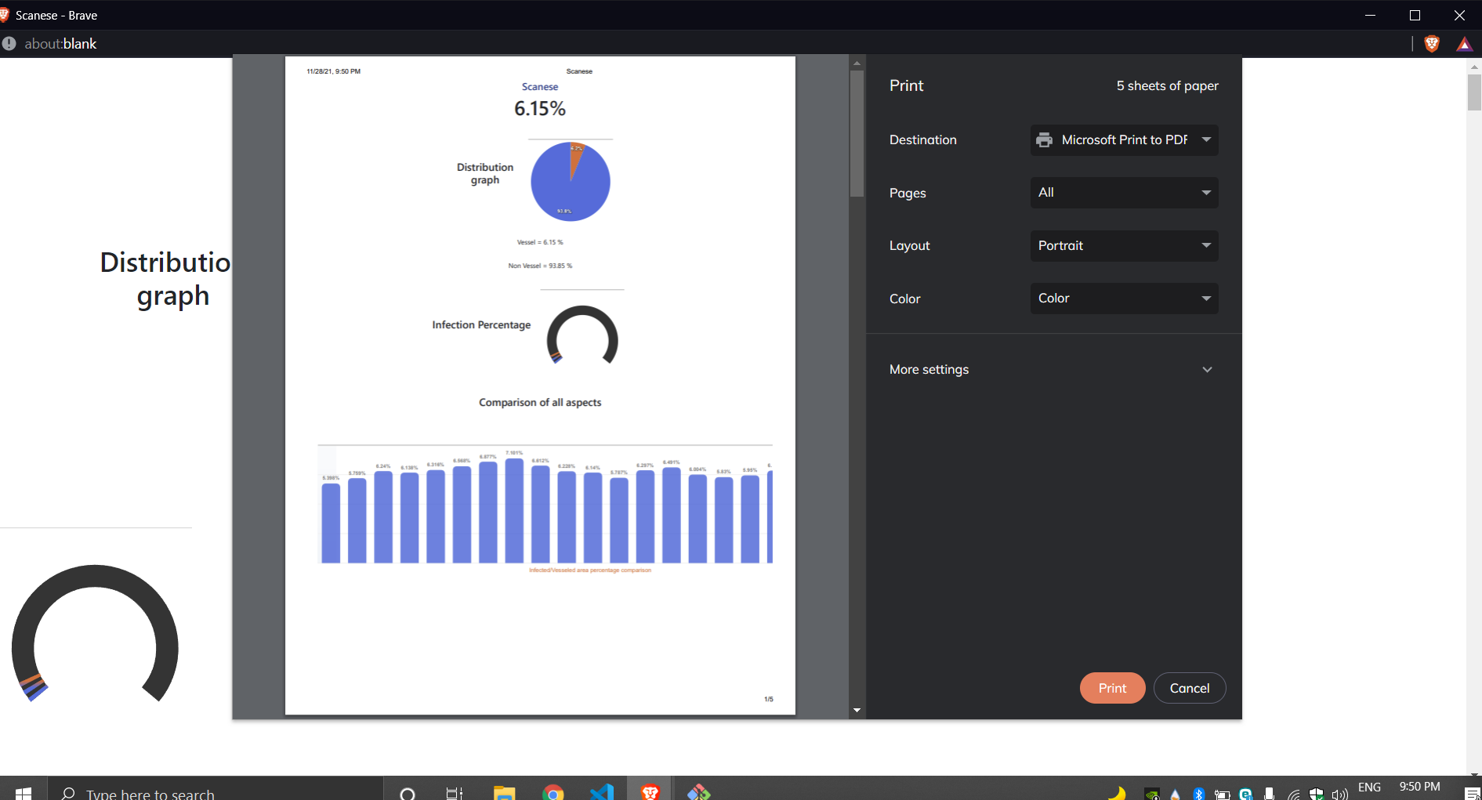

Fig. 11 result page - pdf report generation

1. Conclusions

This work explores the use of different image processing tools using python in the design and implementation of the CT intensity segmentation of lungs. This project helps us in detecting the extent of infection of the disease in the lungs and can be very useful in the times as of now where we are fighting a virus like COVID-19 which infects the lungs. This can also be used to detect the lung tumor in lung patients. This project helps us to get the reports instantly which is very user friendly and easy to understand while also being very detailed. This will help the patient to get their reports instantly and can be reviewed easily by the doctors by either printing the report or even in the PDF formats. The Web App shows different graphs and figures very accurately for better understanding and analysis of the report and also the area wise detection by highlighting the infected area using different image processing techniques has been provided. So the finally obtained model provides very satisfactory results and can be used to detect lung infections in lung patients accurately.

Acknowledgment

We express our sincere indebtedness towards our guide Dr. Prabu S, Vellore Institute of Technology, Vellore for his invaluable guidance, suggestions and supervision throughout the development of this project. Without his kind patronage and guidance the project would not have taken shape. We would also like to express our gratitude and sincere regards towards his kind approval of this project, time to time counselling and advice. We would also like to thank the authors of papers that we had referred to for their amazing work and providing inspiration. We also like to express our gratitude to all other staff and faculties for their kind co - operation and help. Last but not the least we would like to express our deep appreciation towards all our classmates and our indebtedness towards our parents for their moral support and encouragement.

References

1. S. Fazli, M. Jafari and A. Safaei, "Automated lung CT image segmentation using kernel mean shift analysis," 2013 8th Iranian Conference on Machine Vision and Image Processing (MVIP), 2013, pp. 392-396, doi: 10.1109/IranianMVIP.2013.6780017.
2. M. Islam, A. H. Mahamud and R. Rab, "Analysis of CT Scan Images to Predict Lung Cancer Stages Using Image Processing Techniques," 2019 IEEE 10th Annual Information Technology, Electronics and Mobile Communication Conference (IEMCON), 2019, pp. 0961-0967, doi: 10.1109/IEMCON.2019.8936175.
3. K. Asipong, S. Gabbualoy and P. Phasukkit, "Coronavirus infected lung CT scan image segmentation using Deep Learning," 2021 18th International Conference on Electrical Engineering/Electronics, Computer, Telecommunications and Information Technology (ECTI-CON), 2021, pp. 773-776, doi: 10.1109/ECTI-CON51831.2021.9454944.