**Applet in Java**

* Applets are small Java applications that can be accessed on an Internet server, transported over Internet, and can be automatically installed and run as a part of a web document.
* After a user receives an applet, the applet can produce a graphical user interface. It has limited access to resources so that it can run complex computations without introducing the risk of viruses or breaching data integrity.
* Any applet in Java is a class that extends the java.applet.Applet class.
* An Applet class does not have any main() method. It is viewed using JVM. The JVM can use either a plug-in of the Web browser or a separate runtime environment to run an applet application.
* JVM creates an instance of the applet class and invokes **init()** method to initialize an Applet.

Hierarchy of Applet

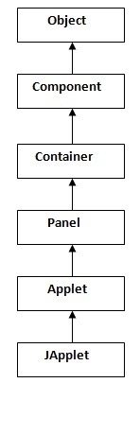

As displayed in the above diagram, Applet class extends Panel. Panel class extends Container which is the subclass of Component.

Lifecycle of Java Applet

1. Applet is initialized.
2. Applet is started.
3. Applet is painted.
4. Applet is stopped.
5. Applet is destroyed.

Lifecycle methods for Applet:

The java.applet.Applet class has 4 life cycle methods and java.awt.Component class provides 1 life cycle methods for an applet.

java.applet.Applet class

For creating any applet **java.applet.Applet** class must be inherited. It provides 4 life cycle methods of applet.

1. **public void init() :** init() is the first method to be called. This is where variable are initialized. This method is called only once during the runtime of applet.
2. **public void start() :** start() method is called after init(). This method is called to restart an applet after it has been stopped.
3. **public void stop() :** stop() method is called to suspend thread that does not need to run when applet is not visible.
4. **public void destroy() :** destroy() method is called when your applet needs to be removed completely from memory.

**Note:**The stop() method is always called before destroy() method.

**Note:**

Every Applet application must import two packages - java.awt and java.applet.

java.awt.* imports the Abstract Window Toolkit (AWT) classes. Applets interact with the user (either directly or indirectly) through the AWT. The AWT contains support for a window-based, graphical user interface. java.applet.* imports the applet package, which contains the class Applet. Every applet that you create must be a subclass of Applet class.

The class in the program must be declared as public, because it will be accessed by code that is outside the program. Every Applet application must declare a paint() method. This method is defined by AWT class and must be overridden by the applet. The paint() method is called each time when an applet needs to redisplay its output, . Another important thing to notice about applet application is that, execution of an applet does not begin at **main()** method. In fact an applet application does not have any main() method.

### Java AWT Hierarchy

The hierarchy of Java AWT classes are given below.

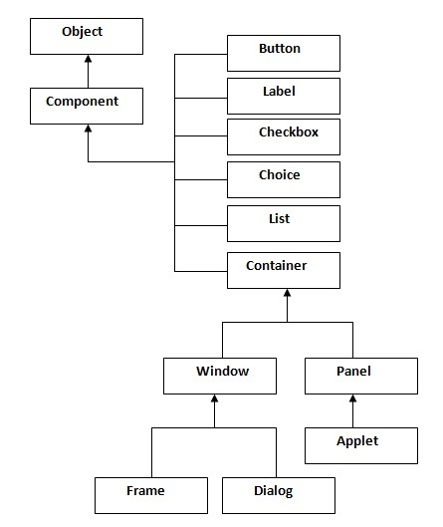

**A Simple Applet Program**

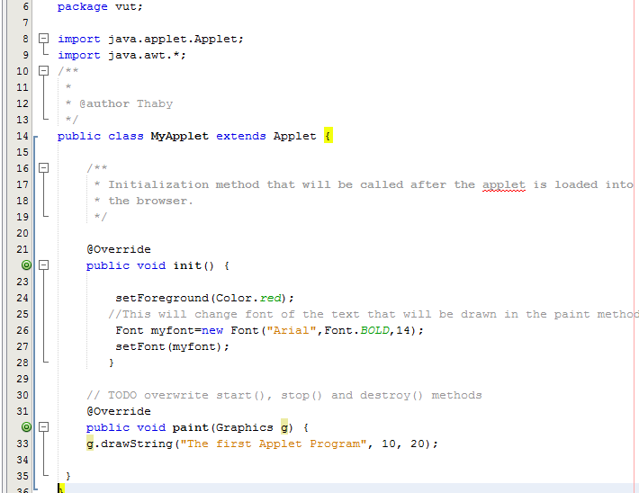

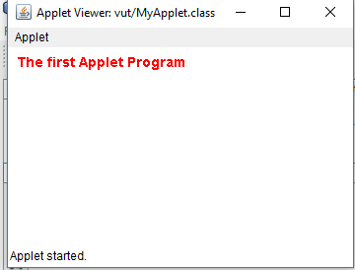

# Displaying Graphics in Applet

java.awt.Graphics class provides many methods for graphics programming.

## **Commonly used methods of Graphics class:**

1. **public abstract void drawString(String str, int x, int y):** is used to draw the specified string.
2. **public void drawRect(int x, int y, int width, int height):** draws a rectangle with the specified width and height.
3. **public abstract void fillRect(int x, int y, int width, int height):** is used to fill rectangle with the default color and specified width and height.
4. **public abstract void drawOval(int x, int y, int width, int height):** is used to draw oval with the specified width and height.
5. **public abstract void fillOval(int x, int y, int width, int height):** is used to fill oval with the default color and specified width and height.
6. **public abstract void drawLine(int x1, int y1, int x2, int y2):** is used to draw line between the points(x1, y1) and (x2, y2).
7. **public abstract boolean drawImage(Image img, int x, int y, ImageObserver observer):** is used draw the specified image.
8. **public abstract void drawArc(int x, int y, int width, int height, int startAngle, int arcAngle):** is used draw a circular or elliptical arc.
9. **public abstract void fillArc(int x, int y, int width, int height, int startAngle, int arcAngle):** is used to fill a circular or elliptical arc.
10. **public abstract void setColor(Color c):** is used to set the graphics current color to the specified color.
11. **public abstract void setFont(Font font):** is used to set the graphics current font to the specified font.

**Graphics Code Example**

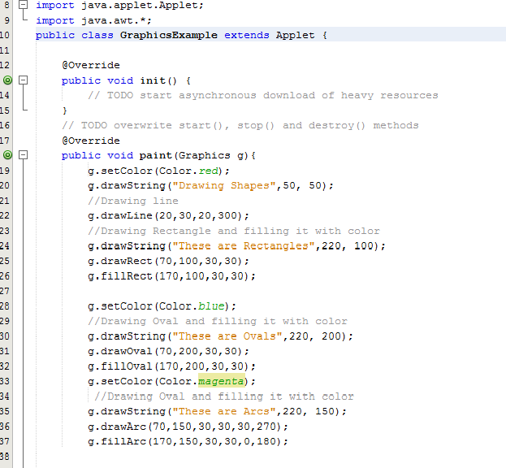

**Output example**

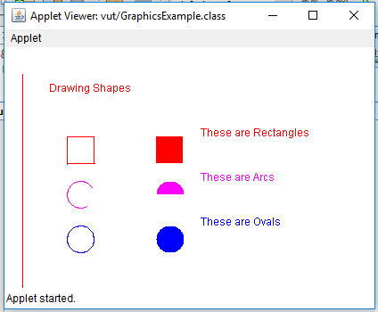

**Assignment Exercise**

**Create an applet program that will draw the following shape, use proper coordinates.**

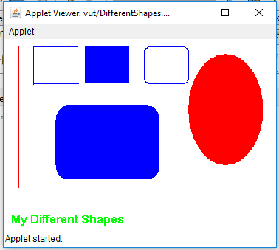**Exercise1**

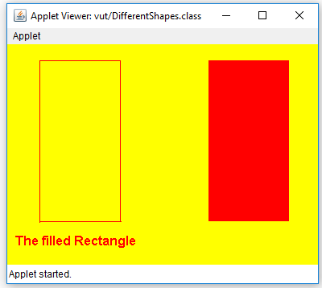 **Exercise2**