**WEATHERLENS**

**Table of Contents**

1. **Introduction**
2. **Project Aim**
3. **Project Specification**
4. **Scenario Analysis**
5. **Deliverable**
6. **Work Plan**
7. **Use Case Diagram**
8. **SiteMap**
9. **Source Code**

**HTML Code**

**CSS Code**

**JS Code**

1. **Application Screenshots**
2. **Our Team**
3. **Limitations**

**WEATHERLENS – A WEATHER FORECASTING APP USING MEAN**

1. **Introduction**:

The Weather Application illustrates how a web-based user interface can be synchronized with the user interface in a device. The Weather Application consists of three parts: the server application, the thermostat (device), and the browser user interface. Weather forecasting is the application of science and technology to predict the conditions of the atmosphere for a given location and time.

Weather forecasts are made by collecting quantitative data about the current state of the atmosphere at a given place and using meteorology to project how the atmosphere will change. The role of Technology has been remarkable in the field of weather forecasting. Weather data is not only necessary for researchers or scientists, ordinary people can be benefited from it as well. People nowadays are feeling the necessity of weather data as well. There are a variety of weather mobile apps in Google Play and the App store.

Those apps have great features and functionalities to satisfy users. However, only a few of them have friendly user interface and human centered interactions, which means that a lot of them might be difficult to be navigated even though they provide enough functionalities. It is not convenient for new users. Therefore, we would like to do improvements on weather mobile apps. It is basically for Apple smart phones and tablets.

1. **Project Aim:**

To make a real time weather application that takes user’s exact location and provides weather forecast for the day and upcoming days also. We also tried to design a simple but visual UI that provides comprehensive data. Also, the application provides suggestions to users based on weather conditions.

1. **Project Specification:**

Real time weather forecasting.

Platform: WINDOWS.

IDE: VSCode.

Takes user’s geolocation as input to provide weather forecast

Hyper-Local Forecast: App will predict rain,storm and weather changes with a per minute accuracy based on the user current location.

Displays detailed weather information for upcoming 7 days including the current.

Weather visualizations with stunning maps.

Can also take custom location as input to provide weather details for that location (GoogleManualSearch API).It is string based basically,so provides data for particular cities only.

1. **Scenario Analysis:**

**a. Screen and Interaction Analysis:** The users will use this mobile app on iOS smart phones and tablets. All the information of this mobile app will be displayed full screen. Basically, the interactions include touch and click and scroll.

**b. Usage Analysis:** Users can use this mobile app whenever they want, every day at home, on their way to travel, and other situations as long as they want to know weather information.User must be connected to the internet,being offline is not an option.Tip of the day is assumed to be useful for the user.

**c. Environment Analysis:**This mobile app only can be used on iOS smart phones and tablet devices. It will be using the Openweather API to get the weather information. It sends requests, and then get responses from the API through the internet.

1. **Deliverable**

a. A properly working and executable .ipa file that will run in any iOS device.

b. A documentation that will provide details about the requirements, specifications and other information.

1. **Work Plan:**

**a. Literature search and review:** We will study about SWIFT programming, iOS development, VSCode environment & features,network requests,use of API sand JSON formatting the fetched data.

**b.Analysis and modeling:** Based on our gathered knowledge base, we will analyze the processes and make a prototype of the application.

**c. Navigation and UI design:** We will design application layout and application flow. Also, we will design the splash screen.

**d. Implementation:** From prototype we will start to integrate the modules together and we will finish all the features enlisted.The program must be proper functioning and error free.

**e. Testing and debugging:** Testing and debugging will be a challenging job for us, as we will let some people use the app and note suggestions from them.Also,we always need to emphasize on the comprehensiveness of our data and the magnificence of our UI.

**f. Work on final report and documentation:** We worked on the final report and software documentations in the last week.A proper functioning copy of the software(written on CD/DVD preferably) shall be provided at the end of the assigned time period.We also kept track of our limitations and enlisted some unimplemented features that we intend to work on in the near future.

1. **Use Case Diagram:**

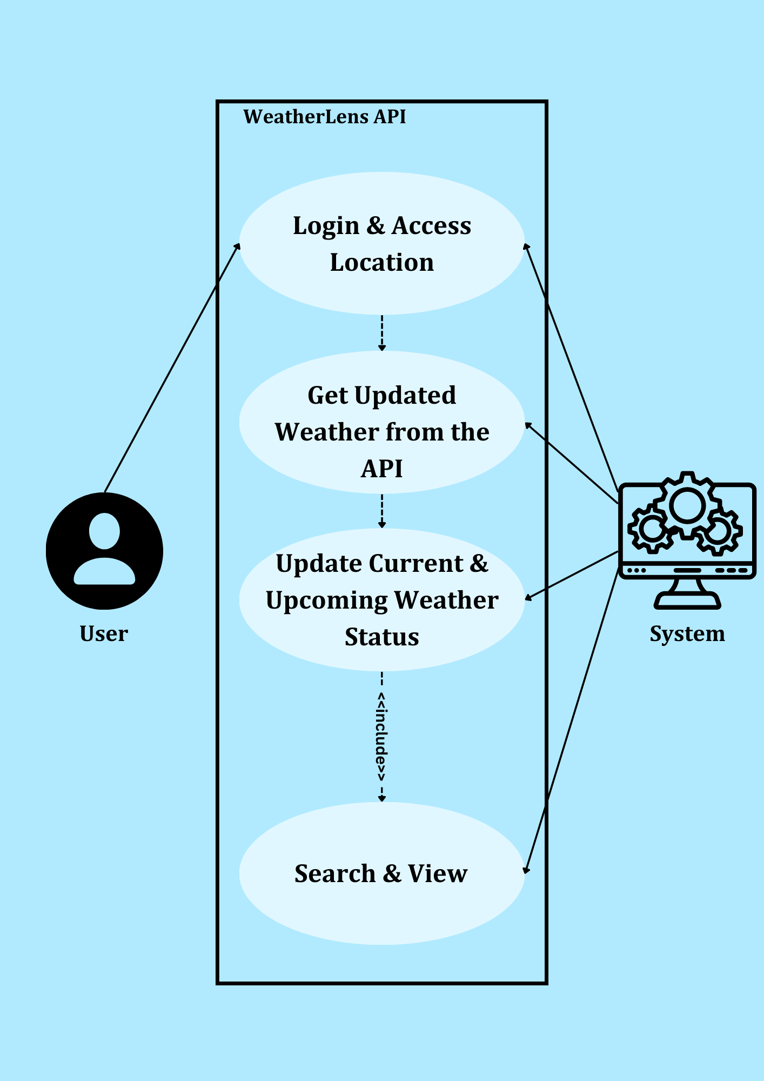

1. **Site Map:**

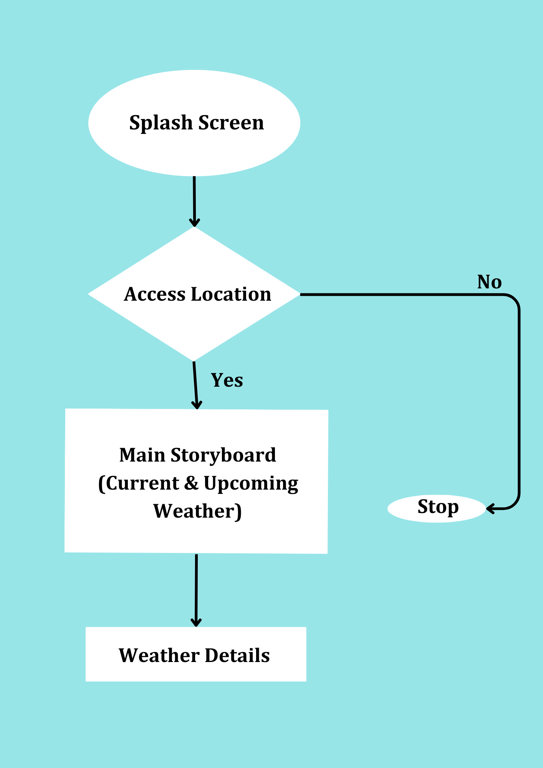

1. **Source Code:**

* **HTML CODE:**

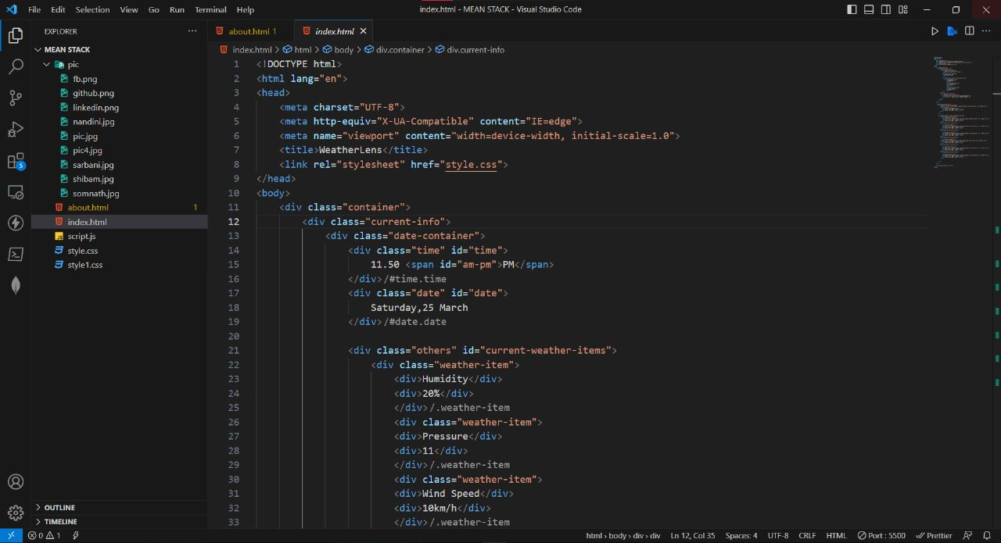

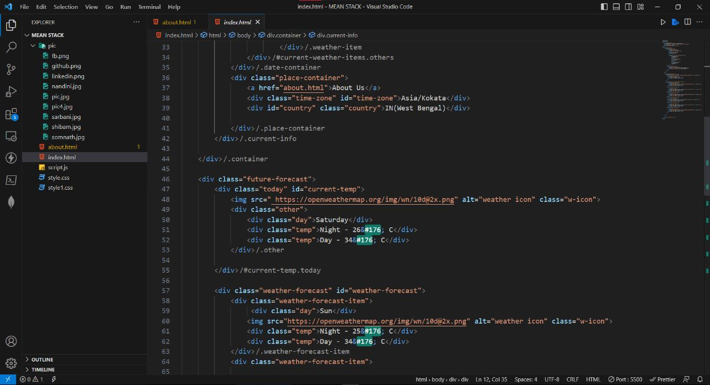

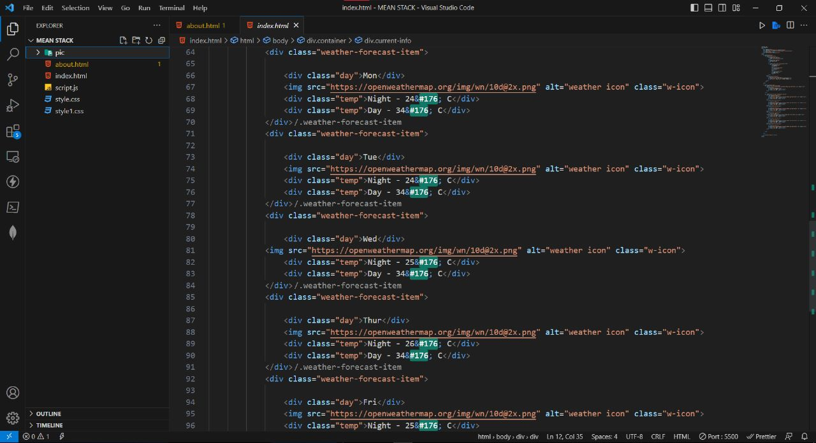

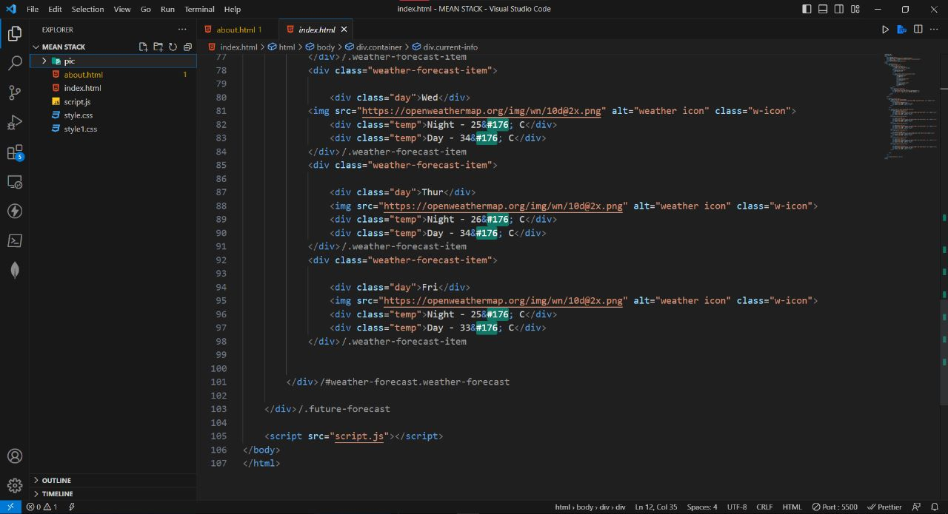

* **CSS CODE:**

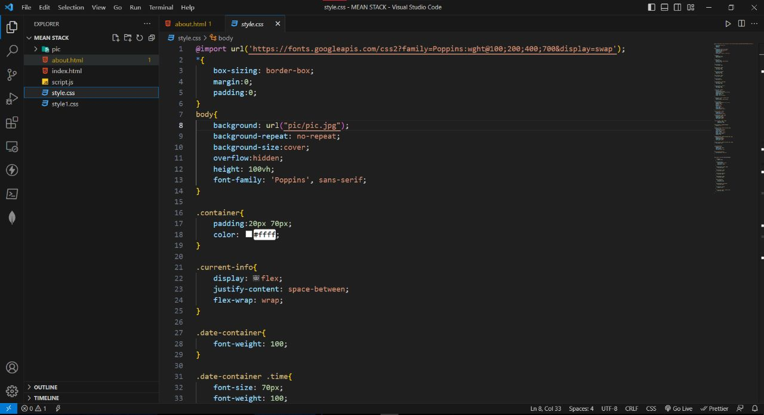

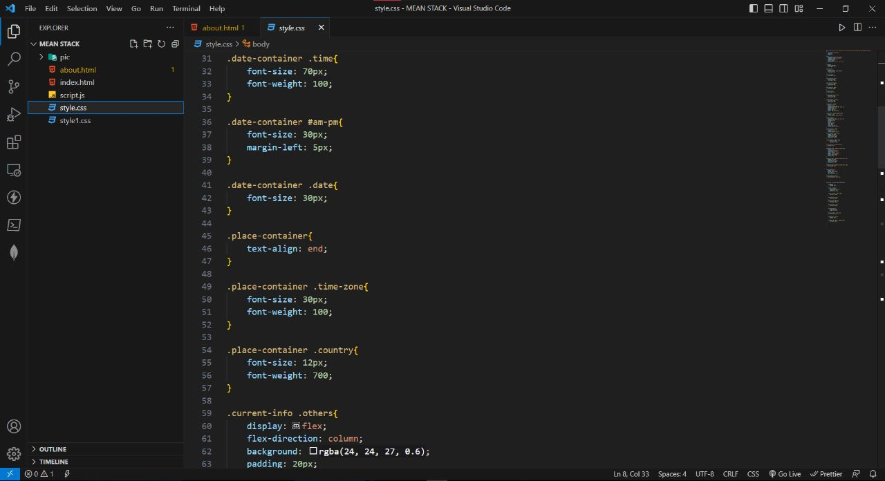

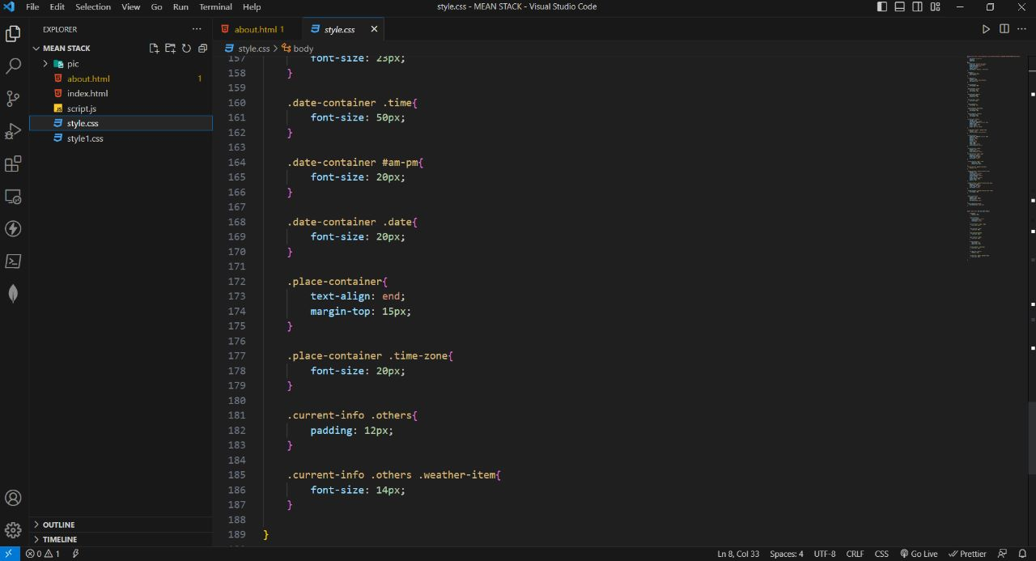

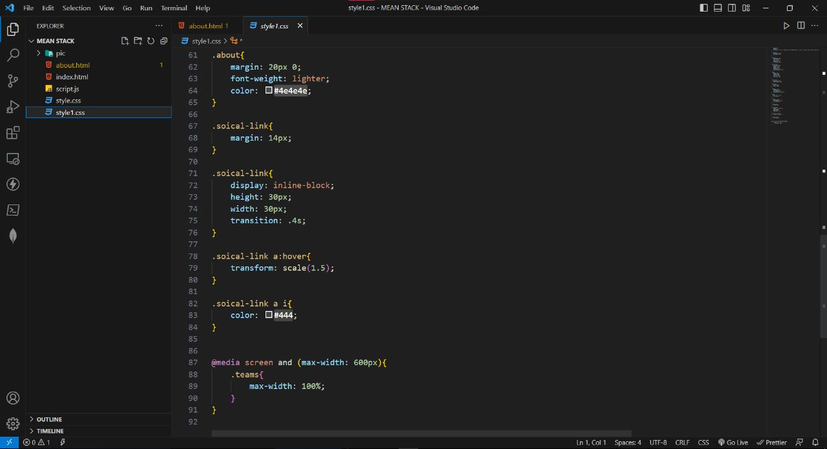

* **JS CODE:**

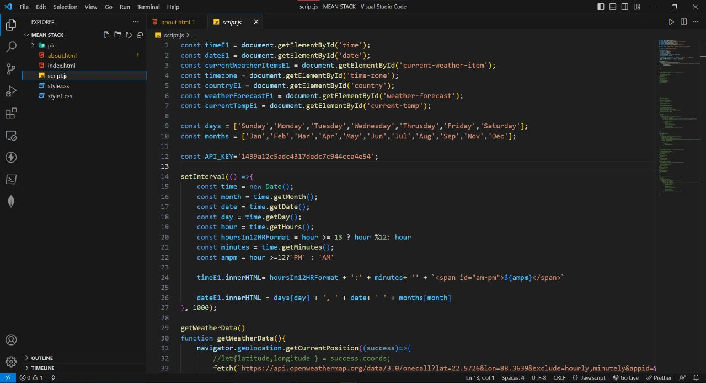

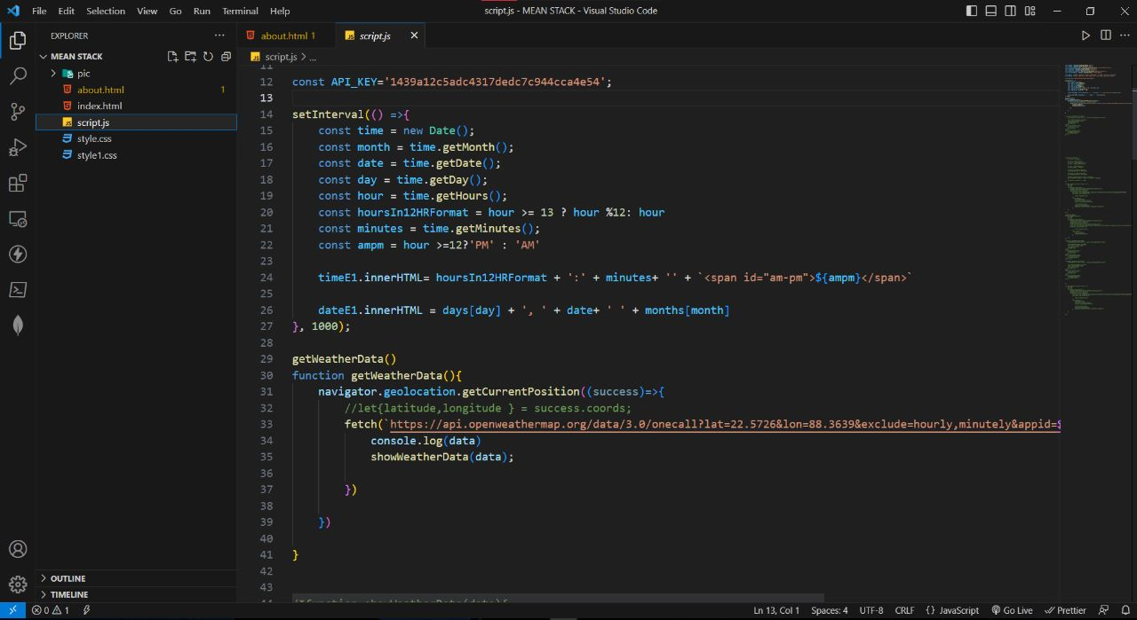

1. **Application Screenshots:**

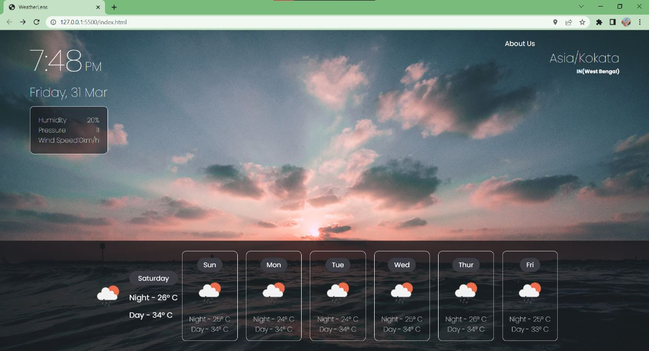

1. **Our Team:**

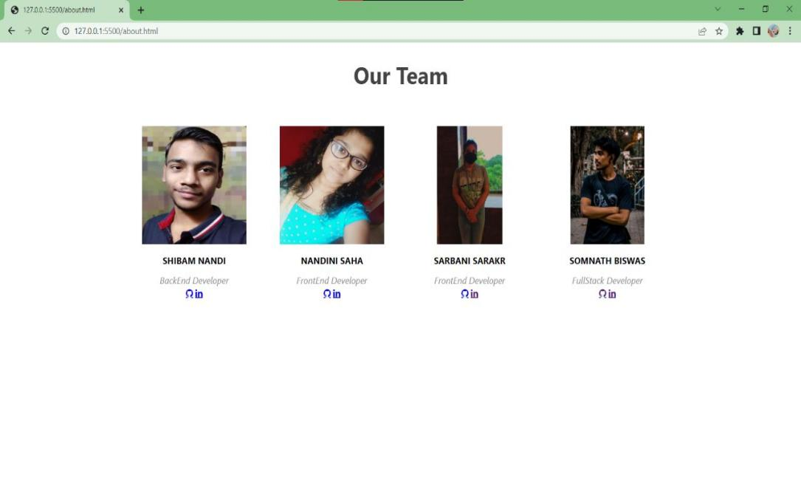

1. **Limitations**

a)Unpaid APIs provide incomplete services.Many details cannot be fetched

b)Often,tuples of upcoming days remain empty once again due to free APIs

c)The GMS API ( Google Manual Search) is actually keyword based that might only provide data of few discrete locations.The data might not be precise and continuous.