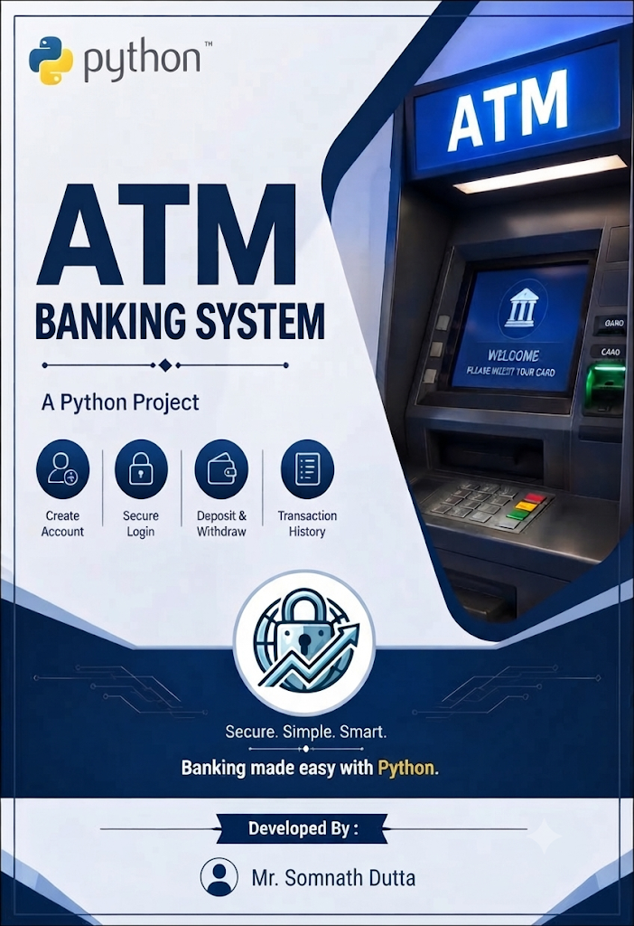
The ATM Python project is a simple implementation of an Automated Teller Machine. The system allows users to perform basic banking transactions such as checking balance, withdrawing money, depositing money, and transferring funds between accounts. The project is designed to provide a user-friendly interface and secure transaction handling.

Features

- User Authentication: Users are required to enter a valid PIN to access their accounts, ensuring security and privacy.
- Balance Inquiry: Users can check their account balance to view the current available funds.
- Cash Withdrawal: Users can withdraw money from their accounts, and the system updates the balance accordingly.
- Cash Deposit: Users can deposit money into their accounts by providing the necessary details.
- Fund Transfer: The system supports transferring funds between different accounts, ensuring accurate and secure transactions.
- Checking Balance: Check the Balance Amount in your account.
- Change Account Number: You can change your existing account Number.
- Logout: After completing transactions, users can securely log out of their accounts to prevent unauthorized access.

Software

- Python
- MySql

Database Specification

- Database Name : ATMMachine1
- Table Name : ATMMoney

Fields | Type | Width | Restriction
ACCONT_NO | INT | (4) | Primary Key
PASSWORD | INT | (8)
NAME | VARCHAR | (20)
CR_AMT | BIGINT |  | DEFAULT 0
WITHDRAWL | BIGINT |  | DEFAULT 0
BALANCE | BIGINT |  | DEFAULT 0

Table Records Operation : ATMMoney
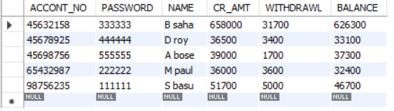

Software Manual Operation

- Menu Driven Option:

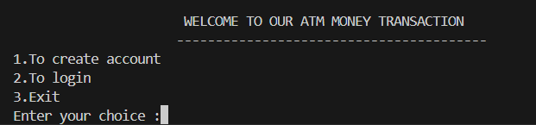

Step – 1

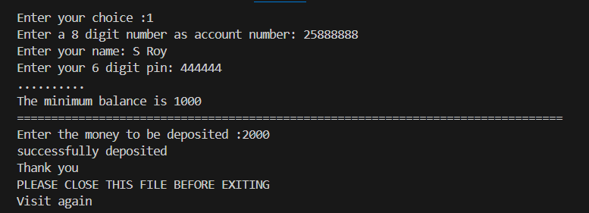

Step – 2

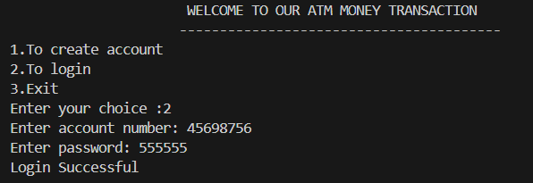

Step – 2.1

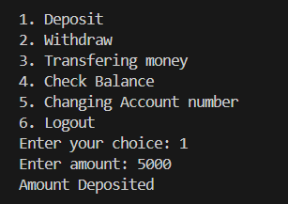

Step – 2.2

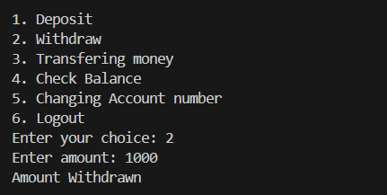

Step – 2.3

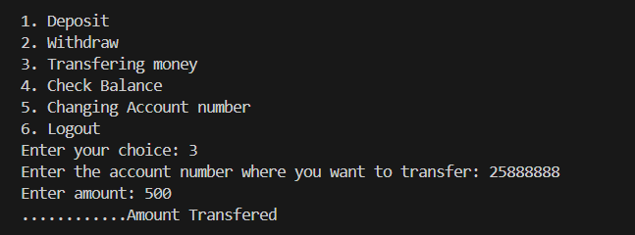

Step – 2.4

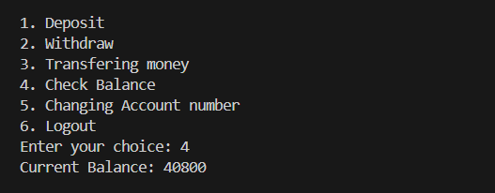

Step – 2.5

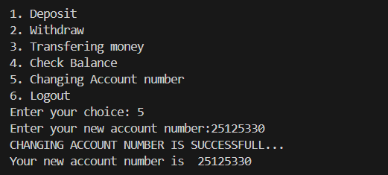

Step – 2.6

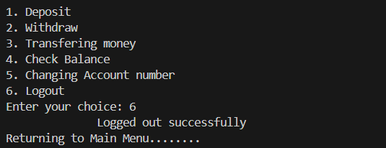

Step – 3

