**QUESTION1:**

**package** CA;

**import** org.openqa.selenium.By;

**import** org.openqa.selenium.WebDriver;

**import** org.openqa.selenium.WebElement;

**import** org.openqa.selenium.chrome.ChromeDriver;

**import** org.openqa.selenium.chrome.ChromeOptions;

**import** io.github.bonigarcia.wdm.WebDriverManager;

**public** **class** Qstn1

{

**public** **static** **void** main( String[] args ) **throws** InterruptedException

{

ChromeOptions co=**new** ChromeOptions();

co.addArguments ("--remote-allow-origins=*");

WebDriverManager.*chromedriver*().setup ();

WebDriver driver=**new** ChromeDriver();

driver.get("https://www.amazon.in/");

Thread.*sleep*(2000);

driver.manage().window().maximize();

driver.findElement(By.*xpath*("//*[@id=\"twotabsearchtextbox\"]")).click();

driver.findElement(By.*xpath*("//*[@id=\"twotabsearchtextbox\"]")).sendKeys("fossil watches");

driver.findElement(By.*xpath*("//*[@id=\"nav-search-submit-button\"]")).click();

Thread.*sleep*(2000);

driver.navigate().to("https://www.amazon.in/Fossil-Smartwatch-SnapdragonSmartphone-Notifications/dp/B09DGS966L/ref=sr_1_25?crid=2LOQNXJII74SZ&keywords=fossil+watches&qid=1681295284&sprefix=fossil+watche%2Caps%2C405&sr=8-25") ;

driver.findElement(By.*xpath*("//*[@id=\"add-to-cart-button\"]")).click();

WebElement

cart=driver.findElement(By.*xpath*("//*[@id=\"nav-cart-count\"]"));

**if**(cart.getText().equals("1")) {

System.***out***.print("Added to cart");

}**else** {

System.***out***.print("Not working successful");

}

}

}

OUTPUT:

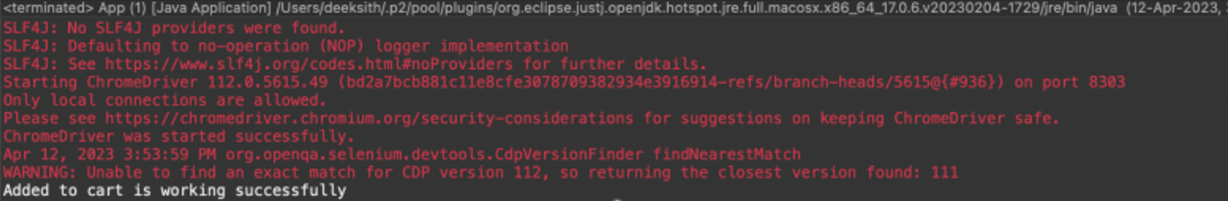

QUESTION 2:

CODING:

**package** CA;

**import** java.util.ArrayList;

**import** java.util.List;

**import** org.openqa.selenium.By;

**import** org.openqa.selenium.Keys;

**import** org.openqa.selenium.WebDriver;

**import** org.openqa.selenium.WebElement;

**import** org.openqa.selenium.chrome.ChromeDriver;

**import** org.openqa.selenium.chrome.ChromeOptions;

**import** io.github.bonigarcia.wdm.WebDriverManager;

**public** **class** q2 {

**public** **static** **void** main(String[] args) **throws** InterruptedException {

ChromeOptions co = **new** ChromeOptions();

co.addArguments("--remote-allow-origins=*");

WebDriverManager.*chromedriver*().setup();

WebDriver driver = **new** ChromeDriver();

String url = "https://www.amazon.in/";

driver.get(url);

driver.manage().window().maximize();

Thread.*sleep*(4000);

WebElement search = driver.findElement(By.*xpath*("//*[@id=\"twotabsearchtextbox\"]"));

search.sendKeys("Apple airpods");

search.sendKeys(Keys.***ENTER***);

Thread.*sleep*(6000);

**boolean** isDisplayed = driver.findElement(By.*xpath*("//*[@id=\"search\"]/div[1]/div[1]/div/span[1]/div[1]/div[3]/div/div/div/div/div")).isDisplayed();

**if**(isDisplayed) {

System.***out***.println("Corresponding Product is displayed !");

}

**else** {

System.***out***.println("Corresponding Product is not displayed !");

}

List<WebElement> product = **new** ArrayList<WebElement>();

product = driver.findElements(By.*className*("a-size-medium"));

**for**(**int** i=0; i<6; i++) {

System.***out***.println(product.get(i).getText());

}

driver.findElement(By.*xpath*("//*[@id=\"n/1388921031\"]/span/a/span")).click();

Thread.*sleep*(5000);

**boolean** isCategorized = driver.findElement(By.*xpath*("//*[@id=\"search\"]/span/div/h1/div/div[1]/div/div/span[1]")).isDisplayed();

**if**(isCategorized) {

System.***out***.println("Category wise displayed");

}

**else** {

System.***out***.println("Category wise not displayed");

}

driver.findElement(By.*xpath*("//*[@id=\"p_36/1318506031\"]/span/a/span")).click();

Thread.*sleep*(4000);

**boolean** isPrice = driver.findElement(By.*xpath*("//*[@id=\"search\"]/span/div/h1/div/div[1]/div/div/span[1]")).isDisplayed();

**if**(isPrice) {

System.***out***.println("Price wise displayed");

}

**else** {

System.***out***.println("Price wise not displayed");

}

Thread.*sleep*(4000);

driver.findElement(By.*xpath*("//*[@id=\"p_n_format_browse-bin/30678584031\"]/span/a/div/label/i")).click();

**boolean** isBrand = driver.findElement(By.*xpath*("//*[@id=\"search\"]/span/div/h1/div/div[1]/div/div/span[1]")).isDisplayed();

**if**(isBrand) {

System.***out***.println("Top brands is displayed");

}

**else** {

System.***out***.println("Top brands is not displayed");

}

Thread.*sleep*(4000);

driver.quit();

}

}

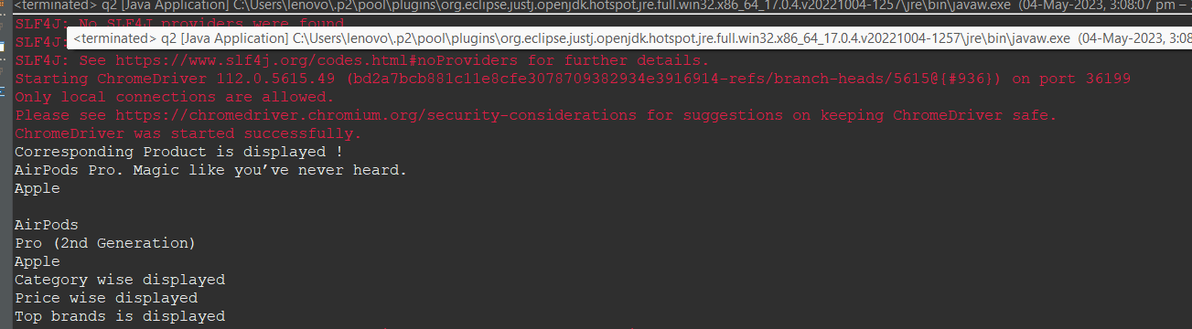

QUESTION 3:

CODING:

package CIA_1;

import org.openqa.selenium.By;

import org.openqa.selenium.Keys;

import org.openqa.selenium.WebDriver;

import org.openqa.selenium.WebElement;

import org.openqa.selenium.chrome.ChromeOptions;

import org.openqa.selenium.edge.EdgeDriver;

import io.github.bonigarcia.wdm.WebDriverManager;

public class Question_3 {

public static void main(String[] args) throws InterruptedException {

ChromeOptions co = new ChromeOptions();

co.addArguments("--remote-allow-origins=*");

WebDriverManager.chromedriver().setup();

WebDriver driver = new EdgeDriver();

String url = "https://www.amazon.in/";

driver.get(url);

driver.manage().window().maximize();

Thread.sleep(4000);

// driver.findElement(By.xpath("//*[@id=\"nav-link-accountList\"]")).click();

driver.findElement(By.xpath("//*[@id=\"nav-signin-tooltip\"]/a/span")).click();

Thread.sleep(5000);

WebElement email = driver.findElement(By.xpath("//*[@id=\"ap_email\"]"));

email.sendKeys("6369442740");

email.sendKeys(Keys.ENTER);

Thread.sleep(5000);

WebElement password = driver.findElement(By.xpath("//*[@id=\"ap_password\"]"));

password.sendKeys("Shree@54321");

password.sendKeys(Keys.ENTER);

Thread.sleep(5000);

// driver.findElement(By.xpath("//*[@id=\"ap_password\"]")).sendKeys("Shree@54321");

//

// Thread.sleep(4000);

// driver.findElement(By.xpath("//*[@id=\"signInSubmit\"]")).submit();

//

Thread.sleep(4000);

driver.findElement(By.xpath("//*[@id=\"nav-link-accountList\"]")).click();

// driver.findElement(By.xpath("//*[@id=\"nav-al-your-account\"]/a[1]/span")).click();

String message = "Your Account";

String actualMessage = driver.findElement(By.xpath("//*[@id=\"a-page\"]/div[2]/div/div[1]/h1")).getText();

// System.out.print(actualMessage);

if(message.equals(actualMessage)) {

System.out.println("Your Account page is displayed");

}

else{

System.out.println("Your Account page is not displayed");

}

Thread.sleep(4000);

driver.get("https://www.amazon.in/gp/css/order-history?ref_=nav_AccountFlyout_orders");

String Ordermessage = "Your Orders";

String actualOrderMessage = driver.findElement(By.xpath("//*[@id=\"a-page\"]/section/div/div[2]/div[1]/h1")).getText();

if(Ordermessage.equals(actualOrderMessage)) {

System.out.println("Your Order page is displayed");

}

else{

System.out.println("Your Order page is not displayed");

}

String orders = driver.findElement(By.xpath("//*[@id=\"a-page\"]/section/div/div[4]/form/label")).getText();

System.out.println(orders);

driver.findElement(By.xpath("//*[@id=\"a-page\"]/section/div/div[3]/ul/li[4]/a")).click();

String cancelled = driver.findElement(By.xpath("//*[@id=\"ordersContainer\"]/div[1]/div")).getText();

System.out.println(cancelled);

Thread.sleep(4000);

}

} }

}

