DAY 3 NAME : Somnath Kumar A

ROLL NO : 727721eucs147

CLASS EXERCISE 1 :

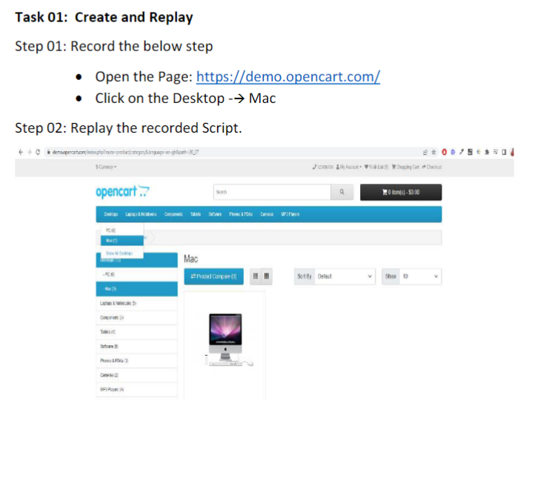

**OUTPUT :**

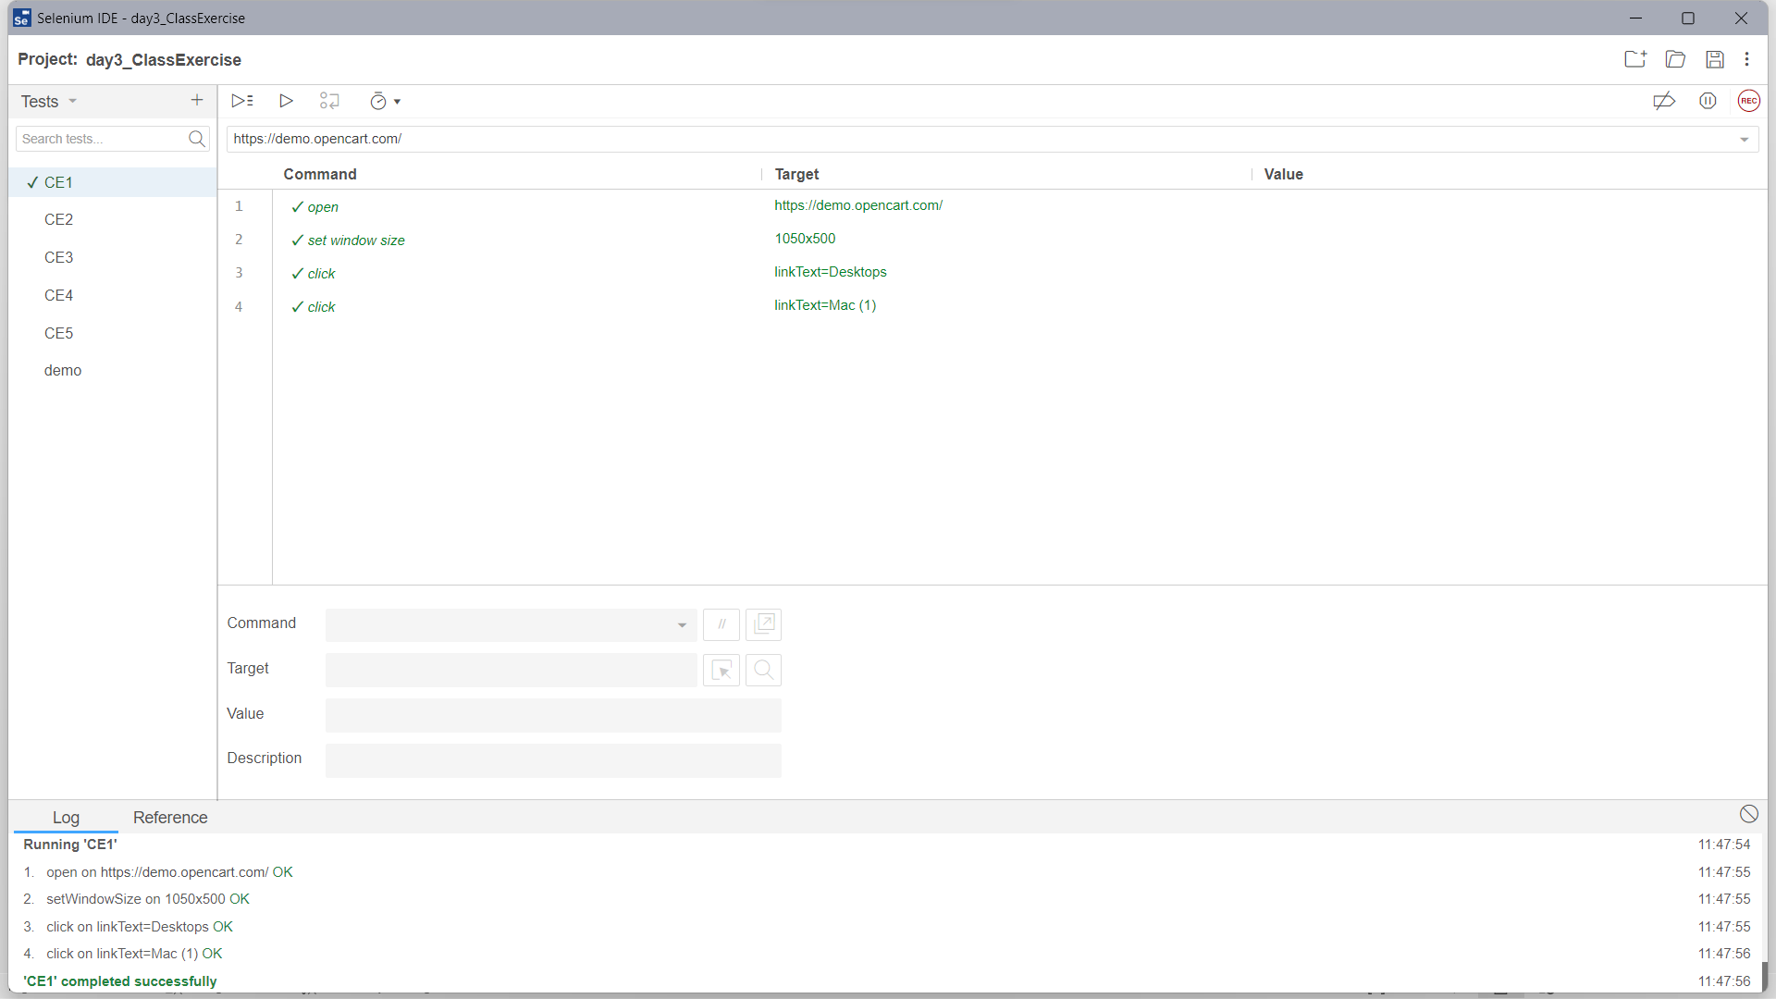

**CLASS EXERCISE 2 :**

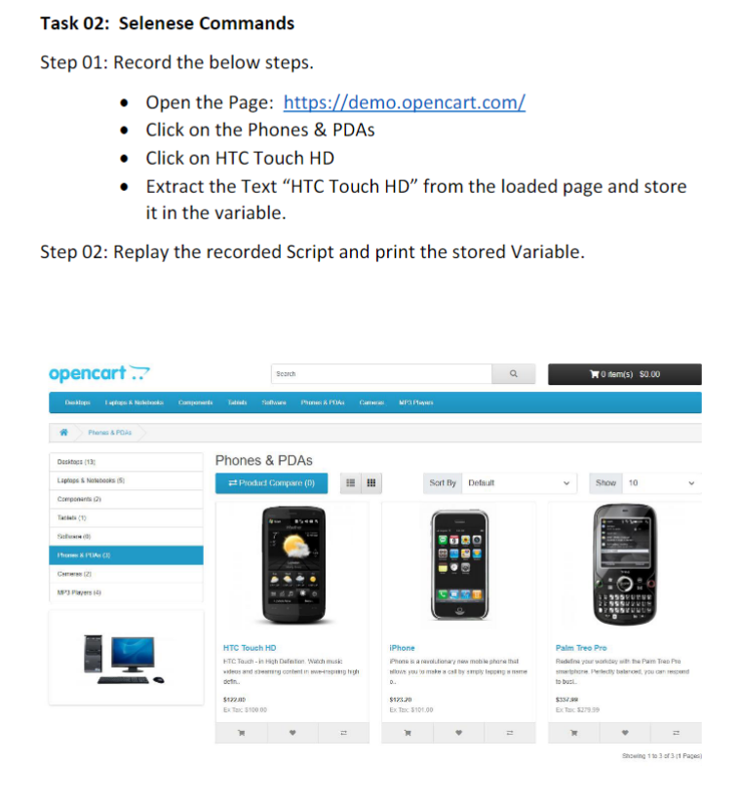

**OUTPUT :**

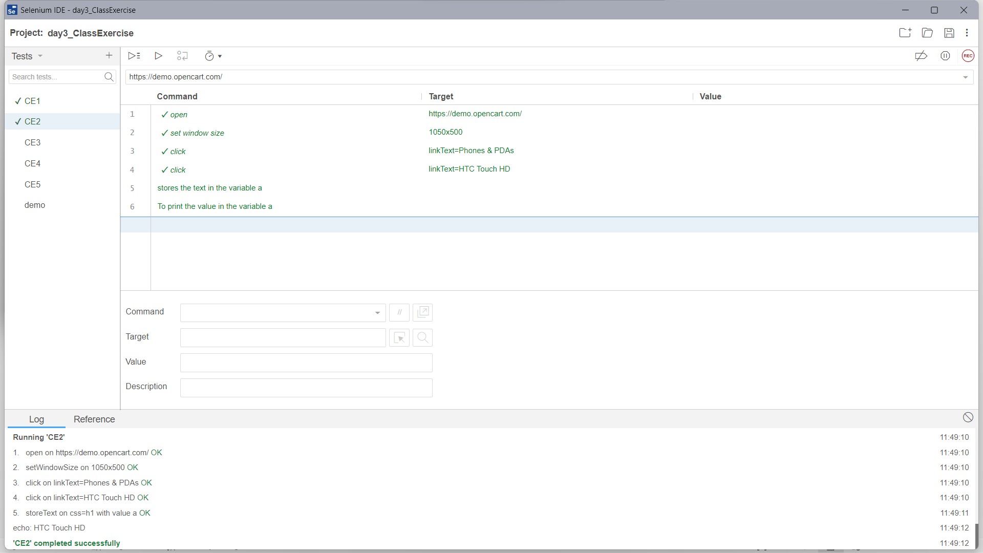

**CLASS EXERCISE 3 :**

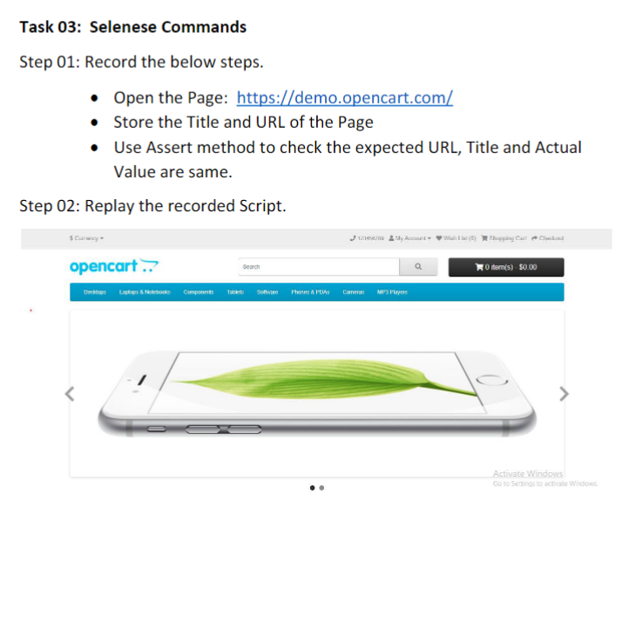

**OUTPUT :**

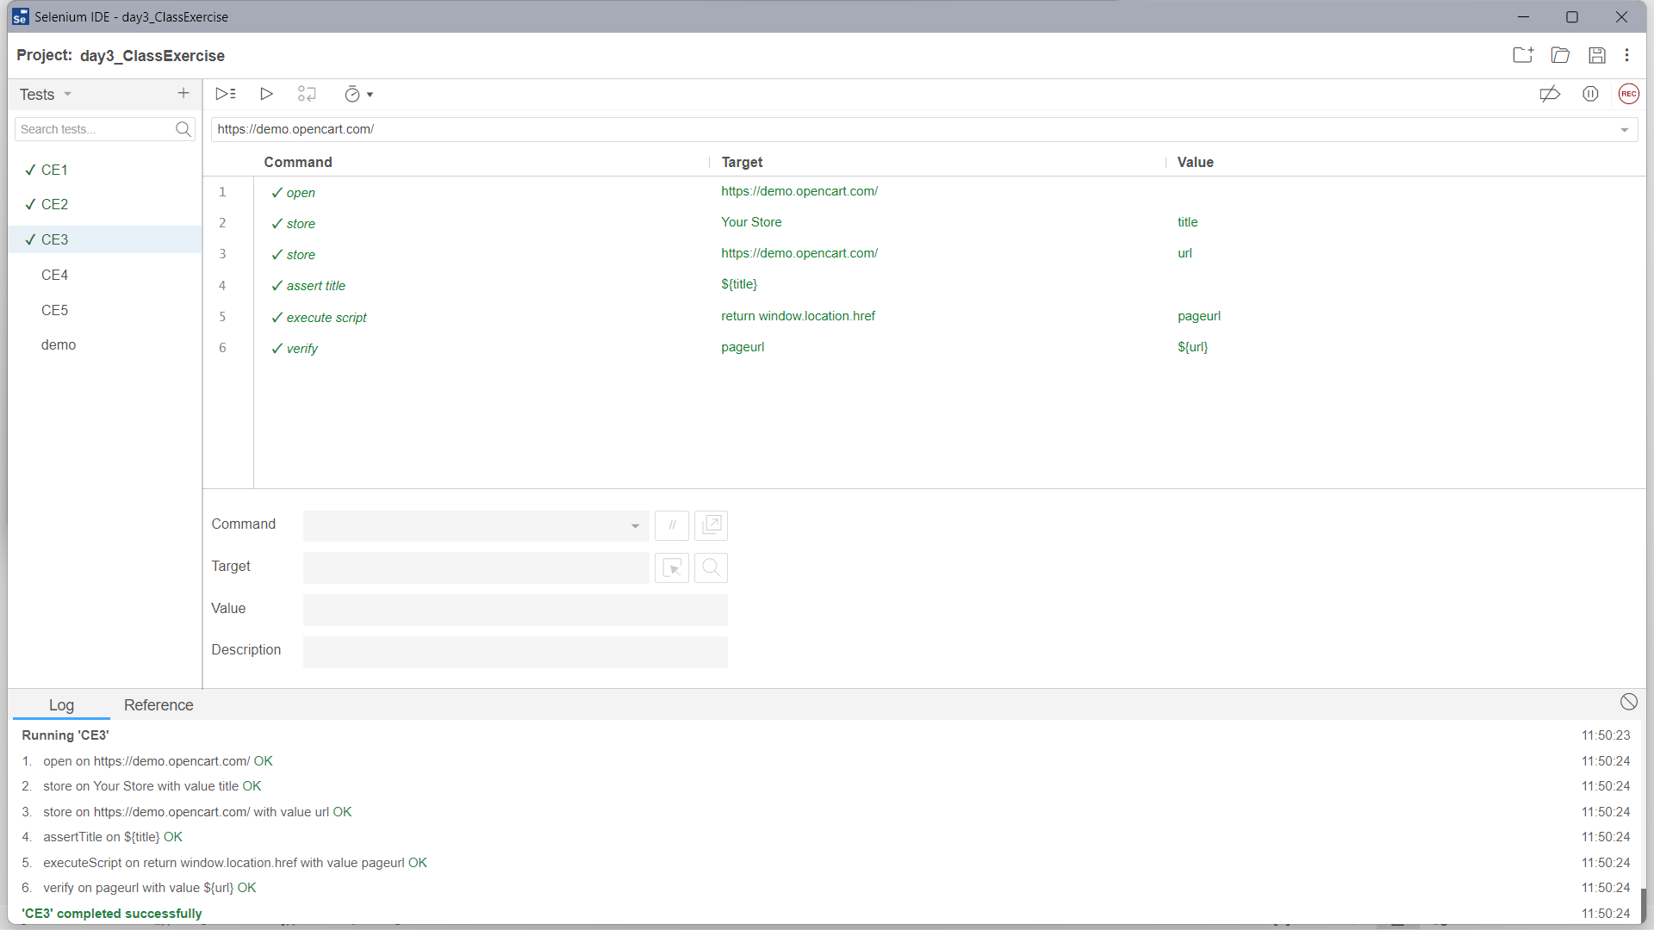

**CLASS EXERCISE 4 :**

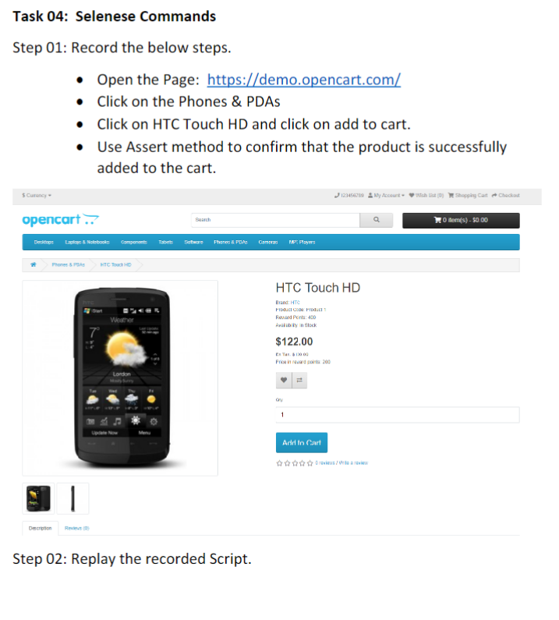

**OUTPUT :**

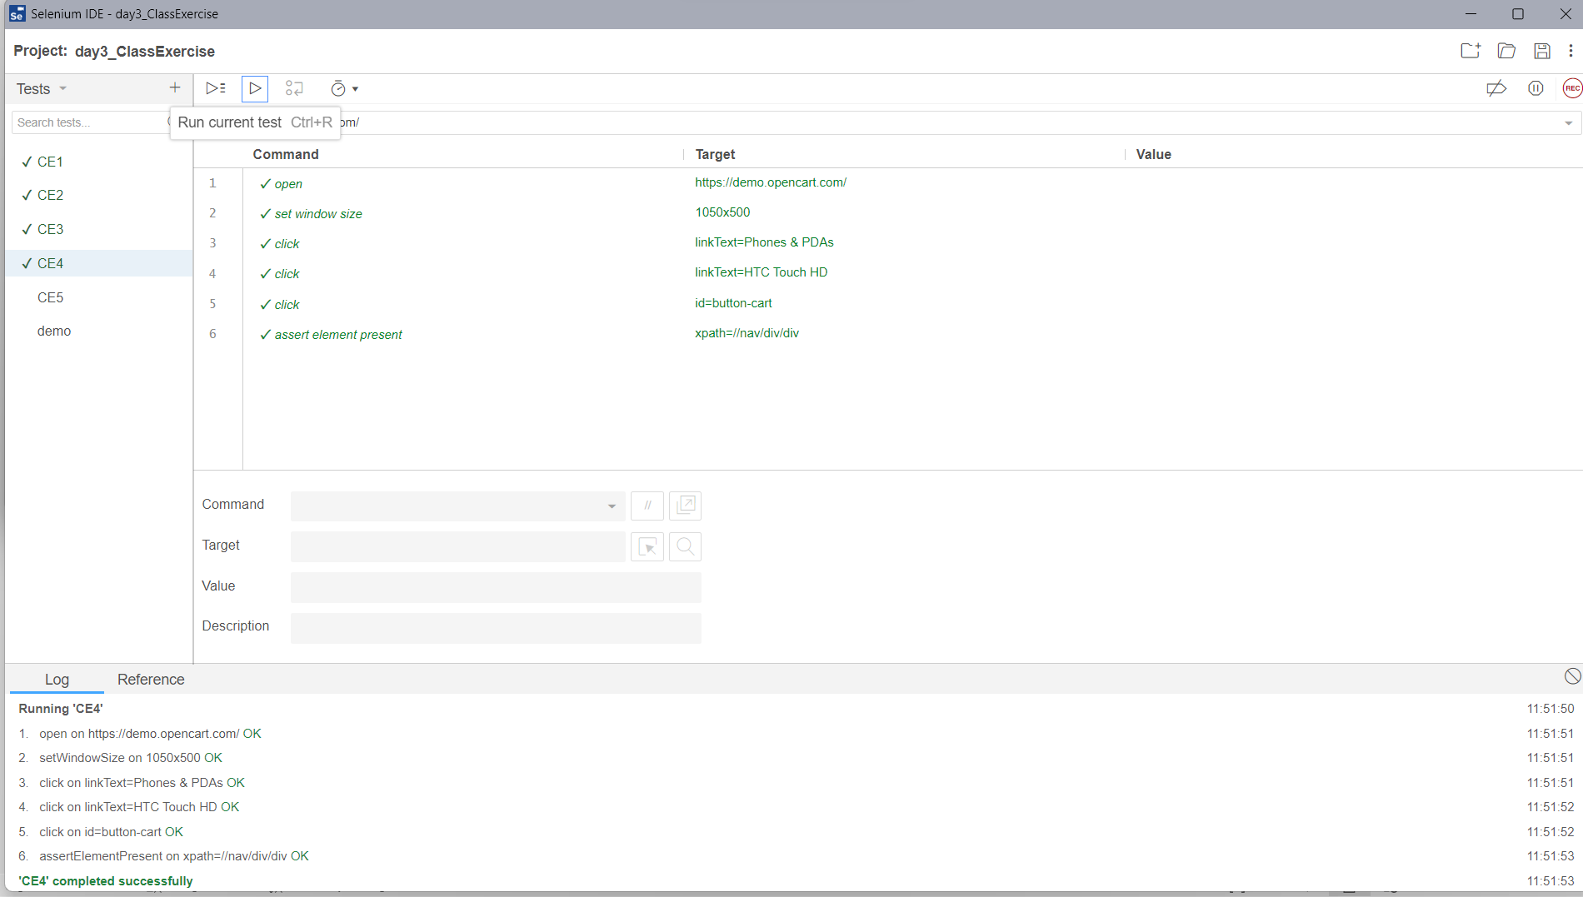

**CLASS EXERCISE 5 :**

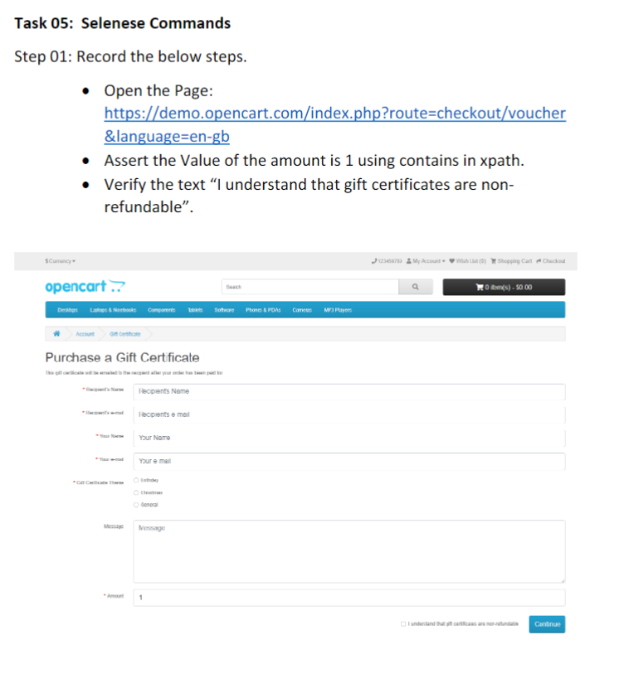

**OUTPUT :**

