DAY9

Somnath Kumar A

727721EUCS147

1)

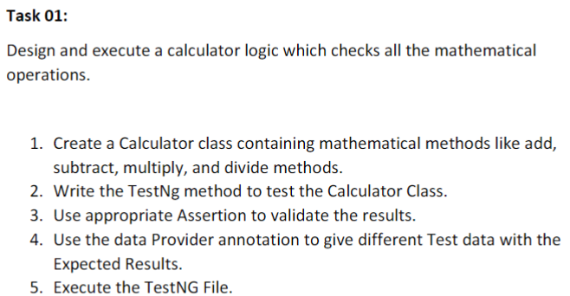

package com.DAY9;

import org.testng.annotations.Test;

import org.testng.annotations.DataProvider;

public class CE1 {

*@Test*(dataProvider = "dp",priority=2)

public void add(Integer n, Integer s)

{

System.out.println("Add:"+(n+s));

}

*@Test*(dataProvider = "dp",priority=3)

public void sub(Integer n,Integer s)

{

System.out.println("Sub:"+(n-s));

}

*@Test*(dataProvider = "dp",priority=1)

public void mul(Integer n,Integer s)

{

System.out.println("Product:"+(n*s));

}

*@Test*(dataProvider="dp",priority=4)

public void div(Integer n,Integer s)

{

System.out.println("Division:"+(n/s));

}

*@DataProvider*

public Object[][] dp() {

return new Object[][] {

new Object[] { 10, 5 },

new Object[] { 20, 4 },

};

}

}

OUTPUT:

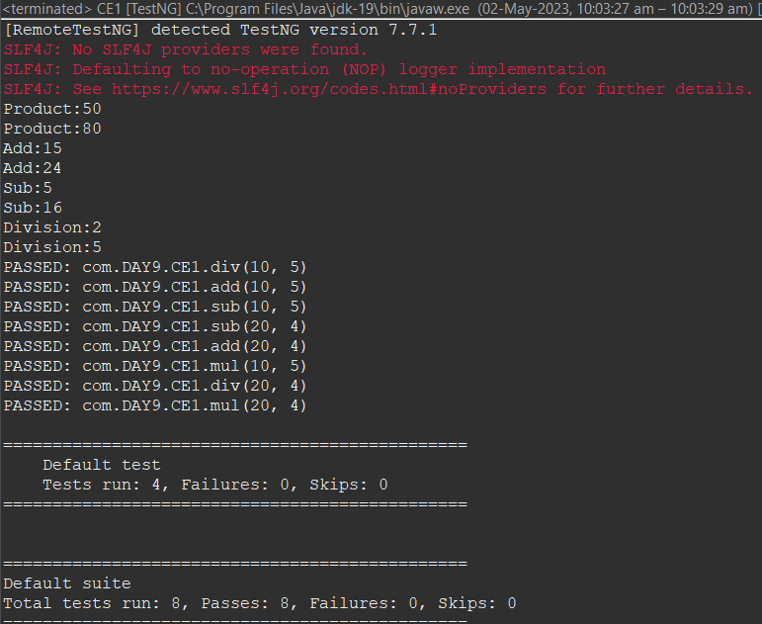

2)

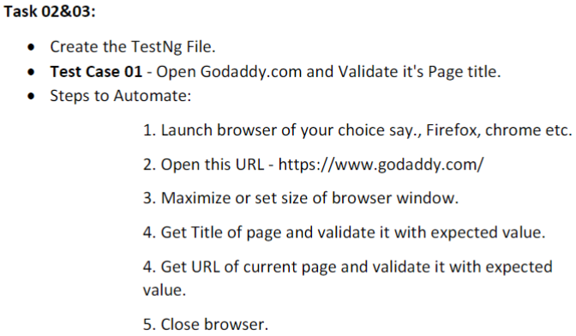

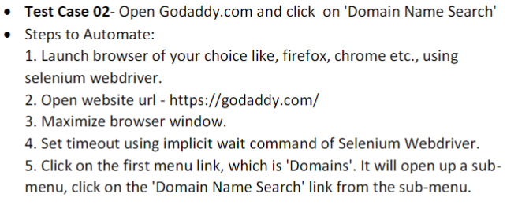

package com.DAY9;

import org.testng.annotations.Test;

import io.github.bonigarcia.wdm.WebDriverManager;

import org.testng.annotations.BeforeClass;

import java.util.concurrent.TimeUnit;

import org.openqa.selenium.By;

import org.openqa.selenium.WebDriver;

//import org.openqa.selenium.WebElement;

import org.openqa.selenium.chrome.ChromeDriver;

import org.openqa.selenium.chrome.ChromeOptions;

import org.testng.Assert;

import org.testng.annotations.AfterClass;

public class CE2 {

WebDriver driver;

@Test(groups="SmokeTest")

public void check() {

String text = driver.getTitle();

String expected="Domain Names, Websites, Hosting & Online Marketing Tools - GoDaddy IN";

Assert.assertEquals(text,expected);

}

@SuppressWarnings("deprecation")

@Test(groups="RegressionTest")

public void testcase2() throws InterruptedException

{

driver.findElement(By.xpath("//*[@id=\"id-631b049a-e9c0-4d24-8710-c504745206dd\"]/div[2]/div[1]/ul/li[1]/button")).click();

driver.manage().timeouts().implicitlyWait(4000,TimeUnit.SECONDS);

driver.findElement(By.xpath("//*[@id=\"id-631b049a-e9c0-4d24-8710-c504745206dd\"]/div[2]/div[1]/ul/li[1]/div/div[2]/div[1]/ul/li[2]/a")).click();

driver.manage().timeouts().implicitlyWait(4000,TimeUnit.SECONDS);

}

@BeforeClass

public void beforeClass() throws InterruptedException {

ChromeOptions co=new ChromeOptions();

co.addArguments("--remote-allow-origins=*");

WebDriverManager.chromedriver().setup();

driver=new ChromeDriver();

driver.get("https://www.godaddy.com/");

driver.manage().window().maximize();

Thread.sleep(6000);

}

@AfterClass

public void afterClass() throws InterruptedException {

Thread.sleep(6000);

driver.close();

}}

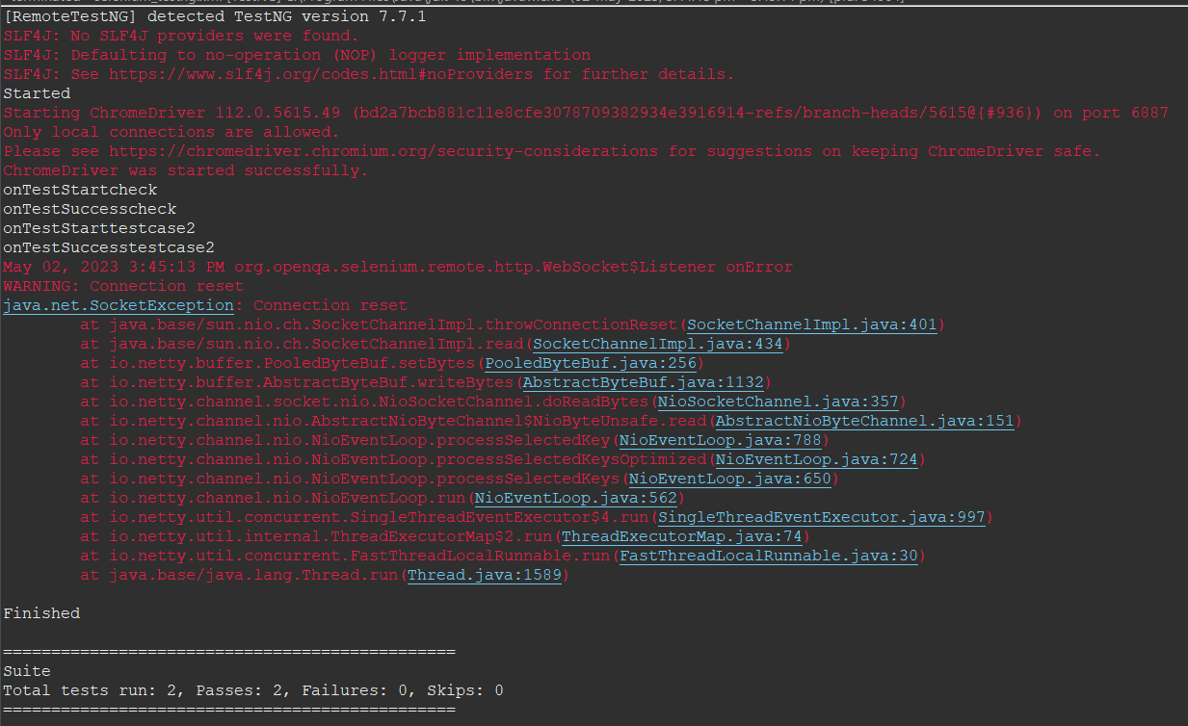

4)

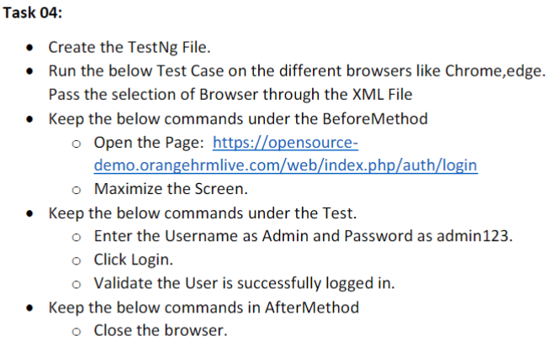

package com.DAY9;

import org.testng.annotations.Test;

import io.github.bonigarcia.wdm.WebDriverManager;

import org.testng.annotations.BeforeMethod;

import org.testng.annotations.Parameters;

//import org.junit.Assert;

import org.openqa.selenium.By;

import org.openqa.selenium.WebDriver;

import org.openqa.selenium.WebElement;

import org.openqa.selenium.chrome.ChromeDriver;

import org.openqa.selenium.chrome.ChromeOptions;

import org.openqa.selenium.edge.EdgeDriver;

import org.testng.Assert;

import org.testng.annotations.AfterMethod;

public class ce4 {

WebDriver driver;

@Test

public void f() throws InterruptedException {

driver.findElement(By.xpath("//*[@id=\"app\"]/div[1]/div/div[1]/div/div[2]/div[2]/form/div[1]/div/div[2]/input")).sendKeys("Admin");

WebElement pswrd = driver.findElement(By.xpath("//*[@id=\"app\"]/div[1]/div/div[1]/div/div[2]/div[2]/form/div[2]/div/div[2]/input"));

pswrd.sendKeys("admin123");

Thread.sleep(2000);

driver.findElement(By.xpath("//*[@id=\"app\"]/div[1]/div/div[1]/div/div[2]/div[2]/form/div[3]/button")).submit();

Thread.sleep(3000);

String dash = driver.findElement(By.xpath("//*[@id=\"app\"]/div[1]/div[1]/header/div[1]/div[1]/span/h6")).getText();

Assert.assertEquals(dash, "Dashboard");

Thread.sleep(3000);

}

@BeforeMethod

@Parameters("browser")

public void beforeMethod(String browser) throws InterruptedException {

ChromeOptions co = new ChromeOptions();

WebDriverManager.chromedriver().setup();

if (browser.equals("chrome")) {

driver = new ChromeDriver();

}

else if (browser.equals("edge")) {

driver = new EdgeDriver();

}

else {

throw new IllegalArgumentException("Invalid browser value: " + browser);

}

driver.get("https://opensource-demo.orangehrmlive.com/web/index.php/auth/login");

driver.manage().window().maximize();

Thread.sleep(4000);

}

@AfterMethod

public void afterMethod() {

driver.quit();

}}

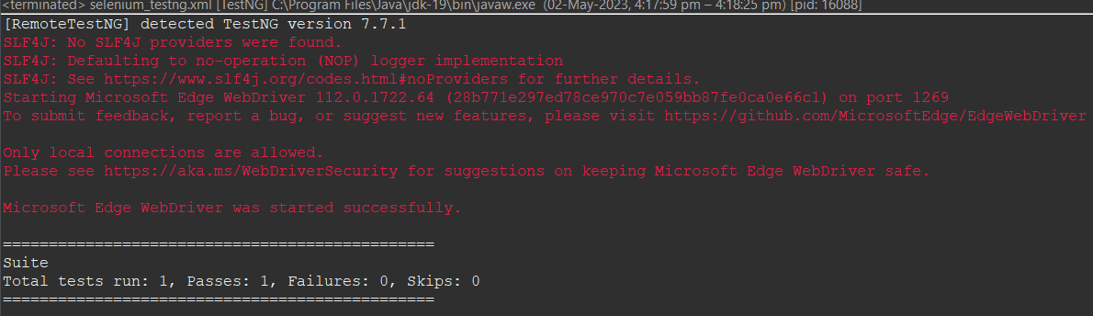

5)

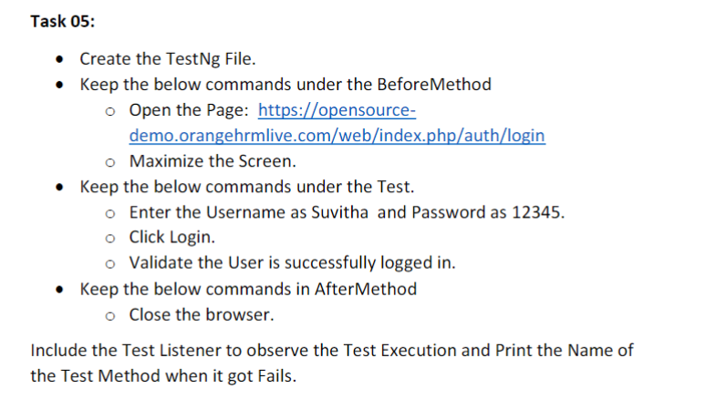

package com.DAY9;

import org.testng.annotations.Test;

import io.github.bonigarcia.wdm.WebDriverManager;

import org.testng.annotations.BeforeMethod;

import org.openqa.selenium.By;

import org.openqa.selenium.WebDriver;

import org.openqa.selenium.WebElement;

import org.openqa.selenium.chrome.ChromeDriver;

import org.openqa.selenium.chrome.ChromeOptions;

import org.testng.Assert;

import org.testng.annotations.AfterMethod;

public class ce5 {

WebDriver driver;

@Test

public void validation() throws InterruptedException {

driver.findElement(By.xpath("//*[@id=\"app\"]/div[1]/div/div[1]/div/div[2]/div[2]/form/div[1]/div/div[2]/input")).sendKeys("Suvitha");

WebElement pswrd = driver.findElement(By.xpath("//*[@id=\"app\"]/div[1]/div/div[1]/div/div[2]/div[2]/form/div[2]/div/div[2]/input"));

pswrd.sendKeys("12345");

driver.findElement(By.xpath("//*[@id=\"app\"]/div[1]/div/div[1]/div/div[2]/div[2]/form/div[3]/button")).click();

Thread.sleep(2000);

WebElement dash = driver.findElement(By.xpath("//*[@id=\"app\"]/div[1]/div[1]/header/div[1]/div[1]/span/h6"));

String get=dash.getText();

Assert.assertEquals(get, "Dashboard");

}

@BeforeMethod

public void beforeMethod() throws InterruptedException {

ChromeOptions co=new ChromeOptions();

co.addArguments("--remote-allow-origins=*");

WebDriverManager.chromedriver().setup();

driver=new ChromeDriver();

driver.get("https://opensource-demo.orangehrmlive.com/web/index.php/auth/login");

Thread.sleep(2000);

driver.manage().window().maximize();

}

@AfterMethod

public void afterMethod() {

driver.close();

}

}

LISTENER CLASS:

package com.DAY9;

import org.testng.ITestContext;

import org.testng.ITestListener;

import org.testng.ITestResult;

public class Listener implements ITestListener{

public void onTestStart(ITestResult result) {

// **TODO** Auto-generated method stub

System.***out***.println("onTestStart"+result.getName());

}

public void onTestSuccess(ITestResult result) {

// **TODO** Auto-generated method stub

System.***out***.println("onTestSuccess"+result.getName());

}

public void onTestFailure(ITestResult result) {

// **TODO** Auto-generated method stub

System.***out***.println("onTestFailure"+result.getName());

}

public void onTestSkipped(ITestResult result) {

// **TODO** Auto-generated method stub

System.***out***.println("onTestSkipped"+result.getName());

}

public void onTestFailedButWithinSuccessPercentage(ITestResult result) {

// **TODO** Auto-generated method stub

System.***out***.println("onTestFailedButWithinSuccessPercentage"+result.getName());

}

public void onTestFailedWithTimeout(ITestResult result) {

// **TODO** Auto-generated method stub

System.***out***.println("onTestFailedWithTimeout"+result.getName());

}

public void onStart(ITestContext context) {

// **TODO** Auto-generated method stub

System.***out***.println("Started"); }

public void onFinish(ITestContext context) {

// **TODO** Auto-generated method stub

System.***out***.println("Finished"); }

}

OUTPUT:

