**Project Name : Employee directory**

Technology:

**Java, Spring Boot, Thyme leaf(HTML,CSS), MySQL ,REST API’s,Postman**

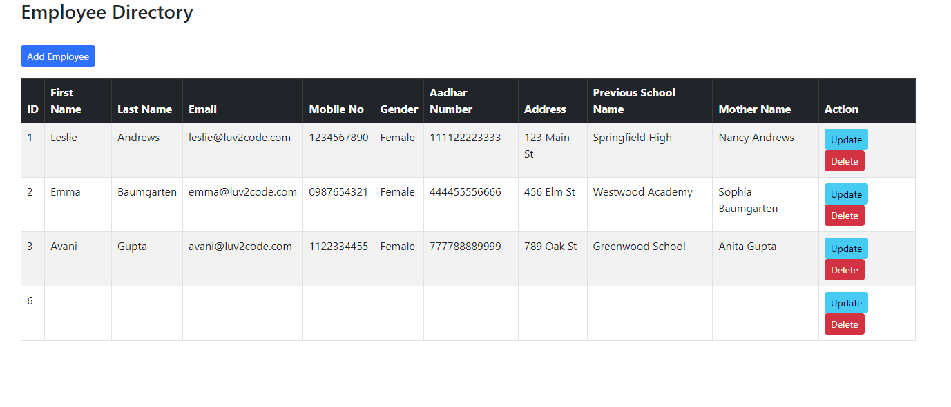

Once we click on Add button then Register form opens..

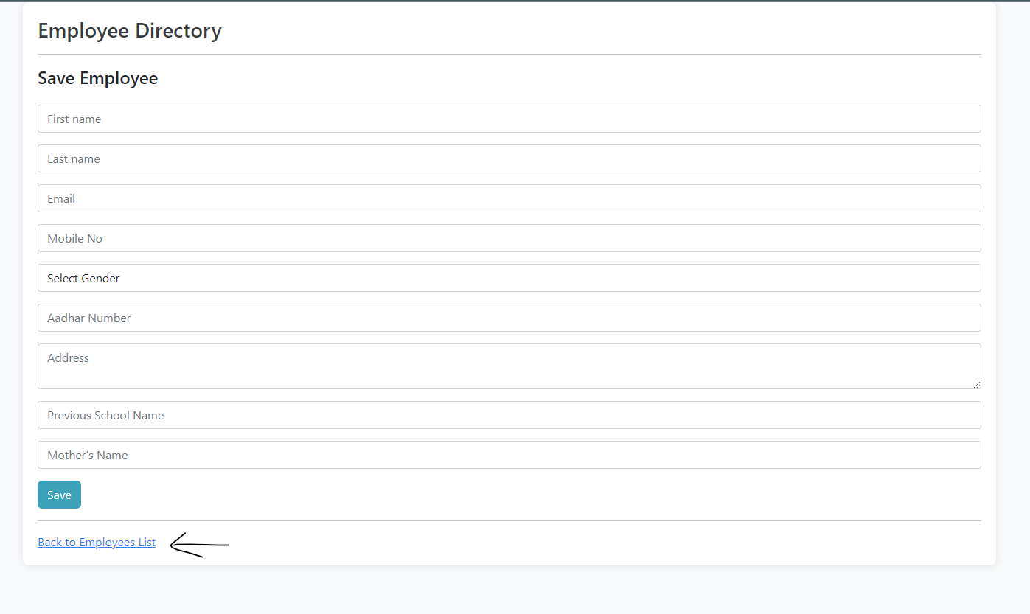

Now here two functionality are there  
1) once we click on save after filling all details the page navigate to employee list and show newly added employee and also update in Databse



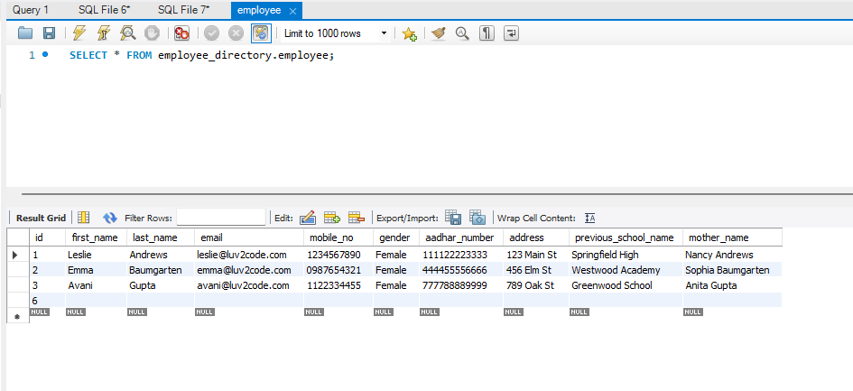

2) added new customize back to employee list functionality also

After that we added Update and Delete functionality to employee see in action column there is two buttons UPDATE and delete so

Once we click on update then register form open with all previously register data after u save the data will update on UI as well as in DB

And same for delete also once you click on delete then employee deleted and its show in UI and DB also