Hat

Table of contents
English version 16
Description 16
Quick start 16
System requirements 16
Installation and launch 17
Creating a simple project 18
Creating a project compatible with Visual Studio 20
Launching the autotest and result 24
Browser Cache 27
Clearing 27
Interface 28
The main menu 28
The Toolbar 30
The Project window - is the Explorer tab 30
The Project window - is the Test tab 34
The Project window - the Library tab 35
The Project window - the Mail tab 36
The system window 37
Reports 38
Autotest Report 38
Log file 41
Mail 42
Send a report on the failure of the autotest to the mail 42
Console launch mode (Jenkins) 44
Running the autotest from the command line 44
A text code editor 48
Code Editor (C#) 48
Using Visual Studio to edit code 52
The structure of the autotest 56
Simple project 56
The PageObjects and StepObjects pattern 59
Creating a new autotest and patterns 62
HatFramework 66
Class: Tester 66
Constructor 66
Tester 66
Constants 67
BY_CSS 67
BY_XPATH 67
IMAGE_STATUS_PROCESS 67
IMAGE_STATUS_PASSED 67
IMAGE_STATUS_FAILED 68
IMAGE_STATUS_MESSAGE 68
IMAGE_STATUS_WARNING 68
IMAGE_STATUS_DEBUG 68
COMPLETED 69
FAILED 69
PASSED 69
PROCESS 69
STOPPED 69
WARNING 70
DEBUG 70
DEFAULT 70
UTF8 70
UTF8BOM 71
WINDOWS1251 71
Variables 71
BrowserView 71
BrowserWindow 72
Locators 72
Locator 72
AddLocator 73
GetLocator 73
GetLocatorValue 73
GetCountLocators 73
ClearLocators 74
RemoveLocator 74
Methods for working with the browser 74
BrowserBasicAuthenticationAsync 74
BrowserClearNetworkAsync 75
BrowserCloseAsync 75
BrowserEnableSendMailAsync 75
BrowserFullScreenAsync 75
BrowserScreenshotAsync 76
BrowserSizeAsync 76
BrowserGetUserAgentAsync 76
BrowserSetUserAgentAsync 77
BrowserGetErrorsAsync 77
BrowserGetNetworkAsync 77
BrowserGoBackAsync 77
BrowserGoForwardAsync 78
BrowserPageReloadAsync 79
Methods for displaying messages 79
ConsoleMsg 79
ConsoleMsgError 80
ClearMessage 80
Description 80
DisableDebugInReport 81
SendMessage 81
SendMessageDebug 82
Methods for preparing and completing testing 82
TestBeginAsync 82
TestEndAsync 82
TestStopAsync 83
GetTestResult 83
DefineTestStop 83
Methods for performing actions 83
Attributes 84
GetAttributeFromElementAsync 85
GetAttributeFromElementByClassAsync 86
GetAttributeFromElementByIdAsync 87
GetAttributeFromElementByNameAsync 88
GetAttributeFromElementByTagAsync 89
GetAttributeFromElementsAsync 90
GetAttributeFromElementsByClassAsync 91
GetAttributeFromElementsByNameAsync 92
GetAttributeFromElementsByTagAsync 93
SetAttributeInElementAsync 94
SetAttributeInElementByClassAsync 95
SetAttributeInElementByIdAsync 96
SetAttributeInElementByNameAsync 97
SetAttributeInElementByTagAsync 98
SetAttributeInElementsAsync 99
SetAttributeInElementsByClassAsync 100
SetAttributeInElementsByNameAsync 101
SetAttributeInElementsByTagAsync 102
Values 102
GetValueFromElementAsync 103
GetValueFromElementByClassAsync 104
GetValueFromElementByIdAsync 105
GetValueFromElementByNameAsync 106
GetValueFromElementByTagAsync 107
SetValueInElementAsync 108
SetValueInElementByClassAsync 109
SetValueInElementByIdAsync 110
SetValueInElementByNameAsync 111
SetValueInElementByTagAsync 112
Clicking 112
ClickElementAsync 113
ClickElementByClassAsync 114
ClickElementByIdAsync 115
ClickElementByNameAsync 116
ClickElementByTagAsync 117
IsClickableElementAsync 118
ScrollToElementAsync 119
Objects 119
GetElementAsync 120
GetFrameAsync 122
GetCountElementsAsync 124
GetCountElementsByClassAsync 125
GetCountElementsByNameAsync 126
GetCountElementsByTagAsync 127
GetHtmlFromElementAsync 128
GetHtmlFromElementByClassAsync 129
GetHtmlFromElementByIdAsync 130
GetHtmlFromElementByNameAsync 131
GetHtmlFromElementByTagAsync 132
IsVisibleElementAsync 133
MakeElementVisibleAsync 134
SetHtmlInElementAsync 135
SetHtmlInElementByClassAsync 136
SetHtmlInElementByIdAsync 137
SetHtmlInElementByNameAsync 138
SetHtmlInElementByTagAsync 139
Waiting 139
WaitAsync 140
WaitElementInDomAsync 141
WaitElementNotDomAsync 142
WaitNotVisibleElementAsync 143
WaitNotVisibleElementByClassAsync 144
WaitNotVisibleElementByIdAsync 145
WaitNotVisibleElementByNameAsync 146
WaitNotVisibleElementByTagAsync 147
WaitVisibleElementAsync 148
WaitVisibleElementByClassAsync 149
WaitVisibleElementByIdAsync 150
WaitVisibleElementByNameAsync 151
WaitVisibleElementByTagAsync 152
Search 152
FindElementAsync 153
FindElementByClassAsync 154
FindElementByIdAsync 155
FindElementByNameAsync 156
FindElementByTagAsync 157
FindVisibleElementAsync 158
FindVisibleElementByClassAsync 159
FindVisibleElementByIdAsync 160
FindVisibleElementByNameAsync 161
FindVisibleElementByTagAsync 162
Styles 162
GetStyleFromElementAsync 163
GetStyleFromElementByClassAsync 164
GetStyleFromElementByIdAsync 165
GetStyleFromElementByNameAsync 166
GetStyleFromElementByTagAsync 167
SetStyleInElementAsync 168
SetStyleInElementByClassAsync 169
SetStyleInElementByIdAsync 170
SetStyleInElementByNameAsync 171
SetStyleInElementByTagAsync 172
Page 172
GetCookiesAsync 173
GetListRedirectUrlAsync 174
GetTitleAsync 175
GetUrlAsync 176
GetUrlResponseAsync 177
GoToUrlAsync 178
GoToUrlBaseAuthAsync 179
LoadPageAsync 180
Text 180
GetTextFromElementAsync 181
GetTextFromElementByClassAsync 182
GetTextFromElementByIdAsync 183
GetTextFromElementByNameAsync 184
GetTextFromElementByTagAsync 185
SetTextInElementAsync 186
SetTextInElementByClassAsync 187
SetTextInElementByIdAsync 188
SetTextInElementByNameAsync 189
SetTextInElementByTagAsync 190
Methods for executing JavaScript 190
ExecuteJavaScriptAsync 190
Methods for executing Rest requests 190
RestGetAsync 190
RestGetBasicAuthAsync 191
RestGetStatusCodeAsync 192
RestPostAsync 192
Methods for measuring the time spent 193
TimerStart 193
TimerStop 193
Methods for sending email and message 194
SendMsgToMailAsync 194
SendMsgToTelegramAsync 194
Methods for checking the result 195
AssertEqualsAsync 195
AssertNotEqualsAsync 195
AssertTrueAsync 196
AssertFalseAsync 196
AssertNotNullAsync 196
AssertNullAsync 196
AssertNoErrorsAsync 197
AssertNetworkEventsAsync 197
Methods for working with files 197
FileDownloadAsync 197
FileGetHashMD5Async 198
FileReadAsync 198
FileWriteAsync 198
Methods for different tasks 198
CreateHashMD5FromTextAsync 199
Class: HTMLElement 199
Constructor 199
HTMLElement 199
Constants 199
BY_INDEX 199
BY_TEXT 200
BY_VALUE 200
Variables 200
Id 200
Name 200
Class 201
Type 201
Methods 201
ClickAsync 201
ClickMouseAsync 202
GetAttributeAsync 202
GetHtmlAsync 202
GetLocatorAsync 202
GetOptionAsync 203
GetStyleAsync 203
GetTextAsync 203
GetValueAsync 204
IsClickableAsync 204
MakeVisibleAsync 204
ScrollToAsync 205
SelectOptionAsync 205
SetAttributeAsync 205
SetHtmlAsync 206
SetStyleAsync 206
SetTextAsync 206
SetValueAsync 206
WaitNotVisibleAsync 207
WaitVisibleAsync 207
Class: FRAMEElement 207
Constructor 207
FRAMEElement 207
Constants 208
BY_INDEX 208
BY_TEXT 208
BY_VALUE 208
Variables 208
Name 208
Index 209
Index 209
Methods 209
ClickElementAsync 209
FindElementAsync 209
FindVisibleElementAsync 210
GetAttributeFromElementAsync 210
GetAttributeFromElementsAsync 211
GetCountElementsAsync 211
GetHtmlFromElementAsync 211
GetOptionAsync 212
GetStyleFromElementAsync 212
GetTextFromElementAsync 213
GetTitleAsync 213
GetUrlAsync 213
GetValueFromElementAsync 214
IsClickableElementAsync 214
IsVisibleElementAsync 214
MakeVisibleAsync 215
ScrollToElementAsync 215
SelectOptionAsync 215
SetAttributeInElementAsync 216
SetAttributeInElementsAsync 216
SetHtmlInElementAsync 217
SetStyleInElementAsync 217
SetTextInElementAsync 217
SetValueInElementAsync 218
WaitNotVisibleElementAsync 218
WaitVisibleElementAsync 219
Plugins 219
HatPluginMySql 219
Installing the plugin 219
Connecting the plugin to the project 221
An example of an autotest 222
Class: TesterMySql 227
Constructor 227
TesterMySql 228
Methods 228
ConnectionOpenAsync 229
ConnectionCloseAsync 230
GetCountEntriesAsync 231
GetEntriesAsync 232
GetEntriesFromTableAsync 233
GetDataTableAsync 234
SetEntryAsync 235
EditEntryAsync 236
RemoveEntryAsync 237
FindEntryAsync 238
AssertHaveInTableAsync 239
AssertDontHaveInTableAsync 240
Practical examples 240
Autotest Group 240
Executing JavaScript code 247
Processing Json data using Newtonsoft 250
Processing XML data for checking the Sitemap 252
Alert, prompt and confirm dialog windows 256
Basic authorization 259
Google analytics and yandex metrika events 262
Version 1.3 (not current) 265
Description 265
SendMessage [changed since version 1.3.0] 265
SendMessageDebug [changed since version 1.3.0] 266
DefineTestStop [changed since version 1.3.0] 267

English version

Created with the Personal Edition of HelpNDoc: Easily create Help documents

Description

Hat
The peculiarity of the Hat browser is that autotests are performed directly in the browser without Selenium and WebDriver.
The built-in Net Framework contains a sufficient number of methods necessary to perform the basic tasks of test automation. The C# programming language and the built-in code editor are used to describe autotest scripts. You can also use Visual Studio as an editor. The user-friendly browser interface displays all the steps of the test with the corresponding description of sales. The verification result is generated in a report and sent to the specified email address. Autotests can be run from the command line of the Windows operating system. This happens when using autotests in popular continuous integration environments such as: Jenkins, TeamCity, GitLab CI/CD.
The official page: https://somovstudio.github.io/
Download the app from GitHub: https://github.com/SomovStudio/Hat
The version of this documentation corresponds to the browser version 1.5.0.2 (update 03/27/2026)

Created with the Personal Edition of HelpNDoc: Produce online help for Qt applications

Quick start

Created with the Personal Edition of HelpNDoc: Qt Help documentation made easy

System requirements
System requirements

1. The operating system Windows 8, 8.1, 10, 11

2. Package Microsoft .NET Framework 4.8 (download the installer .NET Framework Runtime)

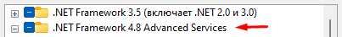

3. Package Microsoft Edge WebView2 (download the installer WebView2 Runtime)

Note: the application archive in the Redist folder contains package installers Microsoft .NET Framework 4.8 и Microsoft Edge WebView2

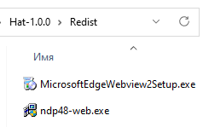

Created with the Personal Edition of HelpNDoc: Free iPhone documentation generator

Installation and launch
Installing and launching the browser Hat

1. Download the browser from the official GitHub page: https://github.com/SomovStudio/Hat/

Check the archive with an antivirus program and if everything is in order, open the archive properties and turn on the "Unlock" flag so that the system does not ask you for permission every time you start the browser.

2. The application is completely portable and the downloaded archive can be unzipped to any location on the hard disk.
Tip: it is better not to install in the Program Files folder, otherwise you will have to give the application administrator rights, unzip it to the root of the disk.

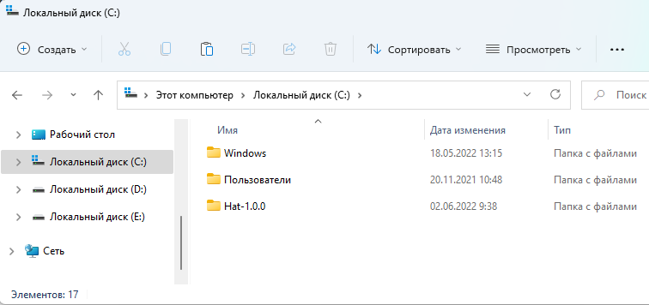

go to the folder Hat-1.0.0
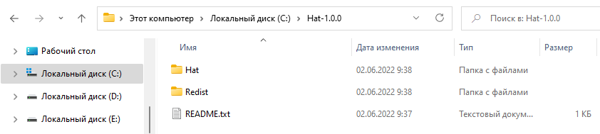

3. The Redist folder contains the package installers Microsoft .NET Framework 4.8 и Microsoft Edge WebView2

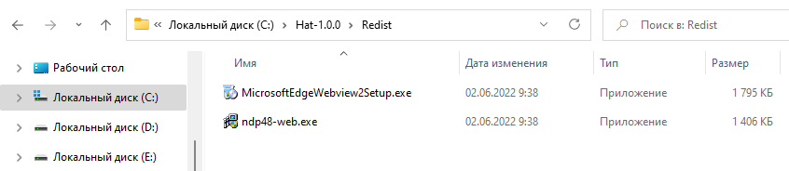

4. The application itself is located in the Hat folder.

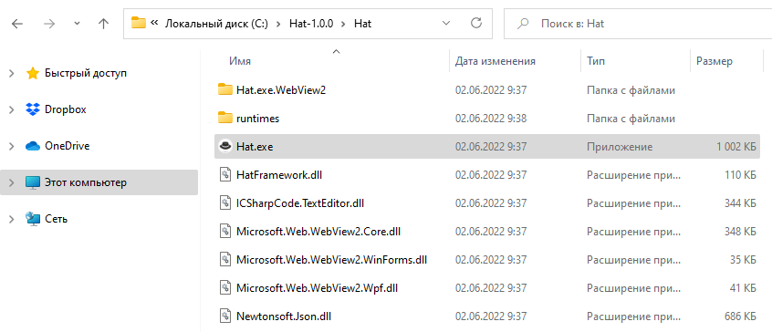

The browser is launched by a file Hat.exe

Created with the Personal Edition of HelpNDoc: Full-featured Help generator

Creating a simple project
Creating a project and launching an autotest

1. In the Project window, on the Explorer tab or in the main Create Project menu, click the Create Simple Project button

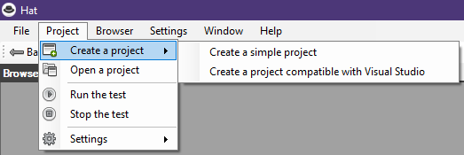

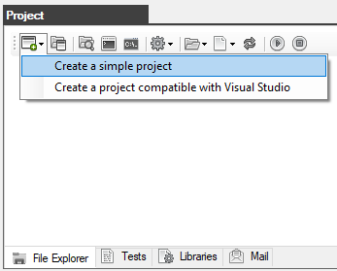

2. Create a folder that will contain the project with any name and anywhere on the disk.
In this case, the Project folder has been created at C:\Hat-1.0.0\
Select the project folder and click OK

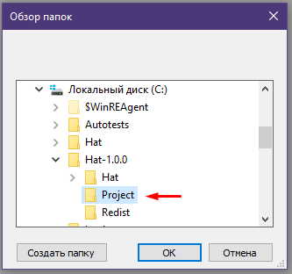

3. In the Project window, the contents of the project will be displayed on the Explorer tab.
As you can see, the project is not empty, it contains several demo autotests.

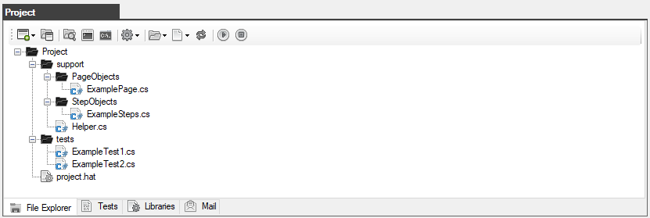

4. Double-click on the ExampleTest1.cs file to open it in the code editor.
In line 60, a line is commented out with a call to the BrowserCloseAsync() method that closes the browser.
This is necessary so that the browser does not automatically close after the completion of the autotest.

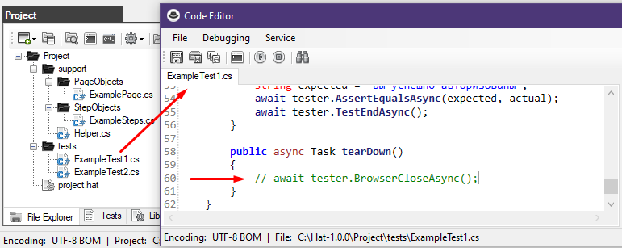

The project has been successfully created.
Created with the Personal Edition of HelpNDoc: Benefits of a Help Authoring Tool

Creating a project compatible with Visual Studio
Creating a project compatible with Visual Studio

1. In the Project window, on the Explorer tab or in the main Create Project menu, click the "Creating a project compatible with Visual Studio" button



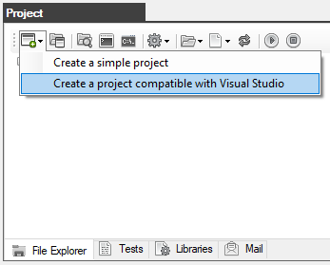

2. A window opens for entering the project name.
Prerequisite the project name must be in Latin letters and without spaces.

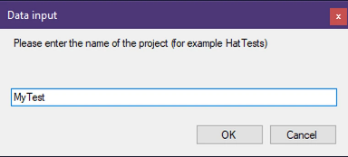

3. Create a folder that will contain the project with any name and anywhere on the disk.
In this case, the Project folder has been created at C:\Hat-1.0.0\
Select the project folder and click OK



4. In the Project window, the contents of the project will be displayed on the Explorer tab.
As you can see, the project is not empty, it contains several demo autotests.



5. This project supports work in Visual Studio (it is assumed that you already have Visual Studio installed)
To open a project in Visual Studio, click on the Explorer button in the Project window

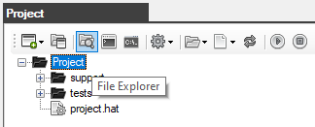

Then double-click on the file with the *.sln extension (in this case, MyTests.sln)

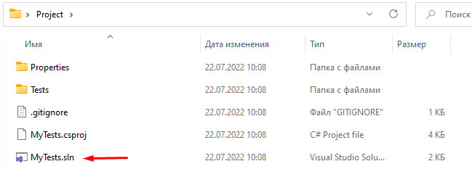

When Visual Studio is loaded, our project will immediately be opened and available for work in the Solution Explorer window

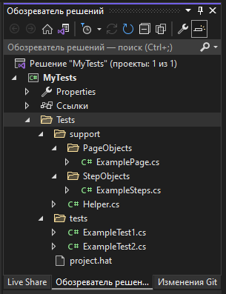

Double-click on the ExampleTest1.cs file to open it in the code editor.
In line 59, a line is commented out with a call to the BrowserCloseAsync() method that closes the browser.
This is necessary so that the browser does not automatically close after the completion of the autotest.

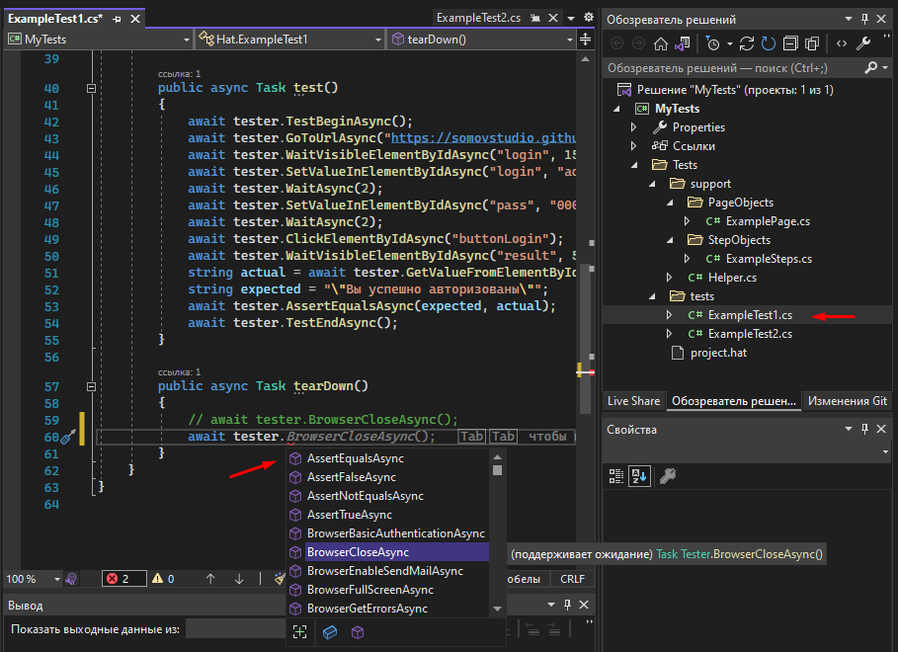

It is very convenient to use Visual Studio because the editor, when entering, shows a drop-down list with all available methods, as well as shows the syntax of the selected method and the variables required by it.

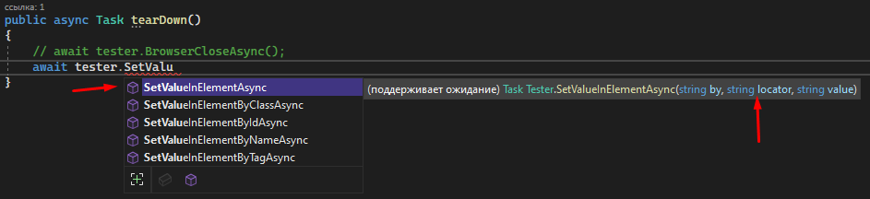

The project has been successfully created.

Created with the Personal Edition of HelpNDoc: Free Web Help generator

Launching the autotest and result
Launching the autotest

To run the autotest, select it in the tests folder and click on the "Run test" button
In our case, the ExampleTest1.cs file is launched

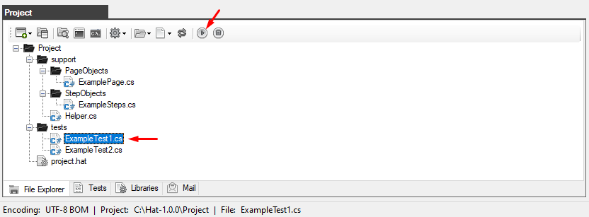

The verification process is displayed on the "Test" tab

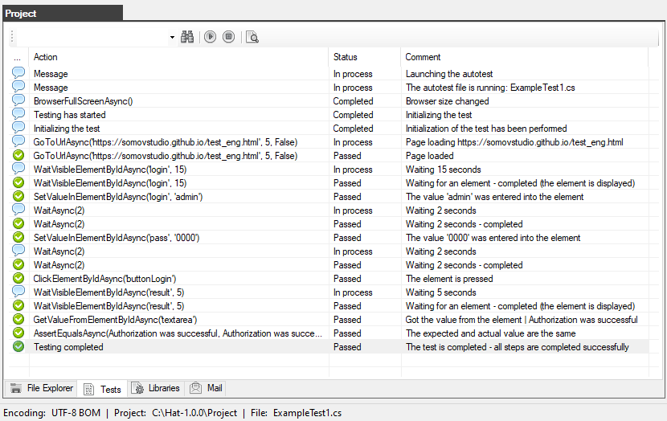

Upon completion of the autotest, a folder "report" will be created in the root of the project, which contains all reports and screenshots with the results of the performed check.

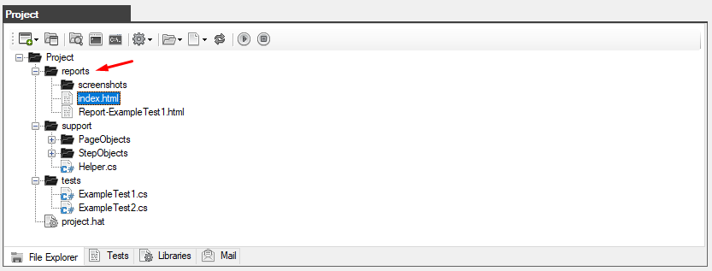

Double-clicking on the report file (for example: index.html or Report-ExampleTest1.html) you will receive a report with a full description of the progress of the autotest.
For more information about reports and sending reports by mail, see the relevant sections.

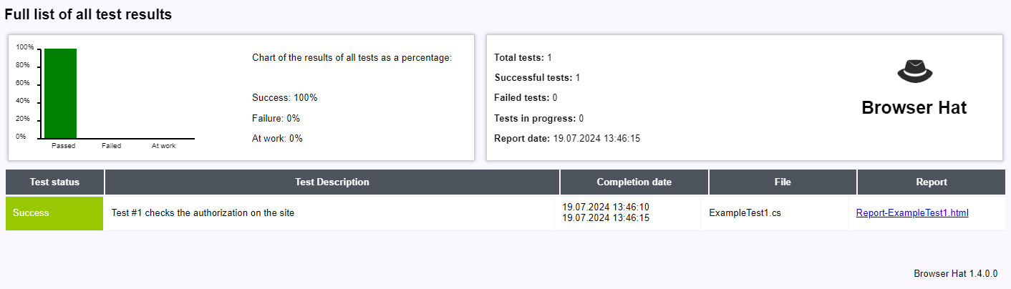

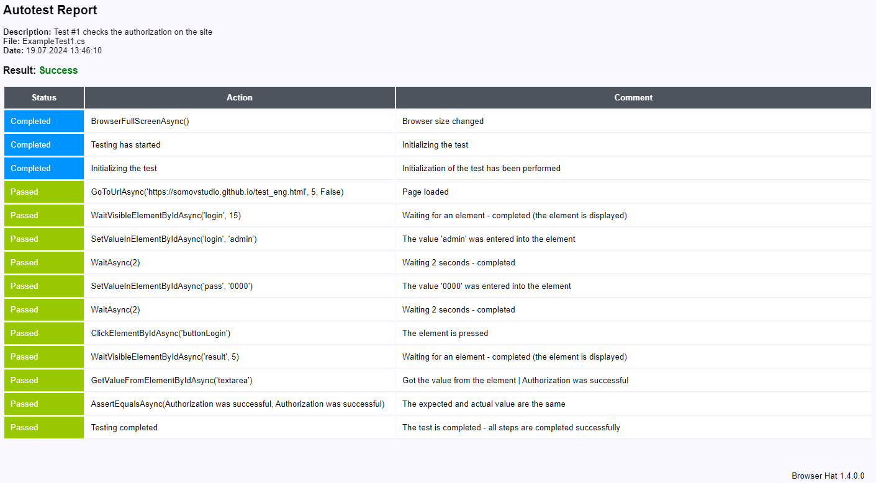

As a result, the project was created, the autotest was launched and a report was received.

Created with the Personal Edition of HelpNDoc: Easy EPub and documentation editor

Browser Cache

Created with the Personal Edition of HelpNDoc: Create cross-platform Qt Help files

Clearing
Кэш браузера - очистка

The browser automatically cleans the cache before each launch and reports this to the console

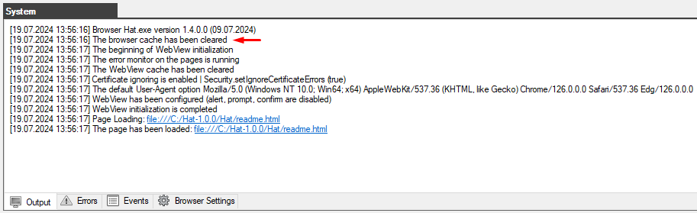

You can also clear the cache manually.
To do this, you need to close the browser and delete the "Hat.exe.WebView2" folder

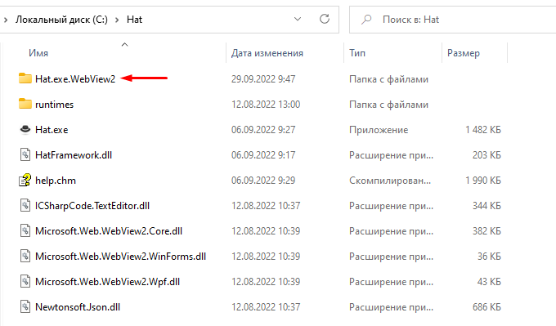

The entire cache is stored in the folder "Hat.exe.WebView 2", after you delete it and launch the browser, this folder will be created again and a new cache of the current session will be stored in it.

Created with the Personal Edition of HelpNDoc: Create help files for the Qt Help Framework

Interface

Created with the Personal Edition of HelpNDoc: Free EPub and documentation generator

The main menu
The main menu

Menu "File" - allows you to save logs to txt files.

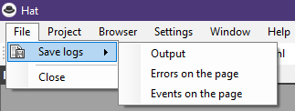

Menu "Project" - creating and opening autotest projects, performing and stopping autotests, as well as settings.

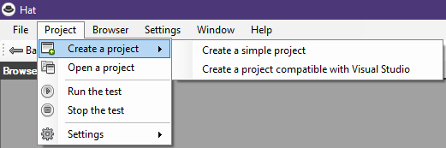

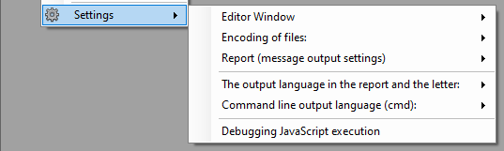

Menu "Browser" - it serves as a browser navigation, as well as allows you to open the developer dashboard "Development Tool" and open the Internet Explorer 11 window

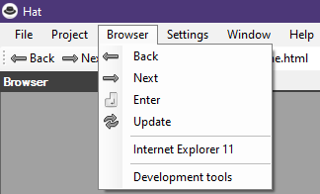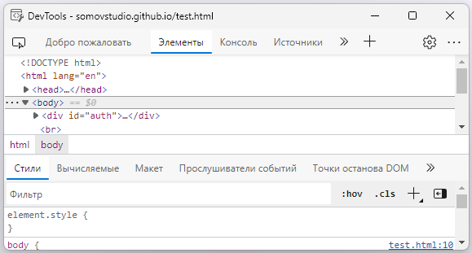

Menu "Settings" - setting the program language

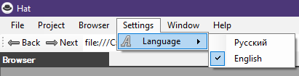

Menu "Window" - allows you to hide or display the system browser windows.

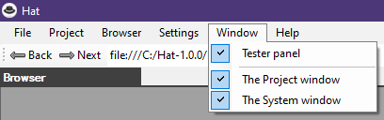

Menu "Help" - contains background information and links to the update and plugin

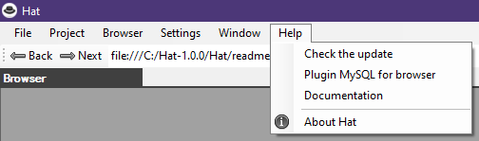

Created with the Personal Edition of HelpNDoc: Easily create iPhone documentation

The Toolbar
The Toolbar

Contains a field for entering the site address and browser navigation buttons.

Created with the Personal Edition of HelpNDoc: Full-featured EBook editor

The Project window - is the Explorer tab
The Project window - is the Explorer tab

The main window for working with the project.

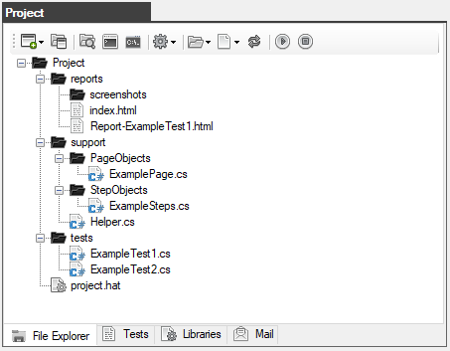

The toolbar contains the following buttons:

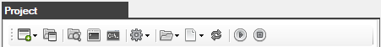

  - Create a project - creates a new autotest project (simple or compatible with Visual Studio)
  - Open a project - opens a previously created autotest project
  - Explorer - opens the project folder in Windows Explorer
  - Form a startup command - opens a window with an already formed autotest startup command for the Windows command prompt (cmd)
  - Command Prompt (cmd) - opens the Windows system console
  - Settings - the settings menu for working with the project
  - Folders - menu for working with folders
  - Files - menu for working with files
  - Update - updating information in the folder and file tree
  - Run the test - runs the selected autotest
  - Stop the test - stops the running autotest

Settings Menu

  - Choosing the way to display the editor window

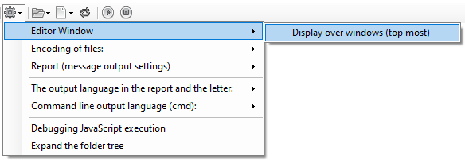

  - Choosing the encoding for the project files

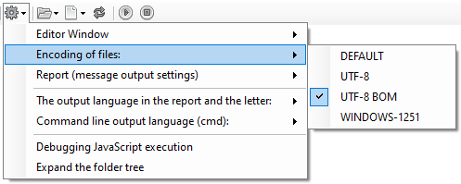

  - Configuring the output of messages in the report, as well as generating a report with all the results of the checks.

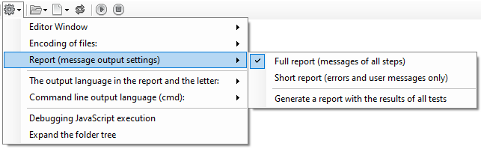

  - Selecting the output language in the report and letter

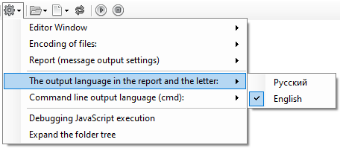

  - Selecting the output language on the command line (cmd)

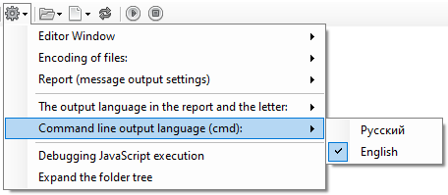

  - Enabling debugging when executing JavaScript code

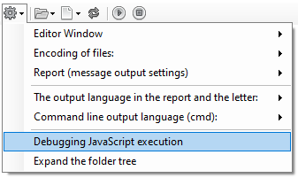

  - Expand the folder and file tree in Explorer

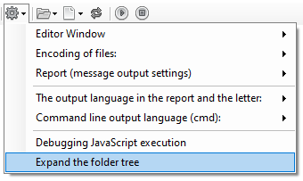

The folder menu allows you to create and delete folders

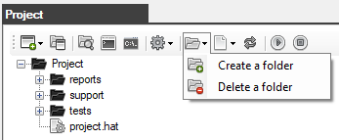

The file menu allows you to create new autotest files, open and delete existing files

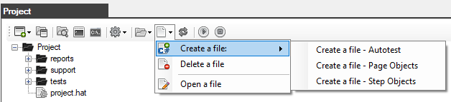

The tree of project folders and files

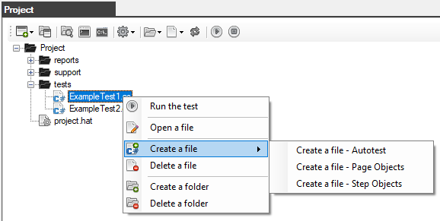

Created with the Personal Edition of HelpNDoc: Create iPhone web-based documentation

The Project window - is the Test tab
The Project window - is the Test tab

Table of autotest steps.

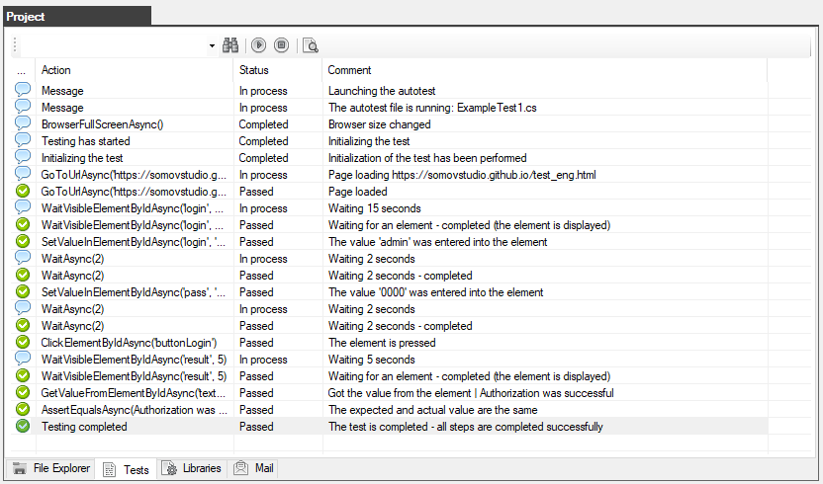

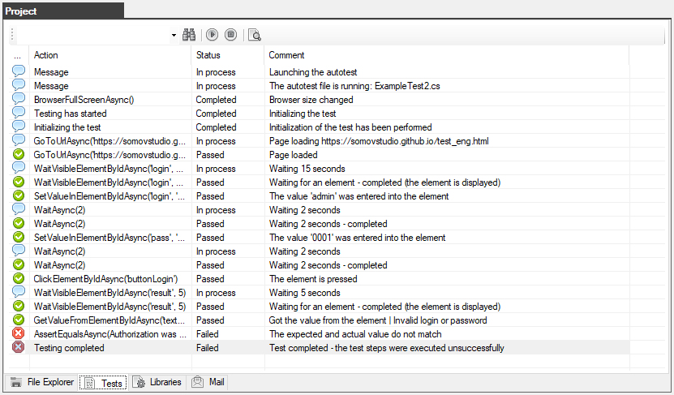

The toolbar contains the following buttons:

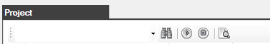

  - Field and Search button - creates a new autotest project
  - Open a project - opens a previously created autotest project
  - Run the test - runs the selected autotest
  - Stop the test - stops the running autotest
  - Detailed information about the step - opens a window with a description of the step

Created with the Personal Edition of HelpNDoc: Easily create iPhone documentation

The Project window - the Library tab
The Project window - the Library tab

List of plug-in libraries required to perform autotests

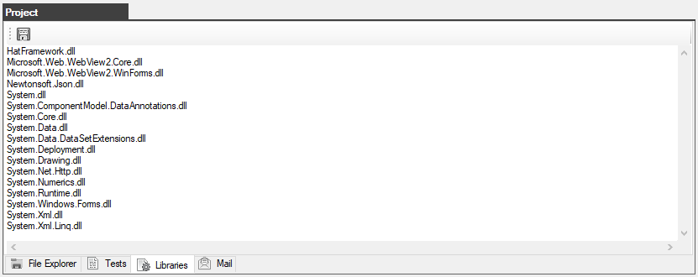

The toolbar contains the following buttons:

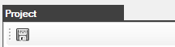

  - Save - saves the list of libraries to the project.hat project file

Created with the Personal Edition of HelpNDoc: Free help authoring environment

The Project window - the Mail tab
The Project window - the Mail tab

Mail server connection settings for sending emails with reports on the results of passing autotests

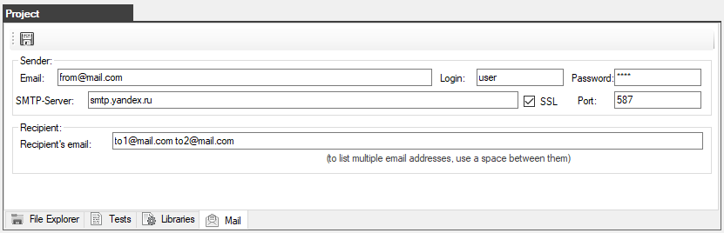

The toolbar contains the following buttons:

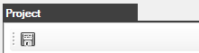

  - Save - saves the settings to the project.hat project file

Created with the Personal Edition of HelpNDoc: What is a Help Authoring tool?

The system window
The system window

The "Output" tab displays all events that occur when the application is running.

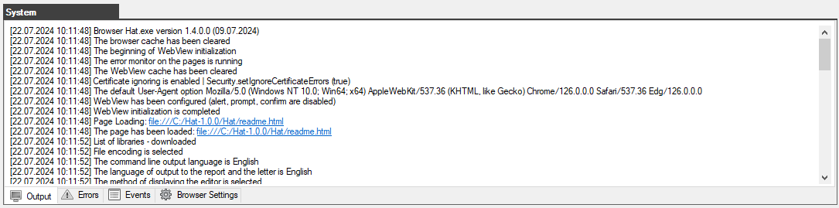

The "Errors" tab displays all errors (console) occurring on loaded pages.

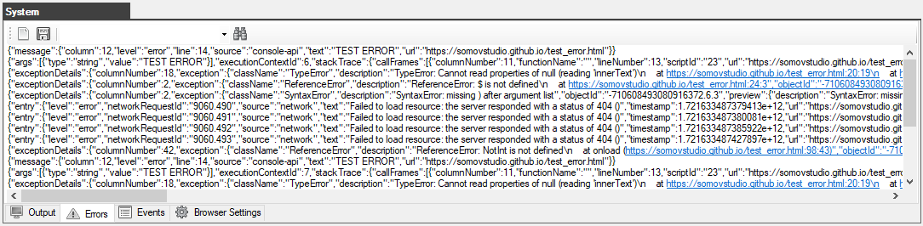

The "Events" tab - displays all events (network) occurring on loaded pages.

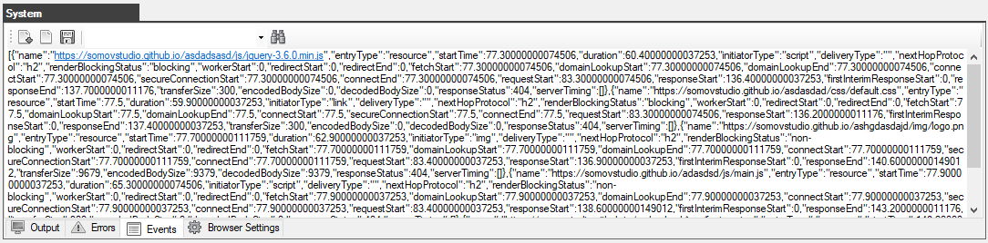

The "Browser Settings" tab is the main browser settings.

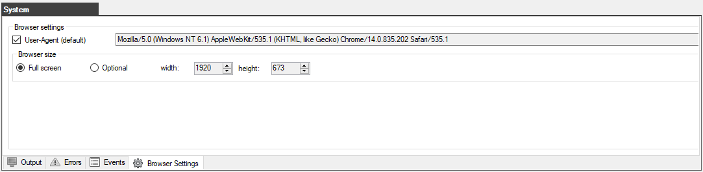

Created with the Personal Edition of HelpNDoc: Free PDF documentation generator

Reports

Created with the Personal Edition of HelpNDoc: Easily create PDF Help documents

Autotest Report
Autotest Report

When you run the autotest, a new reports folder will be created in the project folder if it does not already exist.
After completion of the autotest, a file with a report in html format will be created.
The name of the report file corresponds to the name of the autotest file with the prefix Report
For example, when performing the ExampleTest1.cs autotest, a report will be created with the name Report-ExampleTest1.html
To view the results for all completed autotests, a file is created and updated index.html

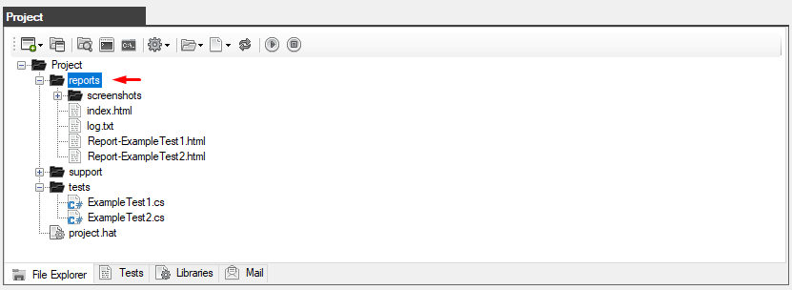

The resulting report opens in any browser

Full report on all completed inspections (index.html ) it looks like this:

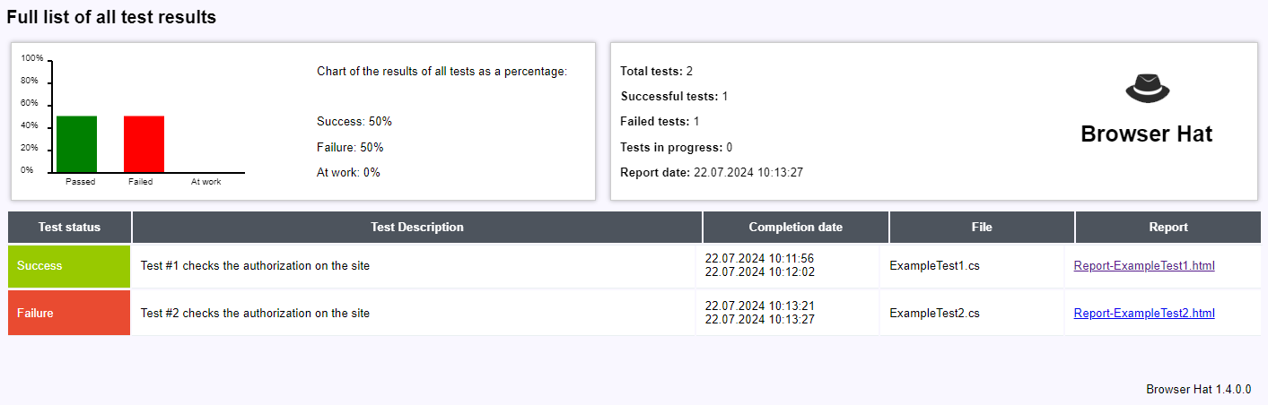

This report (index.html) is created or updated after the completion of any autotest.

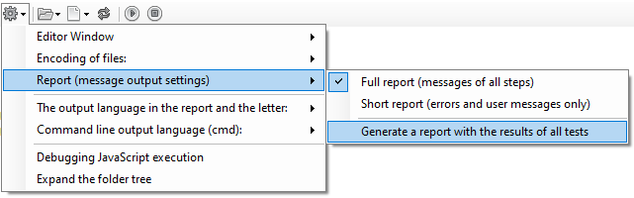

This report can be generated or updated manually via the project settings menu.

The report with the successful completion of all steps and checks looks like this:

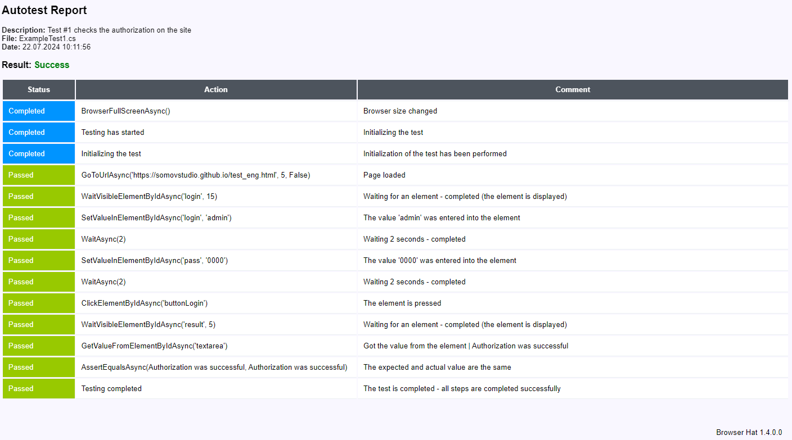

The report on the failed test looks like this:

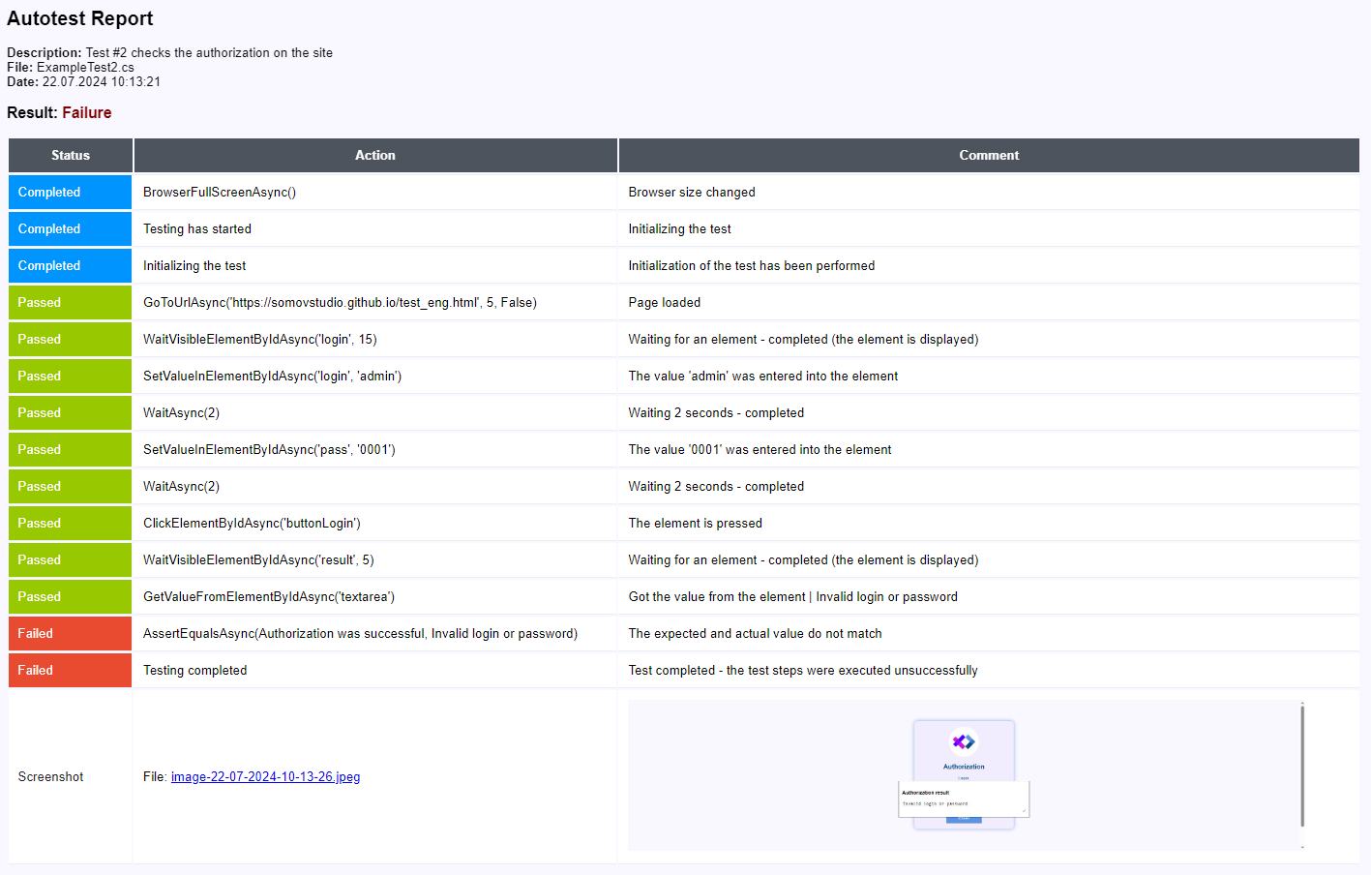

If any critical errors occur during execution, they will be reflected in the report as follows:

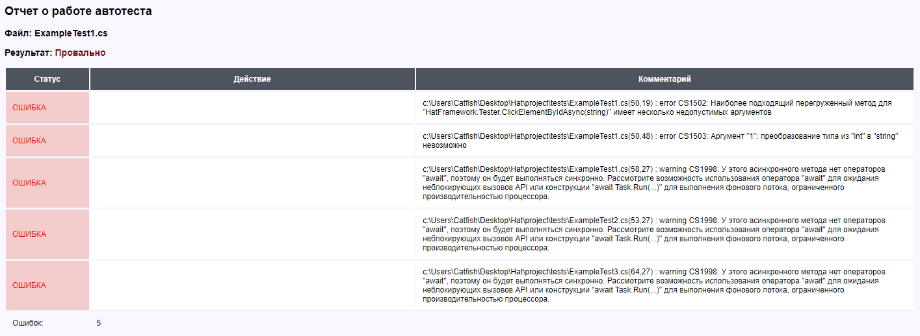

Using the project settings menu, you can switch the report type to "Summary Report", in which case only user messages and error messages will be displayed in the report.

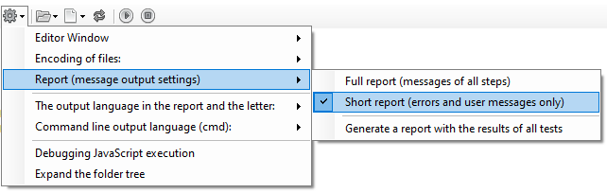

So the reports will look like this:

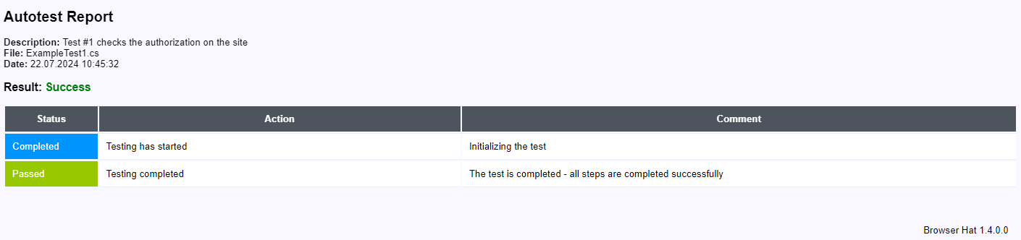

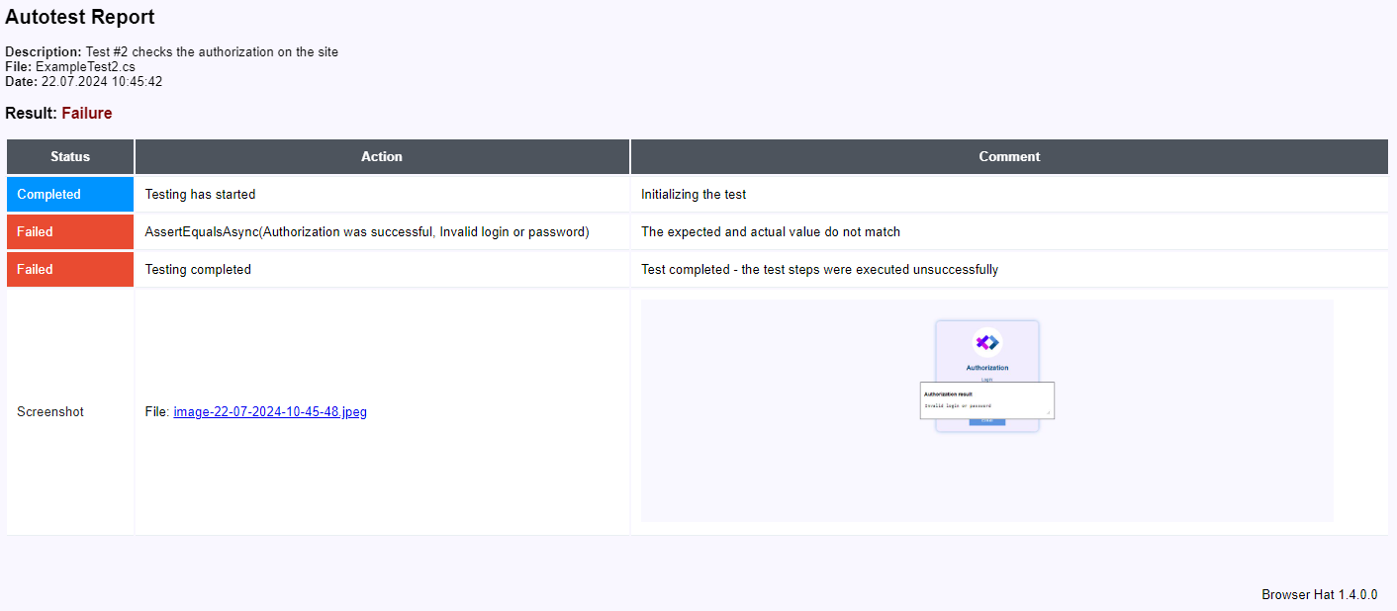

Created with the Personal Edition of HelpNDoc: Create HTML Help, DOC, PDF and print manuals from 1 single source

Log file
Log file (log.txt)

If the autotest fails, not only a report is created, but also an entry is made in the log file log.txt

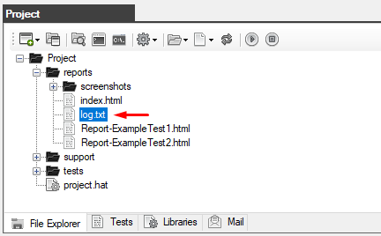

The file records the date and time of the failure, the file name and description of the autotest, as well as the reasons for the failure of the autotest.

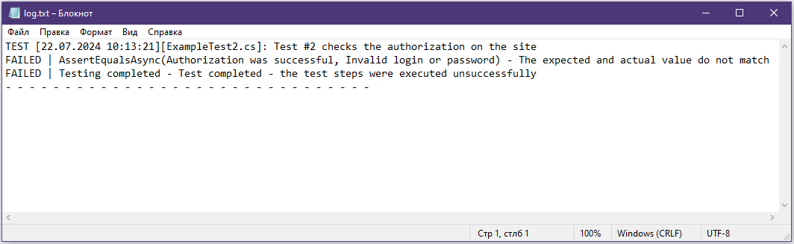

Created with the Personal Edition of HelpNDoc: Easily create CHM Help documents

Mail

Created with the Personal Edition of HelpNDoc: Qt Help documentation made easy

Send a report on the failure of the autotest to the mail
Send a report on the failure of the autotest to the mail

The connection to the mail server is configured in the "Project" window.
This example uses a Yandex mailbox.

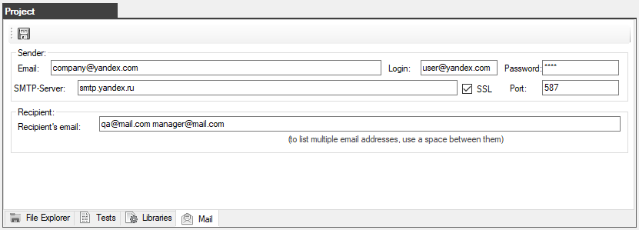

To use the function of sending a report to the mail, you need to enable this option in the autotest using the method BrowserEnableSendMailAsync

public async Task setUp()
{
await tester.BrowserEnableSendMailAsync(true, false); // only in case of failure
await tester.BrowserEnableSendMailAsync(false, true); // only if successful
await tester.BrowserEnableSendMailAsync(); // in both cases
}

In case of failure, a report of the following type will be sent to the listed email addresses

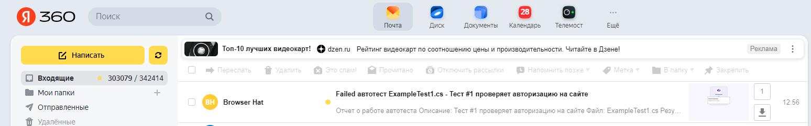

The email will include a screenshot at the time of the error and a report with the steps of execution, as well as user messages.

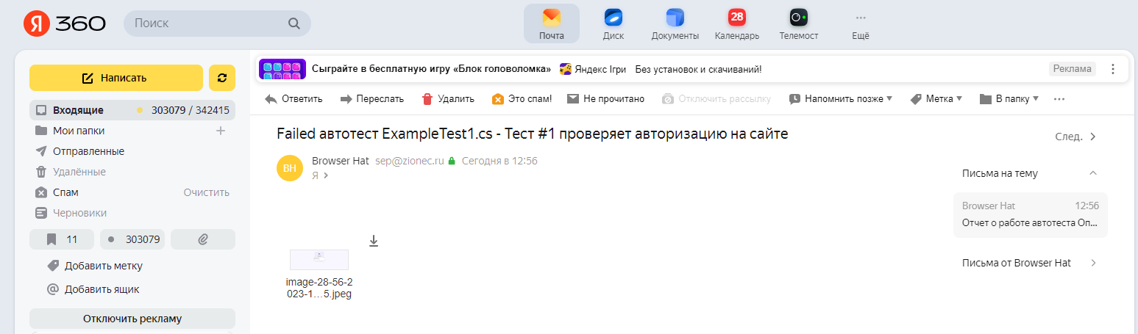
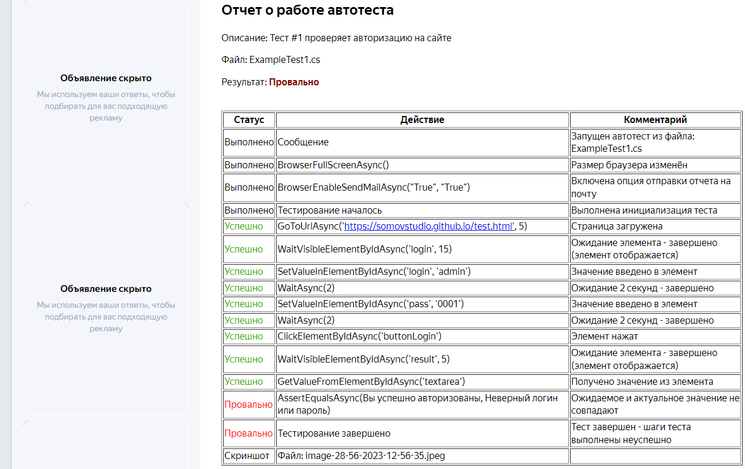

You can send an email at any time, you need to use the function SendMsgToMailAsync

public async Task tearDown()
{
if(tester.GetTestResult() == Tester.PASSED)
{
await tester.SendMsgToMailAsync("Text message", "The test was completed successfully");
}
}

Created with the Personal Edition of HelpNDoc: News and information about help authoring tools and software

Console launch mode (Jenkins)

Created with the Personal Edition of HelpNDoc: Easily create Web Help sites

Running the autotest from the command line
Running the autotest from the command line

To run autotests in popular continuous integration systems, you need to use the Windows command line.



In the "Project" window (on the "Explorer" tab), select the autotest file that you want to run.
Then click on the "Create a launch command" button on the toolbar

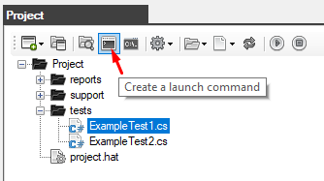

As a result, you will see a window with ready-made commands.

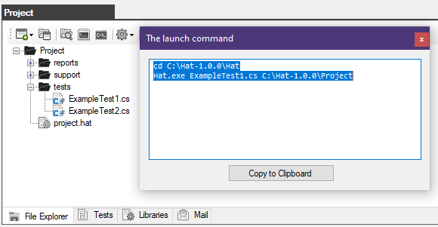

  - the first command: cd C:\Hat-1.0.0\Hat - this is a transition to the folder with the application Hat.exe
  - the second command: Hat.exe ExampleTest1.cs C:\Hat-1.0.0\Project - runs the autotest

The syntax of the startup command:
Hat.exe [Autotest_file_name] [Path_To_The_Project_Folder]

Open the command prompt

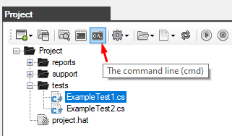

Use the received commands

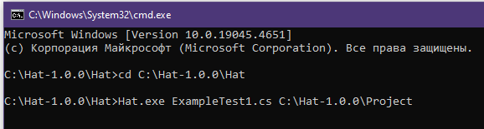

The autotest will be launched, and all the execution steps will be reflected in the console

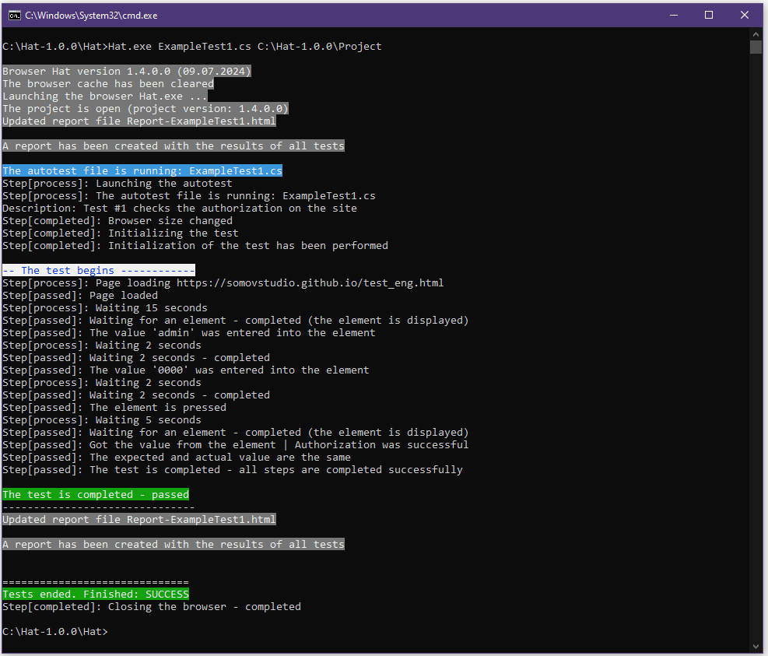

In case of an error, the step will show the method and its properties where the error occurred.

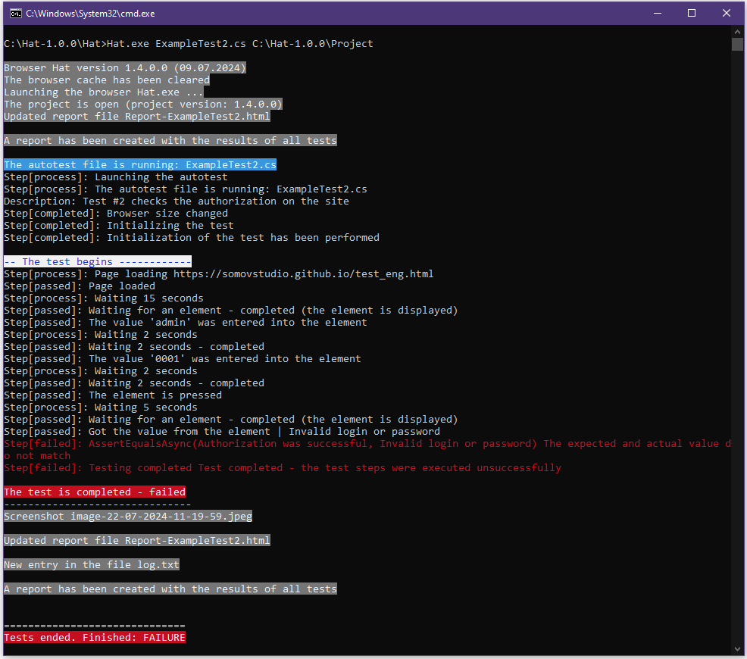

At the end, the result of the entire autotest is shown.

Created with the Personal Edition of HelpNDoc: What is a Help Authoring tool?

A text code editor

Created with the Personal Edition of HelpNDoc: Free EPub and documentation generator

Code Editor (C#)
Code Editor (C#)

Autotests are edited in a special editor.
To open a file with the *.cs extension in the editor, you need to double-click on the desired file in the Project window (on the Explorer tab) or open the context menu and select "Open file".

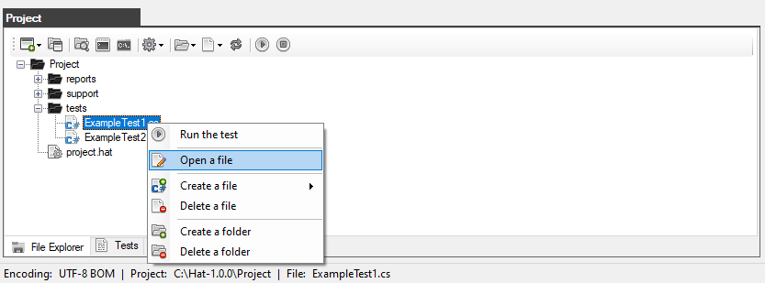

The following editor window will open in front of you.

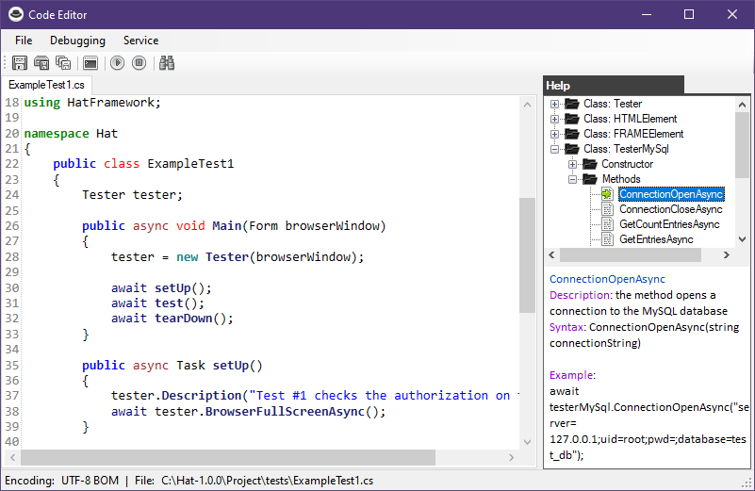

An editor with keyword highlighting, as well as reference information about the built-in methods of the Net Framework framework.
You do not need to manually type the names of the methods, it will be enough to click on it twice (or through the context menu item) so that the method is automatically inserted into the code.

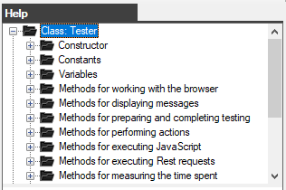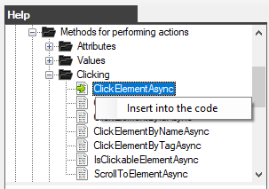

There are buttons on the toolbar:

  - Save File - saves changes to the current file
  - Save file as - allows you to save the script to a new file
  - Save all files - saves changes to all open files
  - Form a startup command - opens a window with an already formed autotest startup command for the Windows command line (cmd)
  - Run the test - runs the selected autotest
  - Stop the test - stops the running autotest
  - Search - executes the search box

The main menu

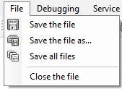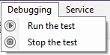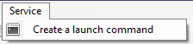
File:
  - Save File - saves changes to the current file
  - Save file as - allows you to save the script to a new file
  - Save all files - saves changes to all open files
  - Close file - closes the file in the current tab

Debugging:
  - Run the test - runs the selected autotest
  - Stop the test - stops the running autotest

Service:
  - Form a startup command - opens a window with an already formed autotest startup command for the Windows command line (cmd)

Performing a search
To open the search window, click on the search buttonor press CTRL+F.

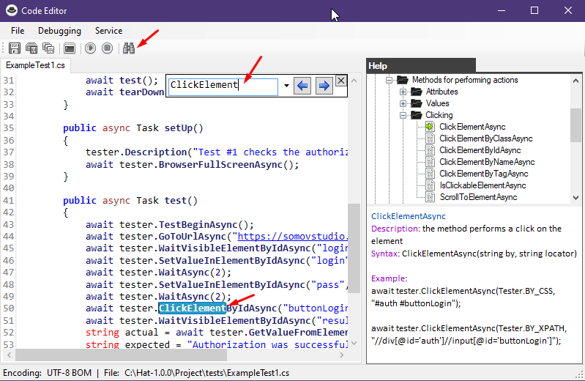

The editor allows you to export a list of built-in methods to simplify writing code.

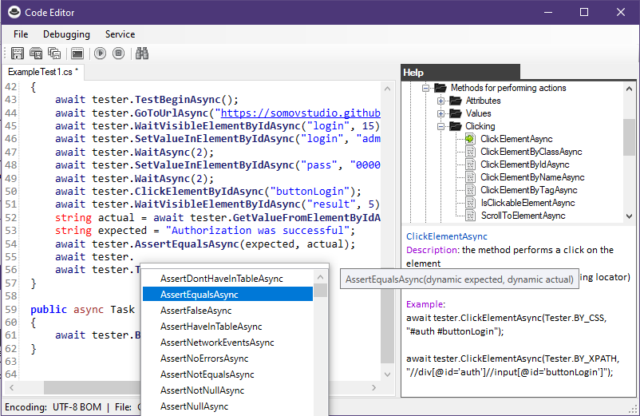

Created with the Personal Edition of HelpNDoc: Qt Help documentation made easy

Using Visual Studio to edit code
Using Visual Studio to edit code

In order to use the autotest project as a Visual Studio editor, it must be created as follows:

1. In the Project window, on the Explorer tab or in the main Create Project menu, click the "Create a project compatible with Visual Studio" button

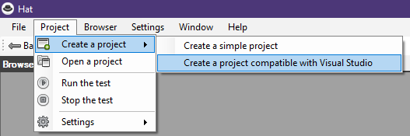

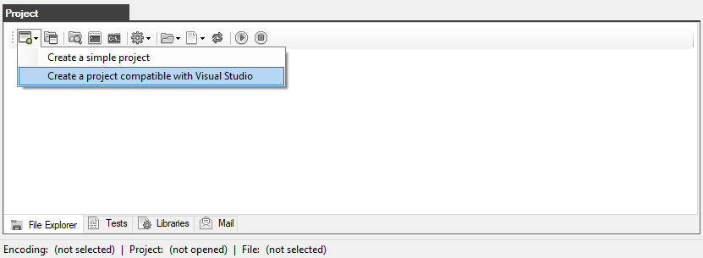

2. A pop-up will open to enter the project name.
Prerequisite the project name must be in Latin letters and without spaces.

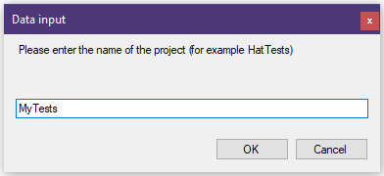

3. Create a folder that will contain the project with any name and anywhere on the disk.
In this case, the Project folder has been created at C:\Hat-1.0.0\
Select the project folder and click OK

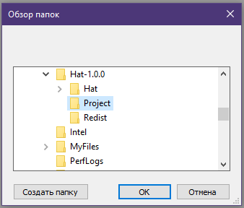

4. In the Project window, the contents of the project will be displayed on the Explorer tab.

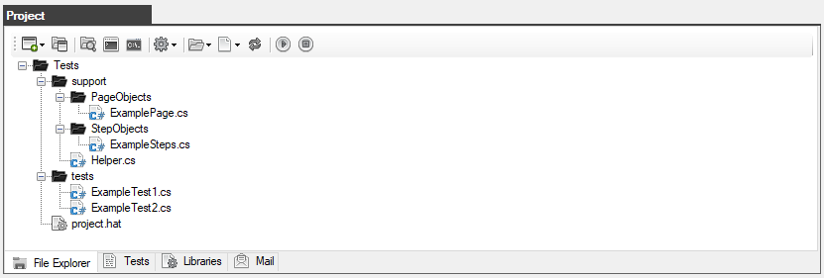

5. This project supports work in Visual Studio (it is assumed that you already have Visual Studio installed)
To open a project in Visual Studio, click on the Explorer button in the Project window

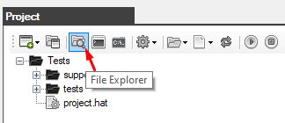

Then double-click on the file with the *.sln extension (in this case, MyTests.sln)



When Visual Studio is loaded, our project will immediately be opened and available for work in the Solution Explorer window



Double-click on the ExampleTest1.cs file to open it in the code editor.
In line 59, a line is commented out with a call to the BrowserCloseAsync() method that closes the browser.
This is necessary so that the browser does not automatically close after the completion of the autotest.



It is very convenient to use Visual Studio because the editor, when entering, shows a drop-down list with all available methods, as well as shows the syntax of the selected method and the variables required by it.



The project has been successfully created and is ready to work with Visual Studio.

Created with the Personal Edition of HelpNDoc: Create cross-platform Qt Help files

The structure of the autotest

Created with the Personal Edition of HelpNDoc: Easily create iPhone documentation

Simple project
Simple project

Autotests are described in a programming language C#.

The structure of the autotest:

using System;  using System.Collections.Generic;  using System.ComponentModel;  using System.Windows.Forms;  using System.Threading;  using System.Threading.Tasks;  using System.IO;  using System.Data;  using System.Drawing;  using System.Linq;  using System.Text;  using System.Text.RegularExpressions;  using System.Net;  using System.Net.Http;  using System.Net.Http.Headers;  using System.Reflection;  using Newtonsoft.Json;  using HatFramework; | At the beginning there is a list of plug-in libraries.  HatFramework - this is an embedded framework in the browser.
namespace Hat  {  public class ExampleTest1  {  }  } | Namespace and class.  The class name must be the same as the file name.
Tester tester;  public async void Main(Form browserWindow)  {  tester = new Tester(browserWindow);  await setUp();  await test();  await tearDown();  } | A global variable is declared whose type is Tester  The main function with which the autotest starts is described.  This function initializes a global variable whose type is Tester.  Next comes the call of asynchronous functions.
public async Task setUp()  {  }  public async Task test()  {  await tester.TestBeginAsync();  await tester.TestEndAsync();  }  public async Task tearDown()  {  } | Asynchronous functions are described that perform:  - setUp - function before the test  - task - test function  - tearDown - function after the test  (the names of the functions can be any, the meaning itself and their sequence are important)  Note: the test should always start with the TestBeginAsync() method and end with the TestEndAsync() method

The demo autotest is complete:

Файл: ExampleTest1.cs
using System;
using System.Collections.Generic;
using System.ComponentModel;
using System.Windows.Forms;
using System.Threading;
using System.Threading.Tasks;
using System.IO;
using System.Data;
using System.Drawing;
using System.Linq;
using System.Text;
using System.Text.RegularExpressions;
using System.Net;
using System.Net.Http;
using System.Net.Http.Headers;
using System.Reflection;
using Newtonsoft.Json;
using HatFramework;

namespace Hat
{
public class ExampleTest1
{
Tester tester;

public async void Main(Form browserWindow)
{
tester = new Tester(browserWindow);

await setUp();
await test();
await tearDown();
}

public async Task setUp()
{
await tester.BrowserFullScreenAsync();
}

public async Task test()
{
await tester.TestBeginAsync();
await tester.GoToUrlAsync("https://somovstudio.github.io/test_eng.html", 5);
await tester.WaitVisibleElementByIdAsync("login", 15);
await tester.SetValueInElementByIdAsync("login", "admin");
await tester.WaitAsync(2);
await tester.SetValueInElementByIdAsync("pass", "0000");
await tester.WaitAsync(2);
await tester.ClickElementByIdAsync("buttonLogin");
await tester.WaitVisibleElementByIdAsync("result", 5);
string actual = await tester.GetValueFromElementByIdAsync("textarea");
string expected = "Authorization was successful";
await tester.AssertEqualsAsync(expected, actual);
await tester.TestEndAsync();
}

public async Task tearDown()
{
await tester.BrowserCloseAsync();
}
}
}

Created with the Personal Edition of HelpNDoc: Free Kindle producer

The PageObjects and StepObjects pattern
The PageObjects and StepObjects pattern

Based on the principles of object-oriented programming, you can easily organize the autotest structure using the PageObjects and StepObjects patterns.

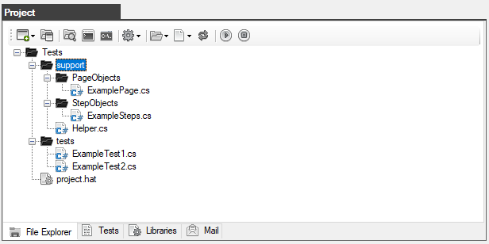

The principle of class interaction:

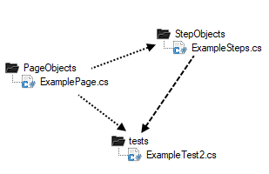

- PageObjects (file ExamplePage.cs) - this is a static class that describes locators and methods that return entire objects to the page.
- StepObjects (file ExampleSteps.cs) - this is a class that inherits all the basic methods from the Tester base class (HatFramework library) and contains its own methods that perform actions with web elements.
- Autotest (file ExampleTest2.cs) - this is a class that directly performs testing using the PageObjects and StepObjects patterns.
- (in this case, the global variable tester has the type ExampleSteps, which inherits the base type Tester)

Demo autotest:

file ExamplePage.cs
using System;
using HatFramework;

namespace Hat
{
public static class ExamplePage
{
public static string URL = @"https://somovstudio.github.io/test_eng.html";
public static string InputLogin = "login";
public static string InputPass = "pass";
public static string ButtonLogin = "buttonLogin";
public static string Result = "result";
public static string Textarea = "textarea";
}
}
file ExampleSteps.cs
using System;
using System.Collections.Generic;
using System.ComponentModel;
using System.Windows.Forms;
using System.Threading;
using System.Threading.Tasks;
using System.IO;
using System.Data;
using System.Drawing;
using System.Linq;
using System.Text;
using System.Text.RegularExpressions;
using System.Net;
using System.Net.Http;
using System.Net.Http.Headers;
using System.Reflection;
using Newtonsoft.Json;
using HatFramework;

namespace Hat
{
public class ExampleSteps : Tester
{
public ExampleSteps(Form browserWindow): base(browserWindow) {}

public async Task FillForm()
{
await this.WaitVisibleElementByIdAsync(ExamplePage.InputLogin, 15);
await this.SetValueInElementByIdAsync(ExamplePage.InputLogin, "admin");
await this.WaitAsync(2);
await this.SetValueInElementByIdAsync(ExamplePage.InputPass, "0000");
await this.WaitAsync(2);
}
}
}

file ExampleTest2.cs
using System;
using System.IO;
using System.Collections.Generic;
using System.ComponentModel;
using System.Data;
using System.Drawing;
using System.Text;
using System.Text.RegularExpressions;
using System.Threading;
using System.Threading.Tasks;
using System.Windows.Forms;
using HatFramework;

namespace Hat
{
public class ExampleTest2
{
ExampleSteps tester;

public async void Main(Form browserWindow)
{
tester = new ExampleSteps(browserWindow);

await setUp();
await test();
await tearDown();
}

public async Task setUp()
{
await tester.BrowserFullScreenAsync();
}

public async Task test()
{
await tester.TestBeginAsync();
await tester.GoToUrlAsync(ExamplePage.URL, 5);
await tester.FillForm();
await tester.ClickElementByIdAsync(ExamplePage.ButtonLogin);
await tester.WaitVisibleElementByIdAsync(ExamplePage.Result, 5);
string actual = await tester.GetValueFromElementByIdAsync(ExamplePage.Textarea);
string expected = "Authorization was successful";
await tester.AssertEqualsAsync(expected, actual);
await tester.TestEndAsync();
}

public async Task tearDown()
{
await tester.BrowserCloseAsync();
}
}
}

Created with the Personal Edition of HelpNDoc: Generate EPub eBooks with ease

Creating a new autotest and patterns
Creating a new autotest

To create a new autotest, you need to select the folder in which you want to create the file in the "Project" window (on the "Explorer" tab), then click on the "Files" button to open the menu and select "Create Autotest file"

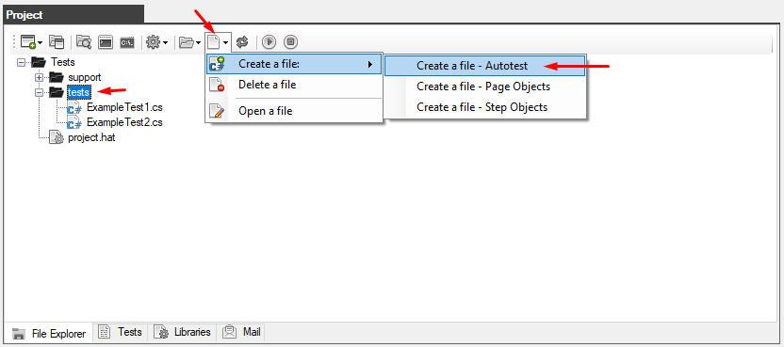
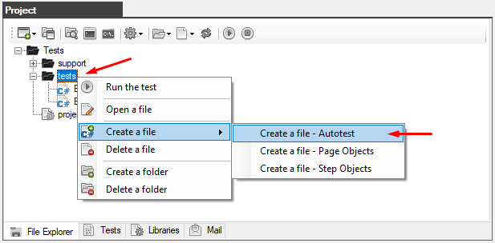

You will be prompted to enter a name for the new file (you do not need to specify the extension)

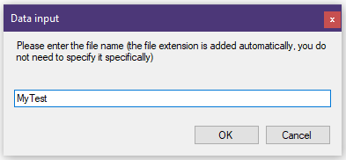

Click OK and a new autotest file will be created. It will immediately appear in the Project window (on the Explorer tab).

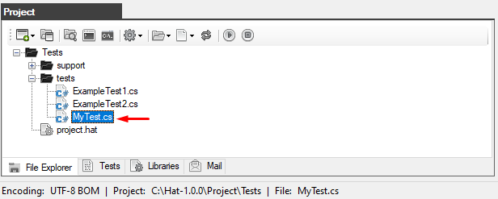

The file is not empty, it will immediately describe all the necessary structure.

using System;
using System.Collections.Generic;
using System.ComponentModel;
using System.Windows.Forms;
using System.Threading;
using System.Threading.Tasks;
using System.IO
using System.Data;
using System.Drawing;
using System.Linq;
using System.Text;
using System.Text.RegularExpressions;
using System.Net;
using System.Net.Http;
using System.Net.Http.Headers;
using System.Reflection;
using Newtonsoft.Json;
using HatFramework;

namespace Hat
{
public class MyTest
{
Tester tester;

public async void Main(Form browserWindow)
{
tester = new Tester(browserWindow);
await setUp();
await test();
await tearDown();
}

public async Task setUp()
{

}

public async Task test()
{

}

public async Task tearDown()
{

}
}
}

Creating patterns

Special templates are also provided for creating the PageObjects and StepObjects pattern files.

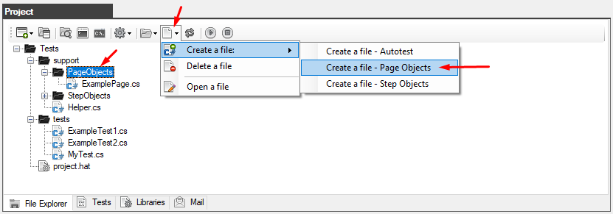

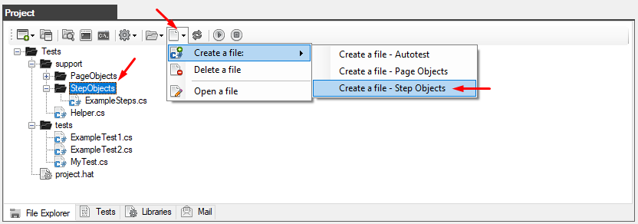

As a result, the following pattern files with a basic description will be created

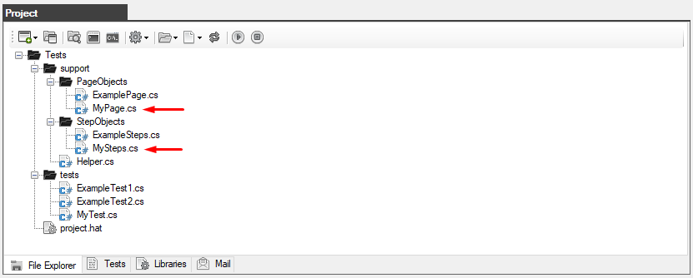

file: MyPage.cs | file: MySteps.cs
using System;  using HatFramework;  namespace Hat  {  public static class MyPage  {  public static string URL = "https://test.com/";  public static string ButtonLogin = "buttonLogin";  }  } | using System;  using System.Collections.Generic;  using System.ComponentModel;  using System.Windows.Forms;  using System.Threading;  using System.Threading.Tasks;  using System.IO;  using System.Data;  using System.Drawing;  using System.Linq;  using System.Text;  using System.Text.RegularExpressions;  using System.Net;  using System.Net.Http;  using System.Net.Http.Headers;  using System.Reflection;  using Newtonsoft.Json;  using HatFramework;  namespace Hat  {  public class MySteps : Tester  {  public MySteps(Form browserWindow): base(browserWindow) {}  public async Task Test()  {  await this.AssertTrueAsync(true);  }  }  }

Created with the Personal Edition of HelpNDoc: Easily create Help documents

HatFramework

Created with the Personal Edition of HelpNDoc: Easily create PDF Help documents

Class: Tester

Created with the Personal Edition of HelpNDoc: Easily create Web Help sites

Constructor

Created with the Personal Edition of HelpNDoc: Write EPub books for the iPad

Tester
Tester
Description: the main class of autotests
Syntax: Tester(Form browserForm)

Example:
Tester tester;
public async void Main(Form browserWindow)
{
tester = new Tester(browserWindow);
}
Created with the Personal Edition of HelpNDoc: Free Kindle producer

Constants

Created with the Personal Edition of HelpNDoc: Free PDF documentation generator

BY_CSS
BY_CSS
Description: the constant indicates the type of locator being entered
Syntax: BY_CSS = "BY_CSS"

Example:
Tester.BY_CSS
Created with the Personal Edition of HelpNDoc: Free iPhone documentation generator

BY_XPATH
BY_XPATH
Description: the constant indicates the type of locator being entered
Syntax: BY_XPATH = "BY_XPATH"

Example:
Tester.BY_XPATH
Created with the Personal Edition of HelpNDoc: Easy to use tool to create HTML Help files and Help web sites

IMAGE_STATUS_PROCESS
IMAGE_STATUS_PROCESS
Description: the index of the image that indicates the status in the process
Syntax: IMAGE_STATUS_PROCESS = 0

Example:
Tester.IMAGE_STATUS_PROCESS
Created with the Personal Edition of HelpNDoc: Create iPhone web-based documentation

IMAGE_STATUS_PASSED
IMAGE_STATUS_PASSED
Description: the index of the image that indicates the status of success
Syntax: IMAGE_STATUS_PASSED = 1

Example:
Tester.IMAGE_STATUS_PASSED
Created with the Personal Edition of HelpNDoc: Easily create Web Help sites

IMAGE_STATUS_FAILED
IMAGE_STATUS_FAILED
Description: the index of the image that indicates the failed status
Syntax: IMAGE_STATUS_FAILED = 2

Example:
Tester.IMAGE_STATUS_FAILED
Created with the Personal Edition of HelpNDoc: Benefits of a Help Authoring Tool

IMAGE_STATUS_MESSAGE
IMAGE_STATUS_MESSAGE
Description: the index of the image that indicates the status of the message
Syntax: IMAGE_STATUS_MESSAGE = 3

Example:
Tester.IMAGE_STATUS_MESSAGE
Created with the Personal Edition of HelpNDoc: Create cross-platform Qt Help files

IMAGE_STATUS_WARNING
IMAGE_STATUS_WARNING
Description: the index of the image that indicates the warning status
Syntax: IMAGE_STATUS_WARNING = 4

Example:
Tester.IMAGE_STATUS_WARNING

Created with the Personal Edition of HelpNDoc: Easily create EPub books

IMAGE_STATUS_DEBUG
IMAGE_STATUS_DEBUG
Description: the index of the image that indicates the debug status
Syntax: IMAGE_STATUS_DEBUG = 5

Example:
Tester.IMAGE_STATUS_DEBUG
Created with the Personal Edition of HelpNDoc: Free HTML Help documentation generator

COMPLETED
COMPLETED
Description: the constant indicates the completed status
Syntax: COMPLETED = "COMPLETED"

Example:
Tester.COMPLETED
Created with the Personal Edition of HelpNDoc: Produce online help for Qt applications

FAILED
FAILED
Description: the constant indicates the failed status
Syntax: FAILED = "FAILED"

Example:
Tester.FAILED
Created with the Personal Edition of HelpNDoc: Easily create EPub books

PASSED
PASSED
Description: the constant indicates the success status
Syntax: PASSED = "PASSED"

Example:
Tester.PASSED

Created with the Personal Edition of HelpNDoc: iPhone web sites made easy

PROCESS
PROCESS
Description: the constant indicates the status in progress
Syntax: PROCESS = "PROCESS"

Example:
Tester.PROCESS
Created with the Personal Edition of HelpNDoc: Easily create iPhone documentation

STOPPED
STOPPED
Description: the constant indicates the stopped status
Syntax: STOPPED = "STOPPED"

Example:
Tester.STOPPED
Created with the Personal Edition of HelpNDoc: Free EPub producer

WARNING
WARNING
Description: the constant indicates the warning status
Syntax: WARNING = "WARNING"

Example:
Tester.WARNING
Created with the Personal Edition of HelpNDoc: What is a Help Authoring tool?

DEBUG
DEBUG
Description: the constant indicates the debug status
Syntax: DEBUG = "DEBUG"

Example:
Tester.DEBUG
Created with the Personal Edition of HelpNDoc: Free Web Help generator

DEFAULT
DEFAULT
Description: the constant indicates the encoding type for the file
Syntax: DEFAULT = "DEFAULT"

Example:
string text = await tester.FileReadAsync(Tester.DEFAULT, "C:\\Hat\\file.txt");
await tester.FileWriteAsync(text, Tester.DEFAULT, "C:\\Hat\\file_copy.txt");

Created with the Personal Edition of HelpNDoc: News and information about help authoring tools and software

UTF8
UTF8
Description: the constant indicates the encoding type for the file
Syntax: UTF8 = "UTF-8"

Example:
string text = await tester.FileReadAsync(Tester.UTF8, "C:\\Hat\\file.txt");
await tester.FileWriteAsync(text, Tester.UTF8, "C:\\Hat\\file_copy.txt");

Created with the Personal Edition of HelpNDoc: Generate EPub eBooks with ease

UTF8BOM
UTF8BOM
Description: the constant indicates the encoding type for the file
Syntax: UTF8BOM = "UTF-8 BOM"

Example:
string text = await tester.FileReadAsync(Tester.UTF8BOM, "C:\\Hat\\file.txt");
await tester.FileWriteAsync(text, Tester.UTF8BOM, "C:\\Hat\\file_copy.txt");

Created with the Personal Edition of HelpNDoc: Write eBooks for the Kindle

WINDOWS1251
WINDOWS1251
Description: the constant indicates the encoding type for the file
Syntax: WINDOWS1251 = "WINDOWS-1251"

Example:
string text = await tester.FileReadAsync(Tester.WINDOWS1251, "C:\\Hat\\file.txt");
await tester.FileWriteAsync(text, Tester.WINDOWS1251, "C:\\Hat\\file_copy.txt");

Created with the Personal Edition of HelpNDoc: Free help authoring environment

Variables

Created with the Personal Edition of HelpNDoc: Easily create iPhone documentation

BrowserView
BrowserView
Description: the variable refers to an object representing the browser area
Syntax: WebView2 BrowserView

Example:
tester.BrowserView.Refresh();
tester.BrowserView.Reload();
tester.BrowserView.Source = new Uri(url);
tester.BrowserView.Update();
Created with the Personal Edition of HelpNDoc: Write eBooks for the Kindle

BrowserWindow
BrowserWindow
Description: the variable refers to the application window
Syntax: Form BrowserWindow

Example:
Tester tester;
public async void Main(Form browserWindow)
{
tester = new Tester(browserWindow);
tester.BrowserWindow.Text = "Browser Hat";
tester.BrowserWindow.Width = 800;
tester.BrowserWindow.Height = 600;
tester.BrowserWindow.Close();
}
Created with the Personal Edition of HelpNDoc: Create HTML Help, DOC, PDF and print manuals from 1 single source

Locators
Created with the Personal Edition of HelpNDoc: Create HTML Help, DOC, PDF and print manuals from 1 single source

Locator
Locator
Description: an additional class for creating locators
Syntax:
public class Locator
{
public string name { get; set; }
public string description { get; set; }
public string type { get; set; }
public string value { get; set; }
}

Example:
Locator locator = new Locator();
locator.name = "inputLogin";
locator.description = "This is the login field";
locator.type = Tester.BY_XPATH;
locator.value = "//input[@id='login']";
Created with the Personal Edition of HelpNDoc: Full-featured Documentation generator

AddLocator
AddLocator
Description: the method creates a locator and adds it to the shared locator storage.
Syntax: AddLocator(string name, string type, string value, string description)
Return value: no return value

Example:
tester.AddLocator("inputLogin", Tester.BY_XPATH, "//input[@id='login']", "This is the login field");
Created with the Personal Edition of HelpNDoc: Benefits of a Help Authoring Tool

GetLocator
GetLocator
Description: the method returns the locator from the locator storage as an object whose class is Locator
Syntax: GetLocator(string name)
Return value: object (Locator)

Example:
await tester.WaitVisibleElementAsync(tester.GetLocator("inputLogin"), 25);
Created with the Personal Edition of HelpNDoc: Easily create EBooks

GetLocatorValue
GetLocatorValue
Description: the method returns the locator value from the locator storage
Syntax: GetLocatorValue(string name)
Return value: string

Example:
string value = tester.GetLocatorValue("inputLogin");

Created with the Personal Edition of HelpNDoc: Single source CHM, PDF, DOC and HTML Help creation

GetCountLocators
GetCountLocators
Description: the method returns the number of locators in the locator storage
Syntax: GetCountLocators()
Return value: int

Example:
int count = tester.GetCountLocators();
Created with the Personal Edition of HelpNDoc: Easy to use tool to create HTML Help files and Help web sites

ClearLocators
ClearLocators
Description: the method clears the locator storage
Syntax: ClearLocators()
Return value: no return value

Example:
tester.ClearLocators();
Created with the Personal Edition of HelpNDoc: Produce Kindle eBooks easily

RemoveLocator
RemoveLocator
Description: the method removes the locator from the locator storage and returns a logical result true or false.
Syntax: RemoveLocator(string name)
Return value: bool (true or false)

Example:
bool result = tester.RemoveLocator("inputLogin");
Created with the Personal Edition of HelpNDoc: News and information about help authoring tools and software

Methods for working with the browser

Created with the Personal Edition of HelpNDoc: Free CHM Help documentation generator

BrowserBasicAuthenticationAsync
BrowserBasicAuthenticationAsync
Description: the browser's navigation method performs the forward action with the specified wait in seconds
Syntax: BrowserBasicAuthenticationAsync(string user, string pass)
Return value: no return value

Example:
Tester tester = new Tester(browserForm);
await tester.BrowserBasicAuthenticationAsync("user", "pass");
await tester.TestBeginAsync();
await tester.GoToUrlAsync("http://test.ru/basic_auth.html", 5);
await tester.TestEndAsync();
Created with the Personal Edition of HelpNDoc: Easily create EBooks

BrowserClearNetworkAsync
BrowserClearNetworkAsync
Description: the method cleans network events in the browser
Syntax: BrowserClearNetworkAsync()
Return value: no return value

Example:
string events = await tester.BrowserClearNetworkAsync();
tester.ConsoleMsg(events);

Created with the Personal Edition of HelpNDoc: Easily create iPhone documentation

BrowserCloseAsync
BrowserCloseAsync
Description: the method closes the browser window
Syntax: BrowserCloseAsync()
Return value: no return value

Example:
await tester.BrowserCloseAsync();
Created with the Personal Edition of HelpNDoc: Free PDF documentation generator

BrowserEnableSendMailAsync
BrowserEnableSendMailAsync
Description: the method includes the option to send a report to the mail in case of failure of the autotest
Syntax: BrowserEnableSendMailAsync(bool byFailure = true, bool bySuccess = true)
Return value: no return value

Example:
Tester tester = new Tester(browserForm);
await tester.BrowserEnableSendMailAsync(true, false); // only in case of failure
await tester.BrowserEnableSendMailAsync(false, true); // only if successful
await tester.BrowserEnableSendMailAsync(); // in both cases
await tester.TestBeginAsync();
...
await tester.TestEndAsync();
Created with the Personal Edition of HelpNDoc: Produce online help for Qt applications

BrowserFullScreenAsync
BrowserFullScreenAsync
Description: the method sets the full-screen size of the browser
Syntax: BrowserFullScreenAsync()
Return value: no return value

Example:
await tester.BrowserFullScreenAsync();
Created with the Personal Edition of HelpNDoc: Easily create Qt Help files

BrowserScreenshotAsync
BrowserScreenshotAsync
Description: the method takes a screenshot of the browser screen
Syntax: BrowserScreenshotAsync(string filename)
Return value: string

Example:
string screenshot = await tester.BrowserScreenshotAsync(null);
screenshot = await tester.BrowserScreenshotAsync("");

screenshot = await tester.BrowserScreenshotAsync("screenshot.jpg");
screenshot = await tester.BrowserScreenshotAsync("C:\\Users\\User\\Desktop\\MyTests\\reports\\screenshots\\test_screenshot.jpg");

tester.ConsoleMsg(screenshot);

Created with the Personal Edition of HelpNDoc: Easily create HTML Help documents

BrowserSizeAsync
BrowserSizeAsync
Description: the method sets the browser size
Syntax: BrowserSizeAsync(int width, int height)
Return value: no return value

Example:
await tester.BrowserSizeAsync(800, 600);
Created with the Personal Edition of HelpNDoc: Free HTML Help documentation generator

BrowserGetUserAgentAsync
BrowserGetUserAgentAsync
Description: the method returns the lowercase value of the browser's User-Agent
Syntax: BrowserGetUserAgentAsync()
Return value: string

Example:
string ua = await tester.BrowserGetUserAgentAsync();
Created with the Personal Edition of HelpNDoc: Benefits of a Help Authoring Tool

BrowserSetUserAgentAsync
BrowserSetUserAgentAsync
Description: the method sets the User-Agent value for the browser
Syntax: BrowserSetUserAgent(string value)
Return value: no return value

Example:
await tester.TestBeginAsync();
await tester.BrowserSetUserAgent("my user-agent");
await tester.TestEndAsync();
Created with the Personal Edition of HelpNDoc: Easy EPub and documentation editor

BrowserGetErrorsAsync
BrowserGetErrorsAsync
Description: the method returns a list of browser errors and warnings
Syntax: BrowserGetErrorsAsync()
Return value: List

Example:
List<string> errors = await tester.BrowserGetErrorsAsync();
foreach (string error in errors)
{
tester.ConsoleMsg(error);
}
Created with the Personal Edition of HelpNDoc: Easy CHM and documentation editor

BrowserGetNetworkAsync
BrowserGetNetworkAsync
Description: the method returns all current messages from the network in json format
Syntax: BrowserGetNetworkAsync()
Return value: string

Example:
string events = await tester.BrowserGetNetworkAsync();
tester.ConsoleMsg(events);
Created with the Personal Edition of HelpNDoc: Free Qt Help documentation generator

BrowserGoBackAsync
BrowserGoBackAsync
Description: the browser's navigation method performs the action backwards with the specified wait in seconds
The abortLoadAfterTime flag automatically completes page loading after the timer is completed
Syntax: BrowserGoBackAsync(int sec, bool abortLoadAfterTime = false)
Return value: no return value

Example:
Tester tester = new Tester(browserForm);
await tester.TestBeginAsync();
await tester.GoToUrlAsync("https://www.yahoo.com/", 5);
string currentUrl = await tester.GetUrlAsync();
await tester.AssertEqualsAsync("https://www.yahoo.com/", currentUrl);

await tester.GoToUrlAsync("https://yandex.ru/", 5);
currentUrl = await tester.GetUrlAsync();
await tester.AssertEqualsAsync("https://yandex.ru/", currentUrl);

await tester.BrowserGoBackAsync(10);
currentUrl = await tester.GetUrlAsync();
await tester.AssertEqualsAsync("https://www.yahoo.com/", currentUrl);

await tester.BrowserGoForwardAsync(10);
currentUrl = await tester.GetUrlAsync();
await tester.AssertEqualsAsync("https://yandex.ru/", currentUrl);
await tester.TestEndAsync();
Created with the Personal Edition of HelpNDoc: Full-featured Help generator

BrowserGoForwardAsync
BrowserGoForwardAsync
Description: the browser's navigation method performs the forward action with the specified wait in seconds
The abortLoadAfterTime flag automatically completes page loading after the timer is completed
Syntax: BrowserGoForwardAsync(int sec, bool abortLoadAfterTime = false)
Return value: no return value

Example:
Tester tester = new Tester(browserForm);
await tester.TestBeginAsync();
await tester.GoToUrlAsync("https://www.yahoo.com/", 5);
string currentUrl = await tester.GetUrlAsync();
await tester.AssertEqualsAsync("https://www.yahoo.com/", currentUrl);

await tester.GoToUrlAsync("https://yandex.ru/", 5);
currentUrl = await tester.GetUrlAsync();
await tester.AssertEqualsAsync("https://yandex.ru/", currentUrl);

await tester.BrowserGoBackAsync(10);
currentUrl = await tester.GetUrlAsync();
await tester.AssertEqualsAsync("https://www.yahoo.com/", currentUrl);

await tester.BrowserGoForwardAsync(10);
currentUrl = await tester.GetUrlAsync();
await tester.AssertEqualsAsync("https://yandex.ru/", currentUrl);
await tester.TestEndAsync();
Created with the Personal Edition of HelpNDoc: Produce online help for Qt applications

BrowserPageReloadAsync
BrowserPageReloadAsync
Description: the method reloads the open page in the browser
The abortLoadAfterTime flag automatically completes page loading after the timer is completed
Syntax: BrowserPageReloadAsync(int sec, bool abortLoadAfterTime = false)
Return value: no return value

Example:
await tester.BrowserPageReloadAsync(25);
Created with the Personal Edition of HelpNDoc: Write EPub books for the iPad

Methods for displaying messages

Created with the Personal Edition of HelpNDoc: Free EPub and documentation generator

ConsoleMsg
ConsoleMsg
Description: the method displays a message in the browser console
Syntax:
ConsoleMsg(string message)
ConsoleMsg(string messageRus, string messageEng)
Return value: no return value

Example:
tester.ConsoleMsg("Текст на Русском языке", "The text is in English");
Created with the Personal Edition of HelpNDoc: Free HTML Help documentation generator

ConsoleMsgError
ConsoleMsgError
Description: the method outputs an error message to the system console and the browser console
Syntax: ConsoleMsgError(string message)
Return value: no return value

Example:
try
{

}
catch (Exception ex)
{
tester.ConsoleMsgError(ex.ToString());
}

Created with the Personal Edition of HelpNDoc: Generate Kindle eBooks with ease

ClearMessage
ClearMessage
Description: the method clears the messages in the output table of the test execution process
Syntax: ClearMessage()
Return value: no return value

Example:
tester.ClearMessage();

Created with the Personal Edition of HelpNDoc: Easily create CHM Help documents

Description
Description
Description: the method sets the description of the test, which is then displayed in the report and letter
Syntax: Description(string text)
Return value: no return value

Example:
public async Task setUp()
{
tester.Description("The test checks the authorization on the site");
}

Created with the Personal Edition of HelpNDoc: Write eBooks for the Kindle

DisableDebugInReport
DisableDebugInReport
Description: this method disables the output of SendMessageDebug debug messages to the report
Syntax: DisableDebugInReport()
Return value: no return value

Example:
tester.DisableDebugInReport();

Created with the Personal Edition of HelpNDoc: Generate Kindle eBooks with ease

SendMessage
SendMessage
Description: the method displays messages in the test execution process table
When executed, action is output to the system console if status is FAILED, WARNING, "", null, otherwise only status and comment are output (without action).

Syntax: SendMessage(string action, string status, string comment)

Example:
tester.SendMessage("the text of the actions", Tester.PROCESS, "the text of the comment");

/* Examples of console output */
// action comment
tester.SendMessage("actions", null, "comment");
tester.SendMessage("actions", "", "comment");

// Step[progress]: comment
tester.SendMessage("actions", Tester.PROCESS, "comment");
// Step[passed]: comment
tester.SendMessage("actions", Tester.PASSED, "comment");
// Step[completed]: comment
tester.SendMessage("actions", Tester.COMPLETED, "comment");
// Step[stopped]: comment
tester.SendMessage("actions", Tester.STOPPED, "comment");

// Step[failed]: действие комментарий
tester.SendMessage("actions", Tester.FAILED, "comment");
// Step[warning]: действие комментарий
tester.SendMessage("actions", Tester.WARNING, "comment");

Created with the Personal Edition of HelpNDoc: Full-featured Documentation generator

SendMessageDebug
SendMessageDebug
Description: the method outputs a debugging message that can be disabled for output to a report and an email
When executed, action is output to the system console if status is FAILED, WARNING, "", null,
otherwise only status and comment are output (without action).

Syntax: SendMessageDebug(string actionRus, string actionEng, string status, string commentRus, string commentEng, int image)

Example:
tester.SendMessageDebug("действия", "action", Tester.PROCESS, "комментарий", "comment", Tester.IMAGE_STATUS_PROCESS);

Created with the Personal Edition of HelpNDoc: Free EPub producer

Methods for preparing and completing testing

Created with the Personal Edition of HelpNDoc: News and information about help authoring tools and software

TestBeginAsync
TestBeginAsync
Description: the method of preparing for the test (each test must necessarily begin with this method)
Syntax: TestBeginAsync()
Return value: no return value

Example:
await tester.TestBeginAsync();

Created with the Personal Edition of HelpNDoc: Full-featured Kindle eBooks generator

TestEndAsync
TestEndAsync
Description: the test completion method (each test must necessarily end with this method), it is this method that saves the report and sends it by mail if such an option is configured and enabled.
Syntax: TestEndAsync()
Return value: no return value

Example:
await tester.TestEndAsync();

Created with the Personal Edition of HelpNDoc: Easily create Help documents

TestStopAsync
TestStopAsync
Description: the method forcibly stops the testing process
Syntax: TestStopAsync()
Return value: no return value

Example:
await tester.TestStopAsync();

Created with the Personal Edition of HelpNDoc: Generate Kindle eBooks with ease

GetTestResult
GetTestResult
Description: the method returns the status of the test being performed
Syntax: GetTestResult()
Return value: string (the value of which is checked by constants: Tester.PASSED, Tester.FAILED, Tester.PROCESS)

Example:
Tester tester = new Tester(browserForm);
await tester.TestBeginAsync();
...
if(tester.GetTestResult() == Tester.PROCESS) { }
...
await tester.TestEndAsync();
if(tester.GetTestResult() == Tester.FAILED) { }
if(tester.GetTestResult() == Tester.PASSED) { }
Created with the Personal Edition of HelpNDoc: Produce online help for Qt applications

DefineTestStop
DefineTestStop
Description: the method checks the status of the process (stopped or not)
Syntax: DefineTestStop()
Return value: bool (true or false)

Example:
if (tester.DefineTestStop() == true) return; // so the test is stopped

Created with the Personal Edition of HelpNDoc: Easy to use tool to create HTML Help files and Help web sites

Methods for performing actions

Created with the Personal Edition of HelpNDoc: Free iPhone documentation generator

Attributes

Created with the Personal Edition of HelpNDoc: Easy CHM and documentation editor

GetAttributeFromElementAsync
GetAttributeFromElementAsync
Description: the method returns a lowercase value from the specified attribute in the selected element
Syntax:
GetAttributeFromElementAsync(string by, string locator, string attribute)
GetAttributeFromElementAsync(Locator locator, string attribute)
Return value: string

Example:
string value = await tester.GetAttributeFromElementAsync(Tester.BY_CSS, "input", "name");
string value = await tester.GetAttributeFromElementAsync(Tester.BY_XPATH, "//input", "name");

string value = await tester.GetAttributeFromElementAsync(tester.GetLocator("locatorName"), "name");
Created with the Personal Edition of HelpNDoc: Qt Help documentation made easy

GetAttributeFromElementByClassAsync
GetAttributeFromElementByClassAsync
Description: the method returns a lowercase value from the specified attribute in the selected element
Syntax: GetAttributeFromElementByClassAsync(string _class, int index, string attribute)
Return value: string

Example:
string value = await tester.GetAttributeFromElementByClassAsync("my-element", 0, "href");

Created with the Personal Edition of HelpNDoc: Generate Kindle eBooks with ease

GetAttributeFromElementByIdAsync
GetAttributeFromElementByIdAsync
Description: the method returns a lowercase value from the specified attribute in the selected element
Syntax: GetAttributeFromElementByIdAsync(string id, string attribute)
Return value: string

Example:
string value = await tester.GetAttributeFromElementByIdAsync("MyElement", "href");

Created with the Personal Edition of HelpNDoc: Easily create Qt Help files

GetAttributeFromElementByNameAsync
GetAttributeFromElementByNameAsync
Description: the method returns a lowercase value from the specified attribute in the selected element
Syntax: GetAttributeFromElementByNameAsync(string name, int index, string attribute)
Return value: string

Example:
string value = await tester.GetAttributeFromElementByNameAsync("MyElement", 0, "href");

Created with the Personal Edition of HelpNDoc: Create HTML Help, DOC, PDF and print manuals from 1 single source

GetAttributeFromElementByTagAsync
GetAttributeFromElementByTagAsync
Description: the method returns a lowercase value from the specified attribute in the selected element
Syntax: GetAttributeFromElementByTagAsync(string tag, int index, string attribute)
Return value: string

Example:
string value = await tester.GetAttributeFromElementByTagAsync("a", 0, "href");

Created with the Personal Edition of HelpNDoc: Produce Kindle eBooks easily

GetAttributeFromElementsAsync
GetAttributeFromElementsAsync
Description: the method returns a list of values of the specified attribute from a set of elements
Syntax:
GetAttributeFromElementsAsync(string by, string locator, string attribute)
GetAttributeFromElementsAsync(Locator locator, string attribute)
Return value: List

Example:
List<string> values = await tester.GetAttributeFromElementsAsync(Tester.BY_CSS, "input", "name");
if(values != null)
{
foreach (string attr in values)
tester.ConsoleMsg(attr);
}

List<string> values = await tester.GetAttributeFromElementsAsync(Tester.BY_XPATH, "//input", "name");
if(values != null)
{
foreach (string attr in values)
tester.ConsoleMsg(attr);
}

List<string> values = await tester.GetAttributeFromElementsAsync(tester.GetLocator("locatorName"), "name");
if(values != null)
{
foreach (string attr in values)
tester.ConsoleMsg(attr);
}
Created with the Personal Edition of HelpNDoc: Easily create Web Help sites

GetAttributeFromElementsByClassAsync
GetAttributeFromElementsByClassAsync
Description: the method returns a list of values of the specified attribute from a set of elements
Syntax: GetAttributeFromElementsByClassAsync(string _class, string attribute)
Return value: List

Example:
List<string> values = await tester.GetAttributeFromElementsByClassAsync("text-field", "name");
foreach (string value in values)
{
tester.ConsoleMsg(value);
}
Created with the Personal Edition of HelpNDoc: Write EPub books for the iPad

GetAttributeFromElementsByNameAsync
GetAttributeFromElementsByNameAsync
Description: the method returns a list of values of the specified attribute from a set of elements
Syntax: GetAttributeFromElementsByNameAsync(string name, string attribute)
Return value: List

Example:
List<string> values = await tester.GetAttributeFromElementsByNameAsync("link", "href");
foreach (string value in values)
{
tester.ConsoleMsg(value);
}
Created with the Personal Edition of HelpNDoc: Full-featured EPub generator

GetAttributeFromElementsByTagAsync
GetAttributeFromElementsByTagAsync
Description: the method returns a list of values of the specified attribute from a set of elements
Syntax: GetAttributeFromElementsByTagAsync(string tag, string attribute)
Return value: List

Example:
List<string> values = await tester.GetAttributeFromElementsByTagAsync("a", "href");
foreach (string value in values)
{
tester.ConsoleMsg(value);
}
Created with the Personal Edition of HelpNDoc: Easily create EBooks

SetAttributeInElementAsync
SetAttributeInElementAsync
Description: the method inserts an attribute with a value into the specified element
Syntax:
SetAttributeInElementAsync(string by, string locator, string attribute, string value)
SetAttributeInElementAsync(Locator locator, string attribute, string value)
Return value: no return value

Example:
await tester.SetAttributeInElementAsync(Tester.BY_CSS, "#auth > h2", "name", "test");
await tester.SetAttributeInElementAsync(Tester.BY_XPATH, "//div[@id='auth']//h2", "name", "test");

await tester.SetAttributeInElementAsync(tester.GetLocator("locatorName"), "name", "test");
Created with the Personal Edition of HelpNDoc: Free EPub producer

SetAttributeInElementByClassAsync
SetAttributeInElementByClassAsync
Description: the method inserts an attribute with a value into the specified element
Syntax: SetAttributeInElementByClassAsync(string _class, int index, string attribute, string value)
Return value: no return value

Example:
await tester.SetAttributeInElementByClassAsync("my-element", 0, "value", "значение");

Created with the Personal Edition of HelpNDoc: Full-featured EPub generator

SetAttributeInElementByIdAsync
SetAttributeInElementByIdAsync
Description: the method inserts an attribute with a value into the specified element
Syntax: SetAttributeInElementByIdAsync(string id, string attribute, string value)
Return value: no return value

Example:
await tester.SetAttributeInElementByIdAsync("MyElement", "value", "value");

Created with the Personal Edition of HelpNDoc: Create iPhone web-based documentation

SetAttributeInElementByNameAsync
SetAttributeInElementByNameAsync
Description: the method inserts an attribute with a value into the specified element
Syntax: SetAttributeInElementByNameAsync(string name, int index, string attribute, string value)
Return value: no return value

Example:
await tester.SetAttributeInElementByNameAsync("MyElement", 0, "value", "value");

Created with the Personal Edition of HelpNDoc: Free PDF documentation generator

SetAttributeInElementByTagAsync
SetAttributeInElementByTagAsync
Description: the method inserts an attribute with a value into the specified element
Syntax: SetAttributeInElementByTagAsync(string tag, int index, string attribute, string value)
Return value: no return value

Example:
await tester.SetAttributeInElementByTagAsync("input", 0, "value", "value");

Created with the Personal Edition of HelpNDoc: Write EPub books for the iPad

SetAttributeInElementsAsync
SetAttributeInElementsAsync
Description: the method inserts an attribute with the specified value into a set of elements and returns a list as a result
Syntax:
SetAttributeInElementsAsync(string by, string locator, string attribute, string value)
SetAttributeInElementsAsync(Locator locator, string attribute, string value)
Return value: List

Example:
List<string> values = await tester.SetAttributeInElementsAsync(Tester.BY_CSS, "input", "class", "test-class");
foreach (string value in values)
{
tester.ConsoleMsg(value);
}

List<string> values = await tester.SetAttributeInElementsAsync(Tester.BY_XPATH, "//input", "class", "test-class");
foreach (string value in values)
{
tester.ConsoleMsg(value);
}

List<string> values = await tester.SetAttributeInElementsAsync(tester.GetLocator("locatorName"), "class", "test-class");
foreach (string value in values)
{
tester.ConsoleMsg(value);
}
Created with the Personal Edition of HelpNDoc: Free PDF documentation generator

SetAttributeInElementsByClassAsync
SetAttributeInElementsByClassAsync
Description: the method inserts an attribute with the specified value into a set of elements and returns a list as a result
Syntax: SetAttributeInElementsByClassAsync(string _class, string attribute, string value)
Return value: List

Example:
List<string> values = await tester.SetAttributeInElementsByClassAsync("text-field", "value", "test");
foreach (string value in values)
{
tester.ConsoleMsg(value);
}
Created with the Personal Edition of HelpNDoc: Free PDF documentation generator

SetAttributeInElementsByNameAsync
SetAttributeInElementsByNameAsync
Description: the method inserts an attribute with the specified value into a set of elements and returns a list as a result
Syntax: SetAttributeInElementsByNameAsync(string name, string attribute, string value)
Return value: List

Example:
List<string> values = await tester.SetAttributeInElementsByNameAsync("link", "href", "www.test.ru");
foreach (string value in values)
{
tester.ConsoleMsg(value);
}
Created with the Personal Edition of HelpNDoc: Full-featured Kindle eBooks generator

SetAttributeInElementsByTagAsync
SetAttributeInElementsByTagAsync
Description: the method inserts an attribute with the specified value into a set of elements and returns a list as a result
Syntax: SetAttributeInElementsByTagAsync(string tag, string attribute, string value)
Return value: List

Example:
List<string> values = await tester.SetAttributeInElementsByTagAsync("a", "href", "www.test.ru");
foreach (string value in values)
{
tester.ConsoleMsg(value);
}
Created with the Personal Edition of HelpNDoc: Free EPub and documentation generator

Values

Created with the Personal Edition of HelpNDoc: Benefits of a Help Authoring Tool

GetValueFromElementAsync
GetValueFromElementAsync
Description: the method returns the value from the specified element
Syntax:
GetValueFromElementAsync(string by, string locator)
GetValueFromElementAsync(Locator locator)
Return value: string

Example:
string value = await tester.GetValueFromElementAsync(Tester.BY_CSS, "input[id='login']");
string value = await tester.GetValueFromElementAsync(Tester.BY_XPATH, "//input[@id='login']");

string value = await tester.GetValueFromElementAsync(tester.GetLocator("locatorName");
Created with the Personal Edition of HelpNDoc: Easy EPub and documentation editor

GetValueFromElementByClassAsync
GetValueFromElementByClassAsync
Description: the method returns the value from the specified element
Syntax: GetValueFromElementByClassAsync(string _class, int index)
Return value: string

Example:
string value = await tester.GetValueFromElementByClassAsync("my-element", 0);

Created with the Personal Edition of HelpNDoc: Generate Kindle eBooks with ease

GetValueFromElementByIdAsync
GetValueFromElementByIdAsync
Description: the method returns the value from the specified element
Syntax: GetValueFromElementByIdAsync(string id)
Return value: string

Example:
string value = await tester.GetValueFromElementByIdAsync("MyElement");

Created with the Personal Edition of HelpNDoc: What is a Help Authoring tool?

GetValueFromElementByNameAsync
GetValueFromElementByNameAsync
Description: the method returns the value from the specified element
Syntax: GetValueFromElementByNameAsync(string name, int index)
Return value: строка (string)

Example:
string value = await tester.GetValueFromElementByNameAsync("MyElement", 0);

Created with the Personal Edition of HelpNDoc: Full-featured Help generator

GetValueFromElementByTagAsync
GetValueFromElementByTagAsync
Description: the method returns the value from the specified element
Syntax: GetValueFromElementByTagAsync(string tag, int index)
Return value: string

Example:
string value = await tester.GetValueFromElementByTagAsync("input", 0);

Created with the Personal Edition of HelpNDoc: Easy EPub and documentation editor

SetValueInElementAsync
SetValueInElementAsync
Description: the method inserts value into the specified element
Syntax:
SetValueInElementAsync(string by, string locator, string value)
SetValueInElementAsync(Locator locator, string value)
Return value: no return value

Example:
await tester.SetValueInElementAsync(Tester.BY_CSS, "input[id='login']", "admin");
await tester.SetValueInElementAsync(Tester.BY_CSS, "input[id='pass']", "0000");

await tester.SetValueInElementAsync(Tester.BY_XPATH, "//input[@id='login']", "admin");
await tester.SetValueInElementAsync(Tester.BY_XPATH, "//input[@id='pass']", "0000");

await tester.SetValueInElementAsync(tester.GetLocator("locatorName"), "admin");
await tester.SetValueInElementAsync(tester.GetLocator("locatorName"), "0000");
Created with the Personal Edition of HelpNDoc: iPhone web sites made easy

SetValueInElementByClassAsync
SetValueInElementByClassAsync
Description: the method inserts value into the specified element
Syntax: SetValueInElementByClassAsync(string _class, int index, string value)
Return value: no return value

Example:
await tester.SetValueInElementByClassAsync("my-element", 0, "value");

Created with the Personal Edition of HelpNDoc: Create help files for the Qt Help Framework

SetValueInElementByIdAsync
SetValueInElementByIdAsync
Description: the method inserts value into the specified element
Syntax: SetValueInElementByIdAsync(string id, string value)
Return value: no return value

Example:
await tester.SetValueInElementByIdAsync("MyElement", "value");

Created with the Personal Edition of HelpNDoc: Create cross-platform Qt Help files

SetValueInElementByNameAsync
SetValueInElementByNameAsync
Description: the method inserts value into the specified element
Syntax: SetValueInElementByNameAsync(string name, int index, string value)
Return value: no return value

Example:
await tester.SetValueInElementByNameAsync("MyElement", 0, "value");

Created with the Personal Edition of HelpNDoc: Write EPub books for the iPad

SetValueInElementByTagAsync
SetValueInElementByTagAsync
Description: the method inserts value into the specified element
Syntax: SetValueInElementByTagAsync(string tag, int index, string value)
Return value: no return value

Example:
await tester.SetValueInElementByTagAsync("input", 0, "value");

Created with the Personal Edition of HelpNDoc: Write eBooks for the Kindle

Clicking

Created with the Personal Edition of HelpNDoc: Produce online help for Qt applications

ClickElementAsync
ClickElementAsync
Description: the method performs a click on the element
Syntax:
ClickElementAsync(string by, string locator)
ClickElementAsync(Locator locator)
Return value: no return value

Example:
await tester.ClickElementAsync(Tester.BY_CSS, "#auth #buttonLogin");
await tester.ClickElementAsync(Tester.BY_XPATH, "//div[@id='auth']//input[@id='buttonLogin']");

await tester.ClickElementAsync(tester.GetLocator("locatorName"));
Created with the Personal Edition of HelpNDoc: Full-featured Help generator

ClickElementByClassAsync
ClickElementByClassAsync
Description: the method performs a click on the element
Syntax: ClickElementByClassAsync(string _class, int index);
Return value: no return value

Example:
await tester.ClickElementByClassAsync("my-element", 0)

Created with the Personal Edition of HelpNDoc: Produce electronic books easily

ClickElementByIdAsync
ClickElementByIdAsync
Description: the method performs a click on the element
Syntax: ClickElementByIdAsync(string id)
Return value: no return value

Example:
await tester.ClickElementByIdAsync("MyElement");

Created with the Personal Edition of HelpNDoc: Easily create CHM Help documents

ClickElementByNameAsync
ClickElementByNameAsync
Description: the method performs a click on the element
Syntax: ClickElementByNameAsync(string name, int index)
Return value: no return value

Example:
await tester.ClickElementByNameAsync("MyElement", 0);

Created with the Personal Edition of HelpNDoc: Easily create EBooks

ClickElementByTagAsync
ClickElementByTagAsync
Description: the method performs a click on the element
Syntax: ClickElementByTagAsync(string tag, int index)
Return value: no return value

Example:
await tester.ClickElementByTagAsync("a", 0);

Created with the Personal Edition of HelpNDoc: Easily create EBooks

IsClickableElementAsync
IsClickableElementAsync
Description: the method determines the clickability of the element and returns true or false
Syntax:
IsClickableElementAsync(string by, string locator)
IsClickableElementAsync(Locator locator)
Return value: bool (true or false)

Пример:
Tester tester = new Tester(browserForm);
await tester.TestBeginAsync();
await tester.GoToUrlAsync("https://somovstudio.github.io/test_eng.html", 5);
bool clickable = await tester.IsClickableElementAsync(Tester.BY_XPATH, "//*[@id='buttonLogin']");
await tester.AssertTrueAsync(clickable);
await tester.TestEndAsync();

bool clickable = await tester.IsClickableElementAsync(tester.GetLocator("locatorName"));
await tester.AssertTrueAsync(clickable);
Created with the Personal Edition of HelpNDoc: Free EPub and documentation generator

ScrollToElementAsync
ScrollToElementAsync
Description: the method scrolls to the specified element (the behaviorSmooth parameter determines the smoothness of scrolling)
Syntax:
ScrollToElementAsync(string by, string locator, bool behaviorSmooth = false)
ScrollToElementAsync(Locator locator, bool behaviorSmooth = false)
Return value: no return value

Example:
await tester.ScrollToElementAsync(Tester.BY_CSS, "body > footer", true);
await tester.ScrollToElementAsync(Tester.BY_XPATH, "/html/body/footer", true);

await tester.ScrollToElementAsync(tester.GetLocator("locatorName"), true);
Created with the Personal Edition of HelpNDoc: Create iPhone web-based documentation

Objects

Created with the Personal Edition of HelpNDoc: Produce Kindle eBooks easily

GetElementAsync
GetElementAsync
Description: the method returns an element in the form of an object whose class HTMLElement
Syntax:
GetElementAsync(string by, string locator)
GetElementAsync(Locator locator)
Return value: object HTMLElement

Example:
HTMLElement element = await tester.GetElementAsync(tester.GetLocator("locatorName"));
await element.ClickAsync();

HTMLElement element = await tester.GetElementAsync(Tester.BY_CSS, "#auth #buttonLogin");
await element.ClickAsync();

HTMLElement element = await tester.GetElementAsync(Tester.BY_XPATH, "//div[@id='auth']//input[@id='buttonLogin']");
await element.ClickAsync();

HTMLElement element = await tester.GetElementAsync(Tester.BY_XPATH, "//*[@id='MyFile']");
tester.ConsoleMsg("ID: " + element.Id);

HTMLElement element = await tester.GetElementAsync(Tester.BY_XPATH, "//h1");
string text = await element.GetTextAsync();
tester.ConsoleMsg(text);
await element.SetTextAsync("text");

HTMLElement element = await tester.GetElementAsync(Tester.BY_XPATH, "//*[@id='MyInput']");
await element.SetValueAsync("text");
string value = await element.GetValueAsync();
tester.ConsoleMsg(value);

HTMLElement element = await tester.GetElementAsync(Tester.BY_XPATH, "//h1");
await element.SetAttributeAsync("class", "my-class");
string attrClass = await element.GetAttributeAsync("class");
tester.ConsoleMsg(attrClass);

HTMLElement element = await tester.GetElementAsync(Tester.BY_XPATH, "//h1");
string html = await element.GetHtmlAsync();
tester.ConsoleMsg(html);

HTMLElement element = await tester.GetElementAsync(Tester.BY_XPATH, "//h1");
await element.SetHtmlAsync("<div>text</div>");

HTMLElement element = await tester.GetElementAsync(Tester.BY_XPATH, "/html/body/footer");
await element.ScrollToAsync();

HTMLElement element = await tester.GetElementAsync(Tester.BY_XPATH, "//h1");
await element.WaitVisibleAsync(2);
await element.WaitNotVisibleAsync(2);
Created with the Personal Edition of HelpNDoc: Easily create iPhone documentation

GetFrameAsync
GetFrameAsync
Description: the method returns an element in the form of an object whose class FRAMEElement
Syntax: GetFrameAsync(int index)
Return value: object FRAMEElement

Example:
Tester tester = new Tester(browserForm);
await tester.TestBeginAsync();
await tester.GoToUrlAsync("https://somovstudio.github.io/test2.html", 5);

FRAMEElement frame = await tester.GetFrameAsync(0);
tester.ConsoleMsg("Index: " + frame.Index);
tester.ConsoleMsg("Name: " + frame.Name);

string name = await frame.GetAttributeFromElementAsync(Tester.BY_XPATH, "//input[@id='login']", "name");

List<string> values = await frame.GetAttributeFromElementsAsync(Tester.BY_XPATH, "//input", "name");
if (values != null)
{
foreach (string attr in values)
tester.ConsoleMsg(attr);
}

await frame.SetAttributeInElementAsync(Tester.BY_XPATH, "//input[@id='buttonLogin']", "name", "NameButtonLogin");

await frame.SetAttributeInElementsAsync(Tester.BY_XPATH, "//input", "name", "test");

await frame.SetValueInElementAsync(Tester.BY_XPATH, "//input[@id='login']", "Тестировщик");
string value = await frame.GetValueFromElementAsync(Tester.BY_XPATH, "//input[@id='login']");

await frame.ClickElementAsync(Tester.BY_XPATH, "//*[@id='buttonLogin']");

bool result = await frame.IsClickableElementAsync(Tester.BY_XPATH, "//*[@id='buttonLogin']");

await frame.ScrollToElementAsync(Tester.BY_XPATH, "//*[@id='buttonLogin']", true);

int result = await frame.GetCountElementsAsync(Tester.BY_XPATH, "//input");

string html = await frame.GetHtmlFromElementAsync(Tester.BY_XPATH, "//*[@id='buttonLogin']");

await frame.SetHtmlInElementAsync(Tester.BY_XPATH, "//*[@id='auth']/h2", "<h2>Тестовый заголовок</h2>");

await frame.WaitNotVisibleElementAsync(Tester.BY_XPATH, "//*[@id='result']", 5);
await frame.ClickElementAsync(Tester.BY_XPATH, "//*[@id='buttonLogin']");
await frame.WaitVisibleElementAsync(Tester.BY_XPATH, "//*[@id='result']", 5);

bool result = await frame.FindElementAsync(Tester.BY_XPATH, "//*[@id='result']", 5);

bool result = await frame.FindVisibleElementAsync(Tester.BY_XPATH, "//*[@id='result']", 5);

string title = await frame.GetTitleAsync();

string url = await frame.GetUrlAsync();

await frame.SetTextInElementAsync(Tester.BY_XPATH, "//*[@id='auth']/h2", "Это тест");
string text = await frame.GetTextFromElementAsync(Tester.BY_XPATH, "//*[@id='auth']/h2");

await frame.SelectOptionAsync(Tester.BY_XPATH, "//*[@id='MySelect']", FRAMEElement.BY_INDEX, "2");
await frame.SelectOptionAsync(Tester.BY_XPATH, "//*[@id='MySelect']", FRAMEElement.BY_VALUE, "Mobile");
await frame.SelectOptionAsync(Tester.BY_XPATH, "//*[@id='MySelect']", FRAMEElement.BY_TEXT, "Other");

string index = await frame.GetOptionAsync(Tester.BY_XPATH, "//*[@id='MySelect']", FRAMEElement.BY_INDEX);
string value = await frame.GetOptionAsync(Tester.BY_XPATH, "//*[@id='MySelect']", FRAMEElement.BY_VALUE);
string text = await frame.GetOptionAsync(Tester.BY_XPATH, "//*[@id='MySelect']", FRAMEElement.BY_TEXT);
Created with the Personal Edition of HelpNDoc: Easily create PDF Help documents

GetCountElementsAsync
GetCountElementsAsync
Description: the method returns the number of found items
Syntax:
GetCountElementsAsync(string by, string locator)
GetCountElementsAsync(Locator locator)
Return value: int

Example:
int count = await tester.GetCountElementsAsync(Tester.BY_CSS, "input");
int count = await tester.GetCountElementsAsync(Tester.BY_XPATH, "//input");

int count = await tester.GetCountElementsAsync(tester.GetLocator("locatorName"));
Created with the Personal Edition of HelpNDoc: Easily create CHM Help documents

GetCountElementsByClassAsync
GetCountElementsByClassAsync
Description: the method returns the number of found items
Syntax: GetCountElementsByClassAsync(string _class)
Return value: int

Example:
int count = await tester.GetCountElementsByClassAsync("my-element");

Created with the Personal Edition of HelpNDoc: Produce electronic books easily

GetCountElementsByNameAsync
GetCountElementsByNameAsync
Description: the method returns the number of found items
Syntax: GetCountElementsByNameAsync(string name)
Return value: int

Example:
int count = await tester.GetCountElementsByNameAsync("MyElement");

Created with the Personal Edition of HelpNDoc: Write EPub books for the iPad

GetCountElementsByTagAsync
GetCountElementsByTagAsync
Description: the method returns the number of found items
Syntax: GetCountElementsByTagAsync(string tag)
Return value: int

Example:
int count = await tester.GetCountElementsByTagAsync("h2");

Created with the Personal Edition of HelpNDoc: Create cross-platform Qt Help files

GetHtmlFromElementAsync
GetHtmlFromElementAsync
Description: the method returns the html representation of the object in a string expression
Syntax:
GetHtmlFromElementAsync(string by, string locator)
GetHtmlFromElementAsync(Locator locator)
Return value: string

Example:
string html = await tester.GetHtmlFromElementAsync(Tester.BY_CSS, "#auth > h2");
string html = await tester.GetHtmlFromElementAsync(Tester.BY_XPATH, "//div[@id='auth']//h2");

string html = await tester.GetHtmlFromElementAsync(tester.GetLocator("locatorName"));
Created with the Personal Edition of HelpNDoc: Free PDF documentation generator

GetHtmlFromElementByClassAsync
GetHtmlFromElementByClassAsync
Description: the method returns the html representation of the object in a string expression
Syntax: GetHtmlFromElementByClassAsync(string _class, int index)
Return value: string

Example:
string html = await tester.GetHtmlFromElementByClassAsync("text-field", 0);
Created with the Personal Edition of HelpNDoc: Full-featured EPub generator

GetHtmlFromElementByIdAsync
GetHtmlFromElementByIdAsync
Description: the method returns the html representation of the object in a string expression
Syntax: GetHtmlFromElementByIdAsync(string id)
Return value: string

Example:
string html = await tester.GetHtmlFromElementByIdAsync("login");
Created with the Personal Edition of HelpNDoc: Produce electronic books easily

GetHtmlFromElementByNameAsync
GetHtmlFromElementByNameAsync
Description: the method returns the html representation of the object in a string expression
Syntax: GetHtmlFromElementByNameAsync(string name, int index)
Return value: string

Example:
string html = await tester.GetHtmlFromElementByNameAsync("field", 0);
Created with the Personal Edition of HelpNDoc: iPhone web sites made easy

GetHtmlFromElementByTagAsync
GetHtmlFromElementByTagAsync
Description: the method returns the html representation of the object in a string expression
Syntax: GetHtmlFromElementByTagAsync(string tag, int index)
Return value: string

Example:
string html = await tester.GetHtmlFromElementByTagAsync("h1", 0);
Created with the Personal Edition of HelpNDoc: News and information about help authoring tools and software

IsVisibleElementAsync
IsVisibleElementAsync
Description: the method determines the visibility of the element and returns the value true or false
Syntax:
IsVisibleElementAsync(string by, string locator)
IsVisibleElementAsync(Locator locator)
Return value: bool (true or false)

Example:
bool result = await tester.IsVisibleElementAsync(Tester.BY_XPATH, "//*[@id='login']");
bool result = await tester.IsVisibleElementAsync(Tester.BY_CSS, "#login");
await tester.AssertTrueAsync(result);

bool result = await tester.IsVisibleElementAsync(tester.GetLocator("locatorName"));
await tester.AssertTrueAsync(result);
Created with the Personal Edition of HelpNDoc: News and information about help authoring tools and software

MakeElementVisibleAsync
MakeElementVisibleAsync
Description: the method makes the element visible by adding styles
Syntax:
MakeElementVisibleAsync(string by, string locator, string visibility = "visible", int opacity = 1, int index = 1000)
MakeElementVisibleAsync(Locator locator, string visibility = "visible", int opacity = 1, int index = 1000)

Example:
await tester.MakeElementVisibleAsync(Tester.BY_XPATH, "//*[@id='button']");
await tester.MakeElementVisibleAsync(Tester.BY_BY_CSS, "//*[@id='button']");

await tester.MakeElementVisibleAsync(tester.GetLocator("locatorName"));
Created with the Personal Edition of HelpNDoc: Create help files for the Qt Help Framework

SetHtmlInElementAsync
SetHtmlInElementAsync
Description: the method inserts the html representation of the object into the specified element
Syntax:
SetHtmlInElementAsync(string by, string locator, string html)
SetHtmlInElementAsync(Locator locator, string html)
Return value: no return value

Example:
await tester.SetHtmlInElementAsync(Tester.BY_CSS, "#auth > h2", "<div>text</div>");
await tester.SetHtmlInElementAsync(Tester.BY_XPATH, "//div[@id='auth']//h2", "<div>text</div>");

await tester.SetHtmlInElementAsync(tester.GetLocator("locatorName"), "<div>text</div>");
Created with the Personal Edition of HelpNDoc: Create iPhone web-based documentation

SetHtmlInElementByClassAsync
SetHtmlInElementByClassAsync
Description: the method inserts the html representation of the object into the specified element
Syntax: SetHtmlInElementByClassAsync(string _class, int index, string html)
Return value: no return value

Example:
await tester.SetHtmlInElementByClassAsync("text-field", 0, "<h1>text</h1>");
Created with the Personal Edition of HelpNDoc: Free Qt Help documentation generator

SetHtmlInElementByIdAsync
SetHtmlInElementByIdAsync
Description: the method inserts the html representation of the object into the specified element
Syntax: SetHtmlInElementByIdAsync(string id, string html)
Return value: no return value

Example:
await tester.SetHtmlInElementByIdAsync("auth", "<h1>text</h1>");
Created with the Personal Edition of HelpNDoc: Free Kindle producer

SetHtmlInElementByNameAsync
SetHtmlInElementByNameAsync
Description: the method inserts the html representation of the object into the specified element
Syntax: SetHtmlInElementByNameAsync(string name, int index, string html)
Return value: no return value

Example:
await tester.SetHtmlInElementByNameAsync("block", 0, "<h1>text</h1>");
Created with the Personal Edition of HelpNDoc: Full-featured Help generator

SetHtmlInElementByTagAsync
SetHtmlInElementByTagAsync
Description: the method inserts the html representation of the object into the specified element
Syntax: SetHtmlInElementByTagAsync(string tag, int index, string html)
Return value: no return value

Example:
await tester.SetHtmlInElementByTagAsync("div", 0, "<h1>text</h1>");
Created with the Personal Edition of HelpNDoc: Easily create CHM Help documents

Waiting

Created with the Personal Edition of HelpNDoc: What is a Help Authoring tool?

WaitAsync
WaitAsync
Description: the method temporarily stops the test execution for the specified number of seconds
Syntax: WaitAsync(int sec)
Return value: no return value

Example:
await tester.WaitAsync(5);

Created with the Personal Edition of HelpNDoc: Free Qt Help documentation generator

WaitElementInDomAsync
WaitElementInDomAsync
Description: the method temporarily stops the test execution for the specified number of seconds and waits for the requested element to appear in the DOM
Syntax:
WaitElementInDomAsync(string by, string locator, int sec)
WaitElementInDomAsync(Locator locator, int sec)
Return value: no return value

Example:
await tester.WaitElementInDomAsync(Tester.BY_XPATH, "//div[@id='result']", 5);
await tester.WaitElementInDomAsync(Tester.BY_CSS, "#result", 5);

await tester.WaitElementInDomAsync(tester.GetLocator("locatorName"), 5);
Created with the Personal Edition of HelpNDoc: Easily create HTML Help documents

WaitElementNotDomAsync
WaitElementNotDomAsync
Description: the method temporarily stops the test execution for the specified number of seconds and waits for the requested element to cease to be present in the DOM
Syntax:
WaitElementNotDomAsync(string by, string locator, int sec)
WaitElementNotDomAsync(Locator locator, int sec)
Return value: no return value

Example:
await tester.WaitElementNotDomAsync(Tester.BY_XPATH, "//div[@id='element']", 5);
await tester.WaitElementNotDomAsync(Tester.BY_CSS, "#element", 5);

await tester.WaitElementNotDomAsync(tester.GetLocator("locatorName"), 5);
Created with the Personal Edition of HelpNDoc: Easy CHM and documentation editor

WaitNotVisibleElementAsync
WaitNotVisibleElementAsync
Description: the method temporarily stops the test execution for the specified number of seconds and waits for the requested element to stop being displayed
Syntax:
WaitNotVisibleElementAsync(string by, string locator, int sec)
WaitNotVisibleElementAsync(Locator locator, int sec)
Return value: no return value

Example:
await tester.WaitNotVisibleElementAsync(Tester.BY_CSS, "div[id='result']", 2);
await tester.WaitNotVisibleElementAsync(Tester.BY_XPATH, "//div[@id='result']", 2);

await tester.WaitNotVisibleElementAsync(tester.GetLocator("locatorName"), 2);
Created with the Personal Edition of HelpNDoc: Easy EPub and documentation editor

WaitNotVisibleElementByClassAsync
WaitNotVisibleElementByClassAsync
Description: the method temporarily stops the test execution for the specified number of seconds and waits for the requested element to stop being displayed
Syntax: WaitNotVisibleElementByClassAsync(string _class, int index, int sec)
Return value: no return value

Example:
await tester.WaitNotVisibleElementByClassAsync("my-element", 0, 25);

Created with the Personal Edition of HelpNDoc: Create cross-platform Qt Help files

WaitNotVisibleElementByIdAsync
WaitNotVisibleElementByIdAsync
Description: the method temporarily stops the test execution for the specified number of seconds and waits for the requested element to stop being displayed
Syntax: WaitNotVisibleElementByIdAsync(string id, int sec)
Return value: no return value

Example:
await tester.WaitNotVisibleElementByIdAsync("MyElement", 25);

Created with the Personal Edition of HelpNDoc: Benefits of a Help Authoring Tool

WaitNotVisibleElementByNameAsync
WaitNotVisibleElementByNameAsync
Description: the method temporarily stops the test execution for the specified number of seconds and waits for the requested element to stop being displayed
Syntax: WaitNotVisibleElementByNameAsync(string name, int index, int sec)
Return value: no return value

Example:
await tester.WaitNotVisibleElementByNameAsync("MyElement", 0, 25);

Created with the Personal Edition of HelpNDoc: Easy EBook and documentation generator

WaitNotVisibleElementByTagAsync
WaitNotVisibleElementByTagAsync
Description: the method temporarily stops the test execution for the specified number of seconds and waits for the requested element to stop being displayed
Syntax: WaitNotVisibleElementByTagAsync(string tag, int index, int sec)
Return value: no return value

Example:
await tester.WaitNotVisibleElementByTagAsync("h1", 0, 25);

Created with the Personal Edition of HelpNDoc: Easily create EBooks

WaitVisibleElementAsync
WaitVisibleElementAsync
Description: the method temporarily stops the test execution for the specified number of seconds and waits for the requested element to be displayed
Syntax:
WaitVisibleElementAsync(string by, string locator, int sec)
WaitVisibleElementAsync(Locator locator, int sec)
Return value: no return value

Example:
await tester.WaitVisibleElementAsync(Tester.BY_CSS, "div[id='result']", 2);
await tester.WaitVisibleElementAsync(Tester.BY_XPATH, "//div[@id='result']", 2);

await tester.WaitVisibleElementAsync(tester.GetLocator("locatorName"), 2);
Created with the Personal Edition of HelpNDoc: Easy EPub and documentation editor

WaitVisibleElementByClassAsync
WaitVisibleElementByClassAsync
Description: the method temporarily stops the test execution for the specified number of seconds and waits for the requested element to be displayed
Syntax: WaitVisibleElementByClassAsync(string _class, int index, int sec)
Return value: no return value

Example:
await tester.WaitVisibleElementByClassAsync("my-element", 0, 25);

Created with the Personal Edition of HelpNDoc: Write EPub books for the iPad

WaitVisibleElementByIdAsync
WaitVisibleElementByIdAsync
Description: the method temporarily stops the test execution for the specified number of seconds and waits for the requested element to be displayed
Syntax: WaitVisibleElementByIdAsync(string id, int sec)
Return value: no return value

Example:
await tester.WaitVisibleElementByIdAsync("MyElement", 25);

Created with the Personal Edition of HelpNDoc: Free EPub and documentation generator

WaitVisibleElementByNameAsync
WaitVisibleElementByNameAsync
Description: the method temporarily stops the test execution for the specified number of seconds and waits for the requested element to be displayed
Syntax: WaitVisibleElementByNameAsync(string name, int index, int sec)
Return value: no return value

Example:
await tester.WaitVisibleElementByNameAsync("MyElement", 25);

Created with the Personal Edition of HelpNDoc: Easy EBook and documentation generator

WaitVisibleElementByTagAsync
WaitVisibleElementByTagAsync
Description: the method temporarily stops the test execution for the specified number of seconds and waits for the requested element to be displayed
Syntax: WaitVisibleElementByTagAsync(string tag, int index, int sec)
Return value: no return value

Example:
await tester.WaitVisibleElementByTagAsync("h1", 25);

Created with the Personal Edition of HelpNDoc: Full-featured EBook editor

Search

Created with the Personal Edition of HelpNDoc: Generate Kindle eBooks with ease

FindElementAsync
FindElementAsync
Description: the method searches for an element in the DOM with a wait in seconds and returns a logical result true or false
Syntax:
FindElementAsync(string by, string locator, int sec)
FindElementAsync(Locator locator, int sec)
Return value: bool (true or false)

Example:
bool result = await tester.FindElementAsync(Tester.BY_CSS, "div[id='result']", 2);
bool result = await tester.FindElementAsync(Tester.BY_XPATH, "//div[@id='result']", 2);

bool result = await tester.FindElementAsync(tester.GetLocator("locatorName"), 2);
Created with the Personal Edition of HelpNDoc: Produce electronic books easily

FindElementByClassAsync
FindElementByClassAsync
Description: the method searches for an element in the DOM with a wait in seconds and returns a logical result true or false
Syntax: FindElementByClassAsync(string _class, int index, int sec)
Return value: bool (true or false)

Example:
bool result = await tester.FindElementByClassAsync("my-element", 0, 5);

Created with the Personal Edition of HelpNDoc: Generate Kindle eBooks with ease

FindElementByIdAsync
FindElementByIdAsync
Description: the method searches for an element in the DOM with a wait in seconds and returns a logical result true or false
Syntax: FindElementByIdAsync(string id, int sec)
Return value: bool (true or false)

Example:
bool result = await tester.FindElementByIdAsync("MyElement", 5);

Created with the Personal Edition of HelpNDoc: Easily create iPhone documentation

FindElementByNameAsync
FindElementByNameAsync
Description: the method searches for an element in the DOM with a wait in seconds and returns a logical result true or false
Syntax: FindElementByNameAsync(string name, int index, int sec)
Return value: bool (true or false)

Example:
bool result = await tester.FindElementByNameAsync("MyElement", 0, 5);

Created with the Personal Edition of HelpNDoc: News and information about help authoring tools and software

FindElementByTagAsync
FindElementByTagAsync
Description: the method searches for an element in the DOM with a wait in seconds and returns a logical result true or false
Syntax: FindElementByTagAsync(string tag, int index, int sec)
Return value: bool (true or false)

Example:
bool result = await tester.FindElementByTagAsync("h1", 0, 5);

Created with the Personal Edition of HelpNDoc: Easily create EPub books

FindVisibleElementAsync
FindVisibleElementAsync
Description: the method searches for a visually displayed element with a wait in seconds and returns a logical result true or false
Syntax:
FindVisibleElementAsync(string by, string locator, int sec)
FindVisibleElementAsync(Locator locator, int sec)
Return value: bool (true or false)

Example:
bool result = await tester.FindVisibleElementAsync(Tester.BY_CSS, "#auth #buttonLogin", 2);
bool result = await tester.FindVisibleElementAsync(Tester.BY_XPATH, "//div[@id='auth']//input[@id='buttonLogin']", 2);

bool result = await tester.FindVisibleElementAsync(tester.GetLocator("locatorName"), 2);
Created with the Personal Edition of HelpNDoc: Full-featured EBook editor

FindVisibleElementByClassAsync
FindVisibleElementByClassAsync
Description: the method searches for a visually displayed element with a wait in seconds and returns a logical result true or false
Syntax: FindVisibleElementByClassAsync(string _class, int index, int sec)
Return value: bool (true or false)

Example:
bool result = await tester.FindVisibleElementByClassAsync("my-element", 0, 5);

Created with the Personal Edition of HelpNDoc: Full-featured multi-format Help generator

FindVisibleElementByIdAsync
FindVisibleElementByIdAsync
Description: the method searches for a visually displayed element with a wait in seconds and returns a logical result true or false
Syntax: FindVisibleElementByIdAsync(string id, int sec)
Return value: bool (true or false)

Example:
bool result = await tester.FindVisibleElementByIdAsync("MyElement", 5);

Created with the Personal Edition of HelpNDoc: Easily create EPub books

FindVisibleElementByNameAsync
FindVisibleElementByNameAsync
Description: the method searches for a visually displayed element with a wait in seconds and returns a logical result true or false
Syntax: FindVisibleElementByNameAsync(string name, int index, int sec)
Return value: bool (true or false)

Example:
bool result = await tester.FindVisibleElementByNameAsync("MyElement", 0, 5);

Created with the Personal Edition of HelpNDoc: What is a Help Authoring tool?

FindVisibleElementByTagAsync
FindVisibleElementByTagAsync
Description: the method searches for a visually displayed element with a wait in seconds and returns a logical result true or false
Syntax: FindVisibleElementByTagAsync(string tag, int index, int sec)
Return value: bool (true or false)

Example:
bool result = await tester.FindVisibleElementByTagAsync("h1", 0, 5);

Created with the Personal Edition of HelpNDoc: Produce online help for Qt applications

Styles

Created with the Personal Edition of HelpNDoc: Create cross-platform Qt Help files

GetStyleFromElementAsync
GetStyleFromElementAsync
Description: the method returns the style of the element from the specified property
Syntax:
GetStyleFromElementAsync(string by, string locator, string property)
GetStyleFromElementAsync(Locator locator, string property)
Return value: string

Example:
string style = await tester.GetStyleFromElementAsync(Tester.BY_CSS, "#auth", "padding");
string style = await tester.GetStyleFromElementAsync(Tester.BY_XPATH, "//div[@id='auth']", "position");

string style = await tester.GetStyleFromElementAsync(tester.GetLocator("locatorName"), "padding");
Created with the Personal Edition of HelpNDoc: Free Web Help generator

GetStyleFromElementByClassAsync
GetStyleFromElementByClassAsync
Description: the method returns the style of the element from the specified property
Syntax: GetStyleFromElementByClassAsync(string _class, int index, string property)
Return value: string

Example:
string style = await tester.GetStyleFromElementByClassAsync("text-field", 0, "border");

Created with the Personal Edition of HelpNDoc: Easy to use tool to create HTML Help files and Help web sites

GetStyleFromElementByIdAsync
GetStyleFromElementByIdAsync
Description: the method returns the style of the element from the specified property
Syntax: GetStyleFromElementByIdAsync(string id, string property)
Return value: string

Example:
string style = await tester.GetStyleFromElementByIdAsync("buttonLogin", "background-color");

Created with the Personal Edition of HelpNDoc: Produce electronic books easily

GetStyleFromElementByNameAsync
GetStyleFromElementByNameAsync
Description: the method returns the style of the element from the specified property
Syntax: GetStyleFromElementByNameAsync(string name, int index, string property)
Return value: string

Example:
string style = await tester.GetStyleFromElementByNameAsync("pass", 0, "height");

Created with the Personal Edition of HelpNDoc: Produce electronic books easily

GetStyleFromElementByTagAsync
GetStyleFromElementByTagAsync
Description: the method returns the style of the element from the specified property
Syntax: GetStyleFromElementByTagAsync(string tag, int index, string property)
Return value: string

Example:
string style = await tester.GetStyleFromElementByTagAsync("h2", 0, "width");

Created with the Personal Edition of HelpNDoc: Easily create Qt Help files

SetStyleInElementAsync
SetStyleInElementAsync
Description: the method sets the style of the element
Syntax:
SetStyleInElementAsync(string by, string locator, string cssText)
SetStyleInElementAsync(Locator locator, string cssText)
Return value: no return value

Example:
await tester.SetStyleInElementAsync(Tester.BY_XPATH, "//div[@id='auth']", "width: 250px; color: white; background-color: #000000;");
await tester.SetStyleInElementAsync(Tester.BY_CSS, "#auth", "width: 250px; color: white; background-color: #000000;");

await tester.SetStyleInElementAsync(tester.GetLocator("locatorName"), "width: 250px; color: white; background-color: #000000;");
Created with the Personal Edition of HelpNDoc: Easily create PDF Help documents

SetStyleInElementByClassAsync
SetStyleInElementByClassAsync
Description: the method sets the style of the element
Syntax: SetStyleInElementByClassAsync(string _class, int index, string cssText)
Return value: no return value

Example:
await tester.SetStyleInElementByClassAsync("text-field", 0, "background-color: #123456;");

Created with the Personal Edition of HelpNDoc: Free Web Help generator

SetStyleInElementByIdAsync
SetStyleInElementByIdAsync
Description: the method sets the style of the element
Syntax: SetStyleInElementByIdAsync(string id, string cssText)
Return value: no return value

Example:
await tester.SetStyleInElementByIdAsync("buttonLogin", "background-color: #123456;");

Created with the Personal Edition of HelpNDoc: Easily create CHM Help documents

SetStyleInElementByNameAsync
SetStyleInElementByNameAsync
Description: the method sets the style of the element
Syntax: SetStyleInElementByNameAsync(string name, int index, string cssText)
Return value: no return value

Example:
await tester.SetStyleInElementByNameAsync("pass", 0, "background-color: #123456;");

Created with the Personal Edition of HelpNDoc: Free EPub producer

SetStyleInElementByTagAsync
SetStyleInElementByTagAsync
Description: the method sets the style of the element
Syntax: SetStyleInElementByTagAsync(string tag, int index, string cssText)
Return value: no return value

Example:
await tester.SetStyleInElementByTagAsync("h2", 0, "background-color: #123456;");

Created with the Personal Edition of HelpNDoc: Free PDF documentation generator

Page

Created with the Personal Edition of HelpNDoc: Free HTML Help documentation generator

GetCookiesAsync
GetCookiesAsync
Description: the method returns a list of cookies (document.cookie)..
Syntax: GetCookiesAsync()

Example:
List<string> cookies = await tester.GetCookiesAsync();
if (cookies.Count() > 0)
{
foreach (string cookie in cookies)
{
tester.ConsoleMsg("COOKIE: " + cookie);
}
}

Created with the Personal Edition of HelpNDoc: Easy CHM and documentation editor

GetListRedirectUrlAsync
GetListRedirectUrlAsync
Description: the method returns a list of redirects that occurred when the page was loaded
Syntax: GetListRedirectUrlAsync()
Return value: List

Example:
Tester tester = new Tester(browserForm);
await tester.TestBeginAsync();
await tester.GoToUrlAsync("https://yandex.ru/", 5);

List<string> redirects = await tester.GetListRedirectUrlAsync();
foreach (string url in redirects)
{
tester.ConsoleMsg(url);
}

Created with the Personal Edition of HelpNDoc: What is a Help Authoring tool?

GetTitleAsync
GetTitleAsync
Description: the method returns the page title
Syntax: GetTitleAsync()
Return value: string

Example:
string text = await tester.GetTitleAsync();

Created with the Personal Edition of HelpNDoc: Free HTML Help documentation generator

GetUrlAsync
GetUrlAsync
Description: the method returns the current URL
Syntax: GetUrlAsync()
Return value: string

Example:
string text = await tester.GetUrlAsync();

Created with the Personal Edition of HelpNDoc: Qt Help documentation made easy

GetUrlResponseAsync
GetUrlResponseAsync
Description: the method returns the HTTP response of the specified URL
Syntax: GetUrlResponseAsync(string url)
Return value: int

Example:
int response = await tester.GetUrlResponseAsync("https://somovstudio.github.io/test.html");
await tester.AssertEqualsAsync(200, response);

Created with the Personal Edition of HelpNDoc: Free CHM Help documentation generator

GoToUrlAsync
GoToUrlAsync
Description: the method loads the website at the specified URL with the specified wait in seconds
The abortLoadAfterTime flag automatically completes page loading after the timer is completed
Syntax: GoToUrlAsync(string url, int sec, bool abortLoadAfterTime = false)
Return value: no return value

Example:
await tester.GoToUrlAsync(@"https://www.google.com/", 25);

Created with the Personal Edition of HelpNDoc: Free HTML Help documentation generator

GoToUrlBaseAuthAsync
GoToUrlBaseAuthAsync
Description: the method loads the website at the specified URL during basic authorization with the specified wait in seconds
The abortLoadAfterTime flag automatically completes page loading after the timer is completed
Syntax: GoToUrlBaseAuthAsync(string url, string login, string pass, int sec, bool abortLoadAfterTime = false)
Return value: no return value

Example:
await tester.GoToUrlBaseAuthAsync("https://dev.site.com", "login", "pass", 25);
Created with the Personal Edition of HelpNDoc: Free Qt Help documentation generator

LoadPageAsync
LoadPageAsync
Description: the method loads a web page at the specified URL with the specified wait time in seconds. The abort Load After Time flag forcibly terminates page loading after the timer ends. Errors when loading the page are ignored and do not cause the autotest to crash.
Syntax: LoadPageAsync(string url, int sec, bool abortLoadAfterTime = false)

Example:
await tester.LoadPageAsync (@"https://www.google.com/", 25, true);
Created with the Personal Edition of HelpNDoc: iPhone web sites made easy

Text

Created with the Personal Edition of HelpNDoc: Easily create Web Help sites

GetTextFromElementAsync
GetTextFromElementAsync
Description: the method returns the text from the specified element
Syntax:
GetTextFromElementAsync(string by, string locator)
GetTextFromElementAsync(Locator locator)
Return value: string

Example:
string text = await tester.GetTextFromElementAsync(Tester.BY_CSS, "#auth > h2");
string text = await tester.GetTextFromElementAsync(Tester.BY_XPATH, "//div[@id='auth']//h2");

string text = await tester.GetTextFromElementAsync(tester.GetLocator("locatorName"));
Created with the Personal Edition of HelpNDoc: Easily create Help documents

GetTextFromElementByClassAsync
GetTextFromElementByClassAsync
Description: the method returns the text from the specified element
Syntax: GetTextFromElementByClassAsync(string _class, int index)
Return value: string

Example:
string text = await tester.GetTextFromElementByClassAsync("my-element", 0);

Created with the Personal Edition of HelpNDoc: Easily create PDF Help documents

GetTextFromElementByIdAsync
GetTextFromElementByIdAsync
Description: the method returns the text from the specified element
Syntax: GetTextFromElementByIdAsync(string id)
Return value: string

Example:
string text = await tester.GetTextFromElementByIdAsync("MyElement");

Created with the Personal Edition of HelpNDoc: Free Web Help generator

GetTextFromElementByNameAsync
GetTextFromElementByNameAsync
Description: the method returns the text from the specified element
Syntax: GetTextFromElementByNameAsync(string name, int index)
Return value: string

Example:
string text = await tester.GetTextFromElementByNameAsync("MyElement", 0);

Created with the Personal Edition of HelpNDoc: Easily create Qt Help files

GetTextFromElementByTagAsync
GetTextFromElementByTagAsync
Description: the method returns the text from the specified element
Syntax: GetTextFromElementByTagAsync(string tag, int index)
Return value: string

Example:
string text = await tester.GetTextFromElementByTagAsync("h1", 0);

Created with the Personal Edition of HelpNDoc: Easy CHM and documentation editor

SetTextInElementAsync
SetTextInElementAsync
Description: the method inserts text into the specified element
Syntax:
SetTextInElementAsync(string by, string locator, string text)
SetTextInElementAsync(Locator locator, string text)
Return value: no return value

Example:
await tester.SetTextInElementAsync(Tester.BY_CSS, "#auth > h2", "text");
await tester.SetTextInElementAsync(Tester.BY_XPATH, "//div[@id='auth']//h2", "text");

await tester.SetTextInElementAsync(tester.GetLocator("locatorName"), "text");
Created with the Personal Edition of HelpNDoc: Free help authoring tool

SetTextInElementByClassAsync
SetTextInElementByClassAsync
Description: the method inserts text into the specified element
Syntax: SetTextInElementByClassAsync(string _class, int index, string text)
Return value: no return value

Example:
await tester.SetTextInElementByClassAsync("my-element", 0, "текст");

Created with the Personal Edition of HelpNDoc: Free HTML Help documentation generator

SetTextInElementByIdAsync
SetTextInElementByIdAsync
Description: the method inserts text into the specified element
Syntax: SetTextInElementByIdAsync(string id, string text)
Return value: no return value

Example:
await tester.SetTextInElementByIdAsync("MyElement", "текст");

Created with the Personal Edition of HelpNDoc: Free EPub producer

SetTextInElementByNameAsync
SetTextInElementByNameAsync
Description: the method inserts text into the specified element
Syntax: SetTextInElementByNameAsync(string name, int index, string text)
Return value: no return value

Example:
await tester.SetTextInElementByNameAsync("MyElement", 0, "текст");

Created with the Personal Edition of HelpNDoc: Full-featured Kindle eBooks generator

SetTextInElementByTagAsync
SetTextInElementByTagAsync
Description: the method inserts text into the specified element
Syntax: SetTextInElementByTagAsync(string tag, int index, string text)
Return value: no return value

Example:
await tester.SetTextInElementByTagAsync("h1", 0, "текст");

Created with the Personal Edition of HelpNDoc: Generate Kindle eBooks with ease

Methods for executing JavaScript

Created with the Personal Edition of HelpNDoc: Easily create iPhone documentation

ExecuteJavaScriptAsync
ExecuteJavaScriptAsync
Description: the method executes JavaScript code and returns a string with the result of execution
Syntax: ExecuteJavaScriptAsync(string script)
Return value: string

Example:
string script = "(function(){ var element = document.getElementById('MyElement'); return element.innerText; }());";
string result = await tester.ExecuteJavaScriptAsync(script);

Created with the Personal Edition of HelpNDoc: Easy to use tool to create HTML Help files and Help web sites

Methods for executing Rest requests

Created with the Personal Edition of HelpNDoc: News and information about help authoring tools and software

RestGetAsync
RestGetAsync
Description: the method executes a Get Rest request and gets the result in json format
Syntax: RestGetAsync(string url, TimeSpan timeout, string charset = "UTF-8")
Return value: string

Example:
string result = await tester.RestGetAsync("https://jsonplaceholder.typicode.com/posts/1/", TimeSpan.FromDays(1), "UTF-8");
tester.ConsoleMsg(result);

This method uses a standard approach:
using System.Net;
using System.Net.Http;
using System.Net.Http.Headers;

Uri uri = new Uri(url);
HttpClient client = new HttpClient();
client.Timeout = TimeSpan.FromDays(1);
client.BaseAddress = uri;
client.DefaultRequestHeaders.Clear();
client.DefaultRequestHeaders.Accept.Clear();
client.DefaultRequestHeaders.Accept.Add(new MediaTypeWithQualityHeaderValue("application/json"));
client.DefaultRequestHeaders.Add("charset", "UTF-8");
client.DefaultRequestHeaders.Add("User-Agent", userAgent);
HttpResponseMessage response = await client.GetAsync(url);
if (response.IsSuccessStatusCode)
{
return await response.Content.ReadAsStringAsync();
}
Created with the Personal Edition of HelpNDoc: Easy to use tool to create HTML Help files and Help web sites

RestGetBasicAuthAsync
RestGetBasicAuthAsync
Description: the method executes a Get Rest request and gets the result in json format
Syntax: RestGetBasicAuthAsync(string login, string pass, string url, string charset = "UTF-8")
Return value: string

Example:
string result = await tester.RestGetBasicAuthAsync("admin", "0000", "https://jsonplaceholder.typicode.com/posts/1/", TimeSpan timeout, "UTF-8");
tester.ConsoleMsg(result);

This method uses a standard approach:
using System.Net;
using System.Net.Http;
using System.Net.Http.Headers;

byte[] authToken = Encoding.ASCII.GetBytes($"{login}:{pass}");
Uri uri = new Uri(url);
HttpClient client = new HttpClient();
client.Timeout = TimeSpan.FromDays(1);
client.BaseAddress = uri;
client.DefaultRequestHeaders.Clear();
client.DefaultRequestHeaders.Accept.Clear();
client.DefaultRequestHeaders.Accept.Add(new MediaTypeWithQualityHeaderValue("application/json"));
client.DefaultRequestHeaders.Add("charset", "UTF-8");
client.DefaultRequestHeaders.Add("User-Agent", userAgent);
client.DefaultRequestHeaders.Authorization = new AuthenticationHeaderValue("Basic", Convert.ToBase64String(authToken));
HttpResponseMessage response = await client.GetAsync(url);
if (response.IsSuccessStatusCode)
{
return await response.Content.ReadAsStringAsync();
}

Created with the Personal Edition of HelpNDoc: Create iPhone web-based documentation

RestGetStatusCodeAsync
RestGetStatusCodeAsync
Description: the method executes a Get Rest request and as a result receives a status code
Syntax: RestGetStatusCodeAsync(string url)
Return value: int

Example:
int statusCode = await tester.RestGetAsync("https://jsonplaceholder.typicode.com");
tester.ConsoleMsg(statusCode.ToString());
Created with the Personal Edition of HelpNDoc: Produce online help for Qt applications

RestPostAsync
RestPostAsync
Description: the method executes a Post Rest request with sending data in json format and receives the result in the same way in json format
Syntax: RestPostAsync(string url, string json, TimeSpan timeout, string charset = "UTF-8")
Return value: string

Example:
string result = await tester.RestPostAsync("https://jsonplaceholder.typicode.com/posts/1/", "{}", TimeSpan.FromDays(1), "UTF-8");
tester.ConsoleMsg(result);

This method uses a standard approach:
using System.Net;
using System.Net.Http;
using System.Net.Http.Headers;

Uri uri = new Uri(url);
HttpClient client = new HttpClient();
client.Timeout = TimeSpan.FromDays(1);
client.DefaultRequestHeaders.Add("charset", "UTF-8");
client.DefaultRequestHeaders.Add("User-Agent", userAgent);
HttpContent content = new StringContent("{}", Encoding.UTF8, "application/json");
HttpResponseMessage response = await client.PostAsync(uri, content);
if (response.IsSuccessStatusCode)
{
return await response.Content.ReadAsStringAsync();
}
Created with the Personal Edition of HelpNDoc: Full-featured EPub generator

Methods for measuring the time spent

Created with the Personal Edition of HelpNDoc: Easily create Qt Help files

TimerStart
TimerStart
Description: the method starts the countdown and returns the value DateTime
Syntax: TimerStart()
Return value: DateTime

Example:
Tester tester = new Tester(browserForm);
DateTime start = await tester.TimerStart();
await tester.TestBeginAsync();
...
await tester.TestEndAsync();
TimeSpan result = await tester.TimerStop(start);
tester.ConsoleMsg("Time " + result.TotalSeconds);
Created with the Personal Edition of HelpNDoc: Create cross-platform Qt Help files

TimerStop
TimerStop
Description: the method completes the countdown and returns the TimeSpan value with the result (for example, 7,132157, which means 7 seconds and 132157 milliseconds)
Syntax: TimerStop(DateTime start)
Return value: TimeSpan

Example:
Tester tester = new Tester(browserForm);
DateTime start = await tester.TimerStart();
await tester.TestBeginAsync();
...
await tester.TestEndAsync();
TimeSpan result = await tester.TimerStop(start);
tester.ConsoleMsg("Time " + result.TotalSeconds);
Created with the Personal Edition of HelpNDoc: Full-featured Help generator

Methods for sending email and message

Created with the Personal Edition of HelpNDoc: Create HTML Help, DOC, PDF and print manuals from 1 single source

SendMsgToMailAsync
SendMsgToMailAsync
Description: the method sends an email
Syntax: SendMsgToMailAsync(string subject, string body, string filename = "")
Return value: no return value

Example:
Tester tester = new Tester(browserForm);
await tester.TestBeginAsync();
...
await tester.TestEndAsync();
if(tester.GetTestResult() == Tester.PASSED)
{
await tester.SendMsgToMailAsync("Text message", "The test was completed successfully");
}

Created with the Personal Edition of HelpNDoc: Easily create HTML Help documents

SendMsgToTelegramAsync
SendMsgToTelegramAsync
Description: the method sends a message to Telegram. To do this, you need to create a bot, add it to the chat and transfer the bot token (botToken), chat ID (chatId), message text (text) and, if necessary, specify the encoding (charset) to the function
Syntax: SendMsgToTelegramAsync(string botToken, string chatId, string text, string charset = "UTF-8", int timeHourFrom = 0, int timeHourBefore = 0)
Return value: no return value

Example:
Tester tester = new Tester(browserForm);
await tester.TestBeginAsync();
...
await tester.TestEndAsync();
if(tester.GetTestResult() == Tester.FAILED)
{
// The message will be sent only if the current sending time falls within the range from 9:00 to 21:00
// if you specify 0, 0, in this case the message will be sent without taking into account the current time
await tester.SendMsgToTelegramAsync("0000000001:ABCDabcd123ABCDabcd123ABCDabcd123ZX", "-123456789", "Text message", "UTF-8", 9, 21);
}

Created with the Personal Edition of HelpNDoc: Free iPhone documentation generator

Methods for checking the result

Created with the Personal Edition of HelpNDoc: Easy EPub and documentation editor

AssertEqualsAsync
AssertEqualsAsync
Description: the method performs a check between the actual and expected values, in case of a mismatch, the check will be considered a failure
Syntax: AssertEqualsAsync(dynamic expected, dynamic actual)
Return value: bool (true or false)

Example:
string expected = "xyz";
string actual = "xyz";
bool result = await tester.AssertEqualsAsync(expected, actual);
Created with the Personal Edition of HelpNDoc: Free EBook and documentation generator

AssertNotEqualsAsync
AssertNotEqualsAsync
Description: the method performs a check between the actual and expected values, in case of a match, the check will be considered a failure
Syntax: AssertNotEqualsAsync(dynamic expected, dynamic actual)
Return value: bool (true or false)

Example:
string expected = "abc";
string actual = "xyz";
bool result = await tester.AssertNotEqualsAsync(expected, actual);
Created with the Personal Edition of HelpNDoc: Free help authoring environment

AssertTrueAsync
AssertTrueAsync
Description: the method checks the value of true or false, and if the value is false, the check will be considered a failure
Syntax: AssertTrueAsync(bool condition)
Return value: bool (true or false)

Example:
bool flag = true;
bool result = await tester.AssertTrueAsync(flag);
Created with the Personal Edition of HelpNDoc: Free help authoring environment

AssertFalseAsync
AssertFalseAsync
Description: the method checks the value of true or false, and if the value is true, the check will be considered a failure
Syntax: AssertFalseAsync(bool condition)
Return value: bool (true or false)

Example:
bool flag = false;
bool result = await tester.AssertFalseAsync(flag);
Created with the Personal Edition of HelpNDoc: Single source CHM, PDF, DOC and HTML Help creation

AssertNotNullAsync
AssertNotNullAsync
Description: the method checks a value that should not be null, and if the value is null, the check will be considered a failure
Syntax: AssertNotNullAsync(dynamic obj)
Return value: bool (true or false)

Example:
string text = "текст";
await tester.AssertNotNullAsync(text);

Created with the Personal Edition of HelpNDoc: Free Qt Help documentation generator

AssertNullAsync
AssertNullAsync
Description: the method checks the value that should be null, and if the value is not null, the check will be considered a failure
Syntax: AssertNullAsync(dynamic obj)
Return value: bool (true or false)

Example:
string text = null;
await tester.AssertNullAsync(text);

Created with the Personal Edition of HelpNDoc: Free help authoring environment

AssertNoErrorsAsync
AssertNoErrorsAsync
Description: the method checks for the absence of errors on the page and if errors are present, the check will be considered a failure
Syntax: AssertNoErrorsAsync(bool showListErrors = false, string[] listIgnored = null)
Return value: bool (true or false)

Example:
Tester tester = new Tester(browserForm);
...
await tester.TestBeginAsync();
await tester.GoToUrlAsync("https://somovstudio.github.io/test_error.html", 25);
await tester.AssertNoErrorsAsync(true, new string[1] { "stats.g.doubleclick.net" });
await tester.TestEndAsync();
Created with the Personal Edition of HelpNDoc: Easily create Web Help sites

AssertNetworkEventsAsync
AssertNetworkEventsAsync
Description: the method checks the presence (presence = true) or absence (presence = false) specified events (events), this method is good to use when checking the events Google Analytics and Yandex Metrika
Syntax: AssertNetworkEventsAsync(bool presence, string[] events)
Return value: bool (true or false)

Example:
await tester.AssertNetworkEventsAsync(true, new string[] {
"ec=zayavka", "ea=b2c_new_main", "el=some_shpd_nm", "zayavka_shpd"
});

Created with the Personal Edition of HelpNDoc: Generate EPub eBooks with ease

Methods for working with files

Created with the Personal Edition of HelpNDoc: Full-featured multi-format Help generator

FileDownloadAsync
FileDownloadAsync
Description: the method downloads the file at the specified URL
Syntax: FileDownloadAsync(string fileURL, string filename, int waitingSec = 60)
Return value: no return value

Example:
await tester.FileDownloadAsync("https://somovstudio.github.io/img/logo.png", "C:\\download\\logo.png", 60);

Created with the Personal Edition of HelpNDoc: Produce electronic books easily

FileGetHashMD5Async
FileGetHashMD5Async
Description: the method determines the MD5 Hash code of the specified file
Syntax: FileGetHashMD5Async(string filename)
Return value: string

Example:
string hash = await tester.FileGetHashMD5Async("C:\\download\\logo.png");

Created with the Personal Edition of HelpNDoc: Easily create Help documents

FileReadAsync
FileReadAsync
Description: the method reads the specified file
Syntax: FileReadAsync(string encoding, string filename)
Return value: string

Example:
string text = await tester.FileReadAsync(Tester.UTF8, "C:\\Hat\\file.txt");

Created with the Personal Edition of HelpNDoc: Free HTML Help documentation generator

FileWriteAsync
FileWriteAsync
Description: the method writes text to the specified file
Syntax: FileWriteAsync(string content, string encoding, string filename)
Return value: no return value

Example:
string text = "my text";
await tester.FileWriteAsync(text, Tester.UTF8, "C:\\Hat\\file.txt");

Created with the Personal Edition of HelpNDoc: Easy to use tool to create HTML Help files and Help web sites

Methods for different tasks

Created with the Personal Edition of HelpNDoc: Free Qt Help documentation generator

CreateHashMD5FromTextAsync
CreateHashMD5FromTextAsync
Description: the method creates a HashDM5 code from the specified text
Syntax: CreateHashMD5FromTextAsync(string text)
Return value: string

Example:
string text = "Hello World";
string hash = await tester.CreateHashMD5FromTextAsync(text);
tester.ConsoleMsg(hash);

Created with the Personal Edition of HelpNDoc: Full-featured Help generator

Class: HTMLElement

Created with the Personal Edition of HelpNDoc: Free EPub and documentation generator

Constructor

Created with the Personal Edition of HelpNDoc: Easily create Help documents

HTMLElement
HTMLElement
Description: auxiliary class, an html element object
Syntax: HTMLElement(Tester tester, string by, string locator)

An example of getting an object:
HTMLElement element = await tester.GetElementAsync(Tester.BY_CSS, "#auth #buttonLogin");
await element.ClickAsync();

HTMLElement element = await tester.GetElementAsync(Tester.BY_XPATH, "//div[@id='auth']//input[@id='buttonLogin']");
await element.ClickAsync();

Created with the Personal Edition of HelpNDoc: News and information about help authoring tools and software

Constants

Created with the Personal Edition of HelpNDoc: Free CHM Help documentation generator

BY_INDEX
BY_INDEX
Description: the constant indicates the type of value being processed
Syntax: BY_INDEX = "BY_INDEX"

Example:
HTMLElement.BY_INDEX
Created with the Personal Edition of HelpNDoc: Easily create EBooks

BY_TEXT
BY_TEXT
Description: the constant indicates the type of value being processed
Syntax: BY_TEXT = "BY_TEXT"

Example:
HTMLElement.BY_TEXT
Created with the Personal Edition of HelpNDoc: Easily create Qt Help files

BY_VALUE
BY_VALUE
Description: the constant indicates the type of value being processed
Syntax: BY_VALUE = "BY_VALUE"

Example:
HTMLElement.BY_VALUE

Created with the Personal Edition of HelpNDoc: Free Kindle producer

Variables

Created with the Personal Edition of HelpNDoc: Easily create Web Help sites

Id
Id
Description: the variable returns or receives the ID data
Syntax: string Id { get; set; }

Example:
HTMLElement element = await tester.GetElementAsync(Tester.BY_XPATH, "//*[@id='MyInput']");
tester.ConsoleMsg("ID: " + element.Id);
Created with the Personal Edition of HelpNDoc: Full-featured EBook editor

Name
Name
Description: the variable returns or receives the Name data
Syntax: string Name { get; set; }

Example:
HTMLElement element = await tester.GetElementAsync(Tester.BY_XPATH, "//*[@id='MyInput']");
tester.ConsoleMsg("NAME: " + element.Name);
Created with the Personal Edition of HelpNDoc: Full-featured multi-format Help generator

Class
Class
Description: the variable returns or receives Class data
Syntax: string Class { get; set; }

Example:
HTMLElement element = await tester.GetElementAsync(Tester.BY_XPATH, "//*[@id='MyInput']");
tester.ConsoleMsg("CLASS: " + element.Class);
Created with the Personal Edition of HelpNDoc: Free help authoring tool

Type
Type
Description: the variable returns or receives Type data
Syntax: string Type { get; set; }

Example:
HTMLElement element = await tester.GetElementAsync(Tester.BY_XPATH, "//*[@id='MyInput']");
tester.ConsoleMsg("TYPE: " + element.Type);
Created with the Personal Edition of HelpNDoc: Produce online help for Qt applications

Methods

Created with the Personal Edition of HelpNDoc: Full-featured Help generator

ClickAsync
ClickAsync
Description: the method performs a click on the element
Syntax: ClickAsync();
Return value: no return value

Example:
await element.ClickAsync();
Created with the Personal Edition of HelpNDoc: News and information about help authoring tools and software

ClickMouseAsync
ClickMouseAsync
Description: the method performs clicking on an element by emulating a mouse
Syntax: ClickMouseAsync()
Return value: no return value

Example:
await element.ClickMouseAsync();
Created with the Personal Edition of HelpNDoc: Benefits of a Help Authoring Tool

GetAttributeAsync
GetAttributeAsync
Description: the method returns the value of the specified attribute from the element
Syntax: GetAttributeAsync(string name);
Return value: string

Example:
string attrClass = await element.GetAttributeAsync("class");
Created with the Personal Edition of HelpNDoc: Easy EPub and documentation editor

GetHtmlAsync
GetHtmlAsync
Description: the method returns the html representation of the element in a string expression
Syntax: GetHtmlAsync();
Return value: string

Example:
string html = await element.GetHtmlAsync();
Created with the Personal Edition of HelpNDoc: Produce Kindle eBooks easily

GetLocatorAsync
GetLocatorAsync
Description: the method returns the element's locator
Syntax: GetLocatorAsync()
Return value: string

Example:
string locator = await element.GetLocatorAsync();
tester.ConsoleMsg(locator);

Created with the Personal Edition of HelpNDoc: Free Qt Help documentation generator

GetOptionAsync
GetOptionAsync
Description: the method returns the index, text, or value of the selected option of the selected option from the select element
Syntax: GetOptionAsync(string by)
Return value: string

Example:
Tester tester = new Tester(browserForm);
await tester.TestBeginAsync();
await tester.GoToUrlAsync("https://somovstudio.github.io/test2.html", 5);
HTMLElement element = await tester.GetElementAsync(Tester.BY_XPATH, "//*[@id='MySelect']");
await element.SelectOptionAsync(HTMLElement.BY_INDEX, "2");
await element.SelectOptionAsync(HTMLElement.BY_VALUE, "Mobile");
await element.SelectOptionAsync(HTMLElement.BY_TEXT, "Other");
string index = await element.GetOptionAsync(HTMLElement.BY_INDEX);
string text = await element.GetOptionAsync(HTMLElement.BY_TEXT);
string value = await element.GetOptionAsync(HTMLElement.BY_VALUE);
...
await tester.TestEndAsync();
Created with the Personal Edition of HelpNDoc: Easily create HTML Help documents

GetStyleAsync
GetStyleAsync
Description: the method returns the style of the element from the specified property
Syntax: GetStyleAsync(string property)
Return value: string

Example:
string style = await element.GetStyleAsync("width");

Created with the Personal Edition of HelpNDoc: Generate Kindle eBooks with ease

GetTextAsync
GetTextAsync
Description: the method returns the text from the element
Syntax: GetTextAsync();
Return value: string

Example:
string text = await element.GetTextAsync();
Created with the Personal Edition of HelpNDoc: Free iPhone documentation generator

GetValueAsync
GetValueAsync
Description: the method returns the value from the element
Syntax: GetValueAsync();
Return value: string

Example:
string value = await element.GetValueAsync();
Created with the Personal Edition of HelpNDoc: Free PDF documentation generator

IsClickableAsync
IsClickableAsync
Description: the method determines the clickability of the element and returns true or false
Syntax: IsClickableAsync()
Return value: bool (true or false)

Example:
Tester tester = new Tester(browserForm);
await tester.TestBeginAsync();
await tester.GoToUrlAsync("https://somovstudio.github.io/test2.html", 5);
HTMLElement element = await tester.GetElementAsync(Tester.BY_XPATH, "//button");
bool clickable = await element.IsClickableAsync();
await tester.AssertTrueAsync(clickable);
await tester.TestEndAsync();
Created with the Personal Edition of HelpNDoc: Free EPub producer

MakeVisibleAsync
MakeVisibleAsync
Description: the method makes the element visible by adding styles
Syntax: MakeVisibleAsync(string by, string locator, string visibility = "visible", int opacity = 1, int index = 1000)

Example:
await tester.MakeVisibleAsync(Tester.BY_XPATH, "//*[@id='button']");

await tester.MakeVisibleAsync(Tester.BY_BY_CSS, "//*[@id='button']");

Created with the Personal Edition of HelpNDoc: iPhone web sites made easy

ScrollToAsync
ScrollToAsync
Description: the method scrolls to the element (the behavior Smooth parameter determines the smoothness of scrolling)
Syntax: ScrollToAsync(bool behaviorSmooth = false);
Return value: no return value

Example:
await element.ScrollToAsync();
await element.ScrollToAsync(true);
await element.ScrollToAsync(false);
Created with the Personal Edition of HelpNDoc: Full-featured EBook editor

SelectOptionAsync
SelectOptionAsync
Description: the method selects an option from the select element by the specified index, text, or value.
Syntax: SelectOptionAsync(string by, string value)
Return value: no return value

Example:
Tester tester = new Tester(browserForm);
await tester.TestBeginAsync();
await tester.GoToUrlAsync("https://somovstudio.github.io/test2.html", 5);
HTMLElement element = await tester.GetElementAsync(Tester.BY_XPATH, "//*[@id='MySelect']");
await element.SelectOptionAsync(HTMLElement.BY_INDEX, "2");
await element.SelectOptionAsync(HTMLElement.BY_VALUE, "Mobile");
await element.SelectOptionAsync(HTMLElement.BY_TEXT, "Other");
string index = await element.GetOptionAsync(HTMLElement.BY_INDEX);
string text = await element.GetOptionAsync(HTMLElement.BY_TEXT);
string value = await element.GetOptionAsync(HTMLElement.BY_VALUE);
...
await tester.TestEndAsync();
Created with the Personal Edition of HelpNDoc: Free EPub and documentation generator

SetAttributeAsync
SetAttributeAsync
Description: the method inserts the value of the specified attribute into the element
Syntax: SetAttributeAsync(string name, string value);
Return value: no return value

Example:
await element.SetAttributeAsync("class", "my-class");
Created with the Personal Edition of HelpNDoc: Easily create PDF Help documents

SetHtmlAsync
SetHtmlAsync
Description: the method inserts html into the element
Syntax: SetHtmlAsync(string html);
Return value: no return value

Example:
await element.SetHtmlAsync("<div>Это тест</div>");
Created with the Personal Edition of HelpNDoc: Easily create EBooks

SetStyleAsync
SetStyleAsync
Description: the method sets the style of the element
Syntax: SetStyleAsync(string cssText)
Return value: no return value

Example:
await element.SetStyleAsync("width: 250px; background-color: #000000;");

Created with the Personal Edition of HelpNDoc: Free EPub producer

SetTextAsync
SetTextAsync
Description: the method inserts text into the element
Syntax: SetTextAsync(string text);
Return value: no return value

Example:
await element.SetTextAsync("this is a test text");
Created with the Personal Edition of HelpNDoc: Easily create Help documents

SetValueAsync
SetValueAsync
Description: the method inserts a value into an element
Syntax: SetValueAsync(string value);
Return value: no return value

Example:
await element.SetValueAsync("this is a text value");
Created with the Personal Edition of HelpNDoc: Free Kindle producer

WaitNotVisibleAsync
WaitNotVisible
Description: the method waits for the specified number of seconds until the element is no longer displayed
Syntax: WaitNotVisibleAsync(int sec)
Return value: no return value

Example:
await element.WaitNotVisibleAsync(2);
Created with the Personal Edition of HelpNDoc: Free Web Help generator

WaitVisibleAsync
WaitVisibleAsync
Description: the method waits for the element to be displayed for the specified number of seconds
Syntax: WaitVisibleAsync(int sec)
Return value: no return value

Example:
await element.WaitVisibleAsync(2);
Created with the Personal Edition of HelpNDoc: Free help authoring environment

Class: FRAMEElement

Created with the Personal Edition of HelpNDoc: Free EPub producer

Constructor

Created with the Personal Edition of HelpNDoc: Free EBook and documentation generator

FRAMEElement
FRAMEElement
Description: an auxiliary class for working with the frame of the specified index
Syntax: FRAMEElement(Tester tester, int index)

An example of getting an object:
FRAMEElement frame = await tester.GetFrameAsync(0);
tester.ConsoleMsg("Index: " + frame.Index);
tester.ConsoleMsg("Name: " + frame.Name);
Created with the Personal Edition of HelpNDoc: Easy to use tool to create HTML Help files and Help web sites

Constants

Created with the Personal Edition of HelpNDoc: iPhone web sites made easy

BY_INDEX
BY_INDEX
Description: the constant indicates the type of value being processed
Syntax: BY_INDEX = "BY_INDEX"

Example:
FRAMEElement.BY_INDEX
Created with the Personal Edition of HelpNDoc: Easy EBook and documentation generator

BY_TEXT
BY_TEXT
Description: the constant indicates the type of value being processed
Syntax: BY_TEXT = "BY_TEXT"

Example:
FRAMEElement.BY_TEXT
Created with the Personal Edition of HelpNDoc: Write EPub books for the iPad

BY_VALUE
BY_VALUE
Description: the constant indicates the type of value being processed
Syntax: BY_VALUE = "BY_VALUE"

Example:
FRAMEElement.BY_VALUE
Created with the Personal Edition of HelpNDoc: Free help authoring tool

Variables

Created with the Personal Edition of HelpNDoc: Free PDF documentation generator

Name
Name
Description: the variable returns or gets the name of the frame
Syntax: string Name { get; set; }

Example:
FRAMEElement frame = await tester.GetFrameAsync(0);
tester.ConsoleMsg("Name: " + frame.Name);
Created with the Personal Edition of HelpNDoc: Free Kindle producer

Index
Index
Description: the variable returns or receives the index of the frame
Syntax: int Index { get; set; }

Example:
FRAMEElement frame = await tester.GetFrameAsync(0);
tester.ConsoleMsg("Index: " + frame.Index);
Created with the Personal Edition of HelpNDoc: Benefits of a Help Authoring Tool

Index
Index
Description: the variable returns or receives the index of the frame
Syntax: int Index { get; set; }

Example:
FRAMEElement frame = await tester.GetFrameAsync(0);
tester.ConsoleMsg("Index: " + frame.Index);
Created with the Personal Edition of HelpNDoc: Easily create HTML Help documents

Methods

Created with the Personal Edition of HelpNDoc: Free HTML Help documentation generator

ClickElementAsync
ClickElementAsync
Description: the method performs a click on the element
Syntax: ClickElementAsync(string by, string locator)
Return value: no return value

Example:
FRAMEElement frame = await tester.GetFrameAsync(0);
await frame.ClickElementAsync(Tester.BY_CSS, "#auth #buttonLogin");

await frame.ClickElementAsync(Tester.BY_XPATH, "//div[@id='auth']//input[@id='buttonLogin']");
Created with the Personal Edition of HelpNDoc: Qt Help documentation made easy

FindElementAsync
FindElementAsync
Description: the method searches for an element in the DOM with a wait in seconds and returns a logical result true or false
Syntax: FindElementAsync(string by, string locator, int sec)
Return value: bool (true or false)

Example:
FRAMEElement frame = await tester.GetFrameAsync(0);
bool result = await frame.FindElementAsync(Tester.BY_CSS, "div[id='result']", 2);

bool result = await frame.FindElementAsync(Tester.BY_XPATH, "//div[@id='result']", 2);
Created with the Personal Edition of HelpNDoc: Generate Kindle eBooks with ease

FindVisibleElementAsync
FindVisibleElementAsync
Description: the method searches for a visually displayed element with a wait in seconds and returns a logical result true or false
Syntax: FindVisibleElementAsync(string by, string locator, int sec)
Return value: bool (true or false)

Example:
FRAMEElement frame = await tester.GetFrameAsync(0);
bool result = await frame.FindVisibleElementAsync(Tester.BY_CSS, "#auth #buttonLogin", 2);

bool result = await frame.FindVisibleElementAsync(Tester.BY_XPATH, "//div[@id='auth']//input[@id='buttonLogin']", 2);
Created with the Personal Edition of HelpNDoc: Produce electronic books easily

GetAttributeFromElementAsync
GetAttributeFromElementAsync
Description: the method returns a lowercase value from the specified attribute in the selected element
Syntax: GetAttributeFromElementAsync(string by, string locator, string attribute)
Return value: string

Example:
FRAMEElement frame = await tester.GetFrameAsync(0);
string value = await frame.GetAttributeFromElementAsync(Tester.BY_CSS, "input", "name");

string value = await frame.GetAttributeFromElementAsync(Tester.BY_XPATH, "//input", "name");
Created with the Personal Edition of HelpNDoc: Free EBook and documentation generator

GetAttributeFromElementsAsync
GetAttributeFromElementsAsync
Description: the method returns a list of values of the specified attribute from a set of elements
Syntax: GetAttributeFromElementsAsync(string by, string locator, string attribute)
Return value: List

Example:
FRAMEElement frame = await tester.GetFrameAsync(0);
List<string> values = await frame.GetAttributeFromElementsAsync(Tester.BY_CSS, "input", "name");
if(values != null)
{
foreach (string attr in values)
tester.ConsoleMsg(attr);
}

List<string> values = await frame.GetAttributeFromElementsAsync(Tester.BY_XPATH, "//input", "name");
if(values != null)
{
foreach (string attr in values)
tester.ConsoleMsg(attr);
}
Created with the Personal Edition of HelpNDoc: Single source CHM, PDF, DOC and HTML Help creation

GetCountElementsAsync
GetCountElementsAsync
Description: the method returns the number of found items
Syntax: GetCountElementsAsync(string by, string locator)
Return value: int

Example:
FRAMEElement frame = await tester.GetFrameAsync(0);
int count = await frame.GetCountElementsAsync(Tester.BY_CSS, "input");

int count = await frame.GetCountElementsAsync(Tester.BY_XPATH, "//input");
Created with the Personal Edition of HelpNDoc: Full-featured multi-format Help generator

GetHtmlFromElementAsync
GetHtmlFromElementAsync
Description: the method returns the html representation of the object in a string expression
Syntax: GetHtmlFromElementAsync(string by, string locator)
Return value: string

Example:
FRAMEElement frame = await tester.GetFrameAsync(0);
string html = await frame.GetHtmlFromElementAsync(Tester.BY_CSS, "#auth > h2");

string html = await frame.GetHtmlFromElementAsync(Tester.BY_XPATH, "//div[@id='auth']//h2");
Created with the Personal Edition of HelpNDoc: Easily create EPub books

GetOptionAsync
GetOptionAsync
Description: the method returns the index, text, or value of the selected option of the selected option from the select element
Syntax: GetOptionAsync(string by, string locator, string type)
Return value: string

Example:
FRAMEElement frame = await tester.GetFrameAsync(0);

string index = await frame.GetOptionAsync(Tester.BY_CSS, "#MySelect", FRAMEElement.BY_INDEX);
string value = await frame.GetOptionAsync(Tester.BY_CSS, "#MySelect", FRAMEElement.BY_VALUE);
string text = await frame.GetOptionAsync(Tester.BY_CSS, "#MySelect", FRAMEElement.BY_TEXT);

string index = await frame.GetOptionAsync(Tester.BY_XPATH, "//*[@id='MySelect']", FRAMEElement.BY_INDEX);
string value = await frame.GetOptionAsync(Tester.BY_XPATH, "//*[@id='MySelect']", FRAMEElement.BY_VALUE);
string text = await frame.GetOptionAsync(Tester.BY_XPATH, "//*[@id='MySelect']", FRAMEElement.BY_TEXT);
Created with the Personal Edition of HelpNDoc: Easily create Qt Help files

GetStyleFromElementAsync
GetStyleFromElementAsync
Description: the method returns the style of the element from the specified property
Syntax: GetStyleFromElementAsync(string by, string locator, string property)
Return value: string

Example:
FRAMEElement frame = await tester.GetFrameAsync(0);
string style = await frame.GetStyleFromElementAsync(Tester.BY_CSS, "#auth > h2", "width");

string style = await frame.GetStyleFromElementAsync(Tester.BY_XPATH, "//div[@id='auth']", "width");

Created with the Personal Edition of HelpNDoc: Create HTML Help, DOC, PDF and print manuals from 1 single source

GetTextFromElementAsync
GetTextFromElementAsync
Description: the method returns the text from the specified element
Syntax: GetTextFromElementAsync(string by, string locator)
Return value: string

Example:
FRAMEElement frame = await tester.GetFrameAsync(0);
string text = await frame.GetTextFromElementAsync(Tester.BY_CSS, "#auth > h2");

string text = await frame.GetTextFromElementAsync(Tester.BY_XPATH, "//div[@id='auth']//h2");
Created with the Personal Edition of HelpNDoc: Create HTML Help, DOC, PDF and print manuals from 1 single source

GetTitleAsync
GetTitleAsync
Description: the method returns the page title
Syntax: GetTitleAsync()
Return value: string

Example:
FRAMEElement frame = await tester.GetFrameAsync(0);
string title = await frame.GetTitleAsync();
Created with the Personal Edition of HelpNDoc: Produce electronic books easily

GetUrlAsync
GetUrlAsync
Description: the method returns the current URL
Syntax: GetUrlAsync()
Return value: string

Example:
FRAMEElement frame = await tester.GetFrameAsync(0);
string url = await frame.GetUrlAsync();
Created with the Personal Edition of HelpNDoc: Free help authoring environment

GetValueFromElementAsync
GetValueFromElementAsync
Description: the method returns the value from the specified element
Syntax: GetValueFromElementAsync(string by, string locator)
Return value: string

Example:
FRAMEElement frame = await tester.GetFrameAsync(0);
string value = await frame.GetValueFromElementAsync(Tester.BY_CSS, "input[id='login']");

string value = await frame.GetValueFromElementAsync(Tester.BY_XPATH, "//input[@id='login']");
Created with the Personal Edition of HelpNDoc: Full-featured EPub generator

IsClickableElementAsync
IsClickableElementAsync
Description: the method determines the clickability of the element and returns true or false
Syntax: IsClickableElementAsync(string by, string locator)
Return value: bool (true or false)

Example:
FRAMEElement frame = await tester.GetFrameAsync(0);
bool clickable = await frame.IsClickableElementAsync(Tester.BY_CSS, "#buttonLogin");
await tester.AssertTrueAsync(clickable);

bool clickable = await frame.IsClickableElementAsync(Tester.BY_XPATH, "//*[@id='buttonLogin']");
await frame.AssertTrueAsync(clickable);
Created with the Personal Edition of HelpNDoc: Full-featured Kindle eBooks generator

IsVisibleElementAsync
IsVisibleElementAsync
Description: the method determines the visibility of the element and returns the value true or false
Syntax: IsVisibleElementAsync(string by, string locator)
Return value: bool (true or false)

Example:
FRAMEElement frame = await tester.GetFrameAsync(0);

bool result = await frame.IsVisibleElementAsync(Tester.BY_XPATH, "//*[@id='login']");

bool result = await frame.IsVisibleElementAsync(Tester.BY_CSS, "#login");

await frame.AssertTrueAsync(result);
Created with the Personal Edition of HelpNDoc: Easy EBook and documentation generator

MakeVisibleAsync
MakeVisibleAsync
Description: the method makes the element visible by adding styles
Syntax: MakeVisibleAsync(string by, string locator, string visibility = "visible", int opacity = 1, int index = 1000)

Example:
await tester.MakeVisibleAsync(Tester.BY_XPATH, "//*[@id='button']");

await tester.MakeVisibleAsync(Tester.BY_BY_CSS, "//*[@id='button']");

Created with the Personal Edition of HelpNDoc: Full-featured Help generator

ScrollToElementAsync
ScrollToElementAsync
Description: the method scrolls to the specified element (the behavior Smooth parameter determines the smoothness of scrolling)
Syntax: ScrollToElementAsync(string by, string locator, bool behaviorSmooth = false)
Return value: no return value

Example:
FRAMEElement frame = await tester.GetFrameAsync(0);
await frame.ScrollToElementAsync(Tester.BY_CSS, "body > footer", true);

await frame.ScrollToElementAsync(Tester.BY_XPATH, "/html/body/footer", true);
Created with the Personal Edition of HelpNDoc: What is a Help Authoring tool?

SelectOptionAsync
SelectOptionAsync
Description: the method selects an option from the select element by the specified index, text, or value
Syntax: SelectOptionAsync(string by, string locator, string type, string value)
Return value: no return value

Example:
FRAMEElement frame = await tester.GetFrameAsync(0);
await frame.SelectOptionAsync(Tester.BY_CSS, "#MySelect", FRAMEElement.BY_INDEX, "2");
await frame.SelectOptionAsync(Tester.BY_CSS, "#MySelect", FRAMEElement.BY_VALUE, "Mobile");
await frame.SelectOptionAsync(Tester.BY_CSS, "#MySelect", FRAMEElement.BY_TEXT, "Other");

await frame.SelectOptionAsync(Tester.BY_XPATH, "//*[@id='MySelect']", FRAMEElement.BY_INDEX, "2");
await frame.SelectOptionAsync(Tester.BY_XPATH, "//*[@id='MySelect']", FRAMEElement.BY_VALUE, "Mobile");
await frame.SelectOptionAsync(Tester.BY_XPATH, "//*[@id='MySelect']", FRAMEElement.BY_TEXT, "Other");
Created with the Personal Edition of HelpNDoc: Create HTML Help, DOC, PDF and print manuals from 1 single source

SetAttributeInElementAsync
SetAttributeInElementAsync
Description: the method inserts an attribute with a value into the specified element
Syntax: SetAttributeInElementAsync(string by, string locator, string attribute, string value)
Return value: no return value

Example:
FRAMEElement frame = await tester.GetFrameAsync(0);
await frame.SetAttributeInElementAsync(Tester.BY_CSS, "#auth > h2", "name", "test");

await frame.SetAttributeInElementAsync(Tester.BY_XPATH, "//div[@id='auth']//h2", "name", "test");
Created with the Personal Edition of HelpNDoc: Produce Kindle eBooks easily

SetAttributeInElementsAsync
SetAttributeInElementsAsync
Description: the method inserts an attribute with the specified value into a set of elements and returns a list as a result
Syntax: SetAttributeInElementsAsync(string by, string locator, string attribute, string value)
Return value: List

Example:
FRAMEElement frame = await tester.GetFrameAsync(0);

List<string> values = await frame.SetAttributeInElementsAsync(Tester.BY_CSS, "input", "class", "test-class");
foreach (string value in values)
{
tester.ConsoleMsg(value);
}

List<string> values = await frame.SetAttributeInElementsAsync(Tester.BY_XPATH, "//input", "class", "test-class");
foreach (string value in values)
{
tester.ConsoleMsg(value);
}
Created with the Personal Edition of HelpNDoc: News and information about help authoring tools and software

SetHtmlInElementAsync
SetHtmlInElementAsync
Description: the method inserts the html representation of the object into the specified element
Syntax: SetHtmlInElementAsync(string by, string locator, string html)
Return value: no return value

Example:
FRAMEElement frame = await tester.GetFrameAsync(0);
await frame.SetHtmlInElementAsync(Tester.BY_CSS, "#auth > h2", "<div>Тестовый блок</div>");

await frame.SetHtmlInElementAsync(Tester.BY_XPATH, "//div[@id='auth']//h2", "<div>Тестовый блок</div>");
Created with the Personal Edition of HelpNDoc: Easily create CHM Help documents

SetStyleInElementAsync
SetStyleInElementAsync
Description:the method sets the style of the element
Syntax: SetStyleInElementAsync(string by, string locator, string cssText)
Return value: no return value

Example:
FRAMEElement frame = await tester.GetFrameAsync(0);
await frame.SetStyleInElementAsync(Tester.BY_XPATH, "//div[@id='auth']", "background-color: #000000;");

await frame.SetStyleInElementAsync(Tester.BY_CSS, "#auth", "background-color: #000000;");

Created with the Personal Edition of HelpNDoc: Full-featured multi-format Help generator

SetTextInElementAsync
SetTextInElementAsync
Description: the method inserts text into the specified element
Syntax: SetTextInElementAsync(string by, string locator, string text)
Return value: no return value

Example:
FRAMEElement frame = await tester.GetFrameAsync(0);
await frame.SetTextInElementAsync(Tester.BY_CSS, "#auth > h2", "Тестовый заголовок");

await frame.SetTextInElementAsync(Tester.BY_XPATH, "//div[@id='auth']//h2", "Тестовый заголовок");
Created with the Personal Edition of HelpNDoc: News and information about help authoring tools and software

SetValueInElementAsync
SetValueInElementAsync
Description: the method inserts a value into the specified element
Syntax: SetValueInElementAsync(string by, string locator, string value)
Return value: no return value

Example:
FRAMEElement frame = await tester.GetFrameAsync(0);
await frame.SetValueInElementAsync(Tester.BY_CSS, "input[id='login']", "admin");
await frame.SetValueInElementAsync(Tester.BY_CSS, "input[id='pass']", "0000");

await frame.SetValueInElementAsync(Tester.BY_XPATH, "//input[@id='login']", "admin");
await frame.SetValueInElementAsync(Tester.BY_XPATH, "//input[@id='pass']", "0000");
Created with the Personal Edition of HelpNDoc: Produce online help for Qt applications

WaitNotVisibleElementAsync
WaitNotVisibleElementAsync
Description: the method temporarily stops the test execution for the specified number of seconds and waits for the requested element to stop being displayed
Syntax: WaitNotVisibleElementAsync(string by, string locator, int sec)
Return value: no return value

Example:
FRAMEElement frame = await tester.GetFrameAsync(0);
await frame.WaitNotVisibleElementAsync(Tester.BY_CSS, "div[id='result']", 2);

await frame.WaitNotVisibleElementAsync(Tester.BY_XPATH, "//div[@id='result']", 2);
Created with the Personal Edition of HelpNDoc: Full-featured EBook editor

WaitVisibleElementAsync
WaitVisibleElementAsync
Description: the method temporarily stops the test execution for the specified number of seconds and waits for the requested element to be displayed
Syntax: WaitVisibleElementAsync(string by, string locator, int sec)
Return value: no return value

Example:
FRAMEElement frame = await tester.GetFrameAsync(0);
await frame.WaitVisibleElementAsync(Tester.BY_CSS, "div[id='result']", 2);

await frame.WaitVisibleElementAsync(Tester.BY_XPATH, "//div[@id='result']", 2);
Created with the Personal Edition of HelpNDoc: Easily create EPub books

Plugins

Created with the Personal Edition of HelpNDoc: Full-featured Help generator

HatPluginMySql

Created with the Personal Edition of HelpNDoc: Easily create HTML Help documents

Installing the plugin
Installing the plugin HatPluginMySql

1. Download and install the browser Hat
link: https://github.com/SomovStudio/Hat/releases

2. Download the plugin HatPluginMySql
link: https://github.com/SomovStudio/HatPluginMySql/releases

3. Unpack the archive HatPluginMySql-1.0.0.zip

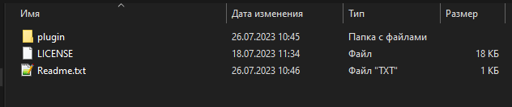

4. Copy the contents of the plugin folder to the root of the Hat browser folder

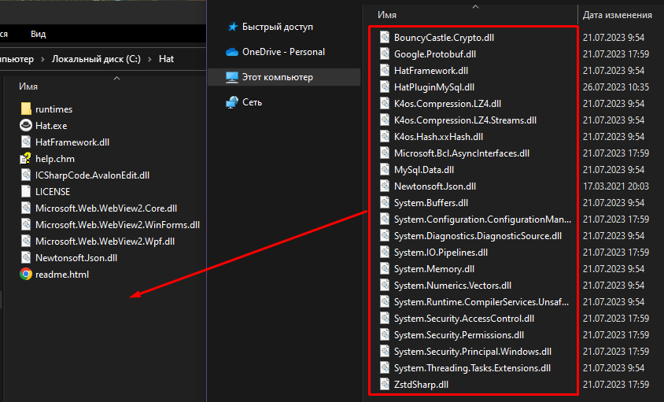

When copying, you may be asked about replacing existing files.
In this case, it is recommended to select "Skip these files".

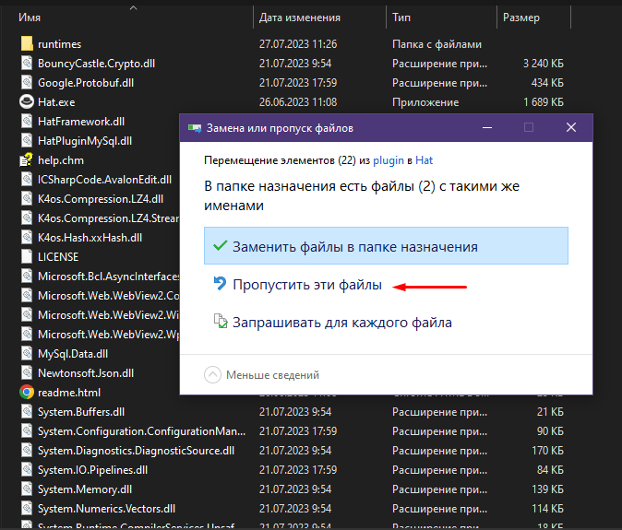

As a result, the following files should be in the root of the folder

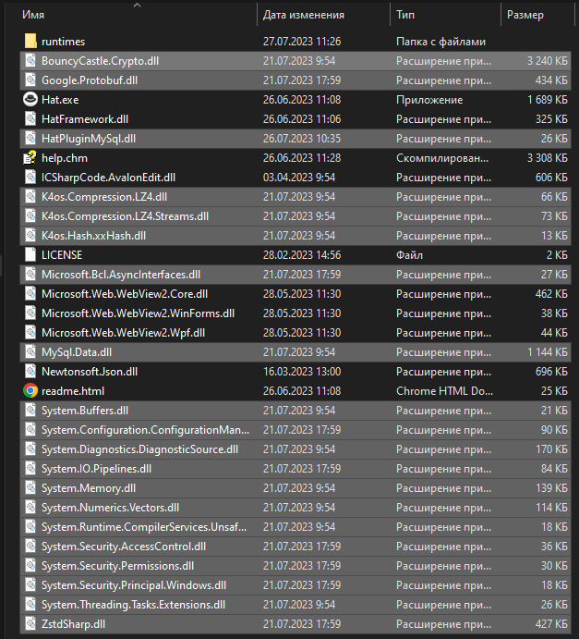

This completes the installation of the plugin!

Created with the Personal Edition of HelpNDoc: Easily create CHM Help documents

Connecting the plugin to the project
Connecting the HatPluginMySql plugin to the autotest project

1. Launch the browser Hat

2. Create a new project or open an existing project

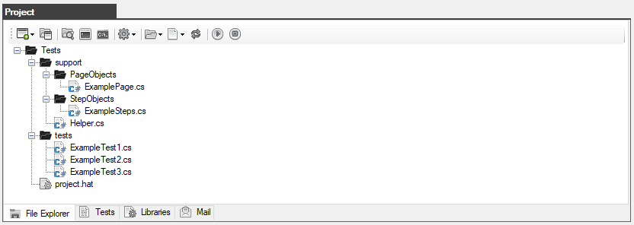

3. Go to the Libraries tab and enter the name of one file at the end of the list HatPluginMySql.dll

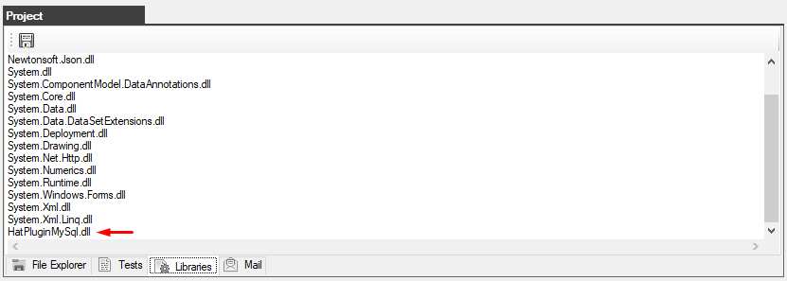

4. Click the "Save" button.

This completes the plug-in connection to the project

Created with the Personal Edition of HelpNDoc: Free EBook and documentation generator

An example of an autotest
An example of an autotest

After the plugin has been installed and connected to the project, let's consider a simple autotest.

We have created a simple database in MySQL named test_db
There is one test_table table in this database with the fields: id, name, age, post

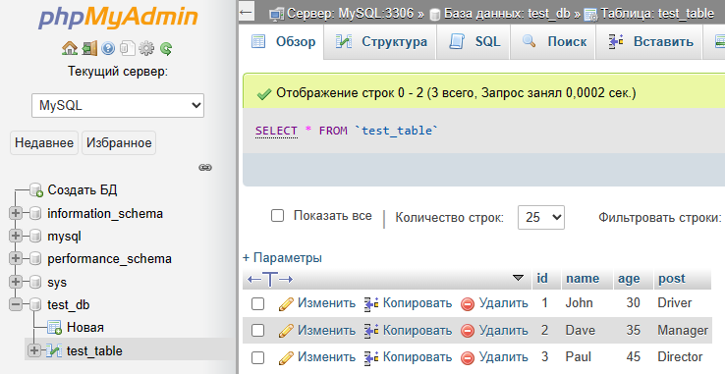

Now let's describe a simple autotest that will add, modify and delete data in the database while checking the correctness of the results.

Файл: ExampleTest3.cs
using System;
using System.Collections.Generic;
using System.ComponentModel;
using System.Windows.Forms;
using System.Threading;
using System.Threading.Tasks;
using System.IO;
using System.Data;
using System.Drawing;
using System.Linq;
using System.Text;
using System.Text.RegularExpressions;
using System.Net;
using System.Net.Http;
using System.Net.Http.Headers;
using System.Reflection;
using Newtonsoft.Json;
using HatFramework;
using HatPluginMySql;
namespace Hat
{
public class ExampleTest3
{
Tester tester;
public async void Main(Form browserWindow)
{
tester = new Tester(browserWindow);
await setUp();
await test();
await tearDown();
}
public async Task setUp()
{
tester.Description("Test #3 checking the database");
await tester.BrowserFullScreenAsync();
}
public async Task test()
{
DataTable dataTable = null;
List<List<string>> entries = new List<List<string>>();
TesterMySql testerMySql = new TesterMySql(tester);
await tester.TestBeginAsync();
await testerMySql.ConnectionOpenAsync("server=127.0.0.1;uid=root;pwd=;database=test_db");
int count = await testerMySql.GetCountEntriesAsync("SELECT * FROM test_table");
if (count > 0)
{
entries = await testerMySql.GetEntriesAsync("SELECT * FROM test_table");
dataTable = await testerMySql.GetDataTableAsync("SELECT * FROM test_table");
foreach (DataRow row in dataTable.Rows)
foreach (DataColumn col in dataTable.Columns)
tester.ConsoleMsg(row[col].ToString());
}
await testerMySql.SetEntryAsync("INSERT INTO test_table VALUES(NULL, 'I am Tester', 100, 'My post QA')");
bool result = await testerMySql.FindEntryAsync("test_table", "name", "'I am Tester'");
await testerMySql.AssertHaveInTableAsync("test_table", "name", "'I am Tester'");
entries = await testerMySql.GetEntriesFromTableAsync("test_table");
if (entries != null){
foreach(List<string> entry in entries)
foreach(string value in entry)
tester.ConsoleMsg(value);
}
await testerMySql.EditEntryAsync("UPDATE test_table SET age = 111 WHERE name = 'I am Tester'");
result = await testerMySql.FindEntryAsync("test_table", "age", "111");
await testerMySql.AssertHaveInTableAsync("test_table", "age", "111");
await testerMySql.RemoveEntryAsync("DELETE FROM test_table WHERE name = 'I am Tester'");
result = await testerMySql.FindEntryAsync("test_table", "name", "'I am Tester'");
await testerMySql.AssertDontHaveInTableAsync("test_table", "name", "'I am Tester'");
await testerMySql.ConnectionCloseAsync();
await tester.TestEndAsync();
}
public async Task tearDown()
{
// await tester.BrowserCloseAsync();
}
}
}

Please note that for the autotests to work correctly, you need to connect the library

using HatPluginMySql;

First, there is a connection to the database

TesterMySql testerMySql = new TesterMySql(tester);
await testerMySql.ConnectionOpenAsync("server=127.0.0.1;uid=root;pwd=;database=test_db");

Data manipulation is performed using different methods

await testerMySql.GetCountEntriesAsync("SELECT * FROM test_table");
await testerMySql.GetEntriesAsync("SELECT * FROM test_table");
await testerMySql.GetEntriesFromTableAsync("test_table");
await testerMySql.GetDataTableAsync("SELECT * FROM test_table");
await testerMySql.SetEntryAsync("INSERT INTO test_table VALUES(NULL, 'I am Tester', 100, 'My post QA')");
await testerMySql.FindEntryAsync("test_table", "name", "'I am Tester'");
await testerMySql.EditEntryAsync("UPDATE test_table SET age = 111 WHERE name = 'I am Tester'");
await testerMySql.RemoveEntryAsync("DELETE FROM test_table WHERE name = 'I am Tester'");

Special methods for checking the presence or absence of data in the database

await testerMySql.AssertHaveInTableAsync("test_table", "name", "'I am Tester'");
await testerMySql.AssertDontHaveInTableAsync("test_table", "name", "'I am Tester'")

At the end, the work with the database is completed by closing the connection to it

await testerMySql.ConnectionCloseAsync();

Let's run the autotest and look at the progress of the check and the result

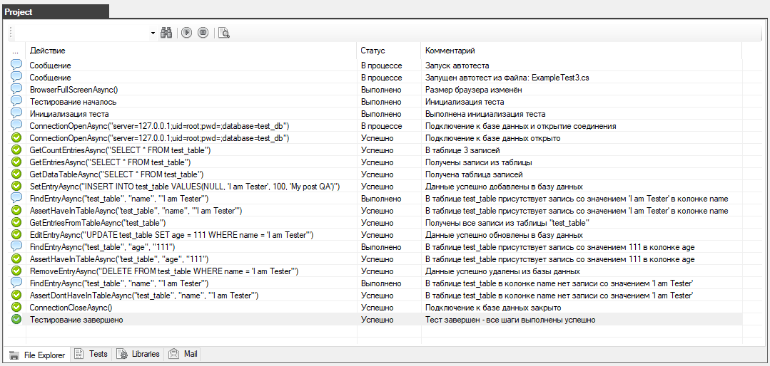

All actions were completed, all checks were successful.

The test was completed successfully.

Created with the Personal Edition of HelpNDoc: Full-featured EBook editor

Class: TesterMySql

Created with the Personal Edition of HelpNDoc: Free EBook and documentation generator

Constructor

Created with the Personal Edition of HelpNDoc: Free help authoring environment

TesterMySql
TesterMySql
Description: the main class of working with a MySQL database
Syntax: TesterMySql(Tester tester)

Example:
Tester tester = new Tester(browserWindow);
TesterMySql testerMySql = new TesterMySql(tester);
Created with the Personal Edition of HelpNDoc: Easily create Help documents

Methods

Created with the Personal Edition of HelpNDoc: Free help authoring environment

ConnectionOpenAsync
ConnectionOpenAsync
Description: the method opens a connection to the MySQL database
Syntax: ConnectionOpenAsync(string connectionString)
Return value: no return value

Example:
await testerMySql.ConnectionOpenAsync("server=127.0.0.1;uid=root;pwd=;database=test_db");

Created with the Personal Edition of HelpNDoc: Full-featured multi-format Help generator

ConnectionCloseAsync
ConnectionCloseAsync
Description: the method closes the connection to the MySQL database
Syntax: ConnectionCloseAsync()
Return value: no return value

Example:
await testerMySql.ConnectionCloseAsync();

Created with the Personal Edition of HelpNDoc: iPhone web sites made easy

GetCountEntriesAsync
GetCountEntriesAsync
Description: the method returns the number of records in the table after executing the query
Syntax: GetCountEntriesAsync(string sqlQuertSelect)
Return value: int

Example:
int count = await testerMySql.GetCountEntriesAsync("SELECT * FROM test_table");

Created with the Personal Edition of HelpNDoc: Create HTML Help, DOC, PDF and print manuals from 1 single source

GetEntriesAsync
GetEntriesAsync
Description: the method returns a list of records from the table after executing the query
Syntax: GetEntriesAsync(string sqlQuertSelect)
Return value: List

Example:
List<List<string>> entries = new List<List<string>>();
entries = await testerMySql.GetEntriesAsync("SELECT * FROM test_table");

foreach(List<string> entry in entries)
foreach(string value in entry)
tester.ConsoleMsg(value);

Created with the Personal Edition of HelpNDoc: Easily create CHM Help documents

GetEntriesFromTableAsync
GetEntriesFromTableAsync
Description: the method returns a list of records from the specified database table
Syntax: GetEntriesFromTableAsync(string tableName)
Return value: List

Example:
List<List<string>> entries = new List<List<string>>();
entries = await testerMySql.GetEntriesFromTableAsync("test_table");

foreach(List<string> entry in entries)
foreach(string value in entry)
tester.ConsoleMsg(value);

Created with the Personal Edition of HelpNDoc: Create iPhone web-based documentation

GetDataTableAsync
GetDataTableAsync
Description: the method returns a table of records from the database table after executing the query
Syntax: GetDataTableAsync(string sqlQuertSelect)
Return value: DataTable

Example:
DataTable dataTable = null;
dataTable = await testerMySql.GetDataTableAsync("SELECT * FROM test_table");

foreach (DataRow row in dataTable.Rows)
foreach (DataColumn col in dataTable.Columns)
tester.ConsoleMsg(row[col].ToString());

Created with the Personal Edition of HelpNDoc: Create HTML Help, DOC, PDF and print manuals from 1 single source

SetEntryAsync
SetEntryAsync
Description: the method executes a query that adds data to the database table and returns the record number
Syntax: SetEntryAsync(string sqlQuertInsert)
Return value: int

Example:
int result = await testerMySql.SetEntryAsync("INSERT INTO test_table VALUES(NULL, 'I am Tester', 100, 'My post QA')");

Created with the Personal Edition of HelpNDoc: Easily create iPhone documentation

EditEntryAsync
EditEntryAsync
Description: the method executes a query that modifies the data in the database table and returns the record number
Syntax: EditEntryAsync(string sqlQuertUpdate)
Return value: int

Example:
int result = await testerMySql.EditEntryAsync("UPDATE test_table SET age = 111 WHERE name = 'I am Tester'");

Created with the Personal Edition of HelpNDoc: Full-featured EBook editor

RemoveEntryAsync
RemoveEntryAsync
Description: the method executes a query that deletes the data in the database table and returns the record number
Syntax: RemoveEntryAsync(string sqlQuertDelete)
Return value: int

Example:
int result = await testerMySql.RemoveEntryAsync("DELETE FROM test_table WHERE name = 'I am Tester'");

Created with the Personal Edition of HelpNDoc: Write EPub books for the iPad

FindEntryAsync
FindEntryAsync
Description: the method searches for data in the specified database table and returns the boolean value of the search result
Syntax: FindEntryAsync(string tableName, string columnName, string value)
Return value: bool (true or false)

Example:
bool result = await testerMySql.FindEntryAsync("test_table", "name", "'I am Tester'");

Created with the Personal Edition of HelpNDoc: Easily create Help documents

AssertHaveInTableAsync
AssertHaveInTableAsync
Description: the method checks the data in the specified database table and returns the boolean value of the search result, in case of a negative result, the check will be considered a failure
Syntax: AssertHaveInTableAsync(string tableName, string columnName, string value)
Return value: bool (true or false)

Example:
bool result = await testerMySql.AssertHaveInTableAsync("test_table", "name", "'I am Tester'");

Created with the Personal Edition of HelpNDoc: Free Kindle producer

AssertDontHaveInTableAsync
AssertDontHaveInTableAsync
Description: the method checks the data in the specified database table and returns the boolean value of the search result, in case of a positive result, the check will be considered a failure
Syntax: AssertDontHaveInTableAsync(string tableName, string columnName, string value)
Return value: bool (true or false)

Example:
bool result = await testerMySql.AssertDontHaveInTableAsync("test_table", "name", "'I am Tester'");

Created with the Personal Edition of HelpNDoc: Free Web Help generator

Practical examples

Created with the Personal Edition of HelpNDoc: Produce online help for Qt applications

Autotest Group
Autotest Group

You can organize a group of autotests and run them.

To do this, create a folder in which the autotests of one group will be stored (for example, the folder group 1)

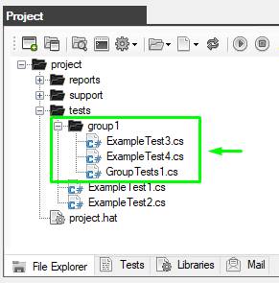

Next, you need to describe several tests and put them in the group1 folder.

Attention: for tests, the Main function must be declared as a Task

the first file: ExampleTest3.cs

File: ExampleTest3.cs
using System;
using System.Collections.Generic;
using System.ComponentModel;
using System.Windows.Forms;
using System.Threading;
using System.Threading.Tasks;
using System.IO;
using System.Data;
using System.Drawing;
using System.Linq;
using System.Text;
using System.Text.RegularExpressions;
using System.Net;
using System.Net.Http;
using System.Net.Http.Headers;
using System.Reflection;
using Newtonsoft.Json;
using HatFramework;

namespace Hat
{
// Auxiliary class for JSON data
public class TestJson
{
public int userId { get; set; }
public int id { get; set; }
public string title { get; set; }
public string body { get; set; }
}

public class ExampleTest3
{
// The main variable for the autotest operation
Tester tester;

// The main input function is declared as a Task. This is important! (the autotest starts working with this function)
public async Task Main(Form browserWindow)
{
// Initialization of the main variable and additional functions
tester = new Tester(browserWindow);

await setUp();
await test();
await tearDown();
}

// The function of getting started with the autotest
public async Task setUp()
{
await tester.BrowserFullScreenAsync(); // Sets the browser resolution to full screen
}

// The function of performing autotest actions
public async Task test()
{
await tester.TestBeginAsync();
await tester.GoToUrlAsync("https://jsonplaceholder.typicode.com", 5);
string result = await tester.RestGetAsync(@"https://jsonplaceholder.typicode.com/posts/1/", TimeSpan.FromDays(1), "UTF-8");
TestJson dataJson = JsonConvert.DeserializeObject<TestJson>(result);
tester.AssertEqualsAsync("1", dataJson.userId.ToString());
await tester.TestEndAsync();
}

// Autotest shutdown function
public async Task tearDown()
{
// await tester.BrowserCloseAsync(); in this case, we don't need the browser to close
}
}
}

the second file: ExampleTest4.cs

File: ExampleTest4.cs
using System;
using System.Collections.Generic;
using System.ComponentModel;
using System.Windows.Forms;
using System.Threading;
using System.Threading.Tasks;
using System.IO;
using System.Data;
using System.Drawing;
using System.Linq;
using System.Text;
using System.Text.RegularExpressions;
using System.Net;
using System.Net.Http;
using System.Net.Http.Headers;
using System.Reflection;
using Newtonsoft.Json;
using HatFramework;

namespace Hat
{
public class ExampleTest4
{
// The main variable for the autotest operation
Tester tester;

// The main input function is declared as a Task. This is important! (the autotest starts working with this function)
public async Task Main(Form browserWindow)
{
// Initialization of the main variable and additional functions
tester = new Tester(browserWindow);

await setUp();
await test();
await tearDown();
}

// The function of getting started with the autotest
public async Task setUp()
{
await tester.BrowserFullScreenAsync(); // Sets the browser resolution to full screen
}

// The function of performing autotest actions
public async Task test()
{
await tester.TestBeginAsync();
await tester.GoToUrlAsync("https://somovstudio.github.io/test_eng.html", 5);
string script = @"(function(){ var element = document.getElementsByTagName('h2')[0]; return element.outerText; }());";
string actual = await tester.ExecuteJavaScriptAsync(script);
string expected = "Authorization";
await tester.AssertEqualsAsync(expected, actual);
await tester.TestEndAsync();
}

// Autotest shutdown function
public async Task tearDown()
{
// await tester.BrowserCloseAsync(); in this case, we don't need the browser to close
}
}
}

We have created two autotests "ExampleTest3.cs" and "ExampleTest4.cs" which are located in the "group1" folder.
Now you need to create a combining autotest GroupTests1.cs that will trigger other autotests.

File: GroupTests1.cs
using System;
using System.Collections.Generic;
using System.ComponentModel;
using System.Windows.Forms;
using System.Threading;
using System.Threading.Tasks;
using System.IO;
using System.Data;
using System.Drawing;
using System.Linq;
using System.Text;
using System.Text.RegularExpressions;
using System.Net;
using System.Net.Http;
using System.Net.Http.Headers;
using System.Reflection;
using Newtonsoft.Json;
using HatFramework;

namespace Hat
{
public class GroupTests1
{
// The main variable for the autotest operation
Tester tester;

// The main input function (the autotest starts with this function)
public async void Main(Form browserWindow)
{
tester = new Tester(browserWindow); // Initializing the main variable
await setUp(); // The function of getting started with the autotest
await test1(browserWindow); // The function that calls the autotest from the script ExampleTest3.cs
await test2(browserWindow); // The function that calls the autotest from the script ExampleTest4.cs
await tearDown(); // Autotest shutdown function
}

public async Task setUp()
{
await tester.BrowserFullScreenAsync();
}

// This function runs the autotest from the script ExampleTest3.cs
public async Task test1(Form browserWindow)
{
tester.SendMessage("Автотест ExampleTest3", "", "Файл: ExampleTest3.cs", Tester.IMAGE_STATUS_MESSAGE);
ExampleTest3 exampleTest3 = new ExampleTest3(); // An autotest variable is being created
await exampleTest3.Main(browserWindow); // The autotest is started
}

// This function runs the autotest from the script ExampleTest4.cs
public async Task test2(Form browserWindow)
{
tester.SendMessage("Автотест ExampleTest4", "", "Файл: ExampleTest4.cs", Tester.IMAGE_STATUS_MESSAGE);
ExampleTest4 exampleTest4 = new ExampleTest4(); // An autotest variable is being created
await exampleTest4.Main(browserWindow); // The autotest is started
}

// Autotest shutdown function
public async Task tearDown()
{
await tester.BrowserCloseAsync(); // Closes the browser
}
}
}

As you can see in the ExampleTest3.CS and ExampleTest4.cs autotest will be called sequentially in the test1 and test2 methods.

Run the GroupTests1.cs group autotest

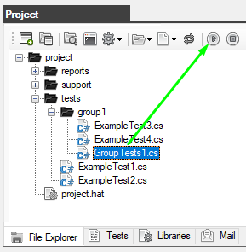

The result on the "Test" tab will reflect the entire progress of the sequential execution of all autotests step by step.

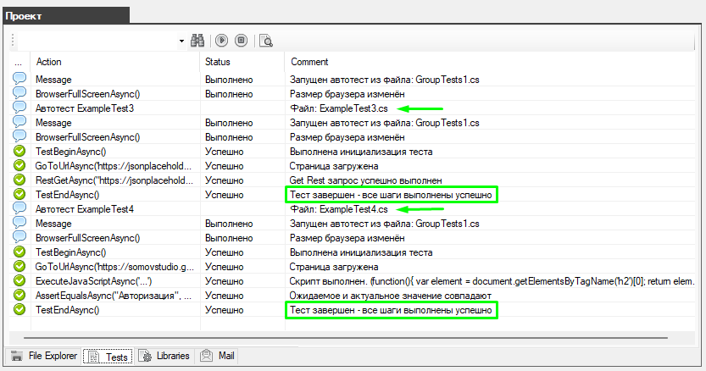

If any of the autotests fails, the check will continue anyway until all the autotests are completed

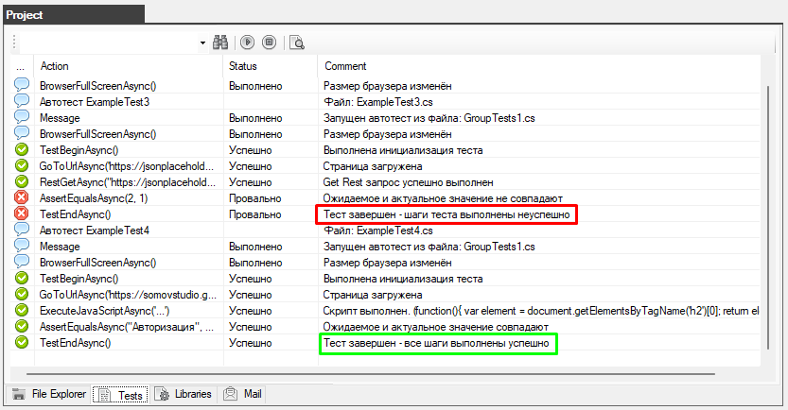

at the same time, the overall result of the GroupTests1.cs group autotest will be considered a failure.

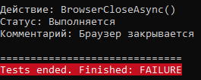

a report on the complete completion of all tests will also be created

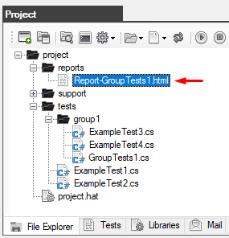

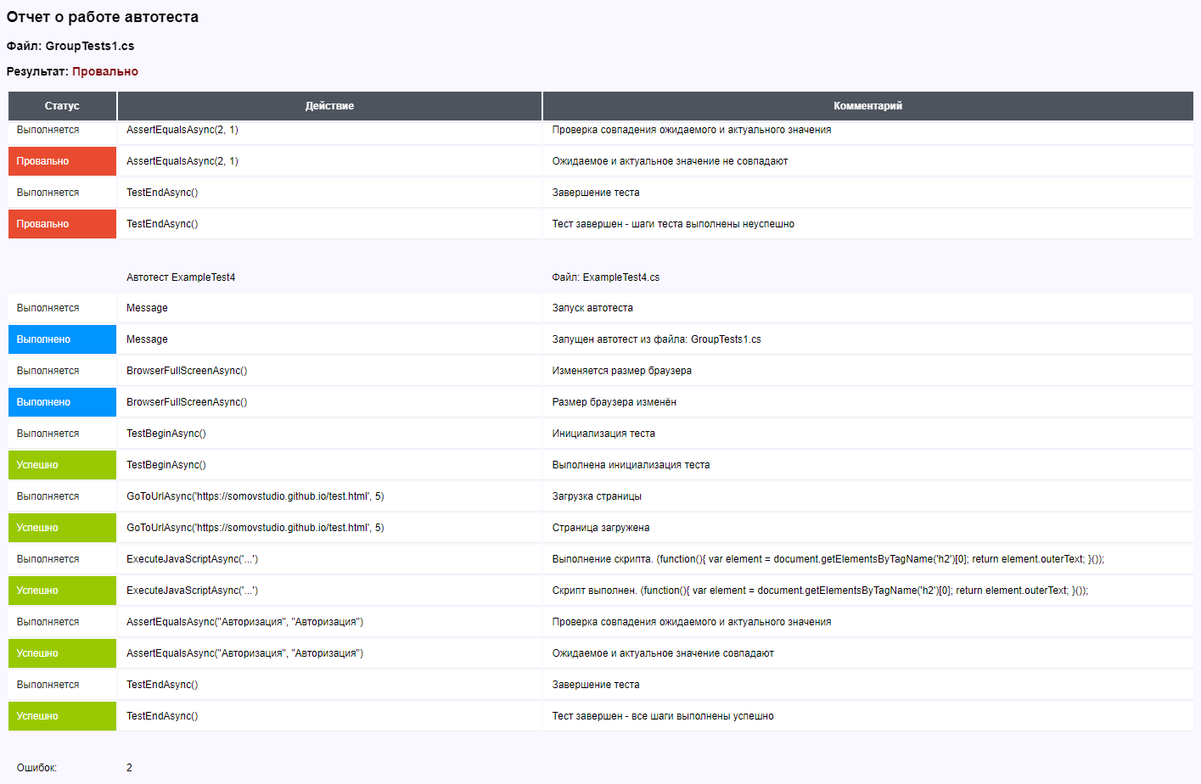

Created with the Personal Edition of HelpNDoc: Qt Help documentation made easy

Executing JavaScript code
Executing JavaScript code

A special ExecuteJavaScriptAsync method has been added to HatFramework to execute JavaScript code.

First, you need to declare a text variable and describe in it the script that you want to execute.

string script = @"(function(){
var element = document.getElementsByTagName('h2')[0];
return element.outerText;
}());";

Now, using the ExecuteJavaScriptAsync method, we will execute the above script and get the result.

string actual = await tester.ExecuteJavaScriptAsync(script);

In this example, you will get the text from the H2 element from the page where this script was called.

Full example:

File: ExampleTest4.cs
using System;
using System.Collections.Generic;
using System.ComponentModel;
using System.Windows.Forms;
using System.Threading;
using System.Threading.Tasks;
using System.IO;
using System.Data;
using System.Drawing;
using System.Linq;
using System.Text;
using System.Text.RegularExpressions;
using System.Net;
using System.Net.Http;
using System.Net.Http.Headers;
using System.Reflection;
using Newtonsoft.Json;
using HatFramework;

namespace Hat
{
public class ExampleTest4
{
Tester tester; // The main variable for the autotest operation

// The main input function (the autotest starts with this function)
public async void Main(Form browserWindow)
{
tester = new Tester(browserWindow); // Initializing the main variable

await setUp(); // The function of getting started with the autotest
await test(); // The function of performing test actions
await tearDown(); // Autotest shutdown function
}

public async Task setUp()
{
await tester.BrowserFullScreenAsync(); // Sets the browser resolution to full screen
}

public async Task test()
{
await tester.TestBeginAsync(); // The beginning of the execution of actions
await tester.GoToUrlAsync("https://somovstudio.github.io/test_eng.html", 5); // Loading the page at the specified address

// Declaring a variable with a JavaScript script description
string script = @"(function(){
var element = document.getElementsByTagName('h2')[0];
return element.outerText;
}());";

// Script Execution
string actual = await tester.ExecuteJavaScriptAsync(script);

// Checking the result
string expected = "Authorization";
await tester.AssertEqualsAsync(expected, actual); // The expected and actual data must match

await tester.TestEndAsync(); // Completing actions
}

public async Task tearDown()
{
await tester.BrowserCloseAsync(); // Closes the browser
}
}
}

Examples of JavaScript and jQuery scripts for the method ExecuteJavaScriptAsync :

- focus on the input element and data entry

var element = document.evaluate("//input[@id='phone']", document, null, XPathResult.FIRST_ORDERED_NODE_TYPE, null).singleNodeValue;
element.focus();
element.value = '9999999999';
element.setAttribute("value", "9999999999");

- focus on the input element and insert data

document.getElementById("phone").focus();
document.execCommand("insertHTML", false, "9999999999");

- entering data into input and calling events

var element = document.evaluate("//input[@id='phone']", document, null, XPathResult.FIRST_ORDERED_NODE_TYPE, null).singleNodeValue;
element.value = '9999999999';
element.dispatchEvent(new KeyboardEvent('keydown', { bubbles: true }));
element.dispatchEvent(new KeyboardEvent('keypress', { bubbles: true }));
element.dispatchEvent(new KeyboardEvent('keyup', { bubbles: true }));
element.dispatchEvent(new Event('input', { bubbles: true }));
element.dispatchEvent(new Event('change', { bubbles: true }));

- highlight the value in the input

var element = document.evaluate("//input[@id='phone']", document, null, XPathResult.FIRST_ORDERED_NODE_TYPE, null).singleNodeValue;
element.select();

- mouse click

var clickEvent = new MouseEvent("click", { "view": window, "bubbles": true, "cancelable": false });
var element = document.evaluate("//input[@id='phone']", document, null, XPathResult.FIRST_ORDERED_NODE_TYPE, null).singleNodeValue;
element.dispatchEvent(clickEvent);

var theEvent = document.createEvent("MouseEvent");
theEvent.initMouseEvent("click", true, true, window, 0, 0, 0, 0, 0, false, false, false, false, 0, null);
element.dispatchEvent(theEvent);

- using jQuery to click a button (if the library is connected on the page under test)

string script = @"$(function() {
console.log('autotest JQUERY');
$('#btn-send > div.btn > a').click();
});";

Created with the Personal Edition of HelpNDoc: Full-featured Kindle eBooks generator

Processing Json data using Newtonsoft
Processing Json data using Newtonsoft

The Newtonsoft.Json library has been added to work with Json data
The official page: https://www.newtonsoft.com/json

As an example, we use a Rest request to the address
https://jsonplaceholder.typicode.com/posts/1/
to get test data in Json format:

{ "userId": 1, "id": 1, "title": "sunt aut facere repellat provident occaecati excepturi optio reprehenderit", "body": "quia et suscipit\nsuscipit recusandae consequuntur expedita et cum\nreprehenderit molestiae ut ut quas totam\nnostrum rerum est autem sunt rem eveniet architecto" }

Next, with the help of Newtonsoft.Json processing of the received result.
First, you need to describe a separate class that lists the fields that are present in the Json

public class TestJson
{
public int userId { get; set; }
public int id { get; set; }
public string title { get; set; }
public string body { get; set; }
}

We execute a Rest request and get the Json data

string result = await tester.RestGetAsync(@"https://jsonplaceholder.typicode.com/posts/1/", TimeSpan.FromDays(1), "UTF-8");

We process the received data and output them

TestJson dataJson = JsonConvert.DeserializeObject<TestJson>(result);
tester.ConsoleMsg("UserID: " + dataJson.userId.ToString());

Full example:

File: ExampleTest3.cs
using System;
using System.Collections.Generic;
using System.ComponentModel;
using System.Windows.Forms;
using System.Threading;
using System.Threading.Tasks;
using System.IO;
using System.Data;
using System.Drawing;
using System.Linq;
using System.Text;
using System.Text.RegularExpressions;
using System.Net;
using System.Net.Http;
using System.Net.Http.Headers;
using System.Reflection;
using Newtonsoft.Json;
using HatFramework;

namespace Hat
{
// Auxiliary class for JSON data
public class TestJson
{
public int userId { get; set; }
public int id { get; set; }
public string title { get; set; }
public string body { get; set; }
}

public class ExampleTest3
{
Tester tester; // The main variable for the autotest operation

// The main input function (the autotest starts with this function)
public async void Main(Form browserWindow)
{
tester = new Tester(browserWindow); // Initializing the main variable

await setUp(); // Функция начала работы с автотестом
await test(); // Функция выполнения действий теста
await tearDown(); // Функция завершения работы с автотестом
}

public async Task setUp()
{
await tester.BrowserFullScreenAsync(); // Sets the browser resolution to full screen
}

public async Task test()
{
await tester.TestBeginAsync(); // The beginning of the execution of actions
await tester.GoToUrlAsync("https://jsonplaceholder.typicode.com", 5); // Loading the page at the specified address

// Executes a Rest request to the API at the specified URL and gets the result in JSON format
string result = await tester.RestGetAsync(@"https://jsonplaceholder.typicode.com/posts/1/", TimeSpan.FromDays(1), "UTF-8");
tester.ConsoleMsg(result); // Outputs the result to the console

// Fetches data from the received JSON
TestJson dataJson = JsonConvert.DeserializeObject<TestJson>(result);

// Outputs data to the console
tester.ConsoleMsg("UserID: " + dataJson.userId.ToString());
tester.ConsoleMsg("ID: " + dataJson.id.ToString());
tester.ConsoleMsg("Title: " + dataJson.title.ToString());
tester.ConsoleMsg("Body: " + dataJson.body.ToString());

await tester.TestEndAsync(); // Completing actions
}

public async Task tearDown()
{
await tester.BrowserCloseAsync(); // Closes браузер
}
}
}

Created with the Personal Edition of HelpNDoc: Easily create Web Help sites

Processing XML data for checking the Sitemap
Processing XML data for checking the Sitemap

The following libraries are used to work with XML

using System.Collections;
using System.Xml;

Let's describe the ReadSitemapXML auxiliary method for reading data from the site map sitemap.xml
This method can be described in the Steps class, but in order for it to be available in any class, it is better to describe it in the Helper.
The blank of the ReadSitemapXML method is closed when reading a link from a file sitemap.xml and as a result, return the list of read links.

File: Helper.cs
using System;
using System.Collections.Generic;
using System.ComponentModel;
using System.Windows.Forms;
using System.Threading;
using System.Threading.Tasks;
using System.IO;
using System.Data;
using System.Drawing;
using System.Linq;
using System.Text;
using System.Text.RegularExpressions;
using System.Net;
using System.Net.Http;
using System.Net.Http.Headers;
using System.Reflection;
using Newtonsoft.Json;
using HatFramework;
using System.Collections;
using System.Xml;

namespace Hat
{
public static class Helper
{
/* Method: reading the XML file of the site map */
public static async Task<List<string>> ReadSitemapXML(Tester tester, string filename, bool useragent)
{
// Declaring a variable whose type is a list (a list for storing links)
List<string> list = new List<string>();

// Declaring a variable that is an error flag (the flag is disabled by default)
bool errors = false;

try
{
// Setting up the system connection parameters ServicePointManager.Expect100Continue = true;
ServicePointManager.SecurityProtocol = SecurityProtocolType.Tls12;
ServicePointManager.ServerCertificateValidationCallback = delegate { return true; };

// We are reading the xml file
XmlDocument xDoc;
if (useragent == false)
{
xDoc = new XmlDocument();
xDoc.Load(filename);
}
else
{
WebClient client = new WebClient();
client.Headers["User-Agent"] = await tester.BrowserGetUserAgentAsync();
client.Headers["Accept"] = "text/html,application/xhtml+xml,application/xml;q=0.9,*/*;q=0.8";
string data = client.DownloadString(filename);

xDoc = new XmlDocument();
xDoc.LoadXml(data);
}

// Reading the elements from the resulting xml file
XmlElement xRoot = xDoc.DocumentElement;
foreach (XmlNode xnode in xRoot)
{
for (int j = 0; j <= xnode.ChildNodes.Count; j++)
{
if (xnode.ChildNodes[j].Name == "loc")
{
// We save the received link to the list
list.Add(xnode.ChildNodes[j].InnerText);
break;
}
}
}
}
catch (Exception ex)
{
errors = true; // enabling the error flag
}

// Checking the error flag (if the flag is set to true, then a failure has occurred and the test will be aborted
await tester.AssertFalseAsync(errors);

return list; // returning the list of links
}
}
}

Now let's describe an autotest in which we will check the site map

File: Sitemap_Test.cs
using System;
using System.Collections.Generic;
using System.ComponentModel;
using System.Windows.Forms;
using System.Threading;
using System.Threading.Tasks;
using System.IO;
using System.Data;
using System.Drawing;
using System.Linq;
using System.Text;
using System.Text.RegularExpressions;
using System.Net;
using System.Net.Http;
using System.Net.Http.Headers;
using System.Reflection;
using Newtonsoft.Json;
using HatFramework;

namespace Hat
{
public class Sitemap_Test
{
// The main variable for the autotest operation
Tester tester;

// The main input function (the autotest starts with this function)
public async void Main(Form browserWindow)
{
// Initialization of the main variable and additional functions
tester = new Tester(browserWindow);
await setUp();
await test();
await tearDown();
}

// The function of getting started with the autotest
public async Task setUp()
{
await tester.BrowserFullScreenAsync(); // Sets the browser resolution to full screen
}

// The function of performing autotest actions
public async Task test()
{
await tester.TestBeginAsync(); // The beginning of the execution of actions

// Loading the page at the specified address
await tester.GoToUrlAsync("https://somovstudio.github.io/sitemap.xml", 25);

// Reading links from a file sitemap.xml
List<string> list = await Helper.ReadSitemapXML(tester, "https://somovstudio.github.io/sitemap.xml", false);

// Processing the list of links
int status = 0;
foreach (string url in list)
{
// Getting the page status (200 - correct, 404 - no page, 502 - the server is not responding, etc.)
status = await tester.RestGetStatusCodeAsync(url);
// Output the result to the console
tester.ConsoleMsg("Status: " + status.ToString() + " | Page: " + url);
// Checking the correctness of the result
await tester.AssertEqualsAsync(200, status);
}

await tester.TestEndAsync(); // Completion of actions
}

// Функция завершения работы с автотестом
public async Task tearDown()
{
await tester.BrowserCloseAsync(); // Closes the browser
}
}
}

Created with the Personal Edition of HelpNDoc: Benefits of a Help Authoring Tool

Alert, prompt and confirm dialog windows
Alert, prompt and confirm dialog windows

The browser has disabled support for the alert, prompt and confirm dialog windows.
So that the code is executed ignoring calls to these dialog windows.

How does it work? Let's take a test page as an example https://somovstudio.github.io/test2.html
Click on the button "Вызвать Alert"
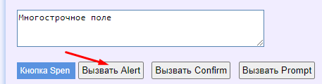

a dialog window opens
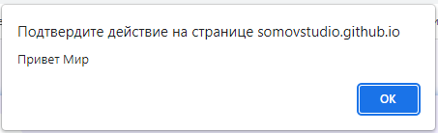

by clicking OK, we will see the message "Привет Мир" in the field

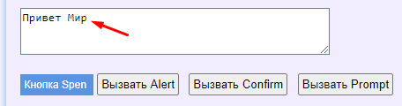

That is, the message "Привет Мир" will be displayed in the field only after clicking OK in the Alert dialog box.

If you press the button "Вызвать Confirm" a question will be asked and the answer will be displayed in the field after clicking on "OK" (or "Cancel")

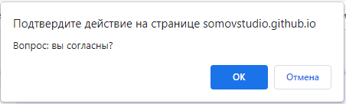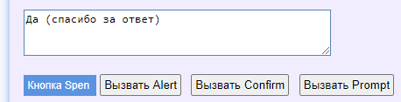

If you press the button "Вызвать Confirm" a question will be asked and the answer will be displayed in the field after entering the number and clicking OK

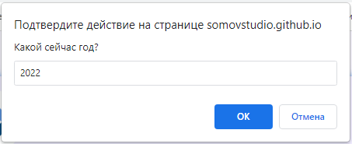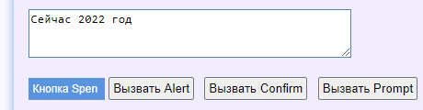

Now let's do the same with autotest hands

File: ExampleTest5.cs
using System;
using System.Collections.Generic;
using System.ComponentModel;
using System.Windows.Forms;
using System.Threading;
using System.Threading.Tasks;
using System.IO;
using System.Data;
using System.Drawing;
using System.Linq;
using System.Text;
using System.Text.RegularExpressions;
using System.Net;
using System.Net.Http;
using System.Net.Http.Headers;
using System.Reflection;
using Newtonsoft.Json;
using HatFramework;

namespace Hat
{
public class ExampleTest5
{
Tester tester; // The main variable for the autotest operation

// The main input function (the autotest starts with this function)
public async void Main(Form browserWindow)
{
tester = new Tester(browserWindow); // Initializing the main variable

await setUp(); // The function of getting started with the autotest
await test(); // The function of performing test actions
await tearDown(); // Autotest shutdown function
}

public async Task setUp()
{
await tester.BrowserFullScreenAsync(); // Sets the browser resolution to full screen
}

public async Task test()
{
await tester.TestBeginAsync(); // The beginning of the execution of actions
await tester.GoToUrlAsync("https://somovstudio.github.io/test2.html", 5); // Loading the page at the specified address
await tester.WaitAsync(2); // Waiting for 2 seconds
await tester.ClickElementByIdAsync("btnAlert"); // Pressing the button
await tester.WaitAsync(2); // Waiting for 2 seconds
await tester.ClickElementByIdAsync("btnConfirm"); // Pressing the button
await tester.WaitAsync(2); // Waiting for 2 seconds
await tester.ClickElementByIdAsync("btnPrompt"); // Pressing the button
await tester.TestEndAsync(); // Completing actions
}

public async Task tearDown()
{
await tester.BrowserCloseAsync(); // Closes the browser
}
}
}

After running the autotest, we will see that the dialog boxes do not open, and the data changes in the field.
The page will load first in its default state

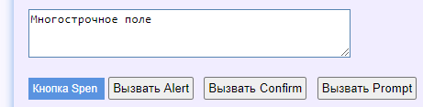

Then, autotest, click the "Call Alert" button, the dialog box will not open, and the message "Hello World" will immediately appear in the field

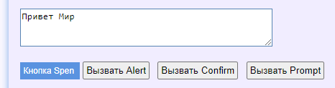

Then, autotest, click the "Call Confirm" button, the dialog box will not open, and the message "No (thanks for the answer)" will immediately appear in the field

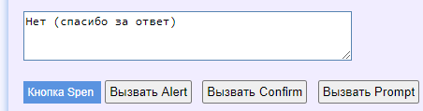

Then, autotest, click the "Call Prompt" button, the dialog box will not open, and the message "Now is a null year" will immediately appear in the field

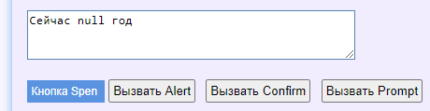

As you can see, the browser ignored the dialog boxes and displayed the default values.
Thus, dialog boxes do not interfere with the execution of autotests.

Created with the Personal Edition of HelpNDoc: Produce Kindle eBooks easily

Basic authorization
Basic authorization

There are cases when the page is closed with basic authorization

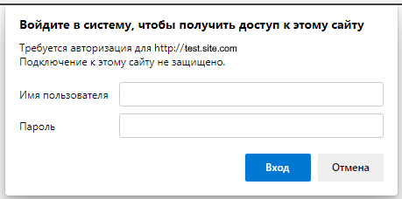

There are two methods for working with basic authorization:
- BrowserBasicAuthenticationAsync - performs authorization before completing the autotest steps
- GoToUrlBaseAuthAsync - navigates to the page with the username and password specified in the address URL

An example of using the method BrowserBasicAuthenticationAsync

File: ExampleTest6.cs
using System;
using System.Collections.Generic;
using System.ComponentModel;
using System.Windows.Forms;
using System.Threading;
using System.Threading.Tasks;
using System.IO;
using System.Data;
using System.Drawing;
using System.Linq;
using System.Text;
using System.Text.RegularExpressions;
using System.Net;
using System.Net.Http;
using System.Net.Http.Headers;
using System.Reflection;
using Newtonsoft.Json;
using HatFramework;

namespace Hat
{
public class ExampleTest5
{
Tester tester; // The main variable for the autotest operation

// The main input function (the autotest starts with this function)
public async void Main(Form browserWindow)
{
tester = new Tester(browserWindow); // Initializing the main variable

await setUp(); // The function of getting started with the autotest
await test(); // The function of performing test actions
await tearDown(); // Autotest shutdown function
}

public async Task setUp()
{
await tester.BrowserFullScreenAsync(); // Sets the browser resolution to full screen
await tester.BrowserBasicAuthenticationAsync("login", "pass"); // Performing basic authorization
}

public async Task test()
{
await tester.TestBeginAsync(); // The beginning of the execution of actions
await tester.GoToUrlAsync("https://test.site.com", 5); // Loading the page at the specified address
await tester.TestEndAsync(); // Completing actions
}

public async Task tearDown()
{
await tester.BrowserCloseAsync(); // Closes the browser
}
}
}

An example of using the method GoToUrlBaseAuthAsync

File: ExampleTest6.cs
using System;
using System.Collections.Generic;
using System.ComponentModel;
using System.Windows.Forms;
using System.Threading;
using System.Threading.Tasks;
using System.IO;
using System.Data;
using System.Drawing;
using System.Linq;
using System.Text;
using System.Text.RegularExpressions;
using System.Net;
using System.Net.Http;
using System.Net.Http.Headers;
using System.Reflection;
using Newtonsoft.Json;
using HatFramework;

namespace Hat
{
public class ExampleTest5
{
Tester tester; // The main variable for the autotest operation
// The main input function (the autotest starts with this function)
public async void Main(Form browserWindow)
{
tester = new Tester(browserWindow); // Initializing the main variable

await setUp(); // The function of getting started with the autotest
await test(); // The function of performing test actions
await tearDown(); // Autotest shutdown function
}

public async Task setUp()
{
await tester.BrowserFullScreenAsync(); // Sets the browser resolution to full screen
}

public async Task test()
{
await tester.TestBeginAsync(); // The beginning of the execution of actions

// Performing basic authorization when loading a page
await tester.GoToUrlBaseAuthAsync("https://test.site.com", "login", "pass", 5);

await tester.TestEndAsync(); // Completing actions
}

public async Task tearDown()
{
await tester.BrowserCloseAsync(); // Closes the browser
}
}
}

Created with the Personal Edition of HelpNDoc: Easily create PDF Help documents

Google analytics and yandex metrika events
Google analytics and yandex metrika events

To get GA and YM events, use special methods.

await tester.AssertNetworkEventsAsync(true, new string[] {
"ec=ga_category", "ea=ga_action", "el=ga_label", "yandex_event"
});
await Helper.ClearBrowserNetworkLogs(tester); // clearing events

Another way to intercept the YM event is to use it ?_ym_debug=1 in the address and browser event handling.

File: ExampleTest7.cs
using System;
using System.Collections.Generic;
using System.ComponentModel;
using System.Windows.Forms;
using System.Threading;
using System.Threading.Tasks;
using System.IO;
using System.Data;
using System.Drawing;
using System.Linq;
using System.Text;
using System.Text.RegularExpressions;
using System.Net;
using System.Net.Http;
using System.Net.Http.Headers;
using System.Reflection;
using Newtonsoft.Json;
using HatFramework;

namespace Hat
{
public class ExampleTest5
{
Tester tester; // The main variable for the autotest operation
List<string> events; // The variable into which all browser events are collected

// The main input function (the autotest starts with this function)
public async void Main(Form browserWindow)
{
tester = new Tester(browserWindow); // Initializing the main variable

await setUp(); // The function of getting started with the autotest
await test(); // The function of performing test actions
await tearDown(); // Autotest shutdown function
}

// A function that listens to browser events
private void browserConsoleEvents(object sender, Microsoft.Web.WebView2.Core.CoreWebView2DevToolsProtocolEventReceivedEventArgs e)
{
events.Add(e.ParameterObjectAsJson);
tester.ConsoleMsg(e.ParameterObjectAsJson);
}

public async Task setUp()
{
await tester.BrowserFullScreenAsync(); // Sets the browser resolution to full screen

/*
* Let's turn on listening for browser events
* A source: https://chromedevtools.github.io/devtools-protocol/tot/Network/
*/
tester.BrowserView.CoreWebView2.GetDevToolsProtocolEventReceiver("Log.entryAdded").DevToolsProtocolEventReceived += browserConsoleEvents;
await tester.BrowserView.CoreWebView2.CallDevToolsProtocolMethodAsync("Log.enable", "{}");
tester.BrowserView.CoreWebView2.GetDevToolsProtocolEventReceiver("Console.messageAdded").DevToolsProtocolEventReceived += browserConsoleEvents;
await tester.BrowserView.CoreWebView2.CallDevToolsProtocolMethodAsync("Console.enable", "{}");
tester.BrowserView.CoreWebView2.GetDevToolsProtocolEventReceiver("Runtime.consoleAPICalled").DevToolsProtocolEventReceived += browserConsoleEvents;
tester.BrowserView.CoreWebView2.GetDevToolsProtocolEventReceiver("Runtime.exceptionThrown").DevToolsProtocolEventReceived += browserConsoleEvents;
await tester.BrowserView.CoreWebView2.CallDevToolsProtocolMethodAsync("Runtime.enable", "{}");
tester.BrowserView.CoreWebView2.GetDevToolsProtocolEventReceiver("Network.dataReceived").DevToolsProtocolEventReceived += browserConsoleEvents;
await tester.BrowserView.CoreWebView2.CallDevToolsProtocolMethodAsync("Network.enable", "{}");
tester.BrowserView.CoreWebView2.GetDevToolsProtocolEventReceiver("Debugger.scriptParsed").DevToolsProtocolEventReceived += browserConsoleEvents;
await tester.BrowserView.CoreWebView2.CallDevToolsProtocolMethodAsync("Debugger.enable", "{}");
}

public async Task test()
{
await tester.TestBeginAsync(); // The beginning of the execution of actions
await tester.GoToUrlAsync("https://test.site.com/?_ym_debug=1", 5); // Loading a page with YM event debugging enabled

await tester.SetValueInElementAsync(Tester.BY_XPATH, "//input[@id='SECOND_NAME']", Helper.TestName);
await tester.WaitAsync(1);
await tester.SetValueInElementAsync(Tester.BY_XPATH, "//input[@id='NAME']", Helper.TestName);
await tester.WaitAsync(1);
await tester.SetValueInElementAsync(Tester.BY_XPATH, "//input[@id='PHONE']", Helper.TestPhone);
await tester.WaitAsync(1);
await tester.ClickElementAsync(Tester.BY_XPATH, "//input[@id='fb_close']");
await tester.WaitAsync(1);
await tester.WaitVisibleElementAsync(Tester.BY_XPATH, "//p[text() = 'Спасибо! Ваша заявка принята.']", 25);
await tester.WaitAsync(5);

// Checking the YM event in the browser event list
tester.SendMessage("Message", Tester.COMPLETED, "Проверка: Событие YM (Goal id: yandex_event)", Tester.IMAGE_STATUS_MESSAGE);
bool checkYM = false;
foreach(string value in events)
{
checkYM = value.Contains("Goal id: yandex_event");
if (checkYM == true)
{
tester.SendMessage("Message", Tester.COMPLETED, "Сработало событие YM: " + value, Tester.IMAGE_STATUS_MESSAGE);
break;
}
}
await tester.AssertTrueAsync(checkYM); // The result of the check

await tester.TestEndAsync(); // Completing actions
}

public async Task tearDown()
{
await tester.BrowserCloseAsync(); // Closes the browser
}

}
}

Thus, the autotest listens to all browser events and, after performing the actions, looks through all events in search of new ones
If the YM event is found, the test is considered successful.

Created with the Personal Edition of HelpNDoc: Easily create iPhone documentation

Version 1.3 (not current)
Created with the Personal Edition of HelpNDoc: Full-featured Documentation generator

Description
Starting with browser version 1.3, the following methods have been changed:
  - SendMessage - the method of change
  - SendMessageDebug - the method of change
  - EditMessage - the method has been deleted
  - EditMessageDebug - the method has been deleted
  - DefineTestStop -the method of change
Created with the Personal Edition of HelpNDoc: Easy EPub and documentation editor

SendMessage [changed since version 1.3.0]
SendMessage
Description: the method displays messages in the test execution process table
When executed, action is output to the system console if status is FAILED, WARNING, "", null, otherwise only status and comment are output (without action).

Syntax: SendMessage(string action, string status, string comment)

Example:
int step = tester.SendMessage("the text of the actions", Tester.PROCESS, "the text of the comment");

/* Examples of console output */
// action comment
int step = tester.SendMessage("actions", null, "comment");
int step = tester.SendMessage("actions", "", "comment");

// Step[progress]: comment
int step = tester.SendMessage("actions", Tester.PROCESS, "comment");
// Step[passed]: comment
int step = tester.SendMessage("actions", Tester.PASSED, "comment");
// Step[completed]: comment
int step = tester.SendMessage("actions", Tester.COMPLETED, "comment");
// Step[stopped]: comment
int step = tester.SendMessage("actions", Tester.STOPPED, "comment");

// Step[failed]: действие комментарий
int step = tester.SendMessage("actions", Tester.FAILED, "comment");
// Step[warning]: действие комментарий
int step = tester.SendMessage("actions", Tester.WARNING, "comment");

Created with the Personal Edition of HelpNDoc: News and information about help authoring tools and software

SendMessageDebug [changed since version 1.3.0]
SendMessageDebug
Description: the method outputs a debugging message that can be disabled for output to a report and an email
When executed, action is output to the system console if status is FAILED, WARNING, "", null,
otherwise only status and comment are output (without action).

Syntax: SendMessageDebug(string actionRus, string actionEng, string status, string commentRus, string commentEng, int image)

Example:
int step = tester.SendMessageDebug("действия", "action", Tester.PROCESS, "комментарий", "comment", Tester.IMAGE_STATUS_PROCESS);

Created with the Personal Edition of HelpNDoc: Free Qt Help documentation generator

DefineTestStop [changed since version 1.3.0]
DefineTestStop
Description: the method checks the status of the process (stopped or not)
Syntax: DefineTestStop()
Return value: bool (true or false)

Example:
int step = tester.SendMessage("the text of the actions", Tester.FAILED, "the text of the comment");
if (tester.DefineTestStop(step) == true) return; // so the test is stopped

Created with the Personal Edition of HelpNDoc: Create HTML Help, DOC, PDF and print manuals from 1 single source

