(24 pt = 2 lines)

Preparing full paper using MS-Word (12pt)
(24 pt = 2 lines)

FirstName M. LastName¹, FirstName M. LastName¹, and FirstName M. LastName² (11pt)
(12 pt = 1 line)
¹ Department of Civil Engineering, ISSMGE University, Country. (9pt)
² Geotechnical Division, ARC Co., Ltd., Country.
(24 pt = 2 lines)

ABSTRACT (10.5pt bold)
(12 pt = 1 line)
This MS-Word file contains instructions about the template and formatting for the full paper to be included in the Proceedings of the 18th Asian Regional Conference (18ARC) on Soil Mechanics and Geotechnical Engineering, which will be held from 9 to 13 November 2027 in Bangkok, Thailand. (10.5 pt)
(10.5 pt)
Keywords: proceedings; template; Asian Regional Conference (up to six keywords)
(24 pt = 2 lines)

1 INTRODUCTION (10.5pt uppercase, bold) (6 pt spacing below)
Authors should submit both the MS-Word file and its PDF file to the member society or TC/ATC. Each member society or TC/ATC may have its own submission deadline. For non-Asia papers, they should be directly submitted to the conference website by 1 March 2027. (10.5pt)

2 Formatting
Detailed formatting is described in the following subsections.

2.1 Page setup (10.5pt bold) (6 pt spacing above)
The paper should be written in English on an A4-size page (21 cm × 29.7 cm) with top/bottom margins of 2.5 cm and left/right margins of 1.8 cm (print area = 17.4 cm × 24.7 cm). The margin sizes are shown in Table 1. The main texts should be typed in two columns. A regular paper cannot exceed 4 pages, including figures, tables, and references. A keynote paper cannot exceed 10 pages. All texts should be in Times New Roman.

Table 1. Sizes of margins. (9pt, left aligned)
Side | Size (cm)
Left | 1.8
Right | 1.8
Top | 2.5
Bottom | 2.5

2.2 Title, authors, affiliations, and keywords
The title, authors’ names, and affiliations should be single spaced and centered in the page. Only capitalize the first word of the title. The title texts should be in 12pt, authors’ names in 11pt, affiliations in 9pt, and key words in 10.5pt.

2.3 Headings
The main headings are in 10.5pt, boldface, and capital letters, with a 12pt empty space before and 6pt empty space after. Secondary headings are in 10.5pt and boldface, with a 6pt empty space before and no empty space after.

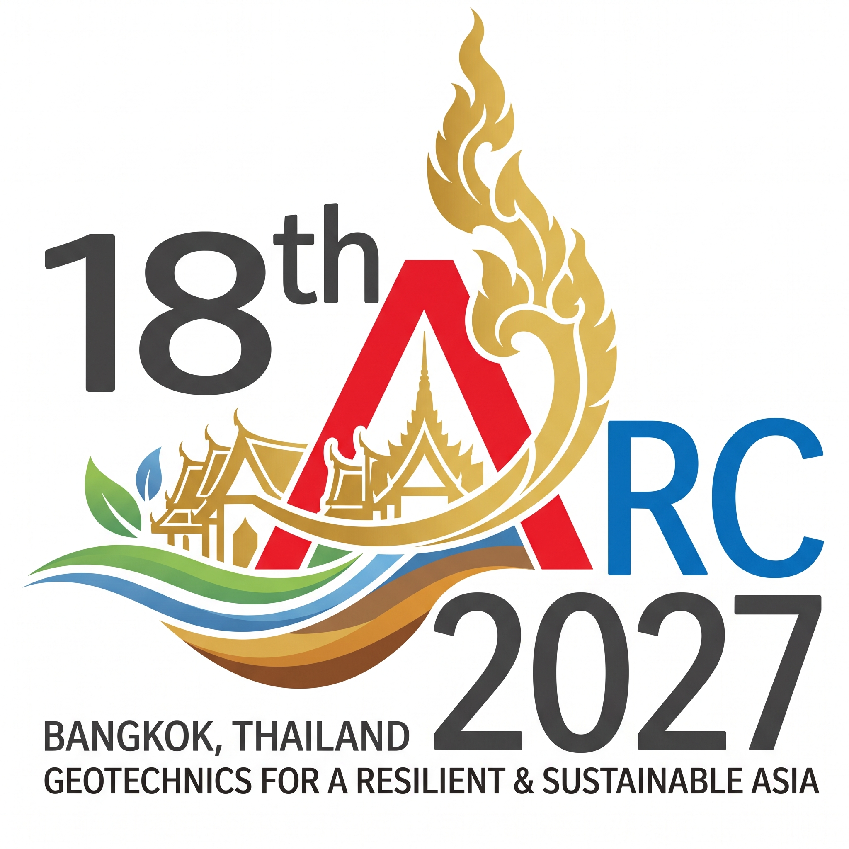
Fig. 1. Logo of 18ARC. (9pt, left aligned)

2.4 Texts
The text should be single-spaced, justified on two sides, in 10.5pt, and in two columns. The first line of each paragraph must be indented by 0.5 cm. Do not put an empty line between two adjacent paragraphs.

2.5 Equations
Equations must be numbered consecutively, using Arabic numbers in parentheses.
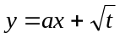 (1)
Equations must be centered with equation numbers aligned to the right. Please keep a 6pt space above and below each equation away from the surrounding texts. Equations should be cited in the text using the equation numbers, e.g., Eq. (1).

2.6 Figures and tables
For tables and figures (such as Table 1 and Fig. 1), their captions should be in 9pt and aligned to the left. Please keep an empty line above and below each table/figure away from the surrounding texts.

2.7 Format for references
References should be introduced in the text using the authors-year format, e.g., Meyerhof (1963) and (Marcuson et al. 1992; Baecher and Christian 2003).

3 Conclusion
Conclusions summarize the findings.

ACKNOWLEDGEMENTS (10.5pt uppercase, bold) (12 pt spacing above and 6 pt spacing below)
Acknowledgements should be written here.

REFERENCES (10.5pt uppercase, bold) (12 pt spacing above and 6 pt spacing below)
Meyerhof, G. G. (1963). Some recent research on the bearing capacity of foundations. Canadian Geotechnical Journal, 1(1), 16-26. (9pt)
Marcuson, W.F., Hynes, M.E., and Franklin, A.G. (1992). Seismic stability and permanent deformation analyses: The last twenty-five years. Proc., Stability and Performance of Slopes and Embankments II, ASCE, New York, 552-592.
Baecher, G. B. and Christian, J. T. (2003). Reliability and Statistics in Geotechnical Engineering, Wiley, Chichester, U.K.

