

A report on
Predict passenger booking cancellations using historical travel and booking data.

Project Submitted By
Name | Reg. No. | Roll Number
Annapareddy Somu praveen kumar | 12312098 | 23

Submitting to Amanpal Singh Rayat

S.no | Table Of Contants | Pg.no
1 | introduction | 1-2
2 | Objectives | 2
3 | methodology | 4-5
4 | working | 4-6
5 | output | 7-9
6 | Advantages and disadvantages | 9
7 | applications | 9
8 | Conclusion | 9-10
9 | Future scope | 10
10 | References | 11
11 | Github link | 11

Abstract
This project focuses on predicting passenger no-shows using historical booking and travel data with the help of machine learning techniques implemented in PySpark. Passenger no-shows and last-minute cancellations are major challenges in transportation systems such as airlines, railways, and bus services, as they result in empty seats, inefficient resource utilization, and significant financial losses for service providers.
The dataset used in this project consists of multiple attributes including passenger booking details, travel type, ticket price, discount values, trip purpose, and customer behavior indicators. These features play a crucial role in determining whether a passenger is likely to cancel a booking. The dataset is initially loaded into a PySpark DataFrame, which allows efficient processing of large-scale data using distributed computing.
Data preprocessing is an essential step in this project. It includes handling missing values, removing duplicate records, filtering inconsistent data entries, and converting data types into appropriate formats. These steps ensure that the dataset is clean, reliable, and suitable for further analysis.
Feature engineering is performed to transform raw data into meaningful inputs for the machine learning model. Categorical variables such as vehicle type, trip reason, and customer category are converted into numerical form using encoding techniques like StringIndexer. Additionally, relevant features are selected and combined into a feature vector using VectorAssembler, which is required for PySpark machine learning models.
A Logistic Regression model is used for classification, as it is suitable for binary outcomes such as cancellation and non-cancellation. The model is trained on the processed dataset and learns patterns that influence passenger behavior. It calculates probabilities and assigns class labels based on a threshold.
The performance of the model is evaluated using metrics such as Accuracy and ROC-AUC. Accuracy measures the overall correctness of predictions, while ROC-AUC evaluates the model’s ability to distinguish between classes. Visualization techniques such as Confusion Matrix and ROC Curve are used to provide a clear understanding of model performance.

1.Introduction
1.1 Background
The transportation industry has undergone a significant transformation with the adoption of digital technologies and online booking systems. Every day, a large volume of passenger data is generated, including booking details, travel preferences, pricing information, and user behavior patterns. This data provides valuable insights that can be utilized to improve operational efficiency and decision-making processes.
One of the major challenges faced by transportation systems is the issue of passenger no-shows and cancellations. When passengers cancel their bookings at the last moment or fail to show up, it results in unused seats and revenue loss. This not only affects the financial performance of the organization but also leads to inefficient utilization of resources such as vehicles, staff, and fuel.
Traditional methods used to manage cancellations are often based on historical averages or manual estimation. These methods lack accuracy and are not capable of handling large and complex datasets. As a result, they fail to provide reliable predictions.
With the advancement of big data technologies, tools such as PySpark have emerged as powerful solutions for processing and analyzing large-scale datasets. PySpark enables distributed data processing, allowing faster computation and scalability.
In this project, historical booking data is analyzed using PySpark, and a machine learning model is developed to predict passenger no-shows. This approach provides a data-driven solution to improve planning and reduce uncertainty in transportation systems.

1.2 Importance of Passenger No-Show Prediction
Passenger no-show prediction is a critical aspect of modern transportation systems. Accurate prediction of cancellations enables organizations to take proactive measures and improve overall efficiency.
One of the primary benefits of predicting no-shows is improved seat management. Transportation providers can implement strategies such as controlled overbooking, ensuring that seats are not left empty. This leads to increased revenue and better utilization of resources.
Another important advantage is improved operational planning. By understanding passenger behavior, companies can adjust schedules, allocate staff efficiently, and optimize resource usage. This reduces operational costs and enhances productivity.
Prediction systems also contribute to improving customer satisfaction. By managing bookings effectively, companies can minimize delays and provide better service quality. Additionally, identifying patterns in passenger behavior allows organizations to offer personalized services and incentives.
Machine learning-based systems provide a more accurate and reliable approach compared to traditional methods. They analyze large volumes of historical data and identify hidden patterns that are not easily visible through manual analysis.
The use of PySpark further enhances the system by enabling efficient processing of large datasets. This makes the solution scalable and suitable for real-world applications.

1.3 Related Concepts and Technologies
This project is based on the integration of big data processing and machine learning techniques. PySpark, which is the Python API of Apache Spark, is used for distributed data processing and analysis. It allows handling of large datasets across multiple nodes, improving performance and efficiency.
PySpark DataFrames provide a structured way to store and manipulate data. They support various operations such as filtering, aggregation, and transformation, which are essential for data preprocessing.
Feature engineering is a critical step in machine learning. It involves transforming raw data into meaningful features that can improve model performance. In this project, categorical variables are converted into numerical form using StringIndexer, and relevant features are selected for analysis.
VectorAssembler is used to combine multiple features into a single vector column. This is required because PySpark machine learning models accept input in vector format.
Logistic Regression is used as the classification algorithm. It works by estimating probabilities using a sigmoid function and is suitable for binary classification problems.
Model evaluation is performed using metrics such as Accuracy and ROC-AUC. These metrics provide insights into the performance and reliability of the model.
This project demonstrates how big data tools and machine learning techniques can be combined to develop intelligent systems for predicting passenger behavior and improving decision-making.

2. Objectives

- To design and develop an advanced predictive system that accurately identifies passenger no-shows using historical booking and travel data.
- To leverage the capabilities of PySpark for efficient handling and processing of large-scale datasets through distributed computing techniques.
- To perform comprehensive data preprocessing, including handling missing values, eliminating duplicate records, and correcting inconsistent data entries to ensure high data quality.
- To apply feature engineering techniques for transforming raw data into meaningful and relevant features that significantly improve model performance.
- To convert categorical attributes into numerical representations using encoding methods such as StringIndexer for effective machine learning model training.
- To develop a Logistic Regression model capable of accurately predicting passenger no-show behavior based on historical patterns.
- To evaluate the model performance using multiple evaluation metrics such as Accuracy and ROC-AUC to ensure reliable and robust predictions.
- To visualize model outcomes using graphical representations such as Confusion Matrix and ROC Curve for better interpretability and decision-making.
- To build a scalable and adaptable system that can be extended and integrated into real-world airline or transportation management systems.
- To highlight the significance of Machine Learning and Big Data Analytics in addressing and solving real-world operational challenges in the transportation industry.

3. Methodology

3.1Methodology
The methodology of this project involves a sequence of steps including data collection, preprocessing, feature engineering, model building, and evaluation using PySpark. The entire process is designed to handle large datasets efficiently and generate meaningful prediction of passenger no-show.

1.Data Collection

- The dataset consists of historical booking data collected from transportation systems.
- It includes features such as ticket price, travel type, discount, and trip purpose.
- The dataset is stored in a CSV format and loaded into a PySpark DataFrame.
- PySpark enables efficient handling of large datasets without memory limitations.

2. Data Preprocessing
- Missing values are identified and handled using appropriate techniques such as imputation or removal to ensure data completeness.
- Duplicate records are removed to maintain data integrity and avoid biased model training.
- Irrelevant columns such as unique IDs and personal details are dropped to reduce noise in the dataset.
- Data types are converted into appropriate formats to ensure compatibility with machine learning algorithms.
- Outliers are detected and handled carefully to improve the overall performance and stability of the model.
3. Feature Engineering
- Categorical variables are converted into numerical form using encoding techniques such as StringIndexer.
- Important features that influence passenger cancellation behavior are identified and selected.
- Additional derived features may be created to enhance prediction accuracy and model efficiency.
- The dataset is transformed into a structured and meaningful format suitable for machine learning analysis.
4. Feature Vector Creation
- VectorAssembler is used to combine multiple feature columns into a single feature vector.
- This step ensures compatibility with PySpark machine learning models and simplifies model input handling.
5. Model Building
- The dataset is divided into training (80%) and testing (20%) sets to evaluate model performance effectively.
- A Logistic Regression algorithm is used as the primary classification model.
- The model learns patterns and relationships between input features and passenger no-show behavior.
6. Model Evaluation
- Accuracy is used to measure the overall correctness of predictions.
- ROC-AUC is used to evaluate the model’s ability to distinguish between classes.
- Additional evaluation techniques can be applied for deeper performance analysis and validation.
7. Visualization
- A Confusion Matrix is used to analyze prediction results and identify classification errors.
- A ROC Curve is used to visualize the model’s performance across different thresholds.
- Visualization techniques help in clearly understanding model behavior and improving decision-making
4. Working

The system is designed to predict passenger no-shows (cancellations) using a structured pipeline built on PySpark. It utilizes historical booking data, including travel details, pricing, and customer behavior, to train a machine learning model and generate accurate predictions. Each stage of the system plays a crucial role in transforming raw data into meaningful insights.
Step 1: Initialize Spark Environment
- The system begins by creating a SparkSession, which serves as the entry point for all PySpark operations.
- It enables distributed processing, allowing efficient handling of large-scale passenger booking datasets.
- Provides access to Spark DataFrames and MLlib for performing machine learning tasks.
- The environment is configured with parameters such as application name and execution mode.
This step ensures the system is ready for scalable and efficient big data processing.
Step 2: Load Dataset
- The passenger booking dataset is loaded into a PySpark DataFrame.
- The dataset includes important features such as:
  - Source (From) and Destination (To)
  - Vehicle Type (Bus, Train, etc.)
  - Vehicle Class (AC / Non-AC)
  - Ticket Price
  - Coupon Discount
  - Trip Reason (Business / Personal)
  - Domestic / International Indicator
  - Cancellation Status (Target Variable)
- DataFrames allow efficient querying, filtering, and transformation operations.
This step converts raw booking data into a structured format suitable for analysis.

Step 3: Data Cleaning
- Missing values (e.g., price, discount) are handled using imputation or removal techniques.
- Duplicate records are removed to prevent bias in model training.
- Irrelevant columns such as booking IDs and user IDs are dropped.
- Inconsistent data (e.g., negative prices, incorrect entries) is filtered out.
This step improves data quality and ensures reliable model performance.

Step 4: Feature Transformation
- Categorical variables such as:
  - Vehicle Type
  - Vehicle Class
  - Trip Reason
  - Source and Destination are converted into numerical values using StringIndexer.
- Numerical features like ticket price and discount are retained and normalized if required.
- Relevant features influencing cancellation behavior are selected.
This step converts raw data into a machine-readable format for model training.

Step 5: Feature Vector Creation
- All transformed features are combined using VectorAssembler.
- Features such as price, discount, encoded vehicle type, and trip reason are merged.
- A single column called features is created to represent all input attributes.
This step prepares the dataset in the required format for PySpark ML models.

Step 6: Model Training
- The dataset is split into:
  - Training Data (80%)
  - Testing Data (20%)
- A Logistic Regression model is trained on the processed data.
- The model learns relationships such as:
  - Higher discounts → Increased cancellation probability
  - Business trips → Lower cancellation rates
  - Certain routes → Higher cancellation trends
- The model uses a sigmoid function to calculate probabilities and optimize weights.
This step enables the system to learn patterns from historical booking behavior.

Step 7: Prediction
- The trained model is applied to the test dataset.
- For each booking, the model generates:
  - Probability of cancellation
  - Predicted label (0 = Not Cancelled, 1 = Cancelled)
- Predictions are compared with actual values for performance analysis.
This step demonstrates how well the model performs on unseen data.

Step 8: Evaluation
- The model is evaluated using key performance metrics:
  - Accuracy → Measures overall correctness of predictions
  - ROC-AUC → Measures classification capability
- A Confusion Matrix is used to analyze errors such as false positives and false negatives.
This step ensures the model is reliable and suitable for real-world deployment.

Step 9: Output Generation
- The final output is presented in a structured and interpretable format.
- The system displays:
  - Actual vs Predicted values
  - Accuracy and ROC-AUC scores
- Graphical representations include:
  - Confusion Matrix
  - ROC Curve
- Key insights derived:
  - Impact of ticket price and discounts on cancellations
  - Influence of trip purpose on passenger behavior
This step provides actionable insights and supports decision-making in transportation systems.

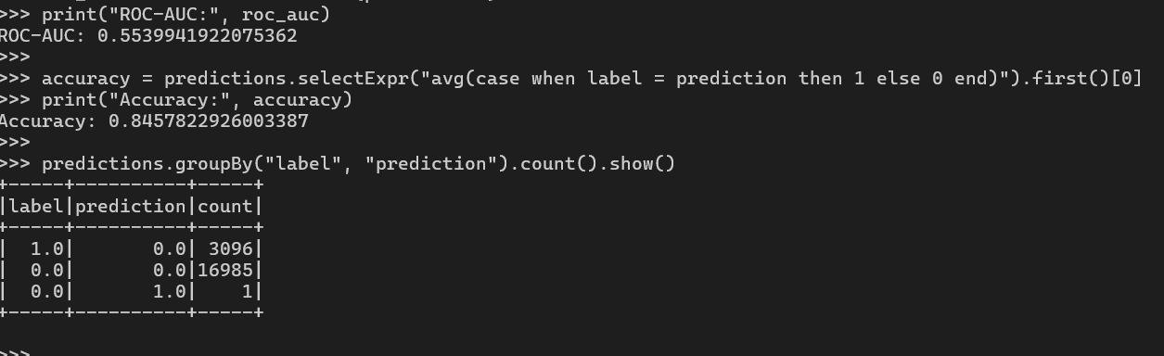
5.Output
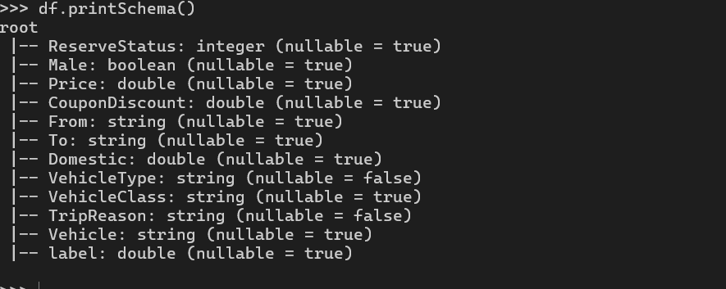
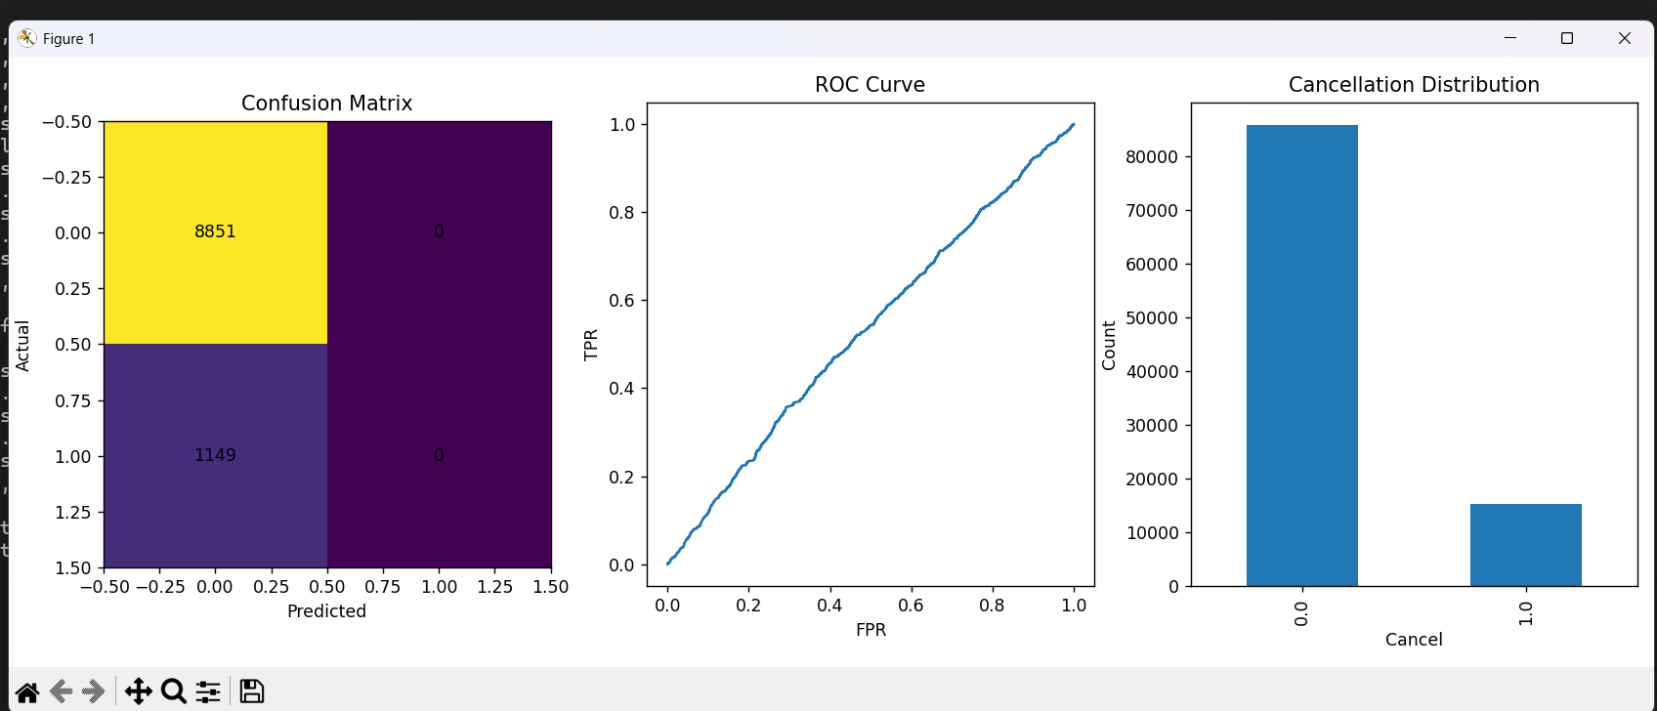

- The system generates predictions indicating whether a passenger is likely to cancel (no-show) or not.
- The results are presented in a structured tabular format containing:
  - Actual cancellation values
  - Predicted values generated by the model
- Evaluation metrics are displayed to assess performance:
  - Accuracy → Measures overall correctness of predictions
  - ROC-AUC → Evaluates the model’s ability to distinguish between classes
- Graphical outputs include:
  - Confusion Matrix → Helps identify correct and incorrect predictions
  - ROC Curve → Visualizes classification performance across thresholds
- Key insights derived from output:
  - Identification of patterns influencing cancellations
  - Understanding model strengths and weaknesses
  - Areas where prediction accuracy can be improved
Overall, the output provides both numerical and visual interpretation of model performance, enabling better analysis and decision-making.

6. Advantages and Disadvantages

Advantages
- Efficient handling of large-scale datasets using PySpark distributed computing.
- Faster data processing compared to traditional systems.
- Provides reliable prediction of passenger no-shows.
- Helps organizations in better planning and operational decision-making.
- Reduces financial losses caused by last-minute cancellations.
- Scalable architecture suitable for real-world transportation systems.
- Easy integration with existing booking and management platforms.
- Improves resource utilization such as seat allocation and scheduling.

Disadvantages
- Logistic Regression may fail to capture complex, non-linear patterns in data.
- Limited or incomplete features can reduce prediction accuracy.
- Requires proper setup and configuration of PySpark environment.
- Model performance is highly dependent on data quality and preprocessing.
- Current implementation is not optimized for real-time prediction.
- May require additional tuning and optimization for large production systems.

7. Applications
- Used in airline industries to predict passenger no-shows and optimize seat allocation strategies.
- Helps railway reservation systems improve ticket management and reduce unused capacity.
- Assists bus transportation services in route optimization and scheduling.
- Useful for online booking platforms to analyze customer behavior patterns.
- Supports smart transportation and urban mobility systems.
- Helps organizations minimize revenue loss due to cancellations.
- Can be integrated into travel analytics systems for better forecasting.
- Useful in demand prediction and capacity planning across transportation sectors.

8. Conclusion
This project successfully demonstrates the implementation of a passenger no-show prediction system using PySpark and machine learning techniques. By leveraging distributed computing, the system efficiently processes large volumes of booking data and transforms it into meaningful insights.
The application of data preprocessing techniques such as handling missing values, removing duplicates, and eliminating inconsistencies ensures that the dataset used for training is clean and reliable. Feature engineering and transformation further enhance the quality of input data, enabling the model to learn effectively.
The Logistic Regression model developed in this project is capable of predicting passenger cancellation behavior with a satisfactory level of accuracy. Evaluation metrics such as Accuracy and ROC-AUC confirm that the model performs well in distinguishing between passengers who are likely to cancel and those who are not.
The results clearly highlight the importance of data-driven decision-making in modern transportation systems. By accurately predicting no-shows, organizations can optimize seat utilization, improve scheduling efficiency, and reduce financial losses caused by cancellations.
Although the current model provides promising results, there is significant scope for further improvement. Incorporating more advanced algorithms, additional features, and real-time data processing can enhance prediction accuracy and system performance.
In conclusion, this project effectively showcases how machine learning and big data technologies can be applied to solve real-world challenges in the transportation domain.

9. Future Scope
- Implementation of advanced machine learning models such as:
  - Random Forest
  - Gradient Boosting
  - XGBoost
to improve prediction accuracy and capture complex patterns.
- Inclusion of additional features such as:
  - Time of booking
  - Weather conditions
  - Passenger travel history
  - Seasonal demand trends
- Development of real-time prediction systems using streaming data technologies like Spark Streaming.
- Integration with web or mobile applications to provide user-friendly interfaces and practical usability.
- Creation of interactive dashboards using visualization tools for better analysis and monitoring.
- Deployment of the system in real-world transportation environments for operational decision-making.
- Incorporation of deep learning techniques for enhanced predictive capabilities.
- Continuous model improvement using feedback loops and updated datasets.
These future enhancements will make the system more robust, accurate, and suitable for real-world deployment at scale.

10.REFERENCES
- Apache Spark Documentation, Apache Spark Official Website.
Available: https://spark.apache.org/docs/latest/
- PySpark Documentation, Apache Spark Python API Guide.
Available: https://spark.apache.org/docs/latest/api/python/
- Scikit-learn Documentation, Scikit-learn Official Documentation.
Available: https://scikit-learn.org/stable/documentation.html
- Logistic Regression – Hastie, T., Tibshirani, R., & Friedman, J.
The Elements of Statistical Learning, Springer, 2009.
- Han, J., Kamber, M., & Pei, J.
Data Mining: Concepts and Techniques, 3rd Edition, Morgan Kaufmann, 2011.
- Géron, A.
Hands-On Machine Learning with Scikit-Learn, Keras, and TensorFlow, O’Reilly Media, 2019.
- Python Software Foundation,
Python Documentation. Available: https://docs.python.org/3/
- Pedregosa, F. et al.
“Scikit-learn: Machine Learning in Python,” Journal of Machine Learning Research, 2011.
- Zaharia, M. et al.
“Apache Spark: A Unified Engine for Big Data Processing,” Communications of the ACM, 2016.
- Matplotlib Documentation,
Available: https://matplotlib.org/stable/index.html

11.Github link

