ProjectSphere Architecture Design Document

Introduction
This document describes the architecture implemented in the ProjectSphere project. ProjectSphere is a student portfolio and discovery application platform where students can register or sign in, maintain a profile, publish projects, search students, view project and profile details.
The document describes the architecture, technical stack, components, interfaces, data model

Technical Architecture
Web Client + API Server + Relational Database
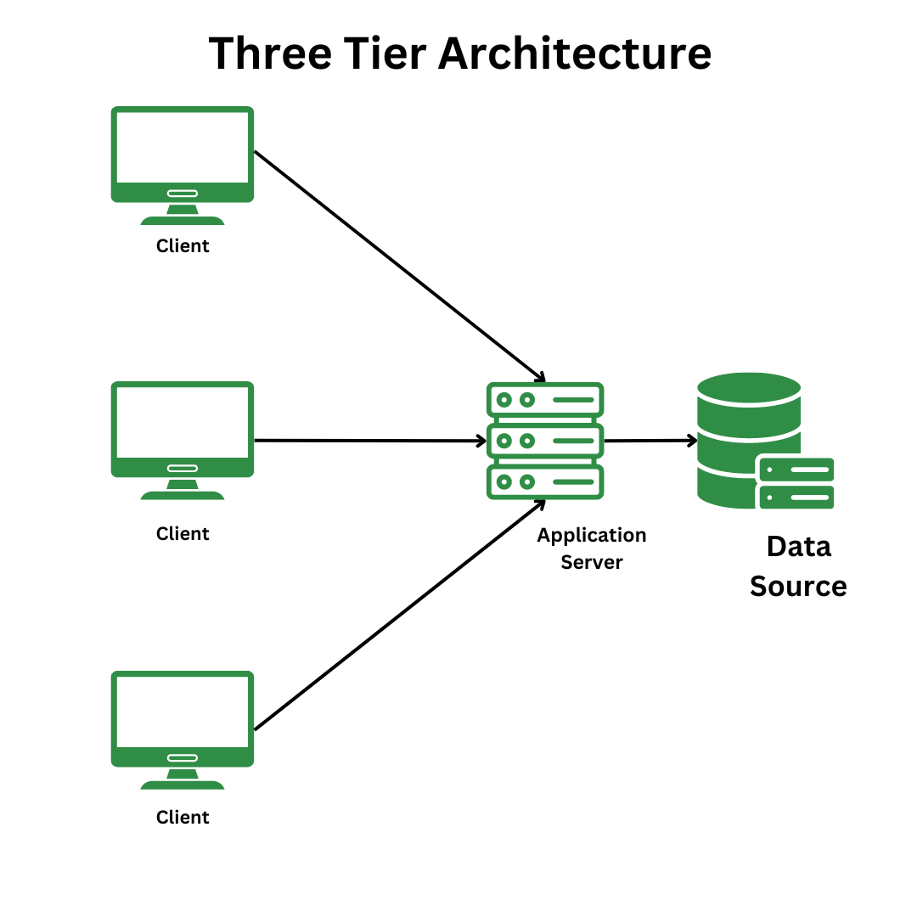

Technologies Used
Next.js 16, NestJS 11, PostgreSQL, Auth0

System Architecture

ProjectSphere is a web-based application composed of an independently running Next.js frontend and a NestJS API. The API connects directly to PostgreSQL. Auth0 supplies an optional identity-provider session, which the frontend synchronizes into the application database through a server-side Next.js route.

The application uses a three-tier web architecture. The frontend owns interaction and presentation; the API owns validation, business rules, and data access; PostgreSQL owns durable application data.
Layer | Components | Responsibilities
Presentation | Next.js App Router pages; React client components; CSS; Lucide icons | Registration, login, dashboard, discovery, favorites, profiles, project details, forms, rendering, and browser-local state.
Web integration | Next.js Auth0 proxy/middleware and /api/auth0/student-session route | Maintains Auth0 session middleware and relays authenticated identity data to the NestJS sync endpoint.
Application API | NestJS modules: Students, Projects, Database | REST endpoints, DTO validation, password hashing, search filtering, ownership checks, SQL operations, CORS, and global /api prefix.
Data | PostgreSQL via node-postgres Pool | students and project tables, primary/foreign keys, unique indexes, JSONB arrays and link objects.
External identity | Auth0 | OIDC-compatible external authentication flow through the Auth0 Next.js SDK.

Component interaction flows
Local registration and login
- The React registration or login form sends a JSON request to the NestJS API at /api/students/register or /api/students/login.
- NestJS applies DTO validation globally; registration also enforces a password policy and hashes the password with bcrypt (12 rounds).
- The Students service stores or verifies the student record in PostgreSQL and returns a public student view without password_hash.
- The browser stores the returned student profile in localStorage under projectsphere.student and uses it to gate client-side pages.
Auth0 sign-in synchronization
- The user starts Auth0 login or signup from the frontend and returns to /auth/sync.
- The Next.js server route reads the Auth0 session and posts identity details to POST /api/students/auth0-sync.
- The API finds a record by Auth0 subject or email, then links it or creates a placeholder-profile student record.
- The browser stores the synchronized public student object and navigates to the dashboard.
Project and discovery flow
- Client components call the NestJS project and student-search REST endpoints using NEXT_PUBLIC_API_URL.
- Project services validate payloads, verify referenced students, and query PostgreSQL. Student search joins projects to students and filters across identity, academic attributes, skills, and project titles.
- The API returns public DTO-shaped JSON, which pages render as cards, lists, forms, and project detail panels.
- Favorites are not written to the API; the browser stores profile and project identifiers in localStorage and fetches them on the favorites screen.

Frontend architecture
Route area | Key implementation | Behavior
/register and /login | Client-side forms | Local credential registration/login plus Auth0 entry points.
/auth/sync | Client component + Next.js route | Completes Auth0 session-to-student synchronization.
/dashboard | Dashboard component | Loads current student projects; creates new project records; displays project statistics.
/discover | Discover component | Searches students by text, college, department, degree, and skills.
/students/[id] | Student profile component | Loads a public profile and its projects in parallel.
/projects/[id] | Project detail component | Displays resources; allows the locally identified owner to edit or delete.
/profile and /favorites | Client components | Edits the current profile and presents browser-local saved profile/project lists.
The frontend is largely client-rendered. It relies on localStorage to hold the active student object and uses client-side redirects when that value is absent or invalid. API base URL configuration is public and defaults to http://127.0.0.1:4000.

Backend architecture
Module | Endpoints | Responsibilities
StudentsModule | POST register; POST login; POST auth0-sync; GET search; GET :id; PUT :id | Student lifecycle, bcrypt credentials, Auth0 account linkage, public profile mapping, and search.
ProjectsModule | GET projects; GET projects/:id; POST projects; PUT projects/:id; DELETE projects/:id | Project CRUD, student existence checks, simple project-owner comparison, and normalized project output.
DatabaseModule | Internal service | Creates a pg connection pool, initializes schema at application startup, exposes parameterized query execution, and closes pool on shutdown.
NestJS runs with a global /api prefix, configurable CORS origins, and a global ValidationPipe configured to transform inputs, whitelist accepted properties, and reject unrecognized properties. Database operations use parameterized SQL through node-postgres.

Data architecture
The database is initialized imperatively when the API starts. The schema has two primary entities with a one-to-many relationship from students to project.
Entity | Key fields | Notes
students | id, auth0_sub, username, name, institution_name, course, year, roll_number, email, contact_number, github_profile, skills, department, degree, password_hash, timestamps | Email is unique. Partial unique indexes protect non-null username and auth0_sub. skills is JSONB.
project | id, student_id, title, description, technologies_used, team_members, images, videos, documentation, external_links, timestamps | student_id references students(id) with ON DELETE CASCADE. Collection/link fields are JSONB.
Relationship: one student may own zero or more projects; every project belongs to exactly one student. Deleting a student cascades to their owned projects. The design stores media and links as external URLs rather than application-managed uploads.

API contract summary
Method and path | Purpose | Access behavior in current code
POST /api/students/register | Create a local student credential record | Public; validates registration attributes and password policy.
POST /api/students/login | Verify local credentials | Public; returns public student record after bcrypt verification.
POST /api/students/auth0-sync | Create or link Auth0 student | Public API endpoint; invoked by server-side Next.js route.
GET /api/students/search | Search student profiles | Public API endpoint; client UI requires localStorage student.
GET/PUT /api/students/:id | Read/update profile | Public API endpoint; PUT has no server-verified caller identity.
GET/POST /api/projects; GET/PUT/DELETE /api/projects/:id | List, create, view, edit, delete projects | Public API endpoints; update/delete compare supplied studentId to project owner but do not authenticate it.

Deployment Environment and configuration

Local development starts the frontend and API as separate processes. The frontend uses the Next.js scripts; the API uses ts-node with server/tsconfig.json. Production builds use next build and tsc -p server/tsconfig.json. The included docker-compose file provisions PostgreSQL 16 Alpine with a persistent named volume and exposes port 5432.
Configuration | Use
DATABASE_URL | PostgreSQL connection string required by the NestJS DatabaseService.
API_PORT | NestJS listening port; defaults to 4000.
FRONTEND_ORIGIN | Comma-separated CORS allowlist for browser frontend origins.
NEXT_PUBLIC_API_URL | Frontend-visible API base URL.
APP_BASE_URL and AUTH0_* | Next.js/Auth0 SDK application and identity-provider configuration.

