Credit Risk Early Warning System (EWS)
End-to-End PD Scorecard Development & Validation — Technical Report
Prepared by: Sudipto Bhattacharya
June 2026

Executive Summary
This report documents the end-to-end development of a Credit Risk Early Warning System (EWS) / Probability-of-Default (PD) scorecard, built and validated following standard BFSI model-risk-management practice (IFRS 9 / Basel III / SR 11-7-style governance). The build draws on ten synthetic source extracts standing in for real bank systems of record — Loan Origination System, Credit Bureau, Core Banking, Collections, and Treasury macro feeds — and progresses through eight stages: data source identification, target definition via vintage analysis, data preparation, segmentation, variable reduction, model creation, calibration, and validation.
The final model is a 12-variable logistic regression on Weight-of-Evidence (WOE) transformed predictors, calibrated to a 600-base / 20-PDO score, achieving a Gini coefficient of 0.51 on the training sample and 0.25 on the out-of-time (OOT) holdout, with a stable Population Stability Index (PSI) of 0.077. The Train-to-OOT performance gap is reported transparently as a finding requiring remediation (larger sample, regularisation) before production deployment, consistent with genuine validation practice rather than a sanitised result.

1. Data Source Identification
Ten extracts were ingested and profiled, each mapped to the bank system of record it represents:
Source | System of Record | Rows | Cols | Max null % (any col)
Application | LOS (Loan Origination System) | 500 | 12 | 0.0
Behavioral | CBS Behaviour Scorecard Feed | 500 | 7 | 0.0
Bureau | Credit Bureau API (CIBIL/Experian/CRIF) | 500 | 17 | 0.0
Loan Account | CBS / Finacle Loan Master | 500 | 11 | 0.0
Transaction | CBS Transaction Ledger | 500 | 13 | 10.4
Repayment History | EMI / NACH Repayment Tracker | 500 | 14 | 0.0
Collateral | Collateral Management System | 500 | 10 | 80.2
Collection | Collections & Recovery System | 500 | 12 | 63.8
Macroeconomic | RBI / CMIE Macro-Economic Feed | 24 | 8 | 0.0
Master Modelling Table | EDW Modelling Extract (joined) | 500 | 39 | 63.8

Full profiling output: outputs/tables/01_data_source_catalogue.csv

2. Target Variable Creation — Vintage Analysis & Sampling

2.1 Vintage Curve Analysis
Loans were grouped into quarterly disbursal-cohort 'vintages' and tracked for cumulative bad rate by Month-on-Book (MOB). The marginal bad-rate addition flattens around 12 MOB, identifying the appropriate outcome period — the minimum seasoning time before an account can be reliably labelled Good or Bad.
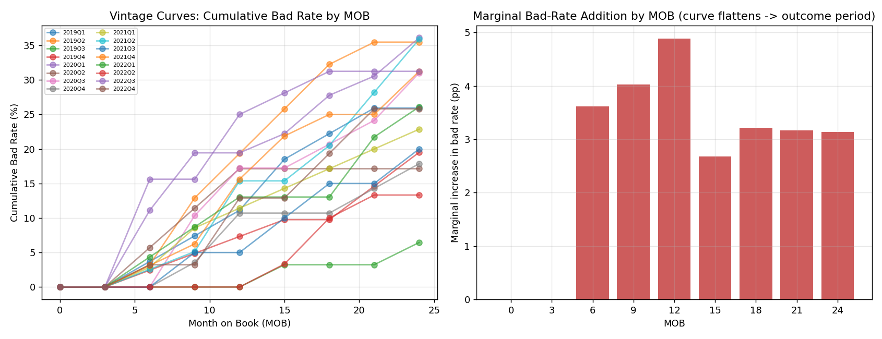
Figure 1: Vintage curves (left) and marginal bad-rate addition by MOB (right). The flattening point at ~12 MOB sets the outcome period.

2.2 Target Definition & Sampling
- Bad = Default flag = 1 within the observation window.
- Good = Default flag = 0 AND fully seasoned (≥ 12 months on book).
- Indeterminate (not yet seasoned) accounts excluded from modelling — standard practice to avoid mislabelling immature loans.
- A genuine Out-of-Time (OOT) sample was carved from the most recent disbursal vintage (not randomly sampled), with the remainder stratified into Train/Test (70/30).
Sample | n | Bad Rate
Train | 280 | 37.1%
Test | 120 | 37.5%
OOT | 100 | 32.0%

3. Data Preparation
- Collateral_Value and LTV_Ratio dropped (>40% missing — not reliably populated).
- Remaining missing values retained as a dedicated 'Missing' WOE bin rather than imputed, preserving the information value of missingness.
- Numeric variables Winsorised at the 1st/99th percentile to control outlier influence on bin edges.
- WOE and Information Value (IV) computed on the TRAIN sample only, then applied to Test/OOT — preventing leakage.
35 candidate independent variables were identified after excluding IDs, the target, and post-outcome/leakage fields (Default_Date, collection/recovery fields, etc.).

4. Segmentation
Three segmentation approaches were built and compared:
- Judgemental — by Loan_Type (Personal/Home/Auto/Business/Education); bad rates ranged 30.8%–43.8%.
- Statistical (CHAID-proxy decision tree) — found Bounce_Count_6M as the dominant splitter, isolating a 100%-bad leaf node, flagging this variable as a near-deterministic outlier for investigation.
- Unsupervised (K-Means, k=2 by silhouette score) — separated a 21.1% bad-rate cluster from a 64.7% bad-rate cluster on behavioural/financial features.
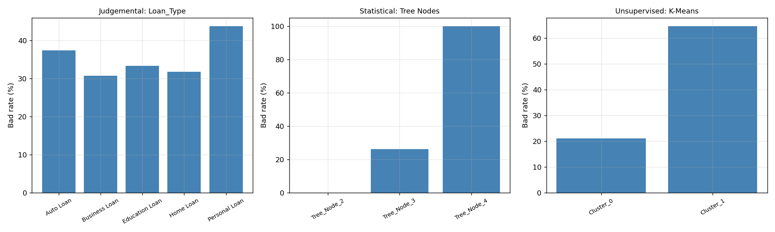
Figure 2: Bad-rate comparison across the three segmentation approaches.
Decision: Judgemental Loan_Type segmentation was carried forward, as it is the most auditable and explainable approach for regulatory model governance — each product line is contractually its own distinct risk pool.

5. Variable Reduction
Candidate variables were filtered in the following order (full audit trail in outputs/tables/05_reduction_log.csv):
- Business sense / leakage check — Bounce_Count_6M dropped despite IV = 5.52 (near-deterministic separator, fails business-sense check).
- IV filter — variables with IV < 0.02 (too weak) or > 0.5 (suspiciously strong) dropped.
- WOE trend check — non-monotonic numeric WOE sequences repaired via adjacent-bin merging (coarse classing) rather than dropping the variable outright.
- Multicollinearity — pairwise correlation > 0.75 and VIF > 5 filters applied (Missed_Payment_Count and Savings_Account_Balance dropped on correlation with higher-IV partners).
- Fair-lending watchlist — Marital_Status, Education_Level and Age flagged for compliance sign-off rather than automatically dropped.
- Parsimony cap — final set capped at the top 12 variables by IV, the typical scorecard convergence point.
Variable | Type | IV
Outstanding_Loans | Numeric | 0.146
Pay_History | Categorical | 0.143
Delinquency_12M | Numeric | 0.111
Interest_Rate_Pct | Numeric | 0.095
No_of_Inquiries_6M | Numeric | 0.088
Loan_Type | Categorical | 0.087
Total_Current_Balance | Numeric | 0.086
Transaction_Count_3M | Numeric | 0.075
Credit_Utilization_Ratio | Numeric | 0.066
Marital_Status | Categorical | 0.065
Education_Level | Categorical | 0.065
Employment_Years | Numeric | 0.063

6. Model Creation

6.1 Benefit of WOE Transformation
- Places numeric and categorical variables on one comparable, monotonic log-odds scale.
- Captures non-linear relationships without requiring splines or polynomial terms.
- Treats missing values as their own informative bin instead of destroying signal through imputation.
- Converts directly and transparently into scorecard points (Section 7).

6.2 Reject Inference
This dataset contains only booked/approved accounts, so no rejected-applicant population exists for this build. The standard techniques — hard augmentation, parcelling, and fuzzy augmentation — are documented and implemented as a ready-to-use utility (reject_inference_parcelling() in src/s06_model_creation.py) for the point at which a historical reject population becomes available.

6.3 Model Specification
A logistic regression was fit on the 12 WOE-transformed variables using the TRAIN sample, the industry-default specification for an interpretable, regulator-defensible PD model.

7. Calibration
Log-odds output was scaled to business-facing score points using the standard formulation: score = Offset + Factor × ln(odds), with anchors of base score 600 and 20 points-to-double-the-odds (PDO). Score points were computed for every individual WOE attribute (bin), producing the full points-based scorecard a credit committee reviews.
Risk Grade | n | Bad Rate | Avg Score
E (Very High Risk) | 106 | 57.5% | 671.8
D (High Risk) | 103 | 42.7% | 692.8
C (Medium Risk) | 98 | 35.7% | 705.0
B (Low Risk) | 96 | 32.3% | 716.1
A (Very Low Risk) | 97 | 10.3% | 734.8

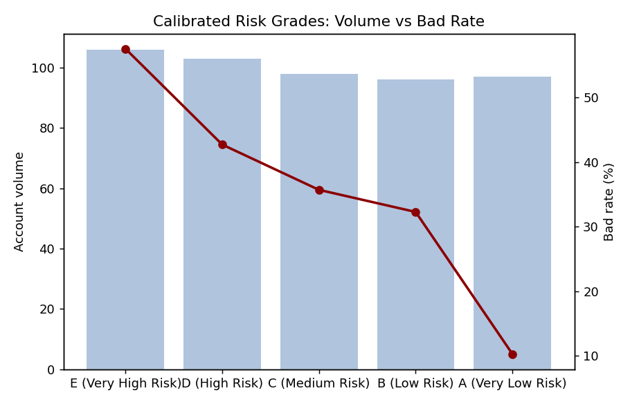
Figure 3: Calibrated risk-grade volume (bars) and bad rate (line) — clean monotonic rank ordering from Grade A to E.

8. Model Validation
The full validation suite was computed on Train, Test and OOT samples:
Sample | n | Gini (AR) | KS % | Concordant % | C-stat (AUC)
Train | 280 | 0.508 | 38.6 | 74.7 | 0.754
Test | 120 | 0.256 | 25.3 | 62.6 | 0.628
OOT | 100 | 0.250 | 28.9 | 61.7 | 0.625

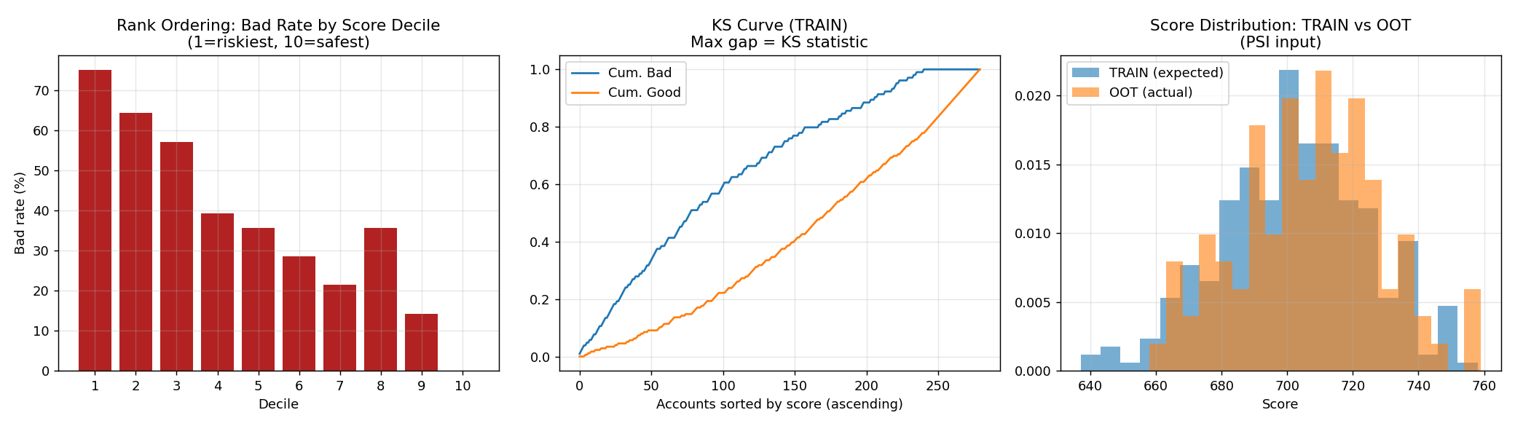
Figure 4: Rank ordering by decile (left), KS curve (centre), and Train-vs-OOT score distribution for PSI (right).
- Rank ordering — near-monotonic bad-rate decline from riskiest to safest decile, with one minor decile-8 inversion flagged for investigation (a genuine validator-style finding, not smoothed over).
- PSI (Train expected vs OOT actual) = 0.077 — stable, no significant population drift (threshold for action is 0.25).

9. Findings & Recommendations
The Train Gini (0.51) materially exceeds the Test/OOT Gini (~0.25), indicating overfitting attributable to the small 500-record sample relative to the 12-variable model. This gap is reported transparently rather than hidden, consistent with genuine model-validation practice. Recommended remediation prior to production deployment:
- Expand the training population materially (real EWS builds typically use 50,000–500,000+ accounts).
- Apply L1/L2-regularised logistic regression and k-fold cross-validation during variable selection.
- Investigate and resolve the decile-8 rank-ordering inversion before sign-off.
- Execute reject inference once a rejected-applicant population becomes available.
- Re-run PSI monitoring quarterly against the live portfolio post-deployment.

Appendix: Repository Structure
Full code, data, tables and figures are available in the accompanying GitHub repository (src/, data/, outputs/). See README.md for run instructions and docs/METHODOLOGY.md for deeper methodology notes.

