**Manav Rachna International Institute Of Research And Studies**

**WEB TECHNOLOGIES LAB**

**Assignment – 1**

***Name – Somya bhardwaj***

***Class – BCA AI ML (IB)***

***Roll No.–24/SCA/BCA(AI&ML)/066***

***Group - 2***

Q1. Create a simple html using basic tags.

Input:

<html>

<head><title>My first page </title>

</head>

<body>Sport is a form of physical acitivity or game, often competitive and organized,

Sports use, maintain, or improve physical ability and skills.

</body>

</html>

Output:

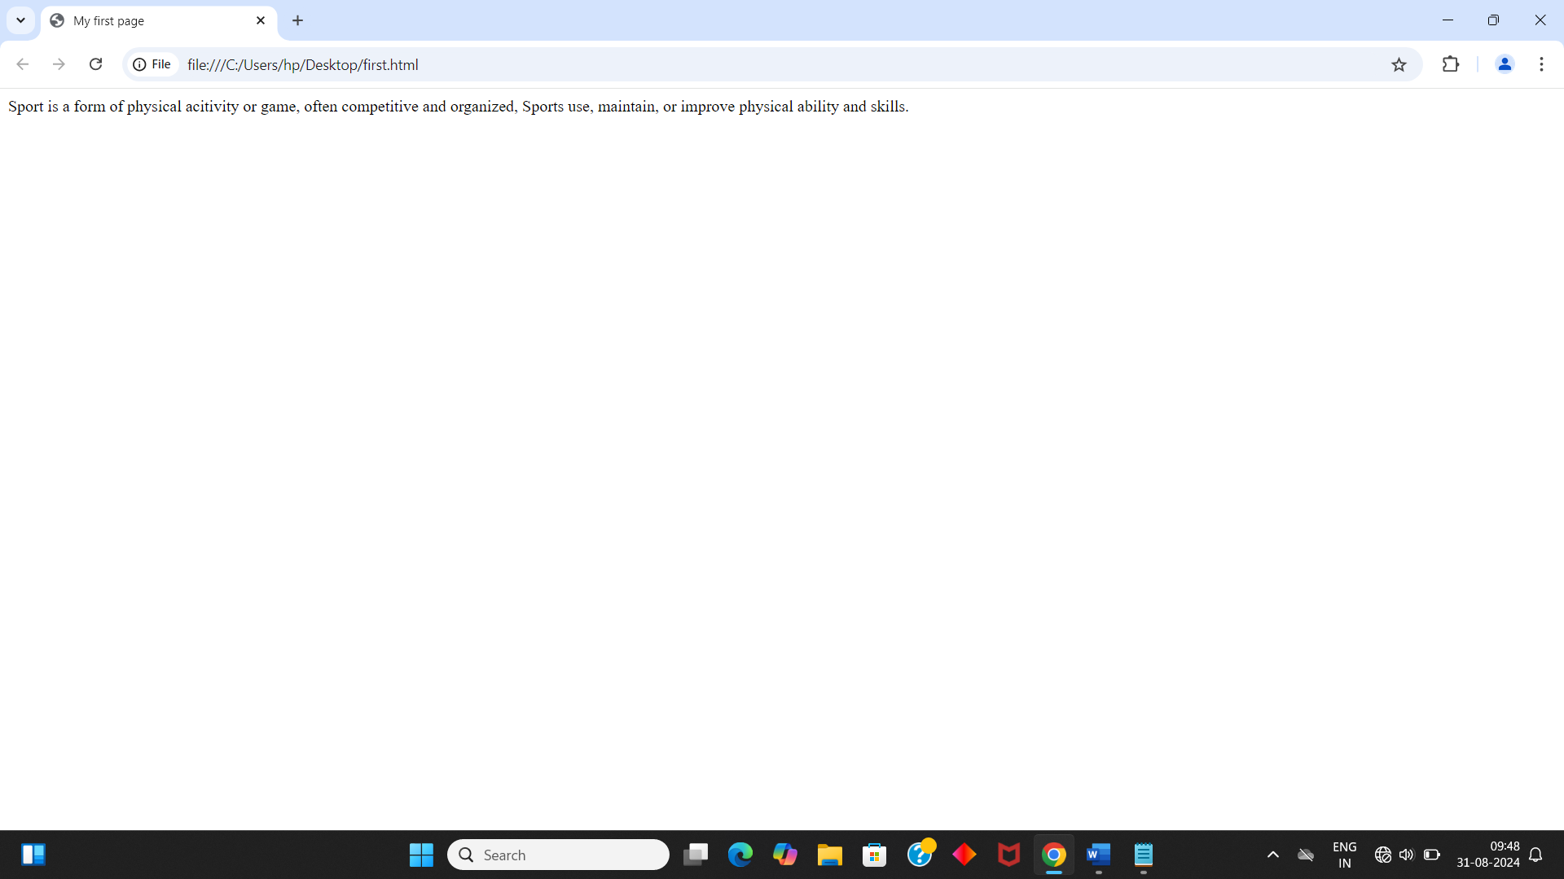

Q2. Create web page that displays your name to the screen.

Input:

<html>

<head><title>My first page </title>

</head>

<body>RAHUL (BCA AI ML) </body>

</html>

Output:

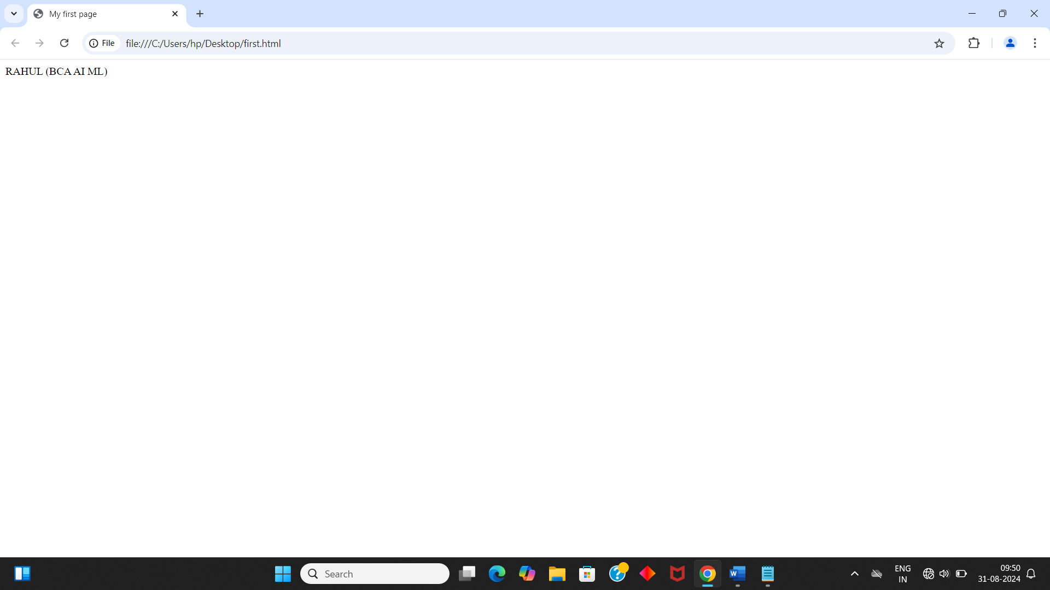

Q3. Create a web page and show the output from 1 to 10 in separate lines.

Input:

<html>

<head><title>My first page </title>

</head>

<body> 1<br>2<br>3<br>4<br>5<br>6<br>7<br>8<br>9<br>10</body>

</html>

Output:

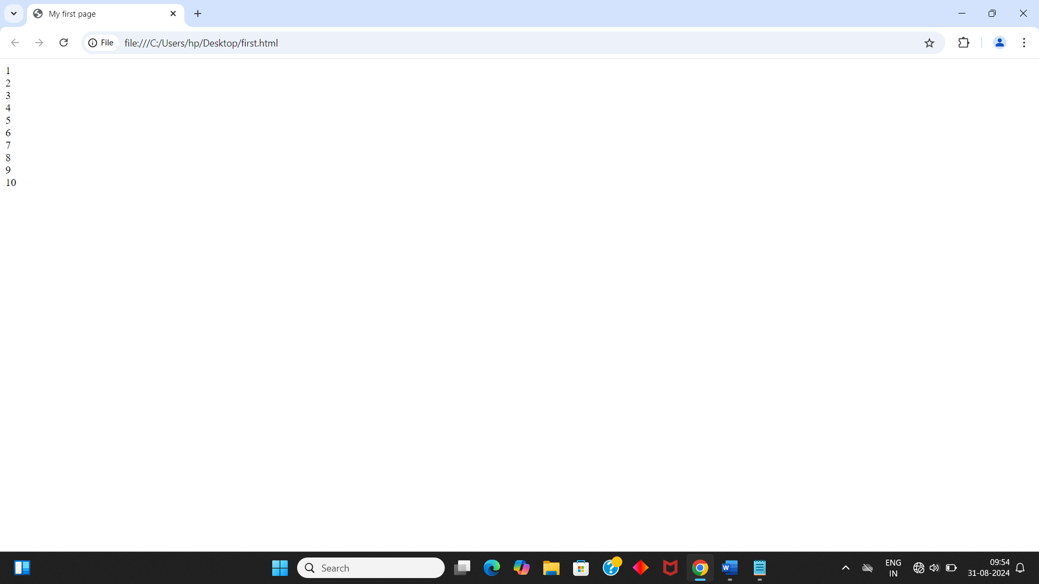

Q4. Create a web page and show the output from 1 to 10 in separate lines, each number being in different color.

Input:

<html>

<head><title>My first page </title>

</head>

<body> 1<br><font color='red'>2<br><font color='green'>3<br><font color='blue'>4<br><font color='orange'>5<br><font color='pink'>6<br><font color='brown'>7<br><font color='yellow'>8<br><font color='cyan'>9<br><font color='purple'>10</body>

</html>

Output:

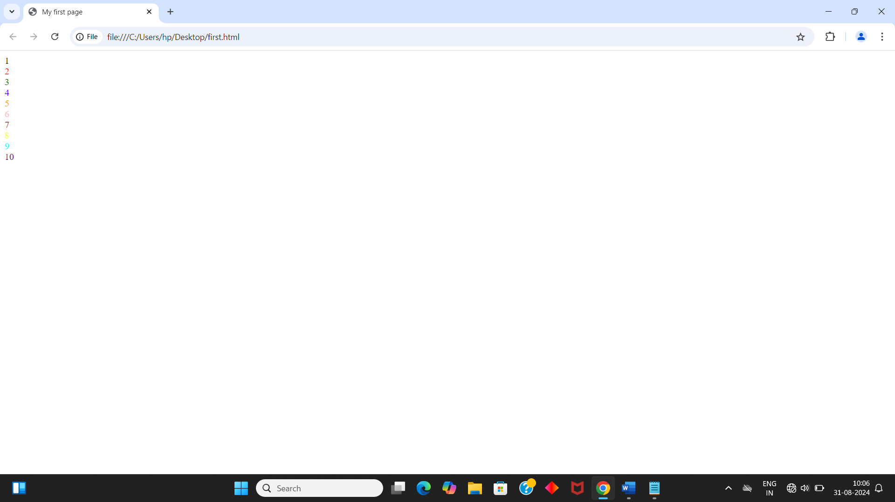

Q5. How do I make a picture as a background on my web pages?

Input:

<html>

<head><title>My first page </title>

</head>

<body background="https://cdn.britannica.com/48/252748-050-C514EFDB/Virat-Kohli-India-celebrates-50th-century-Cricket-November-15-2023.jpg"> 1<br><font color='red'>2<br><font color='green'>3<br><font color='blue'>4<br><font color='orange'>5<br><font color='pink'>6<br><font color='brown'>7<br><font color='yellow'>8<br><font color='cyan'>9<br><font color='purple'>10</body>

</html>

Output:

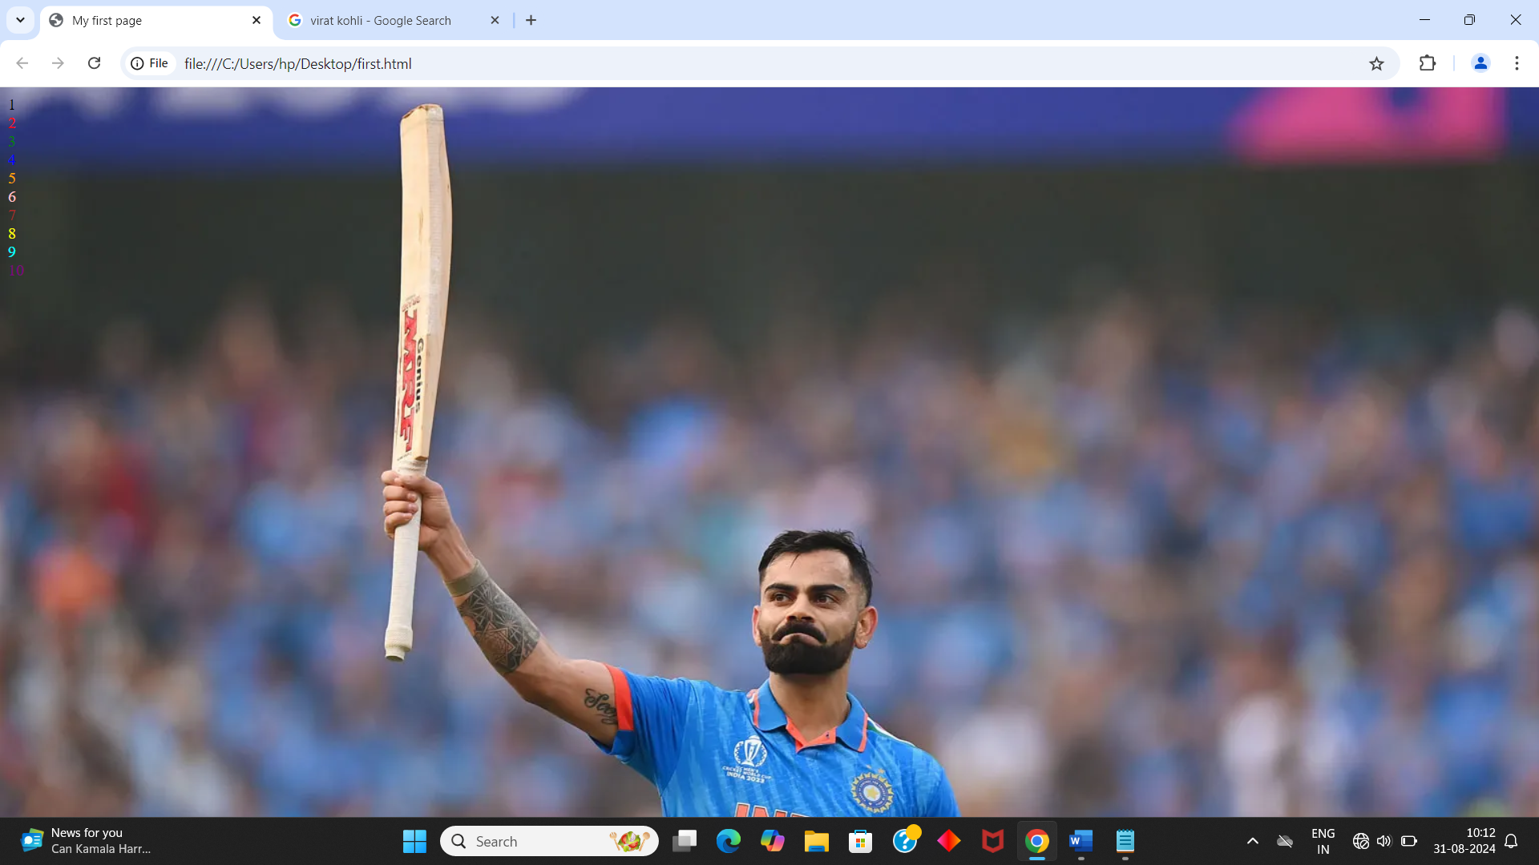

Q6. Create a web page to print a paragraph with 4-5 sentences, each sentence shall have a different font.

Input:

<html>

<head><title>My first page </title>

</head>

<body><font face="arial">Cricket is a bat-and-ball game that is played between two teams of eleven players on a field,<br></font>

<font face="georgia">at the centre of which is a 22-yard (20-metre; 66-foot) pitch with a wicket at each end,<br></font>

<font face="impact">each comprising two bails balanced on three stumps.<br></font>

<font face="courier">Two players from the batting team (the striker and nonstriker) stand in front of either wicket holding bats,</font>

<font face="gill sans">with one player from the fielding team (the bowler) bowling the ball towards the striker's wicket from the opposite end of the pitch.</font>

</body>

</html>

Output:

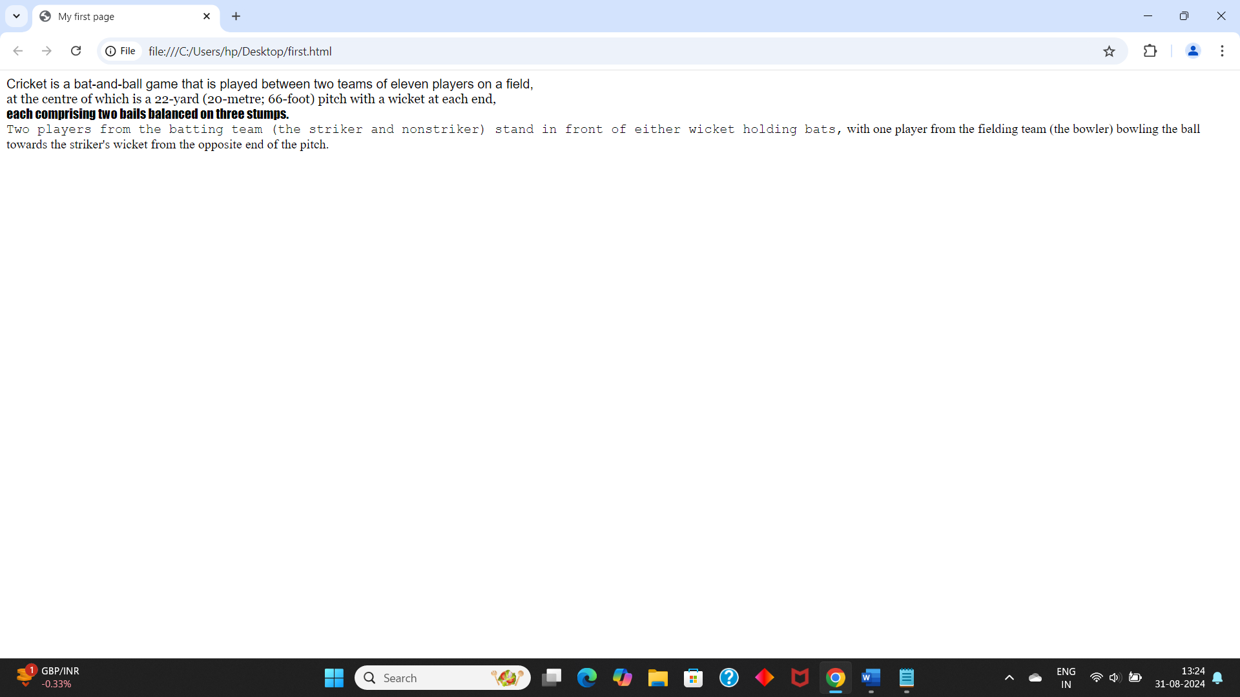

Q7. Write HTML code to print a paragraph that is description of a book, it shall include the title should be underlined and all adjectives shall be bold and italics.

Input:

<html>

<head>

<title>

Description

</title>

</head>

<body>

<center><h1>DRACULA</h1></center>

<br>

<h2><b><i>BRAM STOKER </i></b></h2>

<br>

Dracula is a gothic horror novel by Bram Stoker, published on 26 May 1897. An epistolary novel, the narrative is related through letters, diary entries, and newspaper articles. It has no single protagonist and opens with solicitor Jonathan Harker taking a business trip to stay at the castle of a Transylvanian nobleman, Count Dracula. Harker escapes the castle after discovering that Dracula is a vampire, and the Count moves to England and plagues the seaside town of Whitby.

- <u> DRACULA </u> WAS MY FAVOURITE CHARACTER AND <u> VAMPIRE </u> WAS <b> <u> AMAZING </b> </u>.

</body>

</html>

Output:

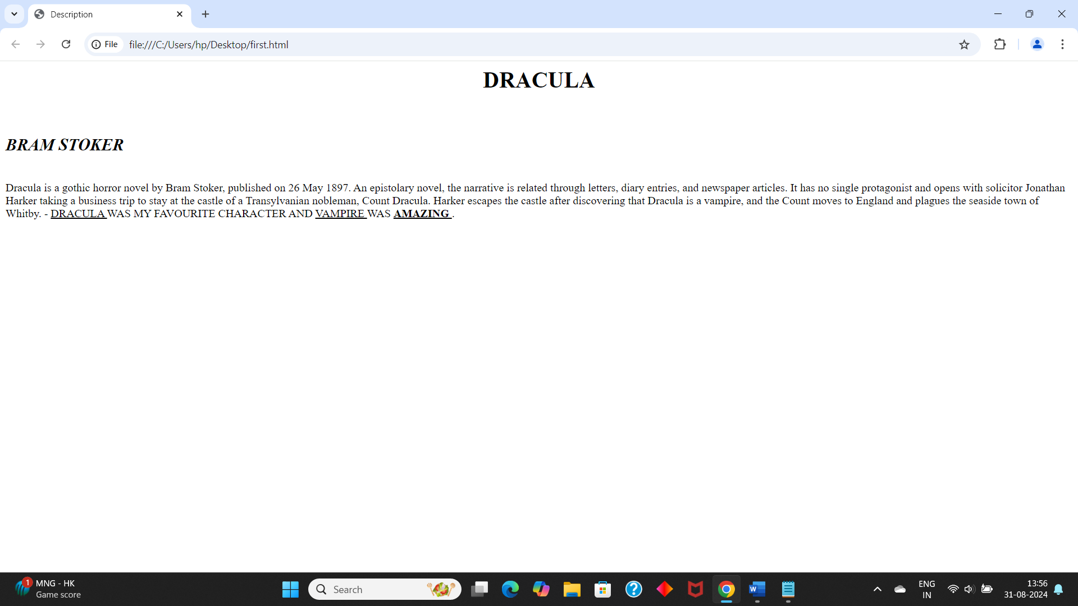

Q8. Write HTML code to print your name using Heading tag, every letter shall be of different heading size.

Input:

<html>

<head>

</head>

<body>

<h1>R</h1><H2>A</H2><H3>H</H3><H4>U</H4><H5>L</H5>

</body>

</html>

Output:

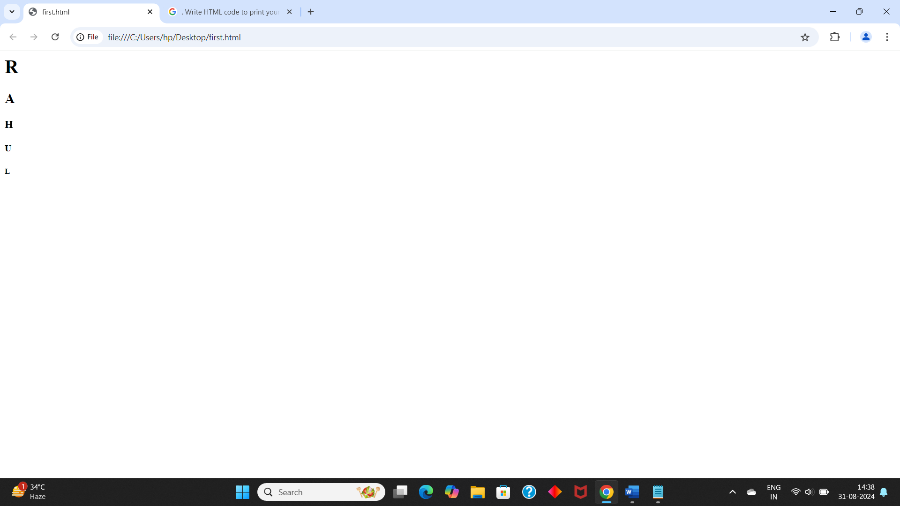

Q9. Write HTML code to print the sequence of numbers 1 – 20. Each number shall be in different line with number 2 next to it as subscript, an equal sign and the result.

Input:

<html>

<head>

<title> number sequence</title>

</head>

<body>

<p>1<sub>2</sub> = 1</p>

<p>2<sub>2</sub> = 4</p>

<p>3<sub>2</sub> = 9</p>

<p>4<sub>2</sub> = 16</p>

<p>5<sub>2</sub> = 25</p>

<p>6<sub>2</sub> = 36</p>

<p>7<sub>2</sub> = 49</p>

<p>8<sub>2</sub> = 64</p>

<p>9<sub>2</sub> = 81</p>

<p>10<sub>2</sub> = 100</p>

<p>11<sub>2</sub> = 121</p>

<p>12<sub>2</sub> = 144</p>

<p>13<sub>2</sub> = 169</p>

<p>14<sub>2</sub> = 196</p>

<p>15<sub>2</sub> = 225</p>

<p>16<sub>2</sub> = 256</p>

<p>17<sub>2</sub> = 289</p>

<p>18<sub>2</sub> = 324</p>

<p>19<sub>2</sub> = 361</p>

<p>20<sub>2</sub> = 400</p>

</body>

</html>

Output:

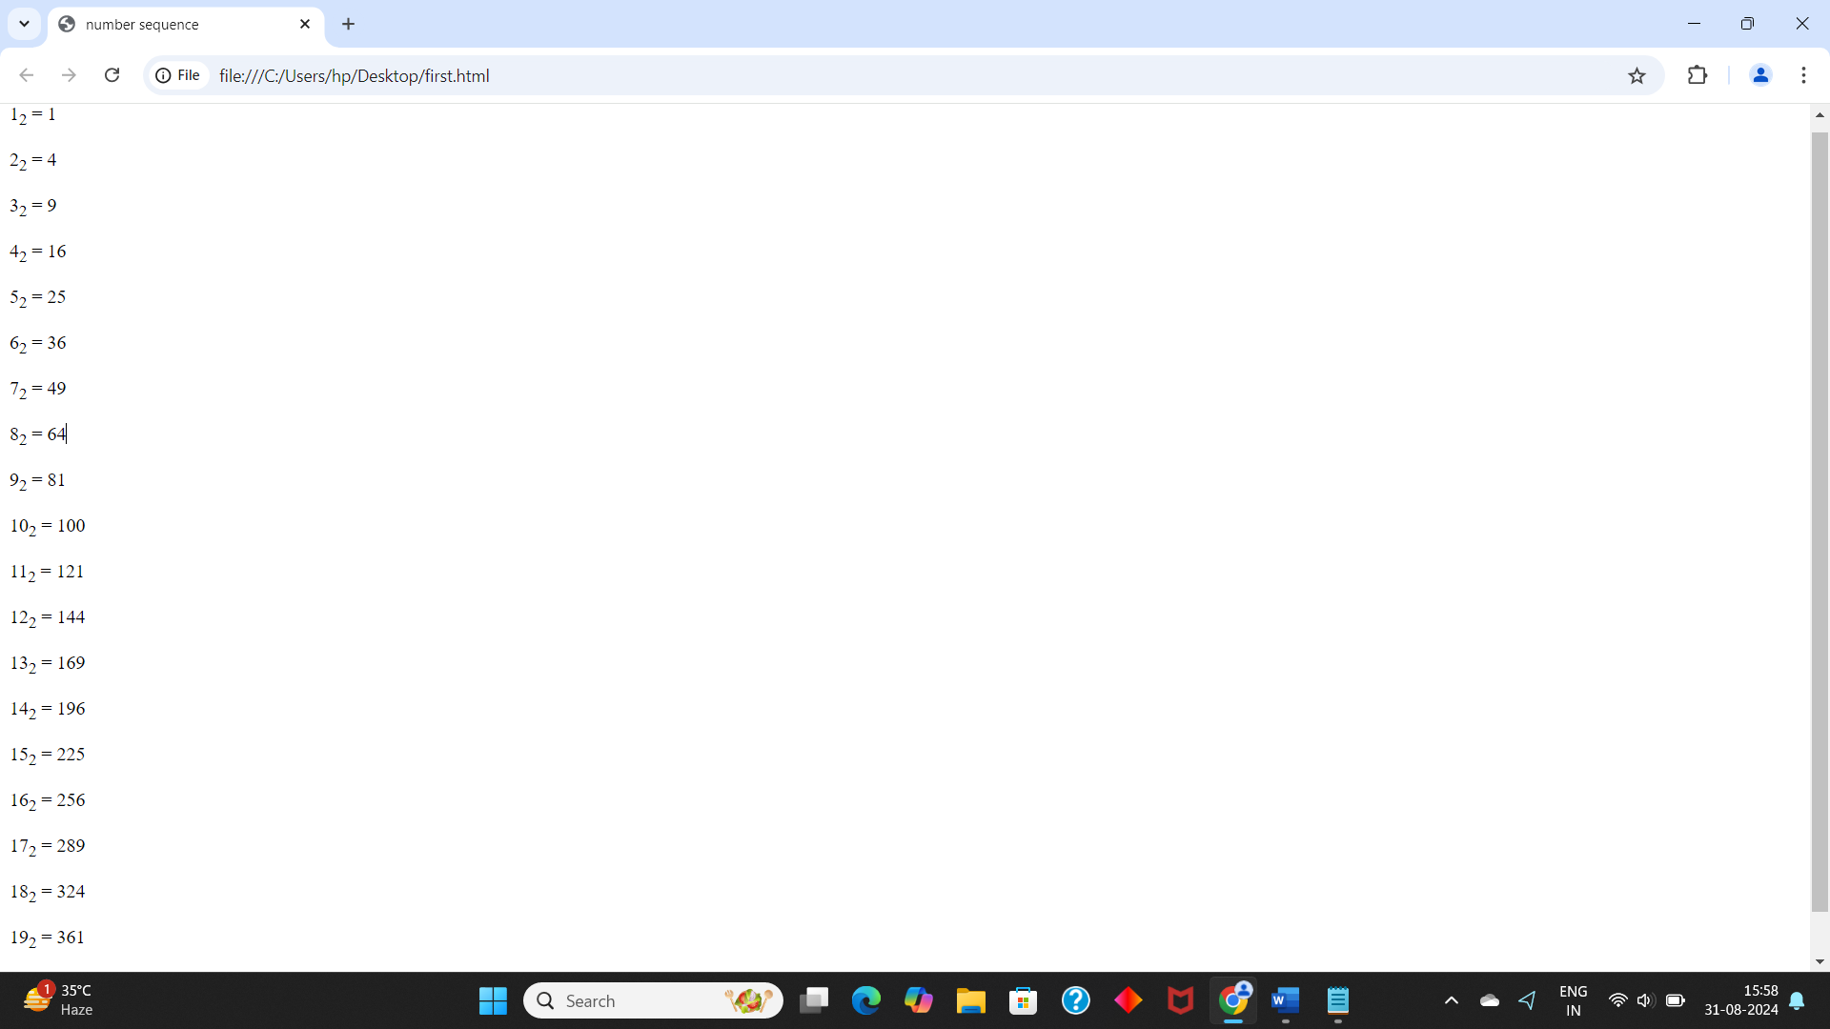

Output:

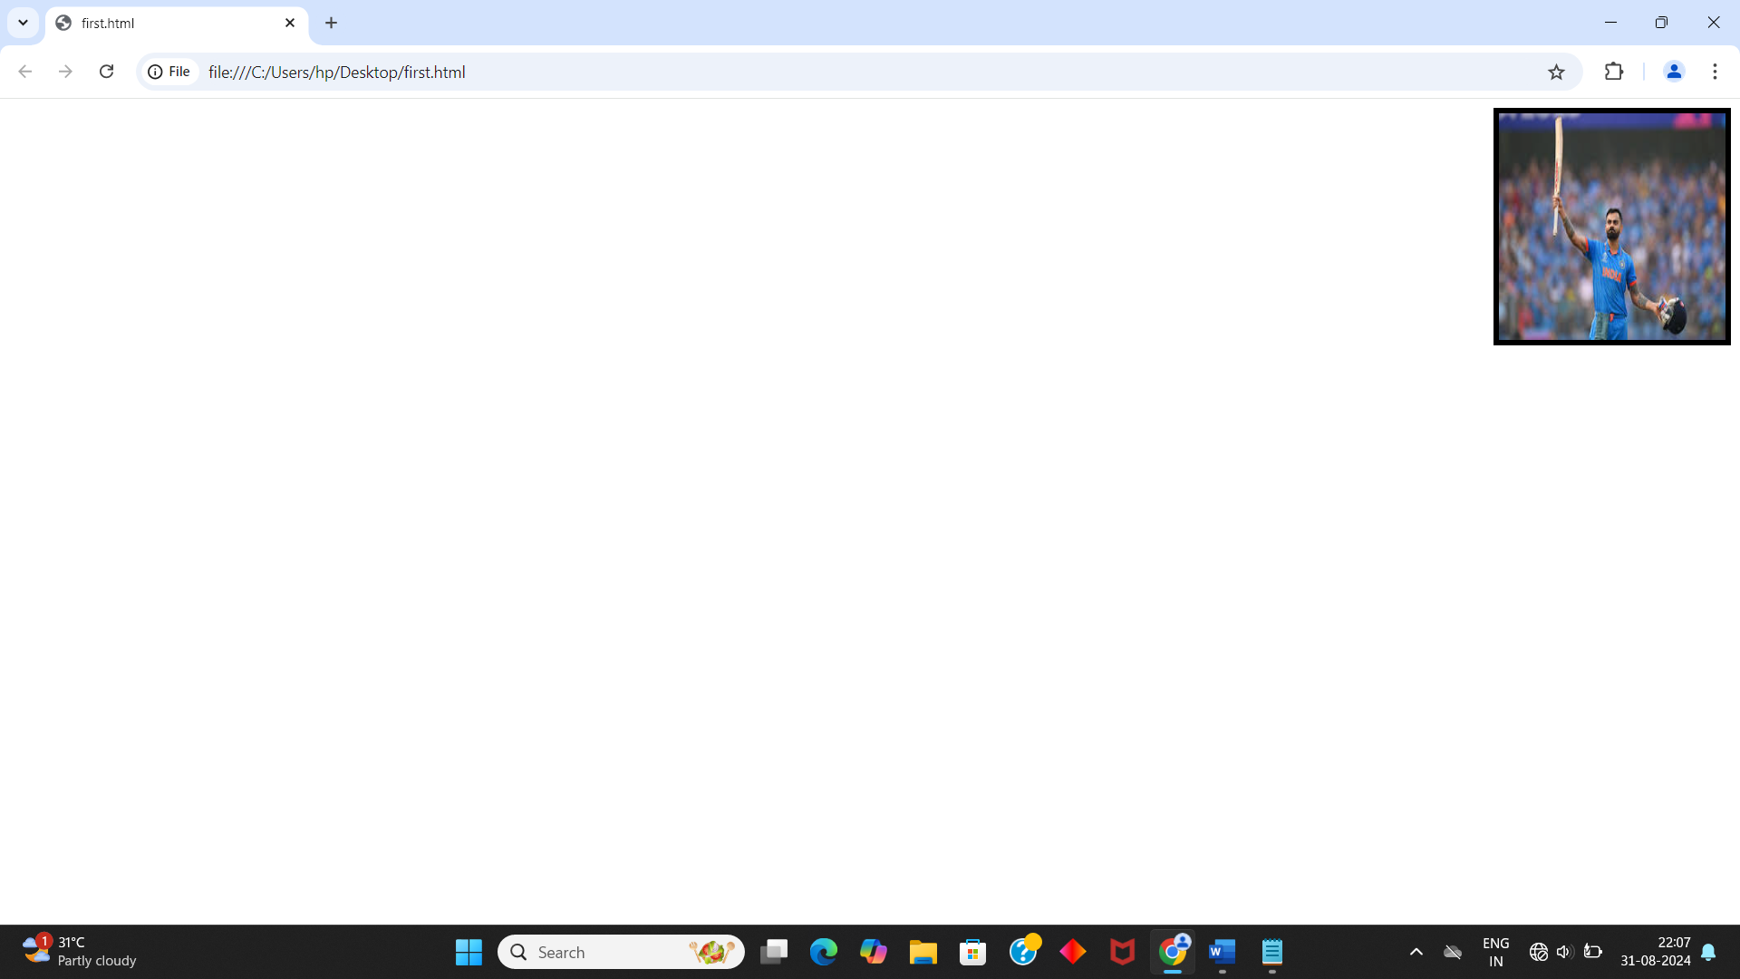

10. Write HTML code to display an image with border of size with width 200, height 200 pixels, leaving Hspace and Vspace of your choice with image hanging in the right side on the screen.

Input:

<!DOCTYPE html>

<html>

<head>

<title>Image Example</title>

</head>

<body>

<img src="your_image.jpg" alt="Image Description" width="200" height="200" style="border: 2px solid black; float: right; margin-left: 20px; margin-top: 20px;">

</body>

</html>

Output:

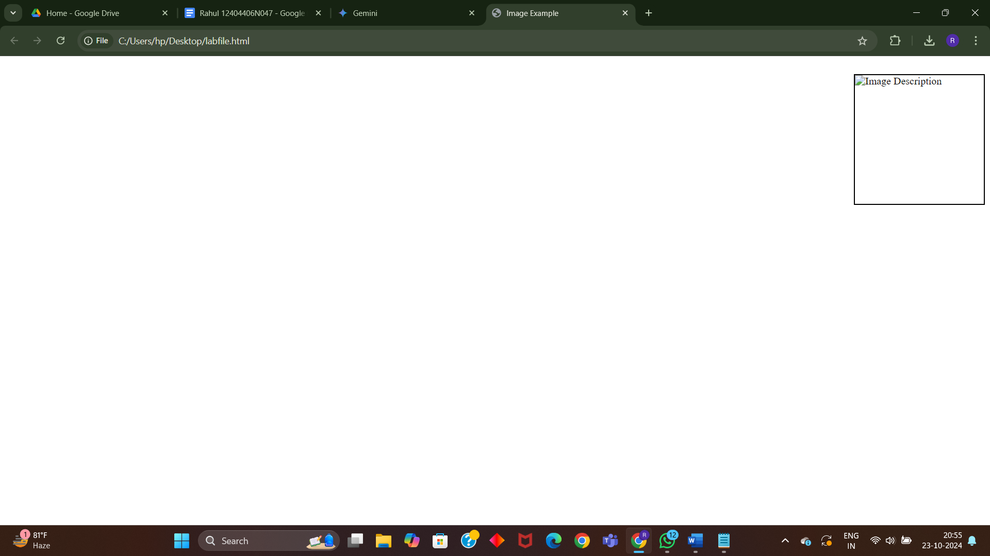

Q11. Write HTML code to create a web page with heading. The heading shall be displayed at the top-center of the page and the image shall be at the centre, just below the heading.

Input :

<html>

<head>web page </head>

<body>

<center><h1>VIRAT KOHLI</h1></center>

<center><img src ="https://im.rediff.com/cricket/2023/jan/17kohli1.jpg"height="300"width="300"></center></body>

</html>

Output :

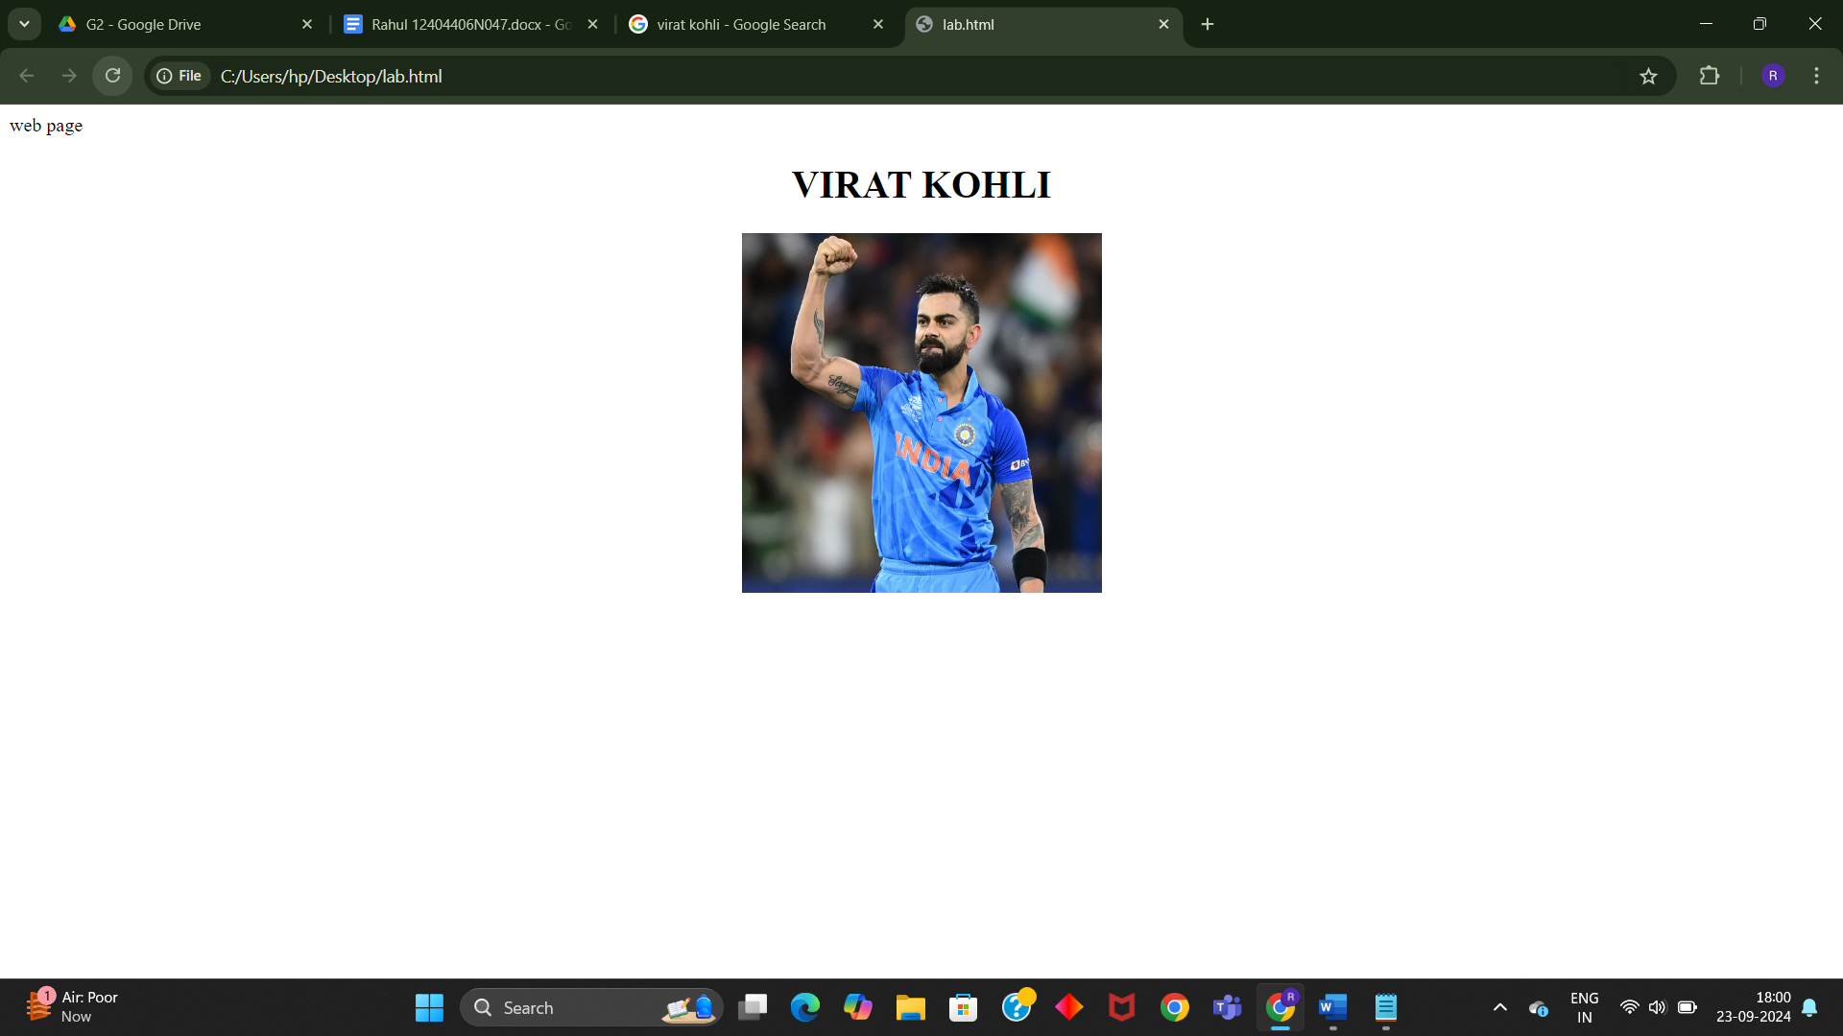

Q12. Write HTML code using Multimedia tags.

Input:

<html>

<head>

<title> multimedia tags</title>

</head>

<body>

<h1> multimedia tags: </h1>

<h1>img</h1>

<center>

<img src="C:\Users\Riaz\Downloads/OIP.jpg" alt="scenery" height="450" , width="450"/>

<h1> audio </h1>

<audio src="C:\Users\USER\Downloads/ringtone.mp3" controls/>

</body>

</html>

Output:

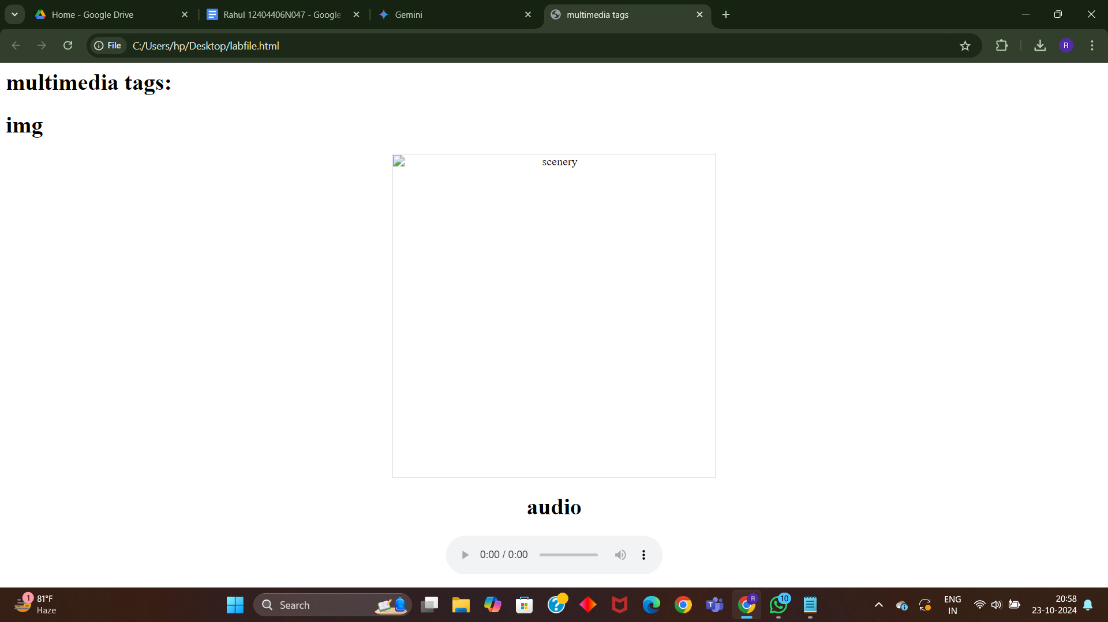

Q13. Create a Table using Rowspan and Colspan taking example of student Record .

Input:

<html>

<head></head>

<body>

<table border='4pt'>

<tr>

<th colspan='2'>Name</th>

<th>class</th>

<th>school</th></tr>

<tr>

<td rowspan='2'>mahatma</td>

<td rowspan='2'>gandhi</td>

<td> 11</td>

<td>mvps</td></tr>

<tr>

<td>A</td></tr>

<tr>

<td rowspan='2'>shree</td>

<td rowspan='2'>krishna</td>

<td> 3</td>

<td>nvps</td></tr>

<tr>

<td>B</td></tr>

<tr>

Q10. Write HTML code to display an image with border of size with width 200, height 200 pixels, leaving Hspace and Vspace of your choice with image hanging in the right side on the screen.

Input:

<html>

<head>

<title>

</title>

</head>

<body>

<img src="C:\Users\hp\Downloads\virat.jpeg" width="200"height="200"border="5px" align="right">

</body>

</html>

<tr>

<td rowspan='2'>bheem</td>

<td rowspan='2'>sen</td>

<td> J</td>

<td>avps</td></tr>

<tr>

<td>A</td></tr>

</table>

</body>

</html>

Output:

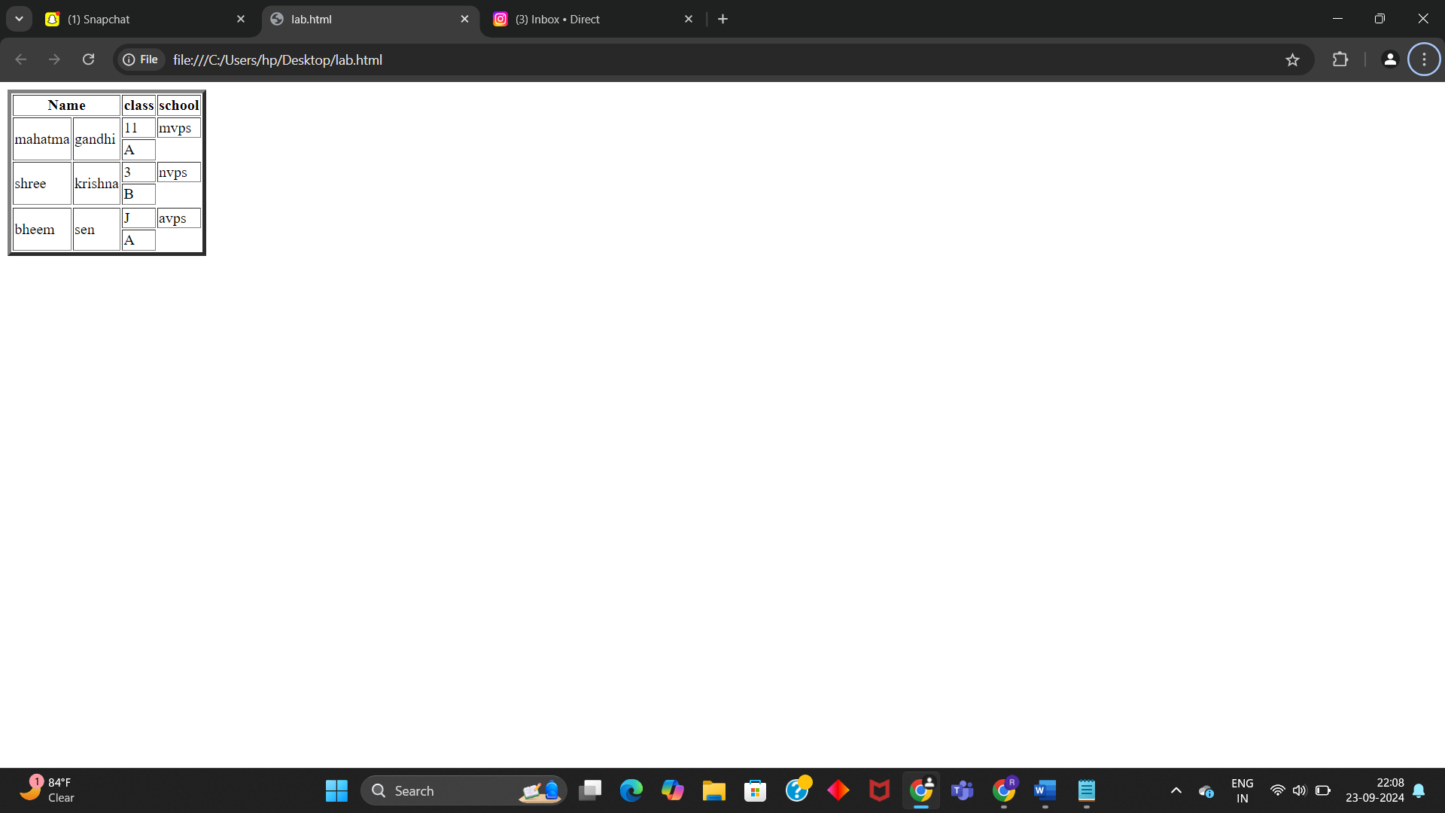

\

Q14.Write HTML code using table tag <table> and cellpadding and cell spacing as its attributes.

Input:

<html>

<head></head>

<body>

<table border="2pt" cellspacing="5pt" cellpadding="5pt">

<tr>

<th>S.no</th>

<th>Roll no.</th>

<th>Name</th>

<th>Address</th></tr>

<tr>

<td>1</td>

<td>123</td>

<td>ABC</td>

<td>FBD</td></tr>

<tr>

<td>2</td>

<td>456</td>

<td>XYZ</td>

<td>delhi</td></tr>

<tr>

<td>3</td>

<td>789</td>

<td>PQR</td>

<td>gurgaon</td></tr>

</table></body>

</html>

Output :

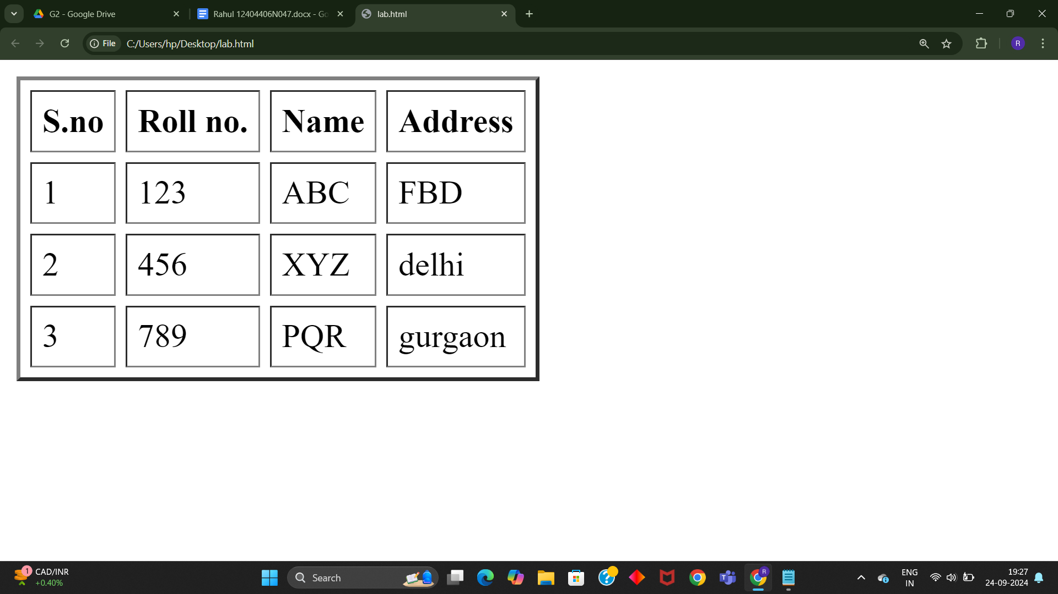

Q15. Create unordered, ordered and definition Lists taking example of your subjects in MCA IST, IInd and IIIrd Semester.

Input :

<html>

<head></head>

<body>

<h3> Subjects in BCA sem 1</h3>

<ol>

<li>Web technologies</li>

<ul>

<li>introduction to Networks</li>

<li>introduction to e-mail</li>

<li>introduction to html</li>

</ul>

<li>Introduction to IT & programming in C</li>

<ul>

<li>Input output devices</li>

<li>compilers,Interpreters,assemblers</li>

<li>various programs in C</li>

</ul>

<li>Mathematics</li>

<ul>

<li>matrices</li>

<li>surds and insurdes</li>

<li>trigonometry</li><ul><ol>

</body>

</html>

Output :

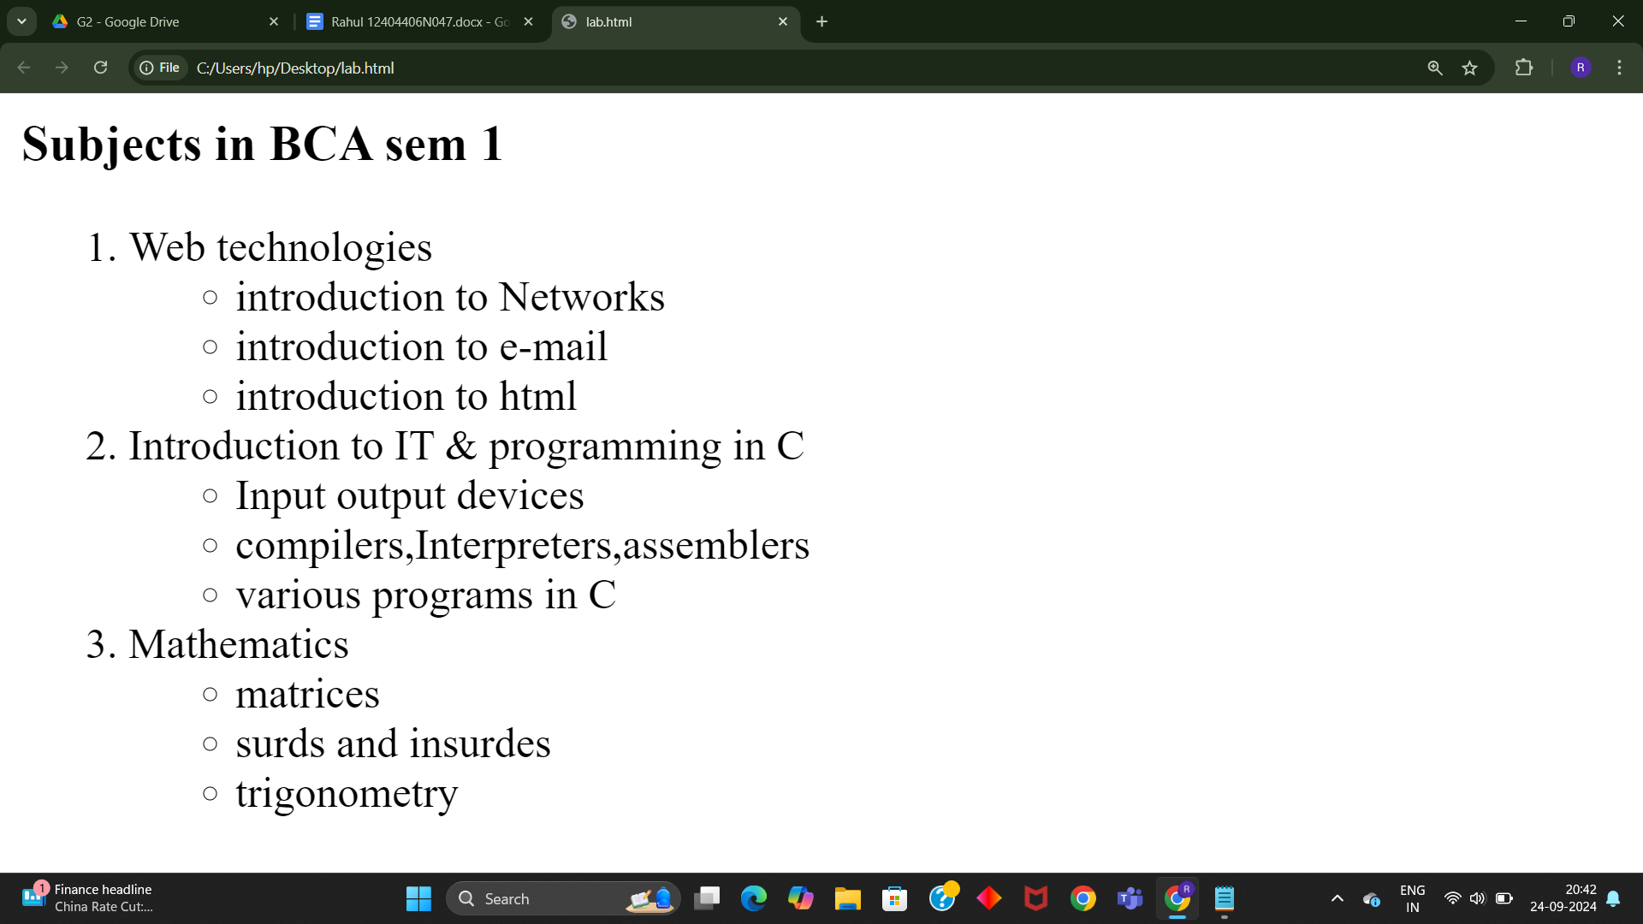

Q16.Write HTML code using <frameset> and <frame> tag with all its attributes .

Input :

Output :

Q17Write HTML code to design a form in HTML using controls and buttons such as Teaxtbox, Textarea, password, submit button, browse button, drop-down menu

Input :

<!DOCTYPE html>

<html>

<head>

<title>Form with Various Controls</title>

</head>

<body>

<h1>Registration Form</h1>

<form action="submit.php" method="post" enctype="multipart/form-data">

<label for="name">Name:</label>

<input type="text" id="name" name="name" required><br><br>

<label for="email">Email:</label>

<input type="email" id="email" name="email" required><br><br>

<label for="password">Password:</label>

<input type="password" id="password" name="password" required><br><br>

<label for="profile_pic">Profile Picture:</label>

<input type="file" id="profile_pic" name="profile_pic"><br><br>

<label for="country">Country:</label>

<select id="country" name="country">

<option value="india">India</option>

<option value="usa">USA</option>

<option

value="uk">UK</option>

</select><br><br>

<label for="message">Message:</label>

<textarea id="message" name="message" rows="5" cols="30"></textarea><br><br>

<input type="submit" value="Submit">

<input type="reset" value="Reset">

</form>

</body>

</html>

Output:

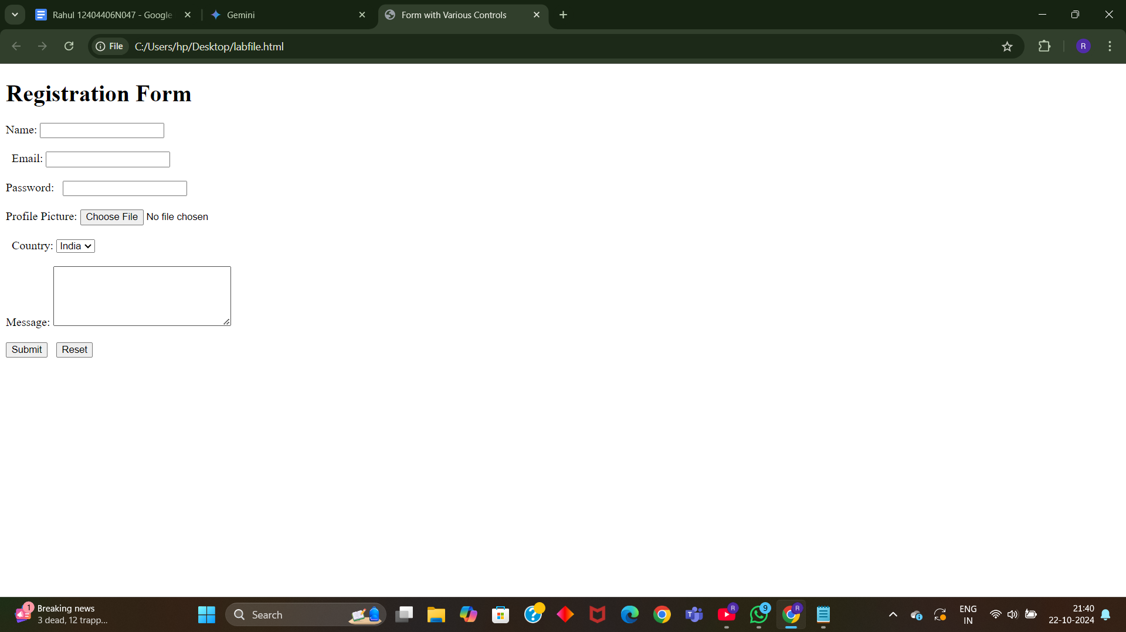

Q18. Write HTML code to design a Registration Form in HTML.

Input:

<!DOCTYPE html>

<html>

<head>

<title>Grade Volleyball Registration Form</title>

</head>

<body>

<h1>Grade Volleyball Registration Form</h1>

<form action="submit.php" method="post">

<label for="first_name">Participant Name</label><br>

<input type="text" id="first_name" name="first_name" placeholder="First"><br>

<input type="text" name="last_name" placeholder="Last"><br><br>

<label for="age">Age</label><br>

<input type="number" id="age" name="age"><br><br>

<label for="grade">Grade</label><br>

<select id="grade" name="grade">

<option value="">Please select</option>

<option value="1">1</option>

<option value="2">2</option>

</select><br><br>

<label for="school_district">School District</label><br>

<input type="text" id="school_district" name="school_district"><br><br>

<label for="shirt_size">Shirt Size</label><br>

<select id="shirt_size" name="shirt_size">

<option value="">Please select</option>

<option value="s">Small</option>

<option value="m">Medium</option>

<option value="l">Large</option>

<option value="xl">Extra Large</option>

</select><br><br>

<label for="parent_first_name">Parent Name</label><br>

<input type="text" id="parent_first_name" name="parent_first_name" placeholder="First"><br>

<input type="text" name="parent_last_name" placeholder="Last"><br><br>

<label for="emergency_contact">Emergency Contact</label><br>

<input type="text" id="emergency_contact" name="emergency_contact"><br><br>

<input type="submit" value="Submit">

</form>

</body>

</html>

Output:

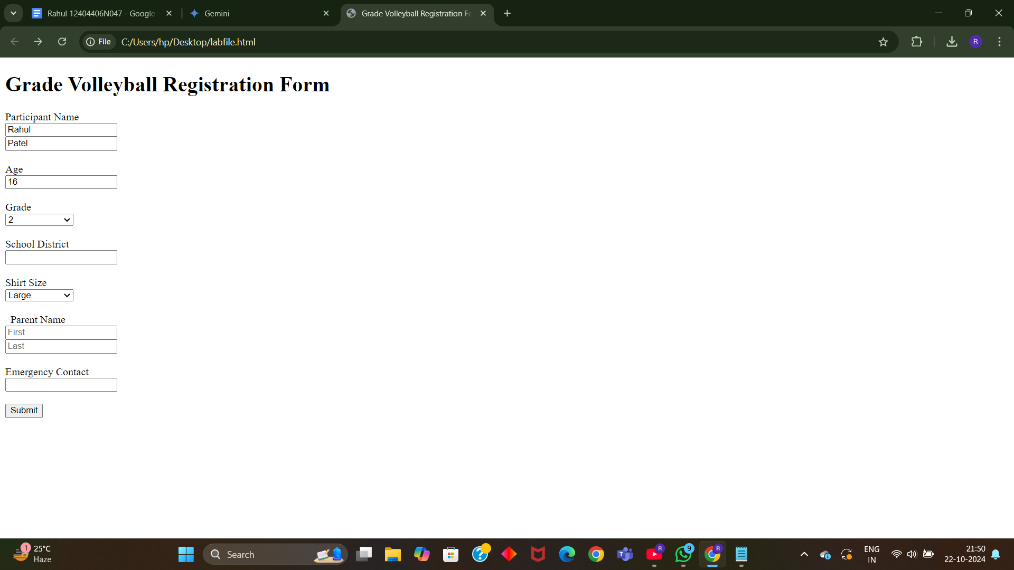

Q19. Write HTML code to design a student admission Form in HTML.

Input:

<!DOCTYPE html>

<html>

<head>

<title>Student Admission Form</title>

</head>

<body>

<h1>Student Admission Form</h1>

<form action="submit.php" method="post">

<label for="student_name">Student Name</label><br>

<input type="text" id="student_name" name="student_name" required><br><br>

<label for="date_of_birth">Date of Birth</label><br>

<input type="date" id="date_of_birth" name="date_of_birth" required><br><br>

<label

for="gender">Gender</label><br>

<input type="radio" id="male" name="gender" value="male">

<label for="male">Male</label>

<input type="radio" id="female"

name="gender" value="female">

<label for="female">Female</label><br><br>

<label for="address">Address</label><br>

<textarea id="address" name="address"

rows="5" cols="30" required></textarea><br><br>

<label for="phone_number">Phone Number</label><br>

<input type="tel" id="phone_number" name="phone_number" required><br><br>

<label for="email">Email</label><br>

<input type="email" id="email" name="email" required><br><br>

<label for="class">Class</label><br>

<select id="class" name="class" required>

<option value="">Please select</option>

<option value="1">1</option>

<option value="2">2</option>

</select><br><br>

<label for="guardian_name">Guardian Name</label><br>

<input type="text" id="guardian_name" name="guardian_name" required><br><br>

<label for="guardian_contact">Guardian Contact</label><br>

<input type="tel" id="guardian_contact" name="guardian_contact" required><br><br>

<input type="submit" value="Submit">

</form>

</body>

</html>

Output:

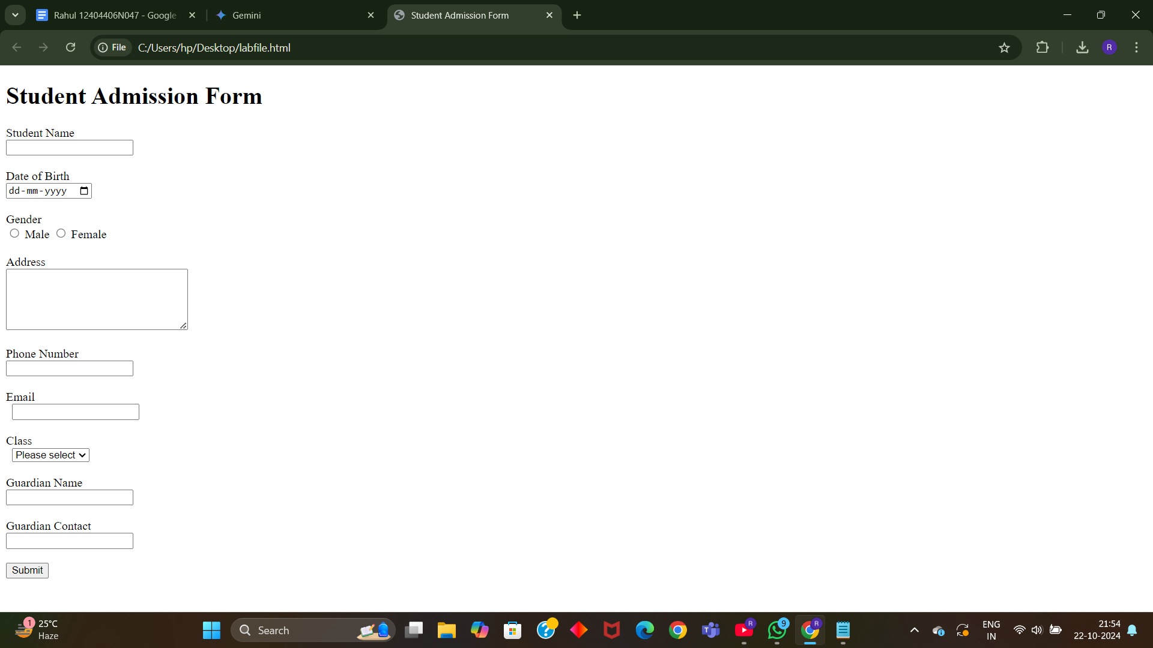

Q20. Create a proper home page of your own using any components and styles.

Input:

<!DOCTYPE html>

<html>

<head>

<title>My Personal Website</title>

<link rel="stylesheet" href="styles.css">

</head>

<body>

<header>

<h1>My Name</h1>

<nav>

<ul>

<li><a href="index.html">Home</a></li>

<li><a href="about.html">About</a></li>

<li><a href="projects.html">Projects</a></li>

<li><a href="contact.html">Contact</a></li>

</ul>

</nav>

</header>

<main>

<section>

<h2>Welcome to My

Website!</h2>

<p>This is a brief introduction about myself. Feel free to explore my projects and contact me.</p>

<img src="profile_pic.jpg" alt="Profile Picture">

</section>

</main>

<footer>

<p>&copy; 2023 My Name</p>

</footer>

</body>

</html>

Output:

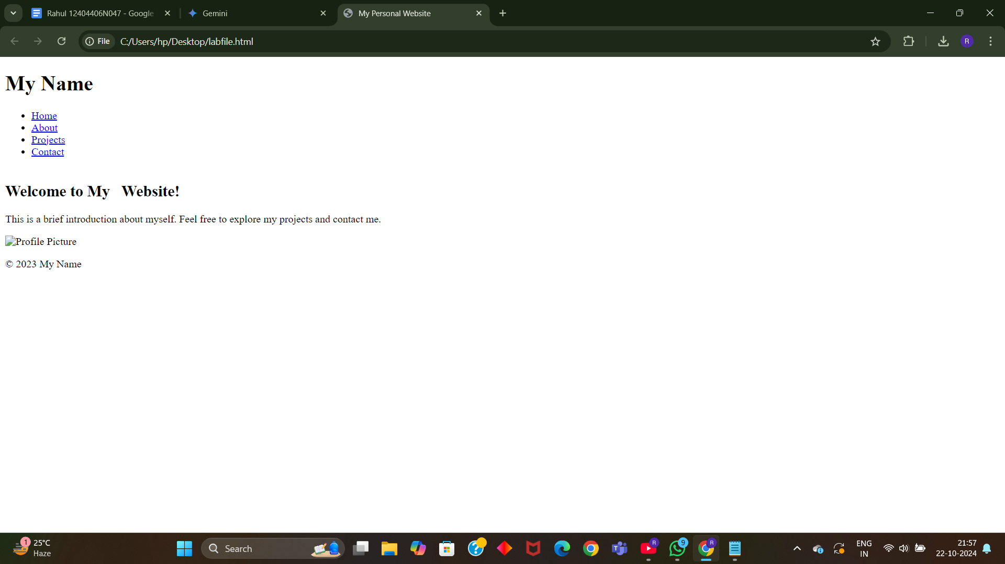

Q21. Write HTML code for including Local hyperlinking in a web page.

Input:

<!DOCTYPE html>

<html>

<head>

<title>Local Hyperlinking Example</title>

</head>

<body>

<h1>Local Hyperlinking</h1>

<p>This is a sample paragraph with a local hyperlink to another section within the same page.</p>

<a href="#section2">Jump to Section 2</a>

<h2 id="section2">Section 2</h2>

<p>This is the content of Section 2.</p>

</body>

</html>

Output:

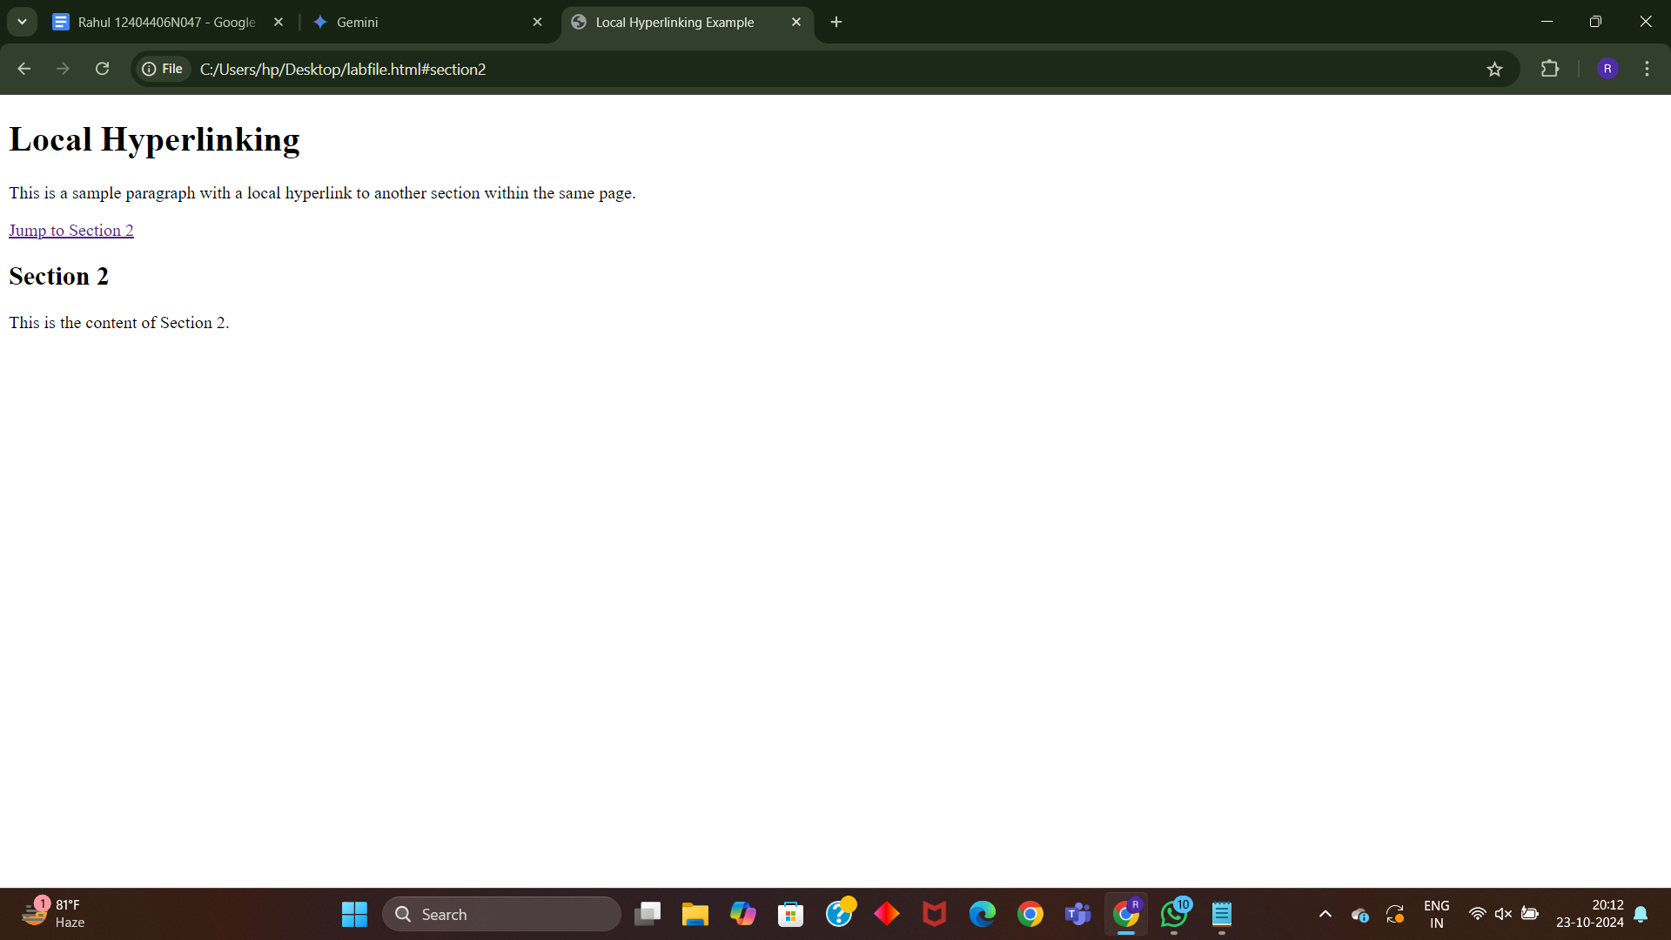

Q22. Write HTML code for including Inter hyperlinking in a web page.

Input:

<!DOCTYPE html>

<html>

<head>

<title>Inter Hyperlinking Example</title>

</head>

<body>

<h1>Inter Hyperlinking</h1>

<p>This is a sample paragraph with an inter-page hyperlink to another HTML file.</p>

<a href="page2.html">Go to Page 2</a>

</body>

</html>

Output:

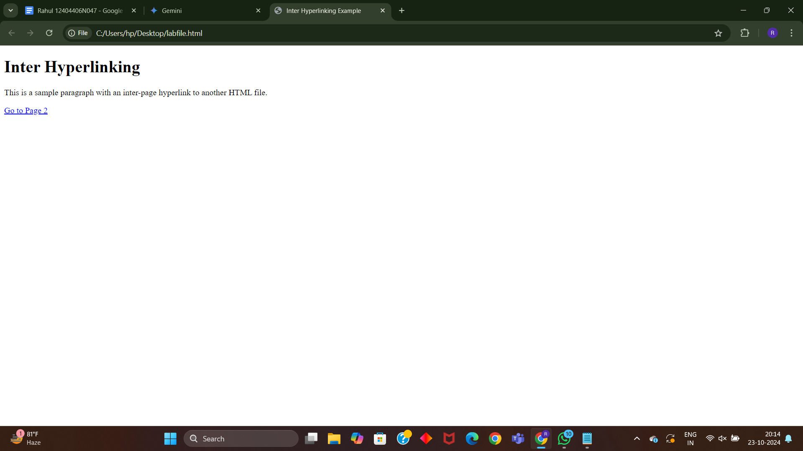

Q23. Write HTML code for including External hyperlinking in a web page.

Input:

<!DOCTYPE html>

<html>

<head>

<title>External Hyperlinking Example</title>

</head>

<body>

<h1>External Hyperlinking</h1>

<p>This is a sample paragraph with an external hyperlink to another website.</p>

<a href="https://www.example.com">Visit Example Website</a>

</body>

</html>

Output:

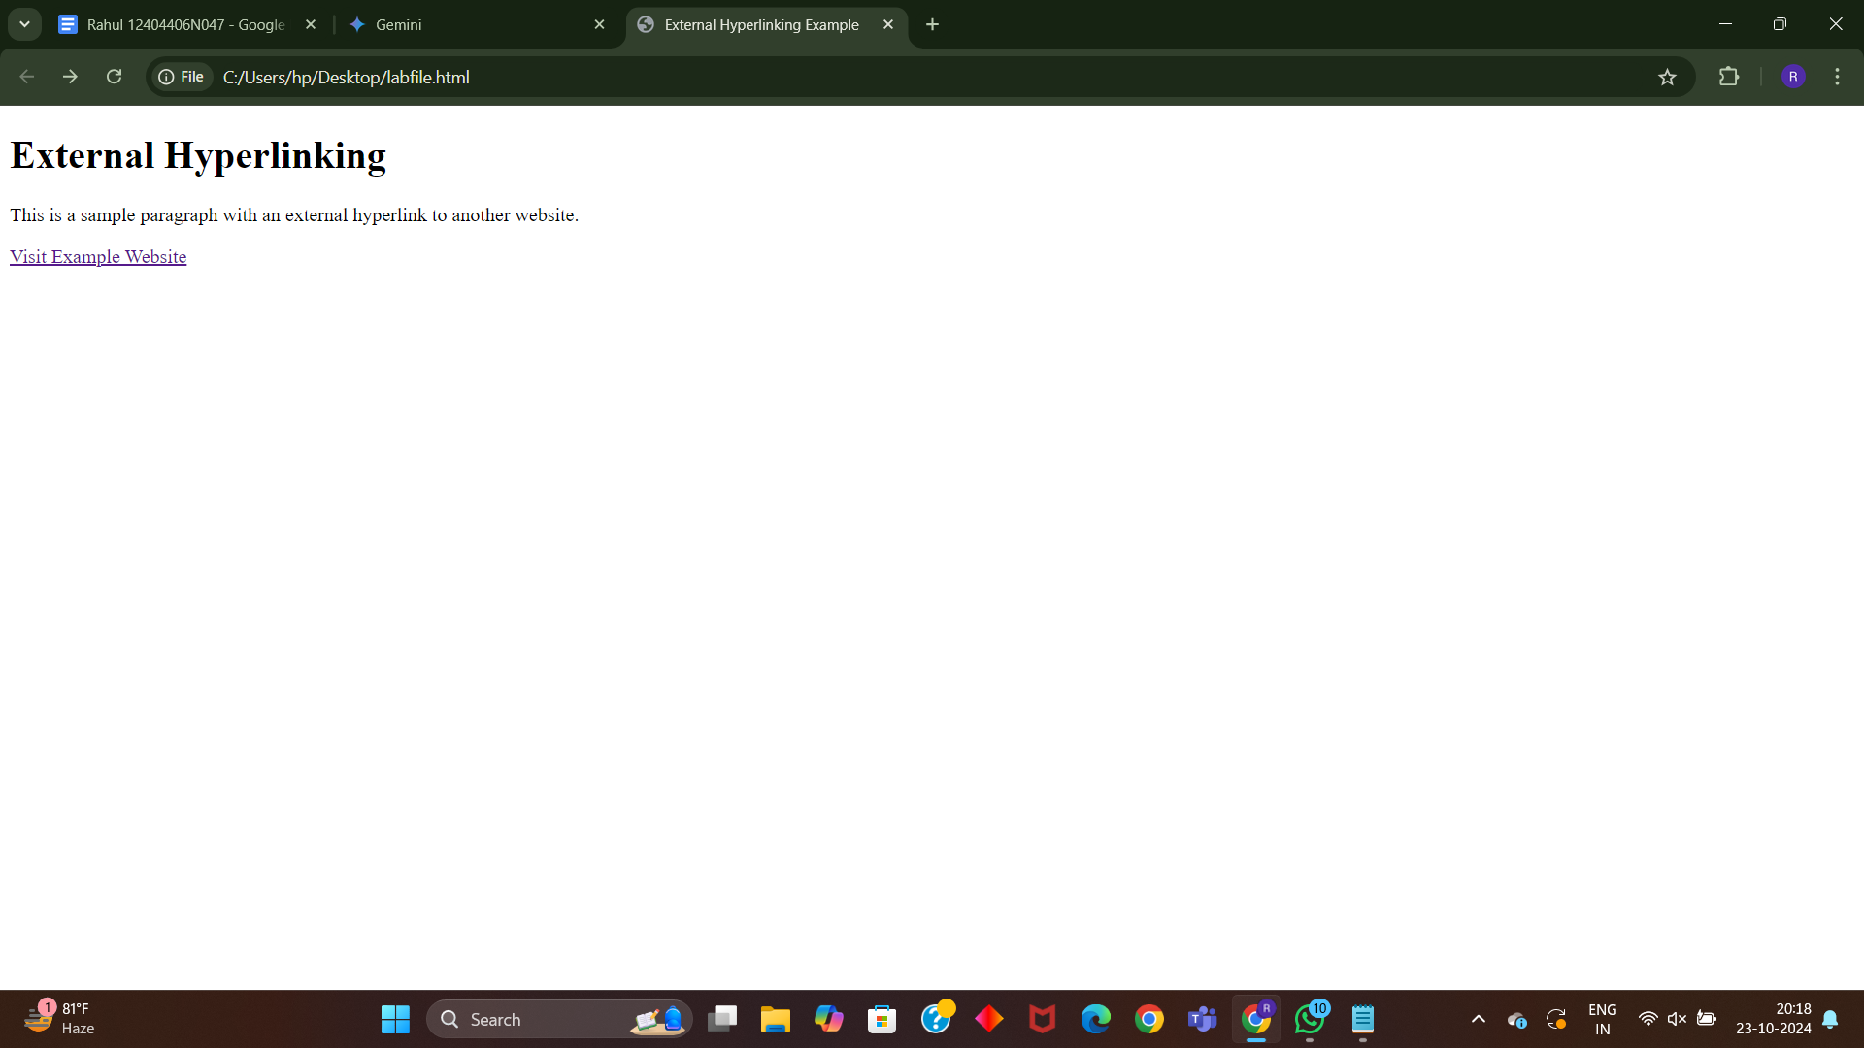

Q24. Write code to show External CSS with HTML code.

Input:

<!DOCTYPE html>

<html>

<head>

<title>External CSS Example</title>

<link rel="stylesheet" href="styles.css">

</head>

<body>

<h1>Hello, World!</h1>

<p>This is a paragraph styled with external CSS.</p>

</body>

</html>

Output:

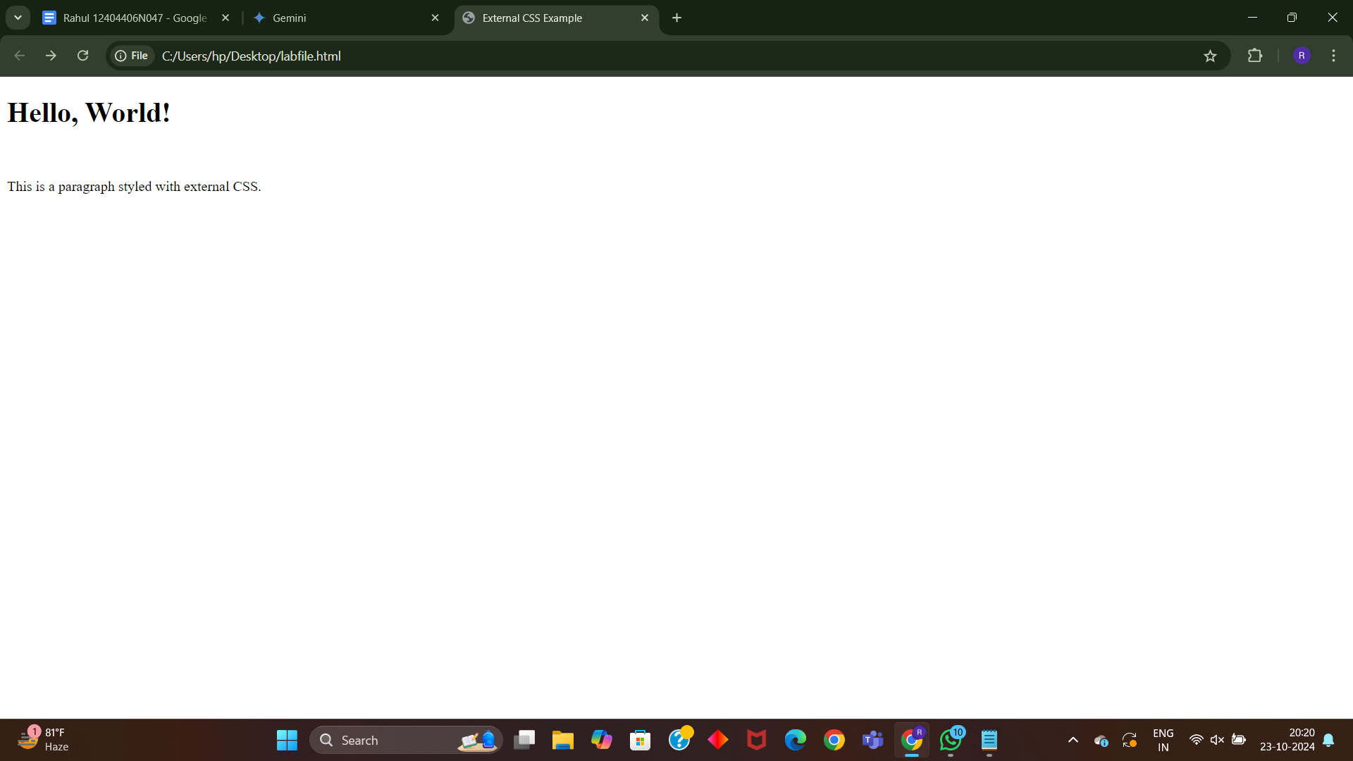

Q25. Write code to show Internal CSS with HTML code.

Input:

<!DOCTYPE html>

<html>

<head>

<title>Internal CSS Example</title>

</head>

<body>

<style>

body {

font-family: Arial, sans-serif;

background-color: lightblue;

}

h1 {

color: red;

text-align: center;

}

p {

color: green;

font-size: 18px;

}

</style>

<h1>Hello, World!</h1>

<p>This is a paragraph styled with internal CSS.</p>

</body>

</html>

Output:

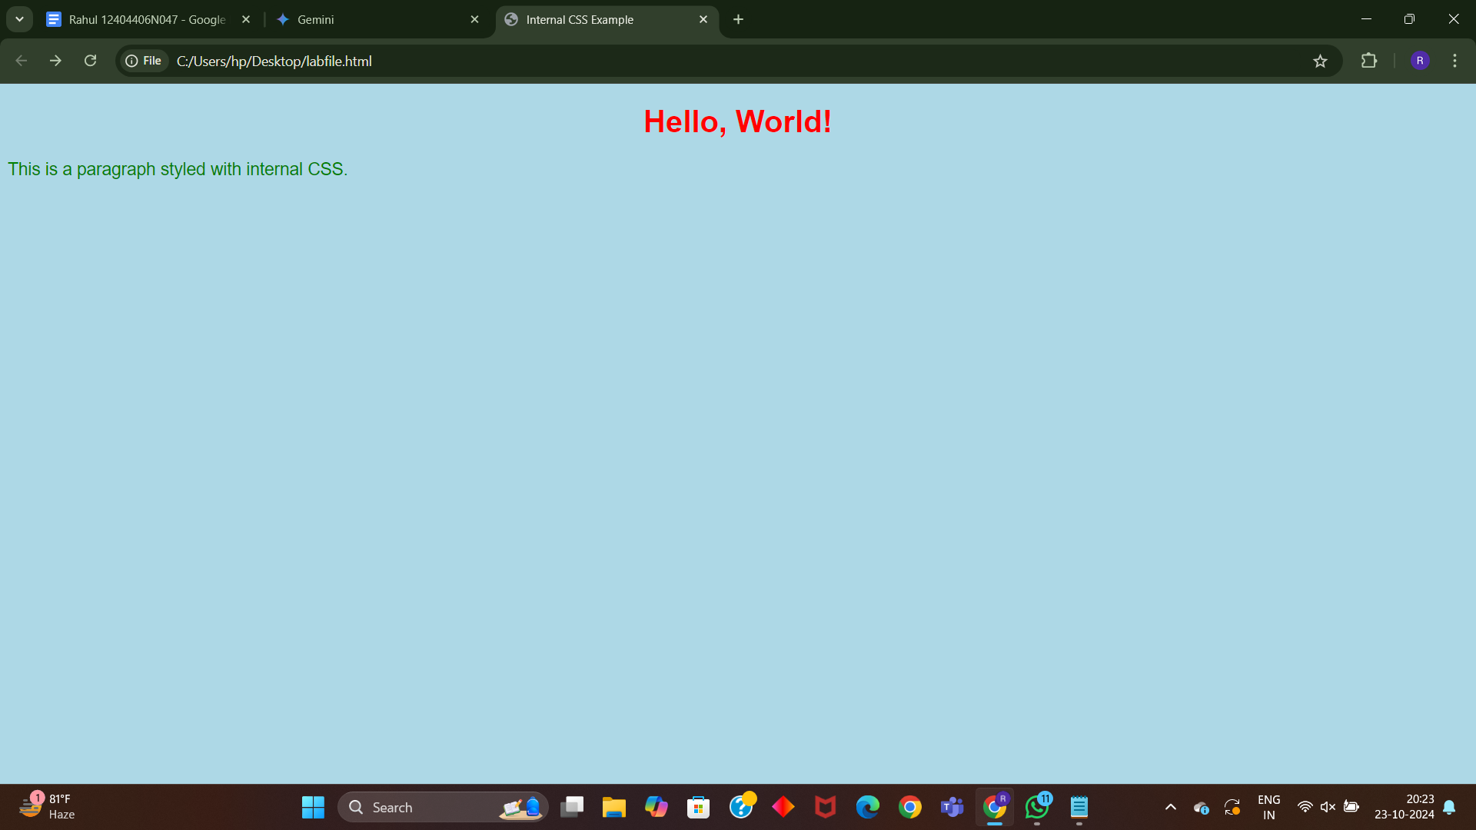

Q26. Write code to show Inline CSS with HTML code.

Input:

<!DOCTYPE html>

<html>

<head>

<title>Inline CSS Example</title>

</head>

<body>

<h1 style="color: red; text-align: center;">Hello, World!</h1>

<p style="color: green; font-size: 18px;">This is a paragraph styled with inline CSS.</p>

</body>

</html>

Output:

