E-Commerce Customer & Order Analytics

1. Problem Statement
The objective of this project is to analyze online customer behavior, the impact of discounting strategies, and the logistical efficiency of deliveries. The e-commerce platform needs actionable insights to optimize profitability and improve customer satisfaction.

2. Dataset Information
This project uses a self-generated synthetic dataset containing 1,250 order records. It includes attributes such as Customer Segment, Delivery Days, Discount Rate, Order Status, and Regional data.

3. Key Performance Indicators (KPIs)
• Total Revenue
• Total Profit
• Average Order Value (AOV)
• Average Delivery Time

4. Exploratory Data Analysis & Visualizations

4.1 Customer Segmentation
The 'Premium' customer segment contributes a disproportionately large amount of revenue compared to 'Occasional' buyers, despite being smaller in population.
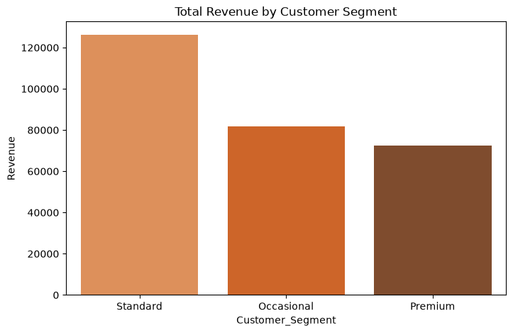

4.2 Impact of Discounts on Profitability
Analysis reveals a critical risk in the South region, where excessive discounting (above 25%) frequently results in negative profit margins on individual orders.
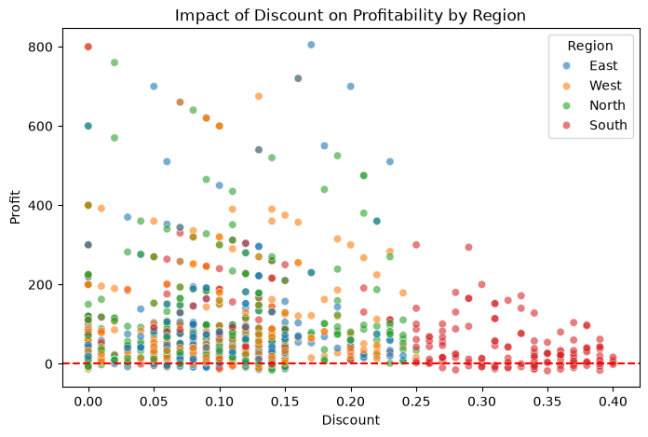

4.3 Delivery Performance and Satisfaction
There is a clear negative correlation between Delivery Days and Customer Rating. Orders taking longer than 7 days to deliver see a sharp decline in average ratings.
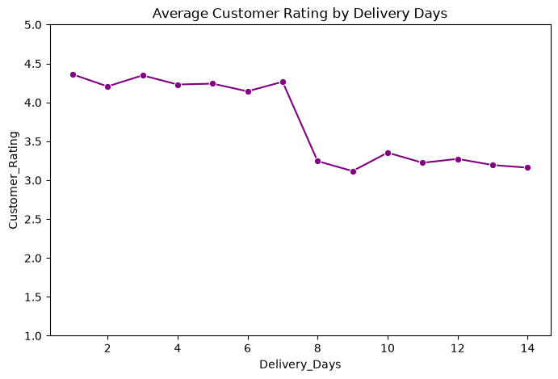

5. Key Insights & Risks
1. Risk: High discounts in the South region are eroding profitability without generating sufficient volume to offset the lower margins.
2. Risk: Extended delivery times (especially in the West region) are directly damaging customer satisfaction and increasing the return rate.
3. Opportunity: Premium customers are highly valuable; increasing their retention will disproportionately boost total revenue.

6. Business Decisions & Actions
• Action 1: Cap promotional discounts at 20% in the South region to protect gross margins.
• Action 2: Renegotiate contracts with logistics partners for the West region to ensure delivery times are kept under 7 days.
• Action 3: Introduce a VIP loyalty tier to specifically nurture the 'Premium' segment and encourage more frequent purchasing behavior.

