**Technology :**

'MyApp' application is developed in Visual Studio 2017 and for database MS Sql server 2012 has been used. The main services (web API) are developed in ASP.NET core2.1.

Application contains 12 end points i.e. 'REST' service. 6 are for customer and remaining 6 are for order.

Screenshot below defines all the end points.

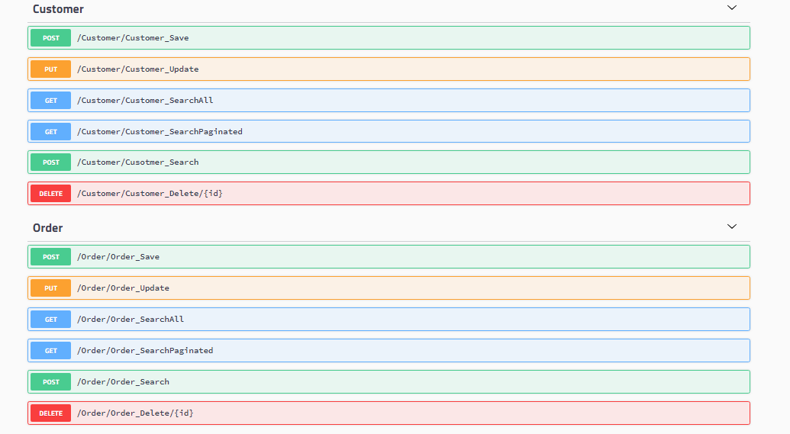

Handler

Provider

Controller

API

Whenever any client hits the API then it will land on controller then controller will decide on which provider will provide the data. All the validation checks are on provider only. All business logic is implemented in provider. Then the request goes to related handler which provides DB connection.

The data from database will be picked according to the request and will be returned following the same path. All the APIs are async services. Exception is handled globally using Nuget package 'NLog'.

DB connection is done through Nuget package 'Dapper'.

For API list (help page) Nuget package 'Swashbuckle' is used which also provides the UI like 'Postman'

with sample request/response object. Developer can test the running APIs with the help of swagger UI.

For unit testing XUnit of visual studio is used.

**Model :**

|  |  |
| --- | --- |
|  |  |
|  |  |

**Database structure:**

Tables :

