ShopNest Store Power BI Capstone Report

# Summary Page Overview

The summary page offers a consolidated snapshot of overall business metrics and operations. It includes key performance indicators such as Total Sales, Total Orders, Average Order Value (AOV), Average Rating, and the Percentage of Delayed Orders. Alongside KPIs, it includes slicers for filtering by Order Month, Product Category, and Customer State to enable dynamic interactions.

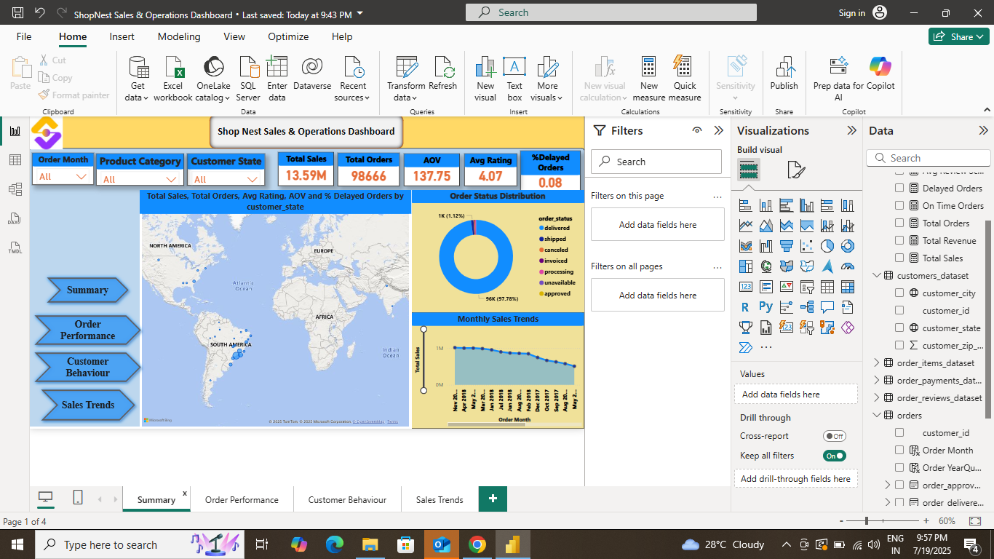

Visuals on this page:  
- A Map Visual showing the geographical distribution of customer states, reflecting regional spread of sales.  
- A Donut Chart displaying distribution of orders by status such as shipped, delivered, unavailable, etc.  
- A Line Chart showing the monthly sales trend over time to understand seasonality and performance patterns.

# Question 1: Which are the top 10 product categories by total sales?

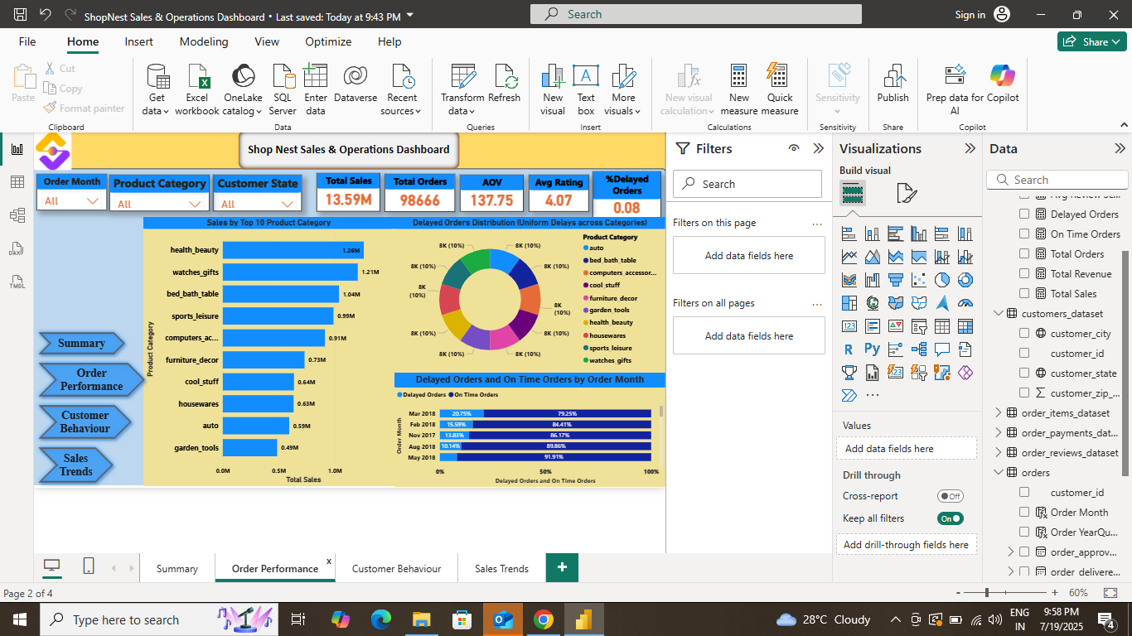

The bar chart on the left presents the Top 10 Product Categories ranked by Total Sales. Health & Beauty leads with the highest sales followed by Watches & Gifts, and Bed, Bath & Table. This visualization is useful for identifying the most profitable categories to prioritize inventory and marketing strategies.

# Question 2: What is the distribution of delayed orders across different product categories?

The donut chart in the center shows a uniform distribution of delayed orders across product categories. Each category has approximately 10% of total delayed orders, indicating no particular category is overly affected. This balanced distribution implies delays are operationally widespread rather than category-specific.

# Question 3: How are delayed and on-time orders distributed over time?

The stacked bar chart at the bottom shows a monthly trend of delayed and on-time orders. Over time, there’s a noticeable increase in on-time orders, particularly from May 2018 onwards, with over 90% being timely. This trend suggests improvements in operational efficiency or fulfillment process.

# Question 4: Distribution of Review Scores

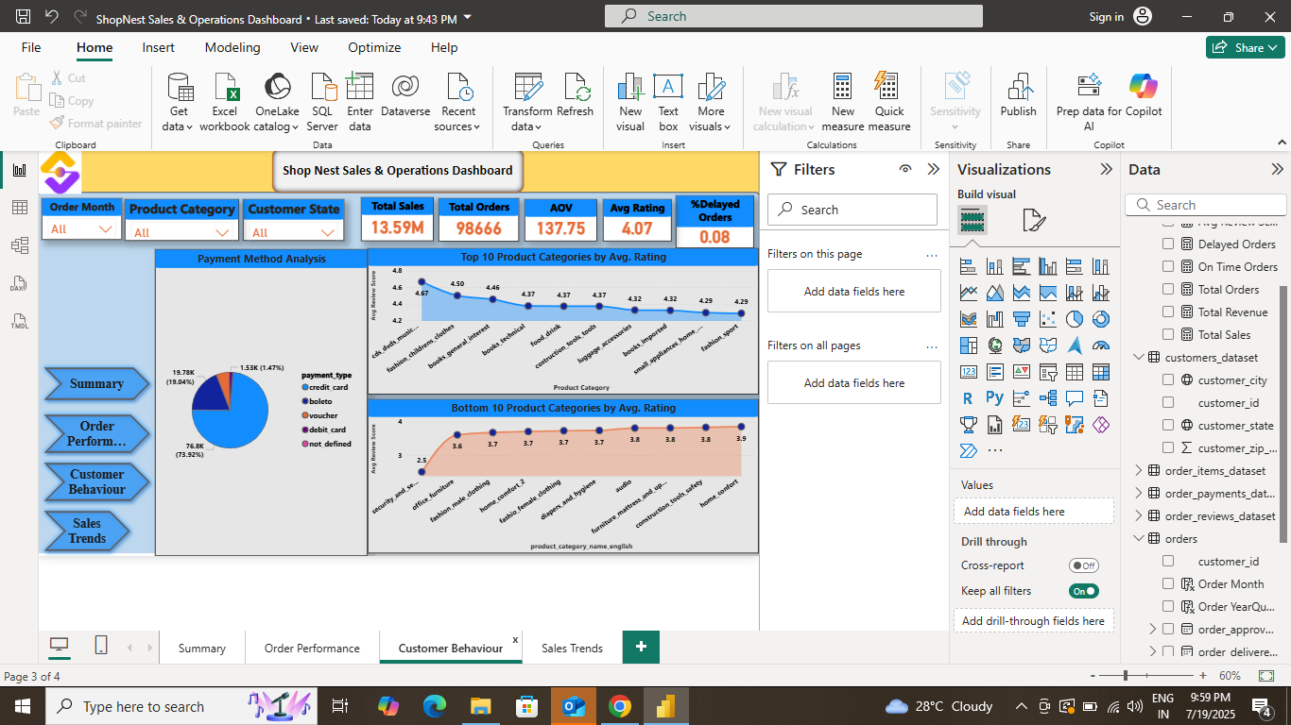

The pie chart on this page visualizes the overall distribution of customer review scores. It helps in understanding customer sentiment across all orders. Most scores are clustered around 4 and 5, indicating generally positive feedback. This gives an overview of how well products and services are meeting expectations.

# Question 5: Top 10 and Bottom 10 Reviewed Product Categories

Two separate bar charts have been used to represent the top 10 and bottom 10 product categories based on average customer review scores.

- The first bar chart displays the highest-rated product categories, which indicate excellent customer satisfaction.  
- The second bar chart highlights the lowest-rated categories, helping to identify areas that may require improvement.



# Question 6: Regional Sales Performance

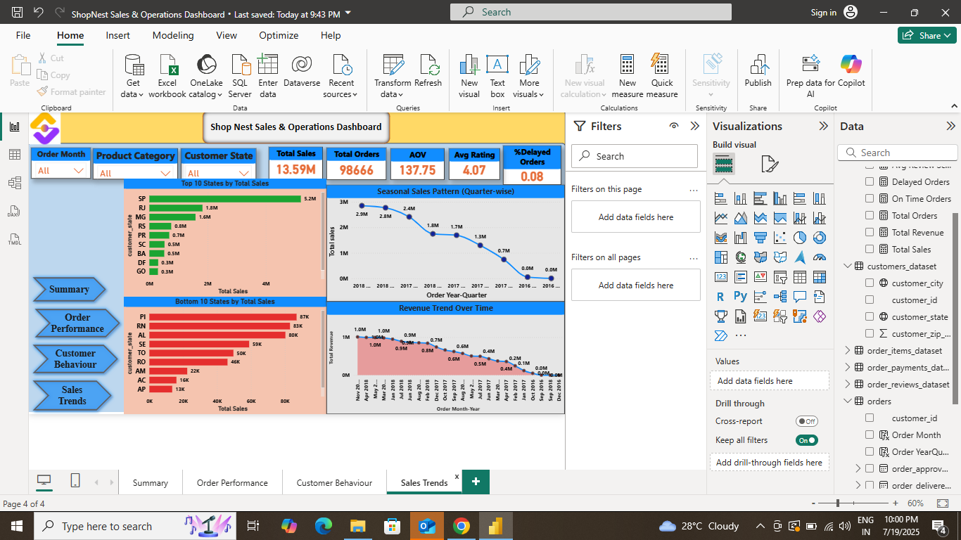

This visual shows regional performance by comparing total sales across different states. It helps identify the highest and lowest performing regions. States like São Paulo and Rio de Janeiro are seen to be leading in sales performance, providing strategic insights for marketing and logistics planning.

# Question 7: Seasonal Sales Trends

The sales trend is analyzed across quarters to identify seasonality in sales. The trend line helps to forecast high and low periods of sales activity. Businesses can plan inventory and marketing efforts based on these insights.

## Question 8: How has the revenue generation trend evolved over time?

The objective of this visual is to analyze how revenue generation has evolved month-over-month across the years. The data helps identify seasonal peaks and dips in customer purchases, useful for planning marketing campaigns and inventory.

A Line and Area Chart has been used here to effectively visualize the sales trend over time, showing both the absolute values and the growing revenue path. This dual visual gives the user a clear understanding of overall patterns in sales performance.

Key Insights:

- Sales tend to peak during specific months, possibly indicating festive or promotional seasons.  
- A consistent upward trend is visible across years, showcasing business growth.