Projects which can be built with ESP32: Alexa enable device IOT of things using theirs party services like sintric pro. Remote car with Bluetooth phone control. Alexa Bell. Surveillance Camera using ESP 32 cam. Temperature, Humidity, Gas sensor system

Algorithm is a step by step approach.

Step 1. Start

Step 2. Initialize ESP32 Cam

step 3. Connect to a network Step 4. if connected then

Get an IP address otherwise

Step 5. After an IP address

Step 6. If connected then Encrypt and send to web server otherwise do again step 4

Step 9. Finish

Wait a while Step 7. Web server decrypts all the payloads Step 8. Send decrypted whole buffer to client

The flowchart of the algorithm has given below

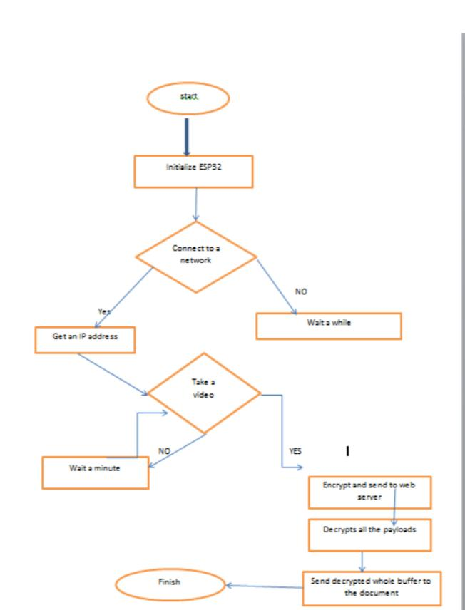.

The small esp32 package deal has a high stage of integrations including:

antenna switches

balun to govern rf

electricity amplifier

low noise reception amplifier

filters and power control modules