Walchand College of Engineering, Sangli
(Government Aided Autonomous Institute)
AY 2025-26
Course Information
Programme | B.Tech. (Computer Science and Engineering)
Class, Semester | Final Year B. Tech., Sem VII
Course Code | 6CS451
Course Name | Cryptography and Network Security Lab

Experiment No. 09
Name – Parag Yadav
PRN – 22510016
Batch – B6

Title – Calculate the message digest of a text using the SHA-1 algorithm

Objectives:

To understand and implement the SHA-1 (Secure Hash Algorithm 1) for generating a fixed-length message digest from a given input text. The goal is to demonstrate how data integrity can be maintained and verified using cryptographic hash functions.

Problem Statement:
In digital communications and data storage, ensuring the integrity of data is crucial. One common approach to verifying that a message has not been altered is to compute a message digest—a fixed-size string that uniquely represents the input data.
Implement a program that:

- Accepts a text input from the user.

Calculates the SHA-1 hash (message digest) of the input text using a cryptographic library or custom logic.
- Outputs the SHA-1 digest in hexadecimal format.

Demonstrates that any change in the input results in a completely different message digest, highlighting the avalanche effect of the hash function.

Additionally, briefly explain the role of SHA-1 in real-world applications, such as digital signatures, checksums, and data integrity verification.

Equipment/Tools:Libraries: hashlib
Python
Theory:

The SHA-1 algorithm (Secure Hash Algorithm 1) is a cryptographic hash function that takes an input message and produces a 160-bit (20-byte) fixed-length hash value, known as a message digest.
Key Properties of SHA-1:
- Deterministic: Same input always produces the same output.
- Fixed Length: Output is always 160 bits, irrespective of input size.
- Irreversible: Cannot reconstruct original data from hash.
- Collision Resistance: It’s computationally infeasible for two different inputs to have the same hash (though collisions have been found in practice).
- Avalanche Effect: A small change in input causes a drastic change in output.

Procedure:

- Start the program.
- Accept a text input from the user.
- Use the SHA-1 algorithm to compute the message digest.
- Display the hash value in hexadecimal format.
- Modify one character in the input and compute the digest again.
- Observe the drastic change in the resulting hash (avalanche effect).
- Conclude how SHA-1 ensures data integrity.

Steps:

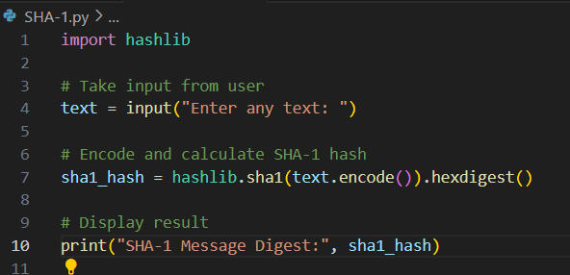
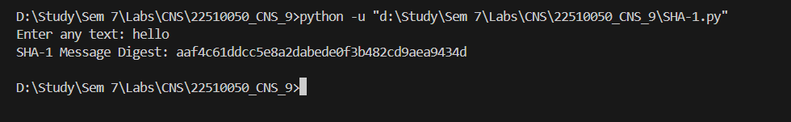
Observations and Conclusion:

- Even a single character change in the input text leads to a completely different SHA-1 hash value.
- The SHA-1 algorithm successfully generates a unique, fixed-length message digest for any given text.
- This demonstrates how cryptographic hash functions maintain data integrity and ensure that even a minor alteration in the input results in a drastically different output.

