Abstract
QR i.e. “Quick Response” code is a 2D matrix code
that is designed by keeping two points under consideration, i.e. it
must store large amount of data as compared to 1D barcodes and
it must be decoded at high speed using any handheld device like
phones. QR code provides high data storage capacity, fast
scanning, omnidirectional readability, and many other
advantages including, error-correction (so that damaged code
can also be read successfully) and different type of versions.
Different varieties of QR code symbols like logo QR code,
encrypted QR code, iQR Code are also available so that user can
choose among them according to their need.
Now these days, a QR code is applied in different application
streams related to marketing, security, academics etc. and gain
popularity at a really high pace. Day by day more people are
getting aware of this technology and use it accordingly. The
popularity of QR code grows rapidly with the growth of
smartphone users and thus the QR code is rapidly arriving at
high levels of acceptance worldwide.
QR i.e. “Quick Response” code is a 2D matrix code
that is designed by keeping two points under consideration, i.e. it
must store large amount of data as compared to 1D barcodes and
it must be decoded at high speed using any handheld device like
phones. QR code provides high data storage capacity, fast
scanning, omnidirectional readability, and many other
advantages including, error-correction (so that damaged code
can also be read successfully) and different type of versions.
Different varieties of QR code symbols like logo QR code,
encrypted QR code, iQR Code are also available so that user can
choose among them according to their need.
Now these days, a QR code is applied in different application
streams related to marketing, security, academics etc. and gain
popularity at a really high pace. Day by day more people are
getting aware of this technology and use it accordingly. The
popularity of QR code grows rapidly with the growth of
smartphone users and thus the QR code is rapidly arriving at
high levels of acceptance worldwide.
QR i.e. “Quick Response” code is a 2D matrix code
that is designed by keeping two points under consideration, i.e. it
must store large amount of data as compared to 1D barcodes and
it must be decoded at high speed using any handheld device like
phones. QR code provides high data storage capacity, fast
scanning, omnidirectional readability, and many other
advantages including, error-correction (so that damaged code
can also be read successfully) and different type of versions.
Different varieties of QR code symbols like logo QR code,
encrypted QR code, iQR Code are also available so that user can
choose among them according to their need.
Now these days, a QR code is applied in different application
streams related to marketing, security, academics etc. and gain
popularity at a really high pace. Day by day more people are
getting aware of this technology and use it accordingly. The
popularity of QR code grows rapidly with the growth of
smartphone users and thus the QR code is rapidly arriving at
high levels of acceptance worldwide.
QR i.e. “Quick Response” code is a 2D matrix code that is designed by keeping two points under consideration, i.e. it must store large amount of data as compared to 1D barcodes and it must be decoded at high speed using any handheld device like phones. QR code provides high data storage capacity, fast scanning, omnidirectional readability, and many other advantages including, error-correction (so that damaged code can also be read successfully) and different type of versions. Different varieties of QR code symbols like logo QR code, encrypted QR code, iQR Code are also available so that user can choose among them according to their need.
Now these days, a QR code is applied in different application streams related to marketing, security, academics etc. and gain popularity at a really high pace. Day by day more people are getting aware of this technology and use it accordingly. The popularity of QR code grows rapidly with the growth of smartphone users and thus the QR code is rapidly arriving at high levels of acceptance worldwide.
As such we undertook this opportunity to create a simple QR Scanner Android Application to scan QR codes and keep the results in a DB file.

Acknowledgement
The satisfaction and euphoria that accompany the successful completion of any task would be incomplete without the mention of the people who made it possible, whose constant guidance and encouragement crowned the efforts with success.
We would like to profoundly thank Chairman Mr. CM Faiz and Management of HKBK College of Engineering for providing such a healthy environment for the successful completion of Project Work.
We would like to express our thanks to the Principal Dr. Tabassum Ara, for her encouragement that motivated us for the successful completion of Project Work.
We wish to express our gratitude to Dr., Professor and Head of Department of Computer Science & Engineering for providing such a healthy environment for the successful completion of Project work.
We wish to express our thanks to our guide Prof. Veeresh, Assistant Professor, Department of Computer Science & Engineering for his Expert Guidance, initiative and providing a good working environment and for his constant support and encouragement.
We would also like to thank all other teaching and technical staffs of Department of Computer Science and Engineering, who have directly or indirectly helped us in the completion of this Project Work.
We would like to reach out to all intellectual erudite from whom we referenced crucial elements of the project. Said benefactors have been mentioned in reference.
And lastly, we would hereby acknowledge and thank our parents who have been a source of inspiration and also instrumental in the successful completion of this project.

Sonam Dorji 1HK19CS151
Sunil Nagar 1HK19CS158
Tabarej Baba 1HK19CS170

Table of content
Abstract i
Acknowledgement ii
Table of figure iv
Chapter 1 : 1
Introduction 1
1.1 Project Overview 1
Chapter 2 : 2
System design 2
2.1 Design Consideration 2
2.2 Design Architecture 3
Chapter 3 : 5
System Requirement Specification 5
3.1 Functional Requirement 5
3.2 Non Functional Requirement 5
3.3 System Requirement 5
Chapter 4 : 6
Implementation 6
4.1 Activity_main.xml 6
4.2 Data_view.xml 7
4.3 MainActivity.java 8
4.4 DBHelper.java 9
4.5 QRContent.java 11
4.6 String.xml 11
4.7 androidManifest.xml 11
Chapter 5 : 13
Output 13
Conclusion v
References vi

Table of figure
Figure 1-1 Working of QR Code 1
Figure 2-1 Design Structure 2
Figure 2-2 Design for activity_main.xml 3
Figure 2-3 Design for data_view.xml 4
Figure 2-4 icon.png 4
Figure 5-1 Application Homepage 13
Figure 5-2 Scanning 14
Figure 5-3 scanned message 15
Figure 5-4 Message Record 16
Figure 5-5 Cleared Record 17
Figure 5-6 App Icon 18

Introduction

Project Overview
A QR code is a type of matrix bar code or two-dimensional code that can store data information and designed to be read by smartphones. QR stands for “Quick Response” indicating that the code contents should be decoded very quickly at high speed. The code consists of black modules arranged in a square pattern on a white background. The information encoded may be text, a URL or other data. The QR code was designed to allow its contents to be decoded at high speed. The popularity of QR codes is growing rapidly all around the world. Nowadays, mobile phones with built-in camera are widely used to recognize the QR Codes.
QR Codes are created by the Toyota subsidiary Denso Wave in 1994, and was initially used for tracking inventory in vehicle parts manufacturing. The idea behind the development of the QR code is the limitation of the barcode information capacity (can only hold 20 alphanumeric characters).
The QR code system consists of a QR code encoder and decoder. The encoder is responsible for encoding data and generation of the QR Code, while the decoder decodes the data from the QR code.
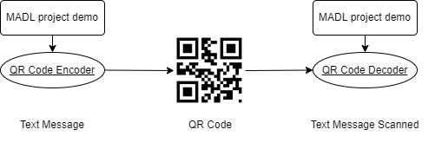
Figure 1-1 Working of QR Code
We only focused on decoding a code using Zxing module in android studio in this project.

System design

Design Consideration
To implement QR Code in Android Studio, we chose Zxing as the interface for its fame and convenience. Zxing stands for Zebra Crossing, it is one of the most popular open-source API for integrating QR (Quick Response) Code processing. It is a barcode image processing library implemented in Java, with ports to other languages. It has support for the 1D product, 1D industrial, and 2D barcodes. Google uses Zxing by web search to obtain millions of barcodes on the web indexable. It also creates the foundation of Android’s Barcode Scanner app and is combined into Google Product and Book Search.
As for the Application interface layout, two simple Activity were chosen.
- Activity_main.xml to display Scan trigger button.
- Dataview.xml to show saved results in the database.
As for the programming framework, Java programs were used.
- MainAcivity.java to create backbone of the App.
- DBHelper.java to create and manage a database for results.
- QRContent.java to display contents of QR Code.
AndroidManifest.xml to manage apk build parameters.
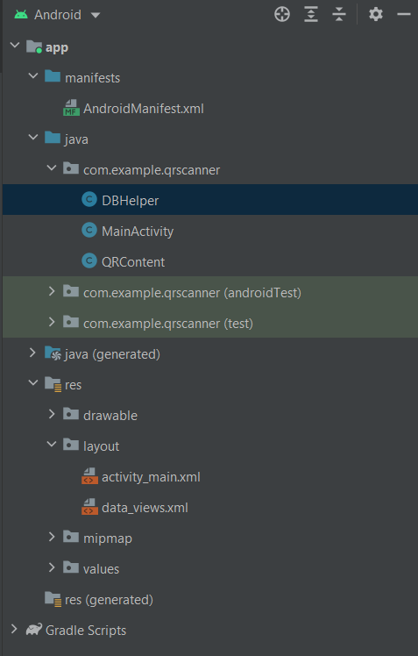
Figure 2-1 Design Structure

Design Architecture

Activity_main.xml
Layout Style
- Linear Layout
Components:
- Text View: College Name
- Text View: Subject Code
- Button: Scanner trigger
- Button: View records
- Text View: Group Member One
- Text View: Group Member Two
- Text View: Group Member Three
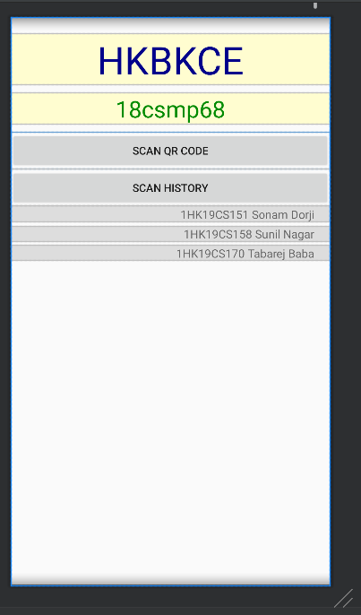
Figure 2-2 Design for activity_main.xml

Data_view.xml
Layout Style
- Linear Layout
Components:
- Table Layout
  - Table Row
    - Button: Go back Trigger
    - Button: Clear Trigger
- Table Layout
  - Text View: label
  - List View: Database Records
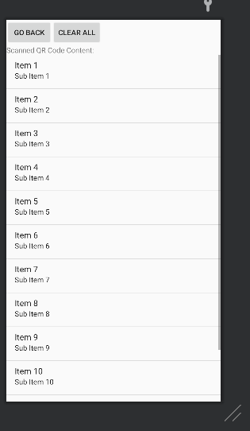
Figure 2-3 Design for data_view.xml

AndroidManifest.xml
Permissions
- Camera
Application
- Icon: icon.png
- Label: MadLab
- Theme: Default Apptheme
Activity
- Name: MainActivity
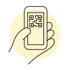
Figure 2-4 icon.png

System Requirement Specification
A System Requirements Specification (SRS) (also known as a Software Requirements Specification) is a document or set of documentation that describes the features and behaviour of a system or software application.

Functional Requirement
- Ability to scan any QR Codes
- Dependable Database to store the scanned messages
- View the stored Database records
- Clear the records

Non Functional Requirement
- Accurate readings
- Consistent storage
- Fast reading
- Simple in implementation

System Requirement

Software Requirement
- Android Studio Bumblebee | 2021.1.1 Patch 3
- Build #AI-211.7628.21.2111.8309675
- Runtime version: 11.0.11+9-b60-7590822 amd64
- VM: OpenJDK 64-Bit Server VM by Oracle Corporation
- Gradle Plugin Version: 3.4.2
- Gradle Version: 5.1.1
- Androidx.appcompat: appcompat:1.0.2
- Junit:junit:4.12
- Zxing: 1.8.4

Hardware Requirement
- Processor Intel(R) Core(TM) i5-10300H CPU @ 2.50GHz 2.50 GHz
- Installed RAM 8.00 GB (7.83 GB usable)
- System type 64-bit operating system, x64-based processor
- Windows 10 10.0
- GC: G1 Young Generation, G1 Old Generation
- Memory: 1280M
- Cores: 8
- Android Phone with at least android lollipop

Implementation

Activity_main.xml
<?xml version="1.0" encoding="utf-8"?>
<LinearLayout xmlns:android="http://schemas.android.com/apk/res/android"
android:orientation="vertical" android:layout_width="match_parent"
android:layout_height="match_parent">
<TextView
android:id="@+id/textView2"
android:layout_width="match_parent"
android:layout_height="wrap_content"
android:text="@string/College"
android:textAllCaps="true"
android:gravity="center"
android:background="#FFFDD0"
android:textColor="#00008B"
android:layout_marginBottom="10dp"
android:layout_marginTop="20dp"
android:textSize="50dp" />
<TextView
android:id="@+id/textView"
android:layout_width="match_parent"
android:layout_height="wrap_content"
android:text="@string/Title"
android:gravity="center"
android:background="#FFFDD0"
android:textColor="#008B00"
android:layout_marginBottom="10dp"
android:textSize="30dp"/>
<Button
android:layout_width="match_parent"
android:layout_height="wrap_content"
android:onClick="onClick"
android:text="Scan QR Code" />
<Button
android:layout_width="match_parent"
android:layout_height="wrap_content"
android:onClick="clickHistory"
android:text="Scan History" />
<TextView
android:id="@+id/textView3"
android:layout_width="match_parent"
android:layout_height="wrap_content"
android:text="@string/sonam"
android:gravity="right"
android:textSize="15dp"
android:paddingRight="20dp"
android:layout_marginBottom="5dp"
android:background="#dddddd"/>
<TextView
android:id="@+id/textView4"
android:layout_width="match_parent"
android:layout_height="wrap_content"
android:paddingRight="20dp"
android:background="#dddddd"
android:gravity="right"
android:text="@string/sunil"
android:layout_marginBottom="5dp"
android:textSize="15dp" />
<TextView
android:id="@+id/textView5"
android:layout_width="match_parent"
android:layout_height="wrap_content"
android:paddingRight="20dp"
android:background="#dddddd"
android:gravity="right"
android:text="@string/tabarej"
android:textSize="15dp" />
</LinearLayout>

Data_view.xml
<?xml version="1.0" encoding="utf-8"?>
<LinearLayout xmlns:android="http://schemas.android.com/apk/res/android"
android:layout_width="match_parent"
android:layout_height="match_parent"
android:orientation="vertical">
<TableLayout
android:layout_width="match_parent"
android:layout_height="wrap_content">
<TableRow
android:layout_width="match_parent"
android:layout_height="match_parent">
<Button
android:layout_width="match_parent"
android:layout_height="wrap_content"
android:onClick="goBackToMain"
android:text="Go back"/>
<Button
android:layout_width="match_parent"
android:layout_height="wrap_content"
android:text="Clear all"
android:onClick="clearAll"/>
</TableRow>
</TableLayout>
<TextView
android:id="@+id/datasTextView"
android:layout_width="match_parent"
android:layout_height="wrap_content"
android:text="Scanned QR Code Content:" />
<ListView
android:id="@+id/datasList"
android:layout_width="match_parent"
android:layout_height="wrap_content" />
</LinearLayout>

MainActivity.java
package com.example.qrscanner;

import android.app.Activity;
import android.app.AlertDialog;
import android.content.DialogInterface;
import android.database.Cursor;
import android.os.Bundle;
import android.util.Log;
import android.view.View;
import android.widget.ArrayAdapter;
import android.widget.ListView;
import android.widget.Toast;
import com.google.zxing.Result;
import java.util.ArrayList;
import me.dm7.barcodescanner.zxing.ZXingScannerView;
public class MainActivity extends Activity implements ZXingScannerView.ResultHandler {
private ZXingScannerView mScannerView;
ArrayList<String> listItem;
ArrayAdapter adapter;
@Override
protected void onCreate(Bundle savedInstanceState) {
super.onCreate(savedInstanceState);
setContentView(R.layout.activity_main);
}
public void onClick(View v) {
mScannerView = new ZXingScannerView(this);
setContentView(mScannerView);
mScannerView.setResultHandler(this);
mScannerView.startCamera();
}
public void clickHistory(View v) {
setContentView(R.layout.data_views);
listItem = new ArrayList<>();
ListView datasList = findViewById(R.id.datasList);
DBHelper db = new DBHelper(this);
Cursor c = db.viewData();
if (c.getCount() == 0){
Toast.makeText(this, "No data to show", Toast.LENGTH_SHORT).show();
}
else {
while (c.moveToNext()){
listItem.add(c.getString(1));
adapter = new ArrayAdapter<>(this, android.R.layout.simple_list_item_1, listItem);
datasList.setAdapter(adapter);
}
}
}
public void goBackToMain(View v) {setContentView(R.layout.activity_main);}
public void clearAll(View v){
DBHelper db = new DBHelper(this);
db.deleteContent(new QRContent());
setContentView(R.layout.activity_main);
Toast.makeText(this, "All data is deleted", Toast.LENGTH_SHORT).show();
}
@Override
protected void onPause() {
super.onPause();
//mScannerView.stopCamera();
}
@Override
public void handleResult(Result result) {
DBHelper db = new DBHelper(this);
Log.w("handleResult", result.getText());
AlertDialog.Builder builder = new AlertDialog.Builder(this);
builder.setTitle("Scan result:");
String res = result.getText();
db.addContent(new QRContent(res));
builder.setMessage(res);
builder.setPositiveButton("OK", new DialogInterface.OnClickListener() {
@Override
public void onClick(DialogInterface dialogInterface, int i) {
}
});
AlertDialog alertDialog = builder.create();
alertDialog.show();
setContentView(R.layout.activity_main);
}
@Override
public void onBackPressed() {
setContentView(R.layout.activity_main);
finish();
}
}

DBHelper.java
package com.example.qrscanner;

import android.content.ContentValues;
import android.content.Context;
import android.database.Cursor;
import android.database.sqlite.SQLiteDatabase;
import android.database.sqlite.SQLiteOpenHelper;

import java.util.ArrayList;
import java.util.List;

public class DBHelper extends SQLiteOpenHelper {
private static final int DATABASE_VERSION = 1;
private static final String DATABASE_NAME = "qrCodeDatas";
private static final String TABLE_DATAS = "QRData";
private static final String KEY_ID = "id";
private static final String KEY_NAME = "content";
public DBHelper(Context context){
super(context, DATABASE_NAME, null, DATABASE_VERSION);
}
@Override
public void onCreate(SQLiteDatabase sqLiteDatabase) {
String CREATE_DATAS_TABLE = "CREATE TABLE " + TABLE_DATAS +"(" + KEY_ID + " INTEGER PRIMARY KEY AUTOINCREMENT," + KEY_NAME + " TEXT)";
sqLiteDatabase.execSQL(CREATE_DATAS_TABLE);
}
@Override
public void onUpgrade(SQLiteDatabase sqLiteDatabase, int i, int i1) {
sqLiteDatabase.execSQL("DROP TABLE IF EXISTS " + TABLE_DATAS);
onCreate(sqLiteDatabase);
}
void addContent(QRContent qr){
SQLiteDatabase db = this.getWritableDatabase();
ContentValues values = new ContentValues();
values.put(KEY_ID, qr.getId());
values.put(KEY_NAME, qr.getContents());
//insert
db.insert(TABLE_DATAS, null, values);
}
//method to delete all datas
public void deleteContent(QRContent qrc){
SQLiteDatabase db = this.getWritableDatabase();
db.delete(TABLE_DATAS, "", null);
}
public List<QRContent> getAllContents() {
List<QRContent> contentList = new ArrayList<>();
String selectQuery = "SELECT * FROM " + TABLE_DATAS;
SQLiteDatabase db = this.getWritableDatabase();
Cursor c = db.rawQuery(selectQuery, null);
if (c.moveToFirst()){
do{
QRContent qrc = new QRContent();
qrc.setId(c.getString(0));
qrc.setContents(c.getString(1));
contentList.add(qrc);
} while (c.moveToNext());
}
return contentList;
}
//method to view data
public Cursor viewData(){
SQLiteDatabase db = this.getWritableDatabase();
String query = "SELECT * FROM " + TABLE_DATAS;
Cursor c = db.rawQuery(query, null);
return c;
}
}

QRContent.java
package com.example.qrscanner;

public class QRContent {
private String id;
private String contents;
public QRContent(){}
public QRContent(String id, String datas){
this.id = id;
this.contents = datas;
}
public QRContent(String datas){
this.contents = datas;
}
public String getId() {
return id;
}
public void setId(String id) {
this.id = id;
}
public String getContents() {
return contents;
}
public void setContents(String contents) {
this.contents = contents;
}
}

String.xml
<resources>
<string name="app_name">QR Scanner</string>
<string name="Title">18csmp68</string>
<string name="College">hkbkce</string>
<string name="label">MadLab</string>
<string name="sonam">1HK19CS151 Sonam Dorji</string>
<string name="sunil">1HK19CS158 Sunil Nagar</string>
<string name="tabarej">1HK19CS170 Tabarej Baba</string>
</resources>

androidManifest.xml
<manifest xmlns:android="http://schemas.android.com/apk/res/android" package="com.example.qrscanner">
<uses-permission android:name="android.permission.CAMERA"/>
<application
android:allowBackup="true"
android:icon="@drawable/icon"
android:label="@string/label"
android:roundIcon="@drawable/icon"
android:supportsRtl="true"
android:theme="@style/AppTheme" >
<activity android:name=".MainActivity">
<intent-filter>
<action android:name="android.intent.action.MAIN"/>
<category android:name="android.intent.category.LAUNCHER"/>
</intent-filter>
</activity>
</application>
</manifest>

Output
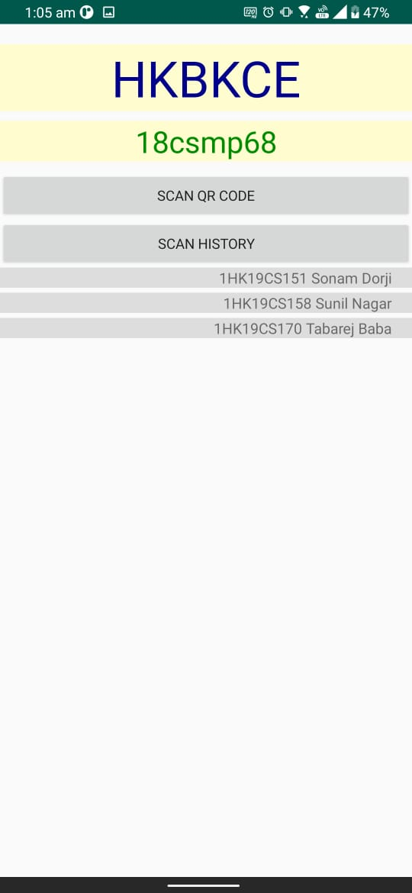
Figure 5-1 Application Homepage

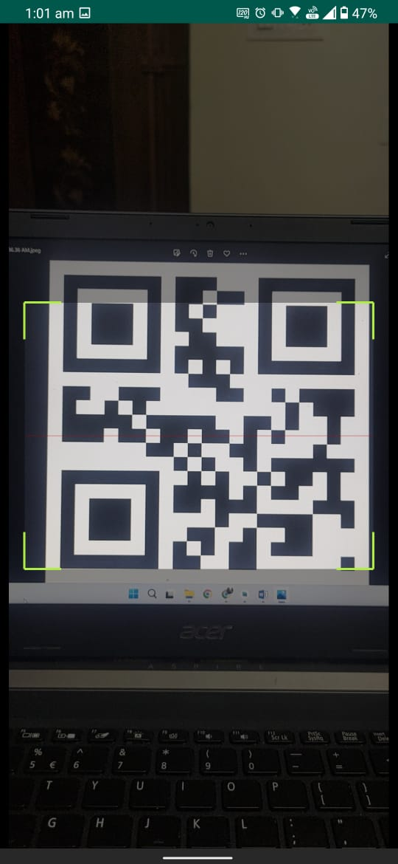
Figure 5-2 Scanning

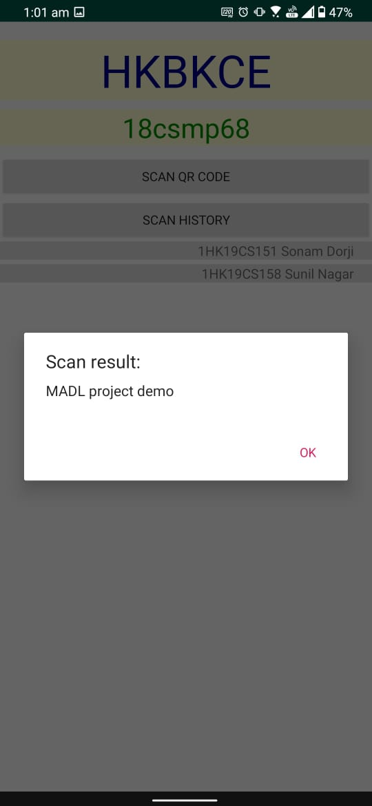
Figure 5-3 scanned message

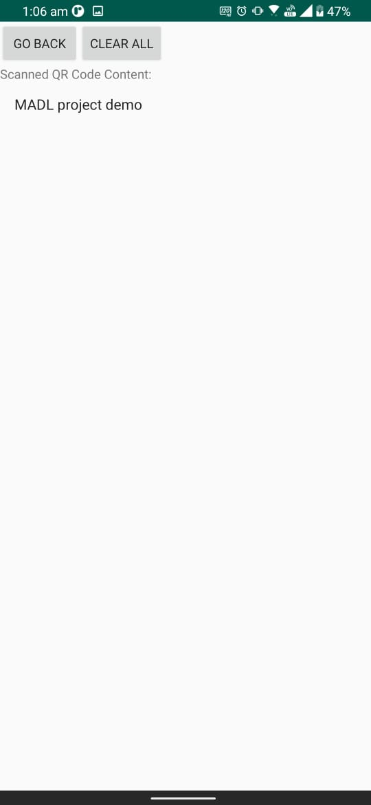
Figure 5-4 Message Record

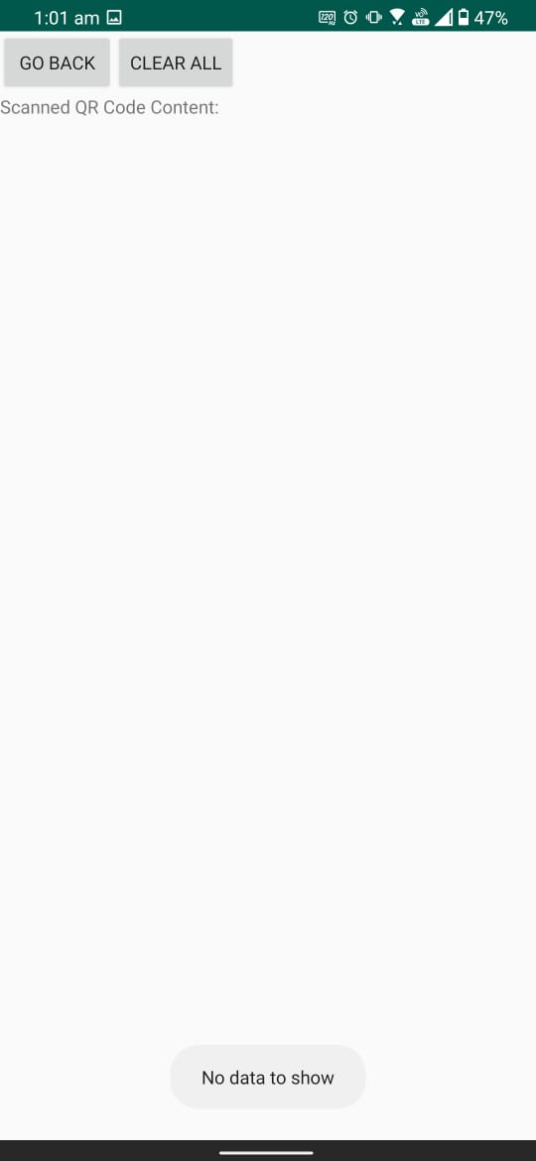
Figure 5-5 Cleared Record

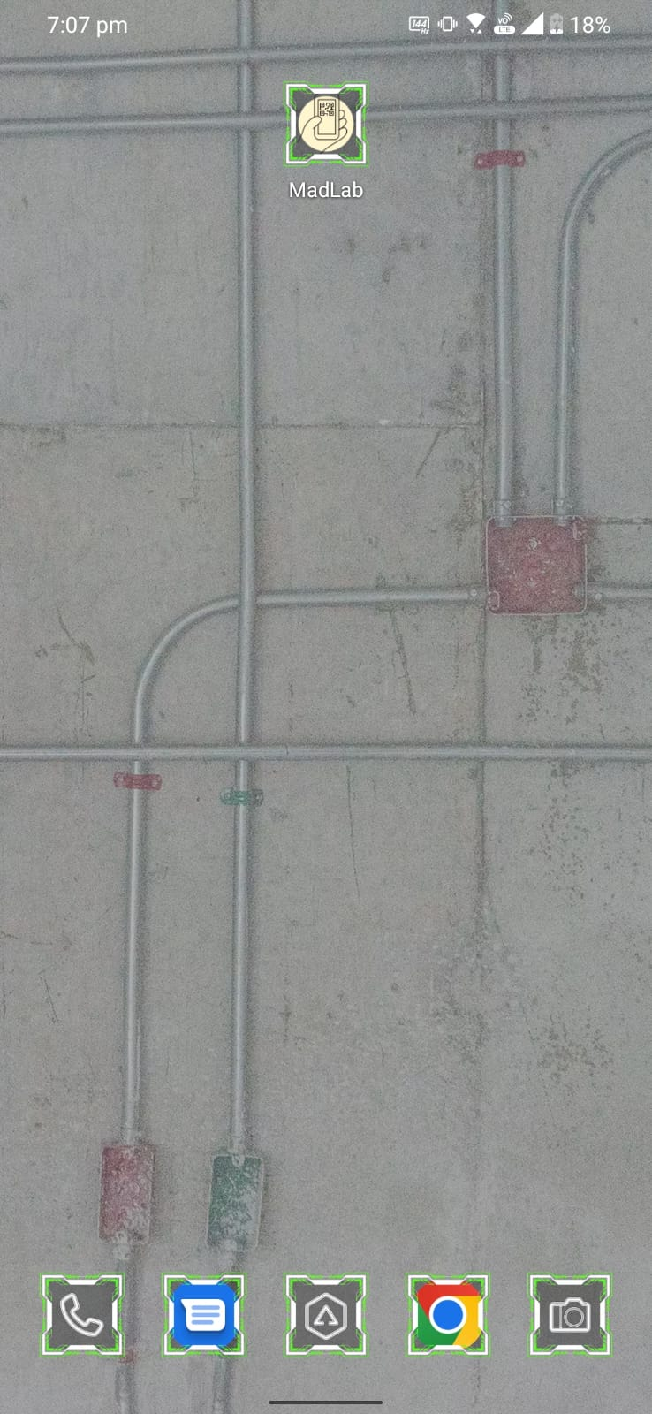
Figure 5-6 App Icon

Conclusion
Adoption of the QR codes grows rapidly during past years and number of users increases exponentially, due to its features like high data storage capacity, fast scanning, error-correction, direct marking and ease of use.
With this project in completion, we are proud to have a custom build QR Code scanner in our android phone build by our own hand. It is accomplished with great efforts, and even more so achievement. It taught us the macro of building an android application from scratch.
It has been a great learning experience with tons of debugs and developments. Here concludes our sixth semester mad lab mini project.

References
- Google Developer Training, “Android Developer Fundamentals Course-Concept Reference, Google Developer Training Team, 2017. https://www.gitbook.com/book/google-developer-training/android-developer-fundamentals-course-concepts/details
- https://github.com/aldinnasrunm/QRScannerAndroid.git
- https://github.com/Son-dorj/madMini.git
- https://www.researchgate.net/publication/318125149_An_Introduction_to_QR_Code_Technology

