Task 1 – Concurrent Workflow Execution Load Testing

Overview
In this report we investigate how the system under test performs when 100 virtual users request an ad-hoc execution of the same workflow at approximately the same time.
The tests were executed against the provided candidate environment with k6.
Two ways of creating an ad-hoc job were tested: synchronous loading (the same request the Hub UI sends when the user clicks Run) and asynchronous loading (asyncLoading=true).

Summary
- Synchronous loading (as in the UI): 88 of 100 workflows completed, 12 failed. All 12 failures are HTTP 500 Internal Error on POST /execution/jobs (job creation), returned after ~30–40 s. The job is not created in this case. Repeated runs showed the same behaviour with a high variance: 74/26, 97/3 and 88/12 completed/failed.
- Asynchronous loading: 100 of 100 workflows completed, 0 failed. Job creation took p95 2.3 s, the whole run was 2.5× faster (e2e p95 22.8 s vs 42.6 s).
- The environment processes the burst (all 100 jobs complete when the request does not wait for the job to be loaded). The failures are caused by the synchronous HTTP request that waits while 100 jobs queue for loading on 2 executors and is cut off by the server after ~30–40 s.
- Under load the workflow execution itself slows down from ~1–3 s (single job) to avg 6–15 s, p95 10–25 s: 100 jobs share the CPU of 2 executors (4 CPU in total, the team limit is fully used).

Test Runs
Test # | Description | Status
Test 1 | 100 VUs × 1 ad-hoc execution at the same time, synchronous job loading (as in the Hub UI) | Completed
Test 2 | 100 VUs × 1 ad-hoc execution at the same time, asynchronous job loading (asyncLoading=true) | Completed

Test Results
Metric | Test 1 – sync | Test 2 – async
Workflows completed / failed | 88 / 12 | 100 / 0
Success rate | 88% | 100%
Failed requests (all POST /execution/jobs, HTTP 500) | 12 of 719 (1.66%) | 0 of 1492 (0%)
Job creation POST /execution/jobs – avg / p95 / max | 26.9 s / 39.3 s / 40.8 s | 1.8 s / 2.3 s / 2.5 s
Workflow execution time (Hub) – avg / p95 / max | 14.8 s / 24.7 s / 25.8 s | 6.1 s / 10.1 s / 11.2 s
End-to-end time (request → final state) – avg / p95 | 37.7 s / 42.6 s | 16.7 s / 22.8 s
Job status request GET /execution/jobs/{id} – avg / p95 | 0.8 s / 1.9 s | 61 ms / 72 ms
Test duration | 1 min 20 s | 28 s
Environment start in setup() | 31.2 s (was stopped) | 0.2 s (already running)

Workflow execution time is taken from the Hub job data (finishedExecutionAt − startedExecutionAt); end-to-end time is measured by k6 from sending the create request until the job status shows a final state.
The table above is taken from the k6 summary; the group and request tables below are taken from InfluxDB, so percentiles can differ slightly.

Test №1 – Burst, synchronous job loading
Goal: reproduce the Run button of the Hub UI for 100 users at the same time and report the number of completed / failed workflows.
Results: 88 completed, 12 failed. The failed jobs were not created: POST /execution/jobs returned 500 An internal error occurred after 31–41 s. Successful create requests also took up to 40.8 s, because the request is answered only after the job is loaded into an executor.
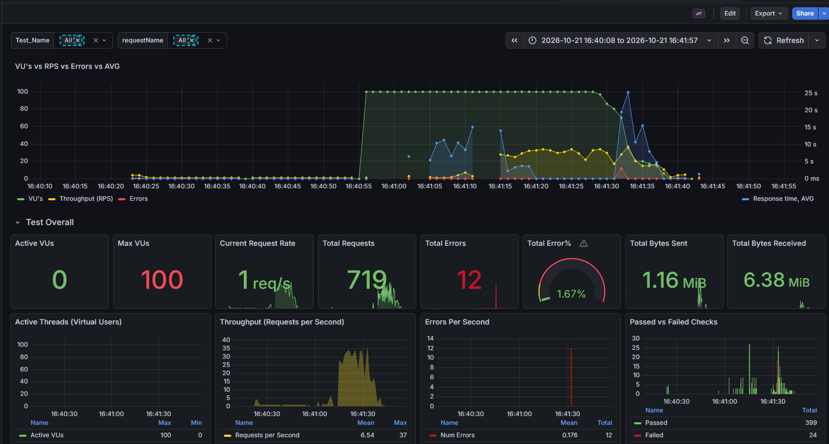
Test 1 – Grafana
Group transactions:
Transaction | Count | Min | Max | Avg | p75 | p90 | p95 | p99 | Errors
setup::Open login page | 1 | 978 ms | 978 ms | 978 ms | 978 ms | 978 ms | 978 ms | 978 ms | 0
setup::Submit login | 1 | 601 ms | 601 ms | 601 ms | 601 ms | 601 ms | 601 ms | 601 ms | 0
setup::Get identity | 1 | 457 ms | 457 ms | 457 ms | 457 ms | 457 ms | 457 ms | 457 ms | 0
setup::Start environment | 1 | 31.2 s | 31.2 s | 31.2 s | 31.2 s | 31.2 s | 31.2 s | 31.2 s | 0
Create job | 100 | 6.65 s | 41.4 s | 27.3 s | 37.3 s | 39.2 s | 39.6 s | 41.1 s | 12
Wait for job completion | 88 | 1.06 s | 30.6 s | 11.7 s | 17.0 s | 23.4 s | 25.4 s | 30.6 s | 0
teardown::Delete test jobs | 1 | 3.82 s | 3.82 s | 3.82 s | 3.82 s | 3.82 s | 3.82 s | 3.82 s | 0

Requests:
Transaction | Request | Count | Failed | Min | Max | Avg | p75 | p90 | p95
Create job | POST /execution/jobs | 100 | 12 | 6.47 s | 40.8 s | 26.9 s | 37.0 s | 38.5 s | 39.2 s
Wait for job completion | GET /execution/jobs/{id} | 570 | 0 | 55.1 ms | 29.6 s | 800 ms | 65.2 ms | 76.6 ms | 2.08 s
setup::Start environment | PUT /execution-status/execution-contexts/{id}/start | 1 | 0 | 79.6 ms | 79.6 ms | 79.6 ms | 79.6 ms | 79.6 ms | 79.6 ms
setup::Start environment | GET /execution-status/execution-contexts/{id} | 30 | 0 | 60.8 ms | 84.2 ms | 66.2 ms | 67.1 ms | 68.3 ms | 73.6 ms
teardown::Delete test jobs | GET /execution/jobs | 9 | 0 | 194 ms | 423 ms | 249 ms | 260 ms | 278 ms | 423 ms
teardown::Delete test jobs | DELETE /execution/jobs | 1 | 0 | 1.40 s | 1.40 s | 1.40 s | 1.40 s | 1.40 s | 1.40 s

Test №2 – Burst, asynchronous job loading
Goal: check whether the failures of Test 1 are caused by the capacity of the environment or by the synchronous job creation request.
Results: 100 completed, 0 failed. Job creation returns immediately (LOAD_REQUESTED), the job is loaded and executed in the background and its status is polled. All 100 jobs finished within ~23 s.
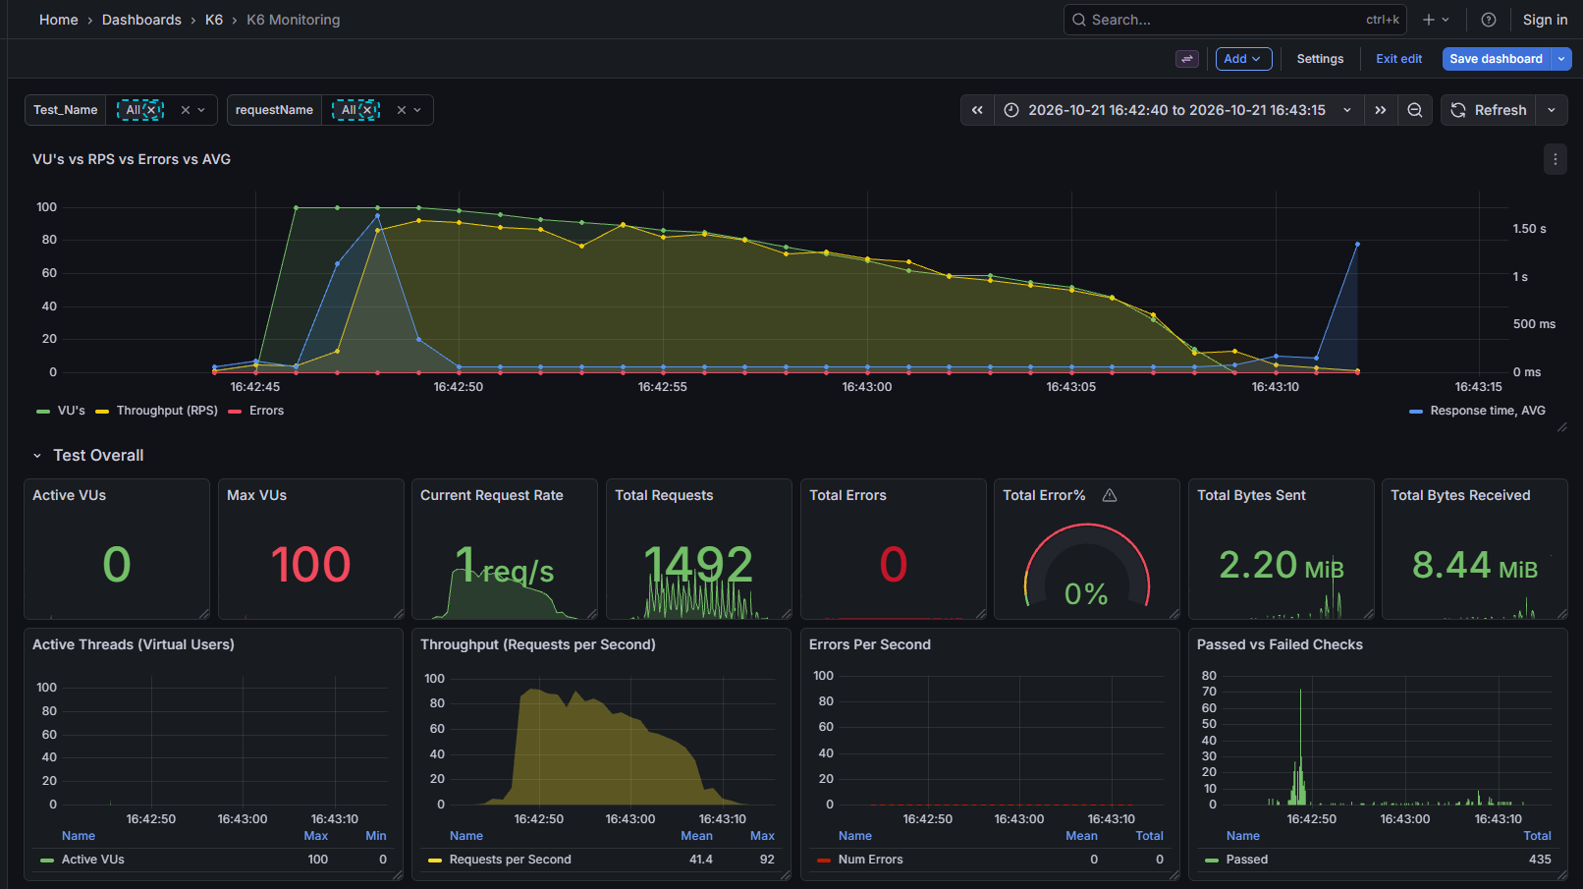
Test 2 – Grafana
Group transactions:
Transaction | Count | Min | Max | Avg | p75 | p90 | p95 | p99 | Errors
setup::Open login page | 1 | 771 ms | 771 ms | 771 ms | 771 ms | 771 ms | 771 ms | 771 ms | 0
setup::Submit login | 1 | 478 ms | 478 ms | 478 ms | 478 ms | 478 ms | 478 ms | 478 ms | 0
setup::Get identity | 1 | 447 ms | 447 ms | 447 ms | 447 ms | 447 ms | 447 ms | 447 ms | 0
setup::Start environment | 1 | 190 ms | 190 ms | 190 ms | 190 ms | 190 ms | 190 ms | 190 ms | 0
Create job | 100 | 1.02 s | 2.81 s | 2.10 s | 2.41 s | 2.58 s | 2.71 s | 2.78 s | 0
Wait for job completion | 100 | 2.19 s | 20.2 s | 14.6 s | 19.1 s | 20.1 s | 20.1 s | 20.2 s | 0
teardown::Delete test jobs | 1 | 3.25 s | 3.25 s | 3.25 s | 3.25 s | 3.25 s | 3.25 s | 3.25 s | 0

Requests:
Transaction | Request | Count | Failed | Min | Max | Avg | p75 | p90 | p95
Create job | POST /execution/jobs | 100 | 0 | 810 ms | 2.51 s | 1.81 s | 2.08 s | 2.23 s | 2.30 s
Wait for job completion | GET /execution/jobs/{id} | 1372 | 0 | 53.1 ms | 347 ms | 61.2 ms | 61.8 ms | 65.6 ms | 71.8 ms
setup::Start environment | PUT /execution-status/execution-contexts/{id}/start | 1 | 0 | 64.4 ms | 64.4 ms | 64.4 ms | 64.4 ms | 64.4 ms | 64.4 ms
setup::Start environment | GET /execution-status/execution-contexts/{id} | 1 | 0 | 64.3 ms | 64.3 ms | 64.3 ms | 64.3 ms | 64.3 ms | 64.3 ms
teardown::Delete test jobs | GET /execution/jobs | 9 | 0 | 113 ms | 376 ms | 193 ms | 182 ms | 205 ms | 376 ms
teardown::Delete test jobs | DELETE /execution/jobs | 1 | 0 | 1.34 s | 1.34 s | 1.34 s | 1.34 s | 1.34 s | 1.34 s

Additional observations
- Result variance in synchronous mode: three runs of Test 1 gave 74/26, 97/3 and 88/12 completed/failed. The failure rate depends on how long the create requests wait in the loading queue.
- Sustained load (`burstRamp`, 0 → 100 VUs in 1 min, 100 VUs for 2 min, 100 → 0 VUs in 1 min, synchronous mode): 1024 of 1024 workflows completed, throughput ~3.5 workflows/s. No failures because requests are spread over time and the loading queue stays short (create p95 13.4 s). Workflow execution time grew to p95 36 s – the CPU of the 2 executors becomes the bottleneck under continuous load.
- Environment start: a stopped environment needs ~30–45 s until both executors are running (auto-stop after 5 min idle). The test starts the environment in setup(), so the cold start does not affect the measured jobs.
- Extra executor after load: after one of the load runs the environment showed 3 executors (2 Running, 1 Starting up for a long time) with maxExecutors = 2; the team CPU limit (4 of 4 used) does not allow it to start.

Unavailable metrics
Metric | Reason
Executor CPU and memory, JVM heap / GC | No access to system under test monitoring
Hub service metrics (execution service, message broker, DB) | No access to system under test monitoring
Server logs for the HTTP 500 errors | No access to logs; Error IDs are provided

Appendix

Infrastructure
Item | Value
System under test | Provided candidate environment
Execution context | TestEnv
Executors | 2 (min = max = 2)
Executor resources | 2 CPU, 8 GB RAM per executor, JAVA_MAX_MEM_RATIO=60
Executor image | r-5.12.0-114
Job defaults | 1 CPU, 1000 MB RAM per job, no limit of jobs per executor
Timeouts | Load 5 min, execution 5 min, start execution 1 min
Auto start / auto stop | Enabled / after 5 min idle
Team limits | 4 CPU cores (4 used)
Workflow | /Users/Initial Team/Initial Space/01 Analyze Data by Training a Decision Tree (385 KB)

Methodology/Approach
- Tool: k6 v1.8.2 with TypeScript, results in InfluxDB + Grafana; the framework and tests are in this repository.
- One user account for all virtual users (agreed in advance); login is done once in setup() and the session cookie is shared by all VUs.
- setup() starts the environment and waits until the minimum number of executors is running.
- Each VU: POST /execution/jobs?workflowUri=…&itemVersion=current-state&wizardExecution=true (ad-hoc job, the same request as the Run button in the Hub UI) → poll GET /execution/jobs/{id} every 1 s until a final state (max 10 min).
- teardown() deletes all jobs created by the test.
- Load model burst: 100 VUs × 1 iteration, all started at the same time (per-vu-iterations).
- Test 2 adds asyncLoading=true to the create request.

Acceptance criteria
The assignment defines no performance thresholds; the following criteria are our assumptions:
Criterion | Threshold | Test 1 | Test 2
Workflow success rate | > 95% | ❌ 88% | ✅ 100%
Workflow execution time p95 | < 10 s | ❌ 24.7 s | ❌ 10.1 s
Job creation p95 | < 40 s | ✅ 39.3 s | ✅ 2.3 s
Job status request p95 | < 5 s | ✅ 1.9 s | ✅ 72 ms
HTTP error rate | < 5% | ✅ 1.66% | ✅ 0%

