

CLINIC SYSTEM
Software Design Document

– Hanoi, January 2022 –

Table of Contents
I. Overview 8
1. Code Packages/Namespaces 8
2. Coding Conventions 9
II. Code Designs 9
1. Common/Login 9
a. Class Diagram 9
b. Class Specifications 9
c. Sequence Diagram 10
2. Common/Register 11
Class Diagram 11
Class Specification 11
Sequence Diagram 12
Database queries 12
3. Admin/Setting List 13
Class Diagram 13
Class Specification 13
Sequence Diagram 14
4. Admin/Setting Details 15
Class Diagram 15
Class Specification 15
Sequence Diagram 15
Database queries 17
5. Admin/Account List 17
Class Diagram 17
Class Specification 17
Sequence Diagram 18
Database queries 18
6. Admin/Account Detail 19
Class Diagram 19
Class Specification 19
Sequence Diagram 19
Database queries 20
7. Marketing/Patient Details 21
Class Diagram 21
Class Specification 21
Sequence Diagram 21
Database queries 22
8. Marketing/Patient edit 23
Class Diagram 23
Class Specification 23
Sequence Diagram 23
Database queries 24
8. Common/Forgot Password 25
Class Diagram 25
Class Specification 25
Sequence Diagram 26
Database queries 26
10. Common/ChangeChange Password 27
Class Diagram 27
Class Specification 27
Sequence Diagram 27
Database queries 28
11. Common/Web Blog List 29
Class Diagram 29
Class Specification 29
Sequence Diagram 29
Database queries 30
12. Common/Web Blog Details 31
Class Diagram 31
Class Specification 31
Sequence Diagram 31
Database queries 32
13. Marketing/Doctor List 33
Class Diagram 33
Class Specification 33
Sequence Diagram 34
Database queries 34
14. Marketing/Doctor Details 36
Class Diagram 36
Class Specification 36
Sequence Diagram 37
Database queries 37
cl15. Marketing/Doctor Edit 38
Class Diagram 38
Class Specification 38
Sequence Diagram 39
Database queries 39
16. Common/ User profile 39
17. Marketing/Patients list 42
18. Marketing/Service List 44
18. Marketing/Service Details 46
Class Diagram 46
Class Specification 47
Sequence Diagram 47
Database queries 49
19. Marketing/Service Feedbacks 50
Class Diagram 50
Class Specification 50
Sequence Diagram 50
Database queries 51
20. Marketing/Blog List 52
Class Diagram 52
Class Specification 52
Sequence Diagram 53
Database queries 53
21. Marketing/Blog Detail 55
Class Diagram 55
Class Specification 55
Sequence Diagram 55
Database queries 56
22. Public/Web Doctor List 57
Class Diagram 57
Class Specification 57
Sequence Diagram 58
Database queries 58
23. Public/Web Doctor Detail 60
Class Diagram 60
Class Specification 60
Sequence Diagram 61
Database queries 61
24. Staff/Appointments List 62
Class Diagram 62
Class Specification 62
Sequence Diagram 63
Database queries 63
25. Staff/Appointments Detail 65
bClass Diagram 65
Class Specification 65
Sequence Diagram 65
Database queries 66
26. Staff/Reservation List 67
Class Diagram 67
Class Specification 67
Sequence Diagram 68
Database queries 68
27. Staff/Reservation Detail 69
28. Public/Services List 72
Class Diagram 72
Class Specification 72
Sequence Diagram 73
29. Public/Service detail 75
Class Diagram 75
Class Specification 75
Sequence Diagram 75
30. Doctor/My Patients 77
Class Diagram 77
Class Specification 77
Sequence Diagram 77
Database queries 78
31. Doctor/My Patient Details 79
Class Diagram 79
Class Specification 79
Sequence Diagram 79
Database queries 80
32. Doctor/My Feedback 80
Class Diagram 80
33. Admin/Dashboard 81
Class Diagram 81
III. Database Design 81
1. Database Schema 81
2. Table Description 81

​​RECORD OF CHANGE
*A - ADDED M - MODIFIED D - DELETED

Effective Date | Changed Items | A*  M, D | Change Description | New Version
12/1/2021 | Create new SRS | A | Create new | 1.0
17/01/2022 | Khương Văn Hùng | A | Home Page | 1.1
17/01/2022 | Phan Trương Thảo | A | User Login | 1.1
17/01/2022 | Trần Thành Lam | A | User Register | 1.1
17/01/2022 | Hà Hữu Việt | A | Settings List | 1.1
17/01/2022 | Nguyễn Văn Trung | A | Setting Details | 1.1
30/01/2022 | Khương Văn Hùng | M | Home Page | 1.2
30/01/2022 | Phan Trương Thảo | M | User Login | 1.2
30/01/2022 | Trần Thành Lam | M | User Register | 1.2
30/01/2022 | Hà Hữu Việt | M | Settings List | 1.2
30/01/2022 | Nguyễn Văn Trung | M | Setting Details | 1.2
30/01/2022 | Trần Thành Lam | A | Web Blogs List | 1.2
30/01/2022 | Trần Thành Lam | A | Web Blog Details | 1.2
30/01/2022 | Phan Trương Thảo | A | Forgot Password | 1.2
30/01/2022 | Phan Trương Thảo | A | Change Password | 1.2
30/01/2022 | Hà Hữu Việt | A | User Profile | 1.2
30/01/2022 | Hà Hữu Việt | A | Patients List | 1.2
30/01/2022 | Nguyễn Văn Trung | A | Patient Details | 1.2
30/01/2022 | Nguyễn Văn Trung | A | Patient Edit | 1.2
30/01/2022 | Đinh Thị Tươi | A | Accounts List | 1.2
30/01/2022 | Đinh Thị Tươi | A | Account Details | 1.2
30/01/2022 | Khương Văn Hùng | A | Doctors List | 1.2
30/01/2022 | Khương Văn Hùng | A | Doctor Details | 1.2
30/01/2022 | Khương Văn Hùng | A | Doctor Edit | 1.2
25/2/2022 | Phan Trương Thảo | A | Web Doctors List | 1.3
25/2/2022 | Phan Trương Thảo | A | Web Doctor Details | 1.3
25/2/2022 | Hà Hữu Việt | A | Web Services List | 1.3
25/2/2022 | Hà Hữu Việt | A | Web Service Details | 1.3
25/2/2022 | Khương Văn Hùng | A | Appointments List | 1.3
25/2/2022 | Khương Văn Hùng | A | Appointment Details | 1.3
25/2/2022 | Khương Văn Hùng | A | Reservations List | 1.3
25/2/2022 | Đinh Thị Tươi | A | Reservation Details | 1.3
25/2/2022 | Đinh Thị Tươi | A | Services List | 1.3
25/2/2022 | Nguyễn Văn Trung | A | Service Details | 1.3
25/2/2022 | Nguyễn Văn Trung | A | Service Feedbacks | 1.3
25/2/2022 | Trần Thành Lam | A | Blogs List | 1.3
25/2/2022 | Trần Thành Lam | A | Blog Details | 1.3
10/03/2022 | Phan Trương Thảo | A | User Authorization | 1.4
10/03/2022 | Khương Văn Hùng | A | Dashboard | 1.4
10/03/2022 | Hà Hữu Việt | A | My Appointments | 1.4
10/03/2022 | Hà Hữu Việt | A | My Appointment Details | 1.4
10/03/2022 | Nguyễn Văn Trung | A | My Patients | 1.4
10/03/2022 | Nguyễn Văn Trung | A | My Patient Details | 1.4
10/03/2022 | Phan Trương Thảo | A | My Feedbacks | 1.4
10/03/2022 | Trần Thành Lam | A | Book Appointment | 1.4
10/03/2022 | Trần Thành Lam | A | Reserve a Service | 1.4
10/03/2022 | Đinh Thị Tươi | A | Appointment History | 1.4
10/03/2022 | Đinh Thị Tươi | A | Reservation History | 1.4
10/03/2022 | Khương Văn Hùng | A | Appointment,Reservation payment | 1.4

I. Overview

1. Code Packages/Namespaces
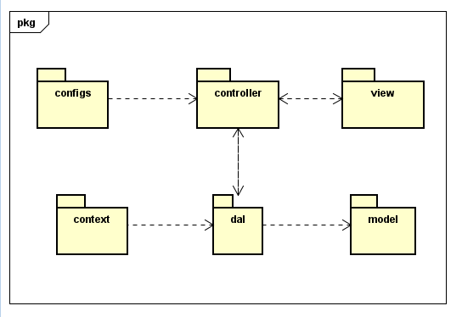
Package descriptions & package class naming conventions
No | Package | Description
1 | controller | Acts as a go-between for the service layer and the Front-end, passing on different input requests
2 | dal | This component is used to get data directly FROM the database
3 | configs | This component helps define configuration
4 | context | This component helps connect database
5 | model | This component includes interfaces used to receive data retrieved FROM the database and classes used to receive data
6 | view | This component display front-end.

II. Code Designs

1. Common/Login

a. Class Diagram
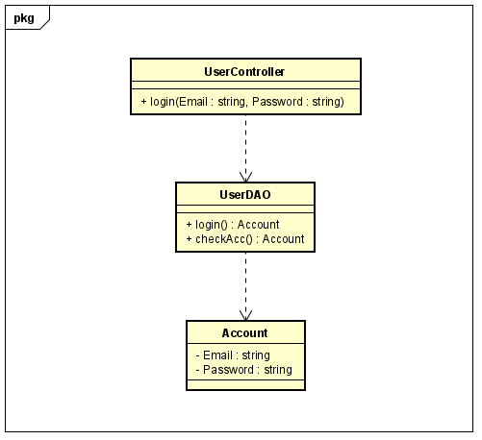

b. Class Specifications

No | Method | Description
01 | login | Using to login into the system
 | checkAcc | Using to check account in database

c. Sequence Diagram
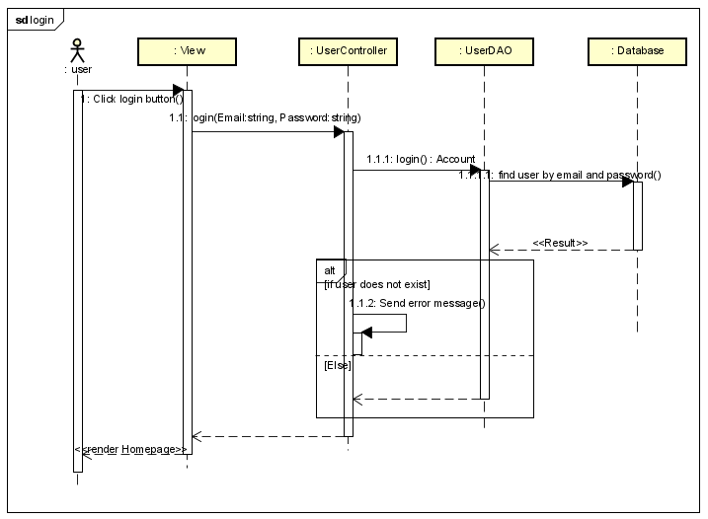d.
d. Database queries
String sql = "SELECT * FROM users where email=? or username=?"

2. Common/Register

Class Diagram
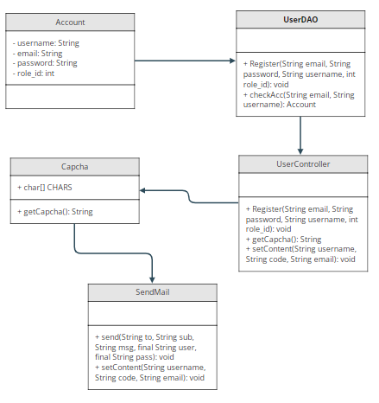

Class Specification

No | Method | Description
1 | Register | use to create new user
2 | checkAcc | use to check username or email exist
3 | getCapcha | get a random string
4 | send | send mail to user
5 | setContent | set email and username that user use to register to send

Sequence Diagram
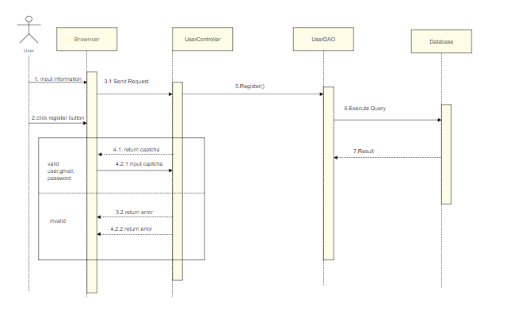

Database queries
- SELECT * FROM users WHERE email=? OR username=?
- INSERT INTO `doctris_system`.`users` (`username`, `password`, `email`, `role_id`) VALUES (?, ?, ?, ?)

3. Admin/Setting List

Class Diagram

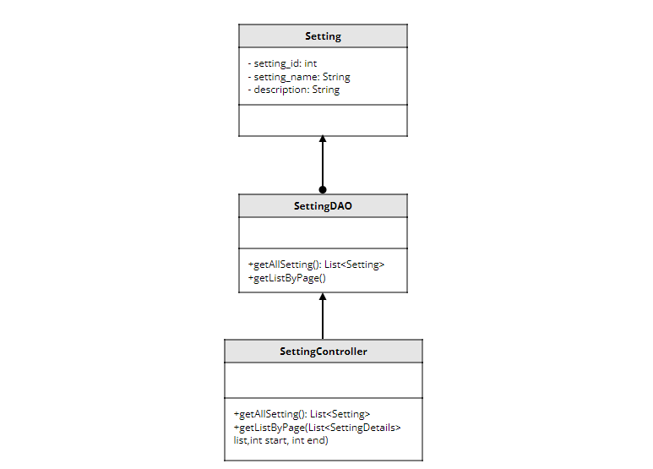

Class Specification

No | Method | Description
1 | getAllSetting | use to list setting
2 | getListByPage | use to pagination

Sequence Diagram
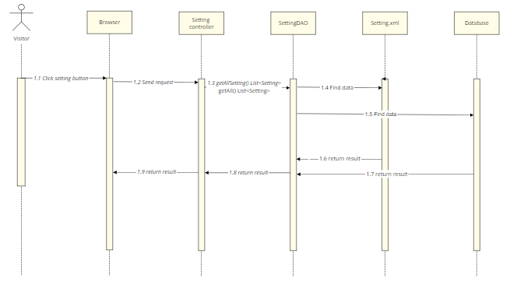
- Database queries
- SELECT * FROM setting
- SELECT * FROM doctris_system.role
UNION
SELECT * FROM doctris_system.category_blog
UNION
SELECT * FROM doctris_system.category_service

4. Admin/Setting Details

Class Diagram
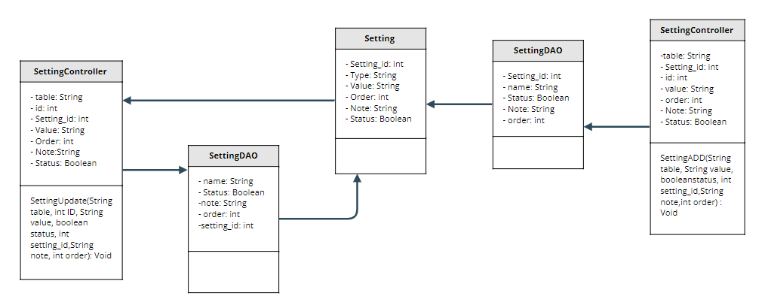

Class Specification

No | Method | Description
1 | SettingADD | use to create new setting
2 | SettingUpdate | use to update setting

Sequence Diagram

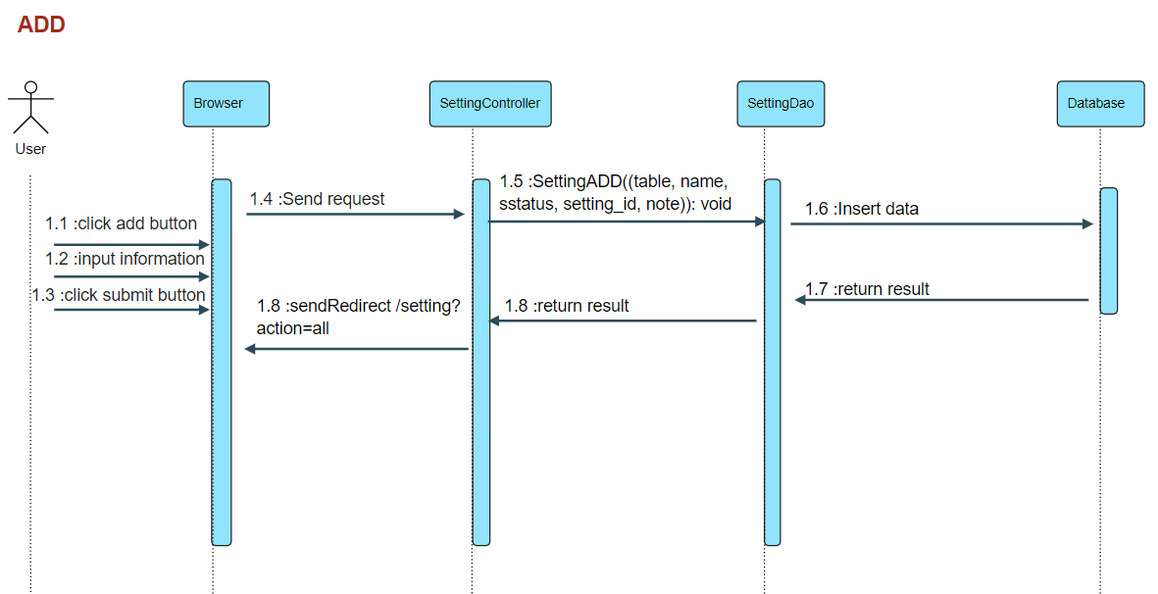

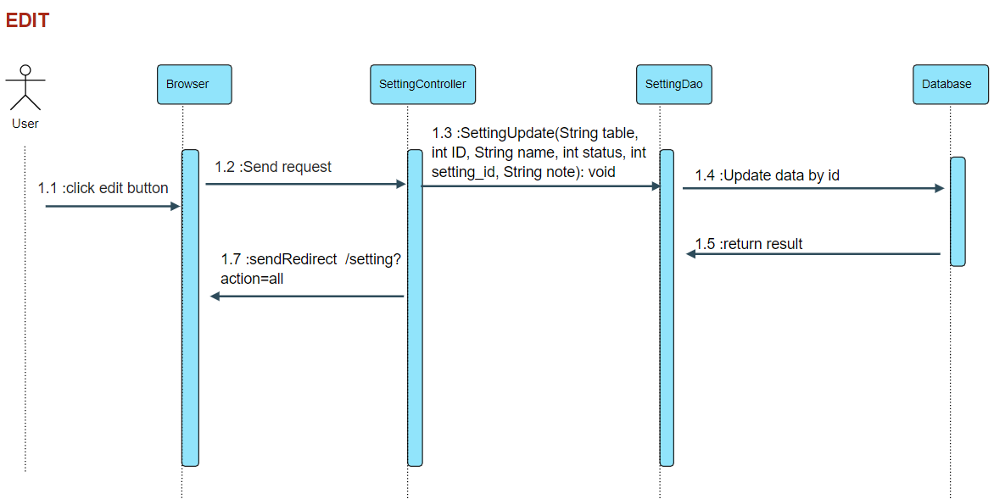

Database queries
- INSERT INTO category_blog `name`, `setting_id`, `status`, `note`, `status` VALUES (?, ?, ?, ?)
- INSERT INTO category_service `name`, `setting_id`, `status`, `note` , `status`VALUES (?, ?, ?, ?)
- INSERT INTO role `name`, `setting_id`, `status`, `note` , `status`VALUES (?, ?, ?, ?)
- UPDATE category_blog SET name = ?, setting_id = ?, status = ?, note = ? , r.order = ? WHERE (id = ?)
- UPDATE category_service SET name = ?, setting_id = ?, status = ?, note = ? , r.order = ? WHERE (id = ?)
- UPDATE role SET name = ?, setting_id = ?, status = ?, note = ? , r.order = ? WHERE (id = ?)

5. Admin/Account List

Class Diagram
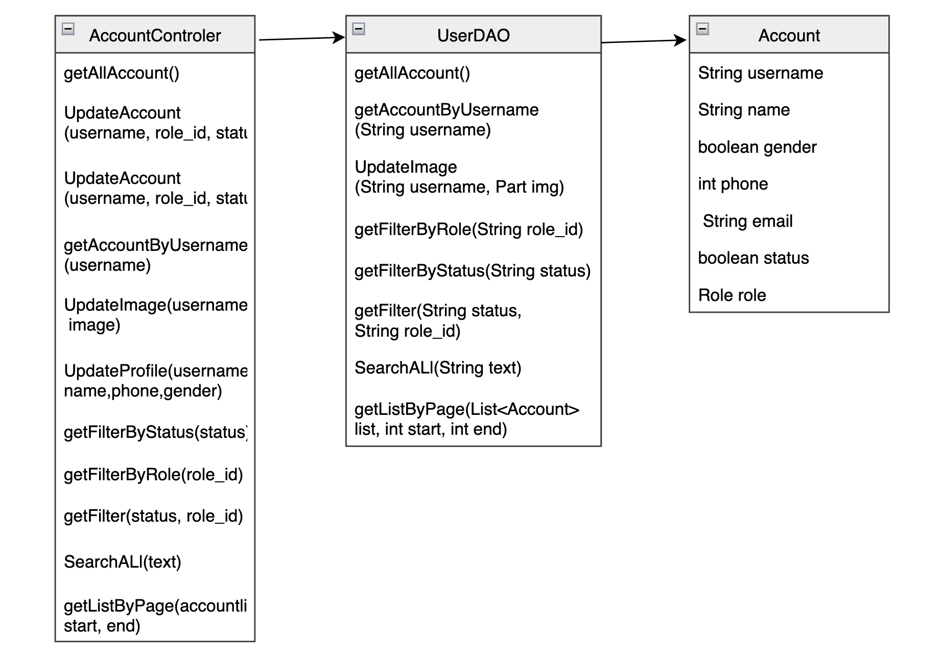

Class Specification

No | Method | Description
1 | getAllAccount | Show list account of user
2 | getAccountByUseName | Search account by username
3 | getListByPage | Show 8 row in a page

Sequence Diagram
Show all account in Account list function
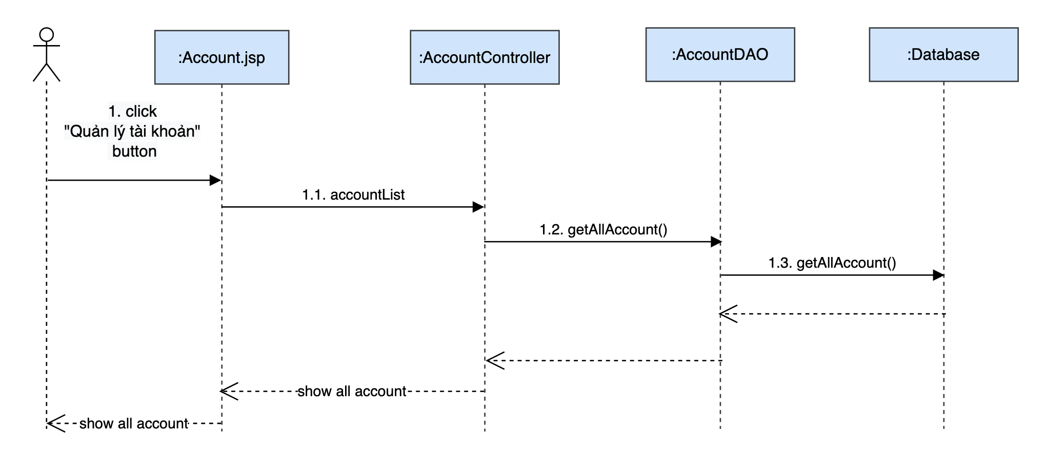

Database queries
- SELECT u.username,u.name,u.gender,u.email,u.phone,r.name,u.status,u.img FROM doctris_system.users u inner join doctris_system.role r on u.role_id = r.id
- SELECT u.username,u.name,u.gender,u.email,u.phone,r.name,u.status,u.img FROM doctris_system.users u inner join doctris_system.role r on u.role_id = r.id where u.role_id = ?
- SELECT u.username,u.name,u.gender,u.email,u.phone,r.name,u.status,u.img FROM doctris_system.users u inner join doctris_system.role r on u.role_id = r.id where u.status = ?SE
- SELECT u.username,u.name,u.gender,u.email,u.phone,r.name,u.status,u.img FROM doctris_system.users u inner join doctris_system.role r on u.role_id = r.id
- SELECT u.username,u.name,u.gender,u.email,u.phone,r.name,u.status,u.img FROM doctris_system.users u inner join doctris_system.role r on u.role_id = r.id where u.role_id = ?
- SELECT u.username,u.name,u.gender,u.email,u.phone,r.name,u.status,u.img FROM doctris_system.users u inner join doctris_system.role r on u.role_id = r.id where u.status = ?SE
- SELECT DISTINCT u.username,u.name,u.gender,u.email,u.phone,r.name,u.status,u.img FROM doctris_system.users u inner join doctris_system.role r on u.role_id = r.id where u.name LIKE ? OR u.email LIKE ? OR u.phone LIKE ? OR u.username LIKE ?
- UPDATE `doctris_system`.`users` SET `role_id` = ?, `status` = ? WHERE (`username` = ?)

6. Admin/Account Detail

Class Diagram
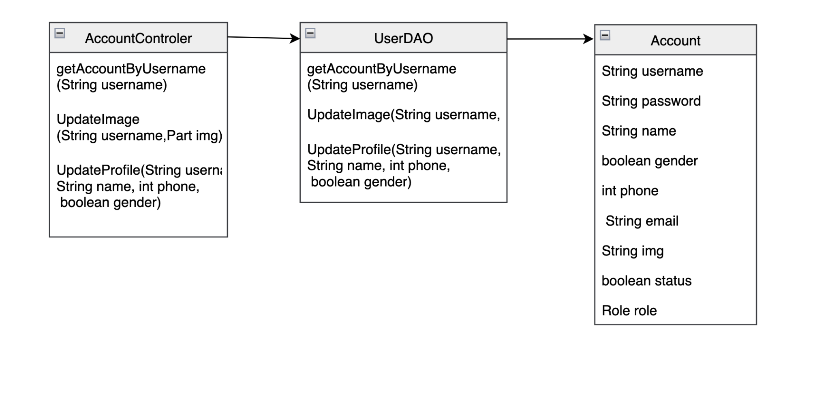

Class Specification

No | Method | Description
1 | getAccountByUseName | Search account by username
2 | UpdateImage | Update image of user
3 | Updateprofile | Update profile of user in account detail

Sequence Diagram
show detail profile of user on “Quản lý tài khoản” function
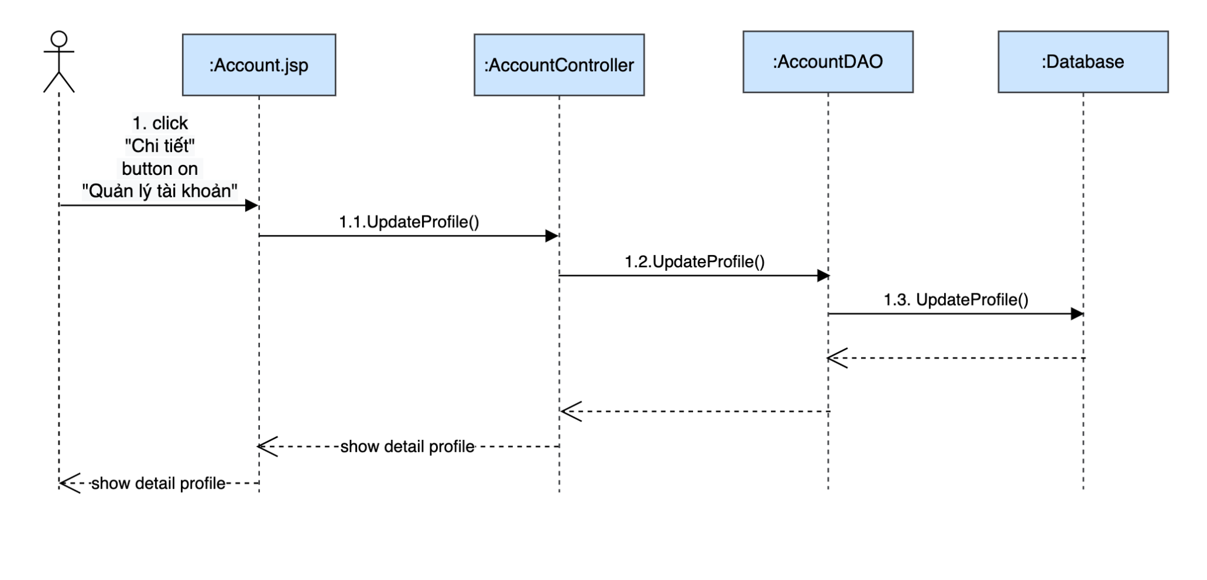
Perform update image user profile
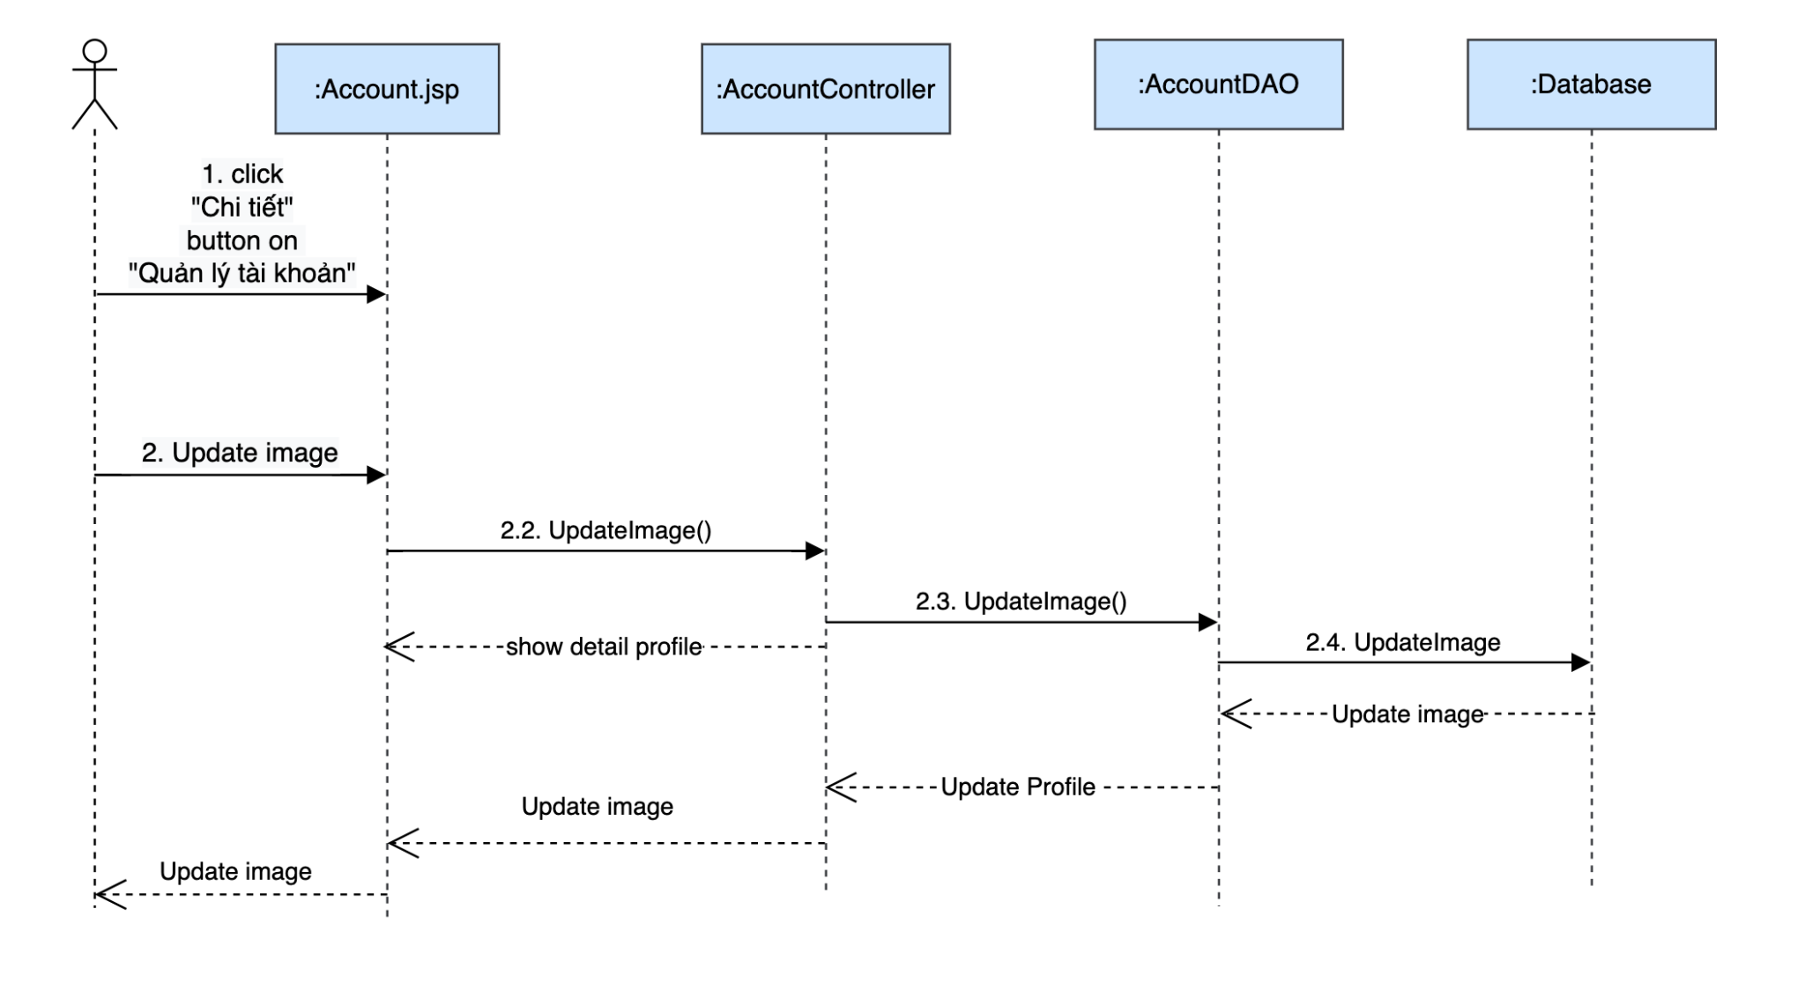

Database queries
- UPDATE `doctris_system`.`users` SET `img` = ? WHERE (`username` = ?)
- UPDATE `doctris_system`.`users` SET `name` = ?, `phone` = ?, `gender` = ? WHERE (`username` = ?)

7. Marketing/Patient Details

Class Diagram
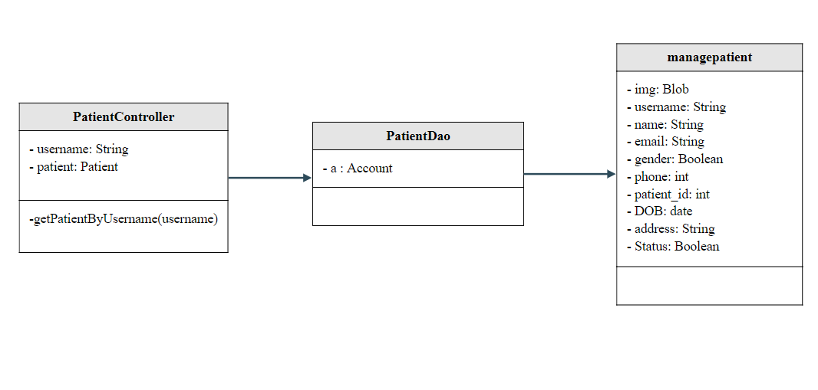

Class Specification

No | Method | Description
1 | getPatientByUsername | used to list the details of that exact patient

Sequence Diagram
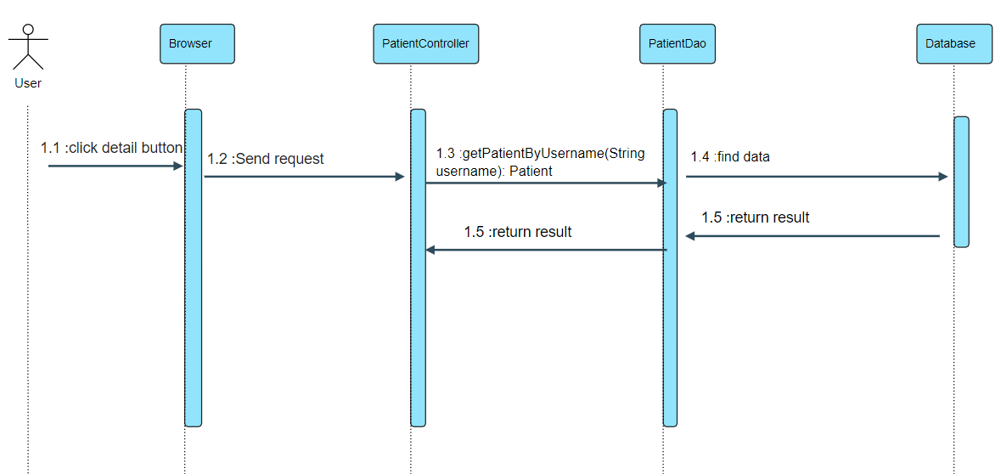

Database queries
- SELECT u.img, u.username,u.name,u.email,u.gender,u.phone,p.patient_id,p.DOB,p.address,p.status FROM patient p inner join users u
on p.username = u.username
where u.username = ?

8. Marketing/Patient edit

Class Diagram
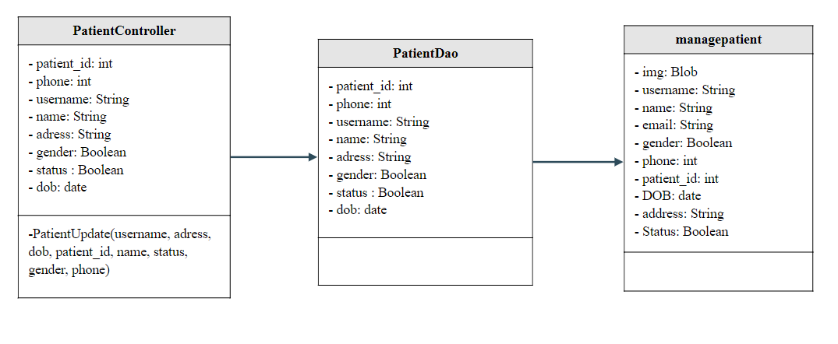

Class Specification

No | Method | Description
1 | PatientUpdate | use to update Patient

Sequence Diagram
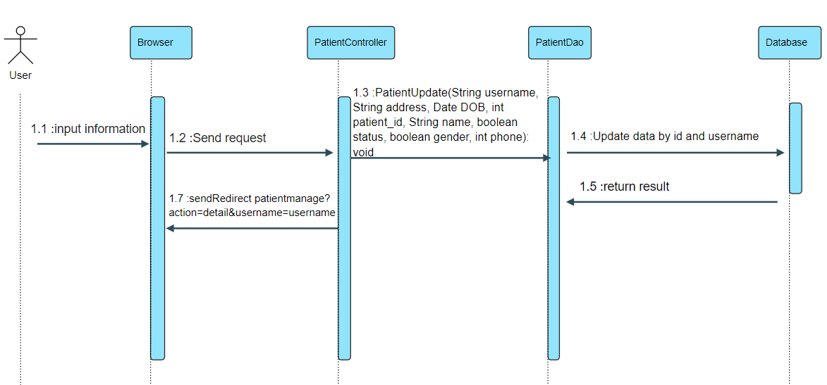

Database queries
- UPDATE `doctris_system`.`patient`
SET
`address` = ?,
`DOB` = ?,
`status` = ?
WHERE `patient_id` = ?
- UPDATE `doctris_system`.`users`
SET
`name` = ?,
`gender` = ?,
`phone` = ?
WHERE `username` = ?

8. Common/Forgot Password

Class Diagram
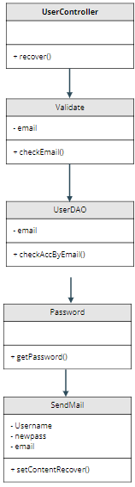

Class Specification

No | Method | Description
1 | recover | using to forgot password
2 | checkEmail | using to check validate email
3 | checkAccByEmail | using to check exist email
4 | getPassword | using to create password randomrandom
5 | setContentRecover | using to send newpassword

Sequence Diagram
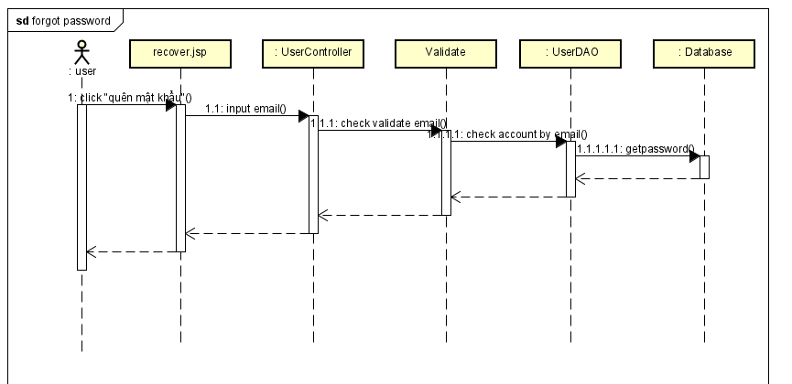

Database queries
- String sql = "UPDATE `doctris_system`.`users` SET `password` = ? WHERE (`username` = ?)";

- String sql = "SELECT * FROM users where email=?";

10. Common/ChangeChange Password

Class Diagram
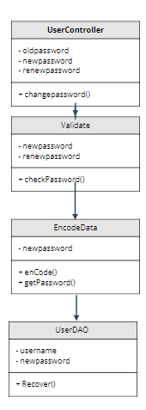

Class Specification

No | Method | Description
1 | changepassword | using to change password
2 | checkPassword | using to check validate passwordpassword
3 | enCode | using to encode password
4 | getPassword | using to update password
5 | Recover | using to save password

Sequence Diagram
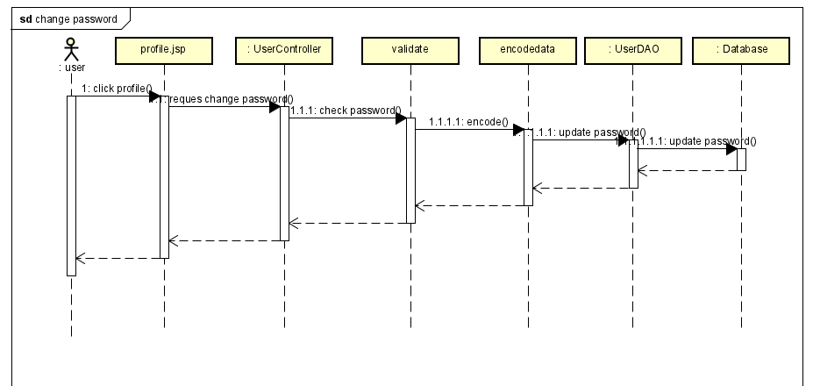

Database queries
- String sql = "UPDATE `doctris_system`.`users` SET `password` = ? WHERE (`username` = ?)";

11. Common/Web Blog List

Class Diagram
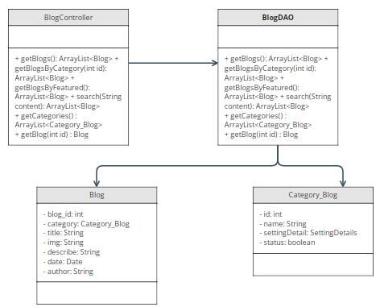

Class Specification

No | Method | Description
1 | getBlogs | get all blog in database order by date
2 | getCategories | get all categories in database
3 | getBlog | get blog by blog id
4 | getBlogBy Featured | get blog which featured
5 | search | get blog that having or contain keyword in its title
6 | getBlogByCategory | get blog in the same category

Sequence Diagram
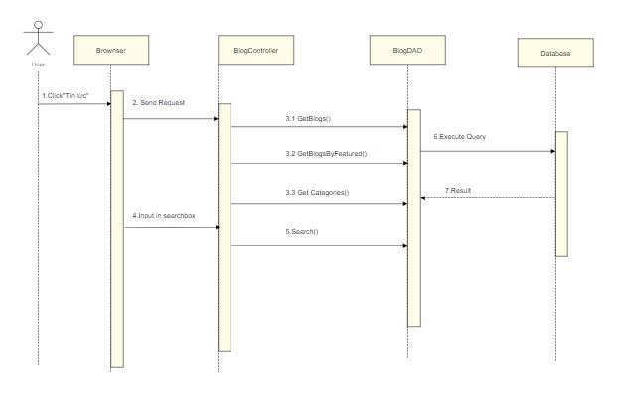

Database queries
- SELECT blog.*, category_blog.name FROM blog
inner join category_blog
on blog.category_id = category_blog.id
order by date desc

- SELECT blog.*, category_blog.name FROM blog
inner join category_blog
on blog.category_id = category_blog.id
where blog_id = ?
order by date desc
- SELECT blog.*, category_blog.name FROM blog
inner join category_blog
on blog.category_id = category_blog.id
where category_id = ?
order by date desc
- Select * FROM blog where featured = 1 ;
- SELECT * FROM blog WHERE title LIKE ? ORDER BY date desc
- SELECT * FROM category_blog;

12. Common/Web Blog Details

Class Diagram


Class Specification

No | Method | Description
1 | getCategories | get all categories in database
2 | getBlog | get blog by blog id
3 | getBlogBy Featured | get blog which featured
4 | search | get blog that having or contain keyword in its title
5 | getBlogByCategory | get blog in the same category

Sequence Diagram
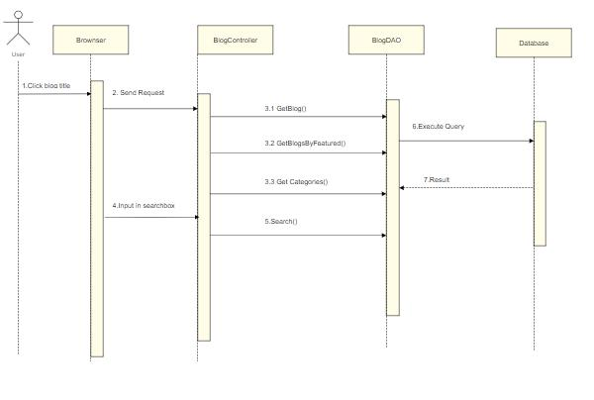

Database queries

- SELECT blog.*, category_blog.name FROM blog
inner join category_blog
on blog.category_id = category_blog.id
where blog_id = ?
order by date desc
- SELECT blog.*, category_blog.name FROM blog
inner join category_blog
on blog.category_id = category_blog.id
where category_id = ?
order by date desc
- Select * FROM blog where featured = 1 ;
- SELECT * FROM blog WHERE title LIKE ? ORDER BY date desc
- SELECT * FROM category_blog;

13. Marketing/Doctor List

Class Diagram
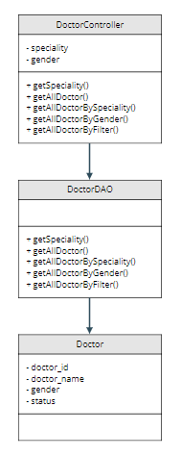

Class Specification

No | Method | Description
1 | getSpeciality
2 | getAllDoctor
3 | getAllDoctorBySpeciality
4 | getAllDoctorByGender
5 | getAllDoctorByFilter

Sequence Diagram
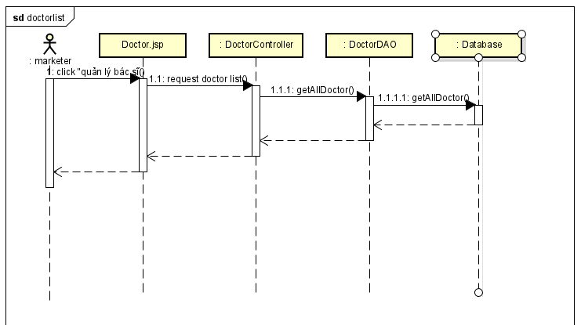

Database queries
- String sql = "select * from doctris_system.category_service";
- String sql = "select cs.name, d.doctor_id,d.doctor_name,d.gender,d.status "
from doctris_system.doctor d "
inner join doctris_system.category_service cs "
on d.category_id = cs.id";
- String sql = "select cs.name, d.doctor_id,d.doctor_name,d.gender,d.status "
from doctris_system.doctor d "
inner join doctris_system.category_service cs "
on d.category_id = cs.id where d.category_id = ?";
- String sql = "select cs.name, d.doctor_id,d.doctor_name,d.gender,d.status "
from doctris_system.doctor d "
inner join doctris_system.category_service cs "
on d.category_id = cs.id where d.gender = ?";
- String sql = "select cs.name, d.doctor_id,d.doctor_name,d.gender,d.status "
from doctris_system.doctor d "
inner join doctris_system.category_service cs "
on d.category_id = cs.id where d.gender = ? and d.category_id = ?";

14. Marketing/Doctor Details

Class Diagram
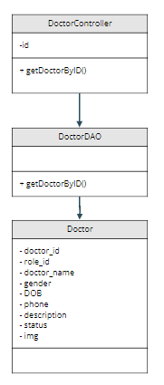

Class Specification

No | Method | Description
 | getDoctorByID

Sequence Diagram
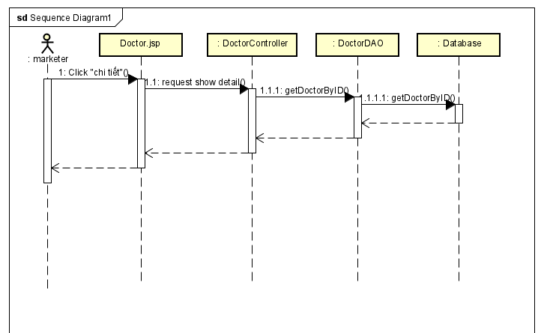

Database queries
String sql = "select cs.name,d.doctor_id,d.role_id,d.doctor_name,d.username,"
d.gender,d.DOB,d.phone,d.description,d.status,d.img,u.email "
from doctris_system.doctor d "
inner join doctris_system.category_service cs on d.category_id = cs.id "
inner join doctris_system.users u on d.username = u.username "
where d.doctor_id = ?";

cl15. Marketing/Doctor Edit

Class Diagram
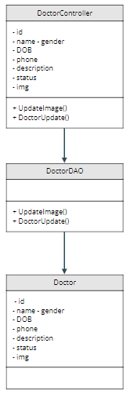

Class Specification

No | Method | Description
1 | UpdateImage
2 | DoctorUpdate

Sequence Diagram

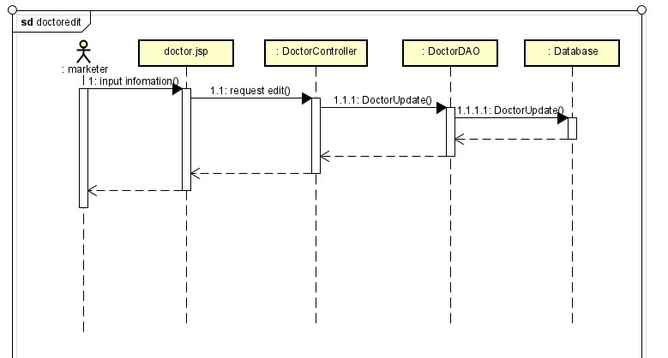

Database queries

16. Common/ User profile
- Class diagram
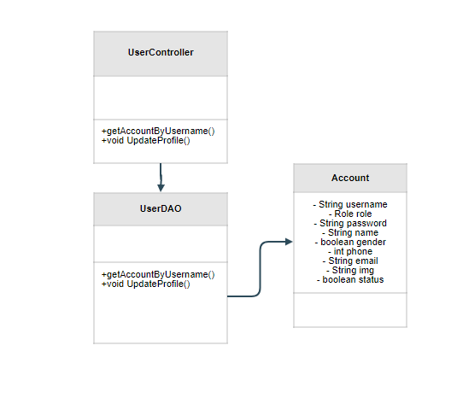

- Class Specification

No | Method | Description
1 | getAccountByUsername | use to find account profile by it’s username
2 | UpdateProfile | use to update user’s profile

- Sequence diagram
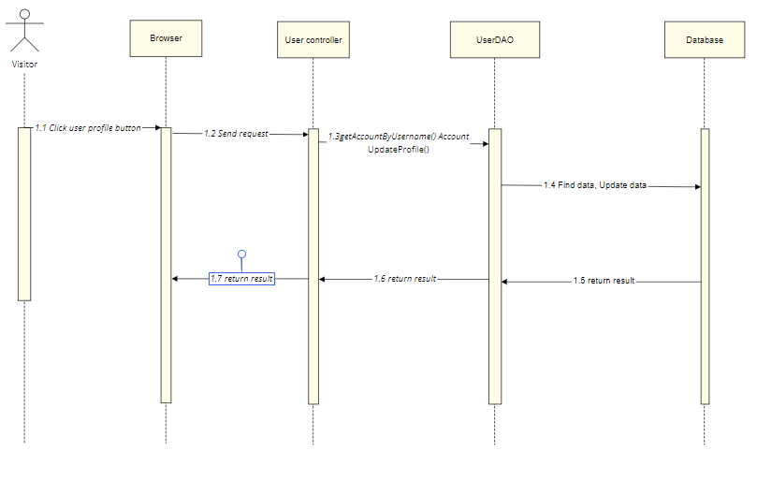
- Database queries
- UPDATE `doctris_system`.`users` SET `role_id` = ?, `status` = ?
WHERE (`username` = ?)
- SELECT u.username,u.name,u.gender,u.email,u.phone,r.name,u.status,u.img
FROM doctris_system.users u
inner join doctris_system.role r
on u.role_id = r.id where u.username = ?

17. Marketing/Patients list
- Class diagram
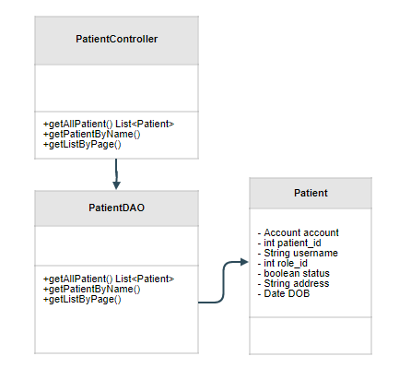
- Class Specification
No | Method | Description
1 | getAllPatient | use to list Patients
2 | getPatientByName | use to find Patient by name
3 | getListByPage | use to pagination

- Sequence diagram
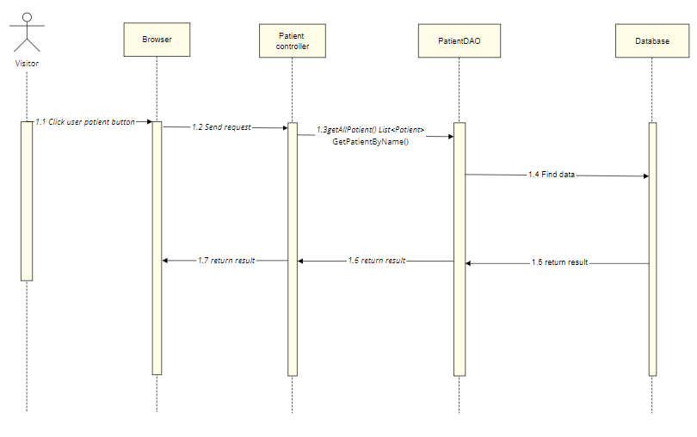
- Database queries
- SELECT p.patient_id,u.username,u.name,u.gender,p.DOB,p.status
FROM doctris_system.patient p
INNER JOIN doctris_system.users u
ON p.username = u.username

- SELECT u.img, u.username, u.name, u.email, u.gender, u.phone, p.patient_id, p.DOB, p.address, p.status
FROM patient p
INNER JOIN users u
ON p.username = u.username
WHERE u.username = ?

18. Marketing/Service List
- Class Diagram
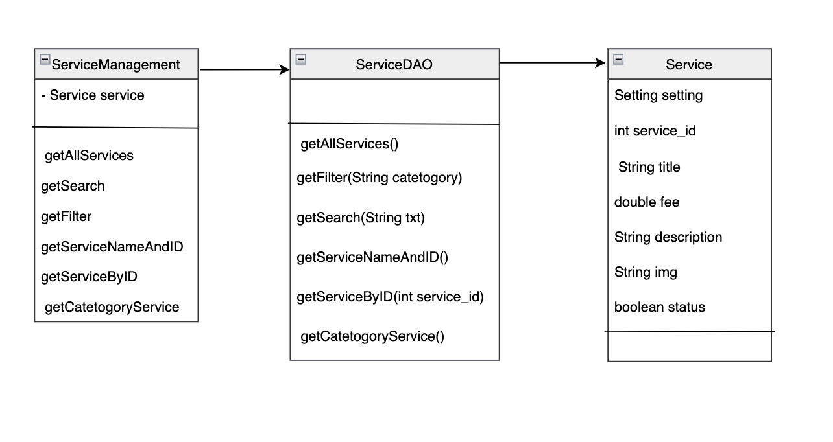
- Class Specification
No | Method | Description
1 | getAllServices | show list service in system includes: ID, ServiceName, type, cost, status
2 | getFilter | Perform search service by category
3 | getSearch | User input to search box
4 | getServiceNameAndID | Search service by name
5 | getServiceByID | Search service by id
6 | getCatetogoryService | Search service by catefory

- Sequence Diagram
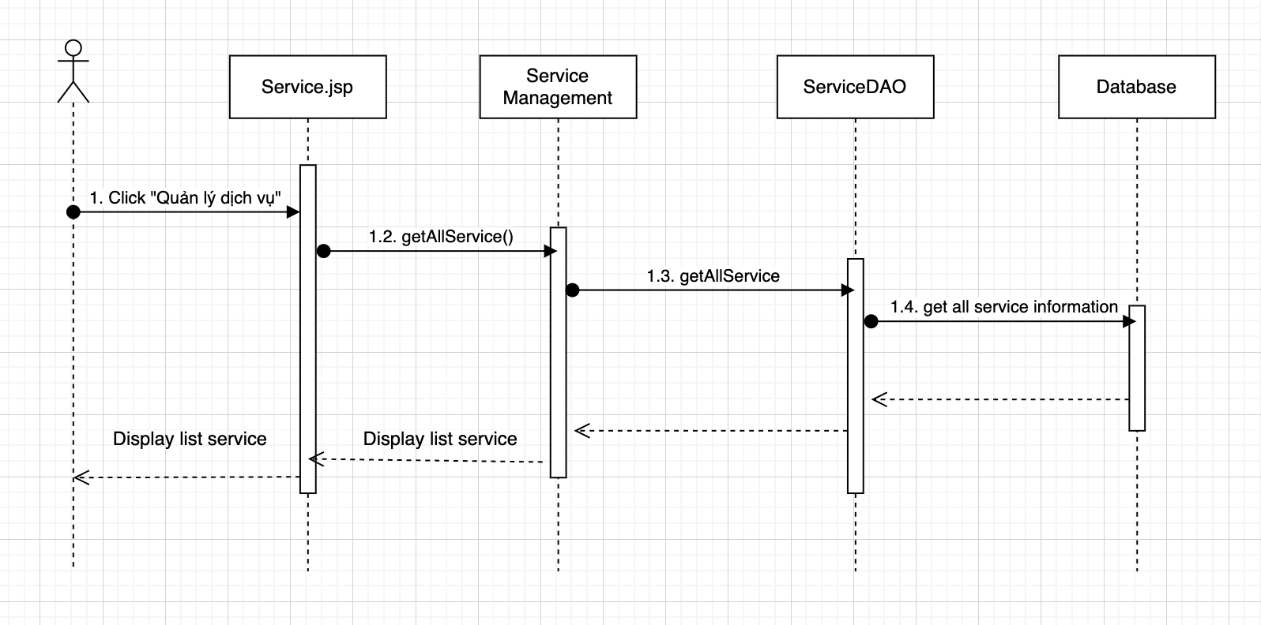
- Database Query
SELECT service.service_id, service.title, category_service.name,
service.fee, service.status FROM service inner join
category_service on service.category_id = category_service.id
order by service.service_id asc

SELECT service.service_id, service.title, category_service.name,
service.fee, service.status FROM service inner join "
category_service on service.category_id = category_service.id where service.category_id = ?
order by service.service_id asc

SELECT service.service_id, service.title, category_service.name,
service.fee, service.status FROM service inner join
category_service on service.category_id = category_service.id where service.title like ?
order by service.service_id asc

select * from doctris_system.category_service

UPDATE `doctris_system`.`service` SET `status` = ? WHERE (`service_id` = ?)

18. Marketing/Service Details

Class Diagram
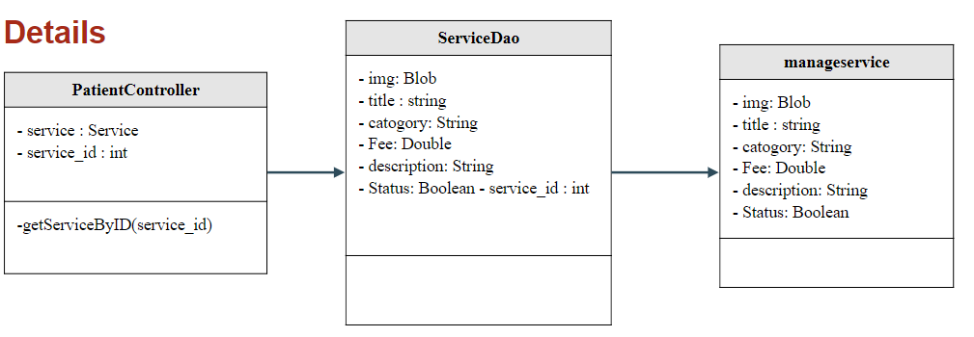
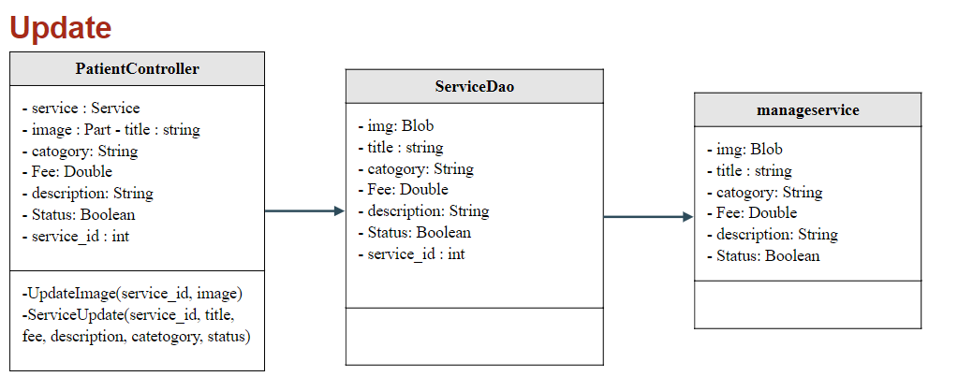
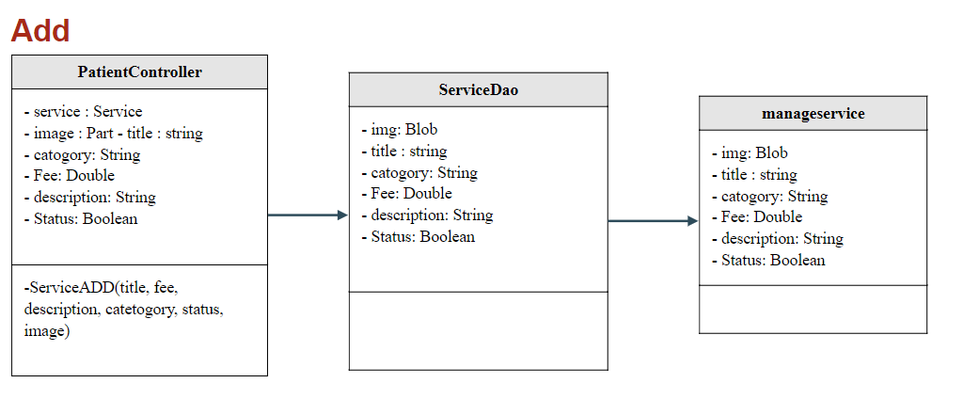

Class Specification

No | Method | Description
1 | getServiceByID | using to view detail service
2 | getCategory Service | using to view category service
3 | ServiceUpdate | using to update information service
4 | ServiceADD | using to add new service
5 | UpdateImage | using to update image service

Sequence Diagram

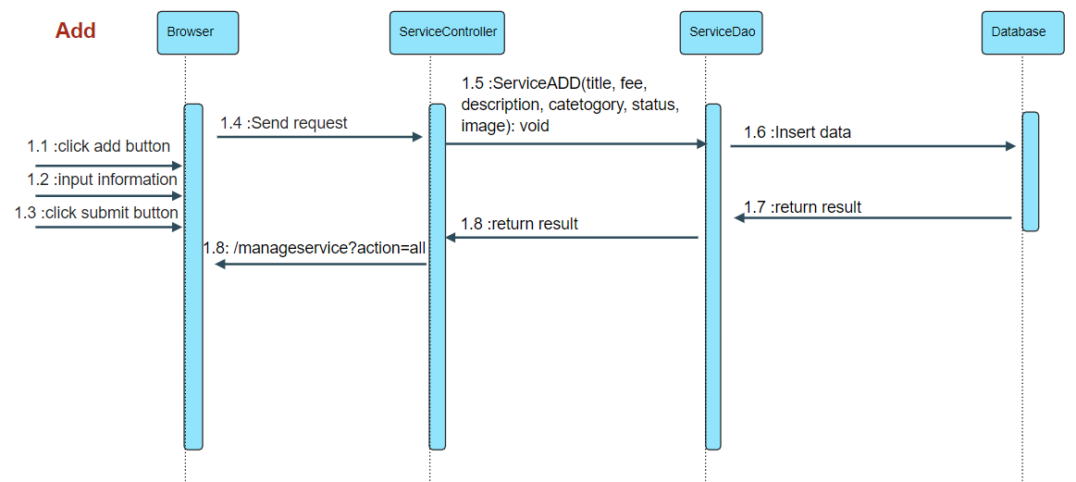
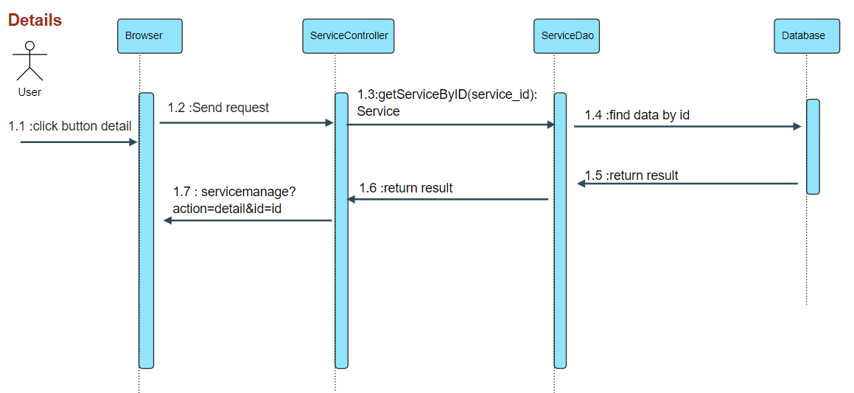
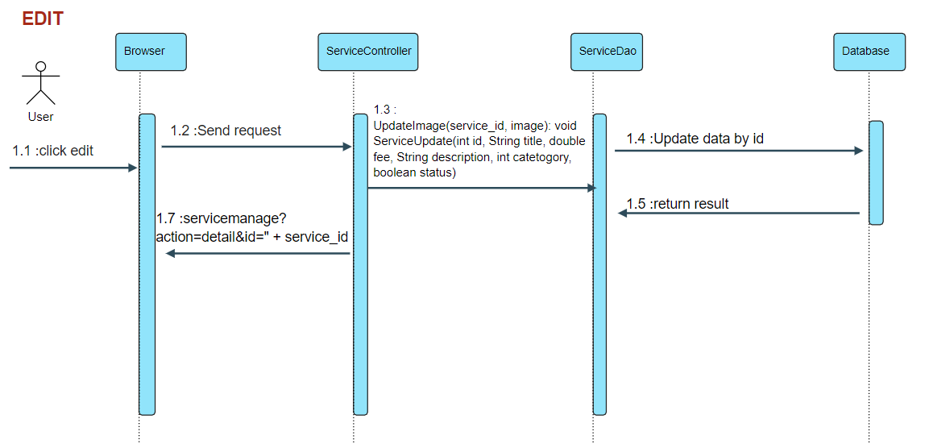

Database queries

- SELECT c.name,s.status,s.service_id,s.title, s.fee,s.description,s.img FROM service s inner join category_service c
on s.category_id = c.id
where s.service_id = ?
- select * from doctris_system.category_service
- UPDATE `doctris_system`.`service` set
`img` = ?
WHERE `service_id` = ?
- UPDATE `doctris_system`.`service` set
`category_id` = ?,
`title` = ?,
`fee` = ?,
`description` = ?,
`status` = ?
WHERE `service_id` = ?
- INSERT INTO `doctris_system`.`service`
(`category_id`,`title`,`fee`,`description`,`img`,`status`)
VALUES(?,?,?,?,?,?)

19. Marketing/Service Feedbacks

Class Diagram
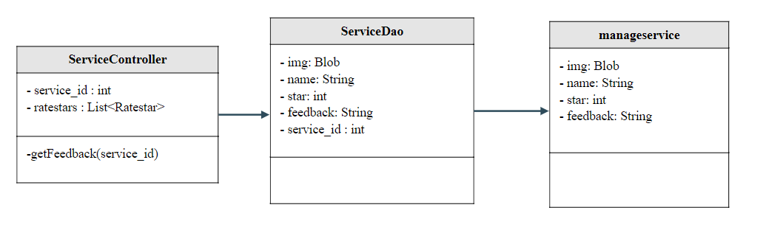

Class Specification

No | Method | Description
1 | getFeedback | View feedbacks from patients to the service

Sequence Diagram
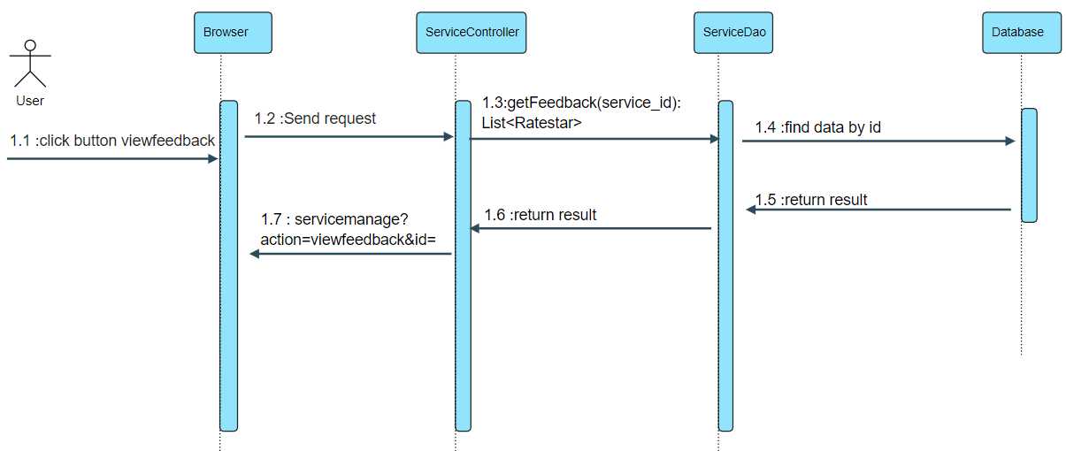

Database queries
- SELECT u.img, u.name, r.star,r.feedback,r.datetime FROM doctris_system.ratestar r
inner join doctris_system.users u on r.username = u.username where r.service_id = ? ORDER BY r.datetime DESC

20. Marketing/Blog List

Class Diagram
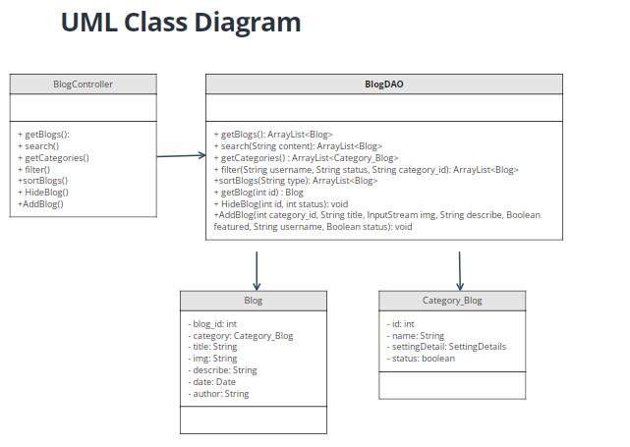

Class Specification

No | Method | Description
1 | getBlogs | get all blog in database order by date
2 | getCategories | get all categories in database
3 | getBlog | get blog by blog id
4 | filter | The user can filter the post by category, author, status
5 | search | get blog that having or contain keyword in its title
6 | HideBlog | change blog’s status to disable or active
7 | AddBlog | Add new blog contain all attribute without blog_id

Sequence Diagram
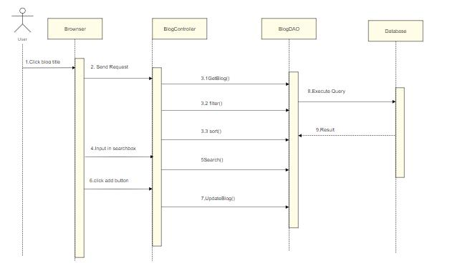

Database queries
- SELECT blog.*, category_blog.name FROM blog
inner join category_blog
on blog.category_id = category_blog.id
order by date desc
- Select b.*, u.name as author, c.name as category_name
from blog as b
Inner join users as u on b.username = u.username
inner join category_blog c on b.category_id = c.id
where
(1=1)
and b.category_id = ?
and b.username = ?
and b.status = ?
order by b.date desc;
- UPDATE `doctris_system`.`blog`
SET
`status` = ?
WHERE `blog_id` = ?;
- INSERT INTO `doctris_system`.`blog`
(`blog_id`,
`category_id`,
`title`,
`img`,
`describe`,
`date`,
`featured`,
`username`,
`status`)
VALUES
(<{category_id: }>,
<{title: }>,
<{img: }>,
<{describe: }>,
<{date: }>,
<{featured: }>,
<{username: }>,
<{status: }>);
- SELECT * FROM blog WHERE title LIKE ? ORDER BY date desc

21. Marketing/Blog Detail

Class Diagram
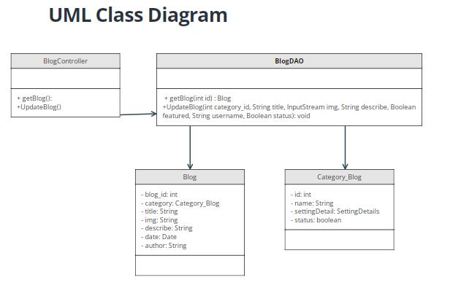

Class Specification

No | Method | Description
1 | getBlog | get blog by blog id
2 | UpdateBlog | change blog information like title, describe, image, category

Sequence Diagram
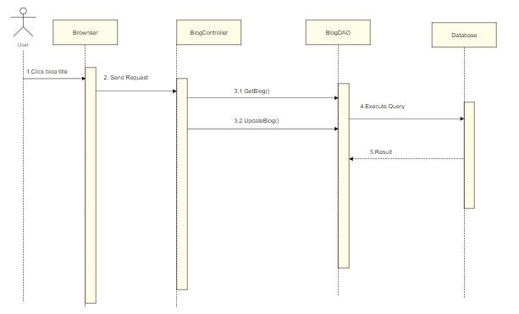

Database queries
- UPDATE `doctris_system`.`blog`
SET
`category_id` = <{category_id: }>,
`title` = <{title: }>,
`img` = <{img: }>,
`describe` = <{describe: }>,
`date` = <{date: }>,
`featured` = <{featured: }>,
`status` = <{status: }>
WHERE `blog_id` = <{expr}>;
- Select b.*, u.name as author, c.name as category_name
from blog as b
Inner join users as u on b.username = u.username
inner join category_blog c on b.category_id = c.id
where b.blog_id = ?
order by b.date desc

22. Public/Web Doctor List

Class Diagram
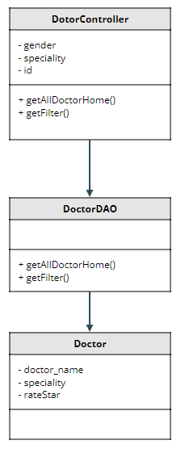

Class Specification

No | Method | Description
1 | getAllDoctorHome | show all doctor
2 | getFilter | show doctor by gender or speciality

Sequence Diagram
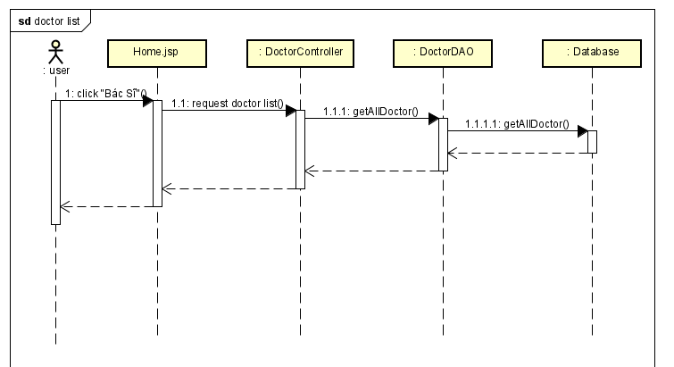

Database queries
String sql = "select concat_ws(cs.id,d.category_id)id,"
cs.name, cs.setting_id ,cs.status,"
d.doctor_id,d.role_id,d.doctor_name,d.username,"
d.gender,d.DOB,d.phone,d.description,d.status,d.img,d.fee "
from doctris_system.doctor d "
inner join doctris_system.category_service cs "
on d.category_id = cs.id";
String spec = "select concat_ws(cs.id,d.category_id)id,"
cs.name, cs.setting_id ,cs.status,"
d.doctor_id,d.role_id,d.doctor_name,d.username,"
d.gender,d.DOB,d.phone,d.description,d.status,d.img,d.fee "
from doctris_system.doctor d "
inner join doctris_system.category_service cs "
on d.category_id = cs.id where d.category_id = ?";
String gen = "select concat_ws(cs.id,d.category_id)id,"
cs.name, cs.setting_id ,cs.status,"
d.doctor_id,d.role_id,d.doctor_name,d.username,"
d.gender,d.DOB,d.phone,d.description,d.status,d.img,d.fee "
from doctris_system.doctor d "
inner join doctris_system.category_service cs "
on d.category_id = cs.id where d.gender = ?";
String filter = "select concat_ws(cs.id,d.category_id)id,"
cs.name, cs.setting_id ,cs.status,"
d.doctor_id,d.role_id,d.doctor_name,d.username,"
d.gender,d.DOB,d.phone,d.description,d.status,d.img,d.fee "
from doctris_system.doctor d "
inner join doctris_system.category_service cs "
on d.category_id = cs.id where d.gender = ? AND d.category_id = ?";

23. Public/Web Doctor Detail

Class Diagram
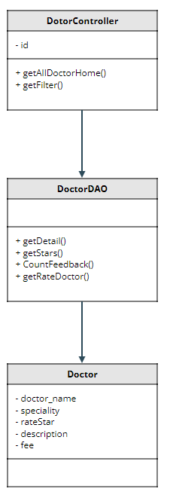

Class Specification

No | Method | Description
1 | getDetail | show detail doctor
2 | getStars | show star of doctor
3 | CountFeedback | show number of feedback
4 | getRateDoctor | show feedback of patient

Sequence Diagram
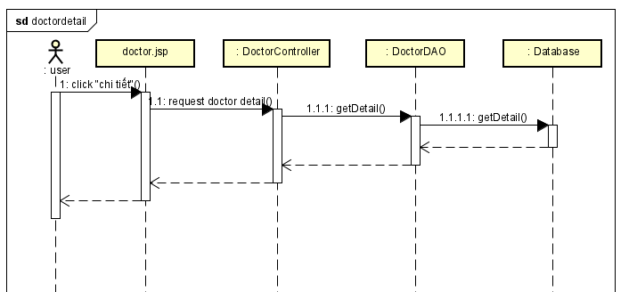

Database queries
String getdoctor = "select concat_ws(cs.id,d.category_id)id,"
cs.name, cs.setting_id ,cs.status,"
d.doctor_id,d.role_id,d.doctor_name,d.username,"
d.gender,d.DOB,d.phone,d.description,d.status,d.img,d.fee "
from doctris_system.doctor d "
inner join doctris_system.category_service cs "
on d.category_id = cs.id where d.doctor_id = ?";
String sql = "SELECT (SUM(star) / COUNT(*)) as star from ratestar where doctor_id = ?";
String sql = "SELECT COUNT(*) from ratestar where doctor_id = ?";
String sql = "SELECT users.name, users.img, ratestar.star, ratestar.feedback, "
ratestar.datetime FROM ratestar inner join users "
on ratestar.username = users.username where ratestar.doctor_id = ? order by ratestar.id desc";

24. Staff/Appointments List

Class Diagram
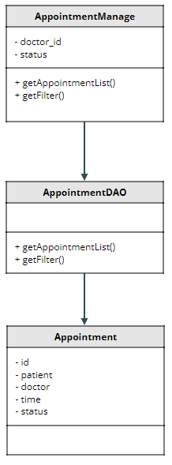

Class Specification

No | Method | Description
1 | getAppointmentList | show list appointment
2 | getFilter | show list appointment by name or status

Sequence Diagram
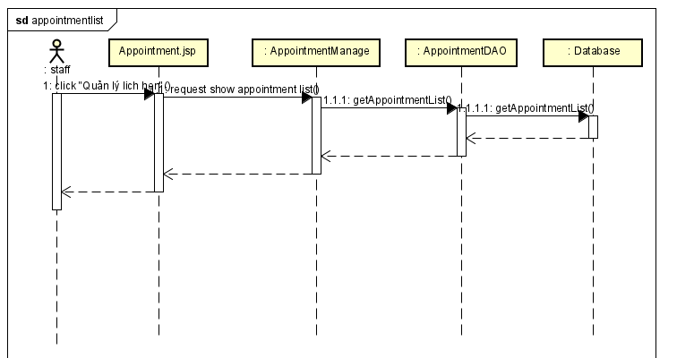

Database queries
String sql = "Select appointments.appointment_id , doctor.doctor_name, users.name , appointments.date ,appointments.time, appointments.status from appointments inner join doctor on appointments.doctor_id = doctor.doctor_id inner join patient on appointments.patient_id = patient.patient_id inner join users on patient.username = users.username";

String filterStatus = "Select appointments.appointment_id , doctor.doctor_name, users.name , appointments.date ,"
appointments.time, appointments.status from appointments "
inner join doctor on appointments.doctor_id = doctor.doctor_id "
inner join patient on appointments.patient_id = patient.patient_id "
inner join users on patient.username = users.username where appointments.status = ?";

String filterDoctor = "Select appointments.appointment_id , doctor.doctor_name, users.name , appointments.date ,"
appointments.time, appointments.status from appointments "
inner join doctor on appointments.doctor_id = doctor.doctor_id "
inner join patient on appointments.patient_id = patient.patient_id "
inner join users on patient.username = users.username where appointments.doctor_id = ?";

String filter = "Select appointments.appointment_id , doctor.doctor_name, users.name , appointments.date ,"
appointments.time, appointments.status from appointments "
inner join doctor on appointments.doctor_id = doctor.doctor_id "
inner join patient on appointments.patient_id = patient.patient_id "
inner join users on patient.username = users.username where appointments.doctor_id = ? AND appointments.status = ?";

25. Staff/Appointments Detail

bClass Diagram
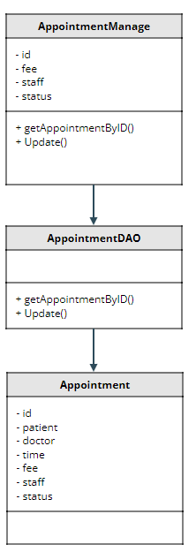

Class Specification

No | Method | Description
1 | getAppointmentByID | show detail appointment
2 | Update | update detail appointment

Sequence Diagram
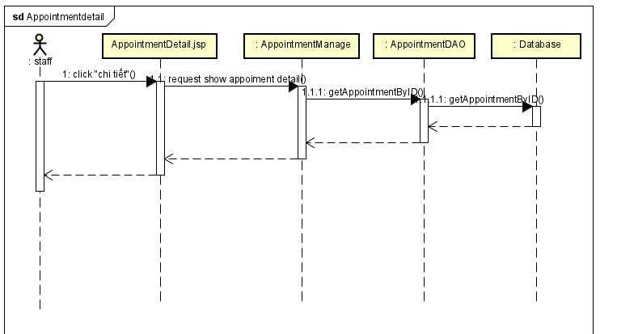

Database queries
String sql = "select doctor.img, doctor.doctor_name, doctor.phone, doctor.gender, "
category_service.name , users.img, users.name, users.phone, "
users.gender, patient.DOB, appointments.date ,appointments.time, "
appointments.status, appointments.description, staff.name, "
appointments.fee, appointments.appointment_id from appointments inner join doctor "
on appointments.doctor_id = doctor.doctor_id "
inner join patient on appointments.patient_id = patient.patient_id "
inner join users on patient.username = users.username "
inner join users staff on appointments.staff = staff.username "
inner join category_service on doctor.category_id = category_service.id "
where appointments.appointment_id = ?";
String sql = "UPDATE `doctris_system`.`appointments` SET `staff` = ?, `status` = ?, `fee` = ? WHERE (`appointment_id` = ?)";

26. Staff/Reservation List

Class Diagram
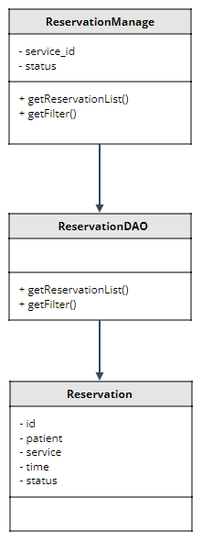

Class Specification

No | Method | Description
1 | getReservationList | show list Reservation
2 | getFilter | show list Reservation by service_id or status

Sequence Diagram
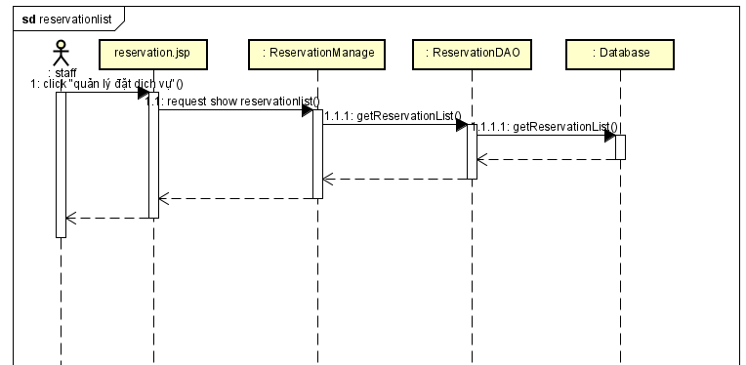

Database queries
String sql = "SELECT reservations.reservation_id, users.name, service.title, "
reservations.date, reservations.time, reservations.status FROM reservations
inner join service on reservations.service_id = service.service_id
inner join patient on reservations.patient_id = patient.patient_id
inner join users on patient.username = users.username";
String filterStatus = "SELECT reservations.reservation_id, users.name, service.title, "
reservations.date, reservations.time, reservations.status FROM reservations
inner join service on reservations.service_id = service.service_id
inner join patient on reservations.patient_id = patient.patient_id
inner join users on patient.username = users.username where reservations.status = ?";

String filterDoctor = "SELECT reservations.reservation_id, users.name, service.title, "
reservations.date, reservations.time, reservations.status FROM reservations
inner join service on reservations.service_id = service.service_id
inner join patient on reservations.patient_id = patient.patient_id
inner join users on patient.username = users.username where reservations.service_id = ?";

String filter = "SELECT reservations.reservation_id, users.name, service.title, "
reservations.date, reservations.time, reservations.status FROM reservations
inner join service on reservations.service_id = service.service_id
inner join patient on reservations.patient_id = patient.patient_id
inner join users on patient.username = users.username where reservations.service_id = ? AND reservations.status = ?";

27. Staff/Reservation Detail
a, Class Diagram
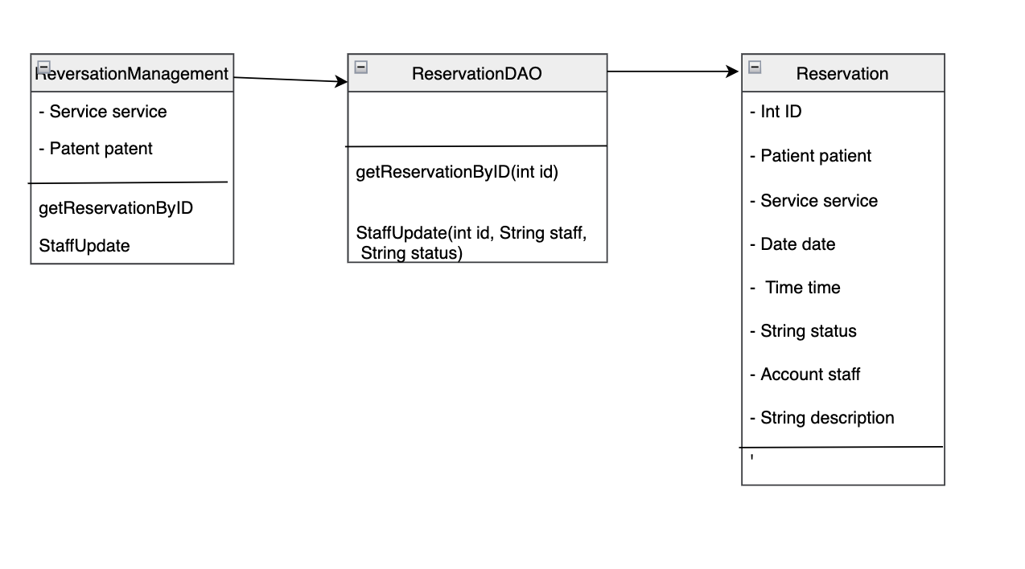
b. Class Specification

No | Method | Description
1 | getReservationByID | show reservation information detail
2 | StaffUpdate | Update staff information in reservation

c. Sequence Diagram
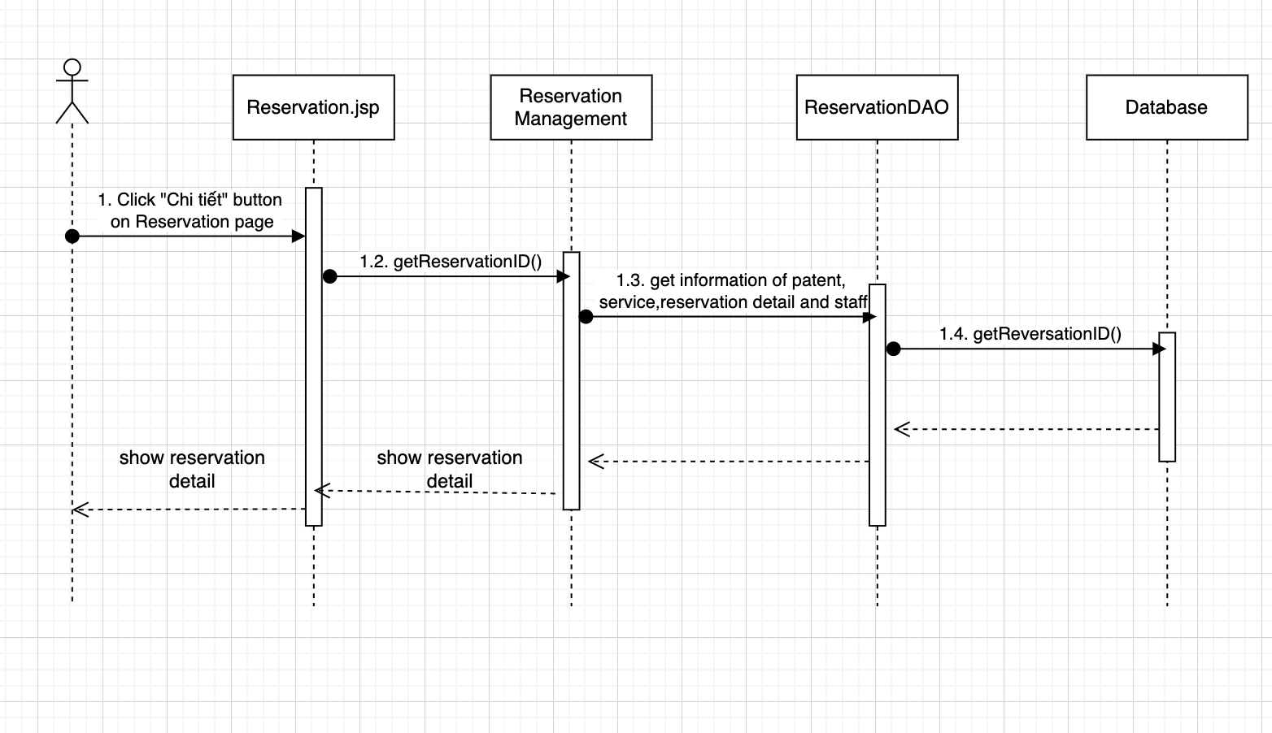
d. Database queries
SELECT reservations.reservation_id, users.img , users.name, users.phone, users.gender,
patient.DOB, service.img, service.title, category_service.name, service.fee ,reservations.date,
reservations.time, reservations.status, staff.name, reservations.description
FROM reservations
inner join service on reservations.service_id = service.service_id
inner join patient on reservations.patient_id = patient.patient_id
inner join users on patient.username = users.username
inner join category_service on service.category_id = category_service.id
inner join users staff on reservations.staff = staff.username where reservations.reservation_id = ?

UPDATE `reservations` SET `staff` = ?, `status` = ? WHERE (`reservation_id` = ?)

SELECT username,name FROM doctris_system.users where role_id = 4

28. Public/Services List

Class Diagram
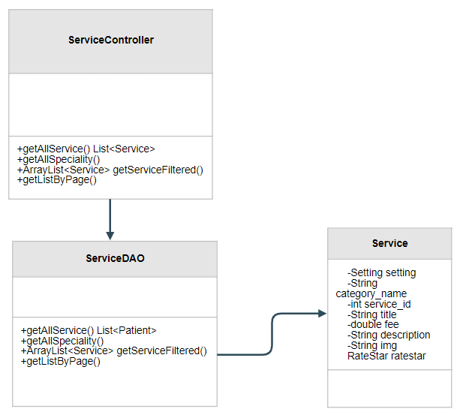

Class Specification

No | Method | Description
1 | getAllService | use to list Services
2 | getServiceById | use to find Service by Id
3 | getListByPage | use to pagination
4 | getAllSpeciality | use to list Speciality

Sequence Diagram
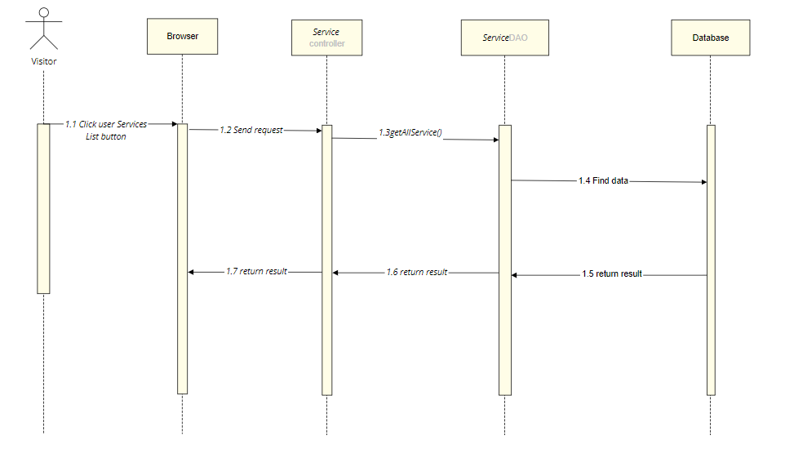
- Database Diagram
-SELECT s.title, cs.name, sum(r.star)/count(r.star), count(r.feedback), s.fee, s.description, s.service_id FROM doctris_system.service s
left join doctris_system.ratestar r
on s.service_id = r.service_id
inner join doctris_system.category_service cs
on cs.id = s.category_id
group by s.title, cs.name, s.fee, s.description, s.service_id
-SELECT s.title, cs.name, sum(r.star)/count(r.star), count(r.feedback), s.fee, s.description, s.service_id FROM doctris_system.service s
left join doctris_system.ratestar r
on s.service_id = r.service_id
inner join doctris_system.category_service cs
on cs.id = s.category_id
group by s.title, cs.name, s.fee, s.description, s.service_id
Having s.service_id = ?
-SELECT cs.name, cs.id FROM doctris_system.service s
inner join doctris_system.category_service cs
on cs.id = s.category_id
group by cs.name, cs.id

29. Public/Service detail

Class Diagram
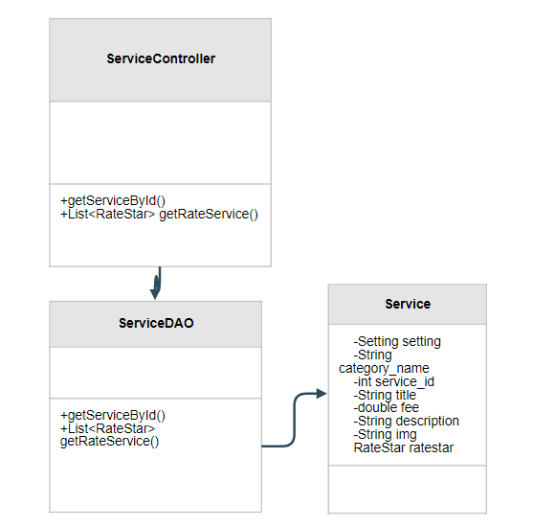

Class Specification

No | Method | Description
1 | getServiceById | use to find Service by Id
2 | getRateService | use to get user rate about the service

Sequence Diagram
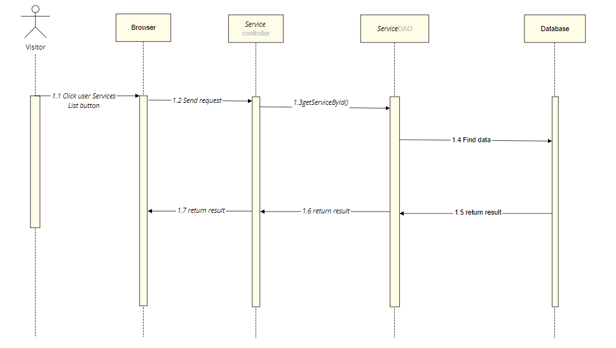
- Database Diagram

-SELECT s.title, cs.name, sum(r.star)/count(r.star), count(r.feedback), s.fee, s.description, s.service_id FROM doctris_system.service s
left join doctris_system.ratestar r
on s.service_id = r.service_id
inner join doctris_system.category_service cs
on cs.id = s.category_id
group by s.title, cs.name, s.fee, s.description, s.service_id
Having s.service_id = ?
-SELECT users.name, users.img, ratestar.star, ratestar.feedback, ratestar.datetime
FROM ratestar inner join users
on ratestar.username = users.username
where ratestar.service_id = ?
order by ratestar.id desc

30. Doctor/My Patients

Class Diagram
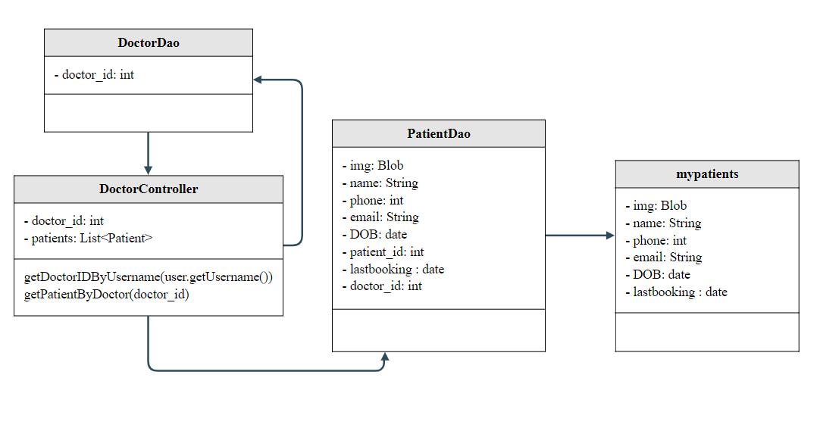

Class Specification

No | Method | Description
1 | getDoctorIDByUsername | use to find doctor_id
2 | getPatientByDoctor | show list of doctor's patients includes: avatar, name, last booking date, date of birth, email, phone

Sequence Diagram
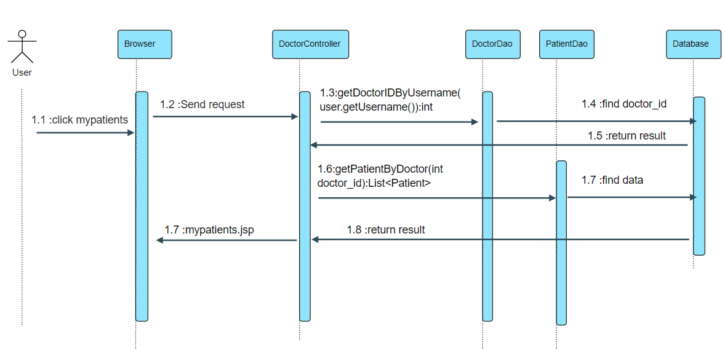

Database queries
- select doctor_id from doctor where username = ?
- select distinct users.img, users.name, users.phone, users.email,patient.DOB,patient.patient_id ,a.pdate as lastbooking from appointments
inner join patient on appointments.patient_id = patient.patient_id
inner join users on patient.username = users.username inner join (
select patient_id as pid , max(date) as pdate from appointments group by patient_id
) as a on a.pid = appointments.patient_id where appointments.doctor_id = ?

31. Doctor/My Patient Details

Class Diagram
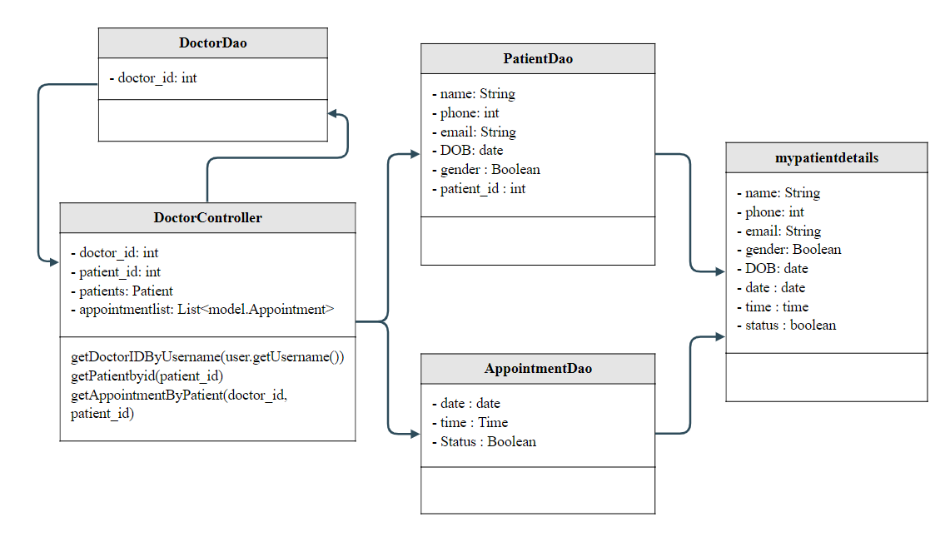

Class Specification

No | Method | Description
1 | getDoctorIDByUsername | use to find doctor_id
2 | getPatientbyid | show detailed information of the doctor's patient includes: name, email, mobile, gender, date of birth
3 | getAppointmentByPatient | show list appointments with him/her

Sequence Diagram
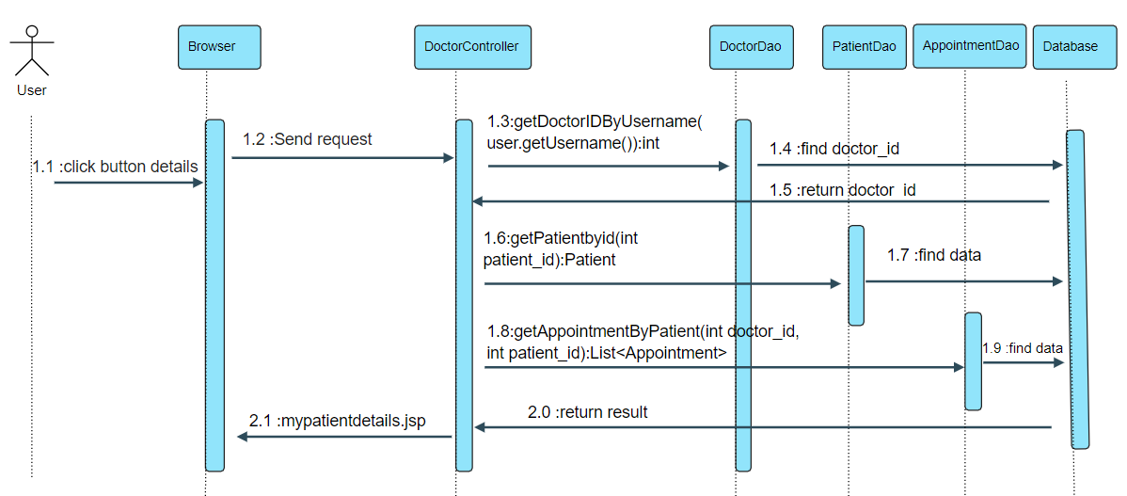

Database queries

- select doctor_id from doctor where username = ?
- SELECT u.name,u.email,u.phone,u.gender,p.DOB FROM users u inner join patient p
on u.username = p.username
where p.patient_id = ? ;
- select a.date,a.time,a.status from appointments a inner join patient p
on a.patient_id = p.patient_id
where a.doctor_id = ? and p.patient_id = ?
ORDER BY a.date ASC

32. Doctor/My Feedback

Class Diagram
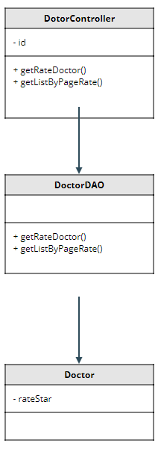

Class Specification

No | Method | Description
1 | getRateDoctor | show feedback of doctor
2 | getListByPageRate | pagination feedback

Sequence Diagram
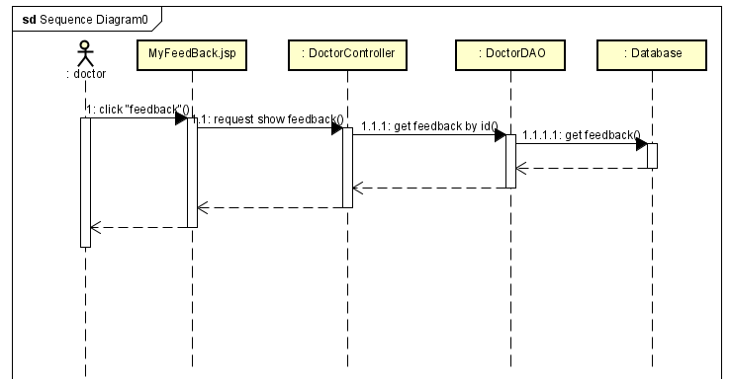

Database queries
String sql = "SELECT users.name, users.img, ratestar.star, ratestar.feedback, "
+ "ratestar.datetime FROM ratestar inner join users "
+ "on ratestar.username = users.username where ratestar.doctor_id = ? order by ratestar.id desc";
v

33. Admin/Dashboard

Class Diagram
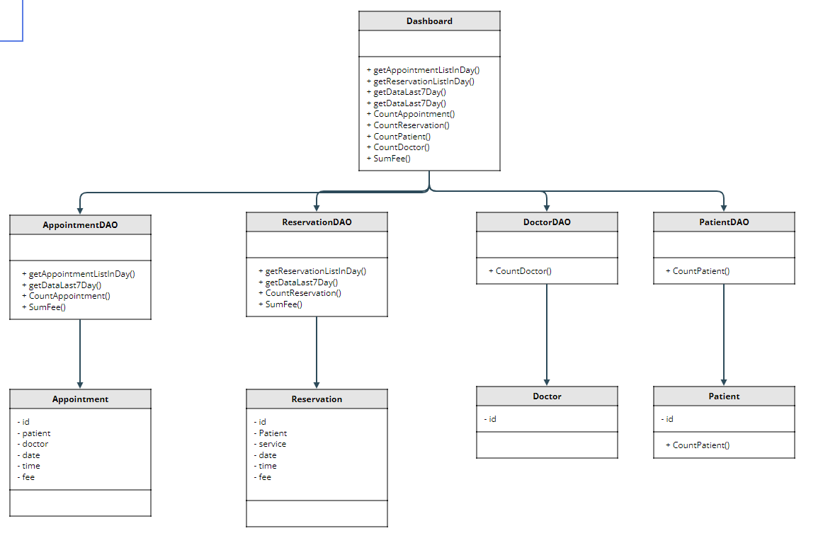

Class Specification

No | Method | Description
1 | getAppointmentListInDay | Get the doctor's appointment for the day
2 | getReservationListInDay | Get service appointment of the day
3 | getDataLast7Day | statistics in 7 days
4 | CountAppointment | Count the number of appointments in the latest month
5 | CountReservation | Count the number of service in the latest month
6 | CountPatient | number of patient active
7 | CountDoctor | number of doctors active
8 | SumFee | get total revenue

Sequence Diagram
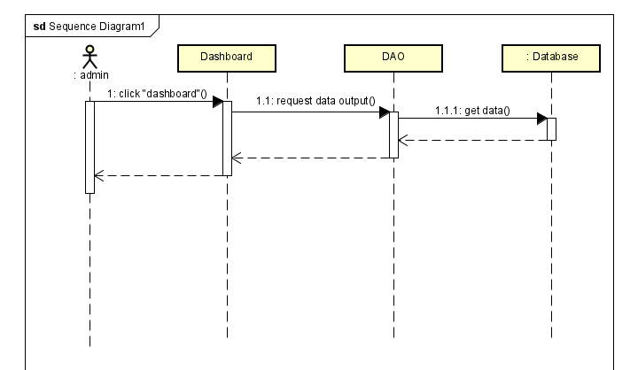

Database queries
String sql = "Select appointments.appointment_id , doctor.doctor_name, users.name , \n"
+ "appointments.date ,appointments.time, appointments.status from appointments \n"
+ "inner join doctor on appointments.doctor_id = doctor.doctor_id inner join patient on \n"
+ "appointments.patient_id = patient.patient_id inner join users on patient.username = users.username where appointments.date = cast(CURDATE() as Date);";

String sql = "SELECT reservations.reservation_id, users.name, service.title, "
+ "reservations.date, reservations.time, reservations.status FROM reservations \n"
+ "inner join service on reservations.service_id = service.service_id \n"
+ "inner join patient on reservations.patient_id = patient.patient_id \n"
+ "inner join users on patient.username = users.username where reservations.date = cast(CURDATE() as Date)";

String sql = " \n"
+ " Select p.day , coalesce(count(u.appointment_id), 0) as count from (\n"
+ " Select curdate() as day\n"
+ " union\n"
+ " Select date_sub(Curdate(),interval 1 day)\n"
+ " union\n"
+ " Select date_sub(Curdate(),interval 2 day)\n"
+ " union\n"
+ " Select date_sub(Curdate(),interval 3 day)\n"
+ " union\n"
+ " Select date_sub(Curdate(),interval 4 day)\n"
+ " union\n"
+ " Select date_sub(Curdate(),interval 5 day)\n"
+ " union\n"
+ " Select date_sub(Curdate(),interval 6 day))as p\n"
+ "left join appointments as u on p.day = u.date group by p.day order by p.day asc";

String sql = "Select p.day , coalesce(count(u.reservation_id), 0) as count from (\n"
+ " Select curdate() as day\n"
+ " union\n"
+ " Select date_sub(Curdate(),interval 1 day)\n"
+ " union\n"
+ " Select date_sub(Curdate(),interval 2 day)\n"
+ " union\n"
+ " Select date_sub(Curdate(),interval 3 day)\n"
+ " union\n"
+ " Select date_sub(Curdate(),interval 4 day)\n"
+ " union\n"
+ " Select date_sub(Curdate(),interval 5 day)\n"
+ " union\n"
+ " Select date_sub(Curdate(),interval 6 day))as p\n"
+ "left join reservations as u on p.day = u.date group by p.day order by p.day asc";
String sql = "select count(*) from appointments";
String sql = "select count(*) from reservations";
String sql = "select count(*) from patient";
String sql = "select count(*) from doctor";
String sql = "select sum(service.fee) from reservations inner join service on reservations.service_id = service.service_id where reservations.status = 'Assigned'";
String sql = "select sum(fee) from appointments where status = 'Assigned'";

34. Patient/Book Appointment

Class Diagram
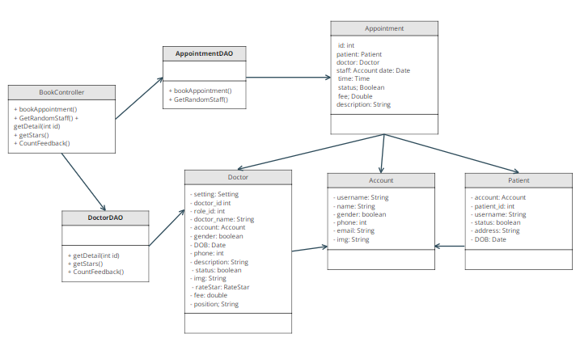

Class Specification

No | Method | Description
1 | bookAppointment | create appointment and add it to later in list
2 | GetRandomStaff | get a account that have role staff
3 | getDetail | get a doctor information by doctor id
4 | getStar | get stars of a doctor by doctor id
5 | CountFeedback | get number of feedback of a doctor by doctor id

Sequence Diagram
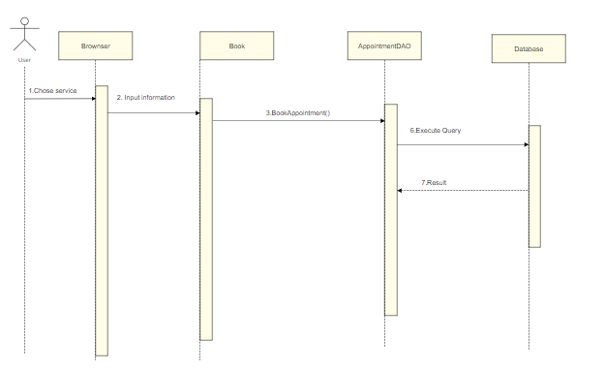

Database queries
- INSERT INTO `appointments` (`doctor_id`, `patient_id`, `staff`, `date`, `time`, `description`, `status`, `fee`, `payment`)
VALUES (?, ?, ?, STR_TO_DATE(?,'%d/%m/%Y'), ?, ?, ?, ?, ?)
- select concat_ws(cs.id,d.category_id)id,
cs.name, cs.setting_id ,cs.status,
d.doctor_id,d.role_id,d.doctor_name,d.username,
d.gender,d.DOB,d.phone,d.description,d.status,d.img,d.fee,d.position
from doctris_system.doctor d
inner join doctris_system.category_service cs
on d.category_id = cs.id where d.doctor_id = ?
- SELECT (SUM(star) / COUNT(*)) as star from ratestar where doctor_id = ?
- SELECT COUNT(*) from ratestar where doctor_id = ?
- select username from users where role_id = 4 AND status = 1 ORDER BY RAND() LIMIT 1

35. Patient/Reserve a Service

Class Diagram
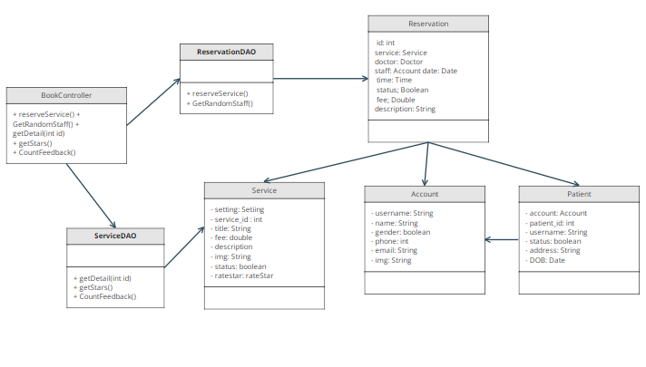

Class Specification

No | Method | Description
1 | reverseService | create reservation and add it to later in list
2 | GetRandomStaff | get a account that have role staff
3 | getDetail | get a service information by servicer id
4 | getStar | get stars of a doctor by service id
5 | CountFeedback | get number of feedback of a service by service id

Sequence Diagram
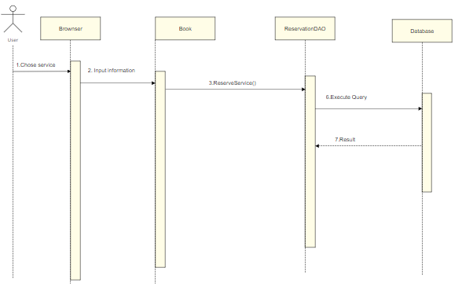

Database queries
- select username from users where role_id = 4 AND status = 1 ORDER BY RAND() LIMIT 1
- INSERT INTO `reservations` (`patient_id`, `service_id`,
`staff`, `date`, `time`, `status`, `description`, `payment`) VALUES
(?, ?, ?, STR_TO_DATE(?,'%d/%m/%Y'), ?, ?, ?, ?)
- SELECT s.title, cs.name, sum(r.star)/count(r.star), count(r.feedback), s.fee, s.description, s.service_id, s.img FROM doctris_system.service s
left join doctris_system.ratestar r
on s.service_id = r.service_id
inner join doctris_system.category_service cs
on cs.id = s.category_id
group by s.title, cs.name, s.fee, s.description, s.service_id
Having s.service_id = ?
- SELECT (SUM(star) / COUNT(*)) as star from ratestar where service_id = ?
- SELECT COUNT(*) from ratestar where service_id = ?

36. Doctor/My Appointments

Class Diagram
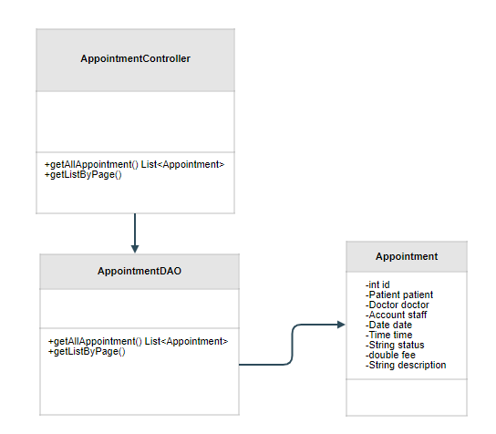

Class Specification

No | Method | Description
1 | getAllAppointment | to get all appointments of a doctor
2 | getListByPageRate | pagination the list

Sequence Diagram
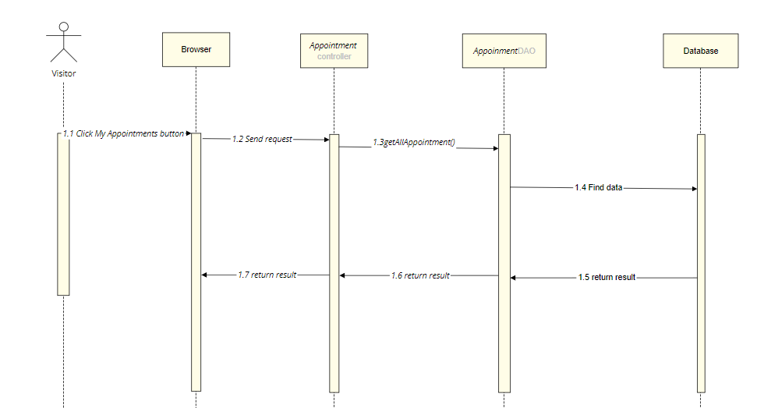

Database queries
SELECT a.appointment_id, p.patient_id, u.name,a.date, a.time,a.status from appointments a
INNER JOIN patient p
ON a.patient_id = p.patient_id
INNER JOIN users u
ON p.username = u.username
WHERE a.doctor_id = ?
group by a.appointment_id, p.patient_id, u.name,a.date, a.time,a.status
order by CAST(a.date AS DATETIME) + CAST(a.time AS DATETIME) desc

37. Doctor/My Appointment Details

Class Diagram
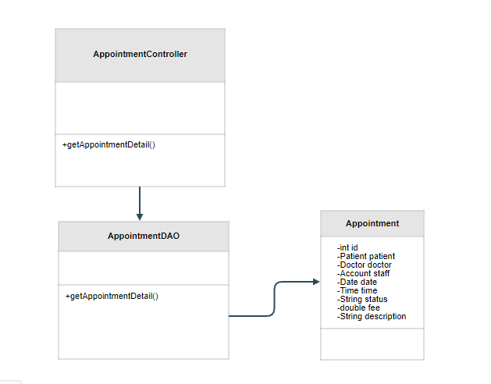

Class Specification

No | Method | Description
1 | getAppointmentDetail | to get detailed information of an Appointment

Sequence Diagram
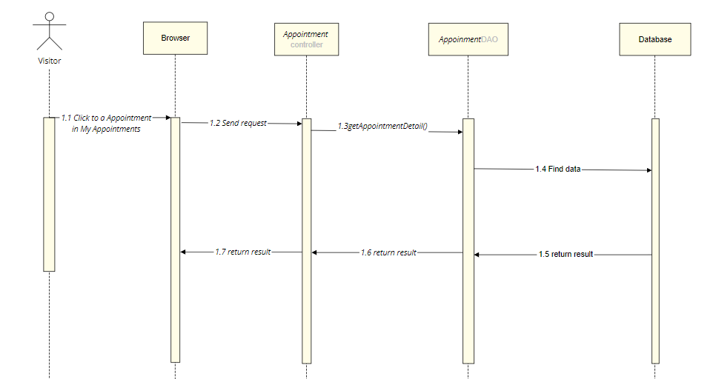

Database queries

SELECT a.appointment_id, p.patient_id, u.name,a.date, a.time,a.status from appointments a
INNER JOIN patient p
ON a.patient_id = p.patient_id
INNER JOIN users u
ON p.username = u.username
WHERE a.appointment_id = ?

38. Patient/ Appointment History

Class Diagram
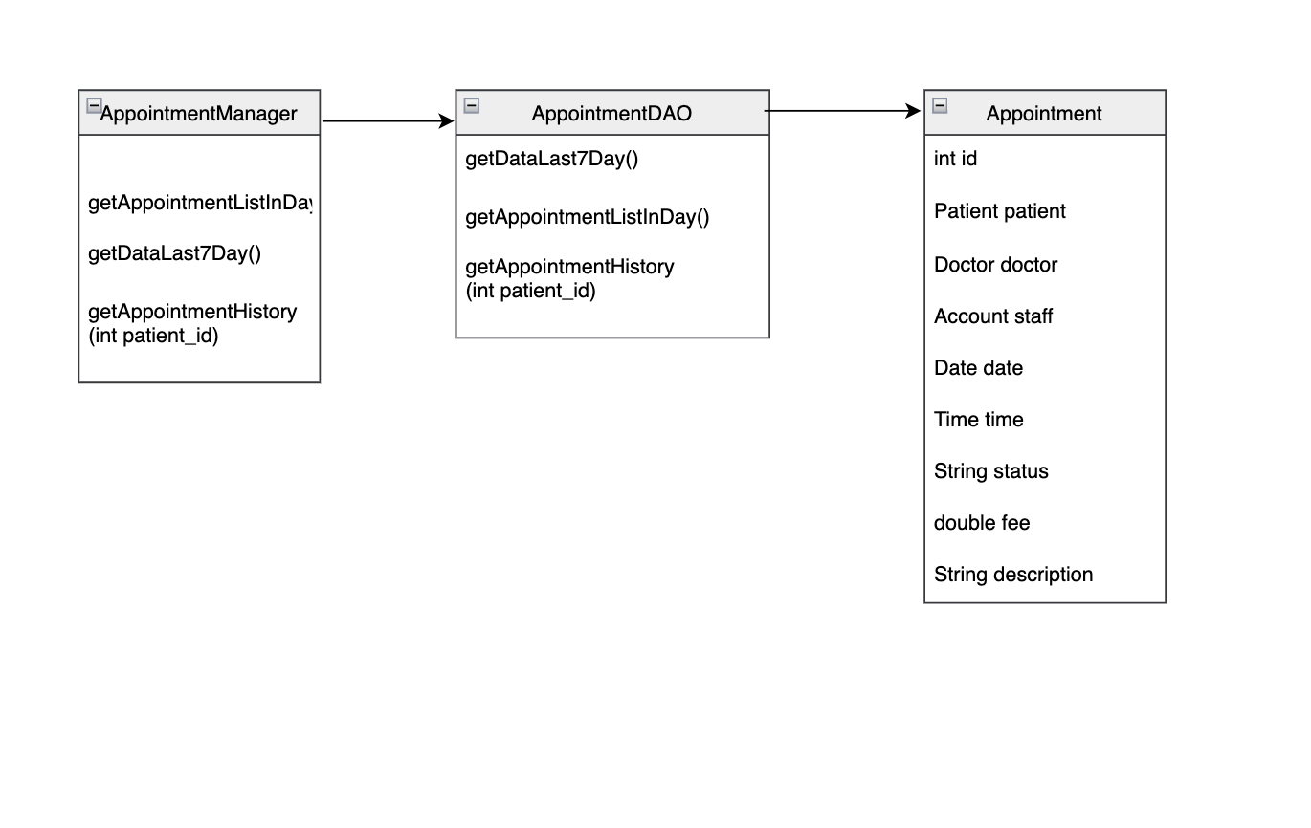

Class Specification

No | Method | Description
1 | getAppointmentListInDay | Display appointment list in to day
2 | getDataLast7Day | Display appointment in a week
3 | getAppointmentHistory | Display all appointment list

Sequence Diagram
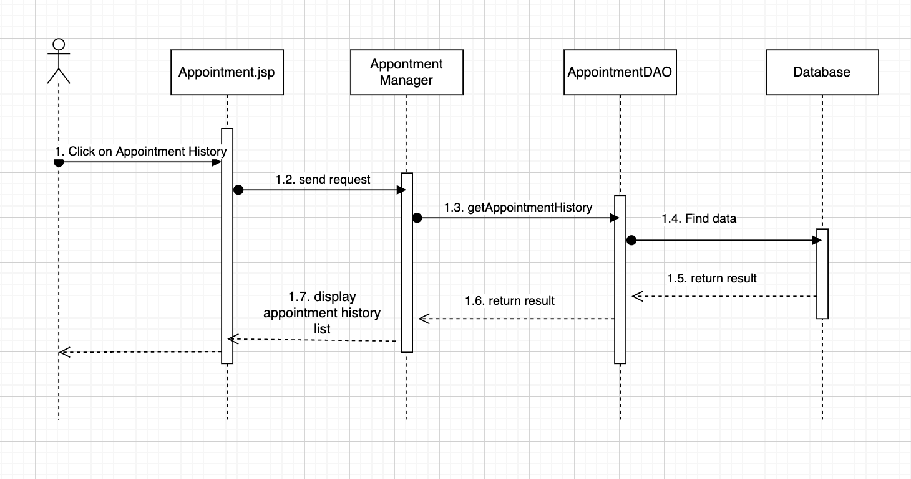

Database queries
Select appointments.appointment_id, doctor.doctor_id, doctor.img,
doctor.doctor_name, users.name , appointments.date ,appointments.time,
appointments.status from appointments inner join doctor
on appointments.doctor_id = doctor.doctor_id inner join patient
on appointments.patient_id = patient.patient_id inner join users
on patient.username = users.username where appointments.patient_id = ?

select patient_id from patient where username =

39. Patient/ Reservation History

Class Diagram
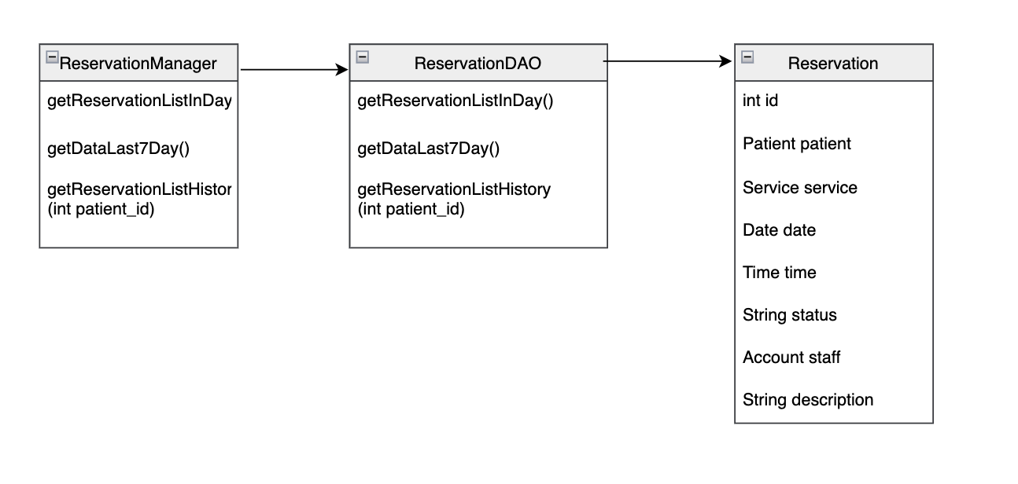

Class Specification

No | Method | Description
1 | getReservationListInDay | Display reservation list in to day
2 | getDataLast7Day | Display reservation in a week
3 | getReservationListHistory | Display all reservation list

Sequence Diagram
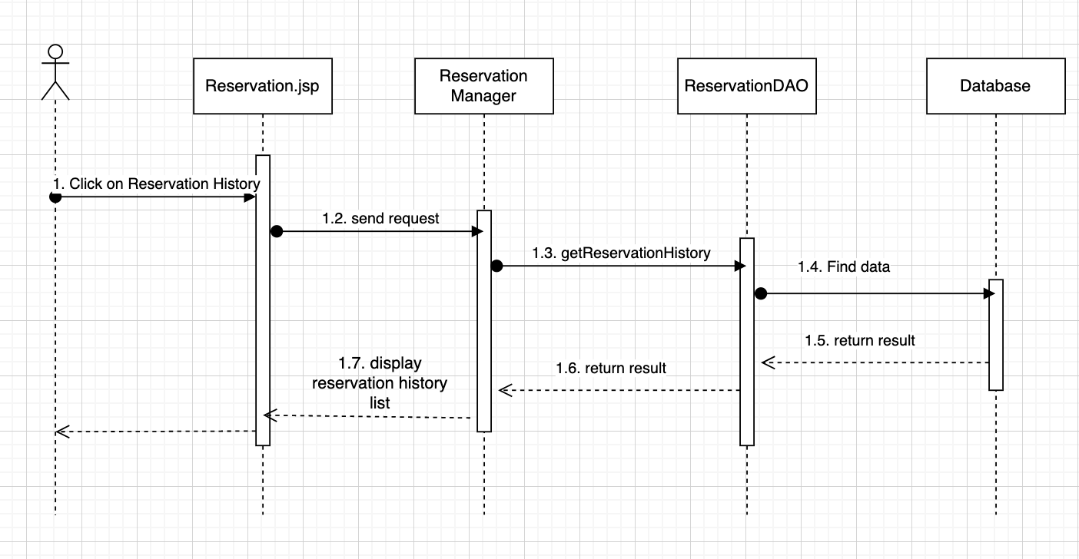

Database queries
SELECT reservations.reservation_id, users.name, service.title,
reservations.date, reservations.time, reservations.status, service.fee FROM reservations
inner join service on reservations.service_id = service.service_id
inner join patient on reservations.patient_id = patient.patient_id
inner join users on patient.username = users.username where reservations.patient_id = ?

III. Database Design

1. Database Schema
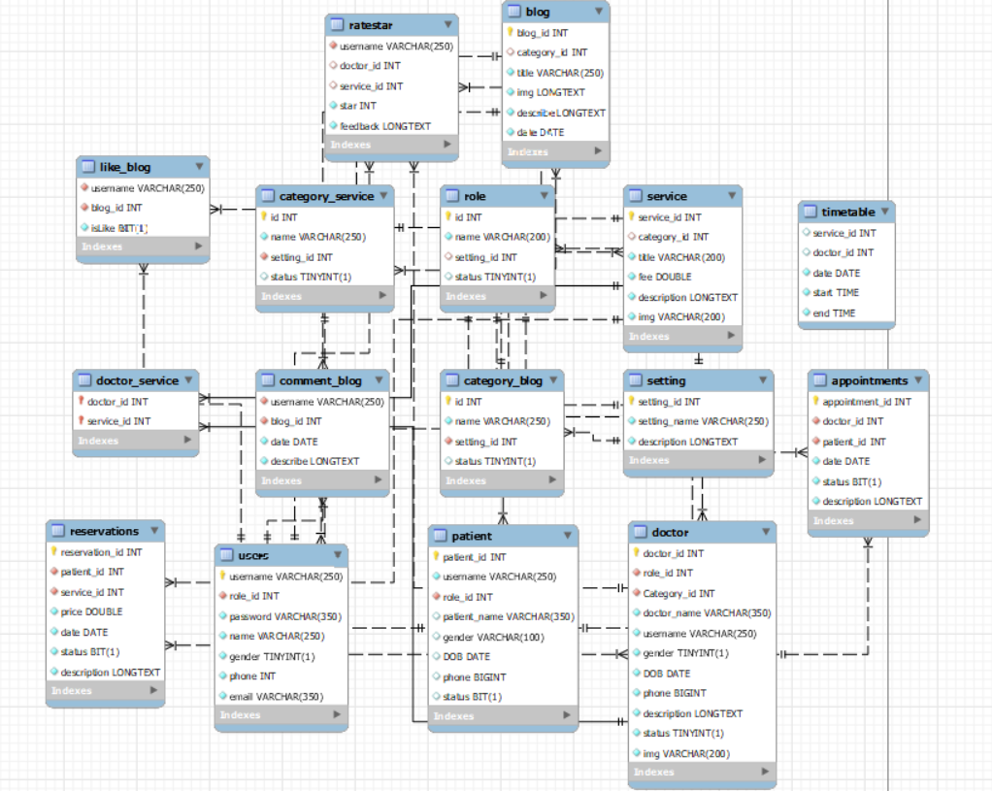

2. Table Description
No | Table | Description
1 | User | username: VARCHAR  role_id: INT  password: VARCHAR  name: VARCHAR  gender: TINYINT  phone: INT  email: VARCHAR  - Primary keys: username  - Foreign keys: role_id
2 | patient | patient_id: INT  username: VARCHAR  role_id: INT  patient_name:VARCHAR  gender:INT  DOB: DATE  phone: BIGINT  status: BIT  - Primary keys: patient_id  - Foreign keys: role_id
3 | doctor | doctor_id: INT  role_id: INT  doctor_name: VARCHAR  username: VARCHAR  gender: BIT  DOB:DATE  phone:BIGINT  descriptionLONGTEXT  status:TINYINT  img:VARCHAR  - Primary keys: doctor_id  - Foreign keys: role_id
4 | setting | setting_id: INT  setting_name:VARCHAR  description:LONGTEXT  - Primary keys: setting_id
5 | service | service_id: INT  category_id: INT  title: VARCHAR  fee:DOUBLE  description: LONGTEXT  - Primary keys: service_id
6 | blog | blog_id: INT  category_id: INT  title: VARCHAR  img: VARCHAR  describe: LONGTEXT  date: DATE  - Primary keys: blog_id
7 | like_blog | username: VARCHAR  blog_id: INT  isLike: BIT  - Foreign keys: username
8 | category_blog | id: INT  name: VARCHAR  setting_id: INT  status: TINYINT  - Primary keys: id  - Foreign keys: setting_id
9 | comment_blog | username: VARCHAR  blog_id: INT  date: DATE  describe: LONGTEXT  - Foreign keys: setting_id
10 | role | id: INT  name: VARCHAR  setting_id: INT  status:TINYINT  - Primary keys: id
11 | category_service | id: INT  name: VARCHAR  setting_id: INT  status: TINYINT  - Primary keys: id  - Foreign keys: setting_id
12 | reservations | reservation_id: INT  patient_id: INT  service_id: INT  price: DOUBLE  date: DATE  status: BIT  description: LONGTEXT  - Primary keys: reservation_id  - Foreign keys: patient_id, service_id
13 | doctor_service | doctor_id: INT  service_id: INT  -Foreign - keys: doctor_id, service_id
14 | ratestar | username: VARCHAR  doctor_id: INT  service_id: INT  star : INT  feedback: LONGTEXT  -Foreign - keys: username
15 | appointments | appointment_id:INT  doctor_id: INT  patient_id: INT  date: DATE  status: BIT  description: LONGTEXT  - Primary keys: appointment_id  - Foreign keys: patient_id, doctor_id
16 | timetable | service_id: INT  doctor_id: INT  date: DATE  start: TIME  end: TIME

