**Function Admin - Testing System**

**Created by [GDP05] Group1**

**January 31, 2019**

**1 Description of function** **3**

**2 Description of URL** **3**

**3 Diagrams** **3**

3.1 Use case diagram 4

3.2 Class diagram 5

3.3 Activities diagrams, Sequence diagrams and Screen design for each function 5

3.3.1 View list Exam 6

3.3.1.1 Activity diagram - View list Exam 6

3.3.1.2 Sequence diagram - View list Exam 6

3.3.1.3 Screen design - View list Exam 7

3.3.2 Create Exam 8

3.3.2.1 Activity diagram - Create Exam 8

3.3.2.2 Sequence diagram - Create Exam 9

3.3.2.3 Screen design - Create Exam 10

3.3.3 Search Exam 11

3.3.3.1 Activity diagram - Search Exam 11

3.3.3.2 Sequence diagram - Search Exam 12

3.3.3.3 Screen design - Search Exam 12

3.3.4 Filter Exam 13

3.3.4.1 Activity diagram - Filter Exam 13

3.3.4.2 Sequence diagram - Filter Exam 13

3.3.5 Sort Exam 14

3.3.5.1 Activity diagram - Sort Exam 14

3.3.5.2 Sequence diagram - Sort Exam 15

3.3.6 Delete Exam 15

3.3.6.1 Activity diagram - Delete Exam 15

3.3.6.2 Sequence diagram - Delete Exam 16

3.3.7 Import Exam 17

3.3.7.1 Activity diagram - Import Exam 17

3.3.7.2 Sequence diagram - Import Exam 18

3.3.8 Export Exam 19

3.3.8.1 Activity diagram - Export Exam 19

3.3.8.2 Sequence diagram - Export Exam 20

3.3.9 Approve Exam 21

3.3.9.1 Activity diagram - Approve Exam 21

3.3.9.2 Sequence diagram - Approve Exam 21

3.3.10 Detail Exam View 21

3.3.10.1 Activity diagram - Detail Exam 21

3.3.10.2 Sequence diagram - Detail Exam 22

3.3.10.3 Update common Exam screen design 22

3.3.11 Update common Exam 22

3.3.11.1 Activity diagram - Update common Exam 22

3.3.11.2 Sequence diagram - Update common Exam 22

3.3.11.3 Update common Exam screen design 22

3.3.12 Update content Exam 22

3.3.12.1 Activity diagram - Update content Exam 22

3.3.12.2 Sequence diagram - Update content Exam 22

3.3.12.3 Update content Exam screen design 22

# 

# 

# 

# **1 Description of function**

This function for Admin includes

* View list Exam
* Create Exam
* View detail Exam
* Update Exam
* Export Exam
* Import Exam
* Delete Exam
* Search Exam
* Filter Exam

# **2 Description of URL**

|  |  |  |  |
| --- | --- | --- | --- |
| Order number | URL | Method | Description |
| 1 | /Exam/ | GET | Return list Exam |
| 2 | /Exam/create | GET | Return Create ExamView |
| 3 | /Exam/id | GET | Return detail Exam |
| 4 | /Exam/id/update | GET | Return update Exam form |

# **3 Diagrams**

## 3.1 Use case diagram

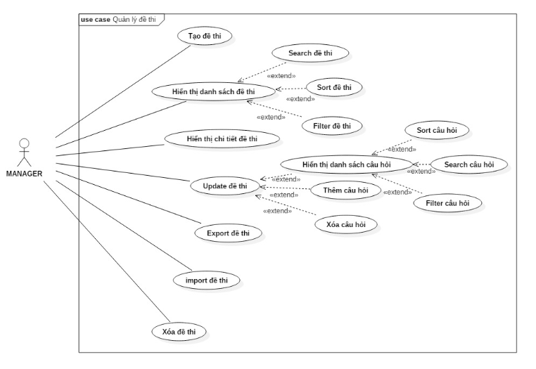

## 3.2 Class diagram

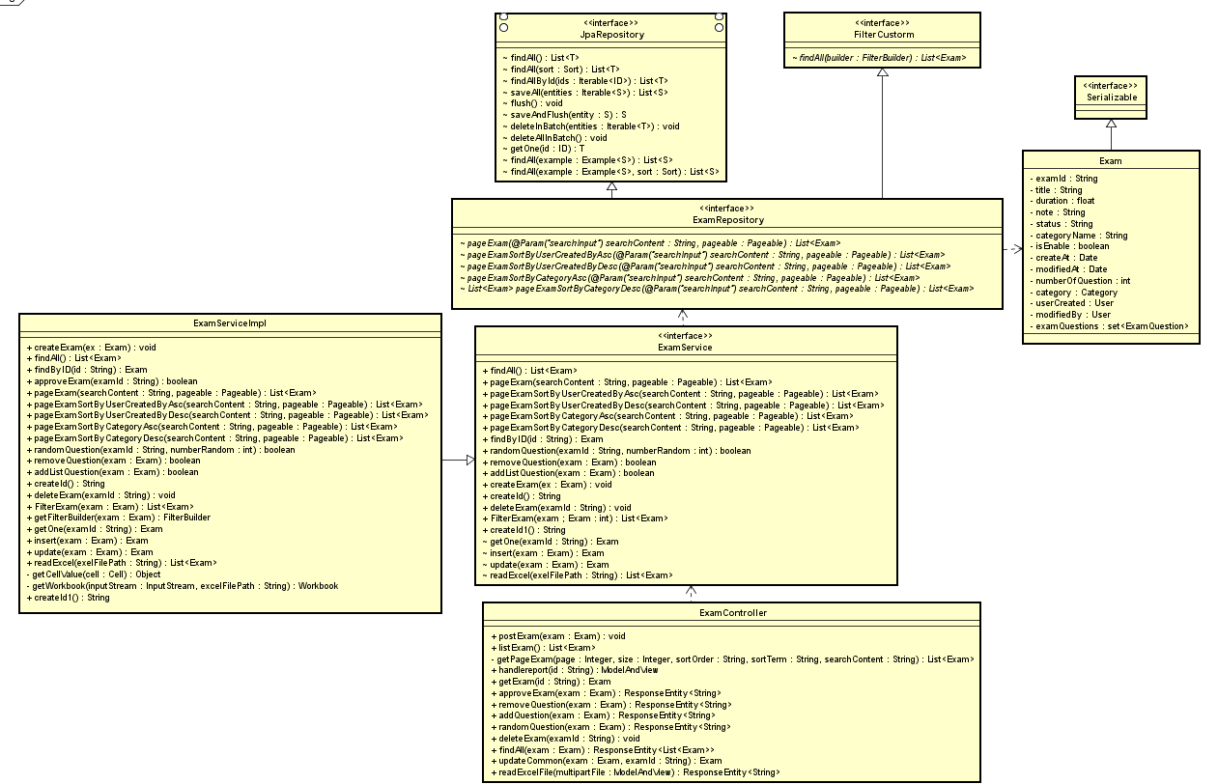

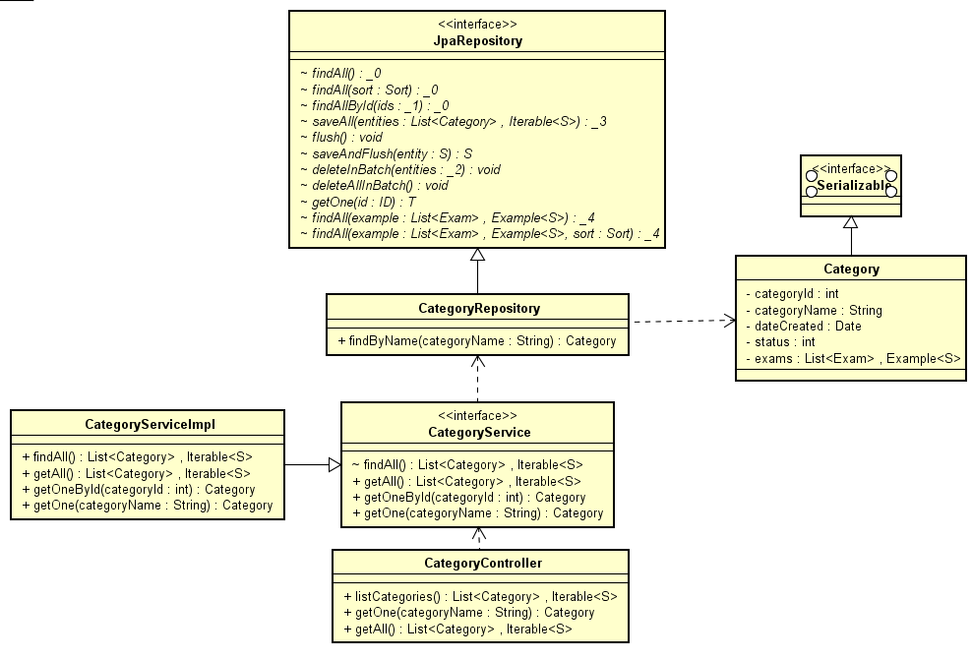

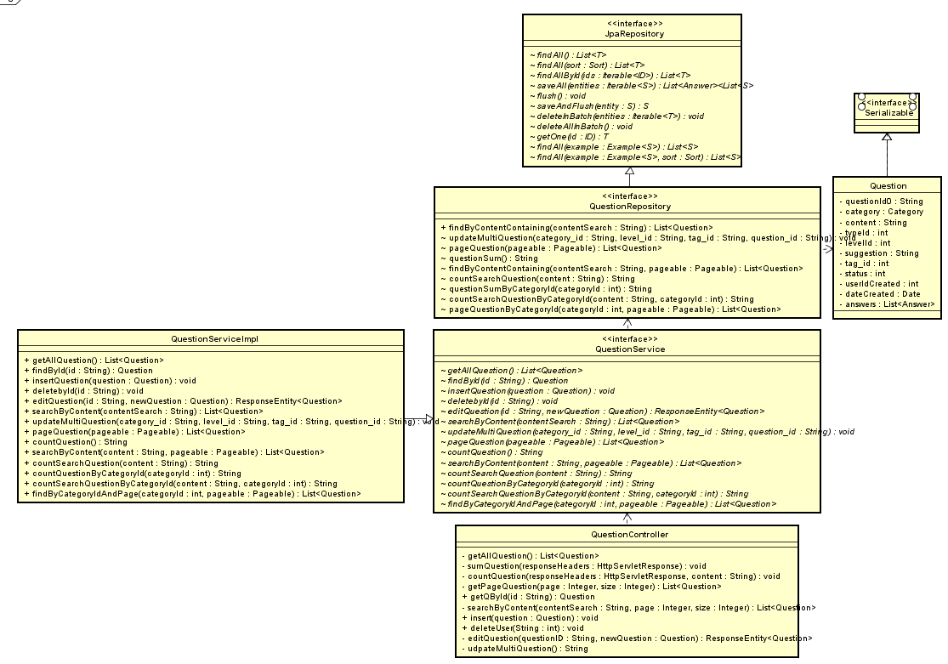

## 3.3 Activities diagrams, Sequence diagrams and Screen design for each function

### 3.3.1 View list Exam

#### 3.3.1.1 Activity diagram - View list Exam

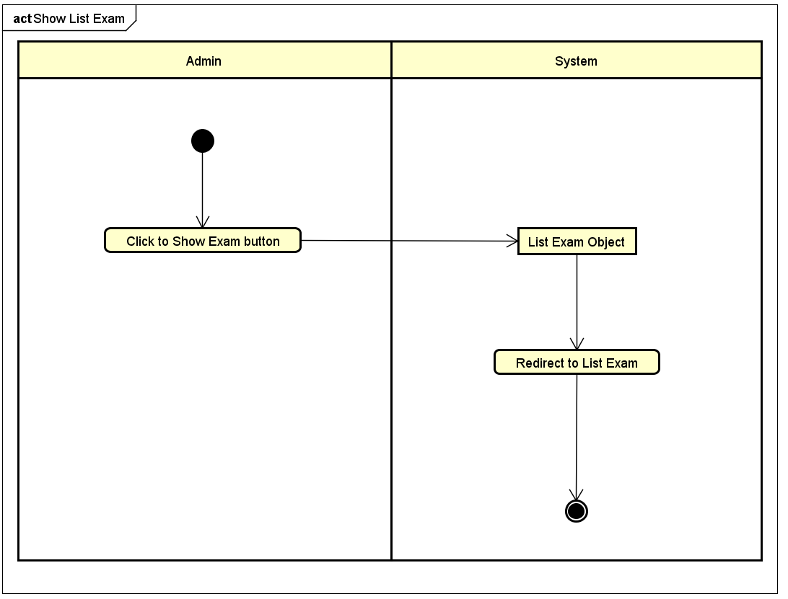

#### 3.3.1.2 Sequence diagram - View list Exam

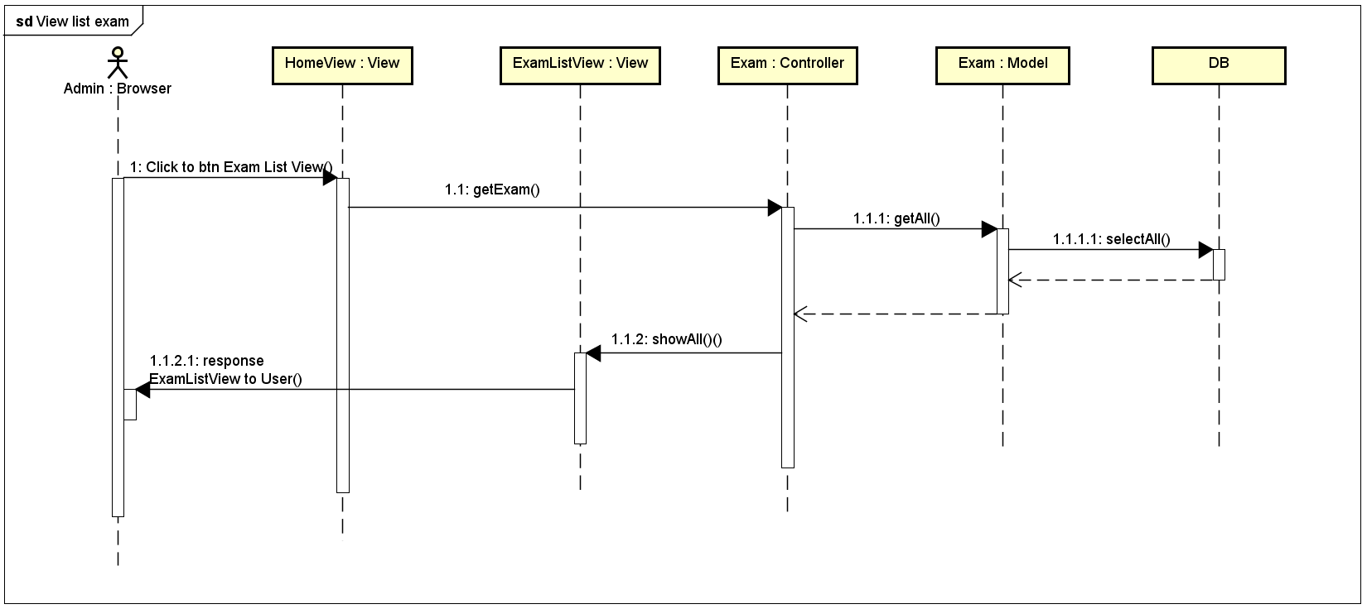

#### 3.3.1.3 Screen design - View list Exam

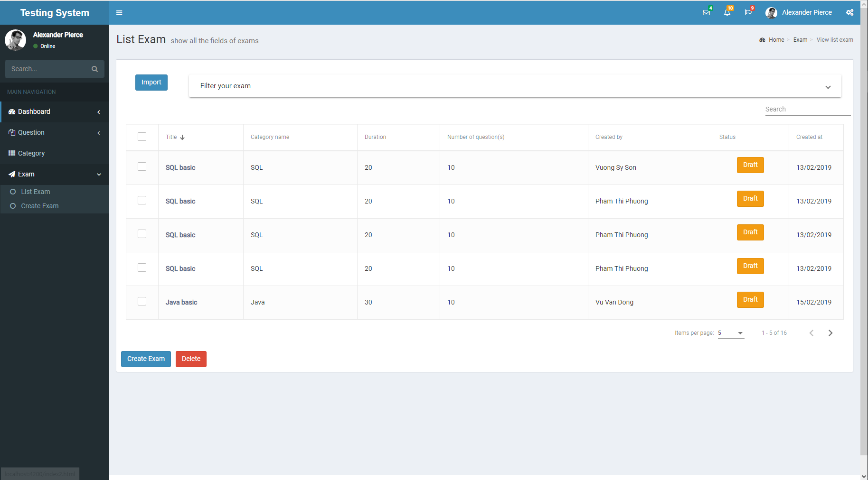

### 3.3.2 Create Exam

#### 3.3.2.1 Activity diagram - Create Exam

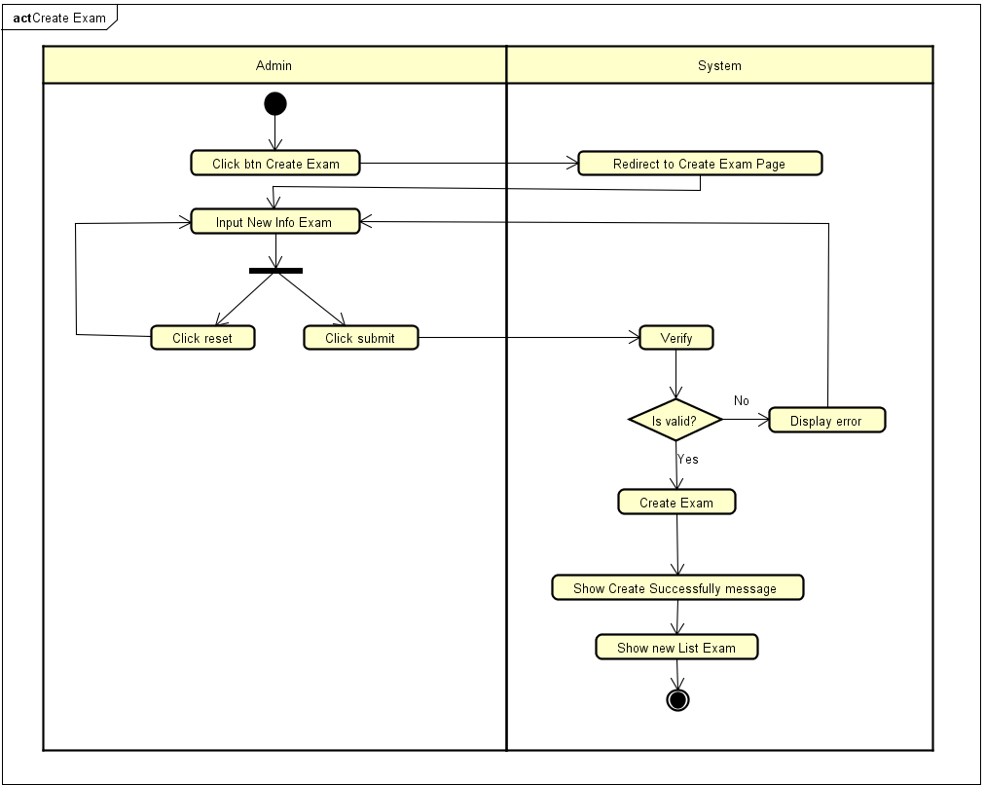

#### 3.3.2.2 Sequence diagram - Create Exam

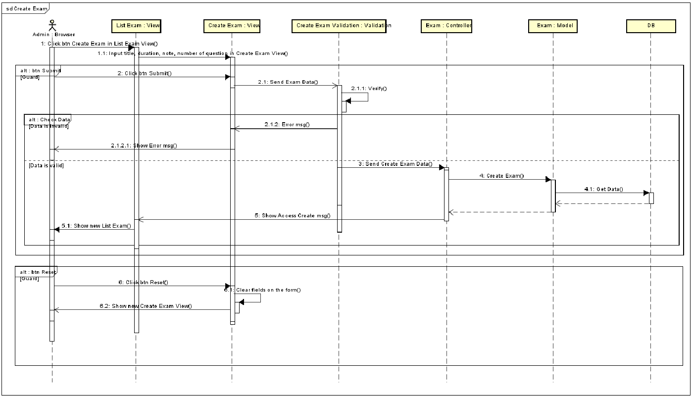

#### 

#### 3.3.2.3 Screen design - Create Exam

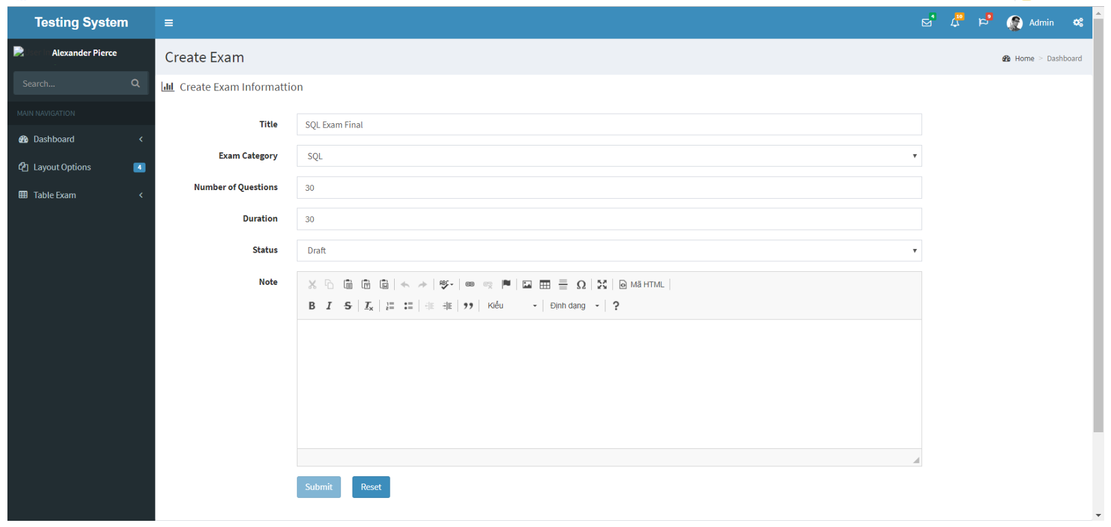

#### 

### 3.3.3 Search Exam

#### 3.3.3.1 Activity diagram - Search Exam

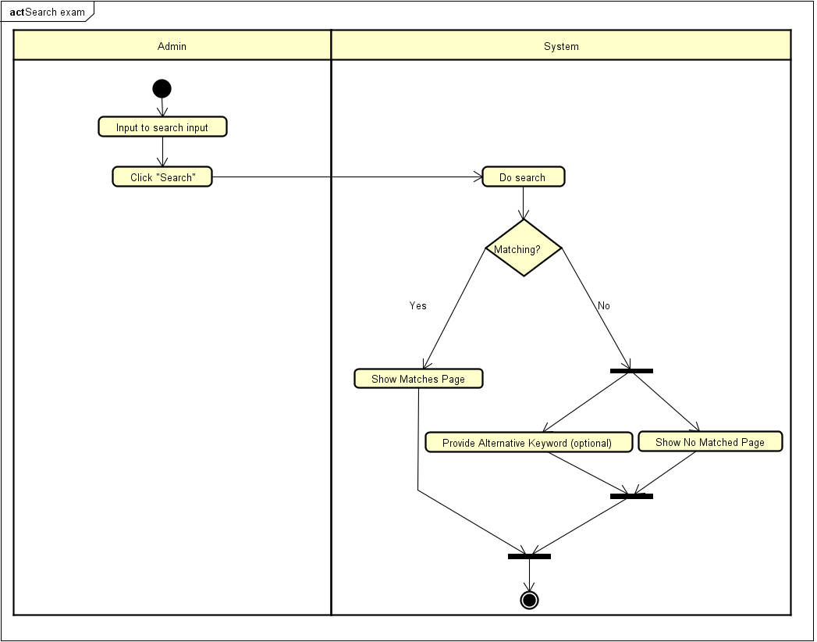

#### 3.3.3.2 Sequence diagram - Search Exam

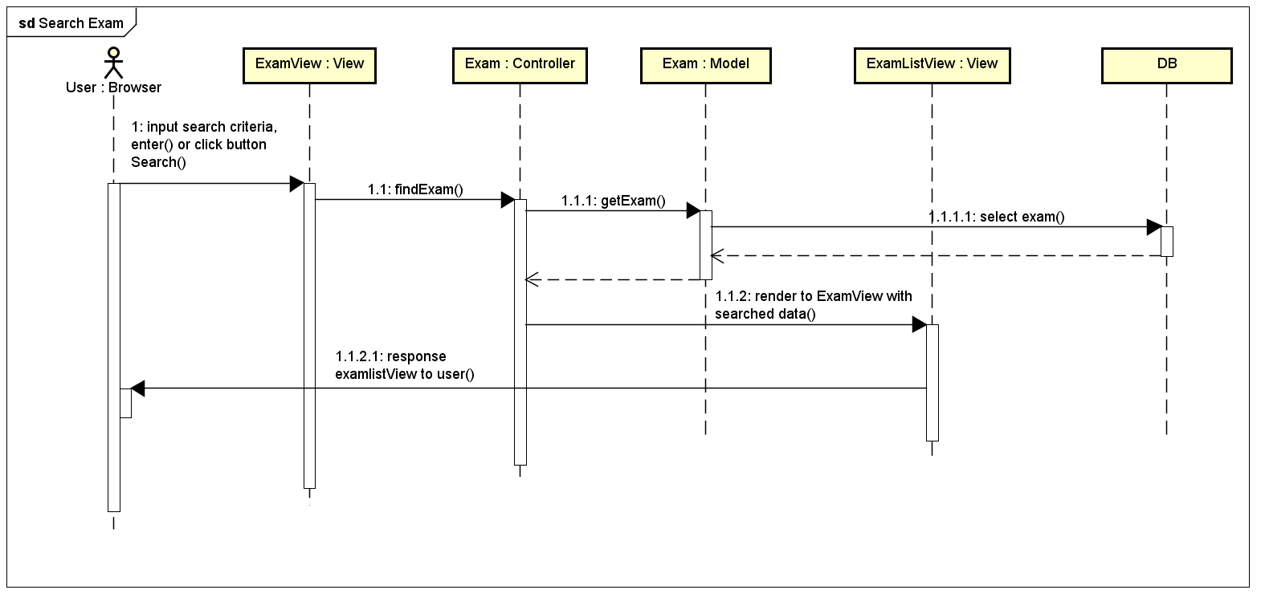

#### 3.3.3.3 Screen design - Search Exam

#### 

### 3.3.4 Filter Exam

#### 3.3.4.1 Activity diagram - Filter Exam

#### 3.3.4.2 Sequence diagram - Filter Exam

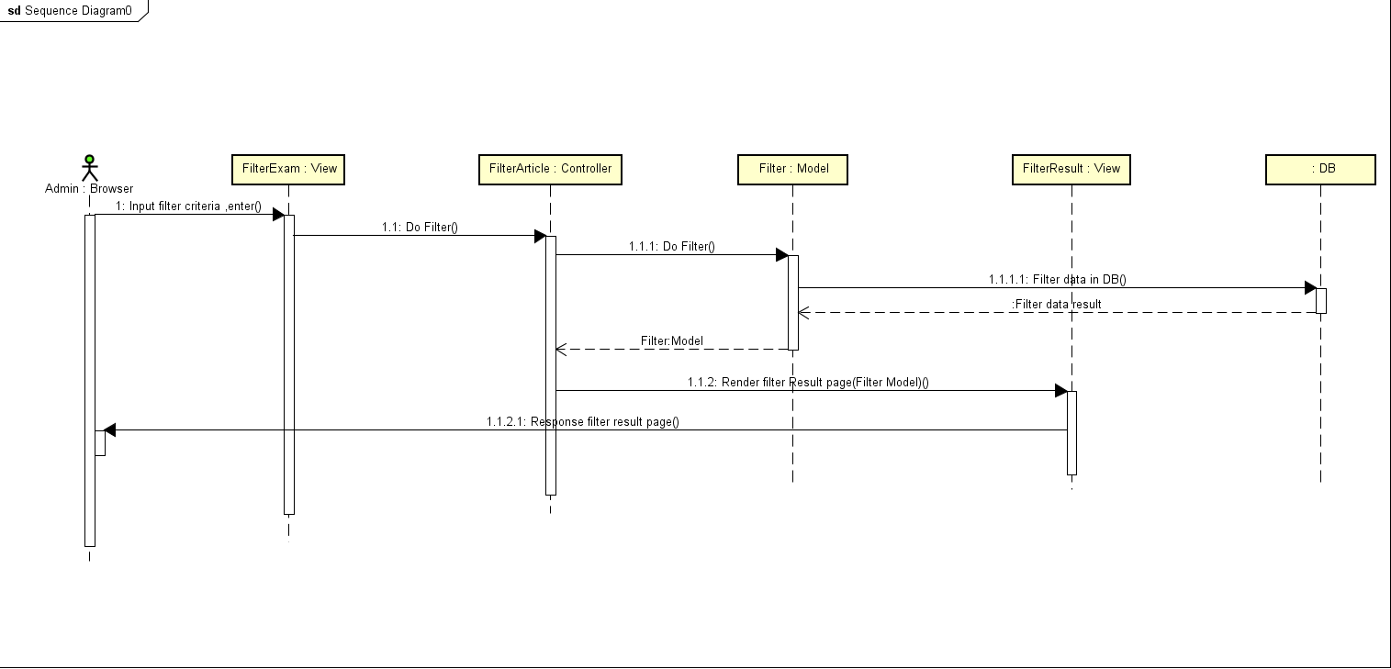

#### 

### 3.3.5 Sort Exam

#### 3.3.5.1 Activity diagram - Sort Exam

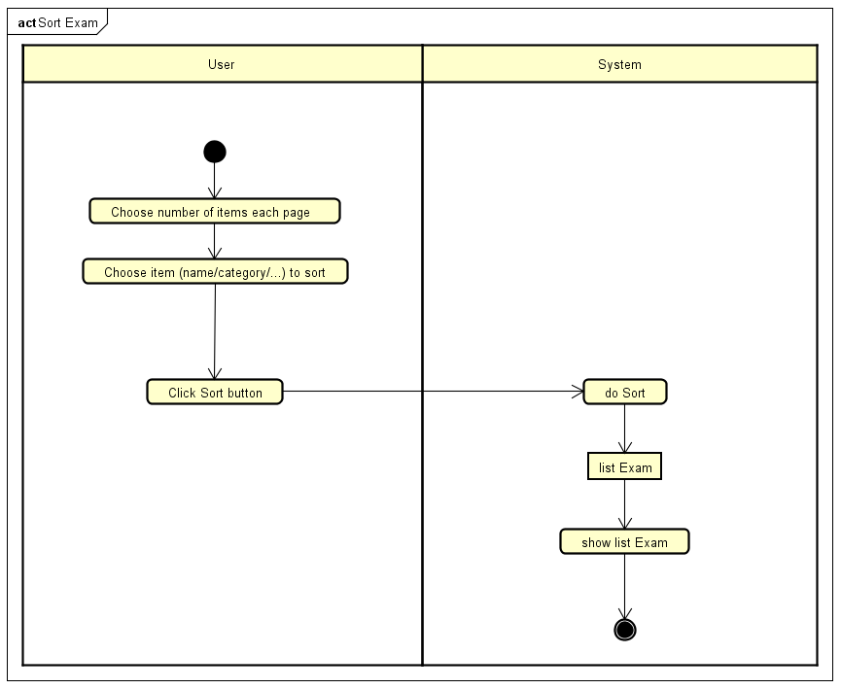

#### 3.3.5.2 Sequence diagram - Sort Exam

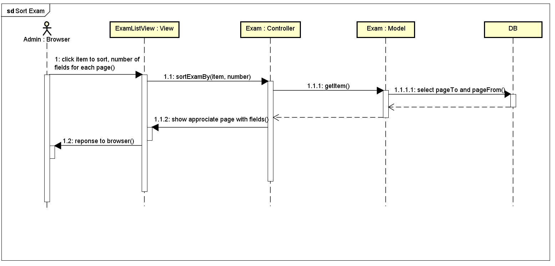

### 3.3.6 Delete Exam

#### 3.3.6.1 Activity diagram - Delete Exam

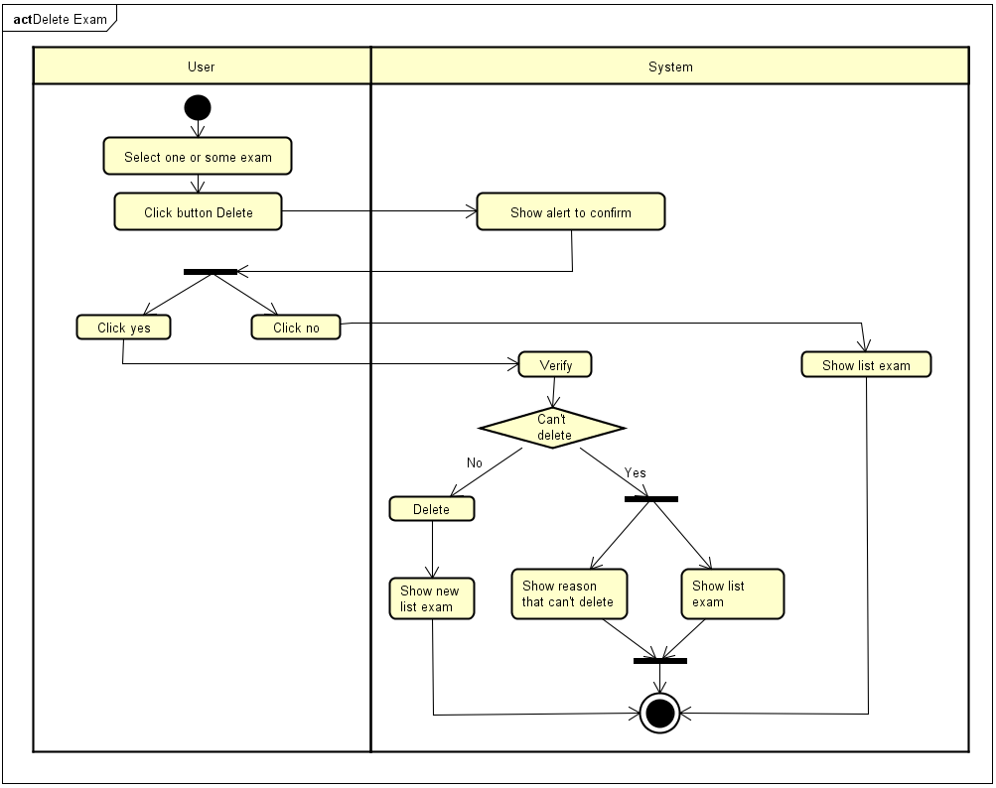

#### 3.3.6.2 Sequence diagram - Delete Exam

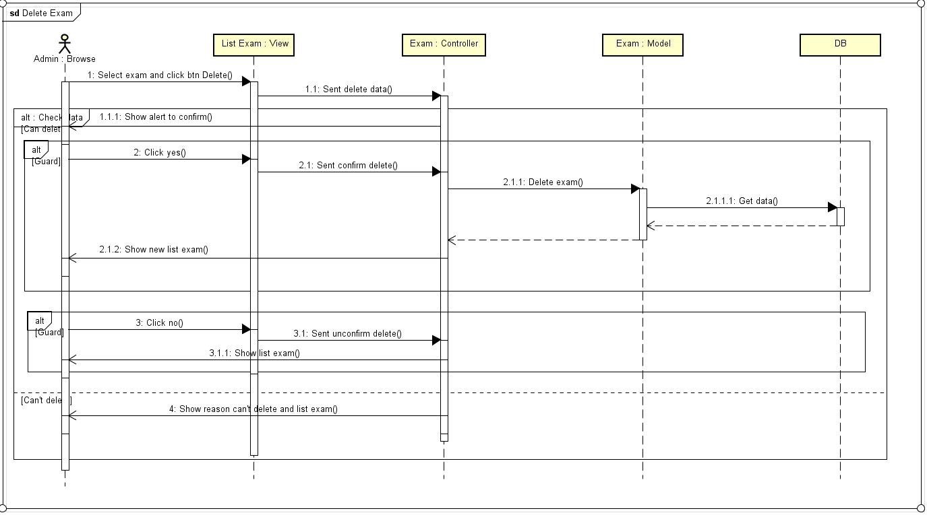

### 3.3.7 Import Exam

#### 3.3.7.1 Activity diagram - Import Exam

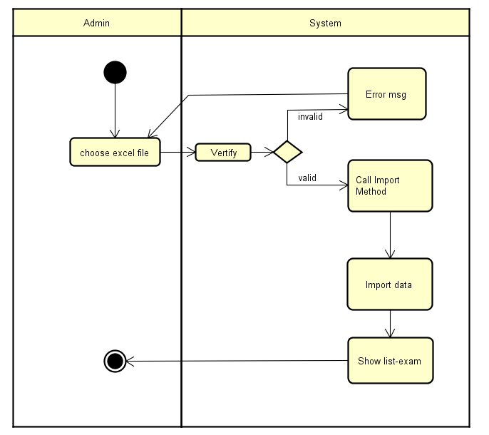

#### 

#### 3.3.7.2 Sequence diagram - Import Exam

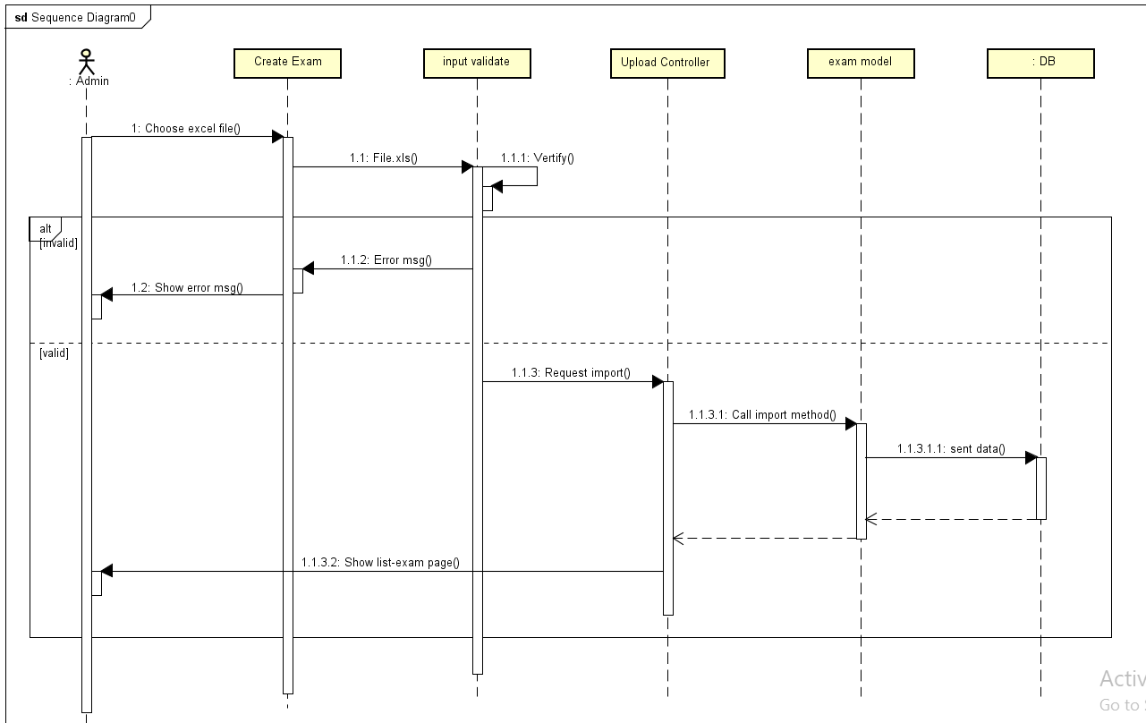

### 3.3.8 Export Exam

#### 3.3.8.1 Activity diagram - Export Exam

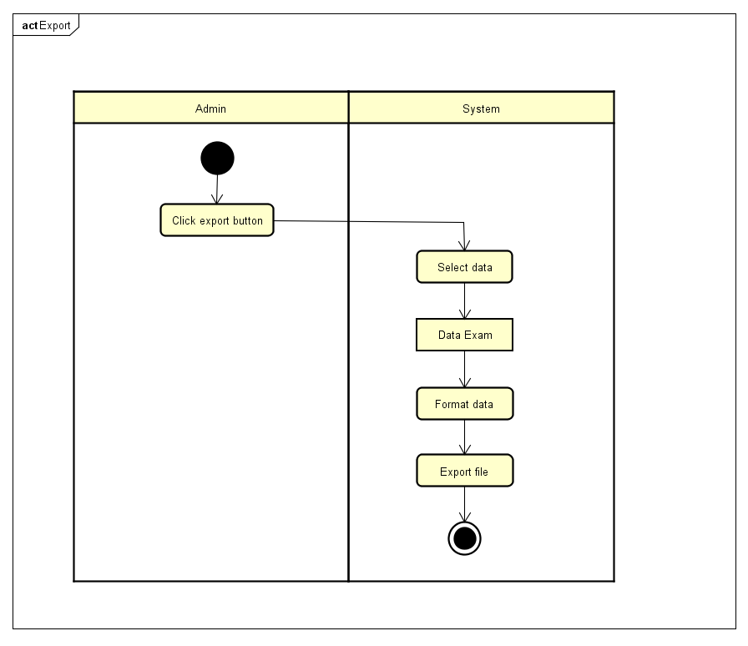

#### 3.3.8.2 Sequence diagram - Export Exam

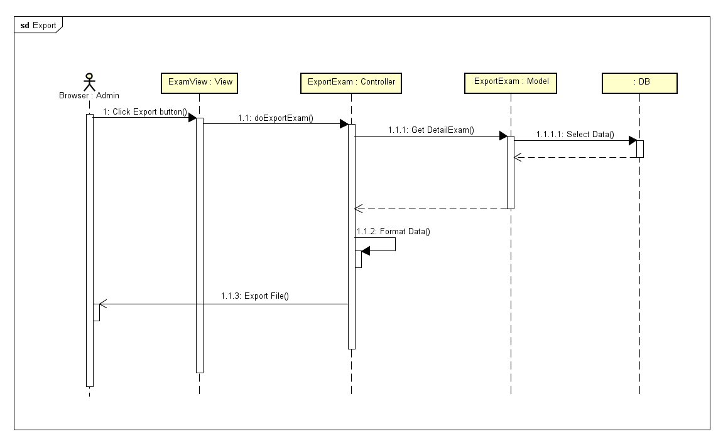

### 3.3.9 Detail Exam View

#### 3.3.9.1 Activity diagram - Detail Exam

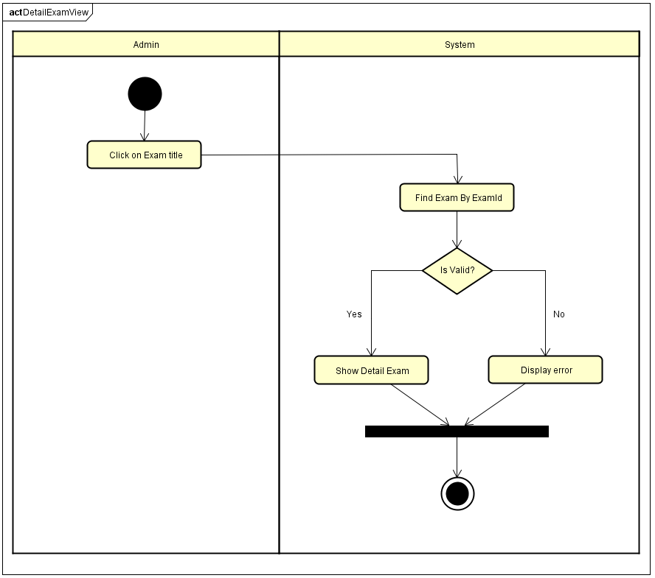

#### 3.3.9.2 Sequence diagram - Detail Exam

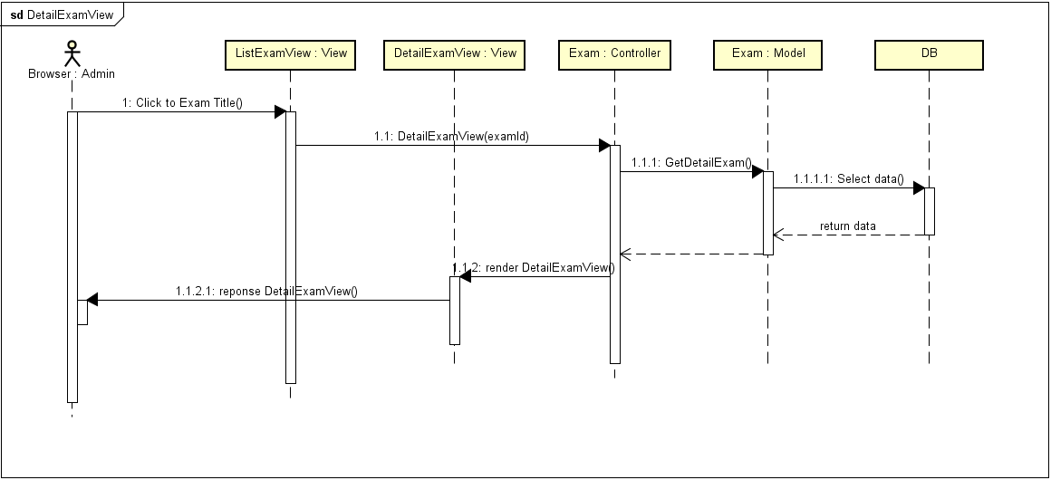

#### 3.3.9.3 Screen design - Detail Exam

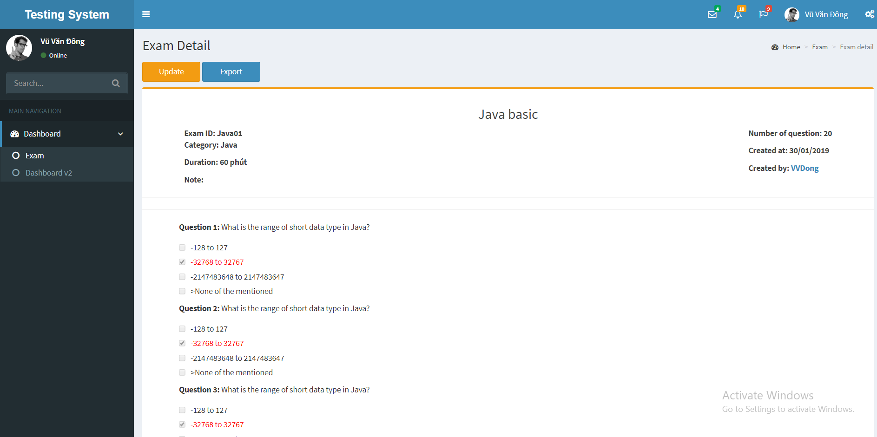

### 3.3.10 Update

#### *3.3.10.1 Approve Exam*

##### 3.3.10.1.1 Activity diagram - Approve Exam

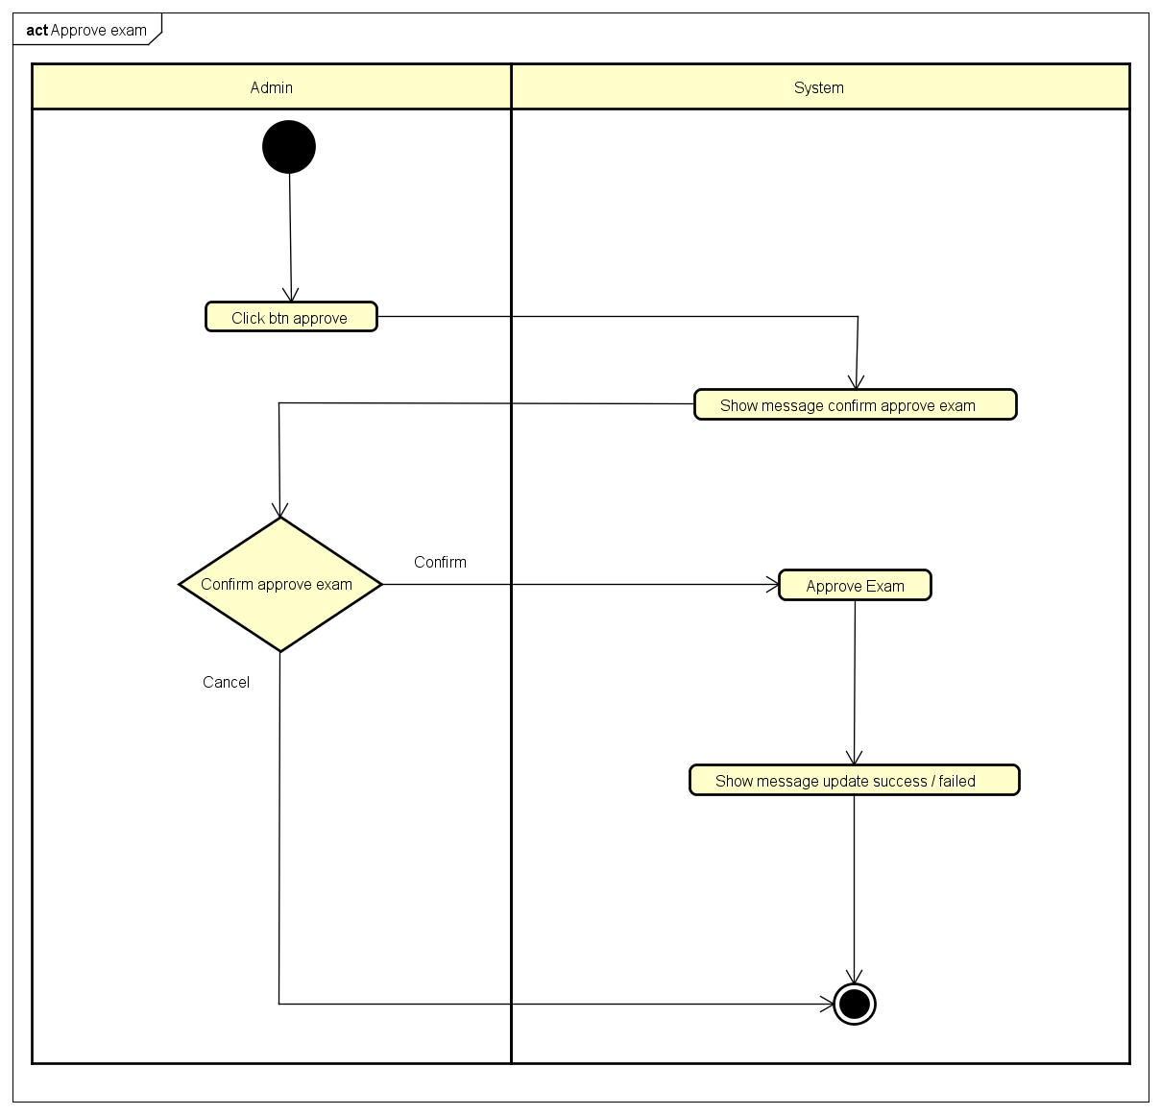

##### 3.3.10.1.2 Sequence diagram - Approve Exam

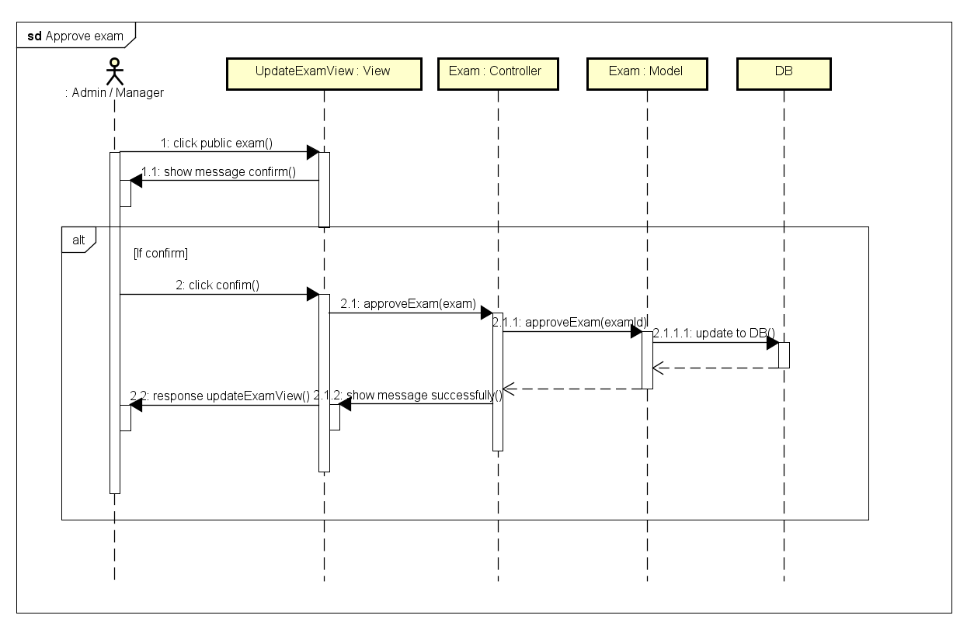

##### 3.3.10.1.3 Screen design - Approve Exam

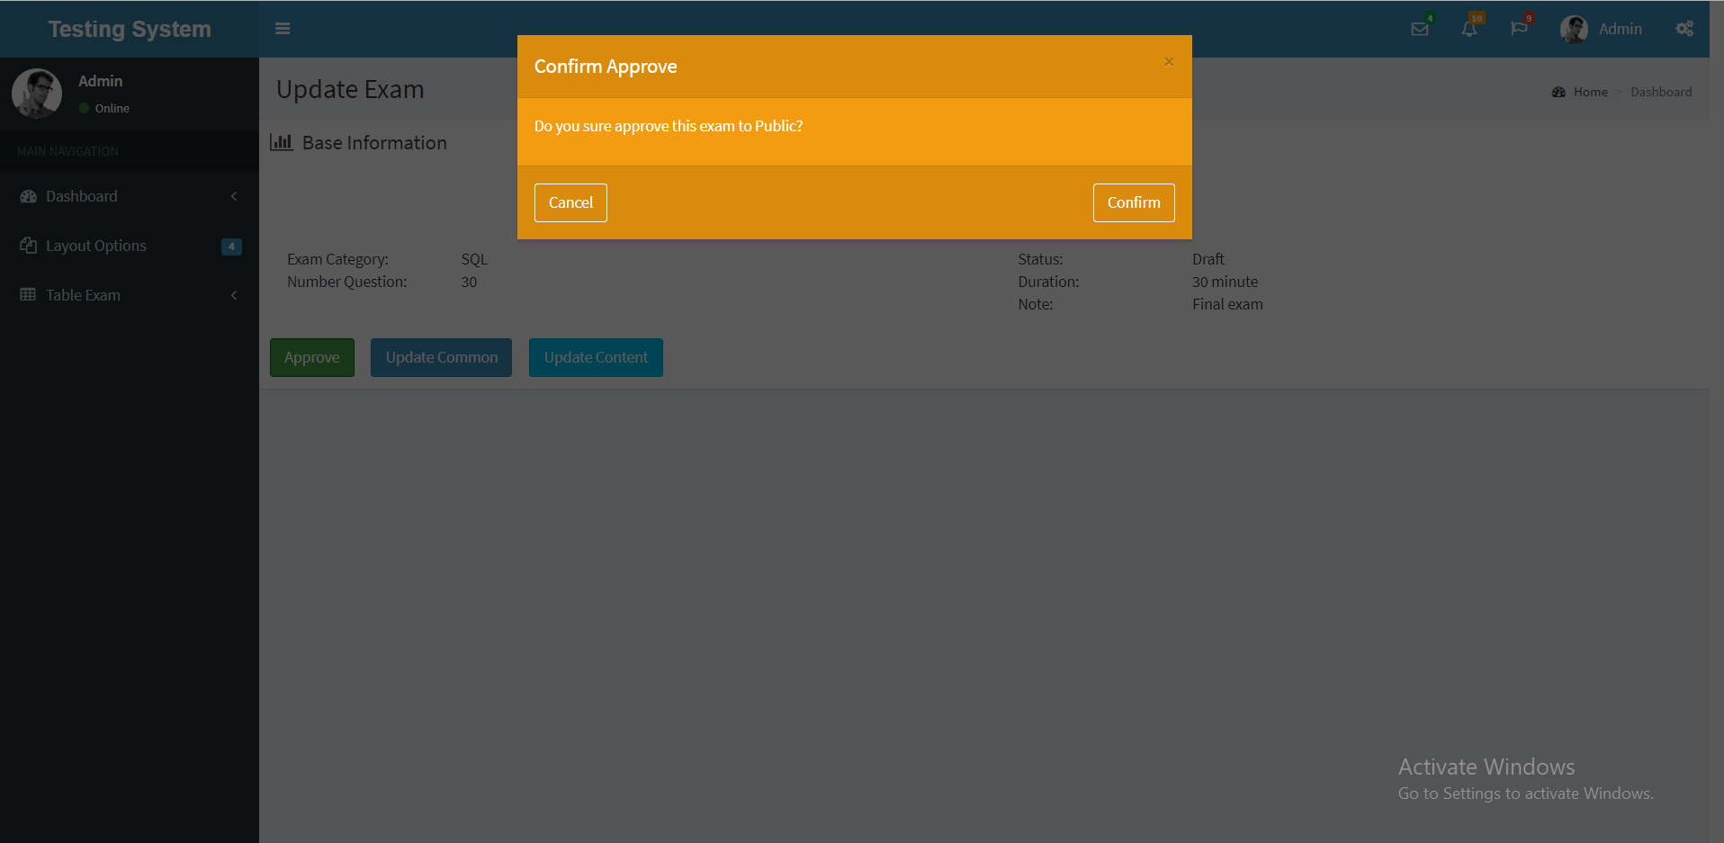

#### *3.3.10.2 Update common Exam*

##### 3.3.10.2.1 Activity diagram - Update common Exam

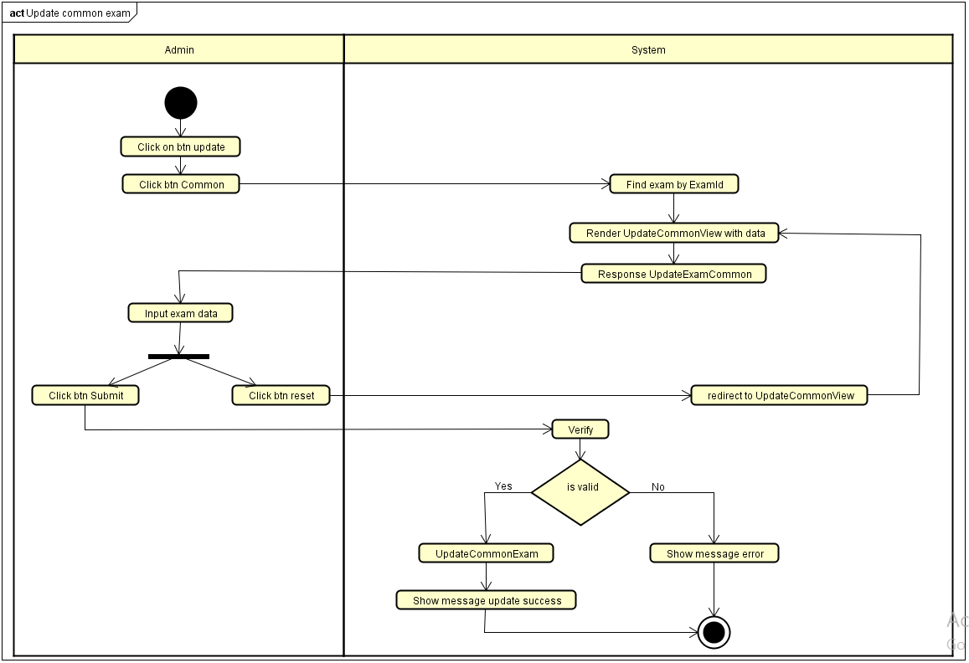

##### 3.3.10.2.2 Sequence diagram - Update common Exam

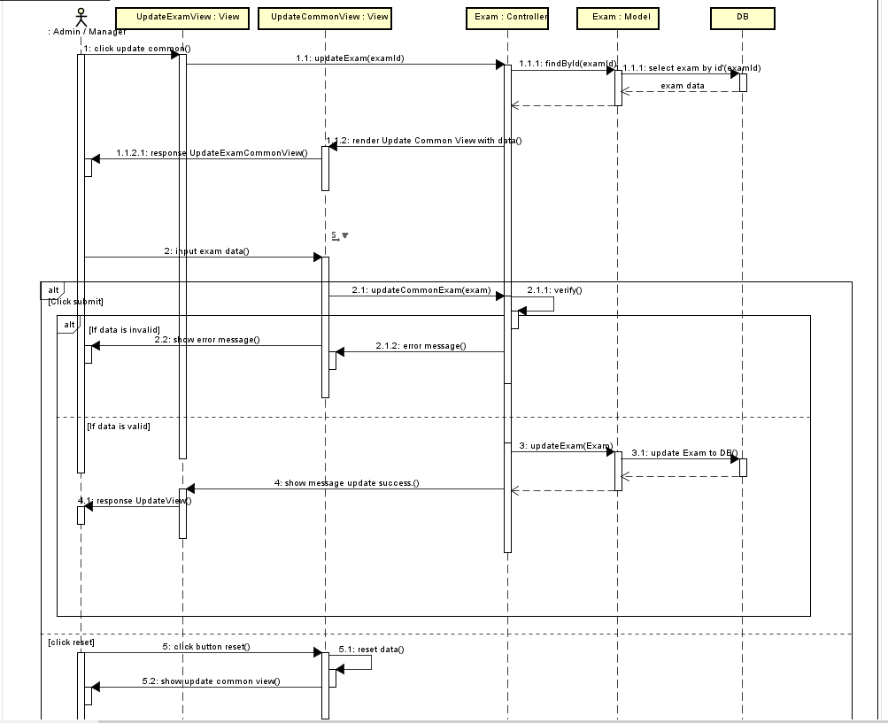

##### 3.3.10.2.3 Screen design - Update common Exam

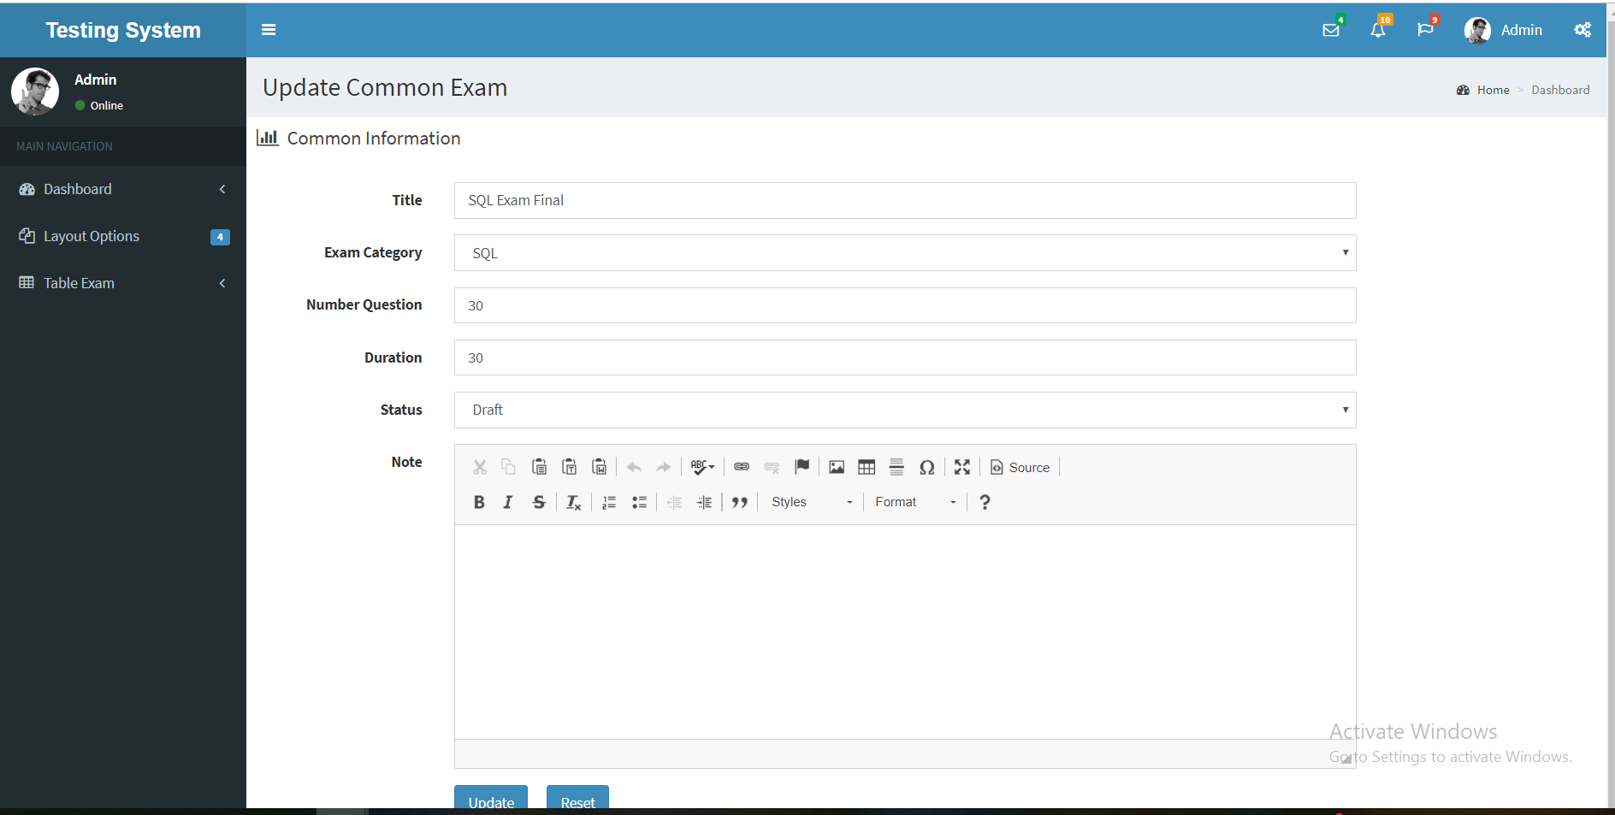

#### *3.3.10.3 Add question*

##### 3.3.10.3.1 Activity diagram – Add question

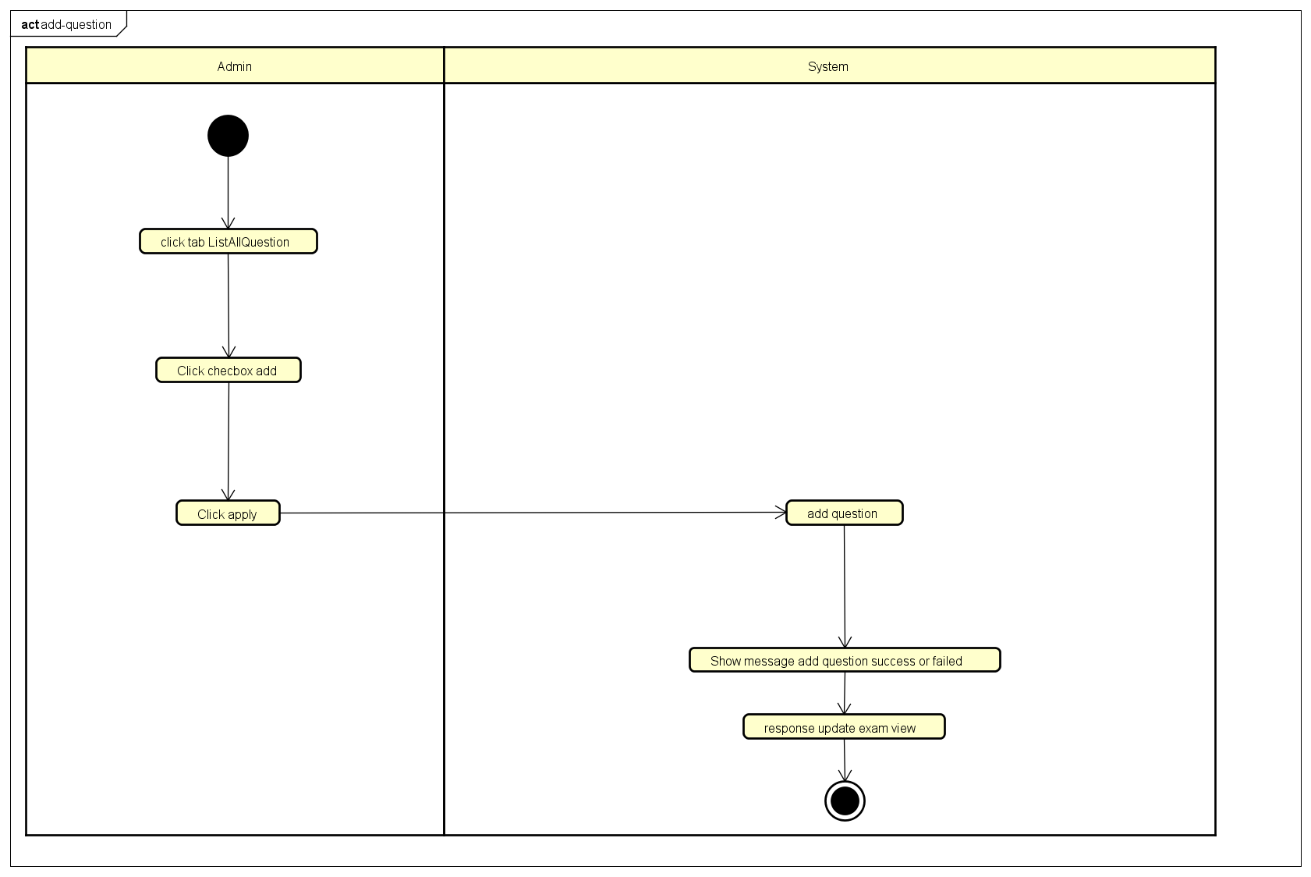

##### 3.3.10.3.2 Sequence diagram – Add question

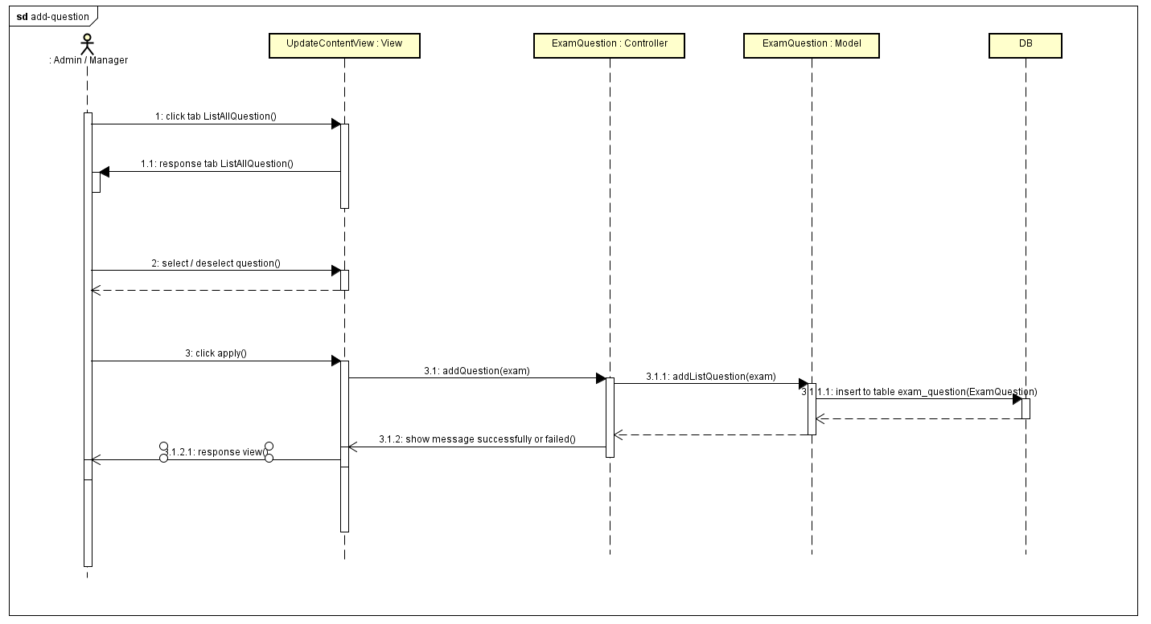

##### 3.3.10.3.3 Screen design – Add question

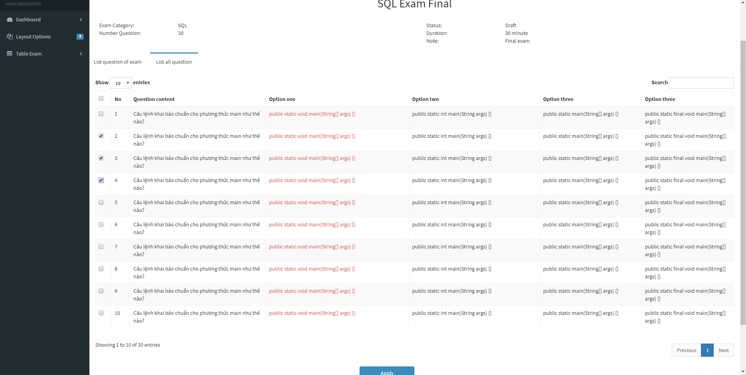

#### *3.3.10.3 Random question*

##### 3.3.10.3.1 Activity diagram – Random question

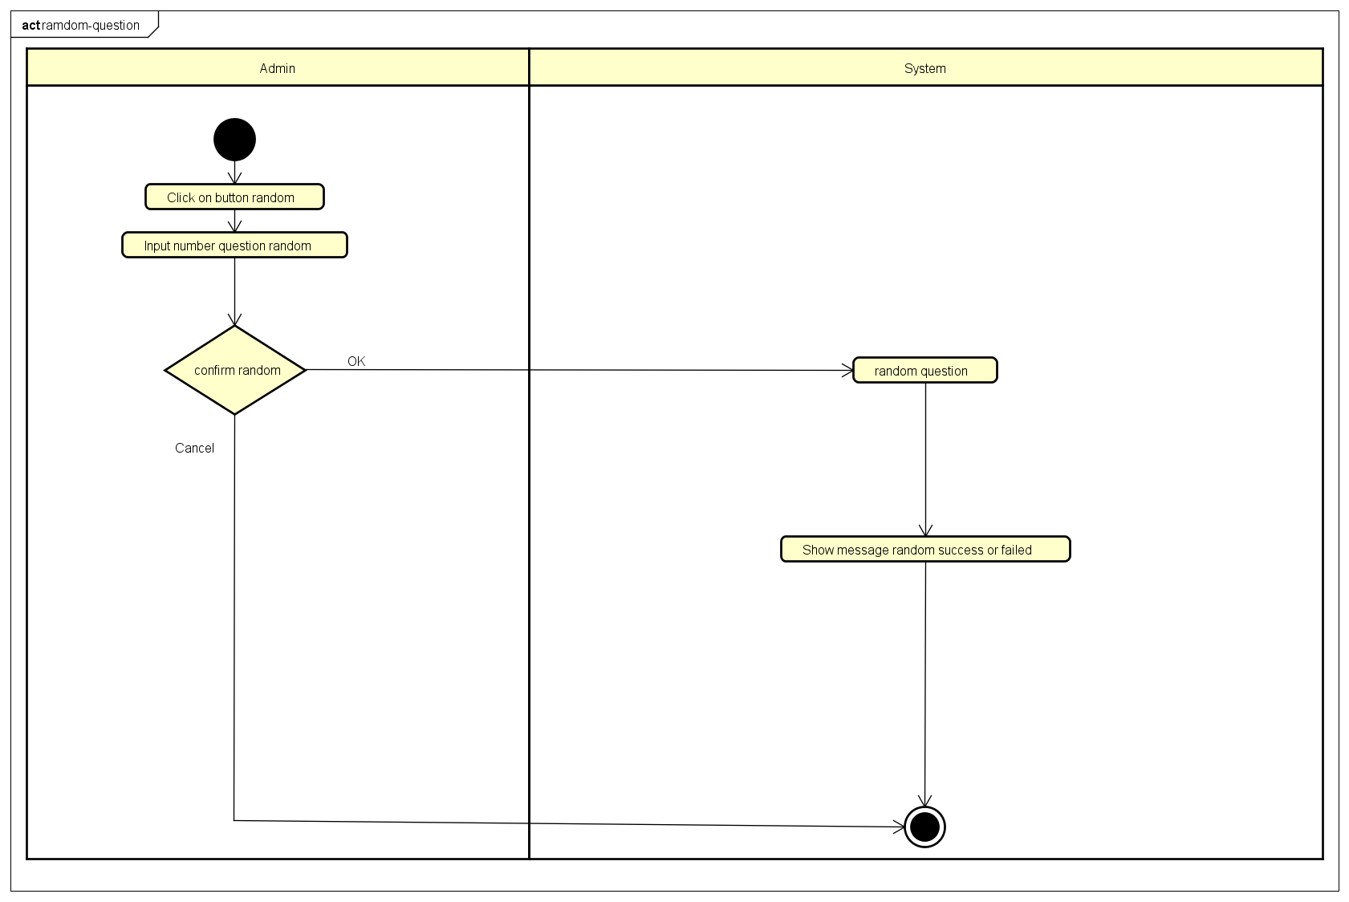

##### 3.3.10.3.2 Sequence diagram – Random question

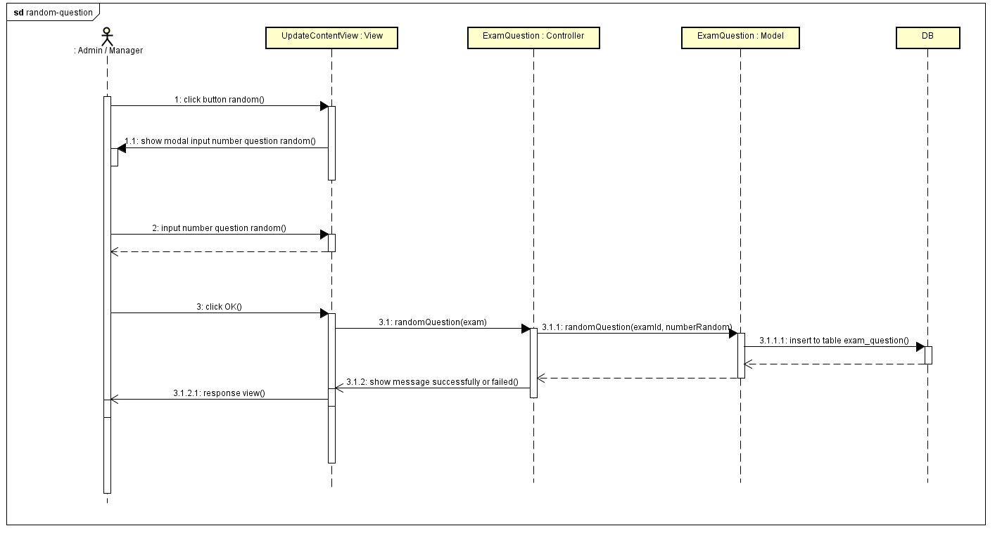

##### 3.3.10.3.3 Screen design –Random question

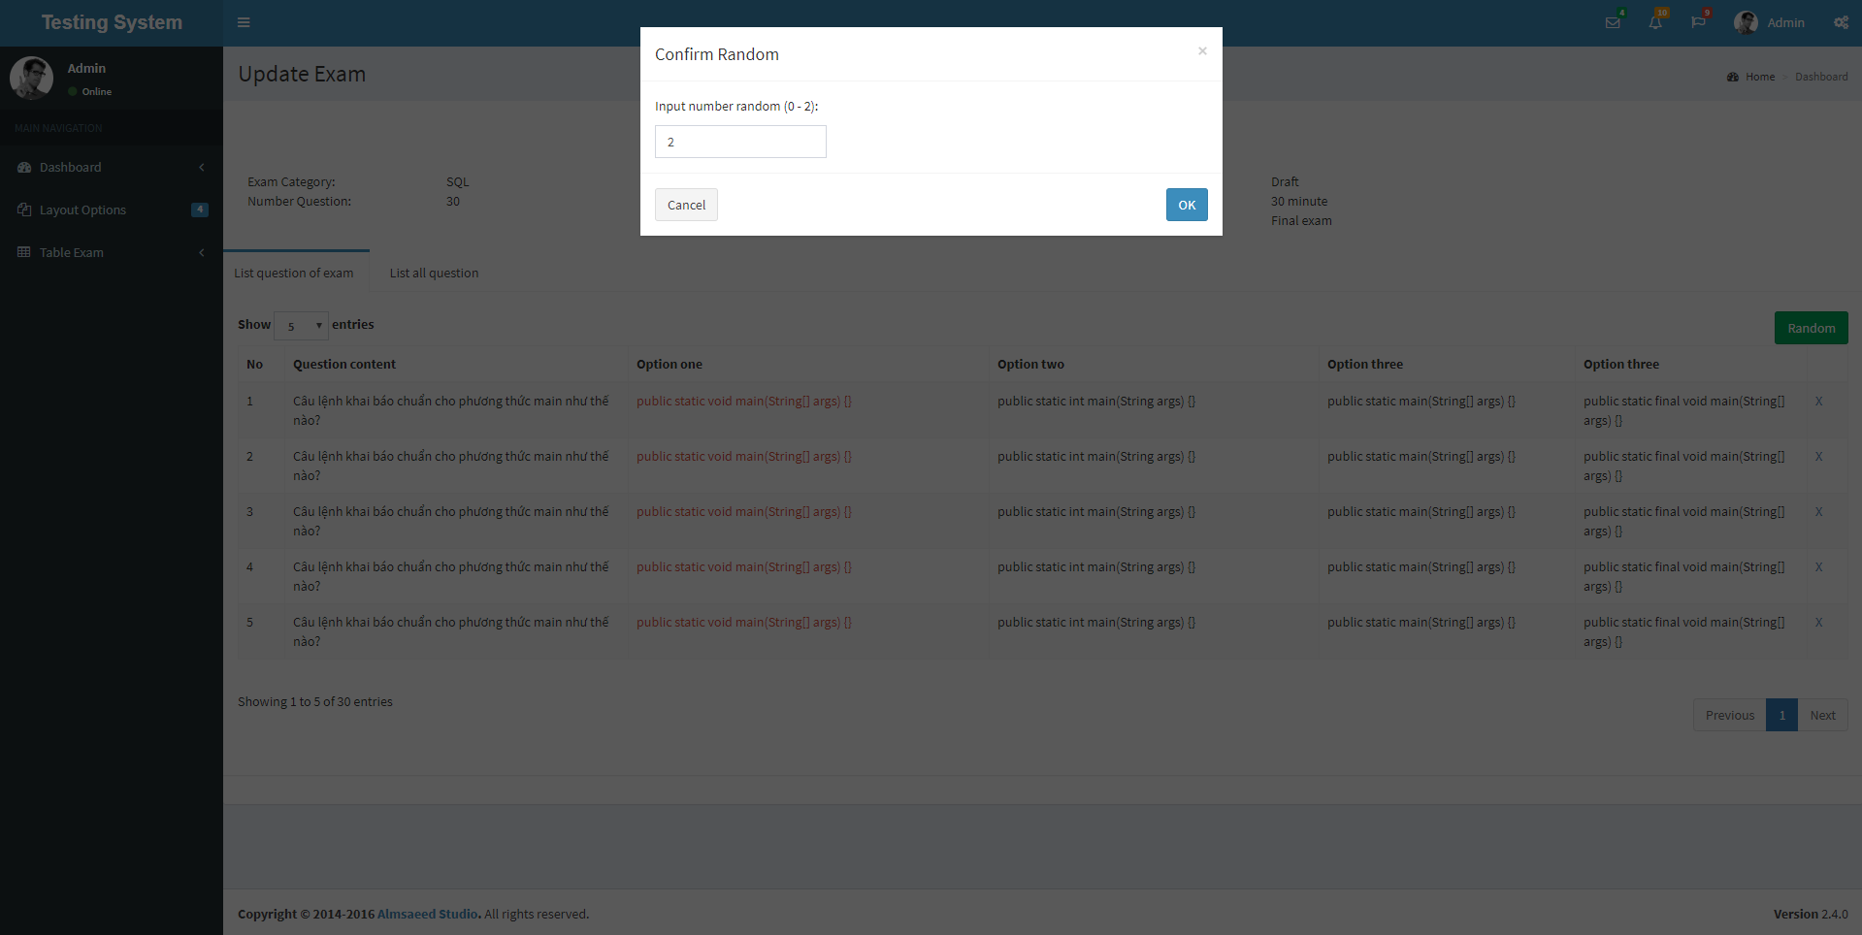

#### *3.3.10.3 Remove question*

##### 3.3.10.3.1 Activity diagram – Remove question

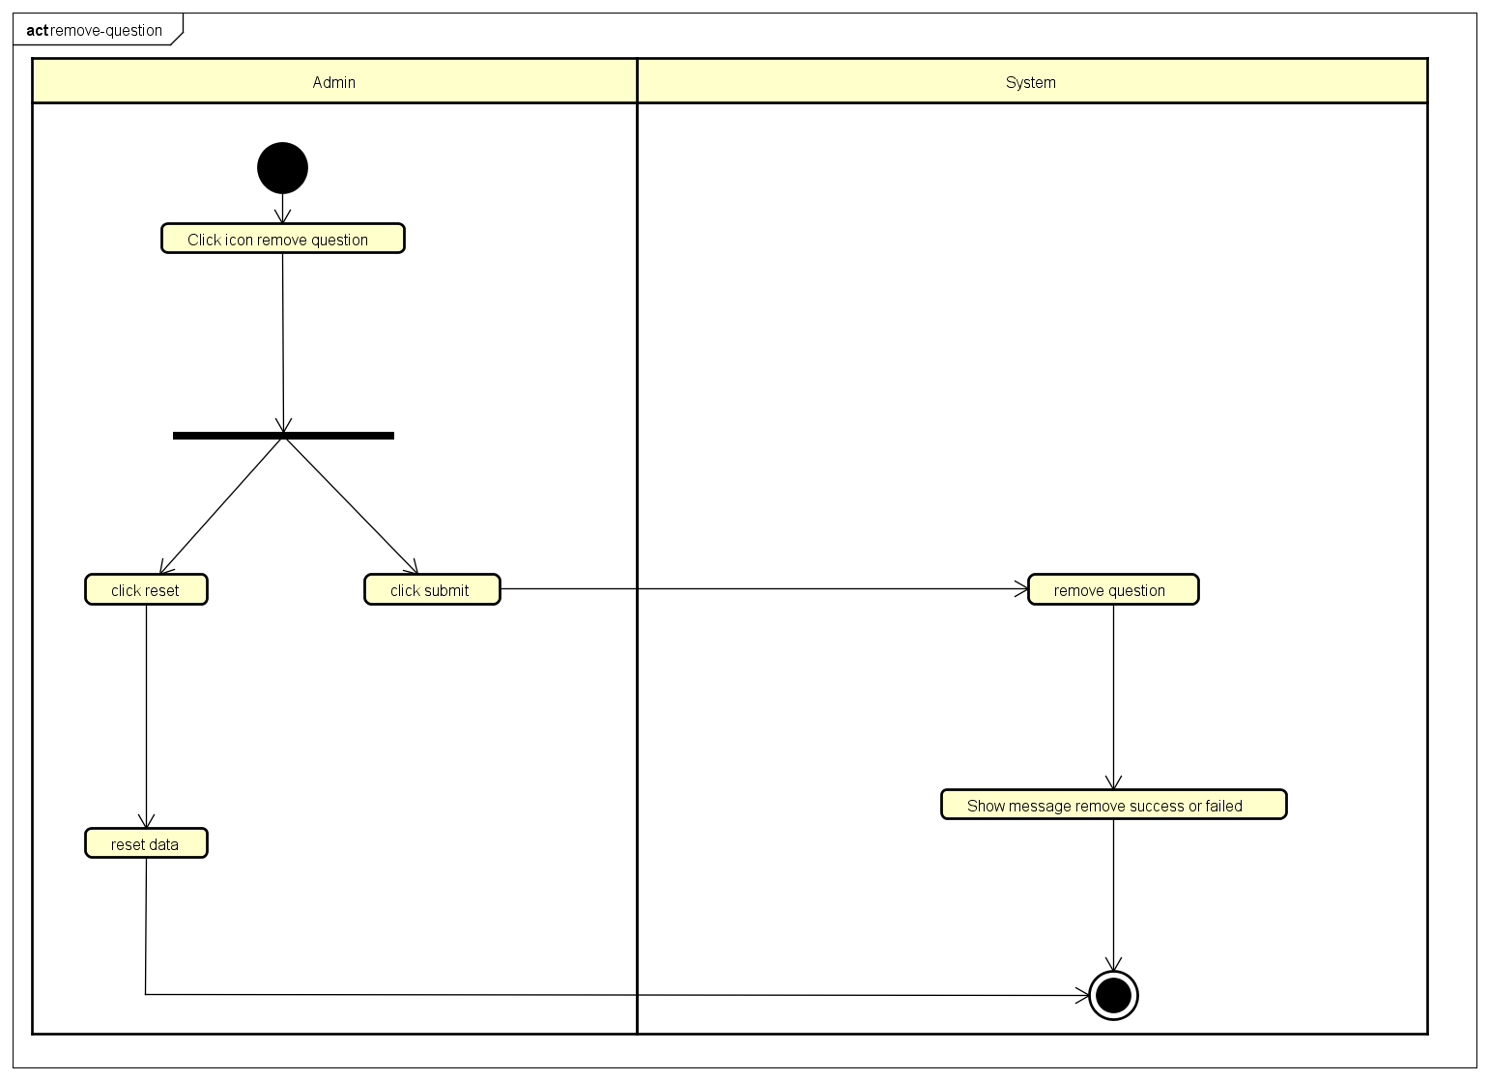

##### 3.3.10.3.2 Sequence diagram – Remove question

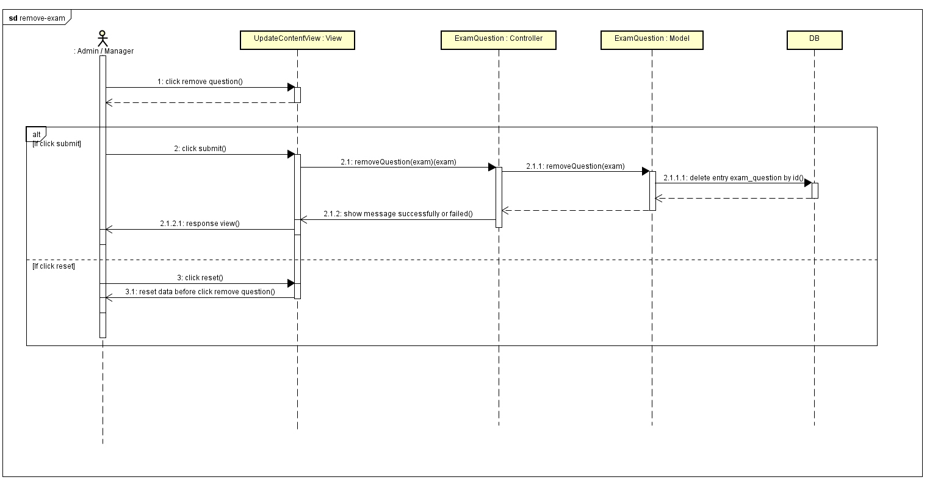

##### 3.3.10.3.3 Screen design – Remove question

