Report: ECG Heartbeat Classification
Mai Ngọc Linh - 23BI14255
January 19, 2026

Catalog
1. Introduction 1
2. Dataset Summary 1
2.1 Data Details 1
2.2 Class Categories 1
3. How the Model Works 2
3.1 The 1D CNN Architecture 2
4. Experimental Results 2
4.1 Performance Table 2
4.2 Training Accuracy Loss 2
4.3 Confusion Matrix 3
4.4 Main Findings 3
5. Conclusion 3

1. Introduction
Heart disease is a major global health issue. Doctors use Electrocardiograms (ECG) to check the heart’s rhythm, but analyzing hours of data is difficult and slow. This project uses a 1D Convolutional Neural Network (CNN) to automatically identify different types of heartbeats. This tool helps doctors process data faster and more accurately.

2. Dataset Summary
We used the MIT-BIH Arrhythmia Database, a standard collection of ECG recordings.

2.1 Data Details
• Structure: Each sample is a sequence of 187 signal points.
• Label: Each sample is assigned to one of five categories (0 to 4).
• Classes: Most beats are ”Normal,” but the dataset also includes various types of ”Ar- rhythmias” (irregular beats).

2.2 Class Categories
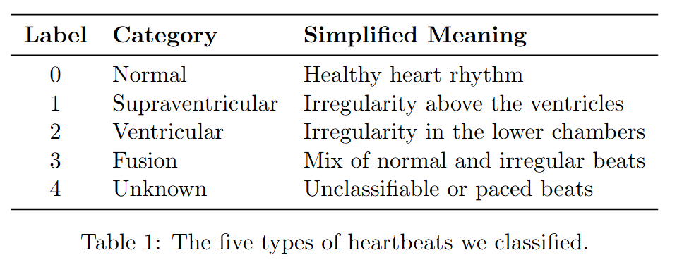

- How the Model Works
We built a Deep Learning model that ”scans” the heartbeat signal to find patterns.

3.1 The 1D CNN Architecture
Instead of looking at just the numbers, the 1D CNN looks at the ”shape” of the wave:
1. Convolution Layers: These act like filters that recognize specific parts of the wave (like the peaks).
2. Pooling Layers: These simplify the data by keeping only the most important features.
3. Dropout (0.5): We turned off 50% of the neurons during training. This forces the model to be smarter and prevents it from simply ”memorizing” the answers.

4. Experimental Results

4.1 Performance Table
The model achieved an overall accuracy of 97%.
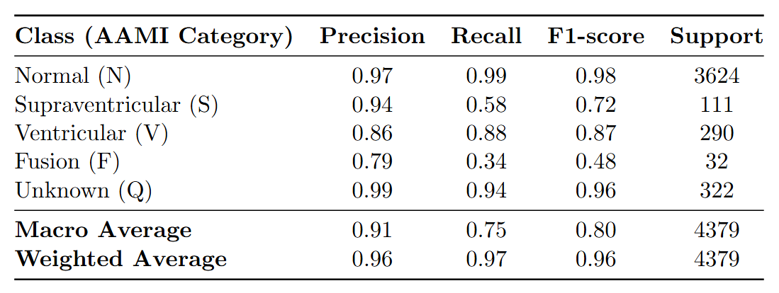
Table 2: Detailed performance metrics for the 1D CNN model on test data.

4.2 Training Accuracy Loss
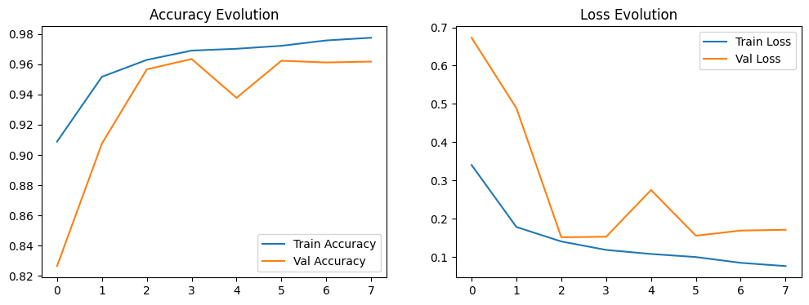
Figure 1: Accuracy and Loss Evolution

4.3 Confusion Matrix
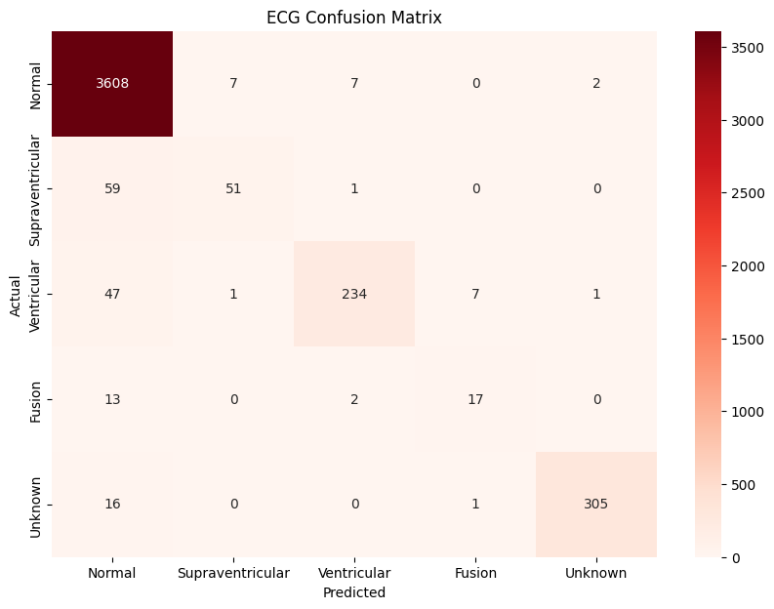
Figure 2: ECG Confusion Matrix

4.4 Main Findings
• Success: The model is excellent at identifying Normal and Unknown beats.
• Challenge: It is harder for the model to find ”Fusion” beats because there are very few examples of them in the data.
• Optimization: We found that using a Dropout rate of 0.5 helped the model perform
much better on new data.

5. Conclusion
The 1D CNN is a powerful tool for reading ECG signals. It is very accurate at spotting healthy beats and most common arrhythmias. Future improvements will focus on collecting more data for the rare heartbeat types to make the model even more reliable for clinical use.

