Algorithm for file updates in Python
Garrison Zhu
3/10/26

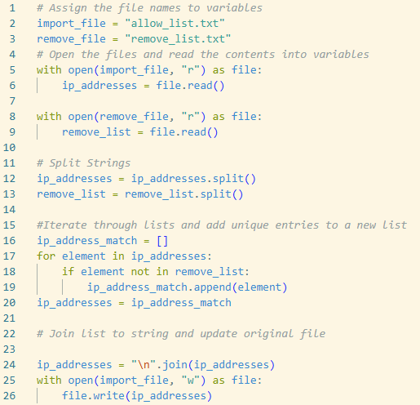

Project description
In this hypothetical scenario, I am a security analyst at a health care company responsible for regularly updating a file that identifies employees who have access to restricted content. The contents of the file are based on who is working with personal patient health records. Employees are restricted based on IP address. There is an allow list for IP addresses permitted to sign in to the restricted subnetwork. There is also a remove list that identifies which employees should be taken off the allow list.

I have decided to create an algorithm that uses Python code to check whether the allow list contains IP addresses contained in the remove list and automatically removes them if a match is found.

Open the file that contains the allow list
The file I want to open is called “allow_list.txt” and is in the same location as the python script. I’ll use a with statement to open the file and work with it. By using the “r” parameter, I’ll be able to read the contents.

# Assign the file names to variables
import_file = "allow_list.txt"
remove_file = "remove_list.txt"

# Open the files
with open(import_file, "r") as file:
#next step
with open(remove_file, "r") as file:
#next step

Read the file contents
Next, I use the .read() method to change the contents of the file into a string so that they can be read. I put the contents into a variable called ip_addresses or remove_list.

# Assign the file names to variables
import_file = "allow_list.txt"
remove_file = "remove_list.txt"

# Open the files and read them into variables
with open(import_file, "r") as file:
ip_addresses = file.read()
with open(remove_file, "r") as file:
remove_list = file.read()
print(remove_list)
print(ip_addresses)

Convert the string into a list

In order to iterate through the list, I need to convert it into a list first. Therefore, I’ll use the .split() method to convert the ip_addresses string into a list.

# Assign the file names to variables
import_file = "allow_list.txt"
remove_file = "remove_list.txt"

# Open the files and read them into variables
with open(import_file, "r") as file:
ip_addresses = file.read()
with open(remove_file, "r") as file:
remove_list = file.read()

# Split strings
ip_addresses = ip_addresses.split()
remove_list = remove_list.split()

Iterate through the remove list
Once variable ip_addresses is a list, I can use a for loop to iterate through the list and look for matches within the remove_list.

# Assign the file names to variables
import_file = "allow_list.txt"
remove_file = "remove_list.txt"

# Open the files and read them into variables
with open(import_file, "r") as file:
ip_addresses = file.read()
with open(remove_file, "r") as file:
remove_list = file.read()

# Split strings
ip_addresses = ip_addresses.split()
remove_list = remove_list.split()

# Iterate through list
for element in ip_addresses:

Remove IP addresses that are on the remove list
Next, I will use this for loop that I have set up to remove the matches between allow_list and remove_list. To do this, I will use the .remove() method to remove the ip addresses identified by the variable “element”

# Assign the file names to variables
import_file = "allow_list.txt"
remove_file = "remove_list.txt"

# Open the files and read them into variables
with open(import_file, "r") as file:
ip_addresses = file.read()
with open(remove_file, "r") as file:
remove_list = file.read()

# Split strings
ip_addresses = ip_addresses.split()
remove_list = remove_list.split()

# Iterate through list
for element in ip_addresses:
if element in remove_list:
ip_addresses.remove(element)

Update the file with the revised list of IP addresses
Finally, now that I have removed those IP addresses from the ip_addresses variable (allow list), I can complete the algorithm by updating the file with this revised list. To do this, I must convert the list back into a string using the .join() method. I will place each separate element in the file by placing them on new lines. Then, I will use another with statement with .write() to write over the file (allow_list.txt).

# Assign the file names to variables
import_file = "allow_list.txt"
remove_file = "remove_list.txt"

# Open the files and read them into variables
with open(import_file, "r") as file:
ip_addresses = file.read()
with open(remove_file, "r") as file:
remove_list = file.read()

# Split strings
ip_addresses = ip_addresses.split()
remove_list = remove_list.split()

# Iterate through list and remove matches
for element in ip_addresses:
if element in remove_list:
ip_addresses.remove(element)

# Join list to string and update original file

ip_addresses = "\n".join(ip_addresses)
with open(import_file, "w") as file:
file.write(ip_addresses)

Summary
This Python algorithm provides an automated and efficient way to manage access by cross-referencing an allow list against a remove list. By converting the allow_list.txt file into a list, the script can identify and delete unauthorized IP addresses by iterating with a for loop. The final steps ensure that data is converted back to a string and that it updates the original file. This process significantly reduces the risk of human/manual error and ensures that patient health records remain accessible only to those who require it. Furthermore, this entire workflow could easily be put into a reusable function, allowing me to pass different file names as parameters into the function.

Update 4/6/26

I have learned that it is bad practice to modify a list while iterating over it. This is because the index for each element shifts when the .remove() method is used. For me to remedy this problem, I’ve decided to modify the code to create a new list that only includes IP addresses NOT found in the remove_list.

# Assign the file names to variables
import_file = "allow_list.txt"
remove_file = "remove_list.txt"

# Open the files and read them into variables
with open(import_file, "r") as file:
ip_addresses = file.read()
with open(remove_file, "r") as file:
remove_list = file.read()

# Split strings
ip_addresses = ip_addresses.split()
remove_list = remove_list.split()

# Iterate through list and add unique entries to new list
ip_address_match = []
for element in ip_addresses:
if element not in remove_list:
ip_address_match.append(element)
ip_addresses = ip_address_match

# Join list to string and update original file

ip_addresses = "\n".join(ip_addresses)
with open(import_file, "w") as file:
file.write(ip_addresses)

