…………………………………………………………………..

…………………………………………………………………………..

Submitted by: Submitted to:

Name: ……………………….... …

Roll NO: ………………………….

Date of Submission:…………

Semester:………………………

Level : Bachelor

Program: BIM

**Table of Content**

***Chapter I Introduction***

**1. Declaration………………………………………………………………………………..2  
1.1 Acknowledgement……………………………………………………………………3  
1.2 Objective & Scope………………………………………………………………………4  
 i. Objective   
ii.Scope**

***Chapter II Tasks And Activities Performed*  
2.1 Theoretical Background……………………………………………………….5  
2.2 Problems in existing system…………………………………………………..5**  
**2.3 Solution to these problems……………………………………………………..5**  
 **2.4 Problem Statement…………………………………………………………………6  
2.5 Analysis Model………………………………………………………………………….6  
 2.6 Requirement analysis and proposed design………………………………..7  
2.7 Feasibility studies…………………………………………………………………………8  
2.8** **Non- Functional Requirement………………………………………………………8  
2.9 Methodology adopted and System implementation……………………..9**

***Chapter III Diagram*  
3.1 Use Case Diagram of system………………………………………………………..10**

**3.2 Data Flow Diagram………………………………………………………………………11  
3.3 Fig: Class Diagram……………………………………………………………………….12  
3.4 Fig: Activity Diagram……………………………………………………………………13**

**3.5 Test Case……………………………………………………………………………………14**

***Chapter IV Disussions And Conclusion***

**4.1 Conclusions………………………………………………………………………………….15**

**4.2 References …………………………………………………………………………………..16**

**4.3 Output Diagram…………………………………………………………………………….17**

**Declaration**  
I hereby declare that this is my own work. Materials of work found by other researchers are mentioned by reference.

Mr.Yubraj Neupane

Supervisor

Acknowledgement  
it is an honor for me to thank all those people who made this project possible. I want to thank my  
advisor. This would not be possible without their help and support.  
I also want to thank all my faculties and friends for their constant help throughout the whole time. I could not have done it without their help.

**Chapter I Introduction**

**1. Objective & Scope**  
**i. Objective**This is a web oriented application allows us to access the whole information about the college, staffs, students, facilities etc. This application provides a virtual tour of Campus. Here we will get the latest information about the students and staffs. This generic application designed for assisting the students of an institute regarding information on the courses, subjects, classes, assignments, grades and timetable. It also provides support that a faculty can also check about his daily schedule, can upload assignments, and notices to the students. Here administrator will manage the accounts of the student and faculties, makes the timetable, and upload the latest information about the campus.

**ii.Scope**

* College information: Through this service one can access the complete information about the college campus such as courses available, admission procedure, placements, college events, achievements etc.
* Student tracking: Any company or any organization that want to check the summary about the student of the college, so that they will be able to choose the particular students for their campus placement And for that purpose they will be given a particular link through which they can access the information required.
* Student attendance status: It gives the attendance status of students. Faculty will update the attendance periodically and can be seen by students and parents.
* Student’s performance in exams: This facility provides the performance of the student in each exam which is conducted by university or college such as midterm performance. Marks obtained by students in exams will be updated by faculties that can be access by students and parents.
* Exam Notification: This facility notifies students and parents about examination schedule.
* Events: It will give information about different events that will be conducted by college time to time. Information about these events will be updated by administrator.
* Online assignments: This service provides the facility to faculty to upload assignments and to students to submit these assignments online.
* Information about staff: It will help in maintaining complete information about college faculty members such as their department, cadre, date of joining, salary, etc. Administrator will register new faculties and remove their account when they leave the college.

**Chapter ii Tasks and Activities Performed**

**2.1 Theoretical Background**

Today in college’s student details are entered manually. The student details in separate records are tedious task. Referring to all these records and updating is needed. There is a chance for more manual errors.

**2.2 Problems in existing system:**

* It was limited to a single system.
* It was less user-friendly.
* It have a lots of manual work (Manual system does not mean that we are working with pen and paper, it also include working on spread sheets and other simple software's)
* It requires more no of employees need to work.
* It was time consuming process.
* The present system was very less secure.
* It is unable to generate different kinds of report.

**2.3 Solution to these problems:**

The development of the new system contains the following activities, which try to automate the entire process keeping in view of the database integration approach.

* User friendliness is provided in the application with various controls.
* The system makes the overall project management much easier and flexible.
* It can be accessed over the Internet.
* Various classes have been used to provide file upload and mail features.
* There is no risk of data mismanagement at any level while the project development is under process.
* It provides high level of security using different protocols like https etc.

**2.4 Problem Statement**

* This process is so time-consuming.
* There is a threat to the record of the student and teachers, in this case, there might be a chance that a person makes entry on someone else record.
* There is no proper way of getting to know about the events and extra curriculum activities happening in colleges.
* It might be the case that student tries to bribe the teachers to avoid the long queue.

So, above this is the whole process of the college management system and its working by our system we can make it a little bit simpler and the fast process of automating it. We can automate this process by creating an application that will allow you to use these things in a fully functional way and the application will include the following entities (an entity is a real-world object).

**2.5 Analysis Model**

This document play a vital role in the development of life cycle (SDLC) as it describes the complete requirement of the system. It means for use by developers and will be the basic during testing phase. Any changes made to the requirements in the future will have to go through formal change approval process.

SPIRAL MODEL was defined by Barry Boehm in his 1988 article, “A spiral Model of Software Development and Enhancement. This model was not the first model to discuss iterative development, but it was the first model to explain why the iteration models.

As originally envisioned, the iterations were typically 6 months to 2 years long. Each phase starts with a design goal and ends with a client reviewing the progress thus far. Analysis and engineering efforts are applied at each phase of the project, with an eye toward the end goal of the project.

The steps for Spiral Model can be generalized as follows:

* The new system requirements are defined in as much details as possible. This usually involves interviewing a number of users representing all the external or internal users and other aspects of the existing system.
* A preliminary design is created for the new system.
* A first prototype of the new system is constructed from the preliminary design. This is usually a scaled-down system, and represents an approximation of the characteristics of the final product.
* A second prototype is evolved by a fourfold procedure:

i. Evaluating the first prototype in terms of its strengths, weakness, and risks.

ii. Defining the requirements of the second prototype.

iii. Planning and designing the second prototype.

Iv.Constructing and testing the second prototype.

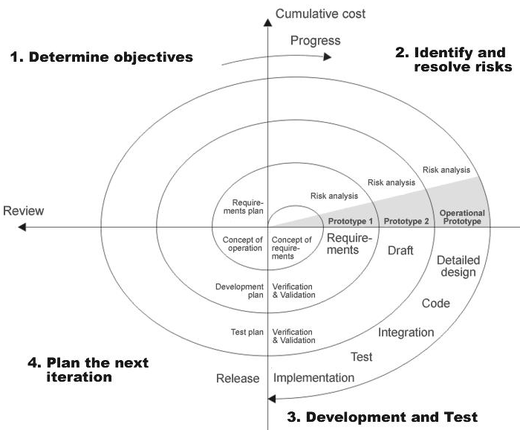

**2.6 Requirement analysis and proposed design**

**2.7 Feasibility studies**

Perform and evaluate feasibility studies like cost-benefit analysis, technical feasibility, time feasibility and operational feasibility for the project. Project Scheduling should be made using PERT charts.

Feasibility study is carried out to decide whether the proposed system is feasible for the company. The feasibility study is to serve as a decision document it must answer three key questions:

* Is there a new and better way to do the job that will benefit the user?
* What are the cost and the savings of the alternative(s)?
* What is recommended?

**I . Technical feasibility:**

Our System will be an online mobile and web based system. Since internet, web browsers and web hosting are easily available, the application will be easy to host and access. Tools and technologies like Sublime, MySQL database, Xampp, are open source so it will not be difficulty in developing the system.

**ii. Economical feasibility:**

Economical Feasibility is the most frequently used method for evaluating the effectiveness of a candidate system. More commonly known as Cost/ Benefit analysis, the procedure is to determine the benefits and savings that are expected from the candidate system and compare them with costs. If the benefits outweigh costs, then the decision is made to design and implement the system.

**iii .Operational Feasibility :**

Our system requires timely update over the extracted data to provide the user with the consistent and reliable information. It is easier to manage. No extra hardware other than a computer is necessary for developing and running the website.

**2.8** **Non- Functional Requirement**

* **Accuracy***:*The data displayed by the website shall be accurate, consistent and timely updated.
* **User Friendly:** The system shall be interactive and easy to use. It shall have nice interface that will attract the students. All the important information about the college shall be easily accessible and clearly visible to the students.
* **Performance:** The system shall be fast. It shall provide all queries of students.

**2.9 Methodology adopted and System implementation:**

* Apache tomcat is used as a web server to host the application.
* All the environment variables are set.
* The application is pasted in the webapps folder.
* Web server is started now.
* Application is run using the web browser by typing http://localhost/project
* Web.xml file is used to control the flow and user actions.

**Chapter III Diagram**

**3.1 Use Case Diagram of System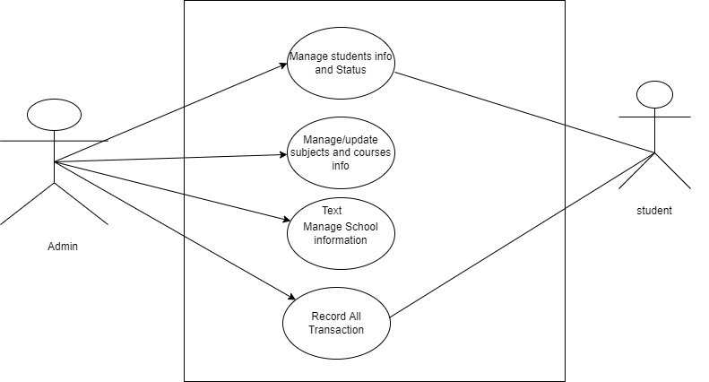3.2 Fig: Data Flow Diagram**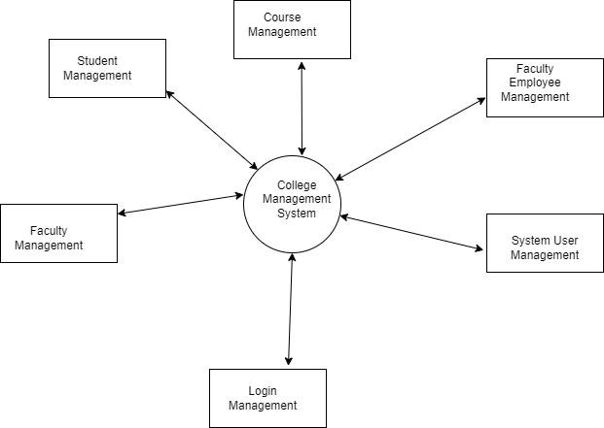

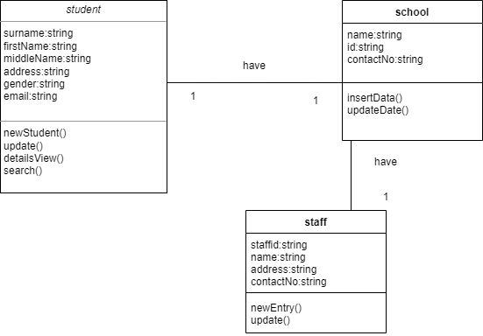

3.3 Fig: Class Diagram

3.4 Fig: Activity Diagram

|  |  |  |  |  |
| --- | --- | --- | --- | --- |
| **Test No.** | **Description** | **Test Data** | **Expected Result** | **Actual Result** |
| 1 | Clicking the login Button with invalid username or password or both. | Username=“ABC”  Password=“ABC” | A message box should display which contains invalid Username and password | pass |
| 2 | Clicking the login Button  Valid username and password | Username=“admin”  Password=“admin” | Redirect to specific Home page to specific user. | pass |

**3.5 Fig: Test Case**

**Chapter IV Discussions and Conclusions**

**4.1 Conclusions**

Our project is only a humble venture to satisfy the needs in an Institution. Several user-friendly  
coding has also adopted. This package shall prove to be a powerful package in satisfying all the  
requirements of the organization. The objective of software planning is to provide a frame work that enables the manger to make reasonable estimates made within a limited time frame at the beginning of the software project and should be updated regularly as the project progresses.

**4.2 References**

[1]. Baba, Y. (n.d.). Retrieved from https://www.yahoobaba.net/php/php-mysqli-fetch-functions

[2]. iyer, m. (n.d.). Retrieved from How To Connect A Signup Form With Database:

https://www.c-sharpcorner.com/Blogs/how-to-connect-a-signup-form-with-database

[3]. sinha, K. (n.d.). Retrieved from Create An HTML Form And Insert Data Into The Database Using PHP: https://www.c-sharpcorner.com/UploadFile/52bd60/create-an-html-form-and-insert-data-into-database162/

[4]. TECHI4YOU. (n.d.). *School Website HTML Tutorial with Project*. Retrieved from https://techi4you.com/f/d/fileTAF

