**InsightStream - News Web Application**

**1. Introduction**

**Project Title: InsightStream – News App**

**Team Members:**

* **Sonashree V (Team Leader)**
* Dheekshitha K
* Lakshitha B
* Sweatha K M
* Jennifer A L

**2. Project Overview**

**Purpose**

InsightStream is a web-based news application designed to deliver real-time news updates from various categories. The project aims to provide users with the latest news articles, enabling seamless navigation and filtering through different news categories.

**Features**

* Trending News Display
* Category-Based Filtering
* Newsletter Subscription
* Clickable News Links Redirecting to Original Source
* Responsive Design

**3. Architecture**

**Component Structure**

* **NavbarComponent.jsx:** Provides navigation across different pages.
* **HeroSection.jsx:** Displays featured news articles.
* **CategoryPage.jsx:** Lists news articles filtered by category.
* **Newsletter.jsx:** Handles newsletter subscription.
* **NewsList.jsx:** Renders news articles dynamically.

**State Management**

Local state is managed using the **useState** hook, while API data is fetched using **Axios**.

**Routing**

Navigation is handled using **React Router DOM** for seamless page transitions.

**4. Setup Instructions**

**Prerequisites**

* Node.js
* Visual Studio Code
* Git

**Installation**

1. Clone the repository:
2. git clone <https://github.com/Sona4suriya/InsightStream_NewsApp.git>
3. Navigate to the project directory:
4. cd InsightStream_NewsApp
5. Install dependencies:
6. npm install
7. Start the application:
8. npm start
9. Access the application at [**http://localhost:3000**](http://localhost:3000/).

**5. Folder Structure**

* **public:** Contains static files and the _redirects file.
* **src**: Main source folder with components, pages, and styles.
* **components**: Reusable React components like Navbar and Newsletter.
* **pages**: Pages containing category-based news rendering.
* **package.json:** Configuration file with project dependencies and scripts.

**6. Running the Application**

To run the application locally, use the command:

npm start

**7. Component Documentation**

**Key Components**

* **NavbarComponent.jsx:** Navigation bar for page switching.
* **HeroSection.jsx:** Displays trending news.
* **CategoryPage.jsx:** Renders filtered news articles.
* **Newsletter.jsx:** Manages email subscription form.

**Reusable Components**

* **NewsList.jsx:** Renders news cards dynamically.

**8. State Management**

**Local State**

State is managed using the **useState** and **useEffect** hooks.

**9. User Interface**

The application is styled using **Bootstrap** and **CSS**, ensuring a responsive layout on both desktop and mobile devices.

**10. Styling**

* **CSS Framework:** Bootstrap
* **Custom Styles:** Plain CSS

**11. Screenshots**

* Home Page

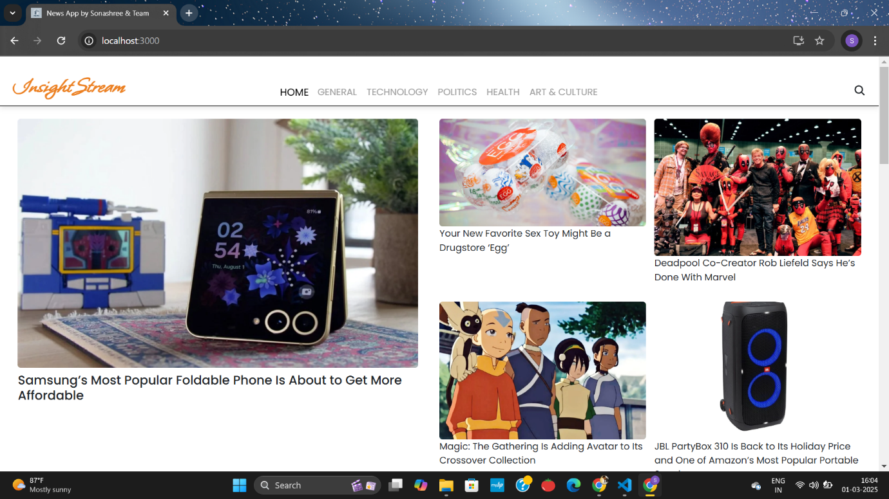

* 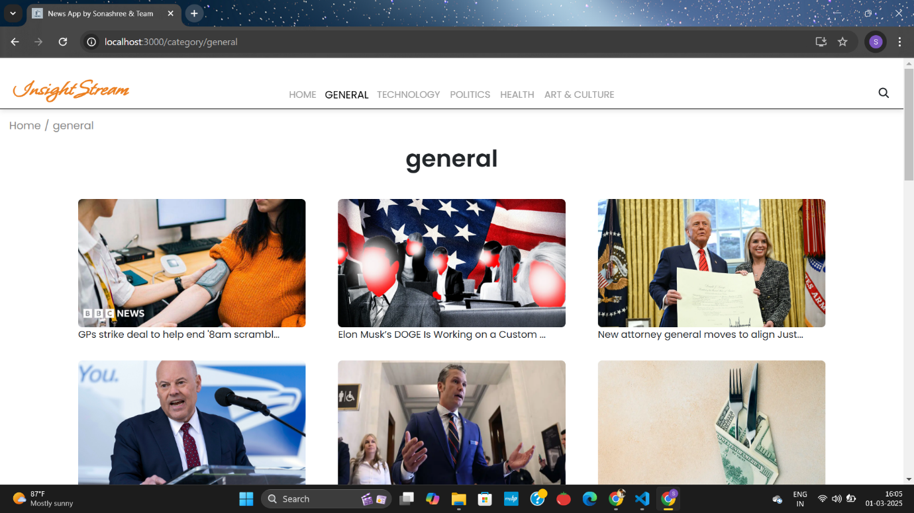Category Page

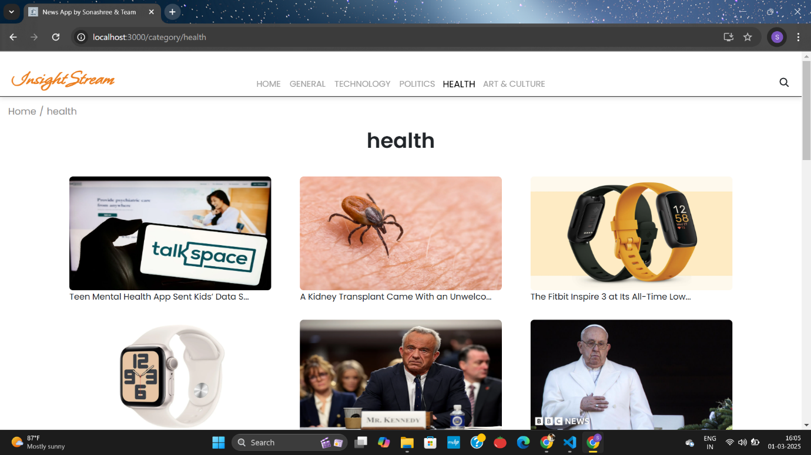

* Newsletter Subscription Page

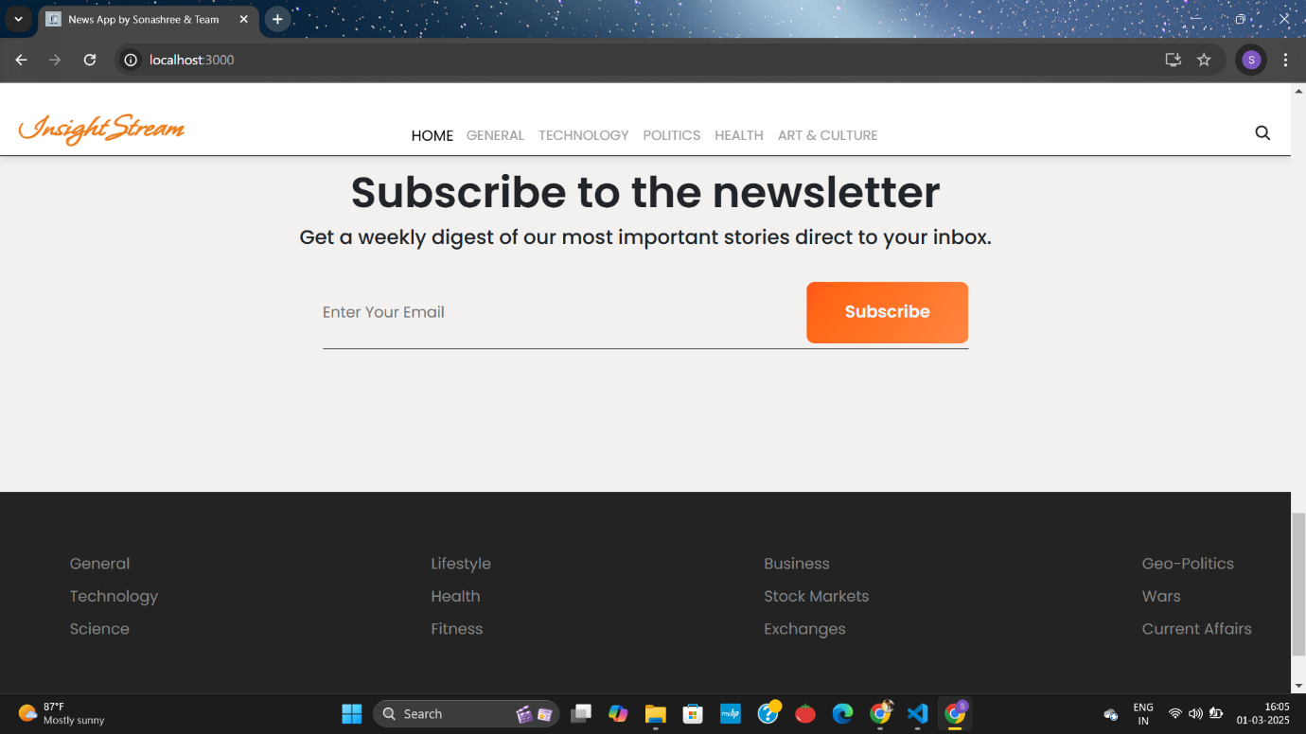

**12. Known Issues**

* News API blocks certain hosting platforms like Netlify.
* Occasional API request failures due to API key limits.

**13. Future Enhancements**

* User Authentication
* Dark Mode
* Multi-Language Support
* Advanced Filtering Options

**14. Acknowledgement**

We would like to express our gratitude to our project guide and institution for their continuous support throughout the project.

**Submitted By:**

* **Sonashree V (Team Leader) – sonaroshan4@gmail.com**
* Dheekshitha K - dheekshithakalidass@gmail.com
* Lakshitha B - lakshithabasker2005@gmail.com
* Sweatha K M - sweathamurugan02@gmail.com
* Jennifer A L - aruleojenni@gmail.com

Date: 02.03.2025