**CONTENT**

|  |  |  |  |
| --- | --- | --- | --- |
| I. | Synopsis | Page | 2 |
| II. | Context diagram | Page | 10 |
| III. | DFD level 1 diagram | Page | 11 |
| IV. | DFD level 2 diagrams | Page | 12 |
| V. | Entity Relationship (ER) diagram | Page | 15 |
| VI. | Use Case diagram | Page | 16 |
| VII. | Use Case description | Page | 17 |
| VIII. | Software Resource Specification(SRS) | Page | 25 |
| IX. | Data dictionary | Page | 32 |
| X. | Code | Page | 35 |
| XI. | Screenshots | Page | 43 |
| XII. | Testing | Page | 45 |

***SYNOPSIS***

***Project Title:***

*CINESHOW: Movie Tickets Booking System*

***Introduction of Project:***

* *“CINESHOW: Movie Ticket Booking System” project is aimed to provide the customer an anytime service for booking the seat in cinema halls and to gather information about the movie. The customer can easily be able to know about the movies released and then make the choice according to their convenience.*
* *In this project, we will illustrate our system by providing Data Flow Diagrams (DFDs), Use Case diagram and description, Entity Relationship diagram, Software Resource Specification (SRS) and Data Dictionary.*
* *Admin can use the system to insert, update and delete data (e.g., movie description, theater information, ticket prices, and user details) that will update the web page.*
* *The project will be designed using MS-Access. The front end will include the forms to be filled by the users according to the modules. The MS-Access database and queries will be used to store the data and information about the movies, theaters and the users.*
* *This project will be useful for both promoters and customers equally. The promoters can promote the movie by displaying the movie in the movie showcase module. The customers can choose their movie according to their choice and with convenience of their choice of seats and timings.*
* *Customers can buy movie tickets and know about new movies released, available seats and cinema locations.*
* *Customers can buy tickets without wasting their time and at affordable prices. This also saves the man power as everything will be computerized.*
* *Cinema owner can inform to customers about new release and discount and also can get feedback from customer. This feedback will be useful for him to make new strategy for business.*
* *The project helps the customer to be updated with all the new movies releases and reviews and help them to choose the show timings, seats, and theater according to their preference.*
* *The project helps the admin to maintain the records of transactions in a convenient manner. Reports about movie, sales, theater, and customer details can be maintained.*
* *The system is divided into two interface layers; first one is Guest Interface (CineShow-GI) and second is Movie Management Interface (CineShow-MMI).*
* *The Guest Interface provides the customer to book tickets of their choice of movie. The Movie Management Interface is for the staff and admin to insert, update and delete the information about the movies and theaters.*
* *The staff and admin have to provide their Username and Password to login so as to access the interface’s permissions accordingly.*
* *The customer has to pay at the counter for which he will be provided with the temporary movie ticket. At the time of procuring the seats in the theater, the customer should carry temporary ticket for confirmation.*

***Objectives of Project:***

*The objective of CINESHOW: Movie Ticket Booking System is to provide anytime service for the customer. It simplifies the task and reduces the paper work. It records the details of all transactions of users. It minimizes the number of staff at the ticket box. It also promotes the film and increases profit. It also provides the admin with the movie report, theater report, booking report and user details information. During implementation, every user will be provided with the training to suit their needs. Specific support will also be provided at the key points. Training will be provided on a timely basis.*

*Some other objectives of CINESHOW: Movie Ticket Booking System are:*

* + *Enhancement:*

*CINESHOW: Movie Ticket Booking System enhances and upgrades the existing system by increasing its efficiency and effectiveness. The software improves the working methods by replacing the existing manual system with the computer-based system.*

* + *Automation:*

*CINESHOW: Movie Ticket Booking System automates each and every activity of the manual system and increases its throughput. Thus, the response time of the system is very less and it works very fast.*

* + *Accuracy:*

*CINESHOW: Movie Ticket Booking System provides the uses a quick response with very accurate information regarding the users etc. Any details or system in an accurate manner, as and when required.*

* + *User-friendliness:*

*The software has a very user-friendly interface. Thus the users will feel very easy to work on it. The software provides accuracy along with a pleasant interface. Make the present manual system more interactive, speedy and user-friendly.*

* + *Availability:*

*The booking reports of the system can be retried as and when required. Thus, there is no delay in the availability of any information, whatever needed, can be captured very quickly and easily.*

* + *Low Cost:*

*Reduce the cost of maintenance as information will be in the structured and formatted way. Therefore, the query will take less time. Every module can be modified independently.*

* *Reusability:*

*The system can be reused in any organization or site of the same group.*

* *Security:*

*Only system admin has the right to access the database important information such as user details. Not every user can access all the information. Each user will be having rights to access the module. Therefore, the security is maintained through data protection.*

*Future Scope of the Project:*

*The project is flexible enough to meet the requirements of the Customers. This project also has the scope of enhancements like:*

* *Home delivery of tickets may be provided.*
* *Online booking of purchases of eatables can be provided.*
* *Online payment for the movie tickets can be provided.*
* *Conference facility can be provided for the corporate meetings in the hall. This will increase the profit of the cinema halls as well as the company organizing event.*
* *Any institute/company can book the tickets for the students/clients and special discount will be provided to them.*

***Input of the Project:***

* *Account Details:*

*The software maintains records of each and every user. Thus, the account details are one of the main inputs. These details include the Username and Password. The information is maintained by the admin to keep the record of each and every customer. This information will be used at the time of user try to login in the system through the login module. The information is stored in the database and fetched from database at the time of login. At the time of login, the data will be fetched from database and matched with the data provided by the user to login.*

* *Movie Details:*

*These details are the most important input of this project. The details of each and every movie will be saved in the database. These details include the information about cast, genre, director name, release date and price of ticket. This information will be stored in the database by the staff members or admin through the movie and theater management module. After login in the system, staff member has to fill every detail about the movie and the theater in which it is being displayed.*

* *Theater Details:*

*These details include theater location, theater name, and number of screens. These details are given by theater owners and imputed by staff members or admin in the project. After login in the system, the staff or admin can fill the above required information about the theater so that it can be displayed in the system. Customer can choose the theater for watching movie after this by accessing the module.*

* *Customer Details:*

*These details include customer’s first name, last name, phone number, email id and password. The phone number will be used as the customer’s username during login procedure. These details are taken to keep the record of all the existing customers of the project. This information can only be accessed by the admin. For the data protection, no other user can access this information. The admin can only keep track of the information and cannot modify the information unless customer has asked for such service.*

***Outputs of the Project:***

* *Temporary Movie Ticket:*

*This is the main outcome of the project. The temporary ticket will be given to the customer after he has made the payment at the counter. The ticket includes all the information about the movie such as movie name, timings, theater name, seat number and price of the ticket. At the time of movie show, the customer should carry this temporary ticket for the conformation otherwise it will not permissible to allow entering the auditorium.*

* *Movie Report:*

*This is another important outcome of the project. A report about the movies will be maintained by the system. This report can only be visible and accessed by the admin of the system. This report helps him to know about the movies released and information about these movies.*

* *Theaters Report:*

*Another report, about theaters, will also be created. This will be on the basis of the information about the information submitted by the staff and admin about theaters. This will help the admin to know which theaters are in collaboration with this system.*

* *Booking Report:*

*Another report is about the transaction made by the users of the system. This report is also accessible by the admin only. The report so formed provides the information about the users and their booking details. This helps the admin to keep track of all the users of the system.*

***CONTEXT DIAGRAM***

# Online Movie Ticket Booking System

Customer Details

Movie Details

Account Details

Booking Report

Temporary Movie Ticket

Theater Statistics Report

Theater Details

Movie Report

***DFD LEVEL 1 DIAGRAM***

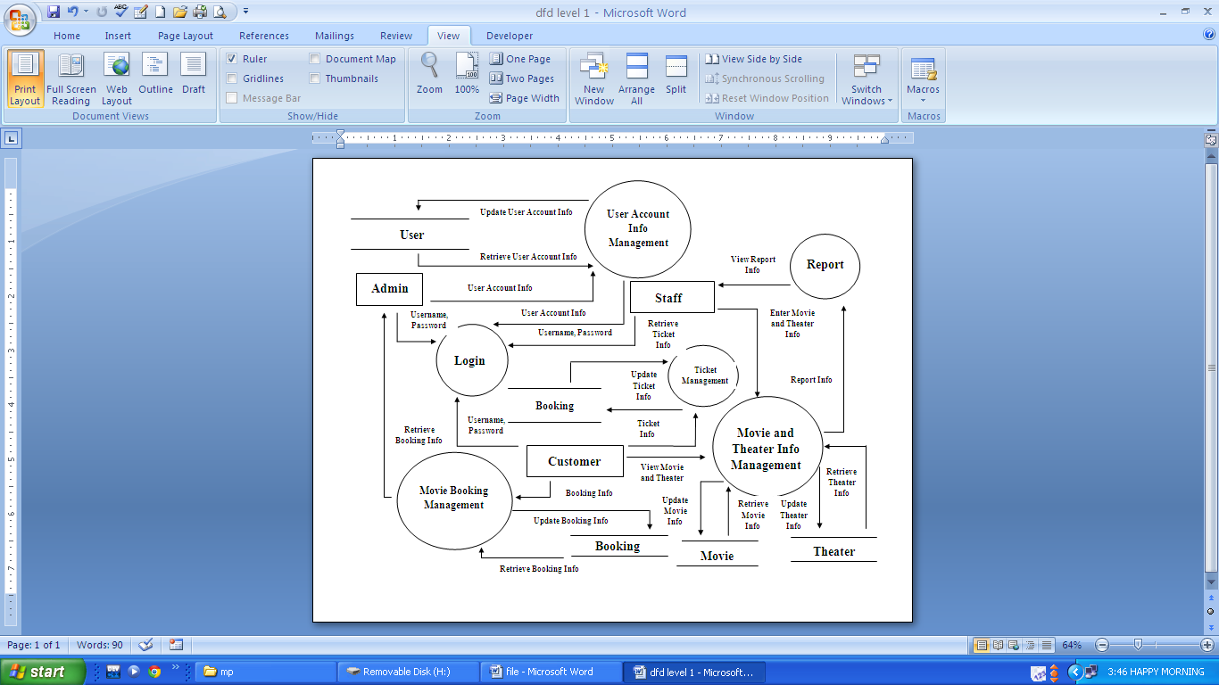

***DFD LEVEL 2 DIAGRAM***

Movie and Theater Management

**Display Theater Info**

**Display Movie Info**

**Validate Process Movie and Theater Management**

**Movie**

**Theater**

**Customer**

**Staff**

Retrieve Theater Info

Retrieve Theater Info

Retrieve Movie Info

Retrieve Movie Info

Enter Movie and Theater Info

Update Theater Info

Update Movie Info

Login

**Login**

**User**

**Admin**

**Staff**

**Customer**

Login Id, Password

Login Id, Password

Login Id, Password

Update/Delete/ Enter User Account Info

Retrieve User Account Info

User Account Info Management

**Validate User Account Info Management**

**Display User Account Info**

**Admin**

**User Account Info Details**

View User Account Info

Enter User Account Info

Retrieve User Account Info

Update User Account Info

**Display Ticket Info**

**Validate Ticket Management Process**

**Movie Details**

**Theater Details**

**Ticket Details**

**Display Movie Info**

**Display Theater Info**

**Customer**

View Ticket Info

View Movie Info

View Theater Info

Retrieve Ticket Info

Retrieve Movie Info

Retrieve Theater Info

Update Movie Info

Retrieve Movie Info

Retrieve Ticket Info

Retrieve Theater Info

Update Theater Info

Update Ticket Info

Ticket Management

***ENTITY RELATIONSHIP DIAGRAM***

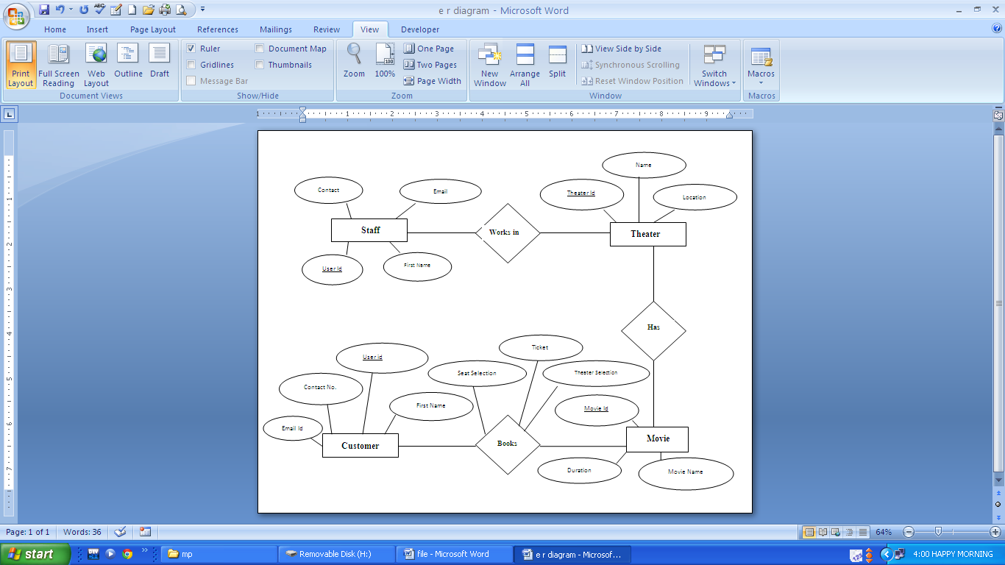

***USE CASE DIAGRAM***

**Admin**

**Staff**

**Customer**

User Account Info Management

Login

Book Movie Ticket

Customer Info Management

Report Generation

Ticket Generation Management

Movie and Theater Info Management

Customer Info Entry

View Movie and Theater Info

***USE CASE DESCRIPTION***

1. **Login:**
   1. Brief Description:

This use case describes how a user logs into the CINESHOW: Movie Ticket Booking System.

* 1. Actors:

The following actors interact and participate in this use case:

* Admin
* Staff
* Customer
  1. Flow of Events:
* Basic Flow:

This use case starts when the actor wishes to Login to the CINESHOW: Movie Ticket Booking System. The system requested that the actor enters his/her contact no. as username and password. As the actor enters his/her username and password, this system validates the entered details and logs the actor into the system.

* Alternative Flow:

Invalid Name/Password/Role

If in the Basic Flow, the actor enters the invalid details, the system displays an error message. The actor can chose to either return to the beginning of the Basic Flow or cancel the login, at which the use case ends.

* 1. Pre-condition:

All the users must have a User Account (i.e. Username and Password) created for them in the system, prior to executing the use cases.

* 1. Post-condition:

If the use case was successful, the actor is logged on the system. If not, the system state is unchanged. If the actor has the role of “Admin” he/she will have access to screens corresponding to all the User Account Management modules. If he/she has the role of “Staff” or “Customer” he/she can access to screens corresponding to Show Management modules of the system.

* 1. Special Requirements:

None

* 1. Extension Points:

None

1. **Movie and Theater Info Management:**
   1. Brief Description:

This use case allows the actor with the role ‘Staff’ and ‘Admin’ to maintain the movie showcasing details. This includes adding, changing and deleting movie details from the system.

* 1. Actors:

The actor with role ‘Staff’ and ‘Admin’ interacts and participates in this use case.

* 1. Flow of Events:
* Basic Flow:

This use case starts when the Staff or Admin wishes to add, change and delete the movie details from the system. Once the Staff or Admin provides the requested information, one of the sub-flows is executed:

* + - If the Staff or Admin selected ‘Add/Edit/Delete Movie Details’, the required sub-flow is executed.
    - If the Staff or Admin selected ‘Add/Edit/Delete Theater Details’, the required sub-flow is executed.

1. Add/Edit/Delete Movie Details’:
   1. Add a movie:

This system requests the Staff or Admin to enter the movie information. This includes the following attributes of the movie:

* Name
* Genre
* Ticket prices
* Release date
* Director Name
* Duration
* Certification

Once the Staff or Admin provides the requested information, the movie details are added to the system and an appropriate message is displayed.

* 1. Update a movie:

This system requests the Staff or Admin to enter the movie name. The Staff or Admin enters the movie name. The system retrieves and displays the movie information. The Staff makes the desired changes to the movie details.

Once the Staff updates the necessary information, the system updates the movie info and show details database with update information.

* 1. Delete a movie:

This system requests the Staff or Admin to enter the movie name. The Staff or Admin enters the movie name. The system deletes the movie records.

* Alternative Flow:
  + Movie not found:

If in the update a movie or delete a movie sub-flows, a movie with specified name does not exist, and the system displays an error message. The Staff or Admin can enter a different movie name or cancel the operation, at which point the use case ends.

* + Update cancelled:

If in update sub-flow, the Staff or Admin decides not to update the movie information, the update is cancelled and the basic flow is restarted at the beginning.

* + Delete cancelled:

If in the delete sub-flow, the Staff or Admin decides not to update the movie information, the update is cancelled and the basic flow is restarted at the beginning.

1. Add/Edit/Delete Theater Details’:
   1. Add a movie:

This system requests the Staff or Admin to enter the theater information. This includes the following attributes of the theater:

* Name
* No Of Screens
* Street Address
* City
* State
* Zipcode

Once the Staff or Admin provides the requested information, the theater details are added to the system and an appropriate message is displayed.

* 1. Update a theater:

This system requests the Staff or Admin to enter the theater name. The Staff or Admin enters the theater name. The system retrieves and displays the theater information. The Staff makes the desired changes to the theater details.

Once the Staff updates the necessary information, the system updates the theater info and show details database with update information.

* 1. Delete a theater:

This system requests the Staff or Admin to enter the theater name. The Staff or Admin enters the theater name. The system deletes the theater records.

* Alternative Flow:
  + Movie not found:

If in the update a theater or delete a theater sub-flows, a theater with specified name does not exist, and the system displays an error message. The Staff or Admin can enter a different movie name or cancel the operation, at which point the use case ends.

* + Update cancelled:

If in update sub-flow, the Staff or Admin decides not to update the theater information, the update is cancelled and the basic flow is restarted at the beginning.

* + Delete cancelled:

If in the delete sub-flow, the Staff or Admin decides not to update the theater information, the update is cancelled and the basic flow is restarted at the beginning.

* 1. Pre-condition:

The Staff or Admin must log onto the system before this use case begins.

* 1. Post-condition:

If the use case was successful, the movie information is added, update, or deleted from the system. Otherwise, the state is unchanged.

* 1. Special Requirements:

None

* 1. Extension Points:

None

1. **Customer Info Management:**
   1. Brief Description:

This use case describes how a customer can create and manage his online account. This allows customer to access the movie and theater details and to book a movie ticket online.

* 1. Actors:

The actor with role of ‘Customer’ interacts and participates in this use case.

* 1. Flow of Events:
* Basic Flow:
  + Create an account:

This system requests the Customer to enter the following information on the website’s Create New Login option on the Login Page. This includes the following:

* + - Account Name
    - Email Id
    - Date of Birth
    - Password
    - Confirm Password
    - A checkbox to agree all the terms and condition

Once the customer provides the requested information, the customer details are added to the system and an afresh account webpage opens.

* + Manage the account:

This system requests the customer to enter the following information on the website’s Exiting Login option on the Login page when he wishes to change the password of his/her login id. This includes the following:

* + - Account Name
    - Password

Once the customer provides the requested information, his/her account page opens.

The customer can change the password of his/her account if he/she wants. The customer enters his account id, current password and the new password and clicks confirm change. The success message is displayed henceforth.

The customer can also retrieve his/her password if in case, he has forgotten it. While logging in the account, he/she clicks forgot password. A new screen appears which makes the customer enter his/her email id and user account name. Once the customer supplies with the above information a success message is displayed henceforth and an email is sent to the mentioned email id which contains the password.

* + Delete an account:

This system requests the customer to enter the following information on the websites Exiting Login option on the Login page when he wishes to delete his/her login id. This includes the following:

* + - Account Name
    - Password

Once the customer provides the requested information, his account page opens. The customer clicks on delete user account. The system prompts the customer to confirm the deletion of the account. The customer confirms the deletion. The system deletes the account.

* Alternative Flow:

Invalid Account Name/Password

If in the Basic Flow, the actor enters an invalid name, password and/or role, the system displays an error message. The actor can choose to either return to the beginning of the Basic Flow or cancel the login, at which the use case ends.

* + Account creation process cancellation:

If in the account creation sub-flow, the customer decides not to create the account, the process is cancelled and the basic flow is restarted at the beginning.

* + Account managing process cancellation:

If in the account managing sub-flow, the customer decides not to change the password of the account, the process is cancelled and the basic flow is restarted at the beginning.

* + Account deletion process cancellation

If in the account deletion sub-flow, the customer (on request) decides not to delete the account, the process is cancelled and the basic flow is restarted at the beginning.

* 1. Pre-condition:

The user must know the cinema website.

* 1. Post-condition:

If the use case was successful, the account is created and managed well.

* 1. Special Requirements:

None

* 1. Extension Points:

None

1. **User Account Info Management:**
   1. Brief Description:

This use case describes how Admin can manage the accounts of all the users.

* 1. Actors:

The actor with role of ‘Admin’ interacts and participates in this use case.

* 1. Flow of Events:
* Basic Flow:

This use case starts when the Admin wishes to manage the accounts of all the users. The system requested the Admin to enter his/her name and password. The Admin enters his/her name and password. This system validates the entered name and logs the actor into the system. The system allows the Admin to view and keep a track of the users.

* Alternative Flow:

Invalid Account Name/Password

If in the Basic Flow, the Admin enters an invalid name and/or password, the system displays an error message. The Admin can choose to either return to the beginning of the Basic Flow or cancel the login, at which the use case ends.

* 1. Pre-condition:

The Admin must know the cinema website.

* 1. Post-condition:

If the use case was successful, the Admin can view the details of all the users.

* 1. Special Requirements:

None

* 1. Extension Points:

None

**V. REPORT GENERATION**

1. Brief description:

This use case documents the procedure for generating the reports as desired by the Admin.

1. Actors:

The actor with role of ‘Admin interacts and participates in this use case.

1. Flow of Events:
   * Basic Flow:

This use case starts when a Admin wants to generate reports of movie statistics, theater statistics, and member details.

* The Staff selects the criteria and enters the various parameters based on the criteria selected.
* The system generates the report and sends to the printer.
* The use case ends.
* Alternative Flow:

Printer out of paper or low on ink:

If the printer goes out of paper or low on ink, then the printing operation is aborted and the necessary action needs to be taken. The use case ends.

1. Pre-condition:

Admin must be logged into the system.

1. Post-condition:

If the use case is successful, the various reports, regarding the details of the movie, theater and members at any time, are generated.

1. Special Requirements:

None

1. Extension Points:

None

***SOFTWARE REQUIREMENT***

***SPECIFICATION (SRS)***

* ***Introduction:***
  + **Purpose:**

This Software Requirements Specification (SRS) will provide detail description of requirements for CINESHOW: Movie Booking System. This SRS helps end users, project managers and software engineers to have clear understanding of the CINESHOW and its functionality that allows correct software to be developed. This SRS provides the foundation for the CINESHOW project. From this SRS, the system will be developed and tested.

This SRS will be used by software engineers as guideline to develop the MBS. End users and project managers will be able to see if the software engineer will be developing the system according to their requirements. If not according to their expectation, end users and project managers can specify how to change the relevant requirements to conform to their expectations and software engineer will change this SRS to conform to the end users and project managers need.

* + **Document Conventions:**

The following are the list of conventions and acronym used in this document and the project.

* + - **Customer:** customer who have created an account.
    - **Interface**: something used to communicate across different mediums
    - **CINESHOW**: Movie Booking System
    - **CINESHOW-MMI**: Movie Management Interface
    - **CINESHOW-GI**: Guest Interface
    - **SRS**: Software Requirements Specification
    - **User**: User of the system such as customer, counter clerk, branch manager, branch supervisor, visitor, head office personnel and credit unit personnel. Anyone who interact with the system using the user interface layer.
    - **Use Case**: A broad level diagram of the project showing basis overview.
  + **Intended Audience and Reading Suggestions**

The intended audience for this document is as follows:

* + - End users
    - Project managers

This document would be reviewed frequently by the above audiences to check if the project follows the requirements.

Any changes to requirements during the project will be updated in this document by making necessary changes.

* + **Project Scope:**

The software product to be produced is the CINESHOW: Movie Booking System which will provide movie booking system to customers to purchase the movie ticket easily.

CINESHOW will have two user interface layers, first one is Guest Interface (CINESHOW-GI) and second one is Movie Management Interface (CINESHOW-MMI).

Customer can book the movie ticket from website which is actually Guest Interface (CINESHOW -GI). CINESHOW -GI will have function for visitor to view movie details and search movies.

CINESHOW system shall at the counter in cash.

To automate the process staff will update and maintain the CINESHOW using Movie Management Interface (MMI).

CINESHOW -MMI will have the following functions and modules in the system.

* + - Login function
    - Add Staff module
    - Reservation module
    - Ticket module
    - Movie module
    - Report module

Access to the module determined by staff account type. Managing the CINESHOW via Movie Management Interface (CINESHOW -MMI), provide facility for customer to book movie ticket.

* + **References:**
    - http:\\www.uml-diagrams.org
    - http:\\argouml.tigris.org/
    - http:\\www.agilemodeling.com/artifacts/useCaseDiagram.htm
* ***Overall Description:***

This SRS is organized into two main sections. The first is The Overall Description and the second is the Specific Requirements. The Overall Description will describe the requirements of the CINESHOW from a general high level perspective. The Specific Requirements section will describe in detail the requirements of the system.

* + **Product Perspective:**

The CINESHOW is an independent standalone system. It is totally self-contained.

* + **Product Function:**

CINESHOW will have two user interface layers, first one is Guest Interface (CINESHOW -GI) and the second one is Movie Management Interface (CINESHOW -MMI).

* **Guest Interface (CINESHOW -GI):**

Guest Interface (CINESHOW -GI) will have the following functions

* + Reservation Module:

Allows visitors to book movie ticket

* + Create Account:

Allows customer to create account

* + Customer Login:

Enable customer to login the system.

* Movie Management Interface (CINESHOW -MMI):

Movie Management Interface (CINESHOW -MMI) is used to update and maintain the CINESHOW by staff. It will have its own URL which only known by staff and they could access the website securely through the interface.

Movie Management Interface (CINESHOW -MMI) will have the following functions and modules in the system.

* + Login Function:

Provides access to CINESHOW -MMI

* + Staff Modules:

Allows new staff data to be added, updated, deleted, and searched. It is accessible by the system admin only.

* + Reservation Module:

Allows staff to reserve and issue the movie tickets.

* + Ticket Module:

Allow staff to issue the movie ticket. It is accessible by the staff only.

* + Movie Module:

Allows new movie data to be added, updated, deleted and searched. It is accessible by admin only.

* + **Report Module:**

Provides the following reports to the respective user.

* + - Movie Report (Only accessible by Admin)
    - Booking Report (Only accessible by Admin)
    - Theater Report (Only accessible by Admin)

Access to the modules is determined by staff account type. Types of account type are as follows:

* Staff
* System Admin

By managing the CINESHOW via Movie Management Interface (CINESHOW -MMI), CINESHOW provides facility for customers to book movie ticket. Customer can CINESHOW the movie ticket from Guest Interface (CINESHOW -GI).

* **User Characteristics:**
  + Educational level of CINESHOW – Low
  + Experience of using CINESHOW – Low
  + Technical Expertise – Low
* **User Documentation:**

List of documents that shall be delivered with CINESHOW

* User Manual
* Online Help
* System Maintenance Documentation.
  + **Assumptions and Dependencies:**

No assumption and dependencies.

* ***System Requirements:***

This section contains all the software requirements at a very detail level, combined with the use case diagram, use case description and the sequence diagram will enable software engineers to design the CINESHOW according to end users requirements, and test engineers to test the system.

* + **Functional Requirements**

Functional requirements define the fundamental actions that system must perform. CINESHOW: Movie booking system could be dividing into two interfaces that work together seamlessly.

The first interface is only accessible to the customers and visitors called Guest Interface (CINESHOW -GI). And the second interface is only accessible by staff called Movie Management Interface (CINESHOW -MMI)

* + - **Guest Interface (**CINESHOW **-GI) Functional Requirements**

Guest Interface (CINESHOW -GI) will have the following functional requirements.

* Reserve Movie Ticket
  + The system shall enable customer or visitor to reserve the movie ticket from the view list of movies and at the theater of their choice.
* Create Account
  + The system shall function to create account. The system shall record all the following data from the customer, except for the optional fields, all other data is mandatory.

 a) Password

 b) Password Confirmation.

 c) First Name

 d) Last Name

 e) Contact Number

 f) Email Id

* Customer Login
  + The system shall have customer login function. Once activated, customer can login using contact no. as username and password.
  + The system shall have password recovery function through the username.
* Book Movie
  + The system shall enable customer to book the movie ticket from Guest Interface (CINESHOW -GI).
  + The system shall display list of movies showcased at each venue.
  + The system shall display for each movie at the venue the following details

 a) Release Date

 b) Duration

 c) Price

* The system shall allow customer who have login only to continue to book the ticket. If customer haven't login, prompt customer to login or create an account. Then only customer can continue.
* Once login, the system shall record the following details in (Booking Screen).
* The system shall record the seats selected by the customer.
* The system shall display thank you (Thank You Screen) message for the booking.
* Customer can pay at the counter in cash.
* **Movie Management Interface (CINESHOW-MMI) Functional Requirements**

Only staff and admin can access Movie Management Interface (CINESHOW -MMI).

The Movie Management Interface (CINESHOW -MMI) is divided into nine main module: Staff Module, Reservation Module, Ticketing Module, Movie Module and Report Module.

Permission to each module depends on staff account type.

The functional requirements of Movie Management Interface (CINESHOW -MMI) are as follows:

* + Login Function
    - The system shall allow only staff with staff username and password to access the system.
    - Access to the modules determined by account type.
  + Staff Module
    - The system shall allow system administrator only to access this module. System administrator shall login first to access this module.
    - The system shall allow the system administrator to add staff.
    - The system shall record all the following details, except the optional fields.

 a) Password

 b) Email Id

 c) First Name

 d) Last Name

 e) Contact Number

* The system shall provide permission to the modules for each staff based on Account Type.
* The system shall have search function.
* Reservation Module
  + The system shall allow staff to access the module. They shall to login first to access this module.
  + The system shall display list of movies showcased.
* The system shall allow the staff to book the seats for the customer.
* The system shall display the total amount to be paid per transaction.
* The system shall allow the staff to print the movie ticket.
* Ticket Module.
  + The system shall allow staff to access the module. They shall to login first to access this module.
  + The system shall allow staff to search the movie reservation by using the confirmation number.
  + The system shall allow the staff to print movie ticket for valid confirmation number.
  + The system shall report invalid confirmation number.
* Movie Module.
  + The system shall allow admin only to add and update new movie details in the system. Admin or Staff shall login first to access this module
  + The system shall record the following details for each movies.

 a) Movie Name

b) Movie Duration

 c) Movie Genre

 d) Movie Director

e) Movie Release Date

 g) Movie Ticket Price

* The system shall have search function to find the movie record using the Movie Title
* Report Module.
  + The system shall generate report based account types.
  + The system shall generate the following reports. Admin shall login first to access the reports.

 a) Movie Report

 b) Booking Report

c) Theater Report

* ***External Interface Requirements:***
  + **User Interfaces:**

Keyboard, mouse and printer.

* **Hardware Interfaces**
* **Processor :** Intel Chipset
* **Memory :** 192GB
* **Hard Drive Capacity :** 750GB, expandable
* **Operating System :** Window XP
* **Software Interfaces**

Database

* MS-Access.
* ***Performance Requirements:***
* The system response time must be less than 10 seconds for both CINESHOW-GI and CINESHOW -MMI.
* The system must process the number of transaction based on the following calculation method.
  + **Reliability Requirement**

CINESHOW system shall have a minimum uptime of 99 % excluding time pre-scheduled for maintenance and/or upgrades.

* + **Safety Requirements**

All system data must be backed up every 24 hours and the backup copies stored in another server at different building or location for disaster recovery.

* + **Security Requirements**

All access permission for the system data may only be changed by the system's administrator.

* + **Design Constraint**

The MBS system shall be developed using MS-Access.

***DATA DICTIONARY***

|  |  |  |  |  |  |
| --- | --- | --- | --- | --- | --- |
| **S. No.** | **Name of Data Item** | **Alias Name** | **Description** | **Related to other Items** | **Range** |
| 1. | Administrator | Admin | User who keeps track of and manages user account | None | None |
| 2. | Staff | None | User who keeps track of and manages movie and show details | None | None |
| 3. | Customer | None | User who selects movie and show details for booking | None | None |
| 4. | Login | None | Process that takes login id and password as inputs required for verification | Related to user table | None |
| 5. | Password | None | Data Item required for validation and verification | None | 8-10 alphanumeric characters |
| 6. | Movie | None | Refers to the name of the movie | None | None |
| 7. | Theater | None | Refers to the name of the theater | None | None |
| 9. | User Information | User Info | Account details of the staff members and customer | Related to user table | Alphanumeric character |
| 10. | Number of Seats | None | Number of seats selected by the customer | None | 2 digits |
| **S. No.** | **Name of Data Items** | **Alias Name** | **Description** | **Related to other Items** | **Range** |
| 11. | Contact Number | None | Refers to the mobile number of the customer so that a confirmation message can be sent regarding booking of the show | None | 10 digits |
| 12. | Show Date | None | Refers to Date of the movie show | None | 2 digits, 3 characters |
| 13. | Ticket | None | It’s the hard copy given to the customer on booking as entry to the cinema hall | Related to ticket management process | None |
| 14. | Seat Price | None | Refers to Cost of the ticket for the selected class | None | 3 digits |
| 15. | Show Timings | None | Refers to the show timings of a particular movie show | None | 4 digits, 2 characters and : |
| 16. | User Account | None | Data Item that Keeps track of user login | Related to user account management process | None |
| 17. | Ticket Information | Ticket Info | Details of the ticket given to customer | Related to ticket management process | Alphanumeric character |

# *CODE*

# I. LOGIN:

Private Sub forget_Click()

DoCmd.OpenForm ("forget_password")

DoCmd.Close acForm, "login", acSaveYes

End Sub

Private Sub home_Click()

DoCmd.OpenForm ("cineshow")

DoCmd.Close acForm, "login", acSaveYes

End Sub

Private Sub login_Click()

Dim str As Variant

str = DLookup("[s_type]", "user", "[contact]=contact.Value AND [password]=password.Value")

If IsNull(str) Then

MsgBox "Incorrect Username or Password"

Forms!login!contact.Value = ""

Forms!login!password.Value = ""

ElseIf str = "Admin" Then

DoCmd.OpenForm ("cchoose")

Forms!cchoose!stype.Value = "admin"

Forms!cchoose!phone.Value = contact.Value

DoCmd.Close acForm, "login", acSaveYes

ElseIf str = "Staff" Then

DoCmd.OpenForm ("choose1")

Forms!choose1!stype.Value = "staff"

Forms!choose1!phone.Value = contact.Value

DoCmd.Close acForm, "login", acSaveYes

Else

DoCmd.OpenForm ("movie_choose")

Forms!movie_choose!s_type.Value = "customer"

Forms!movie_choose!sphone.Value = contact.Value

DoCmd.Close acForm, "login", acSaveYes

End If

End Sub

Private Sub Refresh_Click()

Forms!login!contact.Value = ""

Forms!login!password.Value = ""

End Sub

Private Sub signup_Click()

DoCmd.OpenForm ("registeration_form")

DoCmd.Close acForm, "login", acSaveYes

End Sub

**II. REGISTERATION FORM:**

Private Sub back_Click()

DoCmd.OpenForm ("login")

DoCmd.Close acForm, "registeration_form", acSaveYes

End Sub

Private Sub Refresh_Click()

Forms!registeration_form!first_name.Value = ""

Forms!registeration_form!last_name.Value = ""

Forms!registeration_form!password.Value = ""

Forms!registeration_form!contact.Value = ""

Forms!registeration_form!email.Value = ""

End Sub

Private Sub Submit_Click()

Dim str As Variant

str = DCount("[contact]", "user", "[contact]=contact.Value")

If str = 0 Then

If Forms!registeration_form!password.Value = Forms!registeration_form!confirm.Value Then

DoCmd.RunSQL ("INSERT INTO [user]([first_name], [last_name], [password], [contact], [email], [s_type]) VALUES(first_name.value, last_name.value, password.value, contact.value, email.value, 'Customer')")

DoCmd.OpenForm ("movie_choose")

DoCmd.Close acForm, "registeration_form", acSaveYes

Else

MsgBox "Password Don't Match"

Forms!registeration_form!password.Value = ""

Forms!registeration_form!confirm.Value = ""

End If

Else

MsgBox "Phone No. Not Available. Please provide another no."

Forms!registeration_form!contact.Value = ""

End If

End Sub

* + - 1. **MOVIE BOOKING FORM:**

Private Sub back_Click()

If Forms!movie_choose!s_type = "admin" Then

DoCmd.OpenForm ("cchoose")

Forms!cchoose!stype.Value = Forms!movie_choose!s_type.Value

Forms!cchoose!phone.Value = Forms!movie_choose!sphone.Value

ElseIf Forms!movie_choose!s_type = "staff" Then

DoCmd.OpenForm ("choose1")

Forms!choose1!stype.Value = Forms!movie_choose!s_type.Value

Forms!choose1!phone.Value = Forms!movie_choose!sphone.Value

Else

DoCmd.OpenForm ("login")

End If

DoCmd.Close acForm, "movie_choose", acSaveYes

End Sub

Private Sub Refresh_Click()

Forms!movie_choose!movie_name.Value = ""

Forms!movie_choose!theater_name.Value = ""

Forms!movie_choose!show_date.Value = ""

Forms!movie_choose!show_timing.Value = ""

End Sub

Private Sub Submit_Click()

Dim str As Variant

Dim str1 As Variant

Dim str2 As Variant

Dim sstr As String

Dim sstr1 As String

Dim price As String

str = DLookup("[movie_id]", "movie", "[movie_name]=movie_name.Value")

str1 = DLookup("[user_id]", "user", "[contact]=sphone.Value")

str2 = DLookup("[movie_price]", "movie", "[movie_name]=movie_name.Value")

sstr = CStr(str)

sstr1 = CStr(str1)

price = str2 * no_of_seats.Value

DoCmd.RunSQL ("INSERT INTO [booking] ([movie_id],[user_id],[no_of_seats],[seat_no],[s_date],[s_time],[price]) VALUES(" & sstr & "," & sstr1 & ",no_of_seats.Value,seat_no.Value,s_date.Value,s_time.Value," & CStr(price) & ")")

DoCmd.OpenForm ("thank_u")

Forms!thank_u!stype.Value = Forms!movie_choose!s_type.Value

Forms!thank_u!phone.Value = Forms!movie_choose!sphone.Value

DoCmd.Close acForm, "movie_choose", acSaveYes

End Sub

* + - 1. **THANK YOU FORM:**

Private Sub back_Click()

If Forms!thank_u!stype = "admin" Then

DoCmd.OpenForm ("cchoose")

Forms!cchoose!stype.Value = Forms!thank_u!stype.Value

Forms!cchoose!phone.Value = Forms!thank_u!phone.Value

ElseIf Forms!thank_u!stype = "staff" Then

DoCmd.OpenForm ("choose1")

Forms!choose1!stype.Value = Forms!thank_u!stype.Value

Forms!choose1!phone.Value = Forms!thank_u!phone.Value

Else

DoCmd.OpenForm ("login")

End If

DoCmd.Close acForm, "thank_u", acSaveYes

End Sub

Private Sub logout_Click()

DoCmd.OpenForm ("login")

DoCmd.Close acForm, "thank_u", acSaveYes

End Sub

Private Sub more_Click()

DoCmd.OpenForm ("movie_choose")

Forms!movie_choose!s_type.Value = Forms!thank_u!stype.Value

Forms!movie_choose!sphone.Value = Forms!thank_u!phone.Value

DoCmd.Close acForm, "thank_u", acSaveYes

End Sub

* + - 1. **ADD MOVIE FORM:**

Private Sub back_Click()

DoCmd.OpenForm ("movie")

Forms!movie!s_type.Value = Forms!movie_add!s_type.Value

Forms!movie!sphone.Value = Forms!movie_add!sphone.Value

DoCmd.Close acForm, "movie_add", acSaveYes

End Sub

Private Sub Refresh_Click()

Forms!movie_add!movie_name.Value = ""

Forms!movie_add!movie_price.Value = ""

Forms!movie_add!movie_duration.Value = ""

Forms!movie_add!genre.Value = ""

Forms!movie_add!certification.Value = "--Select--"

Forms!movie_add!director_name.Value = ""

End Sub

Private Sub Submit_Click()

Dim str As String

If Forms!movie_add!certification.Value = "--Select--" Then

str = ""

Else

str = Forms!movie_add!certification.Value

End If

DoCmd.RunSQL ("INSERT INTO [movie]([movie_name],[movie_price],[movie_duration],[genre],[certification],[director_name]) VALUES(movie_name.value,movie_price.value,movie_duration.value,genre.value," & str & ",director_name.value)")

Forms!movie_add!movie_name.Value = ""

Forms!movie_add!movie_price.Value = ""

Forms!movie_add!movie_duration.Value = ""

Forms!movie_add!genre.Value = ""

Forms!movie_add!certification.Value = "--Select--"

Forms!movie_add!director_name.Value = ""

End Sub

# *SCREENSHOTS*

# LOGIN:

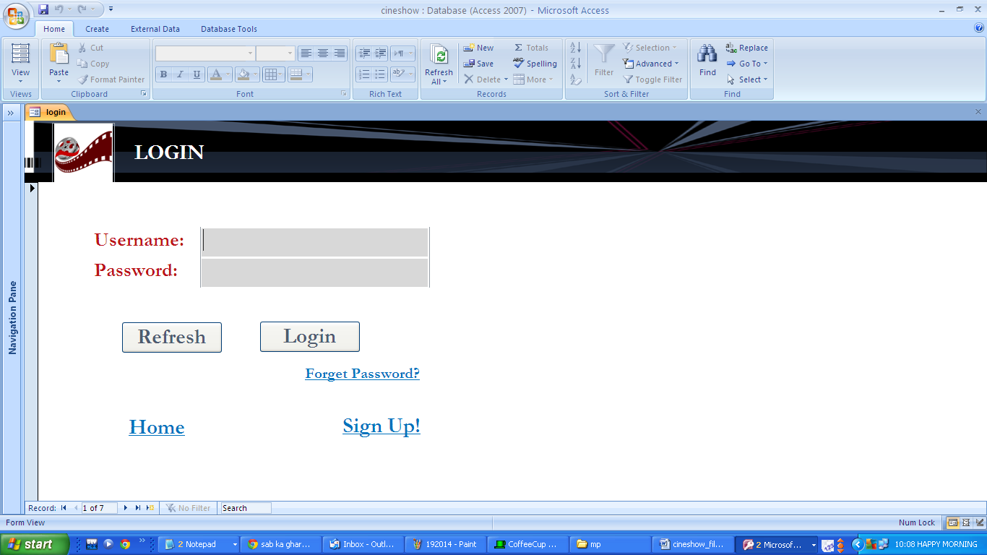

* + - 1. **REGISTERATION FORM:**

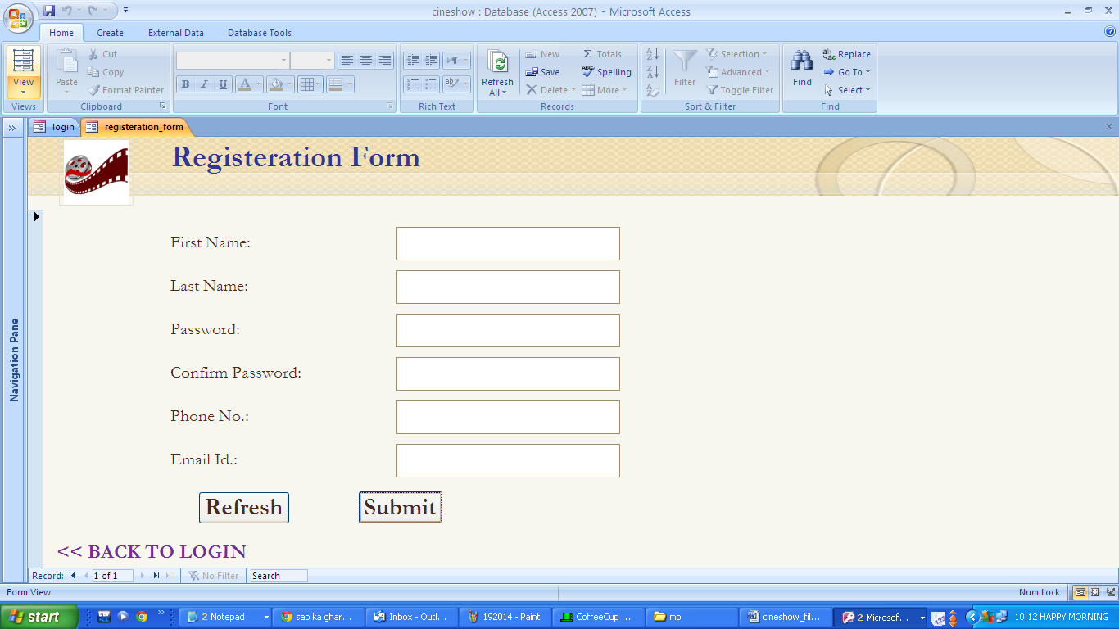

* + - 1. **MOVIE BOOKING FORM:**

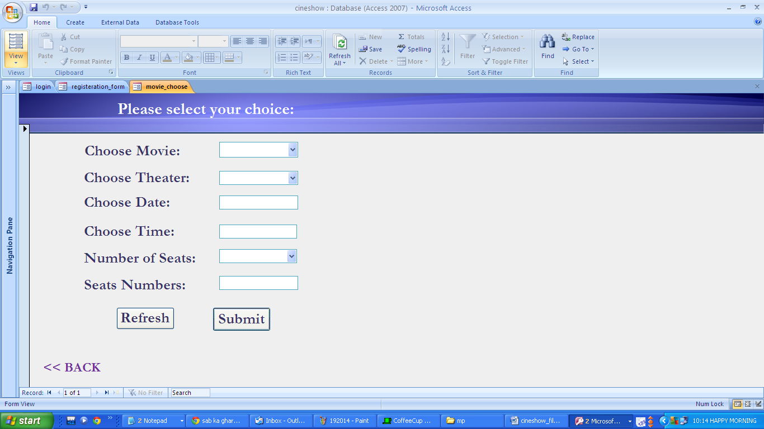

* + - 1. **THANK YOU FORM:**

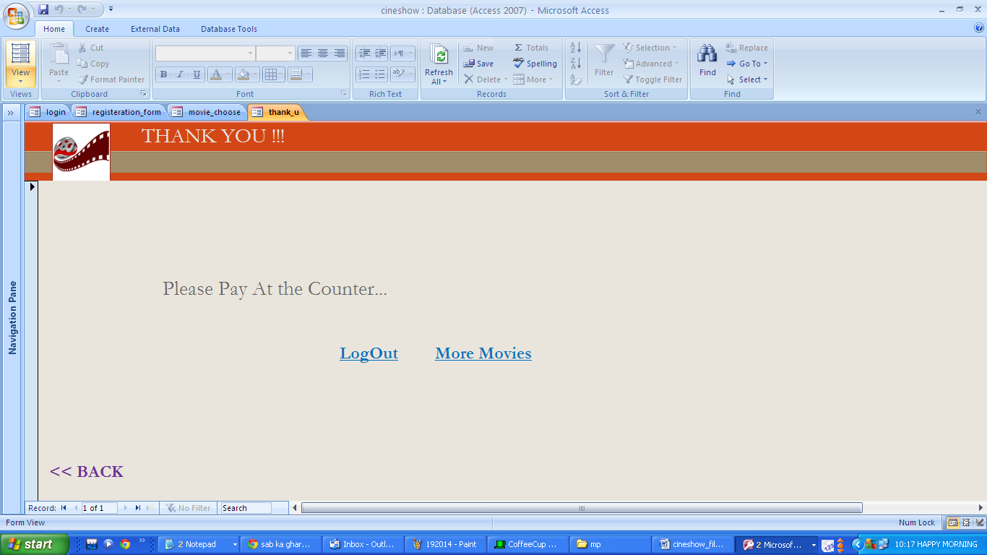

* + - 1. **ADD MOVIE FORM:**

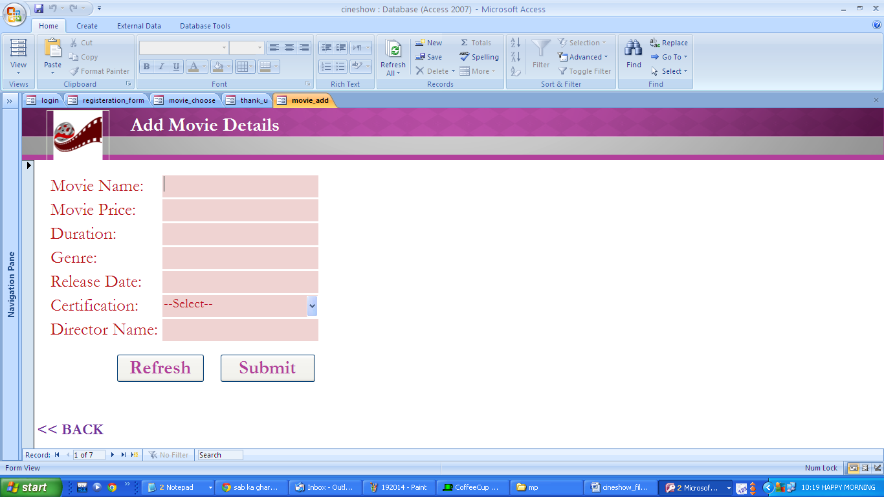

* + - 1. **TEMPORARY MOVIE TICKET:**

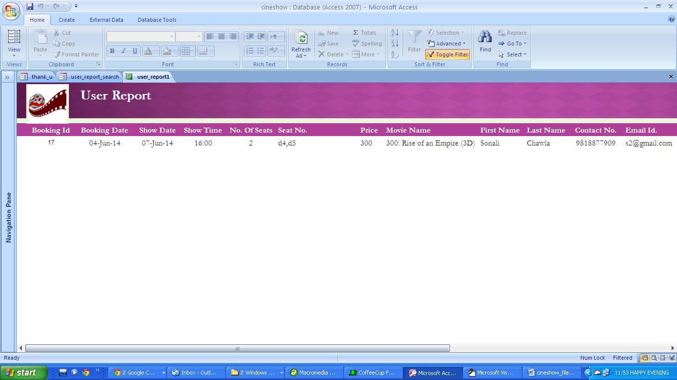

***TESTING***

* **Login:**

|  |  |  |  |
| --- | --- | --- | --- |
| **S. No.** | **Variables** | | **Expected Output** |
| **Username** | **Password** |
| 1. | 9818877909 | sona | Successfully Login |
| 2. | Palavi | Palavi87 | Wrong Username, Username must be number |
| 3. | 156525 | Deepti321 | Wrong Username, Username must be number |
| 4. | Sikander56 | Sikaa890 | Wrong Username, Username must be of 10 digits |

* **Movie Booking Process:**

|  |  |  |  |  |  |
| --- | --- | --- | --- | --- | --- |
| **S. No.** | **Variables** | | | | **Expected Output** |
| **Movie** | **Theater** | **No. Of Tickets** | **Show Date and Time** |
| 1. | Gaddar | Cinimax | 02 | 3-Mar-2014 10:30 | Successfully Booked |
| 2. | Rashi | Movie Times | 3 | 6-Mar-2014 11:30 | Wrong No. Of Tickets, No. of tickets must be of 2 digits |
| 3. | Jaddu | Satyam | 04 | abc | Wrong Show Date and Time, Show Date and Time must in Date Time Format |
| 4. | Aaina | Jannat | 1 | xyz | Wrong No. of tickets and Show Date and Time, No. of tickets should be of 2 digits and Show Date and Time should be in a Date Time Format |

* **Add Movie Process:**

|  |  |  |  |  |  |
| --- | --- | --- | --- | --- | --- |
| **S. No.** | **Variables** | | | | **Expected Output** |
| **Movie Name** | **Movie Price** | **Movie Duration** | **Release Date** |
| 1. | Queen | 125 | 2 hrs 30 mins | 3-Mar-2014 | Successfully Added |
| 2. | MIB25 | A25 | 3 hrs 15 mins | 5-Jun-2014 | Wrong Movie Price, Movie Price must be numeric |
| 3. | 156525 | 625 | abc | 6-Jan-2014 | Wrong Movie Duration, Movie Duration must be alphanumeric |
| 4. | Sikander56 | 150 | 1 hr 30 mins | ghr | Wrong Release Date, Release Date must be of Date |
| 5. | Gandi6 | Gandijii | 235 | 8-May-2014 | Wrong Movie Duration, Movie Duration must be alphanumeric |
| 6. | Janat8 | 541655659 | xyz | thu | Wrong Movie Price, Movie Duration, Release Date |

* **Registeration Form:**

|  |  |  |  |  |  |  |  |
| --- | --- | --- | --- | --- | --- | --- | --- |
| **S. No.** | **Variables** | | | | | | **Expected Output** |
| **First Name** | **Last Name** | **Password** | **Confirm Password** | **Contact No.** | **Email Id** |
| 1. | Sonali | Chawla | sona | sona | 9818877909 | s@gmail.com | Successfully Login |
| 2. | Palavi56 | Chohan | Palavi87 | Palavi87 | 9818877252 | me@yahoo.com | Wrong First Name, First Name must be alphabet |
| 3. | Rahul | Mehra43 | Deepti321 | Deepti321 | 9815544620 | sj@reddiffmail.com | Wrong Last Name, Last Name must be alphabet |
| 4. | Sikander | Sharma | Sikaa890 | Sikaa890 | abc | abc@gmail.com | Wrong Contact No., Contact No. must be number |
| 5. | Sachi | Sheherawat | Meera67 | Meera67 | 654 | xyx@kit.com | Wrong Contact No., Contact No. must be of 10 digits |
| 6.. | Jyoti | Vats | Jyoti99 | Jyoti99 | 9818876235 | sv | Wrong Email Id., Email Id. must be mail id |