**Assignment 1**

* **Write a program to find out the frequency distribution**

**Coding:**

#include<stdio.h>

#include<math.h>

void main()

{

float r,d;

int n;

clrscr();

printf("\nEnter no. of cells.\n");

scanf("%d",&n);

printf("\nEnter radius of each cell.\n");

scanf("%f",&r);

d= sqrt(3*n)*r;

printf("\nFrequency Reused Distance = %f",d);

getch();

}

**Output:**

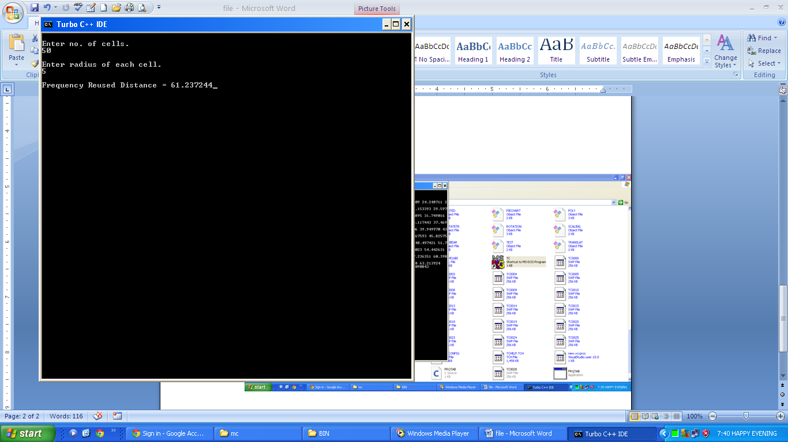

**Assignment 2**

* **Write a program to print table of frequency distribution according to different values of i and j**

**Coding:**

#include<stdio.h>

#include<math.h>

void main()

{ int i,j,n,k;

float r,d;

printf("Enter radius of each cell.\n");

scanf("%f",&r);

printf(" 0 1 2 3 4 5 6 7 8 9 10 11 12\n");

for(i=0;i<=12;i++)

{ printf("%d ",i);

for(k=0;k<i;k++)

{ printf(" "); }

for(j=i;j<=12;j++)

{ n= (i*i)+(j*j)+(i*j);

d= sqrt(3*n)*r;

printf("%f ",d);

} printf("\n");

} getch();}

**Output:**

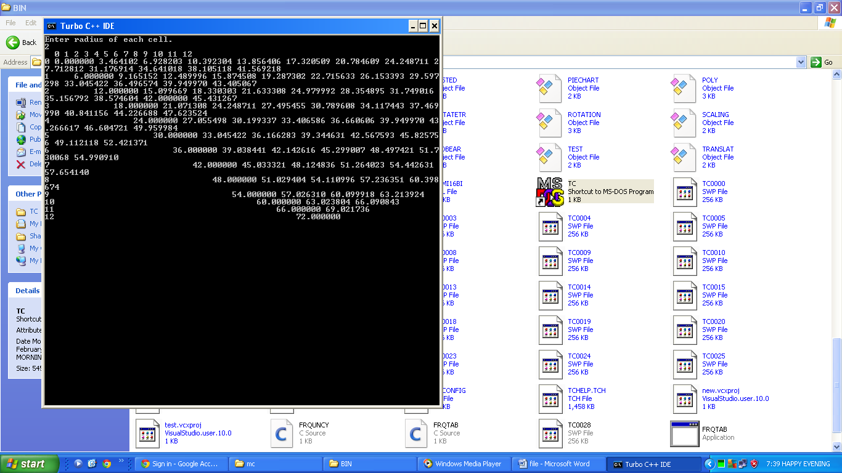

**Assignment 6**

* **Write a program showing Anchor Tag in WML**

**Coding:**

<?xml version="1.0"?>

<!DOCTYPE wml PUBLIC "-//WAPFORUM//DTD WML 1.1//EN"

"http://www.wapforum.org/DTD/wml_1.1.xml">

<wml>

<card title="Messages">

<p>

<anchor>Inbox<br/>

<go href="table.wml"/>

</anchor>

<anchor>Sent

<go href="table.wml"/>

</anchor>

</p>

</card>

</wml>

**Assignment 7**

* **Write a program showing the use of DO TYPE tag in WML.**

**Coding:**

<?xml version="1.0"?>

<!DOCTYPE wml PUBLIC "-//WAPFORUM//DTD WML 1.1//EN"

"http://www.wapforum.org/DTD/wml_1.1.xml">

<wml>

<card title="First Page" id="first">

<do type="Next">

<go href="#second"/>

</do>

<p>

This is first page

</p>

</card>

<card id="second">

<do type="Back">

<go href="#first"/>

</do>

<p>

Hello

</p>

</card>

</wml>

**Assignment 8**

* **Write a program showing ONPICK Event in WML.**

**Coding:**

<?xml version="1.0"?>

<!DOCTYPE wml PUBLIC "-//WAPFORUM//DTD WML 1.1//EN"

"http://www.wapforum.org/DTD/wml_1.1.xml">

<wml>

<card id="one" title="Make ur choice">

<p>

<select name="choice">

<option onpick="#p1" value="BBA">BBA</option>

<option onpick="#p2" value="BCA">BCA</option>

<option onpick="#p3" value="Msc">Msc</option>

</select>

</p>

</card>

<card id="p1" title="Ur choice">

<p>

Your choice is BBA

</p>

</card>

<card id="p2" title="Ur choice">

<p>

Your choice is BCA

</p>

</card>

<card id="p3" title="Ur choice">

<p>

Your choice is Msc

</p>

</card>

</wml>

**Assignment 9**

* **Write a program showing CARDS in WML**

**Coding:**

<?xml version="1.0"?>

<!DOCTYPE wml PUBLIC "-//WAPFORUM//DTD WML 1.2//EN"

"http://www.wapforum.org/DTD/wml12.dtd">

<wml>

<card id="one" title="First Card">

<p>

This is the first card in the deck

</p>

</card>

<card id="two" title="Second Card">

<p>

Ths is the second card in the deck

</p>

</card>

</wml>

**Assignment 10**

* **Write a program showing login form in WML**

**Coding:**

<?xml version="1.0"?>

<!DOCTYPE wml PUBLIC "-//WAPFORUM//DTD WML 1.1//EN"

"http://www.wapforum.org/DTD/wml_1.1.xml">

<wml>

<card id="one" >

<p>

Username:<input type="text" name="use"/>

Password:<input type="password" name="pwd"/>

</p>

<do type="login">

<go href="#two"/>

</do>

</card>

<card id="two" >

<p>

hello $(use)

Your password is $(pwd)

</p>

<do type="back">

<go href="#one"/>

</do>

</card>

</wml>