**EXPERIMENT NO 1**

**Draw a Use Case Diagram for University Explorer System**

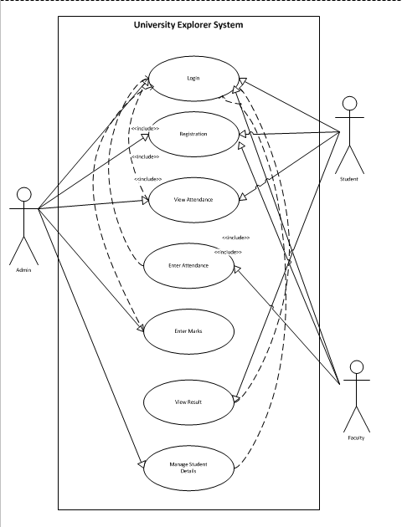

**EXPERIMENT NO 2**

**Draw a Use Case Diagram for Railway Reservation System**

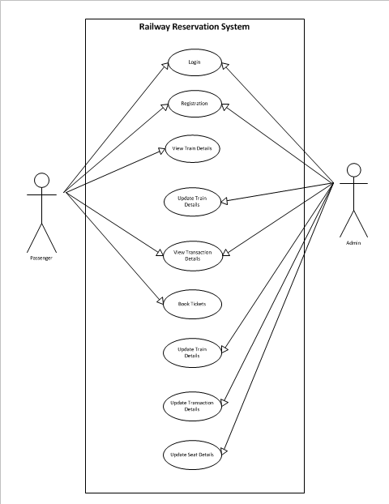

**EXPERIMENT NO 3**

**Draw a Use Case Diagram for University Result Management System**

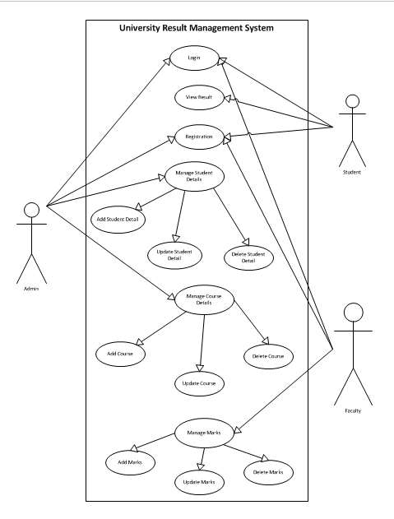

**EXPERIMENT NO 4**

**Draw a Use Case Diagram for Online Banking System**

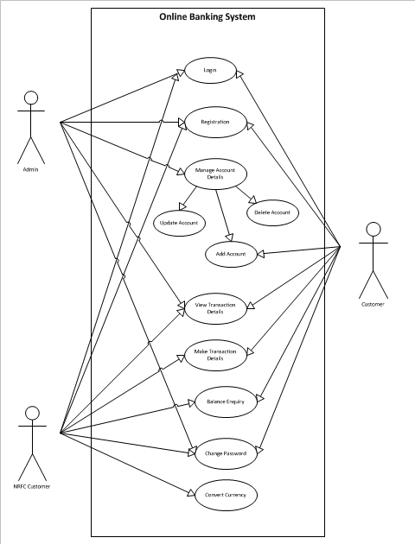

**EXPERIMENT NO 5**

**Draw a Class Diagram for Employee Management System**

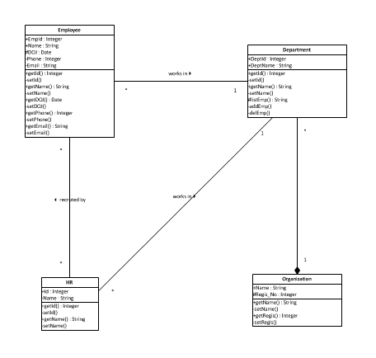

**EXPERIMENT NO 6**

**Draw a Class Diagram for Railway Reservation System**

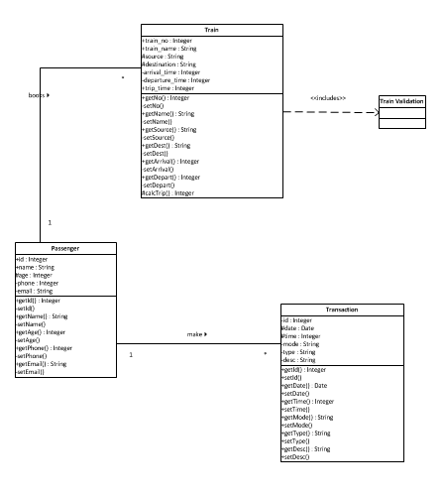

**EXPERIMENT NO 7**

**Draw a Class Diagram for Library Management System**

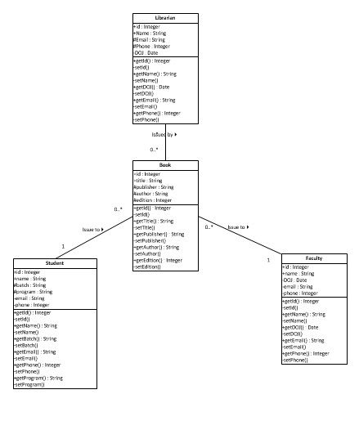

**EXPERIMENT NO 8**

**Draw a Class Diagram for ATM Machine**

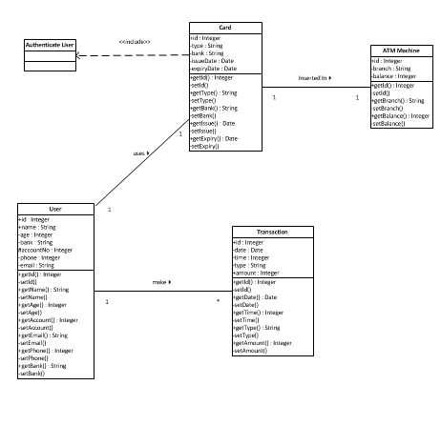

**EXPERIMENT NO 9**

**Draw a Sequence Diagram for ATM Machine**

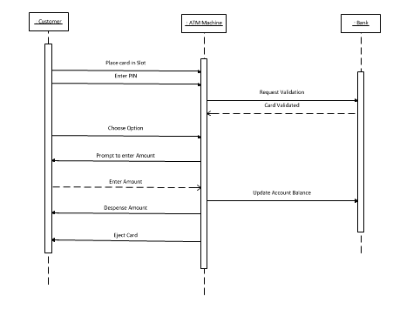

**EXPERIMENT NO 10**

**Draw a Collaboration Diagram for Library Management System**

* Issue Book

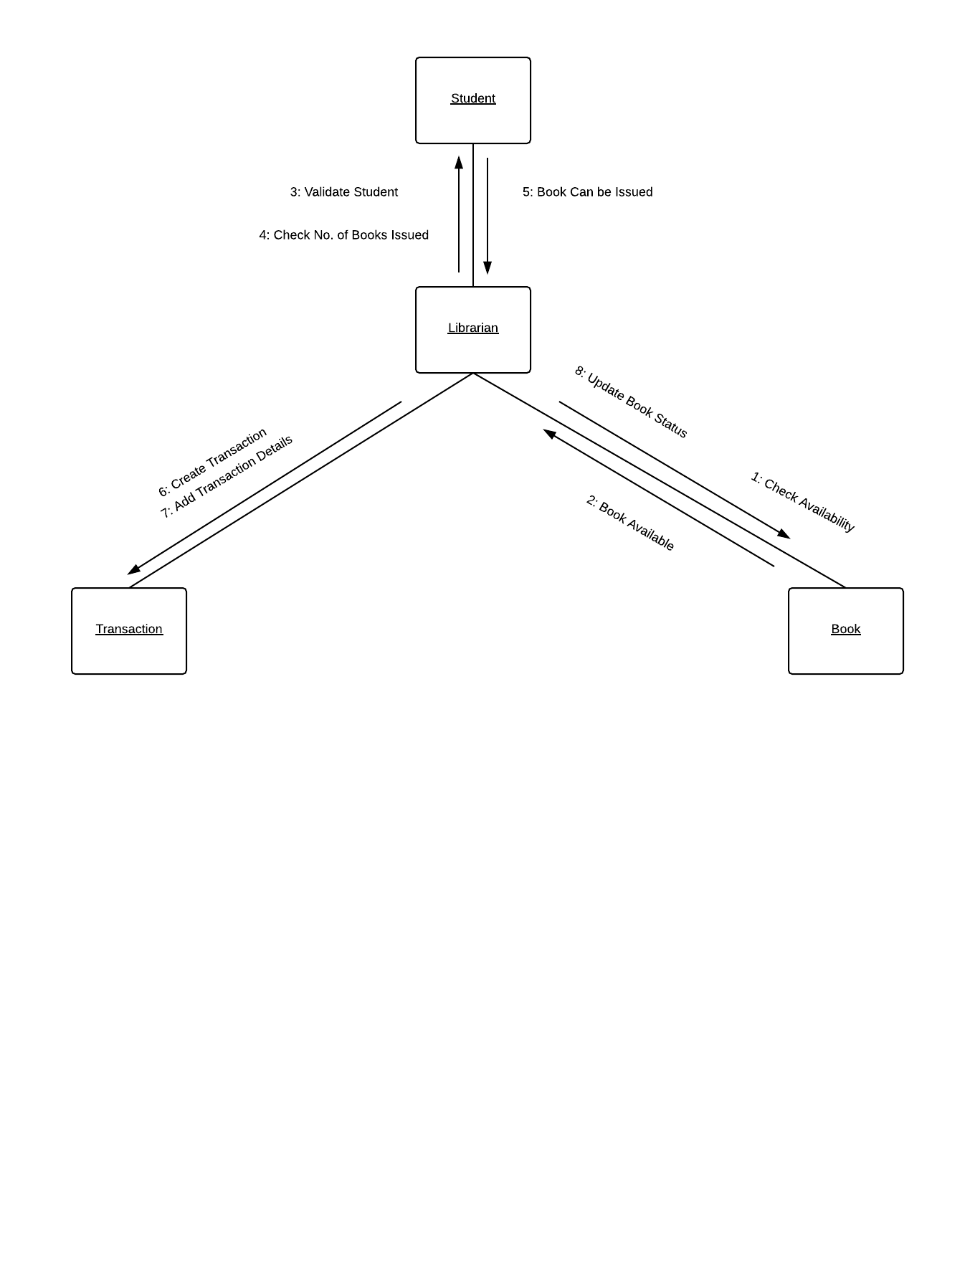

* Return Book

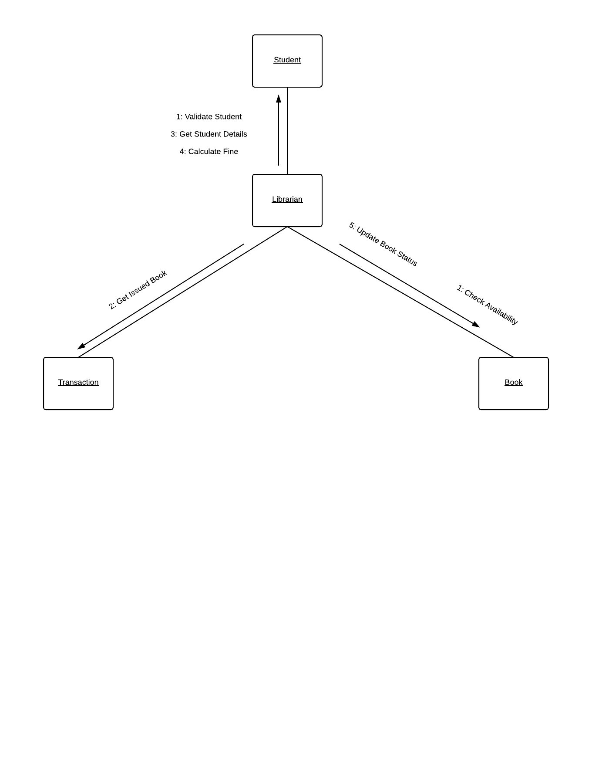

**EXPERIMENT NO 11**

**Draw a State Diagram for ATM Management System**

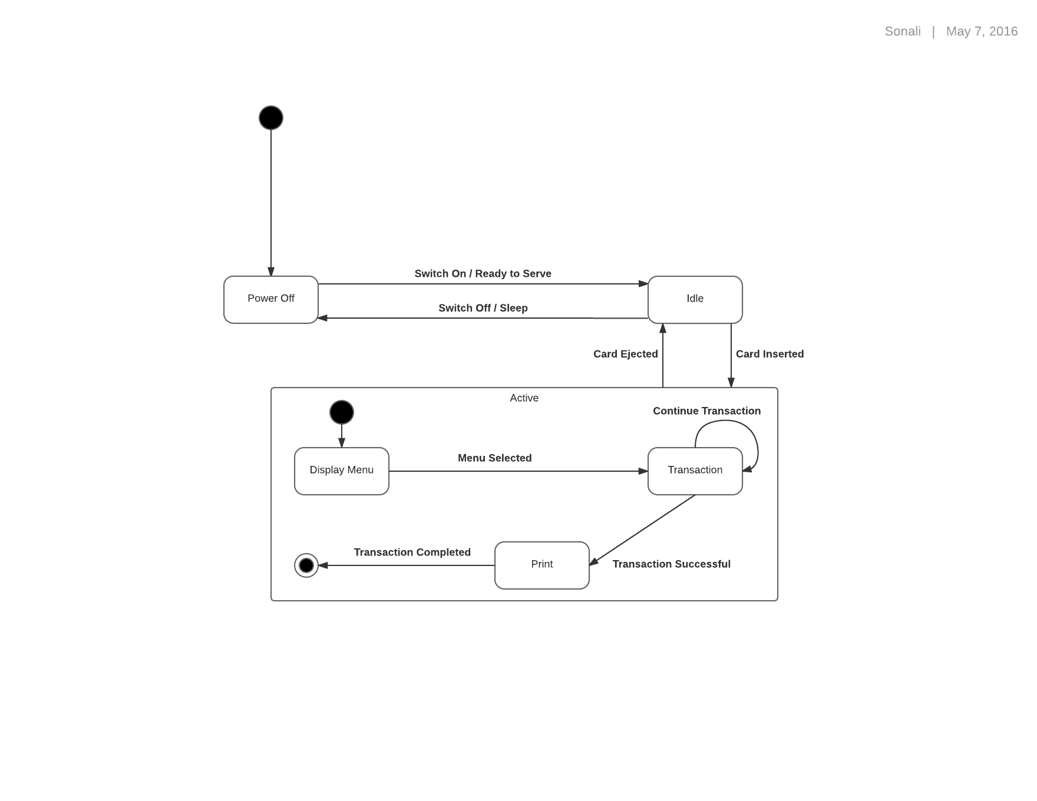

**EXPERIMENT NO 12**

**Draw an Activity Diagram for University Course Management System**

