***Assignment 1(Marquee)***

* Marquee of 4 images moving in different directions using table
  + **Code:**

<html>

<head><title>Marquee</title></head>

<body><center>

<table border="1" width="80%">

<tr><td align="center">

<marquee direction="left"><img src="left.png" width="100" height="100"/></marquee>

</td><td align="center">

<marquee direction="up"><img src="up.png" width="100" height="100"/></marquee>

</td></tr><tr><td align="center">

<marquee direction="down"><img src="down.jpg" width="100" height="100"/></marquee>

</td><td align="center">

<marquee direction="right"><img src="right.jpg" width="100" height="100"/></marquee>

</td></tr></table>

</center></body></html>

* + **Output:**

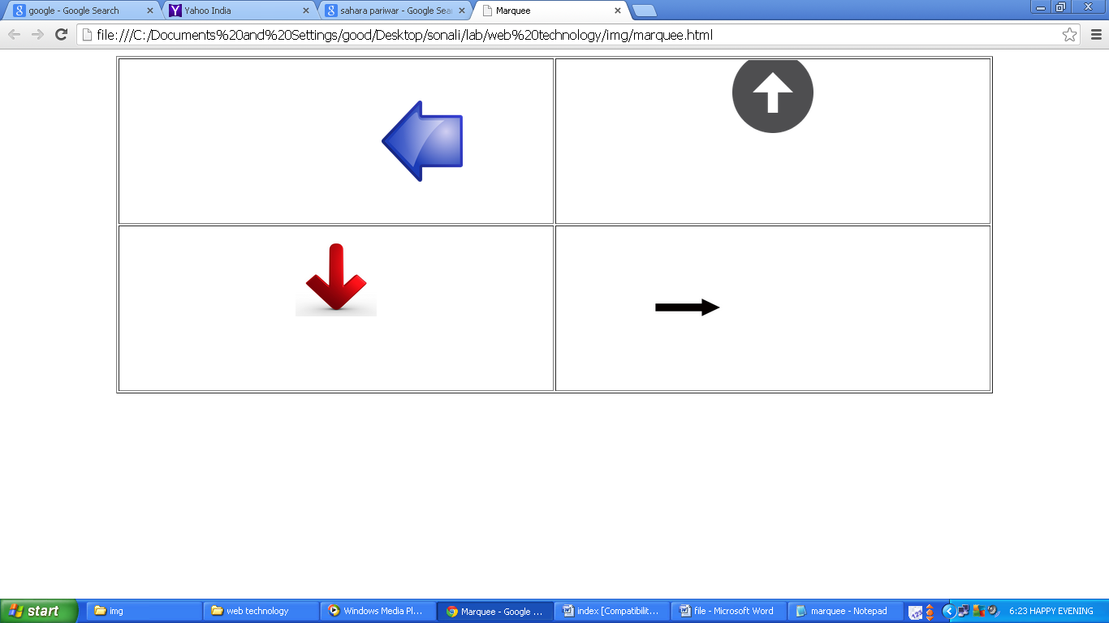

***Assignment 2(<pre> Tag)***

* Poem using pre tag
  + **Code:**

<html>

<head><title>National Anthem</title></head>

<body bgcolor="#A52A2A"><center>

<u><b><font size="8" color="0000CD">National Anthem</font></b></u><br><br>

<pre><font size="7" color="FF7F50">Jana Gana Mana Adhinayaka Jaya He</font>

<font size="6" color="FFFFFF">Bharata Bhagya Vidhata</font>

<font size="5" color="32CD32">Punjaba Sindhu Gujrata Maratha</font>

<font size="4" color="FF7F50">Dravida Utkala Banga</font>

<font size="3" color="FFFFFF">Vindhya Himachala Yamuna Ganga</font>

<font size="2" color="32CD32">Utchala Jaladhi Taranga</font>

<font size="1" color="FF7F50">Tava Subha Name Jage</font>

<font size="2" color="FFFFFF">Tava Subh Ashish Mange</font>

<font size="3" color="32CD32">Gahe Tava Jaya Gatha</font>

<font size="4" color="FF7F50">Jana Gana Mangala Dayaka Jaya He</font>

<font size="5" color="FFFFFF">Bharata Bhagya Vidhata</font>

<font size="6" color="32CD32">Jaya He! Jaya He! Jaya He!</font>

<font size="7" color="FF7F50">Jaya! Jaya! Jaya! Jaya He!</font>

</pre></center></body></html>

* + **Output:**

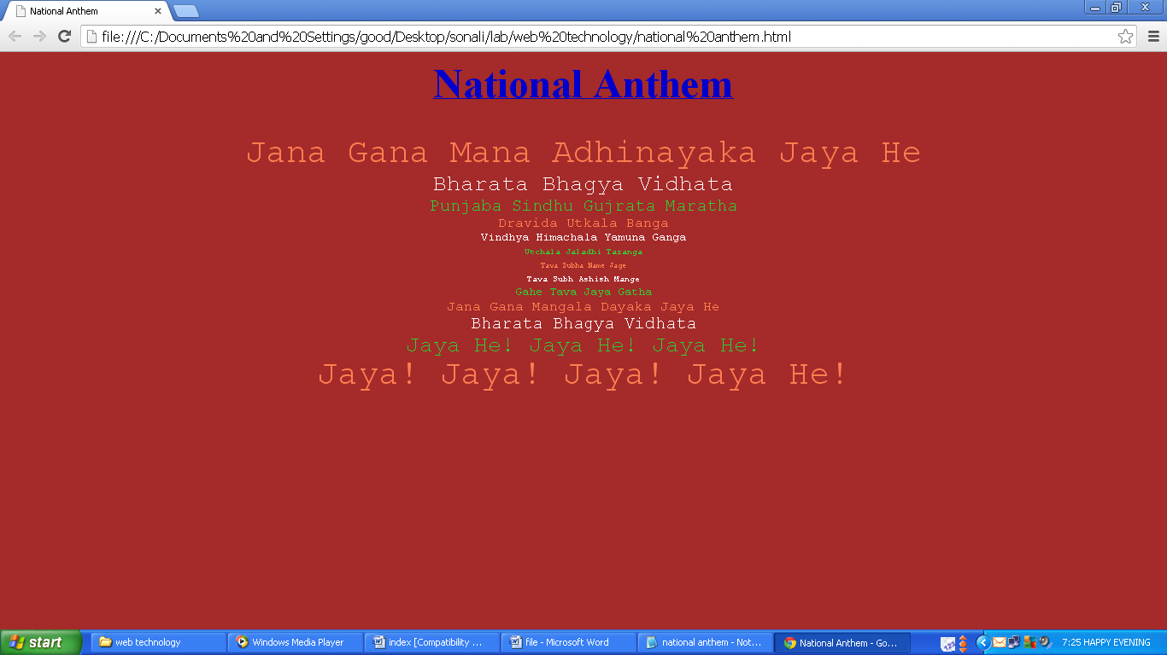

***Assignment 3(Frameset)***

* Frameset structure
  + **Code:**

<html> <head><title>Frame</title></head>

<frameset cols="50%,30%,20%" frameborder="0">

<frame name="a" src="1.html">

<frameset rows="60%,40%">

<frame name="b" src="2.html"><frame name="c" src="3.html">

</frameset><frameset rows="50%,24%,26%">

<frame name="d" src="4.html">

<frame name="e" src="5.html">

<frame name="f" src="6.html">

</frameset></frameset></html>

* + **Output:**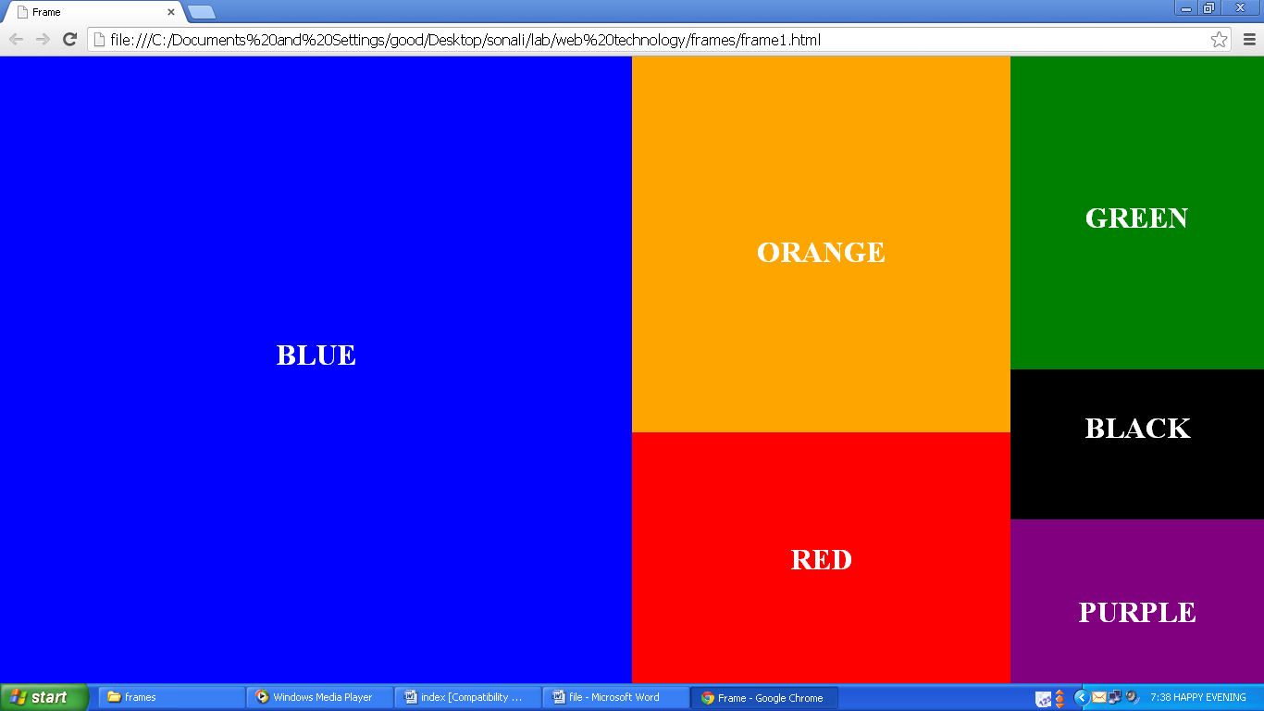
* Frameset having Contains
  + **Code:**

<html>

<head><title>Frame</title></head>

<frameset rows="50%,*" noresize frameborder="0">

<frameset cols="50%,*">

<frame name="image"src="img.html">

<frame name="table" src="table.html">

</frameset><frameset cols="50%,*">

<frame name="list" src="list.html"><frame name="para" src="para.html">

</frameset></frameset></html>

* + **Output:**

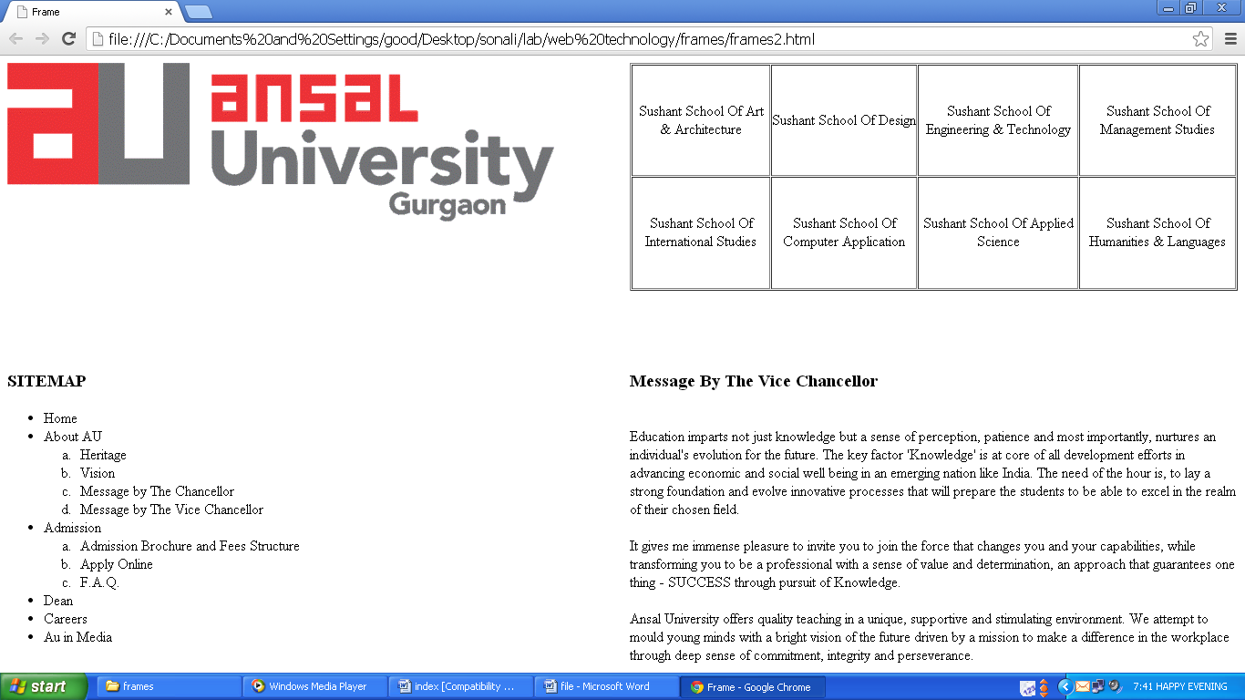

***Assignment 4(Table)***

* Timetable using table tag
  + **Code:**

<html><body><center><font size=3><b>BCA II</b><br><br>

<font face="Adobe Caslon Pro" size=2>

<table border=2 bordercolor="black" cellspacing=”0” cellpadding=”2” width=”80%” height=”1%”>

<tr><td></td>

<td><center>1<br>9.00 -10.00 </td><td><center>2<br>10.00 -11.00</td>

<td><center>3<br>11.00 -12.00</td><td><center>4<br>12.00 -1.00</td>

<td><center>5<br>1.00 -2.00</td><td><center>6<br>2.00 -3.00</td>

<td><center>7<br>3.00 -4.00</td><td><center>8<br>4.00 -5.00</td>

</tr><tr><td><center><font size=6>Mo</font></td>

<td bgcolor="#FF9966"><center>C-106<br><br><b>CS1023</b><br><br>Kiran Kawatra</center></font></td>

<td bgcolor="#CCCC47"><center>C-106<br><br><b>CS1022</b><br><br>Kiran Khatter</center></font></td>

<td bgcolor="#FFB2FF"><center>C-106<br><br><b>CS1026</b><br><br>S.K. Sharma</center></font></td>

<td bgcolor="#FF9966"><center>C-106<br><br><b>CS1024</b><br><br>P. Vidyalakshmi</center></font></td>

<td colspan=”2” bgcolor="#FF9966"><center>C-201(IP LAB-1)<br><br><b>CS1623</b><br><br>Kiran Kawatra</center></font></td>

</tr><tr><td><center><font size=6>Tu</font></td>

<td colspan=”2” bgcolor="#FF9966"><center>C-201(IP LAB-1)<br><br><b>CS1623</b><br><br>Kiran Kawatra</center></font></td>

<td bgcolor="#FF9966"><center>C-106<br><br><b>CS1024</b><br><br>P. Vidyalakshmi</center></font></td>

<td bgcolor="#CCCC47"><center>C-106<br><br><b>CS1022</b><br><br>Kiran Khatter</center></font></td>

<td colspan=”2” bgcolor="#AAAABF"><center>C-106<br><br><b>Soft

Skills</b><br><br>Inst-1</center></font></td>

</tr><tr><td><center><font size=6>We</font></td>

<td bgcolor="#CCCC47"><center>C-106<br><br><b>CS1025</b><br><br>Kiran Khatter</center></font></td>

<td bgcolor="#FF9966"><center>C-106<br><br><b>CS1023</b><br><br>Kiran

Kawatra</center></font></td>

<td bgcolor="#FFB2FF"><center>C-106<br><br><b>CS1026</b><br><br>S.K.

Sharma</center></font></td>

<td bgcolor="#FF9966" colspan=”2”><center>C-003(COMP LAB-2)<br><br><b>CS1608</b><br><br>P. Vidyalakshmi</center></font></td>

<td colspan=”2”><font size=6><center>TDL</center></font></td>

</tr><tr><td><center><font size=6>Th</font></td>

<td></td><td bgcolor="#FF9966"><center>C-106<br><br><b>CS1023</b><br><br>Kiran

Kawatra</center></font></td>

<td bgcolor="#CCCC47"><center>C-106<br><br><b>CS1022</b><br><br>Kiran Khatter</center></font></td>

<td></td><td bgcolor="#CCCC47"><center>C-106<br><br><b>CS1025</b><br><br>Kiran Khatter</center></font></td>

<td bgcolor="#CCCC47" colspan=”2”><center>C-003(COMP LAB-2)<br><br><b>CS1607</b><br><br>Kiran Khatter</center></font></td>

</tr><tr><td><center><font size=6>Fr</font></td>

<td bgcolor="#FFB2FF"><center>C-106<br><br><b>CS1026</b><br><br>S.K.

Sharma</center></font></td>

<td bgcolor="#FF9966"><center>C-106<br><br><b>CS1024</b><br><br>P. Vidyalakshmi</center></font></td>

<td bgcolor="#CCCC47" colspan=”2”><center>C-003(COMP LAB-2)<br><br><b>CS1607</b><br><br>Kiran Khatter</center></font></td>

<td bgcolor="#CCCC47"><center>C-106<br><br><b>CS1025</b><br><br>Kiran Khatter</center></font></td>

<td bgcolor="#FF9966" colspan=”2”><center>C-003(COMP LAB-2)<br><br><b>CS1608</b><br><br>P. Vidyalakshmi</center></font></td>

</tr></body></html>

* + **Output:**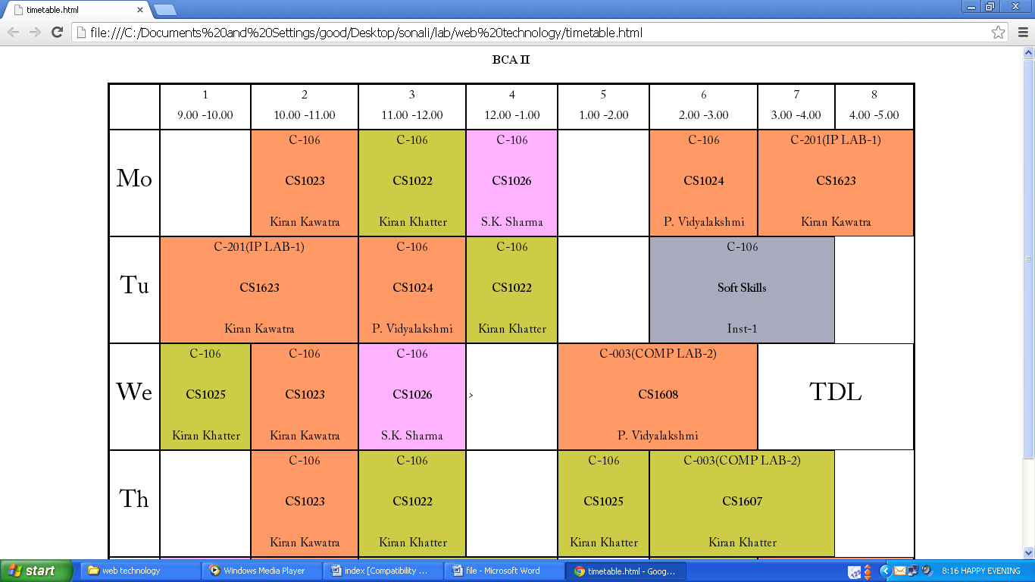
* Table Having Tables
  + **Code:**

<html><head><title>Table</title></head>

<body><table border="5" cellspacing="1" cellpadding="1">

<tr><td valign="top">This is a paragraph.<br>This is another paragraph.</td>

<td valign="top">This cell contains a table:

<table border="5" cellspacing="1" cellpadding="1" width="100%">

<tr><td>A</td><td>B</td></tr>

<tr><td>C</td><td>D</td></tr></table>

</td></tr><tr>

<td>This cell contains a list:

<ul style="disc"><li>apples</li><li>bananas</li><li>pineapples</li></ul>

</td><td><table border="0" cellspacing="1" cellpadding="0">

<tr><td>This is a paragraph.<br>This is another paragraph.</td>

<td>This cell contains a table:<table border="0" cellpadding="1" cellspacing="1">

<tr><td>A</td><td>B</td></tr><tr>

<td>C</td><td>D</td></tr></table>

</td></tr><tr><td>This cell contains a list:

<ul style="disc"><li>apples</li><li>bananas</li><li>pineapples</li></ul>

</td><td>HELLO</td></tr></table>

</td></tr></table></body></html>

* + **Output:**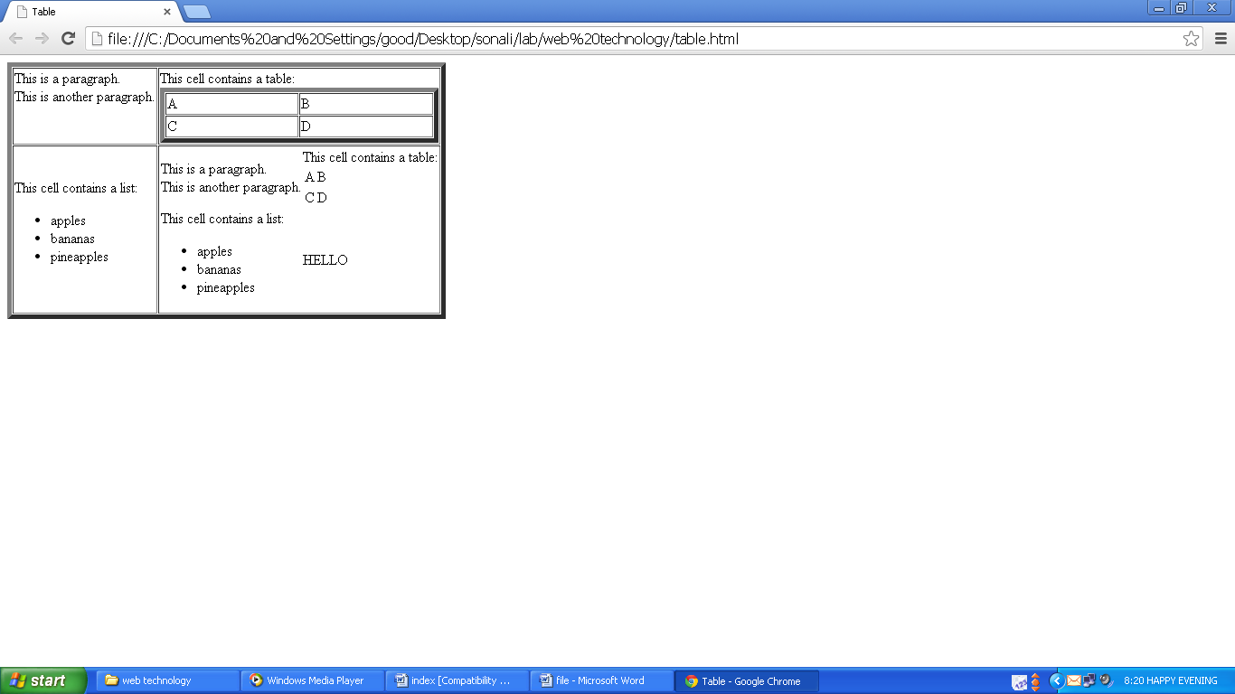

***Assignment 5(Form)***

* Feedback /online form or suggestion form
  + **Code:**

<html><head><title>Form</title></head>

<body><center><form>

<table width="50%" border="0" cellpadding="0" cellspacing="0">

<tr><th colspan="2"><u>Please Enter Details</u><br><br></th></tr>

<tr><td width="50%" align="center">Name:</td><td align="center"><input type="text" name="name"/></td></tr>

<tr><td width="50%" align="center">Login Id:</td><td align="center"><input type="text" name="loginid"/></td></tr>

<tr><td width="50%" align="center">Password:</td><td align="center"><input type="password" name="pwd"/></td></tr>

<tr><td width="50%" align="center">Gender:</td><td align="center"><input type="radio" name="r1" value="male" checked/> Male <input type="radio" name="r1" value="female"/> Female</td></tr>

<tr><td width="50%" align="center">Qualification:</td><td align="center"><select name="qual"><option value="">--Select--</option>

<option value="ug">Under Graduate</option><option value="g">Graduate</option>

<option value="pg">Post Graduate</option></select></td></tr>

<tr><td width="50%" align="center">Interest:</td><td align="center"><input type="checkbox" name="c1" value="sing"/> Singing <input type="checkbox" name="c2" value="dance"/> Dancing <input type="checkbox" name="c3" value="other" checked/> Others</td></tr>

<tr><td align="center" colspan="2"><input type="submit"/> <input type="reset"/></td></tr>

</table></form>

</center></body></html>

* + **Output:**

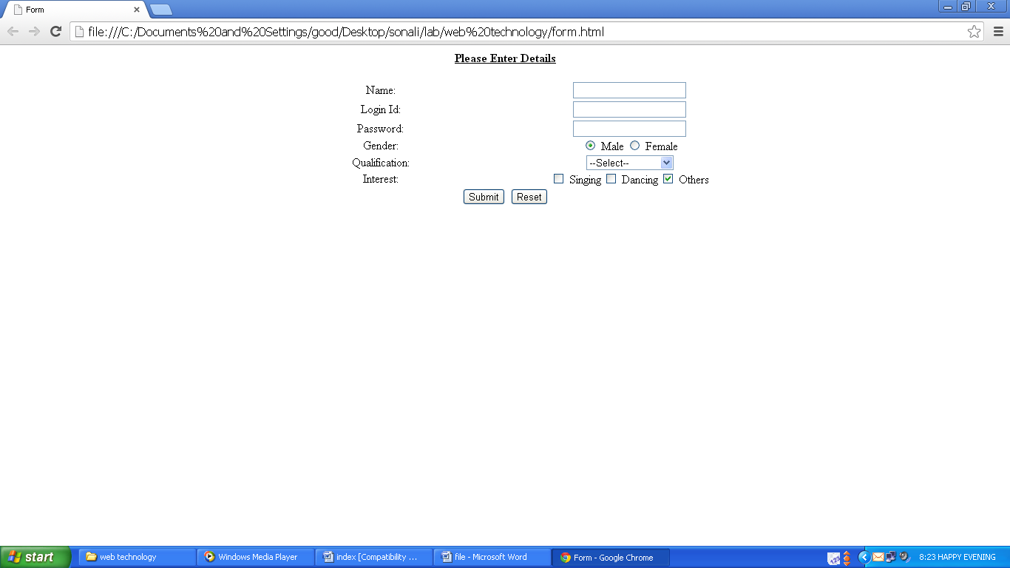

***Assignment 6(List)***

* Ordered and unordered list
  + **Code:**

<html><heda><title>List</title></head>

<body><ul style="disc">

<li><b>School Of Computer Application</b></li>

<ol type="i">

<li>BCA</li><li>B.Sc-IT</li>

<li>MCA</li><li>M.Sc-IT</li>

<li>Ph.D</li></ol>

<li><b>School Of Management Studies</b></li>

<ol type="a">

<li>B.Tech-CSE</li><li>B.Tech-ECE</li>

<li>B.Tech-CE</li><li>B.Tech-EEE</li>

<li>B.Tech-MAE</li><li>B.Tech-Biotechnoly</li>

<li>M.Tech-CSE</li><li>M.Tech-CSE(PT)</li>

<li>M.Tech-ECE</li><li>M.Tech-ESE(PT)</li>

<li>Ph.D</li></ol>

<li><b>School Of Engineering & Technology</b></li>

<ol type="1">

<li>BBA</li><li>B.Sc-HMCT</li>

<li>B.Com(Hons.)</li><li>MBA</li>

<li>Executive MBA(PT)</li><li>Ph.D</li></ol></ul>

</body></html>

* + **Output:**

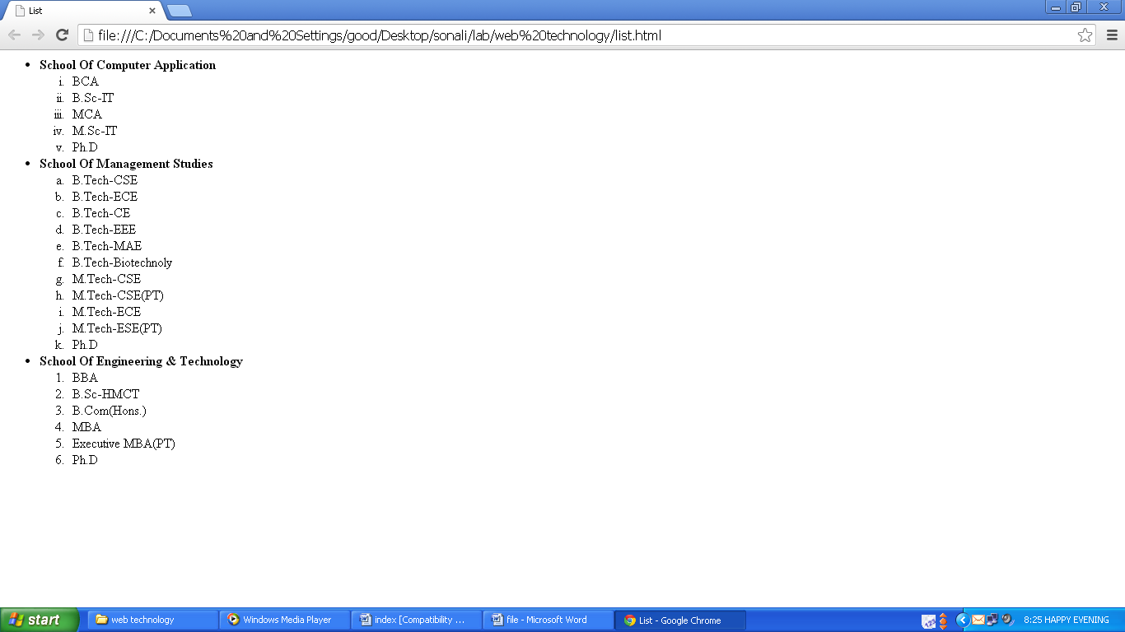

***Assignment 7(Image Map)***

* Image map (using India map)
  + **Code:**

<html><head><title>Map of India</title></head>

<body><center><u><h1>Map of India</h1></u>

<font size="4" color="#FF0000">Click on the states to display details of that states. </font><br><br>

<img src="map-india.png" alt="India" usemap="#states" border="0"/>

<map name="states">

<area shape="poly"coords="178,154,194,168,185,183,185,199,178,210,190,212,189,224,182,227,178,220,169,219,160,223,155,210,150,196,136,190,131,177,150,182,167,176,177,164," href="haryana.html">

<area shape="circle" coords="178,200,191" href="delhi.html">

<area shape="poly" coords="248,539,209,556,199,550,190,568,169,580,185,614,186,646,206,639,220,627,227,607,243,606,233,571," href="tn.html">

<area shape="rect" coords="404,217,429,243" href="sikkim.html">

<area shape="poly" coords="140,555,168,577,183,608,185,645,168,619," href="kerala.html">

<area shape="rect" coords="116,489,129,509" href="goa.html">

<area shape="rect" coords="443,266,503,289" href="meghalaya.html">

<area shape="poly" coords="492,302,471,319,480,336,492,319," href="tripura.html">

<area shape="poly" coords="554,246,513,278,520,287,540,279,52,267," href="nagaland.html">

<area shape="poly" coords="518,281,508,308,533,317,546,292,539,274," href="mani.html">

<area shape="rect" coords="234,567,242,575" href="pondi.html">

</map></center></body></html>

* + **Output:**

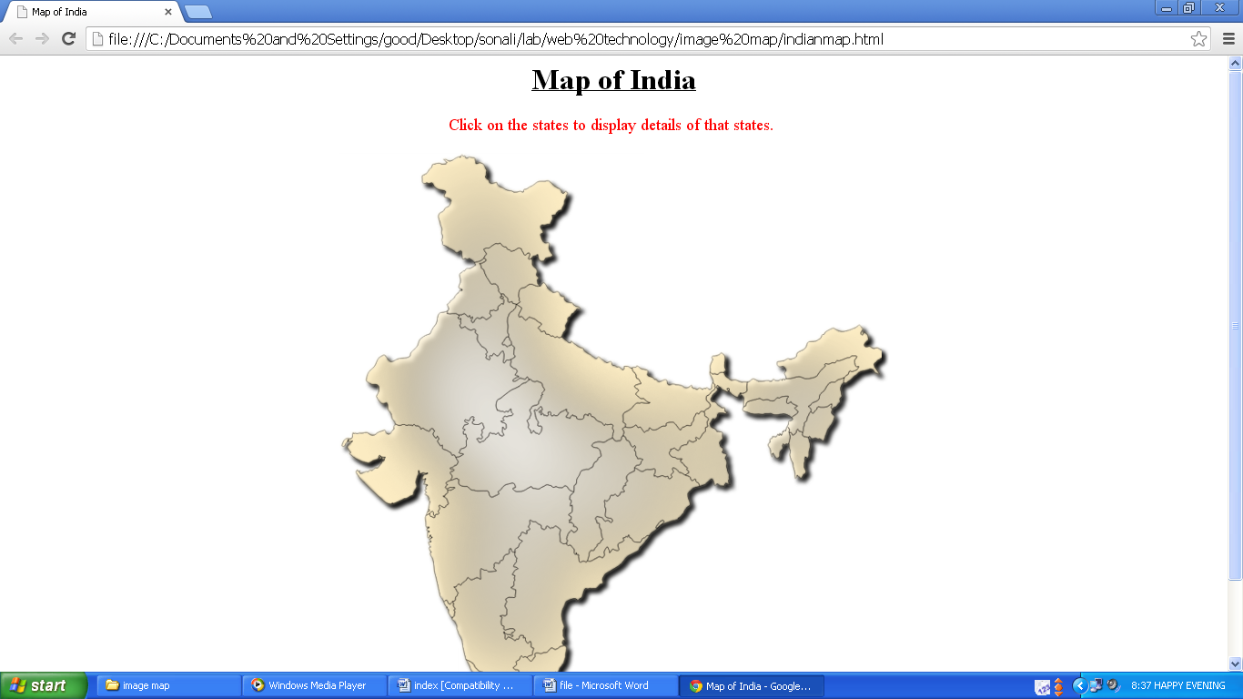

***Assignment 8(External Hyperlink)***

* External linking
  + **Code:**

<html><head><title>External Hyperlink</title></head>

<body bgcolor="DEB887" link="0000ff" vlink="0000ff">

<img src="images.JPEG" height=150 width=200 alt="canon 650d" align="left" border=2>

<font size=7><center><u><i><b><a href="http://en.wikipedia.org/wiki/Canon_EOS_650D" target="_blank">Canon 650D</a></b></i></u></center></font>

<pre><font color="FF0000" face="verdana"><font size=5>Basic Specifications</font>

Part Code 6559B016AA

Review Date 26 Sep 2012

</font>

<font color="black" face="verdana"><img src="images3.JPEG" alt="camera" height=200 width=200 align="right" border=2>

<font size=5>Other Details</font>

CCD effective megapixels 18.0 megapixels

CCD size 22.3x14.9mm

LCD screen size 3.0in

LCD screen resolution 1,040,000 pixels

Articulated screen Yes

Zoom 35mm equivalent 29-88mm

Image stabilisation optical, in kit lens</font>

<img src="images2.JPEG" alt="camera1" height=200 width=200 align="left" border=2/>

</pre></body></html>

* + **Output:**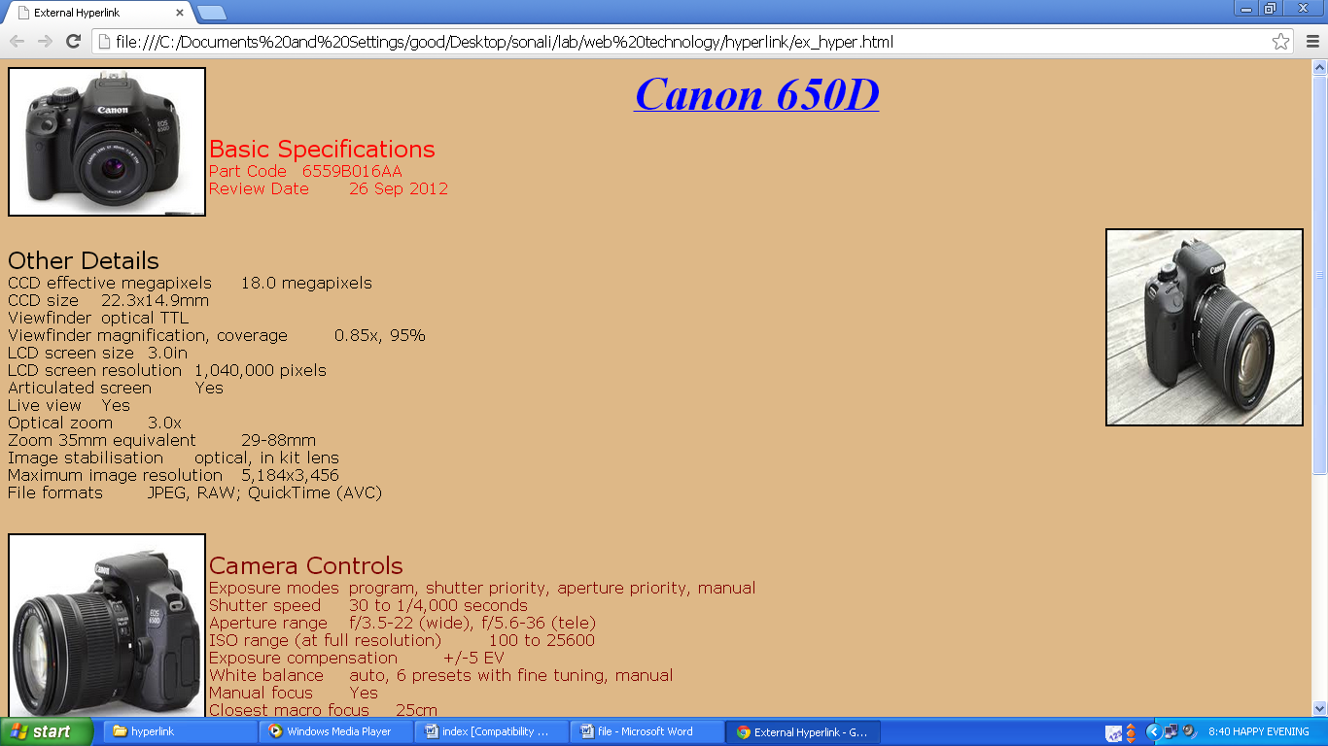

***Assignment 9(Internal Hyperlink)***

* Internal Linking
  + **Code:**

<html><head><title>Internal Hyperlink</title></head><body>

<a name="top" href="#bottom"><img src="down.png" align="right"/></a>

<br><center><img src="hyperlink.jpg" width="550" height="550"/></center>

<a name="bottom" href="#top"><img src="top.png" align="right"/></a>

</body></html>

* + **Output:**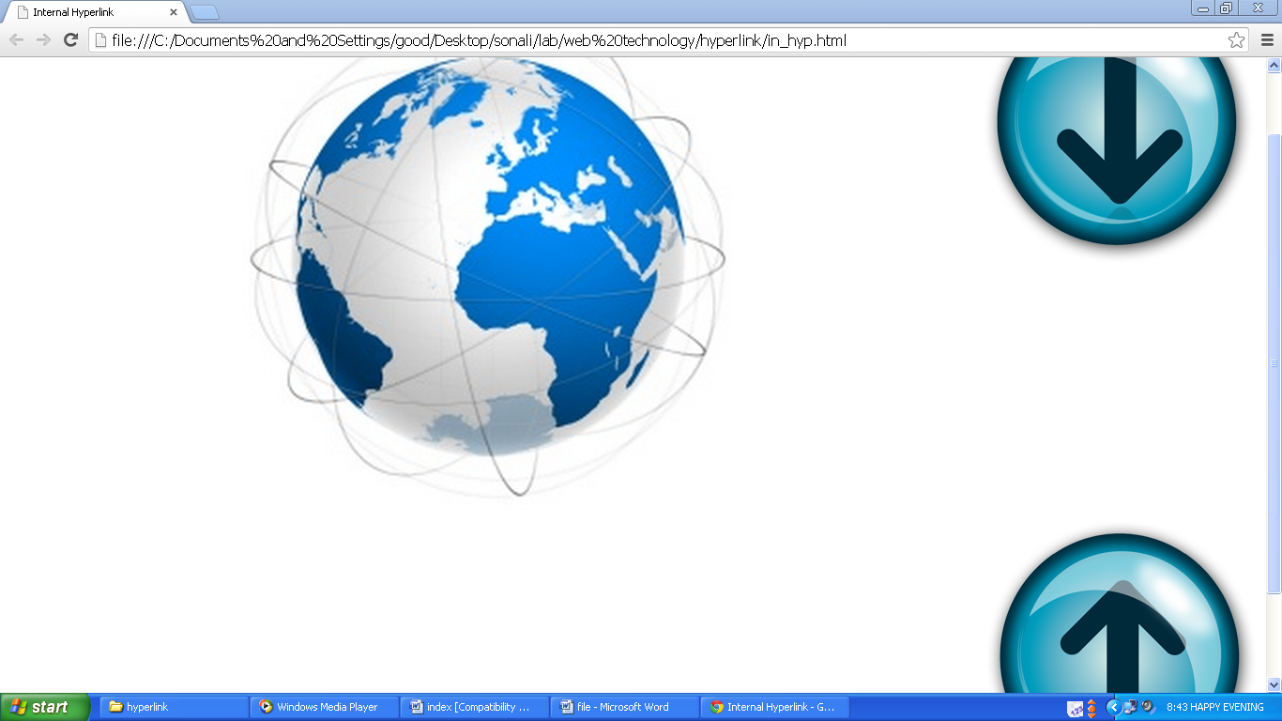

***Assignment 10(Mini Calculator)***

* Mini calculator using JavaScript
  + **Code:**

<html><head><title>Calculator</title></head>

<body><script>

function check()

{

if(isNaN(document.f1.t1.value))

{

alert("Invalid First Input. Please Enter only digits.");

document.getElementById('t1').value="0";

document.getElementById('t3').value="0";

return false;

}

if(isNaN(document.f1.t2.value))

{

alert("Invalid Second Input. Please Enter only digits.");

document.getElementById('t2').value="0";

document.getElementById('t3').value="0";

return false;

}

}

function add()

{

var a=document.f1.t1.value; var b=document.f1.t2.value;

if(a=="0" && b=="0")

{

alert("Enter atleast one input."); return false;

}

var c=+a + +b; document.getElementById('t3').value=c;

}

function sub()

{

var a=document.f1.t1.value; var b=document.f1.t2.value;

if(a=="0" && b=="0")

{

alert("Enter atleast one input."); return false;

}

var c=+a - +b; document.getElementById('t3').value=c;

}

function mul()

{

var a=document.f1.t1.value; var b=document.f1.t2.value;

if(a=="0" && b=="0")

{

alert("Enter atleast one input."); return false;

}

var c=+a * +b; document.getElementById('t3').value=c;

}

function div()

{

var a=document.f1.t1.value; var b=document.f1.t2.value;

if(a=="0" && b=="0")

{

alert("Enter atleast one input."); return false;

}

var c=+a / +b; document.getElementById('t3').value=c;

}

</script><center><form name="f1">

<table border="1" cellpadding="0" cellspacing="0" width="30%" bordercolor="#0000FF">

<tr bgcolor="#0000FF">

<td><font color="#FFFFFF"><b>&nbsp;&nbsp;Calculator</b></font></td>

</tr><tr bgcolor="#ECE8D6"><td>

<table border="0" cellpadding="10" cellspacing="0" width="100%">

<tr><td colspan="2"><label for="t1"><b>Enter First Number:</b></label></td>

<td colspan="2"><input id="t1" type="text" name="t1" value="0" onchange="check()"/></td>

</tr><tr><td colspan="2"><label for="t2"><b>Enter Second Number:</b></label></td>

<td colspan="2"><input id="t2" type="text" name="t2" value="0" onchange="check()"/></td>

</tr><tr><td colspan="2"><label for="t3"><b>Result:</b></label></td>

<td colspan="2"><input type="text" id="t3" name="t3" value="0" readonly/></td>

</tr><tr><td><input type="button" name="b1" value="+" onclick="add()"/></td>

<td><input type="button" name="b2" value="-" onclick="sub()"/></td>

<td><input type="button" name="b3" value="*" onclick="mul()"/></td>

<td><input type="button" name="b4" value="/" onclick="div()"/></td>

</tr></table></td></tr></table></form></center></body></html>

* + **Output:**

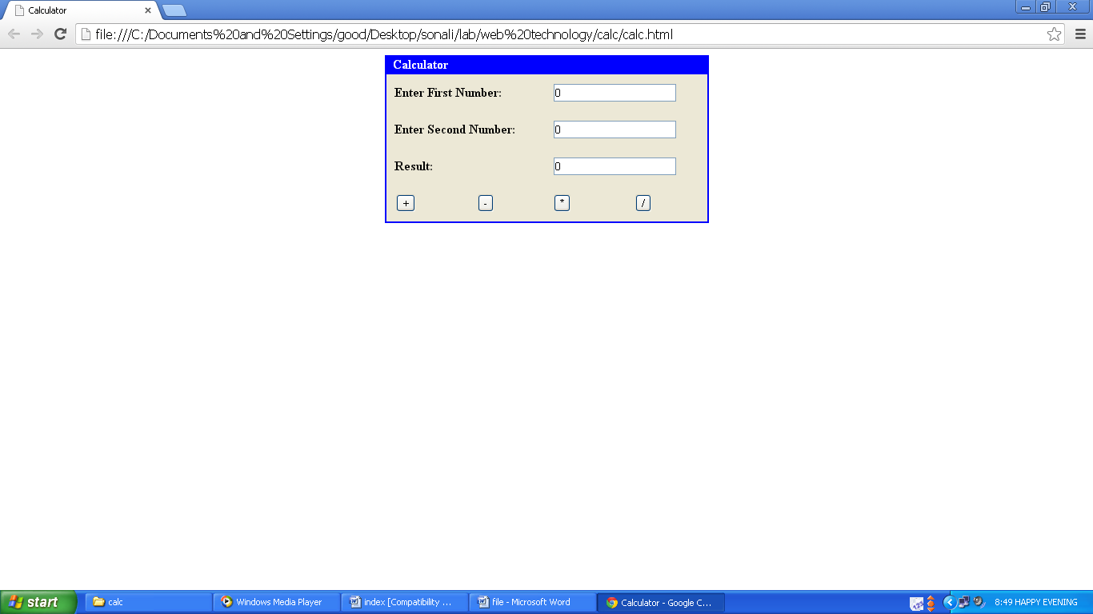

***Assignment 11(Greeting Message)***

* Greeting message acc. to date by JavaScript
  + **Code:**

<html><head><title>Greeting Message</title></head>

<body><script>

var d=new Date();

var t=d.getHours();

if(t<12)

{

alert("Good Morning");

}

else if(t<16)

{

alert("Good Afternoon");

}

else if(t<21)

{

alert("Good Evening");

}

else

{

alert("Good Night");

}

</script></body></html>

* 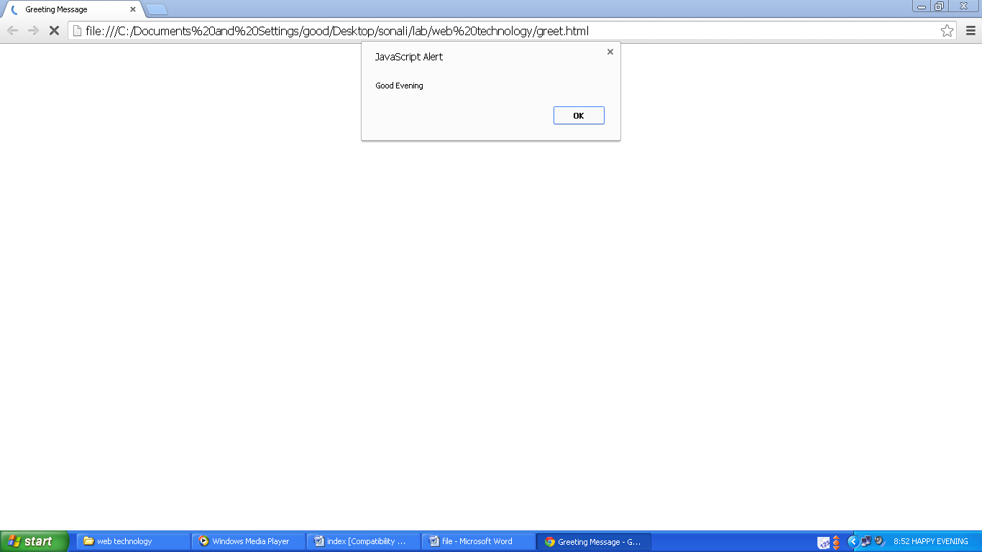**Output:**

***Assignment 12(Change Background Color)***

* Changing background color by JavaScript
  + **Code:**

<html>

<head>

<title>BGCOLOR</title>

</head>

<body>

<script>

function color(bg)

{

document.body.style.backgroundColor=bg;

}

</script>

<form>

<input type="radio" name="r1" value="red" onClick="color('#FF0000')"/> Red

<input type="radio" name="r1" value="green" onClick="color('#ADFF2F')"/> Green

<input type="radio" name="r1" value="blue" onClick="color('#0000FF')"/> Blue

<input type="radio" name="r1" value="yellow" onClick="color('#FFD700')"/> Yellow

</form>

</body>

</html>

* **Output:**

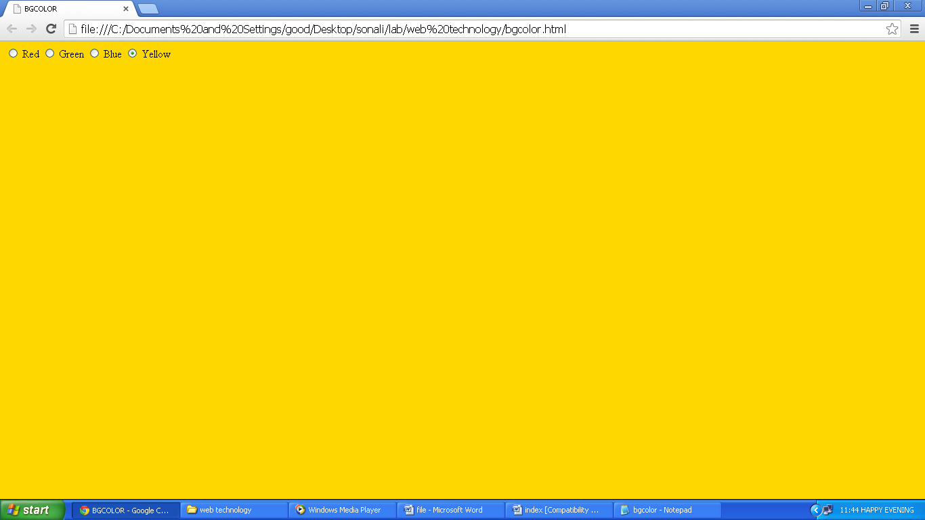

***Assignment 13(Print Table)***

* Print table using JavaScript
  + **Code:**

<html>

<head><title>Table</title></head>

<body>

<script>

document.write("<table border='1'>");

for(var i=0; i<6; i++)

{

document.write("<tr>");

for(var j=0; j<6; j++)

{

document.write("<td>"+i+","+j+"</td>");

}

document.write("</tr>");

}

document.write("</table>");

</script>

</body>

</html>

* **Output:**

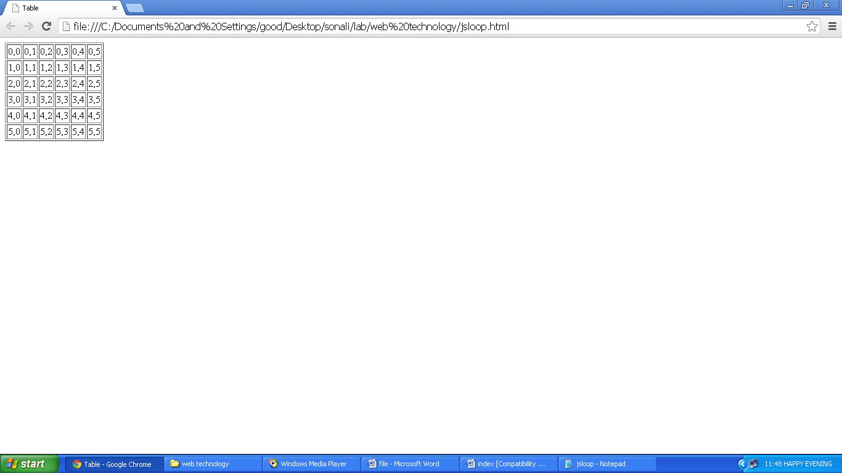

***Assignment 14(Logical Programs)***

* Programs using JavaScript
  + **Code:**

<html><head><title>Logics</title></head><body><script>

function check(a)

{

if(a=='')

{alert("Invalid Input.");

return false;}

}

function prime()

{

var a=prompt("Enter number to check.","");

check(a);a=+a;

for(var i=2;i<a;i++){

if(a%i==0){

f=0;

break;

}else{

f=1;

}}

if(f==0){

alert(a+" is not a Prime number.");

}else{

alert(a+" is a Prime number.");}

}

function odd()

{

var a=prompt("Enter the limit for the series.","");

check(a);a=+a;

var b=1;

for(var i=0;i<a;){

if(b%2!=0){

document.write(b=" ");

i++;}

b++;}

}

function even()

{

var a=prompt("Enter the limit for the series.","");

check(a);a=+a;

var b=1;

for(var i=0;i<a;){

if(b%2==0){

document.write(b+" ");

i++;}

b++;}

}

function fact()

{

var a=prompt("Enter the number.","");

check(a);a=+a;

var f=1;

for (var c=1;c<=a;c++){

f=f*c;}

alert("Factorial is "+f);

}

function fabo()

{

var a=prompt("Enter the number.","");

check(a);a=+a;

var b=0,c=1;

document.write(b+" "+c);

while(a>0){

d=b+c;

document.write(" "+d);

b=c;

c=d;

a--;}

}

function pali()

{

var a=prompt("Enter the number.","");

check(a);a=+a;

var t=a,r=0;

while(t>0){

r=r*10;

r=r+(t%10);

t=parseInt(t/10);}

if(a==r)

alert(a+" is a palindrome number.");

else

alert(a+" is not a palindrome number.");

}

function pali1()

{

var a=prompt("Enter the number.","");

check(a);

a=a.toLowerCase();

var revStr="";

var i=a.length;

for(var j=i;j>=0;j--){

revStr=revStr+a.charAt(j);}

if(a==revStr)

alert(a+" is Palindrome");

else

alert(a+" is not a Palindrome");

}

</script><form name="1">

<input type="radio" name="r" value="prime" onclick="prime()">Prime Numbers</br>

<input type="radio" name="r" value="odd" onclick="odd()">Odd Series</br>

<input type="radio" name="r" value="even" onclick="even()">Even Series</br>

<input type="radio" name="r" value="fabo" onclick="fabo()">Fabonaccii Series</br>

<input type="radio" name="r" value="fact" onclick="fact()">Factorial</br>

<input type="radio" name="r" value="pali" onclick="pali()">Palindrome Number</br>

<input type="radio" name="r" value="pali1" onclick="pali1()">Palindrome String</br>

</form></body></html>

* **Output:**

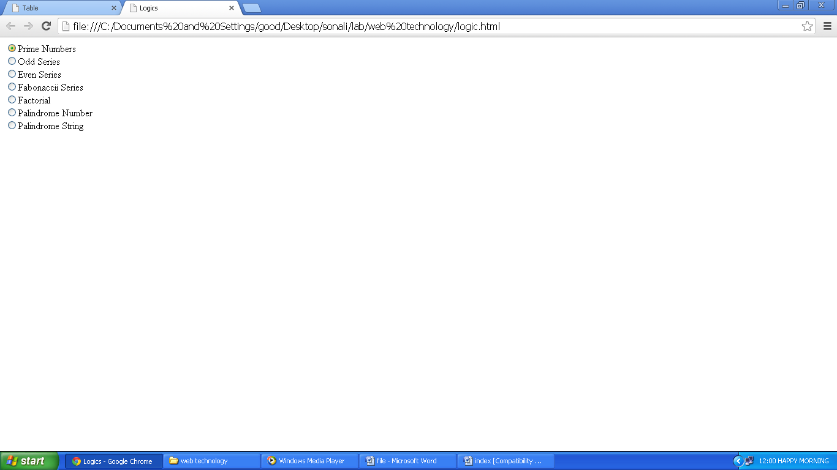

***Assignment 15(Catenation, Replace, Onchange)***

* Catenation in JavaScript
  + **Code:**

<html>

<head><title>concat</title></head>

<body>

<script>

var a=prompt("Enter first name.","");

var b=prompt("Enter second name.","");

var c=a.concat(b);

var d=c.length;

var e=c.toLowerCase();

var f=e.charAt(0).toUpperCase();

a=e.replace(e.charAt(0),f);

alert(a);

document.write("Name: "+a+"<br>Length: "+d);

</script>

</body>

</html>

* **Output:**

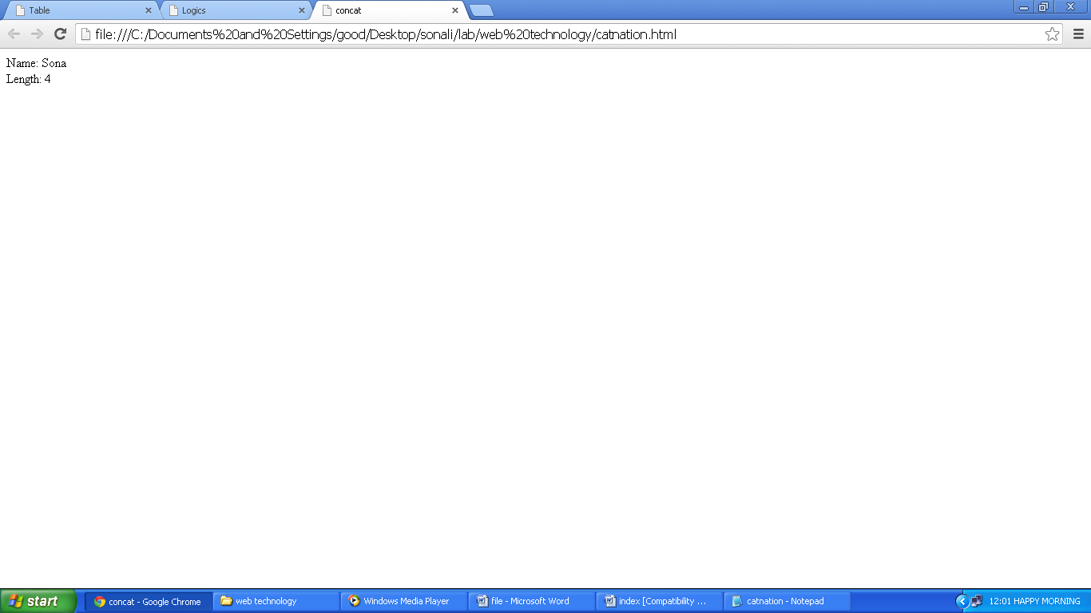

* Replace in JavaScript
  + **Code:**

<html>

<head><title>replace</title></head>

<body onLoad="get()">

<script>

function get()

{

var a=prompt("Enter value.","");

var b=a.replace(a,"Welcome");

alert(b);

}

</script>

</body>

</html>

* **Output:**

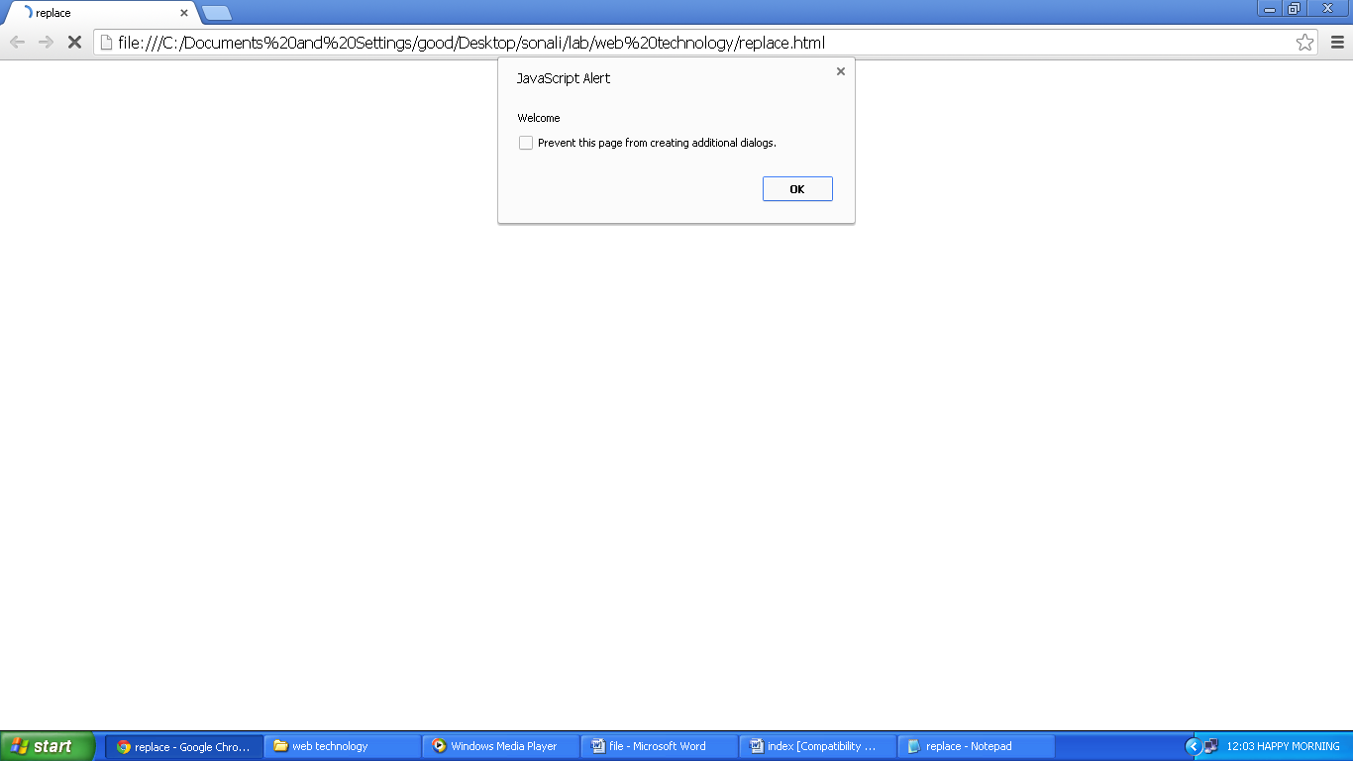

* OnChange Event in JavaScript
  + **Code:**

<html>

<head><title>Onchange</title></head>

<body>

<script>

function get(a)

{

alert(a);

}

</script>

<form>

<select name="y" onchange="get(this.value)">

<option value="1">1</option>

<option value="2">2</option>

<option value="3">3</option>

</select>

</form>

</body>

</html>

* **Output:**

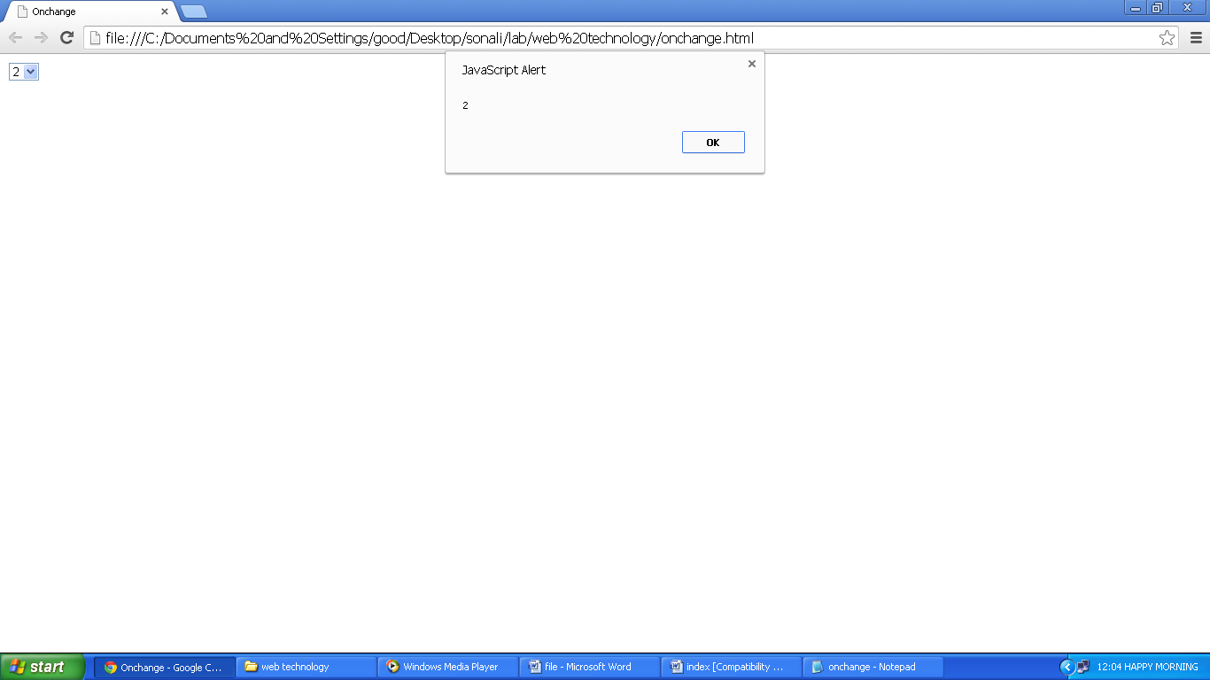

***Assignment 16(Form Validation)***

* Form Validation using JavaScript
  + **Code:**

<html><head><title>Form Validation</title></head><body><script>

function validateEmail()

{

var emailID = document.myForm.EMail.value;

atpos = emailID.indexOf("@");

dotpos = emailID.lastIndexOf(".");

if (atpos < 1 || ( dotpos - atpos < 2 )) {

alert("Please enter correct email ID")

document.myForm.EMail.focus() ;

return false;}

return true;

}

function validate()

{

if( document.myForm.Name.value == "" ){

alert( "Please provide your name!" );

document.myForm.Name.focus() ;

return false;}

if( document.myForm.EMail.value == "" ){

alert( "Please provide your Email!" );

document.myForm.EMail.focus() ;

return false;

}else{

var ret = validateEmail();

if( ret == false ){

return false;} }

if( document.myForm.Zip.value == "" || isNaN( document.myForm.Zip.value ) || document.myForm.Zip.value.length != 5 ){

alert( "Please provide a zip in the format #####." );

document.myForm.Zip.focus() ;

return false;}

if( document.myForm.Country.value == "-1" ){

alert( "Please provide your country!" );

return false;}

return true;

}

</script></head><body>

<form name="myForm" onsubmit="return(validate());">

<table cellspacing="2" cellpadding="2" border="1">

<tr><td align="right">Name</td><td><input type="text" name="Name" /></td> </tr>

<tr><td align="right">EMail</td><td><input type="text" name="EMail" /></td> </tr>

<tr><td align="right">Zip Code</td><td><input type="text" name="Zip" /></td> </tr>

<tr> <td align="right">Country</td> <td>

<select name="Country">

<option value="-1" selected>[choose yours]</option>

<option value="1">USA</option>

<option value="2">UK</option>

<option value="3">INDIA</option>

</select>

</td> </tr>

<tr> <td align="right"></td> <td><input type="submit" value="Submit" /></td> </tr>

</table> </form>

</body> </html>

* **Output:**

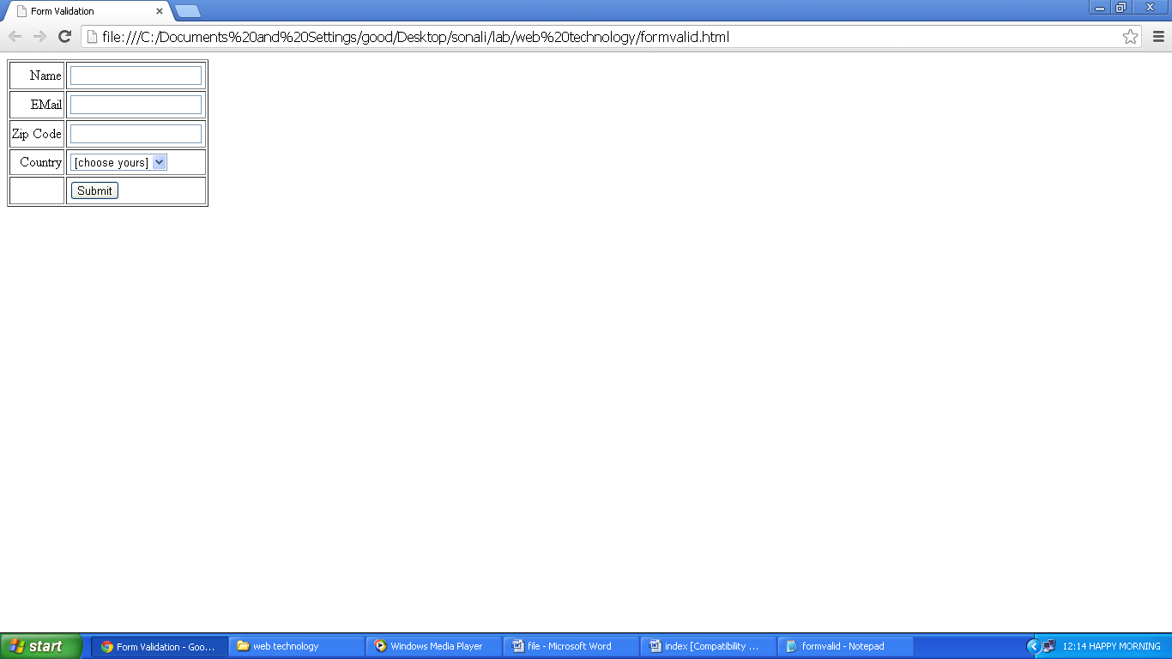

***Assignment 17(Bubble Sorting)***

* Bubble Sorting by JavaScript
  + **Code:**

<html><head><title>Bubble Sort</title></head><body><script>

var no=new Array(5);

for(var i=1;i<=5;i++)

no[i]=parseInt(prompt("enter no ",""));

document.write("Original Entered no = ");

for(var i=1;i<=5;i++)

document.write(no[i] +" ");

document.write("<hr>");var temp;

for(i=1;i<=4;i++){

for(var j=i+1;j<=5;j++){

if(no[i]>no[j]){

temp=no[i];

no[i]=no[j];

no[j]=temp;} }}

document.write("Assending no = ");

for(var i=1;i<=5;i++)

document.write(no[i]+" ");

document.write("<hr>");

document.write("Descending no = ");

for(var i=5;i>=1;i--)

document.write(no[i]+" ");

document.write("<hr>");

</script></body></html>

* **Output:**

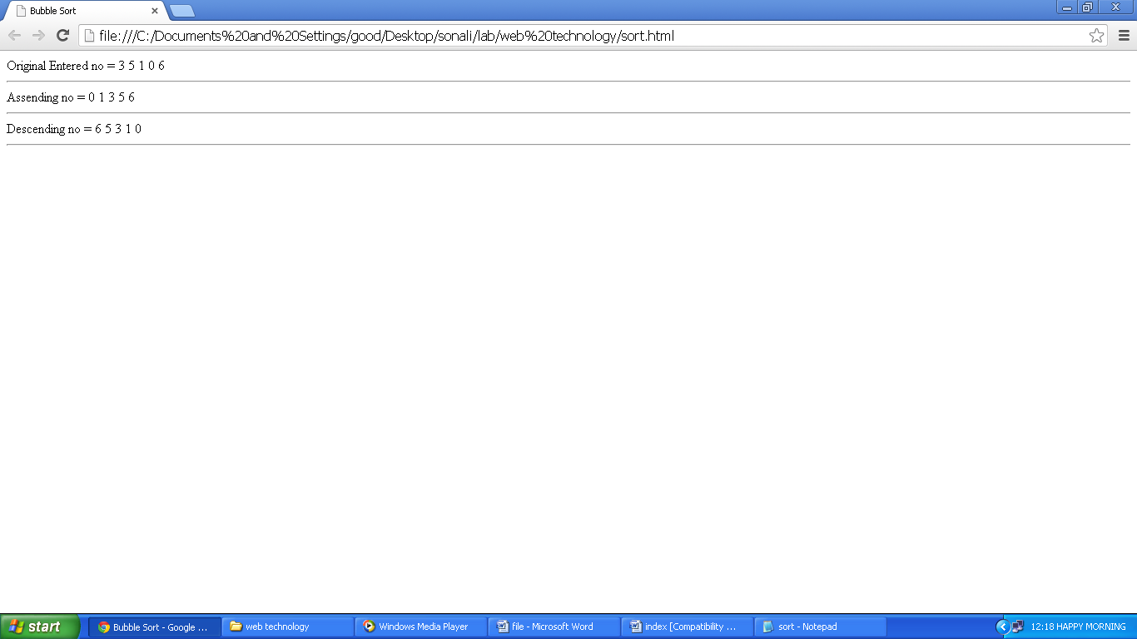

***Assignment 18(Sentence Case)***

* Changing String to Sentence Case using JavaScript
  + **Code:**

<html><head><title>Sentence Case</title></head><body>

<script>

var a=prompt("Enter a String");

if(a=='')

{

alert("Invalid Input");

return false;

}

else

{

var b=a;

a=a.toLowerCase();

a=a.replace(a.charAt(0),a.charAt(0).toUpperCase());

alert(a.length);

for(var i=1;i<a.length;i++)

{

if(a.charAt(i)==" ")

a=a.replace(a.charAt(i+1),a.charAt(i+1).toUpperCase());

}

}

document.write("Old String:<br>"+b);

document.write("<br><hr>New String:<br>"+a);

</script></body></html>

* **Output:**

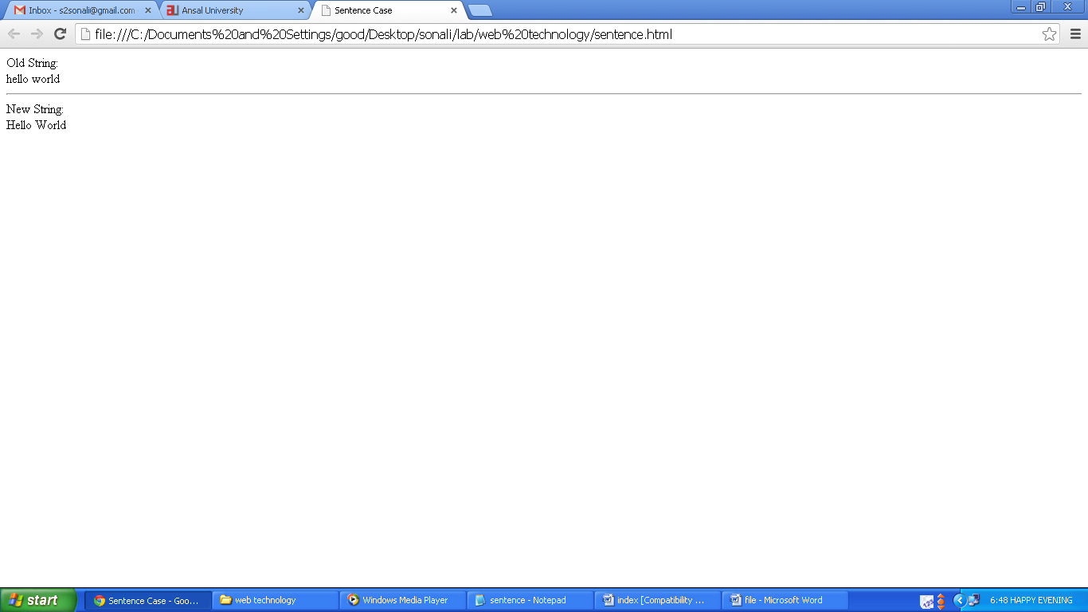

***Assignment 19(Form Validation)***

* Form Validation using PHP
  + **Code:**
    - Form1.php

<html>

<head><title>Form</title></head>

<body>

<center>

<form action="validate.php" method="post">

<table width="50%" border="0" cellpadding="0" cellspacing="0">

<tr><th colspan="2"><u>Please Enter Details</u><br><br></th>

</tr><tr><td width="50%" align="center">Name:</td><td align="center"><input type="text" name="name"/></td></tr>

<tr><td width="50%" align="center">Login Id:</td><td align="center"><input type="text" name="loginid"/></td></tr>

<tr><td width="50%" align="center">Password:</td><td align="center"><input type="password" name="pwd"/></td></tr>

<tr><td width="50%" align="center">Gender:</td><td align="center"><input type="radio" name="r1" value="Male" checked/> Male <input type="radio" name="r1" value="Female"/> Female</td></tr>

<tr><td width="50%" align="center">Qualification:</td><td align="center"><select name="qual"><option value="">--Select--</option>

<option value="Under Graduate">Under Graduate</option>

<option value="Graduate">Graduate</option>

<option value="Post Graduate">Post Graduate</option></select></td></tr>

<tr><td width="50%" align="center">Address:</td><td align="center">

<textarea name="add" rows="3" cols="16"></textarea></td></tr>

<tr><td align="center" colspan="2"><input type="submit"/>

<input type="reset"/></td></tr>

</table>

</form>

</center>

</body>

</html>

* + - Validate.php

<html>

<head><title>Validation</title></head>

<body>

<u><h2>Details Filled:</h2></u>

<?php

echo "<b>Name:</b> ".$_POST['name'];

echo "<br><br><b>Login Id:</b> ".$_POST['loginid'];

echo "<br><br><b>Password:</b> ".$_POST['pwd'];

echo "<br><br><b>Gender:</b> ".$_POST['r1'];

echo "<br><br><b>Qualification:</b> ".$_POST['qual'];

echo "<br><br><b>Address:</b> ".$_POST['add'];

?>

</body>

</html>

* **Output:**

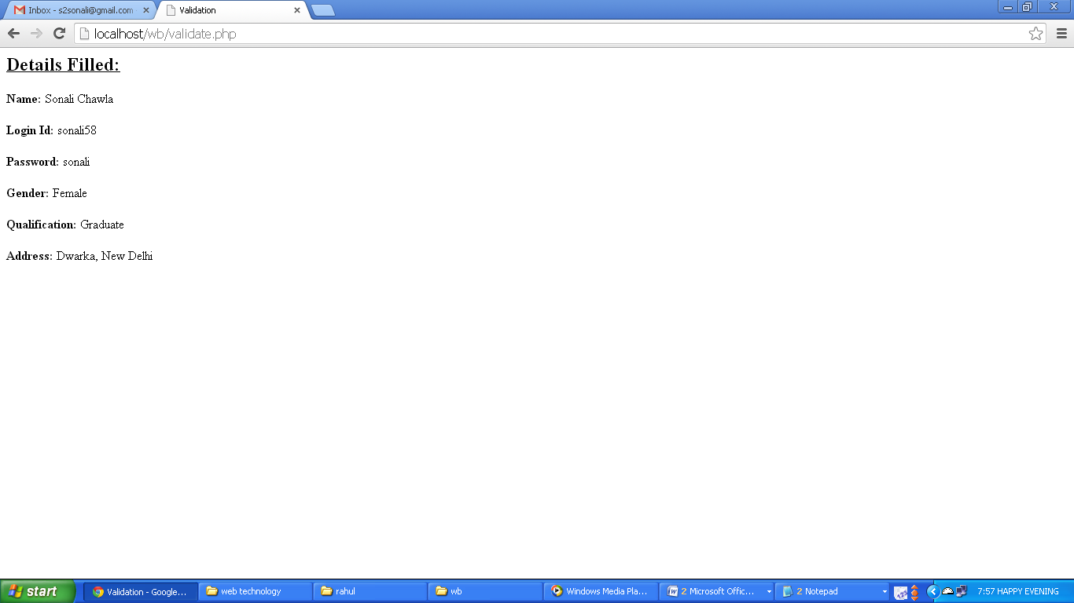

***Assignment 20(Logics Programs)***

* Logical Programs using PHP
  + **Code:**
    - Logic.php

<html><head><title>Logics</title></head><body>

<form method="post" action="cal.php">

Enter Input: <input type="text" name="num">

<br><br>Choose the action:<br>

<input type="radio" name="opt" value="prime">Is this number Prime or not?<br>

<input type="radio" name="opt" value="even">Is this number Even or not?<br>

<input type="radio" name="opt" value="odd">Is this number Odd or not?<br>

<input type="radio" name="opt" value="pali">Is this number Palindrome or not?<br>

<input type="radio" name="opt" value="pali1">Is this string Palindrome or not?<br>

<input type="radio" name="opt" value="fabo">Print Fabonaccii Series<br>

<input type="radio" name="opt" value="fact">Calculate Factorial<br><br>

<input type="submit"></form></body></html>

* + - Cal.php

<html><head><title>Calculate</title></head><body>

<?php

$a=$_POST['num']; $r=$_POST['opt'];

if($r=="prime") { $f=1;

for($i=2;$i<$a;$i++)

{ if($a%$i==0)

{ echo $a." is not a Prime Number."; $f=0;break;

}

}

if($f==1)

echo $a." is a Prime Number.";

}

else if($r=="odd") {

if($a%2!=0)

echo $a." is Odd.";

else

echo $a." is not Odd.";

}

else if($r=="even") {

if($a%2==0)

echo $a." is Even.";

else

echo $a." is not Even.";

}

else if($r=="pali") {

$t=$a; $r=0;

while($t>0)

{

$r=$r*10; $r=$r+($t%10); $t=intval($t/10);

}

if($a==$r)

echo $a." is a palindrome number.";

else

echo $a." is not a palindrome number.";

}

else if($r=="pali1") {

$a=strtolower($a); $r=""; $i=strlen($a);

for($j=$i;$j>=0;$j--)

{ $r=$r+substr($a,$i,1); }

if($a==$r)

echo $a." is Palindrome";

else

echo $a." is not a Palindrome";

}

else if($r=="fabo") {

$b=0;$c=1; echo $b." ".$c;

for($i=0;$i<$a;$i++)

{

$d=$b+$c;

echo " ".$d;

$b=$c; $c=$d;

}

} else {

$f=1;

for ($c=1;$c<=$a;$c++)

{ $f=$f*$c; }

echo "Factorial is ".$f;

} ?></body></html>

* **Output:**

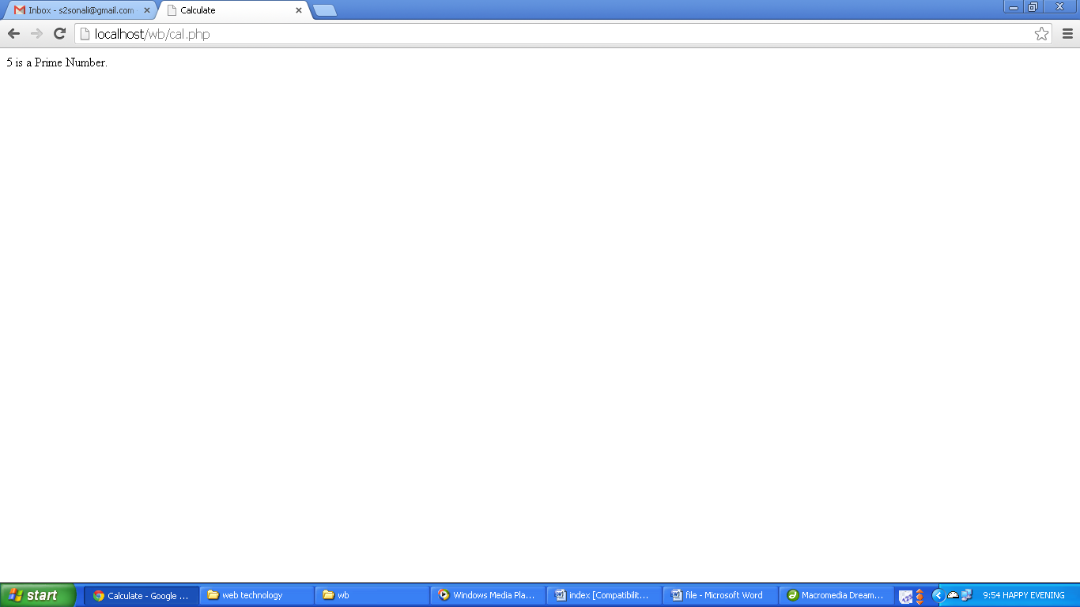

***Assignment 21(Web Page)***

* Login Form
  + **Code:**
    - index.php

<html><head><title>Login</title></head><body><center>

<form action="check.php" method="post">

<table border="1" cellpadding="7">

<tr><th colspan="2">Please Fill Details to Login</th></tr>

<tr><td>Login Id:</td><td><input type="text" name="loginid"></td></tr>

<tr><td>Password:</td><td><input type="password" name="pwd"></td></tr>

<tr><td colspan="2" align="center"><input type="submit"></td></tr>

</table></form></center></body></html>

* + - Check.php

<?php

$a=$_POST['loginid'];$p=$_POST['pwd'];

if($p=="helloworld")

header("location:/wb/book.php");

else

header("location:/wb/index.php");

?>

</body></html>

* **Output:**

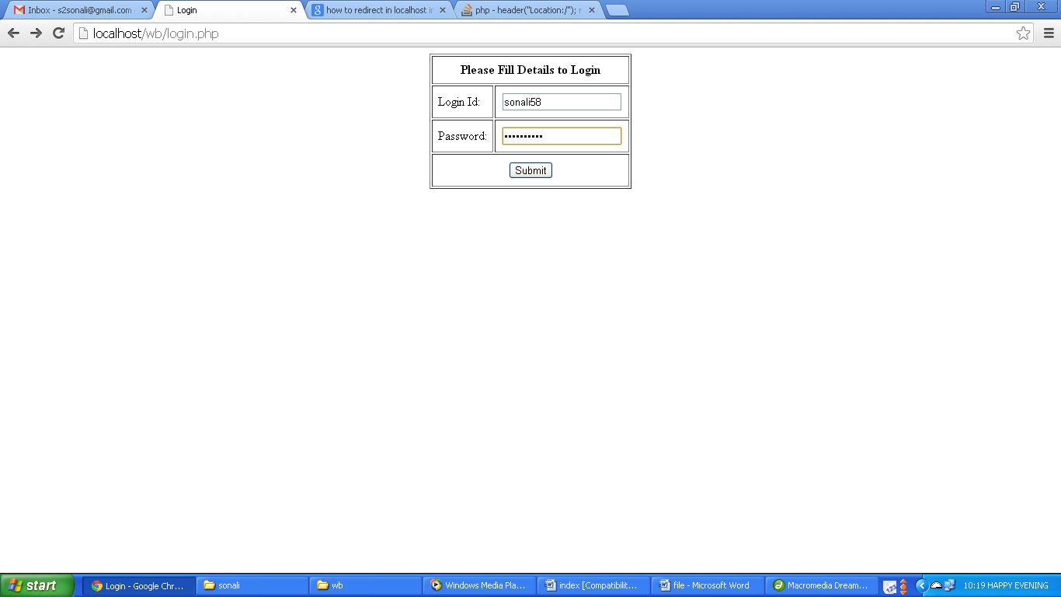

* Home Page
  + **Code:**
    - Book.php

<html><head><title>Book My Show</title><script>

function bg(i)

{ document.getElementById(i).bgColor="#FF0000";}

function bg1(i)

{ document.getElementById(i).bgColor="#000000";}

function bg2(i)

{ document.getElementById(i).bgColor="#FFFFFF";}

function bg3(i)

{ document.getElementById(i).bgColor="#FCF6F0";}

</script> <style>

#main{border-radius:10px;}

body{font-face:arial;}

a{text-decoration:none;}

</style></head>

<body background="bg_main_texture.jpg" vlink="#0000FF" link="#0000FF">

<a href="#top"><img src="up1.png" width="150" height="150" style="position:fixed;bottom:0;right:10px;"/></a>

<script>function get()

{ var a=prompt("Enter Email Id.","");

if(a=="")

{ alert("Please Enter valid Email Id.");

get();

}

var pattern=/^([a-zA-Z0-9_.-])+@([a-zA-Z0-9_.-])+\.([a-zA-Z])+([a-zA-Z])+/;

if(pattern.test(a))

return true;

else

{ alert("Invalid Email Id."); return false; }}</script><center>

<table border="0" width="73%" name="top">

<tr><td width="34%"><font size="2" face="arial">&nbsp;&nbsp;&nbsp;&nbsp;&nbsp;&nbsp;<font color="#0000FF" onClick="window.open('help.html','_top')" target="_parent">24/7 Customer Care</a> | <font color="#0000FF" onClick="get()">Resend Booking Confirmation</font></font></td>

<td colspan="5" align="right" valign="middle" width="450"><b><font color="#0000FF" face="arial">

<script>var d=new Date();var t=d.getHours();

if(t<12){document.write("Good Morning");}

else if(t>=12 && t<16){document.write("Good Afternoon");}

else if(t>=16 && t<21){document.write("Good Evening");}

else{document.write("Good Night");}

</script></font></b></td><td colspan="5" align="right"><script>

var d=new Date();var t=d.getHours();

if(t<12){document.write("<img src='10.gif' width='60' height='45'/>");}

else if(t>=12 && t<16){document.write("<img src='11.gif' width='60' height='60'/>");}

else if(t>=16 && t<21){document.write("<img src='12.gif' width='50' height='50'/>");}

else{document.write("<img src='earth4.gif' width='50' height='50'/>");}

</script><!--<img src="10.gif" width="60" height="45"/>--></td></tr></table>

<table border="0" width="73%"><tr><td>

<table border="0" width="100%" bgcolor="#FFFFFF" cellpadding="7" cellspacing="0">

<tr><td width="17%" align="left"><a href="index.html"><img src="logo.png" border="0" height="60" width="180"/></a></td>

<td align="right" valign="bottom" colspan="4"><form><b>Search:</b> <input type="text" name="search" size="25" onFocus="this.style.backgroundColor='#FF9900'" onBlur="this.style.backgroundColor='#FFFFFF'"/> <input type="submit" name="submit" value="Search"/> </form></td></tr><tr><td colspan="5" align="center" bgcolor="#000000">

<table width="100%" border="0" bgcolor="#000000" cellpadding='0' cellspacing='0'>

<tr><td width="20" align="center" bgcolor="#FF0000" height="25"><a href="index.html"><img src="home4.png" border="0" width="25" height="20"/></a></td>

<td width="50" id="121" align="center" onMouseOver="bg(this.id)" onMouseOut="bg1(this.id)"><a href=""><font color="#FFFFFF" size="3" face="arial"><b>Movies</b></font></a></td>

<td width="120" id="122" align="center" onMouseOver="bg(this.id)" onMouseOut="bg1(this.id)"><a href=""><font color="#FFFFFF" size="3" face="arial"><b>Events & Theatre</b></font></a></td>

<td width="40" id="123" align="center" onMouseOver="bg(this.id)" onMouseOut="bg1(this.id)"><a href="" onMouseOver="color()"><font color="#FFFFFF" size="3" face="arial"><b>Sports</b></font></a></td>

<td width="40" id="124" align="center" onMouseOver="bg(this.id)" onMouseOut="bg1(this.id)"><a href=""><font color="#FFFFFF" size="3" face="arial"><b>Offers</b></font></a></td>

<td width="40" id="125" align="center" onMouseOver="bg(this.id)" onMouseOut="bg1(this.id)"><a href=""><font color="#FFFFFF" size="3" face="arial"><b>Applications</b></font></a></td>

<td width="40" id="126" align="center" onMouseOver="bg(this.id)" onMouseOut="bg1(this.id)"><a href=""><font color="#FFFFFF" size="3" face="arial"><b>Exclusives</b></font></a></td>

</tr></table></td></tr><tr>

<td colspan="5" bgcolor="#FCF6F0"><table border="0" width="100%">

<tr><td width="323"><form><table width="100%" border="0" cellspacing="0" cellpadding="0">

<tr><td colspan="7"><font size="4" face="arial">Instant Ticket Booking<br><br></font></td>

</tr><tr><td width="25%" align="center" bgcolor="#FFDC42" colspan="3"><font size="2" face="arial"><b>Movies</b></font></td>

<td width="25%" align="right"><b><font size="2" face="arial" color="#FF0000">Plays</font>&nbsp;&nbsp;&nbsp;&nbsp; |</b></td>

<td width="25%" align="right"><b><font size="2" face="arial" color="#FF0000">Events</font>&nbsp;&nbsp;&nbsp;&nbsp; |</b></td>

<td width="25%" align="center"><b><font size="2" face="arial" color="#FF0000">Sports</font></b></td></tr><tr>

<td colspan="7">&nbsp;</td></tr><tr>

<td width="15%" align="left" colspan="3"><font size="2" face="arial"><input type="radio" name="type" value="movies" checked/> Movies</font></td>

<td align="right"><marquee behavior="alternate" onMouseOver="this.stop()" onMouseOut="this.start()"><img src="8.jpg" width="600" height="275" border="0"/>

<img src="7.jpg" width="600" height="275" border="0"/> </marquee></td></tr></table></td></tr><tr bgcolor="#FCF6F0"><form> <td width="16%"><table border="1" width="50%" cellspacing="0" cellpadding="0" bordercolor="#FF0000" bgcolor="#FFFFFF><tr>

<td onMouseDown="this.innerHTML='<center><button type=button name=buy>Buy Tickets</button></center>'" onMouseUp="this.innerHTML='Oct 25-27<br>Noida'">

<font face="arial" size="2">Oct 25-27<br>Noida</font></td></tr></table></td></tr></table>

</td><td width="17%"> <table border="1" width="100%" bordercolor="#CCCCCC" bgcolor="#FFFFFF" cellpadding='0' cellspacing='0'><tr><td bordercolor="#CCCCCC"><pre><font face="arial" size="2"><b> Prediction for ‘Zanjeer’</b>

<hr width="290"><i><font size="1"> Posted on August 31, 2013</font></i>

Now this one’s a remake of the 1971 cult action

film of the same name. Will director Apoorva

Lakhia be able to do justice to the original

<font color="#0000FF">Read more</font>

</font></pre>

</td></tr></table></td><td width="10">&nbsp;</td><td><table border="0" width="100%" cellpadding='0' cellspacing='0'><tr><td><table border="0" width="100%" cellpadding='0' cellspacing='0'><tr><td width="100" align="left"colspan="5"><font face="arial" size="3"><b>

Featured</b></font></td></td></tr><tr><td colspan="7"><hr></td></tr><tr>

</td></tr></table></td></tr><tr bgcolor="#FF0000"><td colspan="6"></td></tr>

<tr bgcolor="#000000"><td colspan="6" align="center" height="50"><font color="#FFFFFF" size="2" face="arial">Copyright 2013 © Bigtree Entertainment Pvt. Ltd. All Rights Reserved</font></td>

</tr></table></td></tr></table></center></body></html>

* + **Output:**

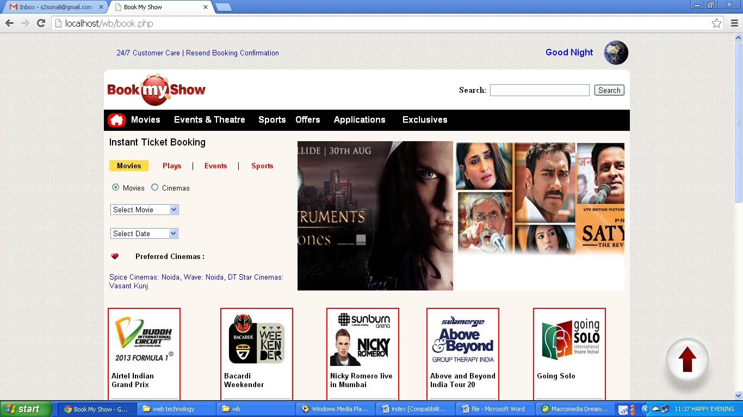

* Feedback Form
  + **Code:**
    - help.php

<html><head><title>Book My Show</title>

<style>

#main{border-radius:10px;}

body{font-face:arial;}

a{text-decoration:none;}

</style></head><body background="bg_main_texture.jpg" vlink="#0000FF" link="#0000FF">

<center><table border="0" width="73%"><tr><td width="34%">

<font size="2" face="arial">&nbsp;&nbsp;&nbsp;&nbsp;&nbsp;&nbsp;<font color="#0000FF" onClick="window.open('help.php','_top')" target="_parent">24/7 Customer Care</a> | <font color="#0000FF" onClick="get()">Resend Booking Confirmation</font></font></td>

<td colspan="5" align="right" valign="middle" width="450">

<b><font color="#0000FF" face="arial">National Capital Region (NCR)</font></b></td>

<td colspan="5" align="right"><script>

var d=new Date();var t=d.getHours();if(t<12){document.write("<img src='10.gif' width='60' height='45'/>");}else if(t>=12 && t<16){document.write("<img src='11.gif' width='60' height='60'/>");}else if(t>=16 && t<21){document.write("<img src='12.gif' width='50' height='50'/>");}else{ document.write("<img src='earth4.gif' width='50' height='50'/>"); }</script></td></tr></table><table border="0" width="73%"><tr><td>

<table border="0" width="100%" bgcolor="#FFFFFF" cellpadding="7" cellspacing="0" id="main"><tr><td width="17%" align="left" colspan="2"><a href="index.php"><img src="logo.png" border="0" height="60" width="180"/></a> </td></tr><tr><td colspan="5" align="center" bgcolor="#000000"><table width="100%" border="0" bgcolor="#000000" cellpadding='0' cellspacing='0'>

<tr><td width="20" align="center" bgcolor="#FF0000" height="25" style="border-radius:10px;"><a href="index.php"><img src="home4.png" style="border-radius:10px;" border="0" width="25" height="20"/></a></td><td width="50" align="center" onMouseOver="this.bgColor='#FF0000'" onMouseOut="this.bgColor='#000000'"><a href=""><font color="#FFFFFF" size="3" face="arial"><b>Movies</b></font></a></td> <td width="120" align="center" onMouseOver="this.bgColor='#FF0000'" onMouseOut="this.bgColor='#000000'"><a href=""><font color="#FFFFFF" size="3" face="arial"><b>Events & Theatre</b></font></a></td>

</tr></table></td></tr><tr bgcolor="#FCF6F0"><td colspan="2">&nbsp;</td></tr>

<tr bgcolor="#FCF6F0"><td rowspan="2" width="350">

<table border="1" cellspacing="0" width="100%" cellpadding="10" bordercolor="#CCCCCC" style="border-radius:10px;"><tr><td bgcolor="#FFFFFF" style="border-radius:10px;">

<font size="3" face="arial"><b>Contact Us Now!!!</b></font><hr><font size="2" face="arial"><form action="submit.php" method="post"><table border="0" cellpadding="5" width="100%"><tr><td width="35%">Name:</td><td><input type="text" name="name" size="40"></td></tr><tr><td width="35%">Phone No.</td><td><input type="text" name="phone" size="40"></td></tr> <tr><td width="35%">Email Id:</td><td><input type="text" name="email" size="40"></td></tr> <tr><td width="35%">City:</td><td><select name="city"><option value="">---Select---</option><option value="Delhi">Delhi</option><option value="NCR">NCR</option></select></td></tr> <tr><td colspan="2">Your Comments/ Suggessions/ Complaints:</td></tr> <tr><td colspan="2"><textarea name="com" rows="6" cols="54"></textarea></td></tr> <tr><td colspan="2" align="center"><input type="submit"></td></tr></table></form><tr bgcolor="#FF0000"><td colspan="6">&nbsp;</td></tr><tr bgcolor="#000000"><td colspan="6" align="center" height="50"><font color="#FFFFFF" size="2" face="arial">Copyright 2013 © Bigtree Entertainment Pvt. Ltd. All Rights Reserved</font></td></tr></table></td></tr></table></center></body></html>

* + **Output:**

