Assignment 1 (Simple Calculator)

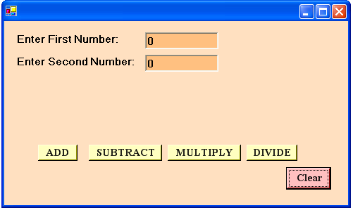

Code:
Public Class calc
Inherits System.Windows.Forms.Form

Private Sub b1_Click_1(ByVal sender As System.Object, ByVal e As System.EventArgs) Handles b1.Click
MsgBox(Val(t1.Text) + Val(t2.Text))
End Sub

Private Sub b2_Click_1(ByVal sender As System.Object, ByVal e As System.EventArgs) Handles b2.Click
MsgBox(Val (t1.Text) - Val(t2.Text))
End Sub

Private Sub b3_Click_1(ByVal sender As System.Object, ByVal e As System.EventArgs) Handles b3.Click
MsgBox(Val(t1.Text) * Val(t2.Text))
End Sub

Private Sub b4_Click_1(ByVal sender As System.Object, ByVal e As System.EventArgs) Handles b4.Click
MsgBox(Val(t1.Text) / Val(t2.Text))
End Sub

Private Sub clr_Click_1(ByVal sender As System.Object, ByVal e As System.EventArgs) Handles clr.Click
t1.Text = "0"
t2.Text = "0"
End Sub

End Class

Assignment 2 (Registration Form)

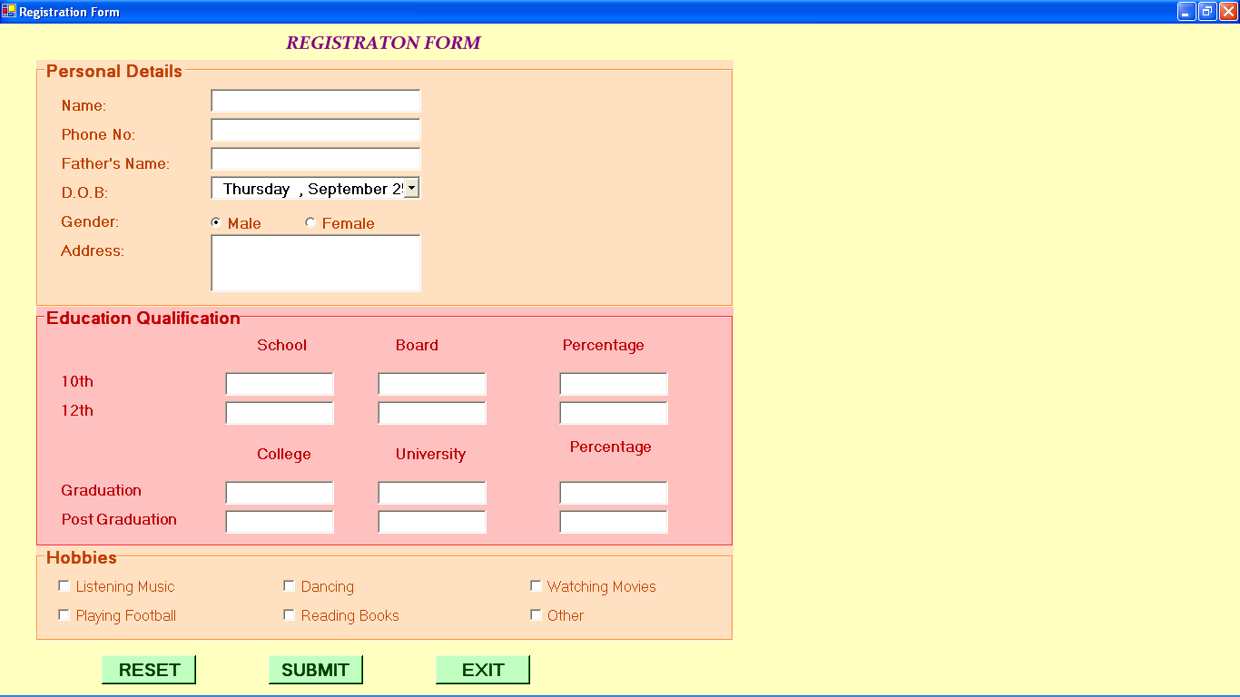
Code:
Public Class registration
Inherits System.Windows.Forms.Form
Private Sub b1_Click(ByVal sender As System.Object, ByVal e As System.EventArgs) Handles b1.Click
t1.Text = "" t2.Text = ""
t3.Text = "" t4.Text = ""
t5.Text = "" te1.Text = ""
te2.Text = "" te3.Text = ""
te4.Text = "" te5.Text = ""
te6.Text = "" te7.Text = ""
te8.Text = "" te9.Text = ""
te10.Text = "" te11.Text = ""
te12.Text = ""
r1.Checked() = True
r2.Checked() = False
ch1.Checked() = False
ch2.Checked() = False
ch3.Checked() = False
ch4.Checked() = False
ch5.Checked() = False
ch6.Checked() = False
End Sub
Private Sub b2_Click(ByVal sender As System.Object, ByVal e As System.EventArgs) Handles b2.Click
MsgBox("Data Submitted")
End Sub

Private Sub b3_Click(ByVal sender As System.Object, ByVal e As System.EventArgs) Handles b3.Click
i = MsgBox("Do You Want to Quit", MsgBoxStyle.YesNo)
If i = vbYes Then
Me.Close()
End If
End Sub
End Class
Assignment 3 (Color Change Form)

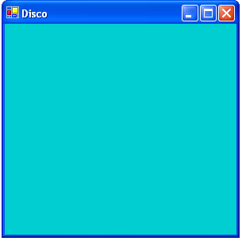

Code:
Public Class disco
Inherits System.Windows.Forms.Form

Private Sub disco_Click(ByVal sender As Object, ByVal e As System.EventArgs) Handles MyBase.Click
Me.BackColor = Color.Sienna
End Sub

Private Sub disco_Closed(ByVal sender As Object, ByVal e As System.EventArgs) Handles MyBase.Closed
MsgBox("Thank You. Have a great day ahead")
End Sub

Private Sub disco_Disposed(ByVal sender As Object, ByVal e As System.EventArgs) Handles MyBase.Disposed
MsgBox("YOU ARE EXITED")
End Sub

Private Sub disco_DoubleClick(ByVal sender As Object, ByVal e As System.EventArgs) Handles MyBase.DoubleClick
Me.BackColor = Color.CadetBlue
End Sub

Private Sub disco_KeyDown(ByVal sender As Object, ByVal e As System.Windows.Forms.KeyEventArgs) Handles MyBase.KeyDown
Me.BackColor = Color.Crimson
End Sub

Private Sub disco_KeyPress(ByVal sender As Object, ByVal e As System.Windows.Forms.KeyPressEventArgs) Handles MyBase.KeyPress
Me.BackColor = Color.DarkSeaGreen
End Sub

Private Sub disco_KeyUp(ByVal sender As Object, ByVal e As System.Windows.Forms.KeyEventArgs) Handles MyBase.KeyUp
Me.BackColor = Color.DarkTurquoise
End Sub

Private Sub disco_Load(ByVal sender As Object, ByVal e As System.EventArgs) Handles MyBase.Load
MsgBox("WELCOME GUEST")
End Sub

Private Sub disco_MouseDown(ByVal sender As Object, ByVal e As System.Windows.Forms.MouseEventArgs) Handles MyBase.MouseDown
Me.BackColor = Color.BlanchedAlmond
End Sub

Private Sub disco_MouseEnter(ByVal sender As Object, ByVal e As System.EventArgs) Handles MyBase.MouseEnter
Me.BackColor = Color.Cornsilk
End Sub

Private Sub disco_MouseHover(ByVal sender As Object, ByVal e As System.EventArgs) Handles MyBase.MouseHover
Me.BackColor = Color.AliceBlue
End Sub

Private Sub disco_MouseLeave(ByVal sender As Object, ByVal e As System.EventArgs) Handles MyBase.MouseLeave
Me.BackColor = Color.Chocolate
End Sub

Private Sub disco_MouseMove(ByVal sender As Object, ByVal e As System.Windows.Forms.MouseEventArgs) Handles MyBase.MouseMove
Me.BackColor = Color.Gainsboro
End Sub

Private Sub disco_MouseUp(ByVal sender As Object, ByVal e As System.Windows.Forms.MouseEventArgs) Handles MyBase.MouseUp
Me.BackColor = Color.Honeydew
End Sub

Private Sub disco_MouseWheel(ByVal sender As Object, ByVal e As System.Windows.Forms.MouseEventArgs) Handles MyBase.MouseWheel
Me.BackColor = Color.Indigo
End Sub

Private Sub disco_LostFocus(ByVal sender As Object, ByVal e As System.EventArgs) Handles MyBase.LostFocus
Me.BackColor = Color.Thistle
End Sub

End Class

Assignment 4 (Form With Controls)

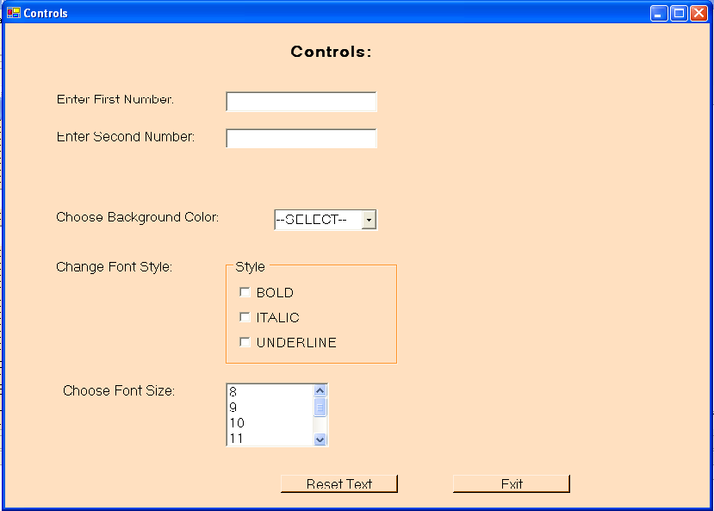

Code:
Public Class Controls_form
Inherits System.Windows.Forms.Form
Private Sub t4_SelectedIndexChanged(ByVal sender As System.Object, ByVal e As System.EventArgs) Handles t4.SelectedIndexChanged
Dim i As String
i = t4.SelectedItem
If i = "Green" Then
Me.BackColor() = Color.Green
ElseIf i = "Red" Then
Me.BackColor() = Color.Red
ElseIf i = "Blue" Then
Me.BackColor() = Color.Blue
End If
End Sub
Private Sub c1_Click(ByVal sender As System.Object, ByVal e As System.EventArgs) Handles c1.CheckedChanged
If c1.Checked() Then
t1.Font = New Font(t1.Font, FontStyle.Bold)
t2.Font = New Font(t2.Font, FontStyle.Bold)
Else
t1.Font = New Font(t1.Font, FontStyle.Regular)
t2.Font = New Font(t2.Font, FontStyle.Regular)
End If
End Sub
Private Sub t5_SelectedIndexChanged(ByVal sender As System.Object, ByVal e As System.EventArgs) Handles t5.SelectedIndexChanged
Dim i As Integer
i = t5.SelectedIndex
If i = 0 Then
t1.Font = New Font(t1.Font.FontFamily, 8)
t2.Font = New Font(t2.Font.FontFamily, 8)
ElseIf i = 1 Then
t1.Font = New Font(t1.Font.FontFamily, 9)
t2.Font = New Font(t2.Font.FontFamily, 9)
ElseIf i = 2 Then
t1.Font = New Font(t1.Font.FontFamily, 10)
t2.Font = New Font(t2.Font.FontFamily, 10)
ElseIf i = 3 Then
t1.Font = New Font(t1.Font.FontFamily, 11)
t2.Font = New Font(t2.Font.FontFamily, 11)
ElseIf i = 4 Then
t1.Font = New Font(t1.Font.FontFamily, 12)
t2.Font = New Font(t2.Font.FontFamily, 12)
ElseIf i = 5 Then
t1.Font = New Font(t1.Font.FontFamily, 13)
t2.Font = New Font(t2.Font.FontFamily, 13)
ElseIf i = 6 Then
t1.Font = New Font(t1.Font.FontFamily, 14)
t2.Font = New Font(t2.Font.FontFamily, 14)
End If
End Sub
Private Sub c2_CheckedChanged(ByVal sender As System.Object, ByVal e As System.EventArgs) Handles c2.CheckedChanged
If c2.Checked() Then
t1.Font = New Font(t1.Font, FontStyle.Italic)
t2.Font = New Font(t2.Font, FontStyle.Italic)
Else
t1.Font = New Font(t1.Font, FontStyle.Regular)
t2.Font = New Font(t2.Font, FontStyle.Regular)
End If
End Sub
Private Sub c3_CheckedChanged(ByVal sender As System.Object, ByVal e As System.EventArgs) Handles c3.CheckedChanged
If c3.Checked() Then
t1.Font = New Font(t1.Font, FontStyle.Underline)
t2.Font = New Font(t2.Font, FontStyle.Underline)
Else
t1.Font = New Font(t1.Font, FontStyle.Regular)
t2.Font = New Font(t2.Font, FontStyle.Regular)
End If
End Sub
Private Sub b1_Click(ByVal sender As System.Object, ByVal e As System.EventArgs) Handles b1.Click
t1.Text = ""
t2.Text = ""
t1.Font = New Font(t1.Font, FontStyle.Regular)
t2.Font = New Font(t2.Font, FontStyle.Regular)
t1.Font = New Font(t1.Font.FontFamily, 8)
t2.Font = New Font(t2.Font.FontFamily, 8)
t4.SelectedItem() = "--Select--"
c1.Checked = False
c2.Checked = False
c3.Checked = False
t5.SelectedIndex() = 0
Me.BackColor = Color.Bisque
End Sub
Private Sub b2_Click(ByVal sender As System.Object, ByVal e As System.EventArgs) Handles b2.Click
Me.Close()
End Sub End Class
Assignment 5 (Scientific Calculator)

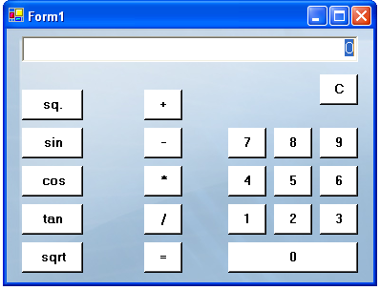

Code:
Public Class Form1
Inherits System.Windows.Forms.Form

Dim a As String
Dim b As Integer

Private Sub b1_Click(ByVal sender As System.Object, ByVal e As System.EventArgs) Handles b1.Click
If t1.Text = "" Then
t1.Text = 1
Else
t1.Text = t1.Text + "1"
End If
End Sub

Private Sub b2_Click(ByVal sender As System.Object, ByVal e As System.EventArgs) Handles b2.Click
If t1.Text = "" Then
t1.Text = 2
Else
t1.Text = t1.Text + "2"
End If
End Sub

Private Sub b3_Click(ByVal sender As System.Object, ByVal e As System.EventArgs) Handles b3.Click
If t1.Text = "" Then
t1.Text = 3
Else
t1.Text = t1.Text + "3"
End If
End Sub

Private Sub b4_Click(ByVal sender As System.Object, ByVal e As System.EventArgs) Handles b4.Click
If t1.Text = "" Then
t1.Text = 4
Else
t1.Text = t1.Text + "4"
End If
End Sub

Private Sub b5_Click(ByVal sender As System.Object, ByVal e As System.EventArgs) Handles b5.Click
If t1.Text = "" Then
t1.Text = 5
Else
t1.Text = t1.Text + "5"
End If
End Sub

Private Sub b6_Click(ByVal sender As System.Object, ByVal e As System.EventArgs) Handles b6.Click
If t1.Text = "" Then
t1.Text = 6
Else
t1.Text = t1.Text + "6"
End If
End Sub

Private Sub b7_Click(ByVal sender As System.Object, ByVal e As System.EventArgs) Handles b7.Click
If t1.Text = "" Then
t1.Text = 7
Else
t1.Text = t1.Text + "7"
End If
End Sub

Private Sub b8_Click(ByVal sender As System.Object, ByVal e As System.EventArgs) Handles b8.Click
If t1.Text = "" Then
t1.Text = 8
Else
t1.Text = t1.Text + "8"
End If
End Sub

Private Sub b9_Click(ByVal sender As System.Object, ByVal e As System.EventArgs) Handles b9.Click
If t1.Text = "" Then
t1.Text = 9
Else
t1.Text = t1.Text + "9"
End If
End Sub

Private Sub b0_Click(ByVal sender As System.Object, ByVal e As System.EventArgs) Handles b0.Click
If t1.Text = "" Then
t1.Text = 0
Else
t1.Text = t1.Text + "0"
End If
End Sub

Private Sub bclr_Click(ByVal sender As System.Object, ByVal e As System.EventArgs) Handles bclr.Click
t1.Text = ""
End Sub

Private Sub bplus_Click(ByVal sender As System.Object, ByVal e As System.EventArgs) Handles bplus.Click
a = "+"
If t1.Text = "" Then
b = 0
Else
b = t1.Text
End If
t1.Text = ""
End Sub

Private Sub bsq_Click(ByVal sender As System.Object, ByVal e As System.EventArgs) Handles bsq.Click
Dim i As Integer
Dim j As Integer
i = t1.Text()
j = i * i
t1.Text = j
End Sub

Private Sub bsin_Click(ByVal sender As System.Object, ByVal e As System.EventArgs) Handles bsin.Click
Dim i As Double
Dim j As Double
i = t1.Text()
j = Math.Sin(i)
t1.Text = j
End Sub

Private Sub bcos_Click(ByVal sender As System.Object, ByVal e As System.EventArgs) Handles bcos.Click
Dim i As Double
Dim j As Double
i = t1.Text()
j = Math.Cos(i)
t1.Text = j
End Sub

Private Sub btan_Click(ByVal sender As System.Object, ByVal e As System.EventArgs) Handles btan.Click
Dim i As Double
Dim j As Double
i = t1.Text()
j = Math.Tan(i)
t1.Text = j
End Sub

Private Sub bsqrt_Click(ByVal sender As System.Object, ByVal e As System.EventArgs) Handles bsqrt.Click
Dim i As Integer
Dim j As Integer
i = t1.Text()
j = Math.Sqrt(i)
t1.Text = j
End Sub

Private Sub bmius_Click(ByVal sender As System.Object, ByVal e As System.EventArgs) Handles bmius.Click
a = "-"
If t1.Text = "" Then
b = 0
Else
b = t1.Text
End If
t1.Text = ""
End Sub

Private Sub bmul_Click(ByVal sender As System.Object, ByVal e As System.EventArgs) Handles bmul.Click
a = "*"
If t1.Text = "" Then
b = 0
Else
b = t1.Text
End If
t1.Text = ""
End Sub

Private Sub bdiv_Click(ByVal sender As System.Object, ByVal e As System.EventArgs) Handles bdiv.Click
a = "/"
If t1.Text = "" Then
b = 0
Else
b = t1.Text
End If
t1.Text = ""
End Sub

Private Sub bequal_Click(ByVal sender As System.Object, ByVal e As System.EventArgs) Handles bequal.Click
Dim j As Integer
If a = "+" Then
j = b + t1.Text
ElseIf a = "-" Then
j = b - t1.Text
ElseIf a = "*" Then
j = b * t1.Text
ElseIf a = "/" Then
j = b / t1.Text
End If
t1.Text = j
End Sub

End Class

Assignment 6 (Login Form)

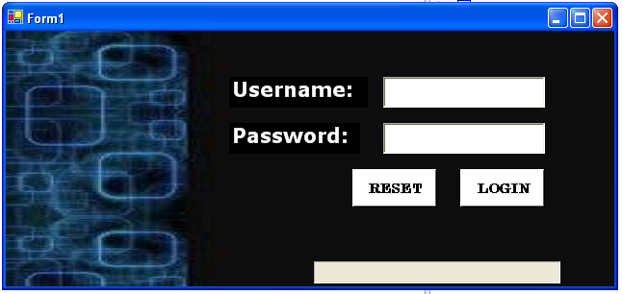

Code:
Public Class Form1
Inherits System.Windows.Forms.Form

Private Sub b1_Click(ByVal sender As System.Object, ByVal e As System.EventArgs) Handles b1.Click
If t1.Text = "sonali" And t2.Text = "abc" Then
Timer1.Enabled = True
Else
MsgBox("Invalid Usernamer and password")
End If

End Sub

Private Sub b2_Click(ByVal sender As System.Object, ByVal e As System.EventArgs) Handles b2.Click
t1.Text = ""
t2.Text = ""
End Sub

Private Sub Timer1_Tick(ByVal sender As System.Object, ByVal e As System.EventArgs) Handles Timer1.Tick
If pb.Value < 100 Then
pb.Value = pb.Value + 20
Else
Me.Close()
Dim a As New welcome
a.Show()
End If
End Sub

End Class

Assignment 7 (Logic Form)

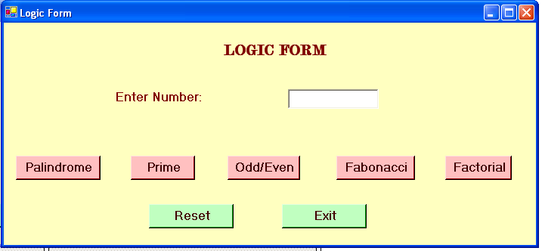

Code:
Public Class Logic_Form
Inherits System.Windows.Forms.Form

Private Sub b1_Click(ByVal sender As System.Object, ByVal e As System.EventArgs) Handles b1.Click
Dim n As Integer
Dim m As Integer
Dim r As Integer
Dim p As Integer
n = t1.Text
r = 0
m = n
While m <> 0
p = m Mod 10
r = (r * 10) + p
m = m / 10
End While
If n = r Then
MsgBox("This is a Palindrome Number")
Else
MsgBox("This is not a Palindrome Number")
End If
End Sub

Private Sub b2_Click(ByVal sender As System.Object, ByVal e As System.EventArgs) Handles b2.Click
Dim n As Integer
Dim i As Integer
Dim f As Integer
f = 0
n = t1.Text
For i = 2 To n - 1
If n Mod i = 0 Then
f = 1
End If
Next
If f = 1 Then
MsgBox("This is not a prime number")
Else
MsgBox("This is a prime number")
End If
End Sub

Private Sub b3_Click(ByVal sender As System.Object, ByVal e As System.EventArgs) Handles b3.Click
Dim i As Integer
i = t1.Text
If i Mod 2 = 0 Then
MsgBox("This is an even number")
Else
MsgBox("This is a odd number")
End If
End Sub

Private Sub b4_Click(ByVal sender As System.Object, ByVal e As System.EventArgs) Handles b4.Click
Dim i As Integer
Dim j As Integer
Dim a As Integer
Dim b As Integer
Dim c As Integer
Dim sh As String
j = t1.Text
sh = "0,1"
a = 0
b = 1
For i = 0 To j - 2
c = a + b
sh = sh + "," + c.ToString
a = b
b = c
i = i + 1
Next
MsgBox(sh)
End Sub
Private Sub b5_Click(ByVal sender As System.Object, ByVal e As System.EventArgs) Handles b5.Click
Dim n As Integer
Dim j As Integer
Dim i As Integer
n = t1.Text
j = 1
For i = 1 To n
j = j * i
Next
MsgBox(j)
End Sub
Private Sub b6_Click(ByVal sender As System.Object, ByVal e As System.EventArgs) Handles b6.Click
t1.Text = ""
End Sub
Private Sub b7_Click(ByVal sender As System.Object, ByVal e As System.EventArgs) Handles b7.Click
Dim i As String
i = MsgBox("Do you want to exit", MsgBoxStyle.YesNo)
If i = vbYes Then
Me.Close()
End If
End Sub

End Class
Assignment 8 (Form With Tabs)

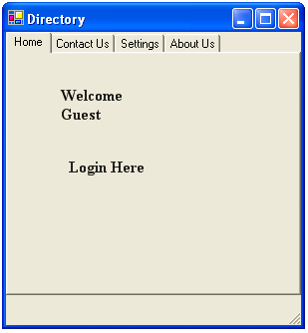

Code:
Public Class Directory
Inherits System.Windows.Forms.Form

Private Sub l2_Click(ByVal sender As System.Object, ByVal e As System.EventArgs) Handles l2.Click
Dim l As New Form1
l.Show()
End Sub

End Class

Assignment 9 (Matrix Calculation)

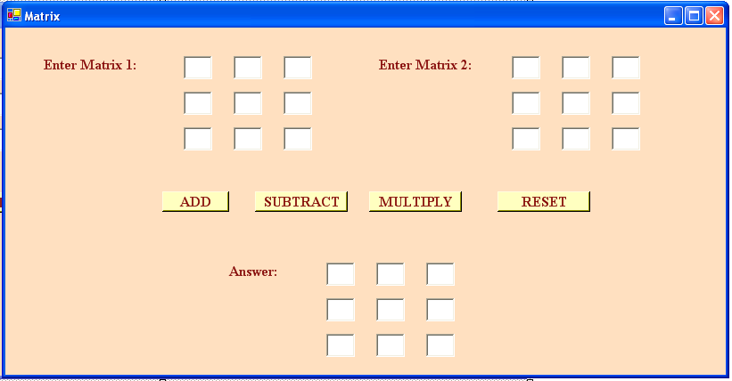

Code:
Public Class Matrix
Inherits System.Windows.Forms.Form

Private Sub b1_Click(ByVal sender As System.Object, ByVal e As System.EventArgs) Handles b1.Click
a(1, 1) = a11.Text
a(1, 2) = a12.Text
a(1, 3) = a13.Text
a(2, 1) = a21.Text
a(2, 2) = a22.Text
a(2, 3) = a23.Text
a(3, 1) = a31.Text
a(3, 2) = a32.Text
a(3, 3) = a33.Text

b(1, 1) = b11.Text
b(1, 2) = b12.Text
b(1, 3) = b13.Text
b(2, 1) = b21.Text
b(2, 2) = b22.Text
b(2, 3) = b23.Text
b(3, 1) = b31.Text
b(3, 2) = b32.Text
b(3, 3) = b33.Text
Dim i, j As Integer
For i = 1 To 3
For j = 1 To 3
c(i, j) = a(i, j) + b(i, j)
Next
Next
c11.Text = c(1, 1)
c12.Text = c(1, 2)
c13.Text = c(1, 3)
c21.Text = c(2, 1)
c22.Text = c(2, 2)
c23.Text = c(2, 3)
c31.Text = c(3, 1)
c32.Text = c(3, 2)
c33.Text = c(3, 3)
End Sub

Private Sub b2_Click(ByVal sender As System.Object, ByVal e As System.EventArgs) Handles b2.Click
a(1, 1) = a11.Text
a(1, 2) = a12.Text
a(1, 3) = a13.Text
a(2, 1) = a21.Text
a(2, 2) = a22.Text
a(2, 3) = a23.Text
a(3, 1) = a31.Text
a(3, 2) = a32.Text
a(3, 3) = a33.Text

b(1, 1) = b11.Text
b(1, 2) = b12.Text
b(1, 3) = b13.Text
b(2, 1) = b21.Text
b(2, 2) = b22.Text
b(2, 3) = b23.Text
b(3, 1) = b31.Text
b(3, 2) = b32.Text
b(3, 3) = b33.Text
Dim i, j As Integer
For i = 1 To 3
For j = 1 To 3
c(i, j) = a(i, j) - b(i, j)
Next
Next
c11.Text = c(1, 1)
c12.Text = c(1, 2)
c13.Text = c(1, 3)
c21.Text = c(2, 1)
c22.Text = c(2, 2)
c23.Text = c(2, 3)
c31.Text = c(3, 1)
c32.Text = c(3, 2)
c33.Text = c(3, 3)
End Sub

Private Sub b3_Click(ByVal sender As System.Object, ByVal e As System.EventArgs) Handles b3.Click
a(1, 1) = a11.Text
a(1, 2) = a12.Text
a(1, 3) = a13.Text
a(2, 1) = a21.Text
a(2, 2) = a22.Text
a(2, 3) = a23.Text
a(3, 1) = a31.Text
a(3, 2) = a32.Text
a(3, 3) = a33.Text

b(1, 1) = b11.Text
b(1, 2) = b12.Text
b(1, 3) = b13.Text
b(2, 1) = b21.Text
b(2, 2) = b22.Text
b(2, 3) = b23.Text
b(3, 1) = b31.Text
b(3, 2) = b32.Text
b(3, 3) = b33.Text
Dim i, j, k As Integer
For i = 1 To 3
For j = 1 To 3
c(i, j) = 0
For k = 1 To 3
c(i, j) = c(i, j) + (a(i, k) * b(k, j))
Next
Next
Next
c11.Text = c(1, 1)
c12.Text = c(1, 2)
c13.Text = c(1, 3)
c21.Text = c(2, 1)
c22.Text = c(2, 2)
c23.Text = c(2, 3)
c31.Text = c(3, 1)
c32.Text = c(3, 2)
c33.Text = c(3, 3)
End Sub

Private Sub b4_Click(ByVal sender As System.Object, ByVal e As System.EventArgs) Handles b4.Click
a11.Text = ""
a12.Text = ""
a13.Text = ""
a21.Text = ""
a22.Text = ""
a23.Text = ""
a31.Text = ""
a32.Text = ""
a33.Text = ""

b11.Text = ""
b12.Text = ""
b13.Text = ""
b21.Text = ""
b22.Text = ""
b23.Text = ""
b31.Text = ""
b32.Text = ""
b33.Text = ""

c11.Text = ""
c12.Text = ""
c13.Text = ""
c21.Text = ""
c22.Text = ""
c23.Text = ""
c31.Text = ""
c32.Text = ""
c33.Text = ""
End Sub

End Class

Assignment 10 (Notepad Using Main Menu)

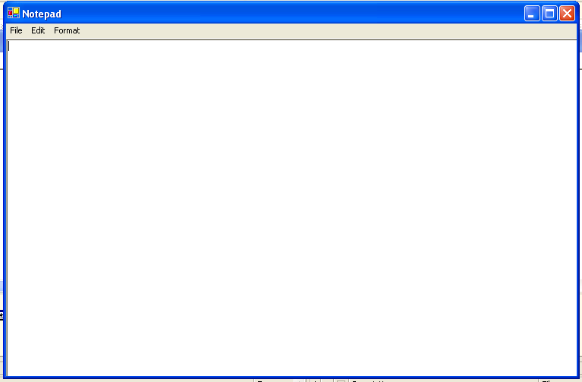

Code:
Public Class Notepad
Inherits System.Windows.Forms.Form
Dim na As String
Private Sub l2_Click(ByVal sender As System.Object, ByVal e As System.EventArgs) Handles l2.Click
od.InitialDirectory = "C:\"
od.Filter = "Text Files(*.txt)|*.txt"
od.ShowDialog()
Dim a As String
a = od.FileName
If System.IO.File.Exists(a) = True Then
rt.LoadFile(a, RichTextBoxStreamType.PlainText)
na = a
Else
MsgBox("File Does Not Exists")
End If
End Sub
Private Sub l3_Click(ByVal sender As System.Object, ByVal e As System.EventArgs) Handles l3.Click
If na <> "" Then
FileOpen(1, na, OpenMode.Output)
PrintLine(1, rt.Text)
FileClose(1)
Else
sd.InitialDirectory = "C:\"
sd.Filter = "Text Files(*.txt)|*.txt"
sd.ShowDialog()
Dim a As String
a = sd.FileName
FileOpen(1, a, OpenMode.Output)
PrintLine(1, rt.Text)
FileClose(1)
End If
End Sub
Private Sub l4_Click(ByVal sender As System.Object, ByVal e As System.EventArgs) Handles l4.Click
Me.Close()
End Sub
Private Sub l5_Click(ByVal sender As System.Object, ByVal e As System.EventArgs) Handles l7.Click
Clipboard.SetDataObject(rt.SelectedText)
rt.SelectedText() = ""
End Sub
Private Sub l6_Click(ByVal sender As System.Object, ByVal e As System.EventArgs) Handles l8.Click
Clipboard.SetDataObject(rt.SelectedText)
End Sub
Private Sub l7_Click(ByVal sender As System.Object, ByVal e As System.EventArgs) Handles l9.Click
Dim a As IDataObject
a = Clipboard.GetDataObject
rt.SelectedText() = a.GetData(DataFormats.Text)
End Sub
Private Sub MenuItem1_Click(ByVal sender As System.Object, ByVal e As System.EventArgs) Handles l5.Click
rt.Undo()
End Sub

Private Sub MenuItem2_Click(ByVal sender As System.Object, ByVal e As System.EventArgs) Handles l6.Click
rt.Redo()
End Sub

Private Sub l10_Click(ByVal sender As System.Object, ByVal e As System.EventArgs) Handles l10.Click
fd.ShowDialog()
rt.Font = fd.Font
End Sub

Private Sub l11_Click(ByVal sender As System.Object, ByVal e As System.EventArgs) Handles l11.Click
cd.ShowDialog()
If cd.ShowDialog = Windows.Forms.DialogResult.OK Then
rt.SelectionColor = cd.Color
End If
End Sub

Private Sub l1_Click(ByVal sender As System.Object, ByVal e As System.EventArgs) Handles l1.Click
Dim a As New Notepad
a.Show()
na = ""
End Sub

Private Sub l12_Click(ByVal sender As System.Object, ByVal e As System.EventArgs) Handles l12.Click
cd.ShowDialog()
If cd.ShowDialog = Windows.Forms.DialogResult.OK Then
rt.BackColor = cd.Color
End If
End Sub

End Class
Assignment 11 (Notepad Using Tabs and Toolbar)

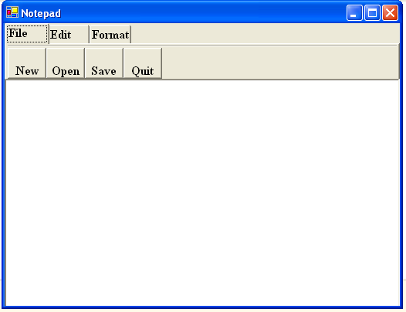

Code:
Public Class notepad1
Inherits System.Windows.Forms.Form

Dim na As String

Private Sub tb1_ButtonClick(ByVal sender As System.Object, ByVal e As System.Windows.Forms.ToolBarButtonClickEventArgs) Handles tb1.ButtonClick
If tb1.Buttons.IndexOf(e.Button) = 0 Then
Dim a As New notepad1
a.Show()
na = ""
ElseIf tb1.Buttons.IndexOf(e.Button) = 1 Then
od.InitialDirectory = "C:\"
od.Filter = "Text Files(*.txt)|*.txt"
od.ShowDialog()
Dim a As String
a = od.FileName
If System.IO.File.Exists(a) = True Then
rt.LoadFile(a, RichTextBoxStreamType.PlainText)
na = a
Else
MsgBox("File Does Not Exists")
End If
ElseIf tb1.Buttons.IndexOf(e.Button) = 2 Then
If na <> "" Then
FileOpen(1, na, OpenMode.Output)
PrintLine(1, rt.Text)
FileClose(1)
Else
sd.InitialDirectory = "C:\"
sd.Filter = "Text Files(*.txt)|*.txt"
sd.ShowDialog()
Dim a As String
a = sd.FileName
FileOpen(1, a, OpenMode.Output)
PrintLine(1, rt.Text)
FileClose(1)
End If
ElseIf tb1.Buttons.IndexOf(e.Button) = 3 Then
Me.Close()
End If
End Sub

Private Sub tb2_ButtonClick(ByVal sender As System.Object, ByVal e As System.Windows.Forms.ToolBarButtonClickEventArgs) Handles tb2.ButtonClick
If tb2.Buttons.IndexOf(e.Button) = 0 Then
Clipboard.SetDataObject(rt.SelectedText)
rt.SelectedText() = ""
ElseIf tb2.Buttons.IndexOf(e.Button) = 1 Then
Clipboard.SetDataObject(rt.SelectedText)
ElseIf tb2.Buttons.IndexOf(e.Button) = 2 Then
Dim a As IDataObject
a = Clipboard.GetDataObject
rt.SelectedText() = a.GetData(DataFormats.Text)
End If
End Sub

Private Sub tb3_ButtonClick(ByVal sender As System.Object, ByVal e As System.Windows.Forms.ToolBarButtonClickEventArgs) Handles tb3.ButtonClick
If tb3.Buttons.IndexOf(e.Button) = 0 Then
fd.ShowDialog()
rt.Font = fd.Font
ElseIf tb3.Buttons.IndexOf(e.Button) = 2 Then
cd.ShowDialog()
If cd.ShowDialog = Windows.Forms.DialogResult.OK Then
rt.SelectionColor = cd.Color
End If
ElseIf tb3.Buttons.IndexOf(e.Button) = 1 Then
cd.ShowDialog()
If cd.ShowDialog = Windows.Forms.DialogResult.OK Then
rt.BackColor = cd.Color
End If
End If
End Sub

Private Sub rt_TextChanged(ByVal sender As System.Object, ByVal e As System.EventArgs) Handles rt.TextChanged
End Sub

End Class

Assignment 12 (Vowel in C++.NET)

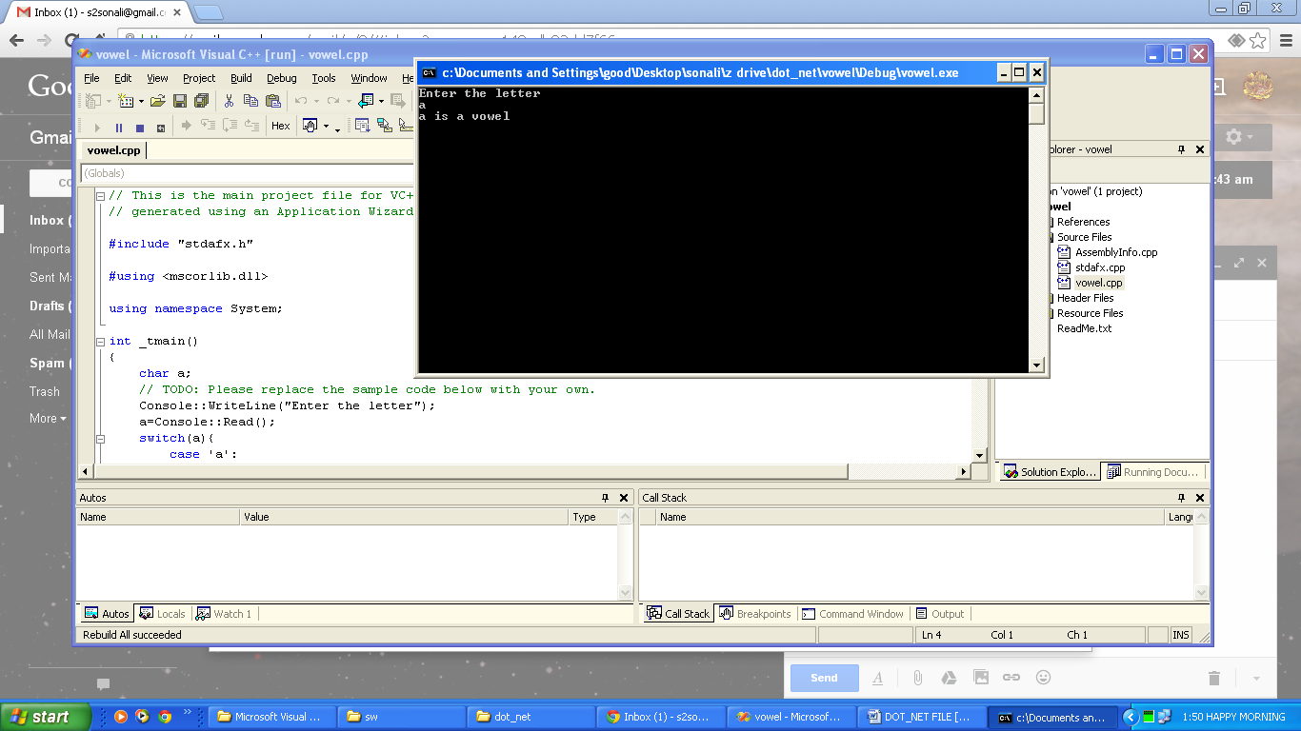

Code:
#include "stdafx.h"

#using <mscorlib.dll>

using namespace System;

int _tmain()
{
char a;
Console::WriteLine("Enter the letter");
a=Console::Read();
switch(a){
case 'a':
Console::WriteLine("a is a vowel");
break;
case 'e':
Console::WriteLine("e is a vowel");
break;
case 'i':
Console::WriteLine("i is a vowel");
break;
case 'o':
Console::WriteLine("o is a vowel");
break;
case 'u':
Console::WriteLine("u is a vowel");
break;
default:
Console::WriteLine(a+" is not a vowel");
break;
}
getchar();
return 0;
}

Assignment 13 (Data Greater Than 50 in C++.NET)

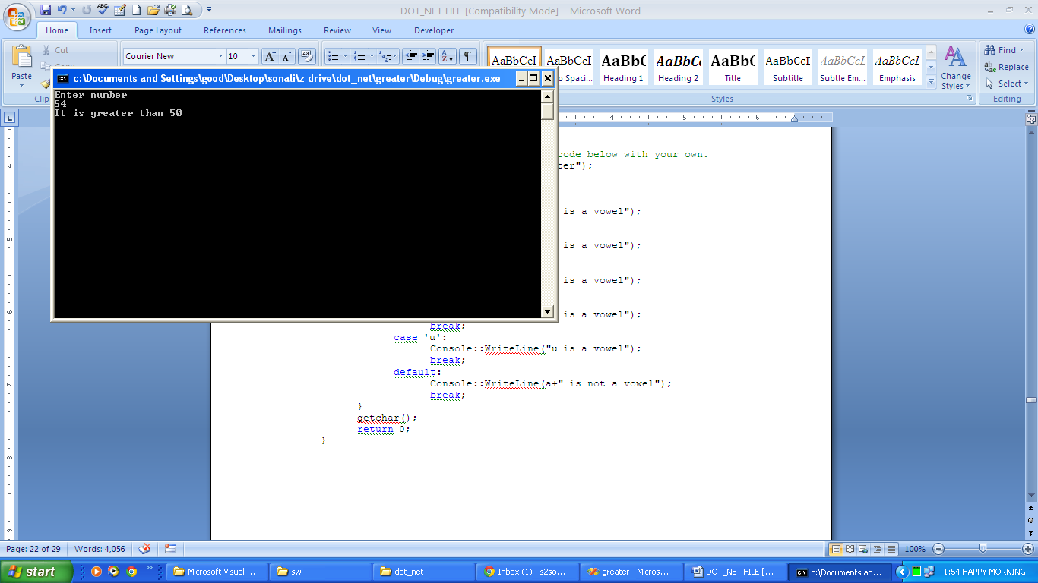

Code:
#include "stdafx.h"

#using <mscorlib.dll>

using namespace System;

int _tmain()
{
int a;
Console::WriteLine("Enter number");
a=Console::Read();
if(a>50){
Console::WriteLine("It is greater than 50");}
else if(a<50){
Console::WriteLine("It is smaller than 50");}
else
{Console::WriteLine("It is equal to 50");}
getchar();
return 0;
}

Assignment 14 (Squares in C++.NET)

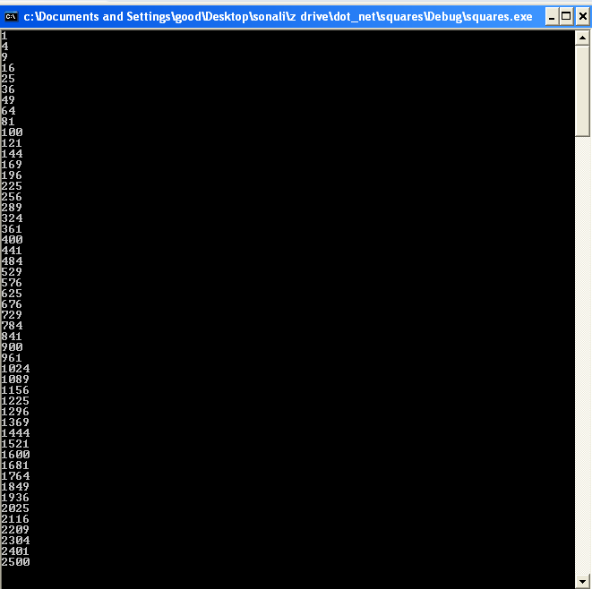

Code:
#include "stdafx.h"

#using <mscorlib.dll>

using namespace System;

int _tmain()
{
for(int i=1;i<=50;i++)
{
Console::WriteLine(i*i);
}
getchar();
return 0;
}

Assignment 15 (Area of Rectangle in C++.NET)

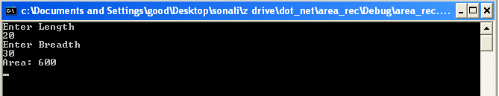

Code:
#include "stdafx.h"

#using <mscorlib.dll>

using namespace System;

void area(int c,int d)
{
int e;
e=c*d;
Console::Write("Area: ");
Console::WriteLine(e);
}
int _tmain()
{
int a,b;
Console::WriteLine("Enter Length");
a=Int32::Parse(Console::ReadLine());
Console::WriteLine("Enter Breadth");
b=Int32::Parse(Console::ReadLine());
area(a,b);
getchar();
return 0;
}

Assignment 16 (Fibonacci Series in J#.NET)

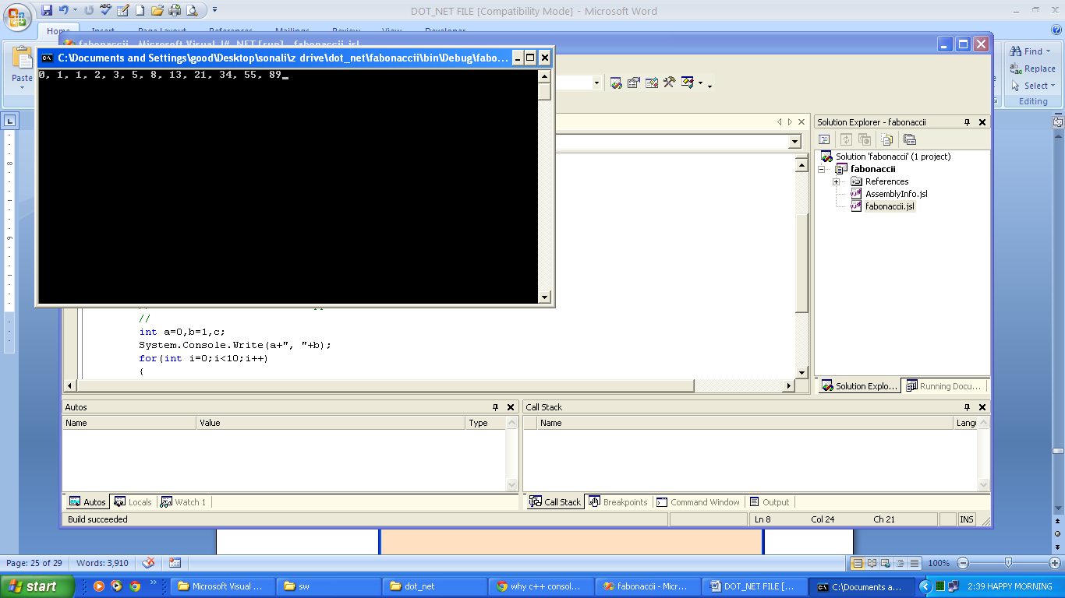

Code:
package fabonaccii;

public class fabonaccii
{
public fabonaccii()
{

}

public static void main(String[] args)
{

int a=0,b=1,c;
System.Console.Write(a+", "+b);
for(int i=0;i<10;i++)
{
c=a+b;
System.Console.Write(", "+c);
a=b;
b=c;
}
System.Console.Read();
}
}

Assignment 17 (Factorial in J#.NET)

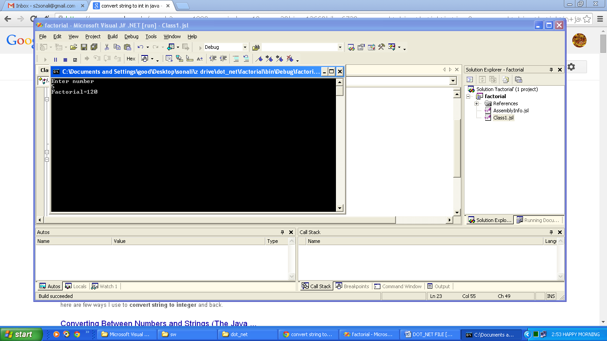

Code:
package factorial;

public class Class1
{
public Class1()
{

}

public static void main(String[] args)
{

int a,f=1;
System.Console.WriteLine("Enter number");
a=Integer.parseInt(System.Console.ReadLine());
for(int i=1;i<=a;i++)
{
f=f*i;
}
System.Console.WriteLine("Factorial="+f);
System.Console.Read();
}
}

Assignment 18 (Tables 2-20 in J#.NET)
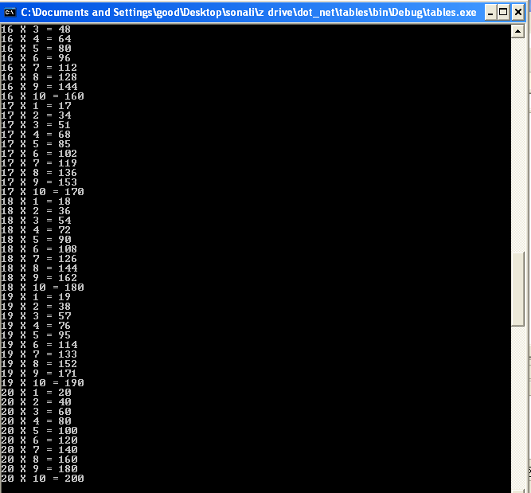

Code:
package tables;

public class Class1
{
public Class1()
{

}

public static void main(String[] args)
{

int i,j;
for(i=2;i<=20;i++)
{
for(j=1;j<=10;j++)
{
System.Console.WriteLine(i+" X "+j+" = "+(i*j));
}
}
System.Console.Read();

}
}

Assignment 19 (Prime Number in J#.NET)

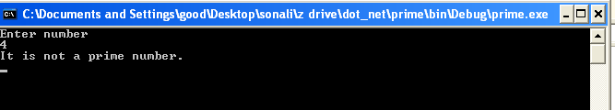

Code:
package prime;

public class Class1
{
public Class1()
{

}

public static void main(String[] args)
{
int a,f=0;
System.Console.WriteLine("Enter number");
a=Integer.parseInt(System.Console.ReadLine());
for(int i=2;i<a;i++)
{
if(a%i==0)
{f=1;}
}
if(f==1)
{System.Console.WriteLine("It is not a prime number.");}
else
{System.Console.WriteLine("It is a prime number");}
System.Console.Read();
}
}

Assignment 20 (Database Connectivity)

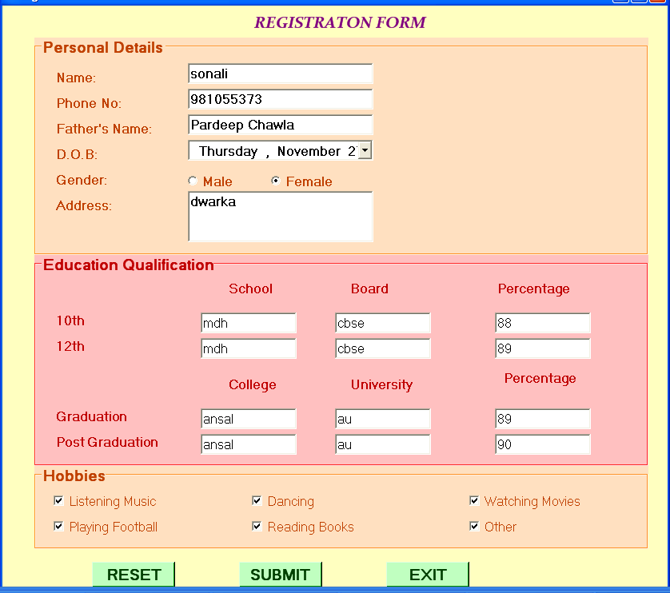

Code:
Imports System.Data.OleDb
Imports System.Data
Public Class registration
Inherits System.Windows.Forms.Form
Dim i As String
Dim sql As String
Dim con As New OleDb.OleDbConnection
Dim cmd As New OleDb.OleDbCommand

Private Sub b1_Click(ByVal sender As System.Object, ByVal e As System.EventArgs) Handles b1.Click
t1.Text = "" t2.Text = ""
t3.Text = "" t4.Text = ""
t5.Text = "" te1.Text = ""
te2.Text = "" te3.Text = ""
te4.Text = "" te5.Text = ""
te6.Text = "" te7.Text = ""
te8.Text = "" te9.Text = ""
te10.Text = "" te11.Text = ""
te12.Text = ""
r1.Checked() = True r2.Checked() = False
ch1.Checked() = False ch2.Checked() = False
ch3.Checked() = False ch4.Checked() = False
ch5.Checked() = False ch6.Checked() = False
End Sub

Private Sub b2_Click(ByVal sender As System.Object, ByVal e As System.EventArgs) Handles b2.Click
Dim a, b As String
If r1.Checked = True Then
a = "Male"
Else
a = "Female"
End If
b = ""
If ch1.Checked = True Then
b = ch1.Text
End If
If ch2.Checked = True Then
b = b + ", " + ch2.Text
End If
If ch3.Checked = True Then
b = b + ", " + ch3.Text
End If
If ch4.Checked = True Then
b = b + ", " + ch4.Text
End If
If ch5.Checked = True Then
b = b + ", " + ch5.Text
End If
If ch6.Checked = True Then
b = b + ", " + ch6.Text
End If
con.Open()
sql = "Insert into student (Name, Phone, Father_name, dob, Gender, Address,10_school,10_board,10_percent,12_school,12_board,12_percent,g_clg,g_unv,g_percent,pg_clg,pg_unv,pg_percent,Hobbies) values('" & t1.Text & "','" & t2.Text & "','" & t3.Text & "','" & t4.Text & "','" & a & "','" & t5.Text & "','" & te1.Text & "','" & te2.Text & "'," & te3.Text & ",'" & te4.Text & "','" & te5.Text & "'," & te6.Text & ",'" & te7.Text & "','" & te8.Text & "'," & te9.Text & ",'" & te10.Text & "','" & te11.Text & "'," & te12.Text & ",'" & b & "')"
cmd = New OleDbCommand(sql, con)
Try
cmd.ExecuteNonQuery()
Catch ex As Exception
MsgBox(ex.Message())
End Try
MsgBox("Data Submitted")
con.Close()
End Sub

Private Sub b3_Click(ByVal sender As System.Object, ByVal e As System.EventArgs) Handles b3.Click
i = MsgBox("Do You Want to Quit", MsgBoxStyle.YesNo)
If i = vbYes Then
Me.Close()
End If
End Sub

Private Sub registration_Load(ByVal sender As System.Object, ByVal e As System.EventArgs) Handles MyBase.Load
Dim constr = "PROVIDER=Microsoft.ACE.OLEDB.12.0;Data Source=C:\Documents and Settings\good\My Documents\registration.accdb"
con = New OleDbConnection(constr)
End Sub
End Class

