**Web Based User Identification System.**

**Aim:**

To implement the following mini project (Application Development using Oracle/Mysql)

**Web Based User Identification System.**

**Concepts Involved:**

**FRONT END TOOLS:**

**Bootstrap:**

Bootstrap is an open-source Javascript framework developed by the team at Twitter. It is a combination of HTML, CSS, and Javascript code designed to help build user interface components. Bootstrap was also programmed to support both HTML5 and CSS3.Also it is called Front-end-framework.

Bootstrap is a free collection of tools for creating a websites and web applications. It contains HTML and CSS-based design templates for typography, forms, buttons, navigation and other interface components, as well as optional JavaScript extensions.

Some Reasons for programmers preferred Bootstrap Framework:

1. Easy to get started
2. Great grid system
3. Base styling for most HTML elements(Typography,Code,Tables,Forms,Buttons,Images,Icons)
4. Extensive list of components
5. Bundled Javascript plugins

### Why Use Bootstrap?

Following are the main advantage of Bootstrap:

* It is very easy to use. Anybody having basic knowledge of HTML and CSS can use Bootstrap.
* It facilitates users to develop a responsive website (can automatically adjust itself to look good on all devices, from smart phones to desktops etc.).
* It is compatible on most of browsers like Chrome, Firefox, Internet Explorer, Safari and Opera etc.

### What Bootstrap Package Contains?

Scaffolding:Bootstrap provides a basic structure with Grid System, link styles, and background.

CSS:Bootstrap comes with the feature of global CSS settings, fundamental HTML elements style and an advanced grid system.

Components: Bootstrap contains a lot of reusable components built to provide iconography, dropdowns, navigation, alerts, pop-overs, and much more.

JavaScript Plugins:Bootstrap also contains a lot of custom jQuery plugins. You can easily include them all, or one by one.

Customize: Bootstrap components are customizable and you can customize Bootstrap's components, LESS variables, and jQuery plugins to get your own style.

## Primary Bootstrap Files:

As a front-end framework, Bootstrap has three primary files:

* **bootstrap.js** which is a jQuery/JavaScript framework.
* **bootstrap.css** which is a CSS framework
* **glyphicons** which is a set of icon fonts

jQuery, which is quite widely used and very popular JavaScript library, is required for Bootstrap to function. It adds cross browser compatibility and simplifies JavaScript.

**BUSINESS LOGIC WITH PHP:**

## What Exactly Is Php?

* PHP stands for Hypertext Preprocessor.
* PHP is an interpreted language, i.e., there is no need for compilation.
* PHP is a server-side scripting language.
* PHP is faster than other scripting languages, for example, ASP and JSP.

## Why Use Php?

* PHP is **open source and free.**
* Short learning curve compared to other languages such as JSP, ASP etc.
* Large community document
* Most web hosting servers support PHP by default unlike other languages such as ASP that need IIS. This makes PHP a cost effective choice.
* PHP is regular updated to keep abreast with the latest technology trends.
* Other benefit that you get with PHP is that it’s a **server side scripting language**; this means you only need to install it on the server and client computers requesting for resources from the server do not need to have PHP installed; only a web browser would be enough.
* PHP has **in-built support for working hand in hand with MySQL**; this doesn’t mean you can’t use PHP with other database management systems. You can still use PHP with
  + Postgres
  + Oracle
  + MS SQL Server
  + ODBC etc.
* PHP is **cross platform;** this means you can deploy your application on a number of different operating systems such as windows, Linux, Mac OS etc.

**Oracle 18c:**

Oracle Database 18c, is the latest generation of the world’s most popular database, and may be deployed on-premises and/or in Oracle Cloud running on general purpose hardware or engineered systems specifically designed for database workloads such as Oracle Exadata and Oracle Database Appliance. It provides businesses of all sizes with access to the world’s fastest, most scalable and reliable database technology for secure and cost-effective deployment of transactional and analytical workloads in the Cloud, on-premises and Hybrid Cloud configurations. Oracle Database 18c adds new functionality and enhancements to features previously introduced in Oracle Database 12c, including:

* Multitenant Architecture for massive cost savings and agility.
* In-Memory Column Store for massive performance gains for real-time analytics.
* Native Database Sharding for high availability of massive web applications.
* Many more critical capabilities for enhanced database performance, availability, security, analytics and application development
* **Cost-based Optimization.** Automatic SQL query optimization, automatic statistics gathering, automatic query rewrite automatic SQL Plan management and automatic SQL tuning.
* **Data Optimization.** Automatic undo management, automatic segment space management, Automatic Storage Management, Automatic Data Optimization and automatic columnar cache.
* **Cloud-Scale Operations**. Automatic standby management (broker), Diagnostic Framework, Multitenant Architecture, automatic database clone refresh and machine learning in Cluster Health Advisor

**PROJECT DESCRIPTION:-**

**This project is made using Web Technologies as follows:**

1. HTML
2. CSS 3
3. PHP 5
4. Oracle 18c

**GETTING STARTED:**

**XAMPP:**

XAMPP stands for Cross-Platform (X), Apache (A), MariaDB (M), PHP (P) and Perl (P). It is a simple, lightweight Apache distribution that makes it extremely easy for developers to create a local web server for testing and deployment purposes. Everything needed to set up a web server – server application (Apache), database (MariaDB), and scripting language (PHP) – is included in an extractable file. XAMPP is also cross-platform, which means it works equally well on Linux, Mac and Windows.

**Starting Apache And MySQL in XAMPP:**

The XAMPP Control Panel allows you to manually start and stop Apache and MySQL. To start Apache or MySQL manually, click the ‘Start’ buttonunder ‘Actions’.

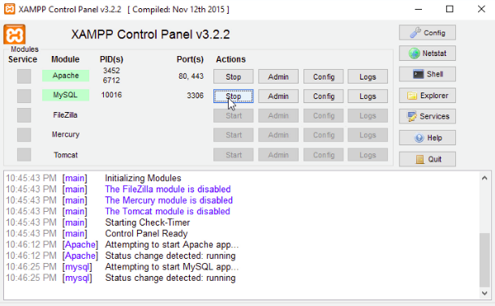

**GETTING INTO PROJECT:**

**LOGIN:**

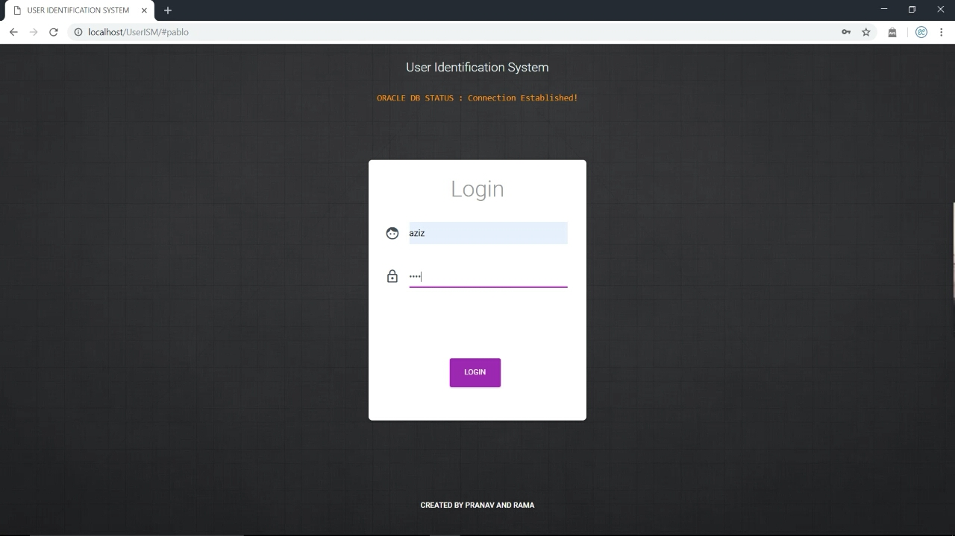

**USER ENTRY:**

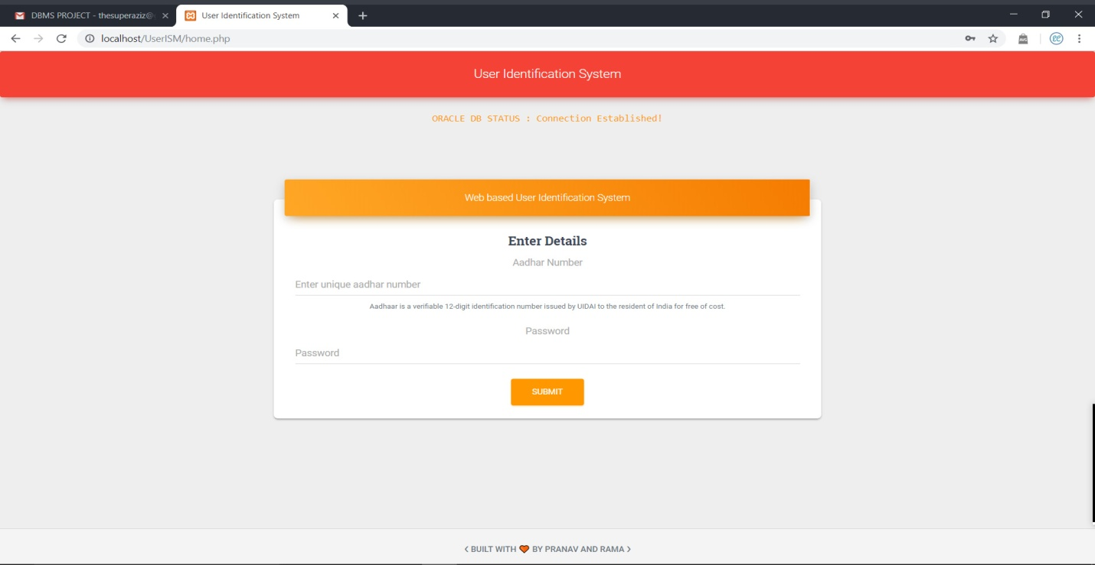

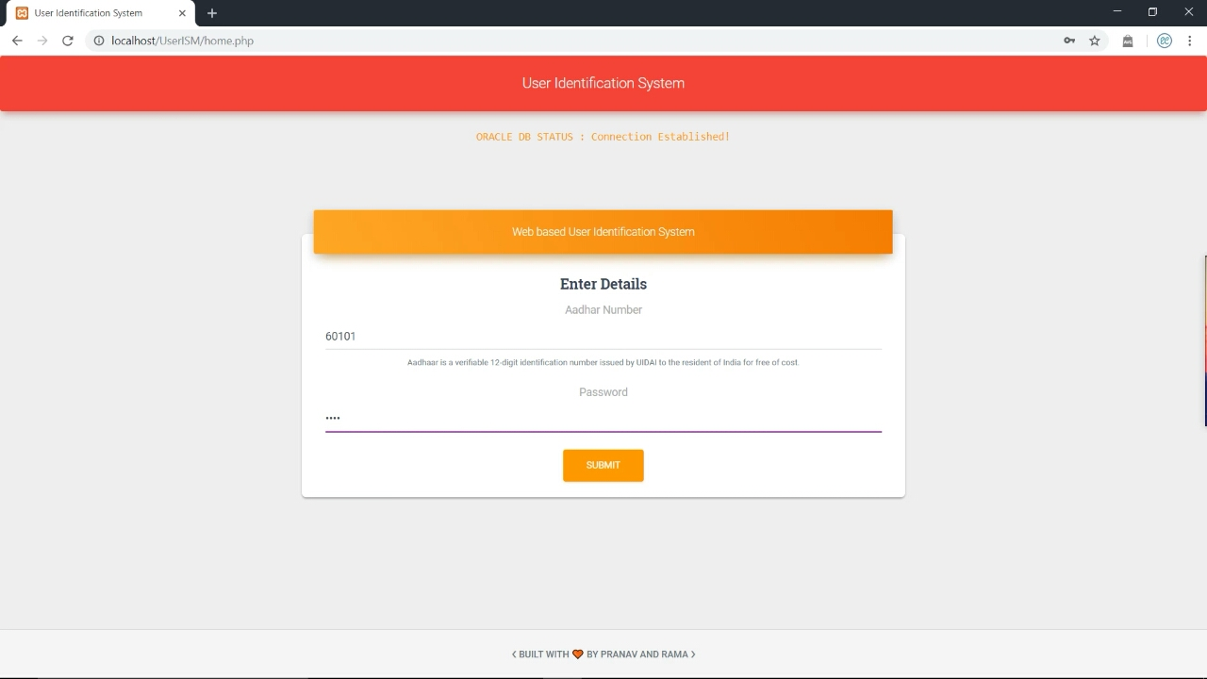

**USER IDENTIFICATION:**

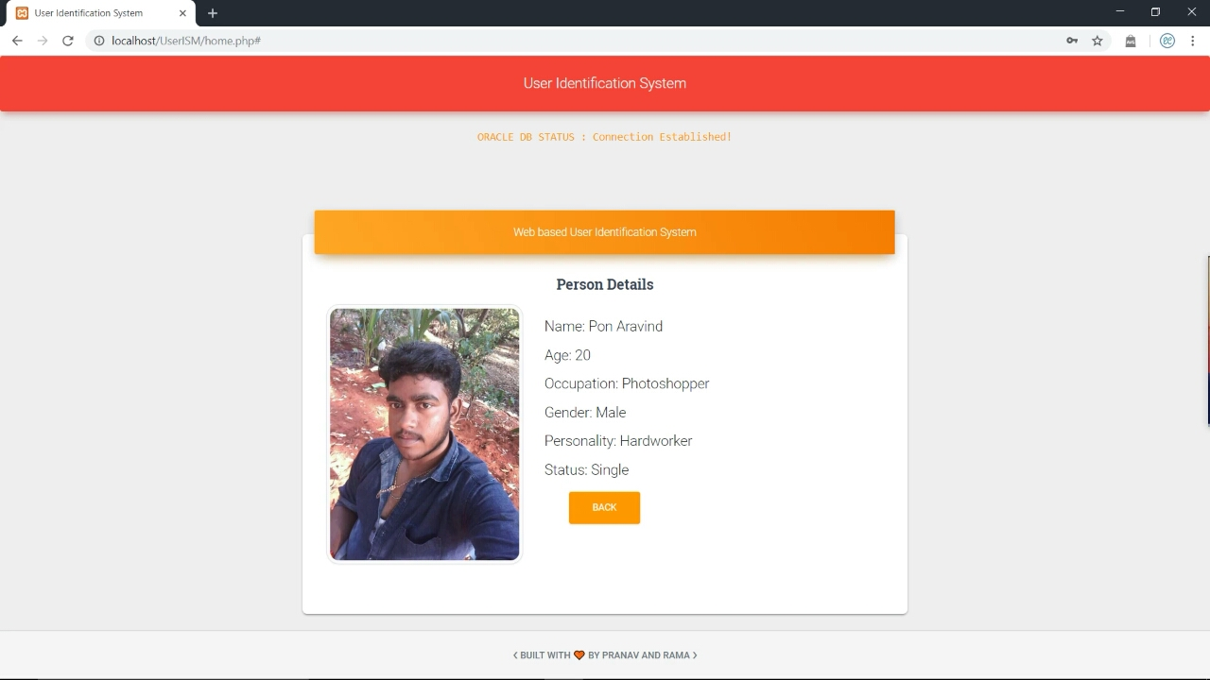

**ANOTHER USER ENTRY:**

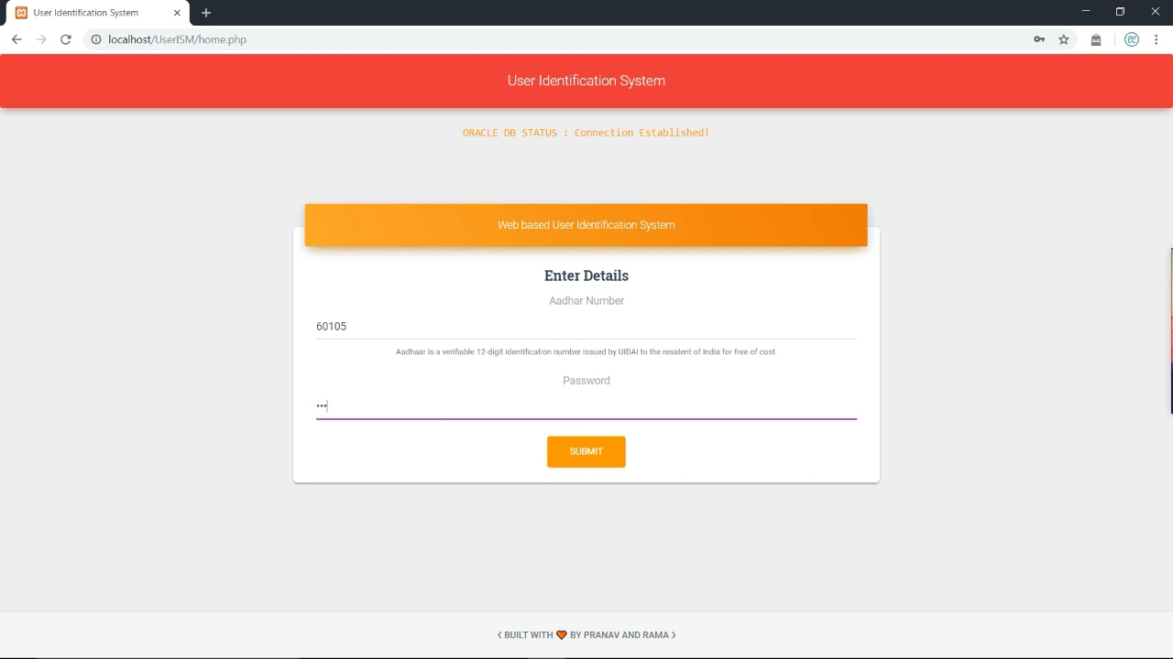

**USER IDENTIFICATION:**

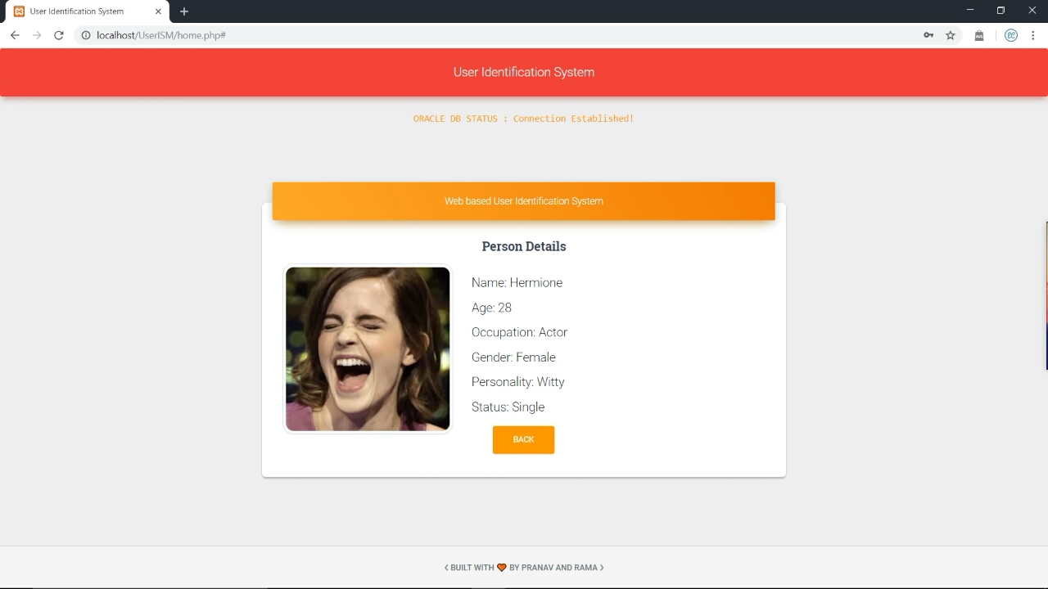

**SAMPLE:**

