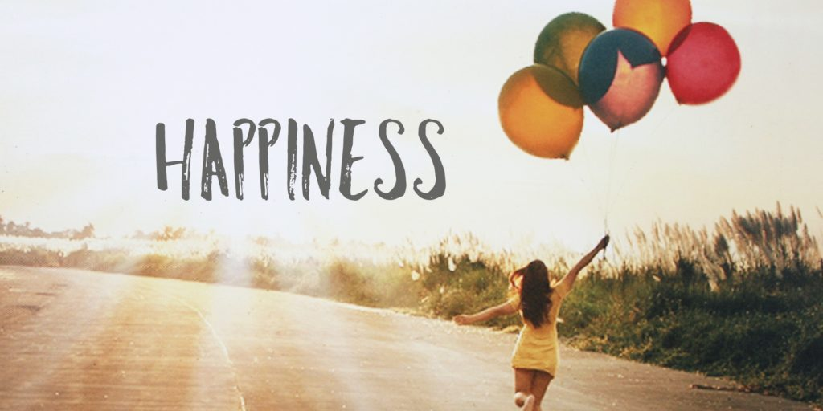What is happiness ?

some will reduce happiness to a state of having money,

shelter or affording luxurious goods but to me it’s a state

of knowing what ever you need is a possibility.

