**FRONT END ENGINEERING-II**

Project Report

Semester-IV(Batch-2022)

**Background Color Selector Using Bootstrap And JavaScript**

**Supervised By: Submitted By:**

Mr. Raveesh Samkaria Sonakshi

2210990862(G31)

**Department of Computer Science and Engineering**

**Chitkara University Institute of Engineering & Technology, Chitkara University, Punjab**

**Abstract**

The "Background Color Selector" project utilizes Bootstrap and JavaScript to create a user-friendly interface for selecting and applying background colors to a web page.

In this project, Bootstrap is leveraged for its responsive design components and grid system, providing a solid foundation for building the layout of the color selector interface. JavaScript is employed to handle user interactions and dynamically update the background color of the page based on user input.

The key features of the project include:

* Color Slider: A visually appealing color sliders are displayed, allowing users to choose from a variety of colors.
* Color Selection: Users can select a color from the sliders by sliding on it.
* Dynamic Background Update: Upon color selection, JavaScript dynamically updates the background color of the web page in real-time.

Overall, the "Background Color Selector" project combines the power of Bootstrap for layout and styling with JavaScript for interactivity, providing users with an intuitive way to customize the background color of a web page.

**Table Of Content**

|  |  |  |
| --- | --- | --- |
| **Sr No.** | **Section** | **Page No.** |
| **1.** | Introduction | 4 |
| **2.** | Problem Statement | 5 |
| **3.** | Technical Details | 6 |
| **4.** | File Structure | 7 |
| **5.** | Code | 8-11 |
| **6.** | Result | 11-12 |
| **7.** | References | 12 |

**Introduction**

In today's digital landscape, web design is not just about aesthetics but also about creating engaging and interactive user experiences. One such element that can greatly enhance user engagement is the ability to customize the look and feel of a webpage according to personal preferences. In this context, the "Background Color Selection" project emerges as a simple yet effective tool, leveraging the power of Bootstrap and JavaScript to empower users to personalize the background color of a webpage effortlessly.

The project aims to provide users with a visually appealing and user-friendly interface for selecting and applying background colors to a webpage. By integrating Bootstrap's responsive design components and grid system with JavaScript's dynamic functionality, this project offers a seamless and intuitive experience for users .

Through this project, users can explore a diverse range of colors through a vibrant color sliders and instantly see the changes reflected in the background of the webpage. Whether it's adding a pop of color to a blog post, customizing the backdrop of an online portfolio, or simply experimenting with different color schemes, the Background Color Selection project empowers users to express their creativity and personalize their online experience.

With its simplicity, versatility, and accessibility, this project serves as a practical demonstration of how the combination of Bootstrap and JavaScript can be harnessed to create interactive and visually appealing web applications. Whether you're a beginner looking to delve into web development or an experienced developer seeking inspiration for your next project, the Background Color Selection project offers a valuable learning opportunity and a glimpse into the limitless possibilities of modern web design.

**Problem Statement**

The project aims to address the need for a user-friendly and interactive solution for customizing the background color of webpages. While there are various tools and applications available for web design, many lack simplicity, accessibility, and real-time visualization of color changes. Therefore, the specific problem statement for the Background Color Selector project is as follows:

"Design and develop a web-based application using Bootstrap and JavaScript that enables users to easily select and apply background colors to a webpage in real-time. The application should provide a visually appealing color palette, intuitive user interface. The solution should prioritize simplicity, accessibility, and instant visual feedback to enhance the user experience and encourage creative expression."

In essence, the project seeks to bridge the gap between complex design tools and the need for a simple yet effective solution for background color customization in web design. By leveraging the capabilities of Bootstrap and JavaScript, the aim is to empower users with a practical and user-friendly tool that enhances their ability to personalize and beautify their online content.

**Technical Details**

The front-end website for the background color selector was constructed with a minimalist approach, employing only essential technologies to ensure a streamlined user experience. Here are the primary technical details of the project:

* **HTML Structure:** The website's structure was crafted using semantic HTML mark up to enhance accessibility and clarity. Each page was organized with appropriate tags to facilitate straightforward navigation and readability.
* **CSS Styling:** Cascading Style Sheets (CSS) were utilized for styling the website's layout, typography, and color schemes. Custom CSS rules were applied to maintain a consistent visual design across the site while optimizing load times and code simplicity.
* **Responsive Design:** Responsive design principles were implemented to ensure the website's compatibility with various devices and screen sizes. Media queries and flexible layouts were employed to adapt the content and design elements responsively without reliance on frameworks.
* **JavaScript:** JavaScript facilitated interactive features, enhancing user engagement and interactivity on the website. Careful optimization of JavaScript code ensured smooth performance and compatibility across different browsers and devices, elevating the overall user experience.

**File Structure**

* **index.html:** This file serves as the main entry point for the website. It contains the HTML mark-up defining the structure and content of the web pages. Within this file, sections such as the header, navigation bar, main content area, footer, and any additional elements are defined.
* **Style.css:** The CSS file contains the styling rules that dictate the visual presentation of the website. This includes defining colours, fonts, layout properties, and any other stylistic elements. Selectors within this file target specific HTML elements or classes to apply the desired styles.
* Script.js: The script.js file serves as the backbone of the background color selector’s dynamic functionality, orchestrating its behavior and interactions. Within this file, JavaScript functions are meticulously crafted to enable real-time updates and interactive features essential for the background’s operation. These functions are finely tuned to ensure accurate time display and seamless user interaction.

**Code:**

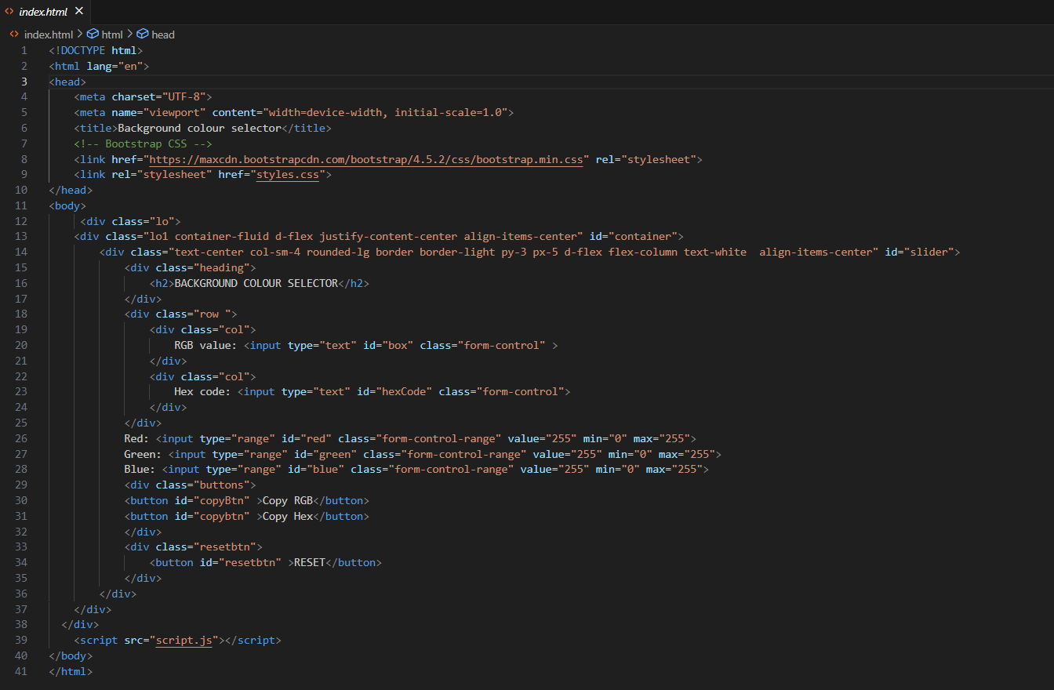

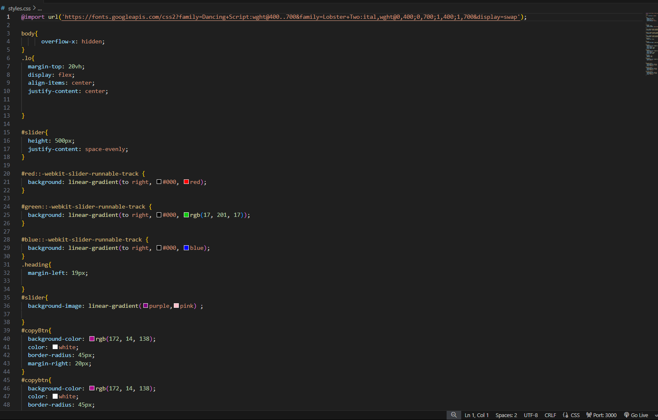

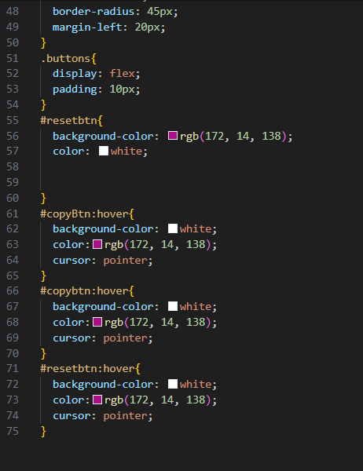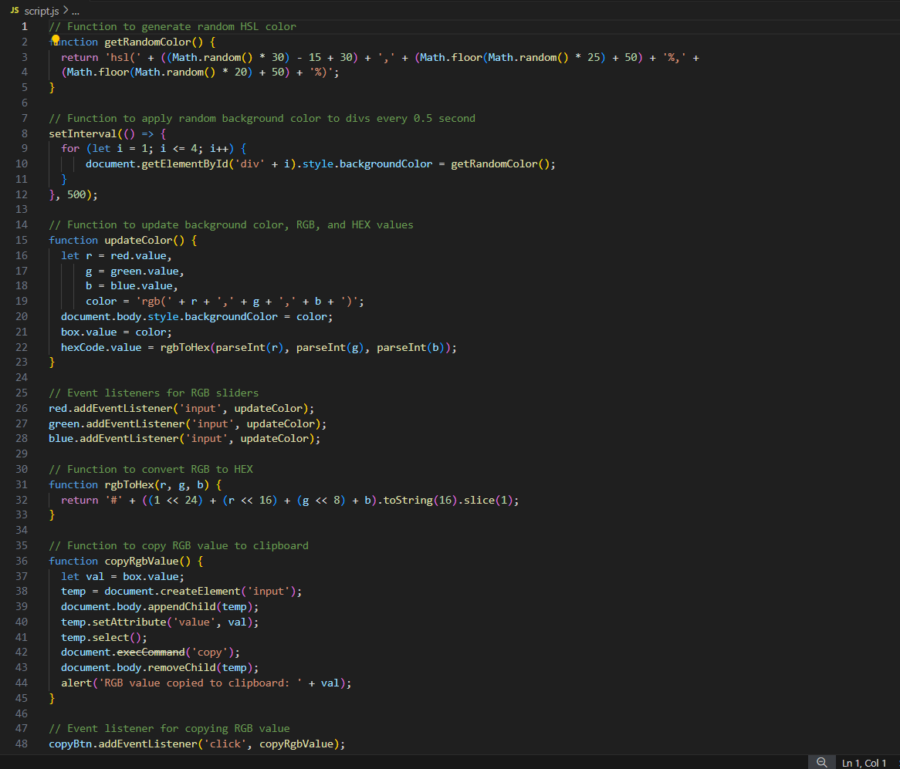

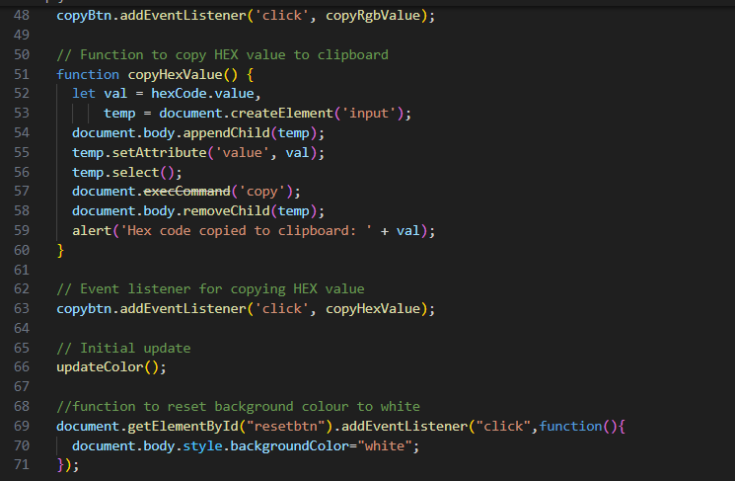

**Results:**

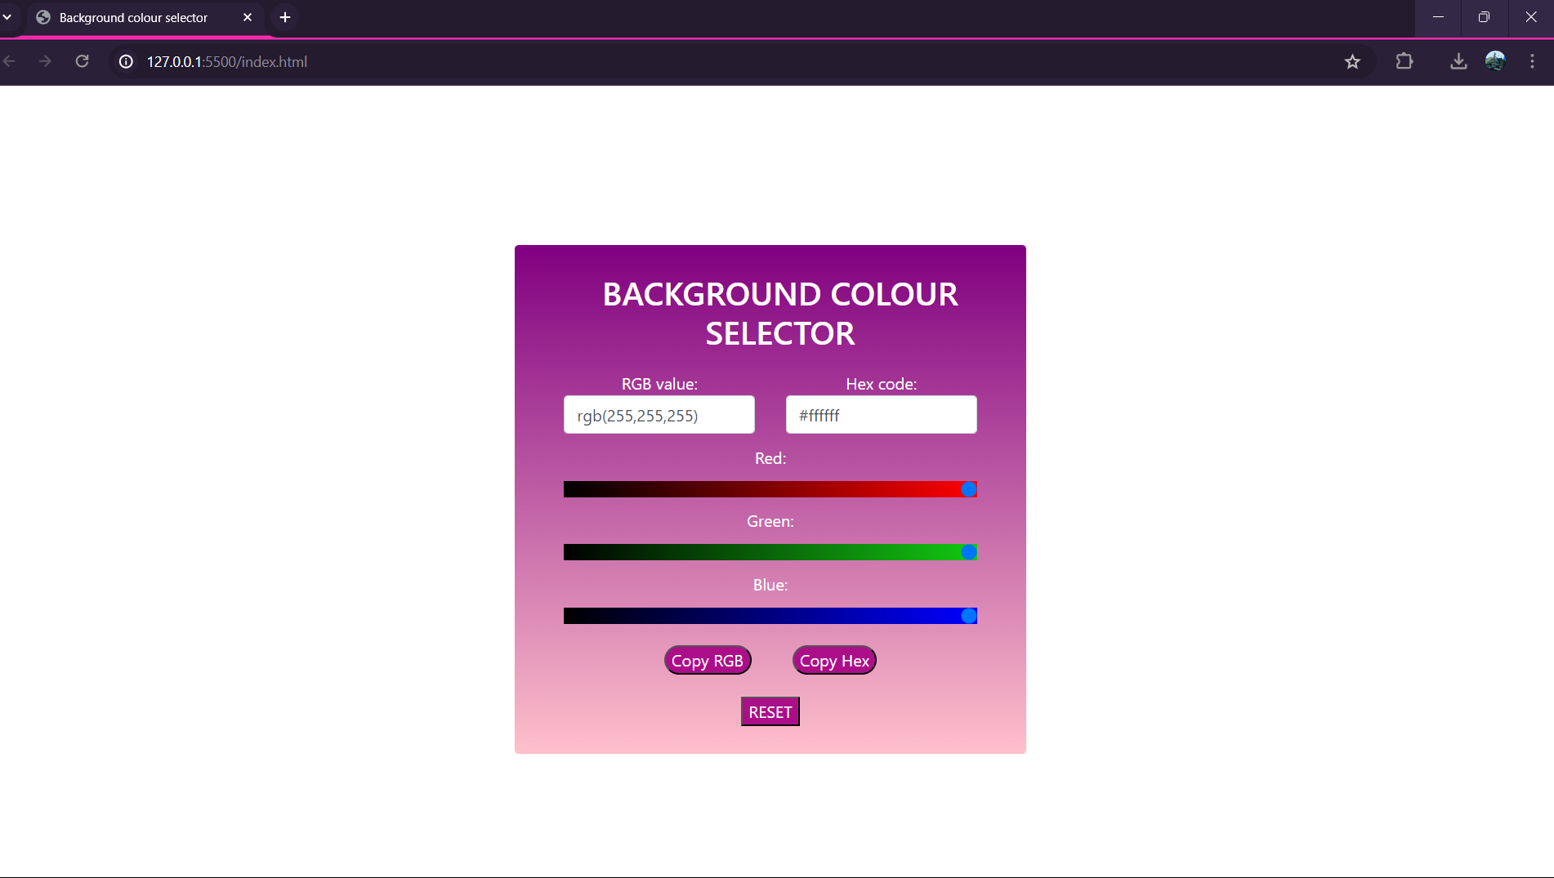

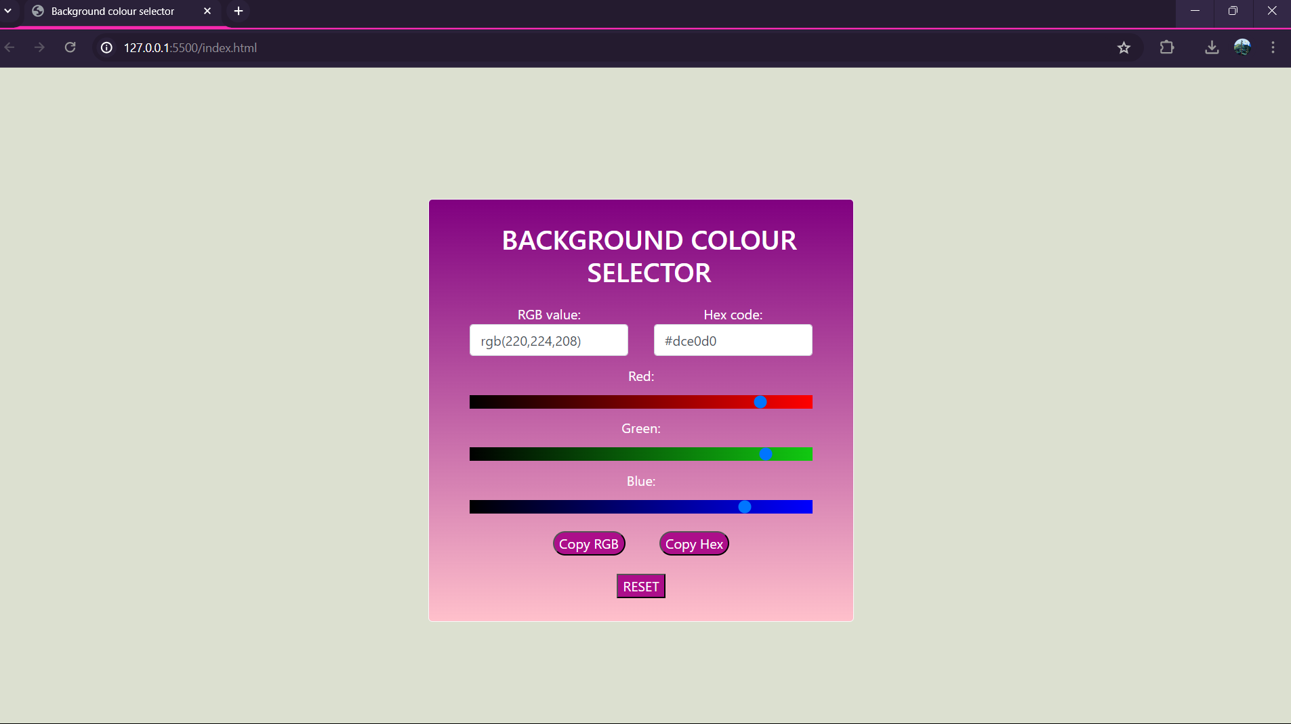

**REFERENCES**

1. https://bootstrap.com
2. [www.w3schools.com](http://www.w3schools.com)
3. https://mdbootstrap.com