STUDENT PERFORMANCE
ANALYTICS SYSTEM
Python with AI — Project Documentation
Student Name | Sonakshi Kamulu
College | Malla Reddy Deemed to be University
Department / Course | Computer Science and Engineering (CSE)
Project Title | Student Performance Analytics System
Technologies Used | Python, Pandas, NumPy
Main Program | main.py
Dataset | students.csv
GitHub Repository | https://github.com/SonakshiKamulu/student-performance-analytics
Review the report before submission and ensure all details match your final project.

1. Project Objective
The objective of the Student Performance Analytics System is to analyze student marks and attendance using Python. The program reads student records from a CSV file and calculates total marks, average marks, grades, pass/fail status, subject-wise averages, class average, highest and lowest performers, the top five students, and average attendance. It helps organize the records and produce a consistent summary of class performance.

2. Problem Statement
Calculating totals, averages, grades, and attendance summaries manually for multiple students can take time and may introduce mistakes. This project demonstrates how a Python program can process tabular student data and generate academic summaries automatically.

3. Technologies Used
Technology | Purpose
Python | Used to write the program, functions, conditions, and calculations.
Pandas | Used to read the CSV file and organize and analyze student records in a DataFrame.
NumPy | Used for numerical operations and average calculations.
Visual Studio Code | Used to edit and run the Python program.
GitHub | Used to store and share project files online.
CSV | A simple table-like file format used for the student dataset.

4. Dataset Description
The dataset file is named students.csv and contains 15 student records, as shown in the program output. The visible columns are Student_ID, Name, Department, Python, Java, Mathematics, Attendance, Total, Average, Grade, and Result. The first seven fields are input data; Total, Average, Grade, and Result are calculated and displayed by the program.
The sample marks are treated as marks out of 100, and Attendance is represented as a percentage. The dataset appears to use sample student names. Do not upload confidential or personally identifying student data without permission. Confirm that 15 records meets the exact requirement in your internship instructions.

5. Project File Structure
StudentPerformanceAnalytics/
main.py — Python program.
students.csv — input dataset.
README.md — project overview and run instructions.
Student_Performance_Analytics_Project_Documentation_FINAL.docx — this report.
project_output1.png and project_output2.png — output screenshots (optional).

6. Implementation Overview

6.1 Loading the data
The program reads students.csv into a Pandas DataFrame so records can be processed as rows and columns.

6.2 Calculating totals and averages
The program adds the Python, Java, and Mathematics marks to calculate each student's total. It calculates the average across these three subjects.

6.3 Assigning grades
The program assigns letter grades based on average marks. The displayed results show grades A through E for the sample data. Confirm the exact grade boundaries in main.py and use the official scheme if your trainer supplied one.

6.4 Checking pass/fail
The output marks 13 students as Pass and 2 as Fail. The screenshot shows Arjun and Kiara as Fail. Confirm the rule in main.py; do not describe a pass threshold unless it matches the code.

6.5 Class and subject analysis
The program calculates the overall class average and average marks for Python, Java, and Mathematics.

6.6 Identifying performers
The program identifies the highest and lowest performers by average and displays the top five students in descending average order.

6.7 Attendance summary
The program calculates and displays the average attendance percentage across the student records.

7. Key Features
- Reads student records from a CSV file.
- Displays student details and calculated results.
- Calculates total and average marks.
- Assigns grades and pass/fail results.
- Calculates class and subject-wise averages.
- Counts passed and failed students.
- Identifies highest and lowest performers.
- Displays the top five students.
- Calculates average attendance.

8. How to Run the Project
- Open the StudentPerformanceAnalytics folder in Visual Studio Code.
- Choose Terminal > New Terminal.
- Check the folder contents by entering: ls
- If the required libraries are not installed, enter: python3 -m pip install pandas numpy
- Run the program by entering: python3 main.py
- Review the output and fix any error before submission.

9. Actual Output and Results
The following results are visible in the screenshots provided from a successful run of python3 main.py:
Measure | Observed result
Number of students | 15
Overall class average | 70.16
Python average | 69.27
Java average | 69.60
Mathematics average | 71.60
Students passed | 13
Students failed | 2
Highest performer | Isha — 93.00
Lowest performer | Kiara — 33.33
Average attendance | 85.13%
Top five | Isha, Diya, Anvi, Aditya, Aarav

Output Screenshot 1 — Student Records and Class Summary
This screenshot shows the student table, class average, subject-wise averages, and pass/fail count.
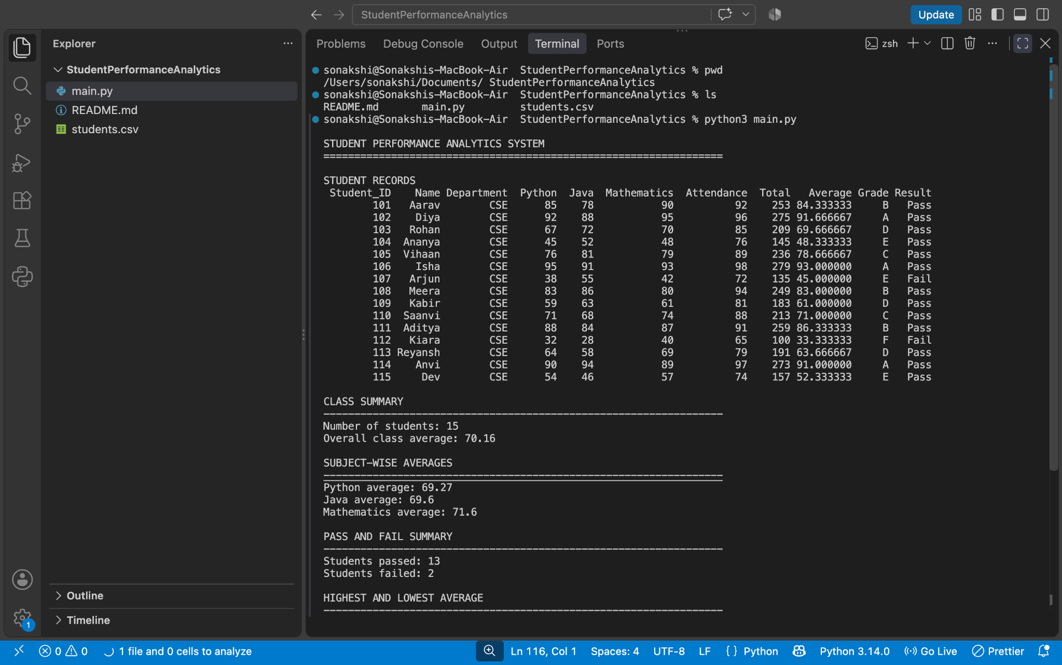

Output Screenshot 2 — Highest/Lowest, Top Five, and Attendance
This screenshot shows the highest and lowest performers, the top five students, and average attendance.
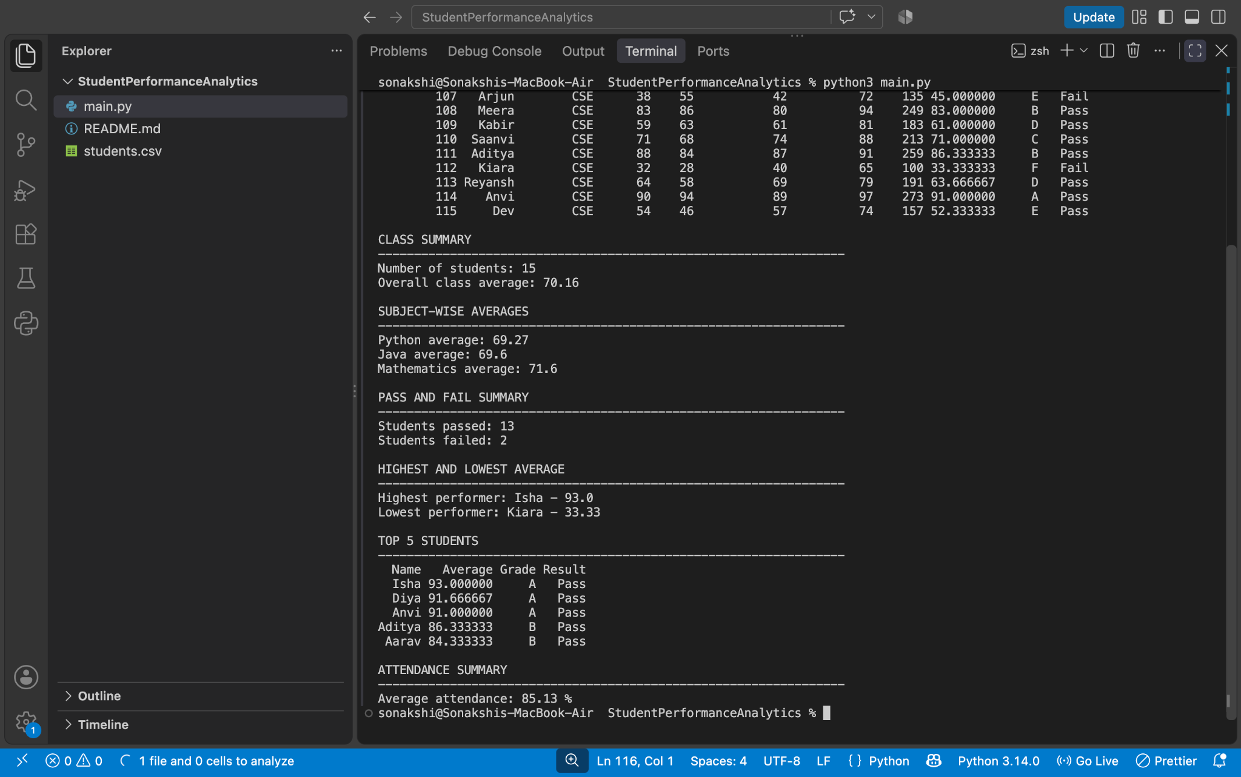

10. Testing and Validation
The screenshots show that the program ran and printed the following results. Complete the checks below before final submission:
☐ The program runs using python3 main.py without an error.
☐ The program reads 15 student records from students.csv.
☐ The displayed class and subject averages are checked against the final dataset.
☐ The pass/fail and grade rules match the code and any instructor requirements.
☐ The GitHub repository contains the current versions of main.py, students.csv, README.md, and this report.

11. Challenges and Learning
This project provides practice with reading CSV data, organizing data in a Pandas DataFrame, using NumPy for numerical operations, writing functions, applying conditions, and summarizing records. Edit this section to describe the actual challenges you encountered and how you resolved them.

12. Limitations and Future Improvements
This is a terminal-based program that uses a fixed set of subject columns and grading rules. Possible future improvements include validation for missing or invalid values, support for additional subjects, exporting summaries to a file, visualizing results with charts, or creating a graphical user interface.

13. Conclusion
The Student Performance Analytics System demonstrates how Python, Pandas, and NumPy can be used to process student marks and attendance and produce a useful class summary. The program output reports 15 students, a class average of 70.16, 13 passes, 2 failures, and average attendance of 85.13%. These figures should be kept in the final report only while they match the final dataset and program output.

14. GitHub Repository
Repository URL: https://github.com/SonakshiKamulu/student-performance-analytics
Before submitting, open the repository link and confirm that the files are visible. Upload the latest version of main.py, students.csv, README.md, this report, and any other files required by the trainer. Submit the repository URL through the official internship submission form.

Final Submission Checklist
☐ Verify student and college details.
☐ Confirm the dataset and grading rules meet the assignment instructions.
☐ Check that the output values match the final program run.
☐ Review screenshots for readability.
☐ Confirm the repository URL opens and files are visible.
☐ Upload the final report and project files to GitHub.
☐ Submit the repository link through the course's Google Form.

