DOCKER PROJECT SUBMISSION STEPS:

Step 1: Create a dockerfile for custom Image

FROM alpineRUN apk add --update redisEXPOSE 6379CMD ["redis-server"]

Step 2:

Command to push the dockerfile to Dockerhub

# docker push dockerhubaccount/myprojectredis

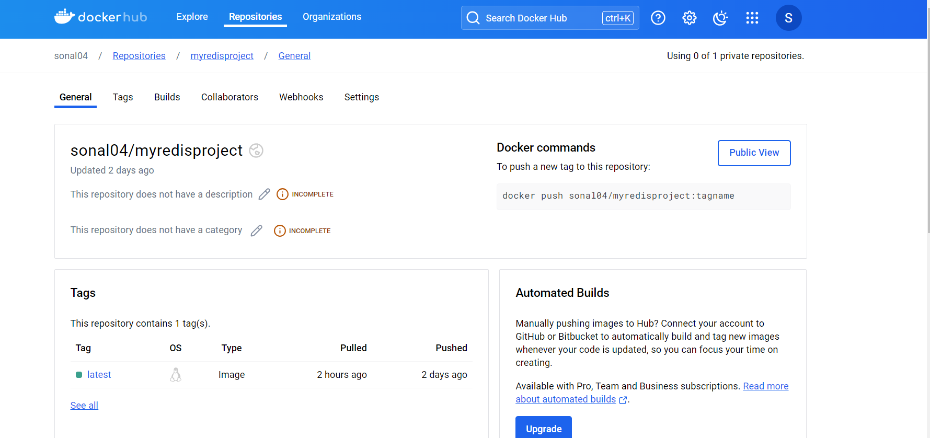

Step 3: Deployment of the Image in Kubernetes cluster:

# kubectl get nodes

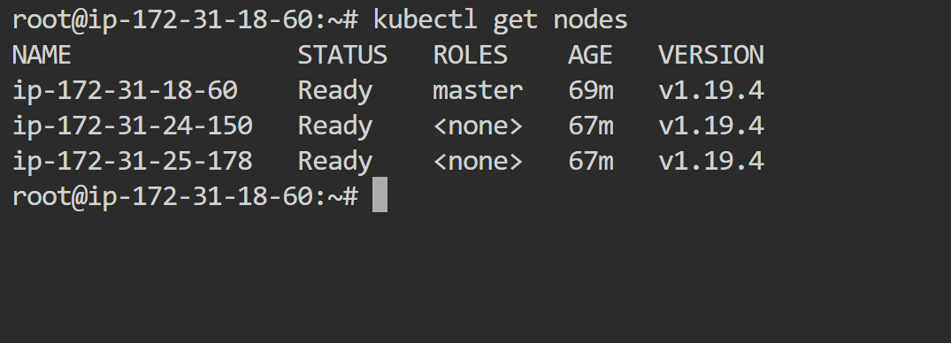

Deployment:

apiVersion: apps/v1 # this is the name of the library that K8s woll use to create deployment object

kind: Deployment

metadata:

name: myproject-deploy

spec:

replicas: 3

selector:

matchLabels:

app: webserver

template: # this pod template using which replicas will be created

metadata:

labels: # every replica/pod will have a unique name given by K8s

app: webserver

spec:

containers:

- name: c1

image: sonal04/myredisproject

