|  |
| --- |
| Setup Guide |
| Google Cloud Platform Account Setup |

**HOW TO CREATE A GOOGLE CLOUD ACCOUNT?**

A GCP account can be created in the below four steps -

* Step 1 - Create a GMAIL account
* Step 2 - Use GMAIL account to log into GCP console
* Step 3 - Add credit card details to enable billing
* Step 4 - Create a project

# Step 1 - Create a GMAIL account

* Go to [https://accounts.google.com/signup/v2/webcreateaccount?flowName=GlifWebSignIn&flo wEntry=SignUp](https://accounts.google.com/signup/v2/webcreateaccount?flowName=GlifWebSignIn&amp;flowEntry=SignUp) to create a new gmail account
* You may also opt to use your existing Gmail account
* Fill in the details and click next

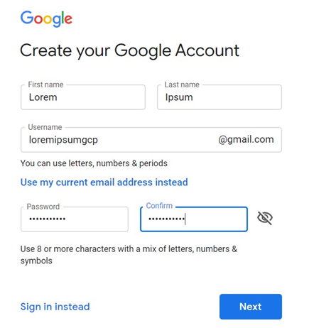

* Add your mobile number and verify using verification code
* Add details about your recovery address, data of birth and Gender
* Once account setup is complete - go to <https://mail.google.com/mail/u/0/>
* Login as your new account
* Click Next
* In the next page, click - Yes, I'm in
* In the next page, agree to the T&C

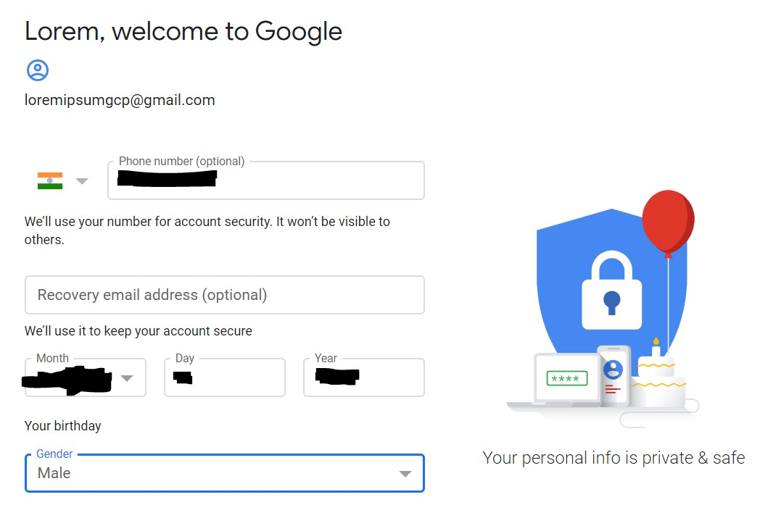

# Step 2 - Log in to GCP console

* On your browser (preferably chrome), navigate to [https://console.cloud.google.com](https://console.cloud.google.com/)

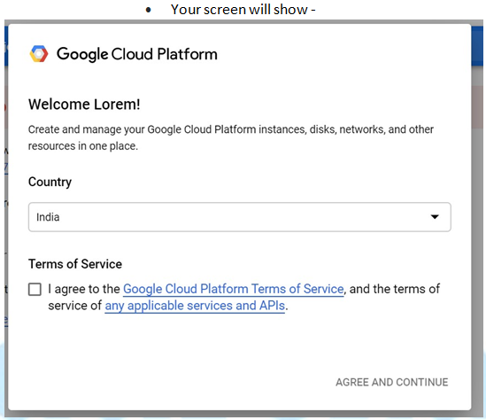

* Agree the terms and conditions and you now have a free tier account for GCP

# Step 3 - Enable Billing to receive $300 credits

* On top of your screen you will see the link to enable billing



* Click on the **Activate** Button to go to the next page
* In the next page - select your country and Agree to the T&C and click **Continue**

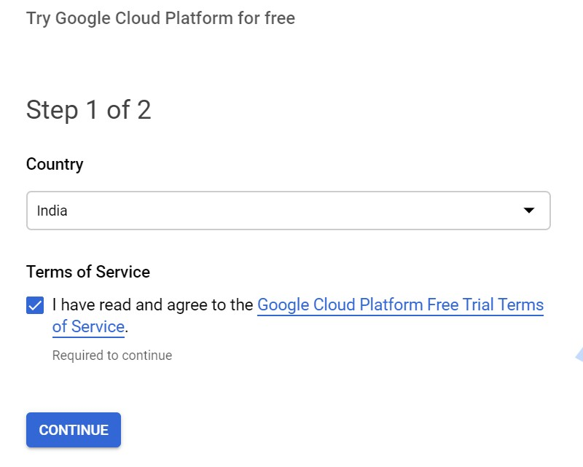

In the next page -

* Change account type to - **Individual**
* Select your Tax status type
* Add your Address
* Add details about your registered ID like SSN/PAN etc.
* Add credit card details

## **NOTE** - It is **YOUR** responsibility to ensure that you shut down your GCP resources so that you dont incur unnecessary charges. Google provides you with an evaluation credit of $300, upto which you will not be charged. Once you cross the limit of $300 Google will charge you for the resources that you utilize. All cloud providers has the **PAY AS YOU GO** model, which ensures that you are charged only for the resources that you are utilizing.

**NOTE** - Ensure that your card supports auto debit. I have seen a few instances where debit cards were **rejected** as they dont support auto debit

* Once done - click **Start My Free Trial**

# STEP 4 - Create a new project

* The top blue menu bar has an option of **Select a project**



* Click on **Select a project** dropdown
* By default a new project would be created

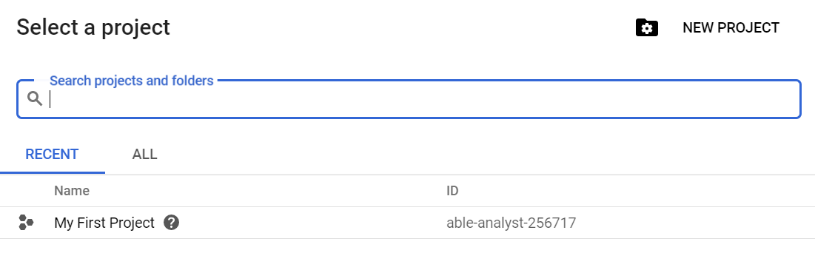

* Select the project **My first project** and you are good to go.

## **NOTE** - Google Cloud **Projects** provides a good way to bundle all your resources together. Which means that deleting the project entirely will delete all the resources inside it. This is really helpful when you dont remember what resources have been created and what resources are getting billed. Deleting the project completely will ensure that you are not billed for anything

## ***Create UBUNTU VM Instance:***

## ***Once after setting project successfully & enabled the billing for it.***

## ***On your google cloud home page, top left corner click 3dash symbol as shown below,***

## ***You will see various services offered by google.***

## ***Now scroll down list of services until you see “Compute Engine” then click on it***

## ***It will pop up with various other services under compute engine as show below***

## ***Now click on “VM Instances”***

## 

## ***After clicking on VM Instances it will show below screen***

## ***Now Click on CREATE INSTANCE above to create a new instance.***

## 

## ***After clicking on “CREATE INSTANCE” it will show below screen***

## ***Name: “type any name” (ex: machine1)***

## ***Series: N1 (do not change this)***

## ***Machine type: (choose the appropriate capacity as per the requirement)***

## 

## ***Scroll down for other options such As:***

## ***Boot disk: click on change (now you will see other screen like below right side)***

## ***Operation system: choose Ubuntu***

## ***Version: Ubuntu 18.04LTS***

## ***Boot disk type: leave the default***

## ***Size: leave the default***

## ***Then click on “select” at the bottom***

## ***Now you should see as below left side Boot disk section shows Ubuntu***

## ***Identity and API access Section:***

## ***Service account: Compute Engine default service account (default)***

## ***Access scopes: Allow default access (default)***

## ***Now click on “create” at the bottom.***

## 

## 

## ***Once we click on create you will see below screen.***

## ***The machine will get ready in couple of minutes & you will see as below highlighted.***

## ***To login to the machine click on SSH 🡪 open in browser window.***

## 

## ***To create more VMs, repeat same process***

## ***Setup Firewall rules, for applications access running on VMs.***

## ***On your google cloud home page, top left corner click 3dash symbol as shown below,***

## ***You will see various services offered by google.***

## ***Now scroll down list of services until you see “VPC network” then click on it***

## ***It will pop up with various other services under compute engine as show below***

## ***Now click on “Firewall rules”***

## 

## ***After clicking on Firewall rules it will show below screen***

## ***Now Click on CREATE FIREWALL RULE above to create a New rule.***

## 

## ***Now you will see below screen follow the setting as highlighted in screenshot below***

## ***And click on Create Option at the bottom.***

## 

## 

## ***Now you will see below screen, this setting will enable the all traffic to all VM instances in the default network.***

## 