Create Google Kubernetes cluster :

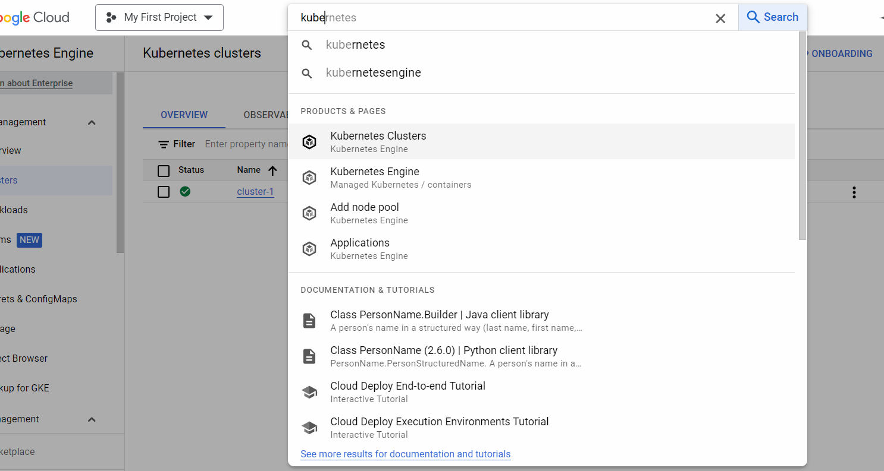

Click on Create cluster

Create a standard cluster.

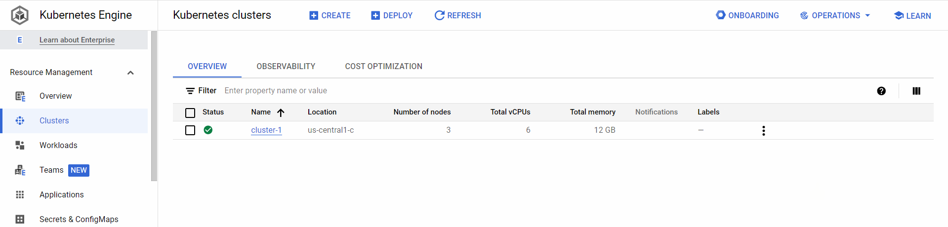

Click on 3 dots 🡪 click on connect option

Copy the command and click on run in cloud shell

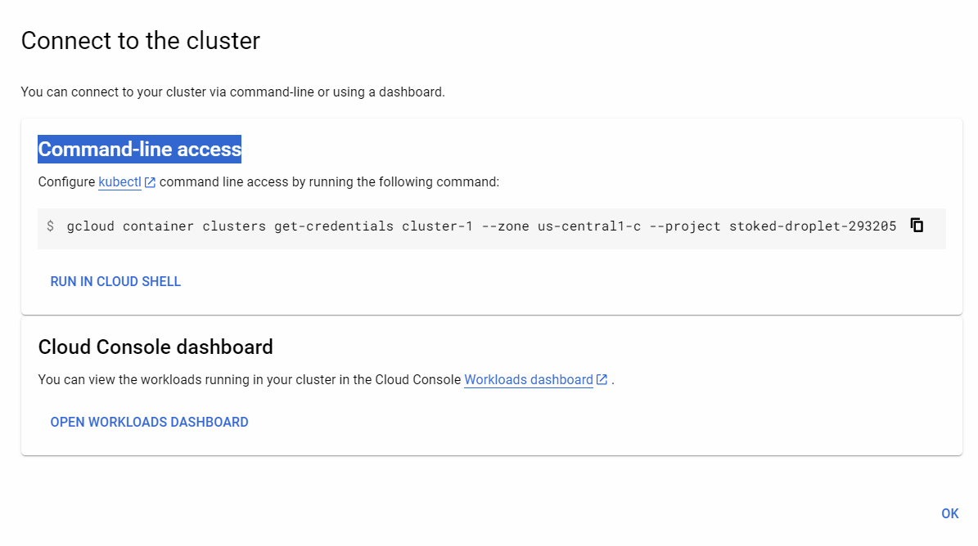

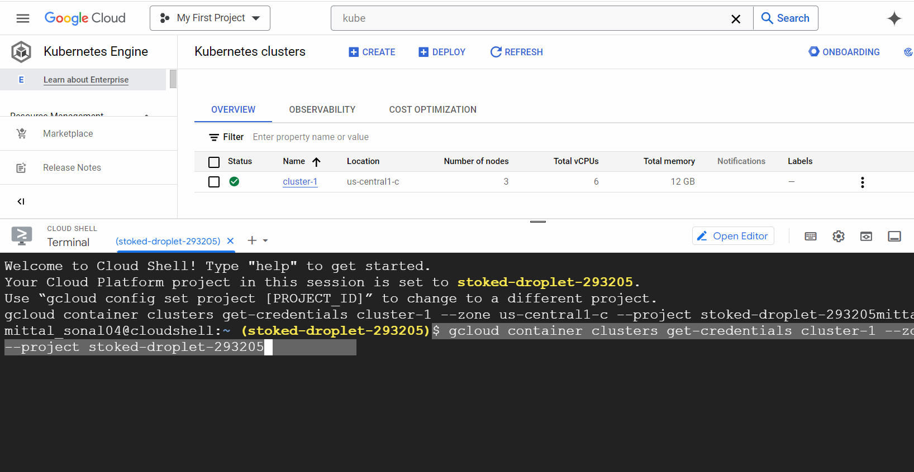

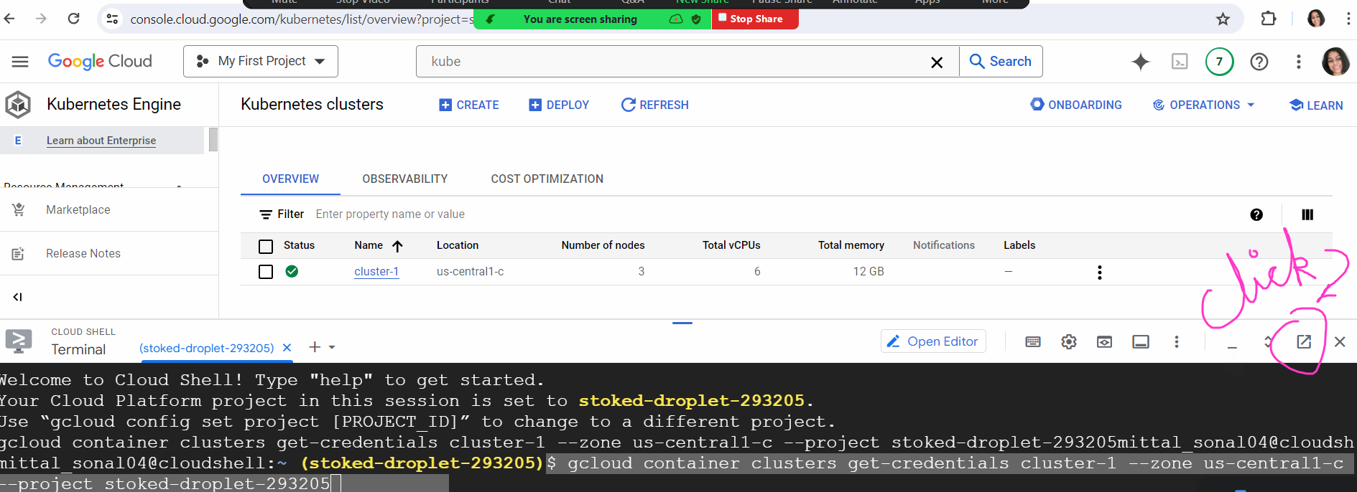

Click on Authorize

