Click on Ec2

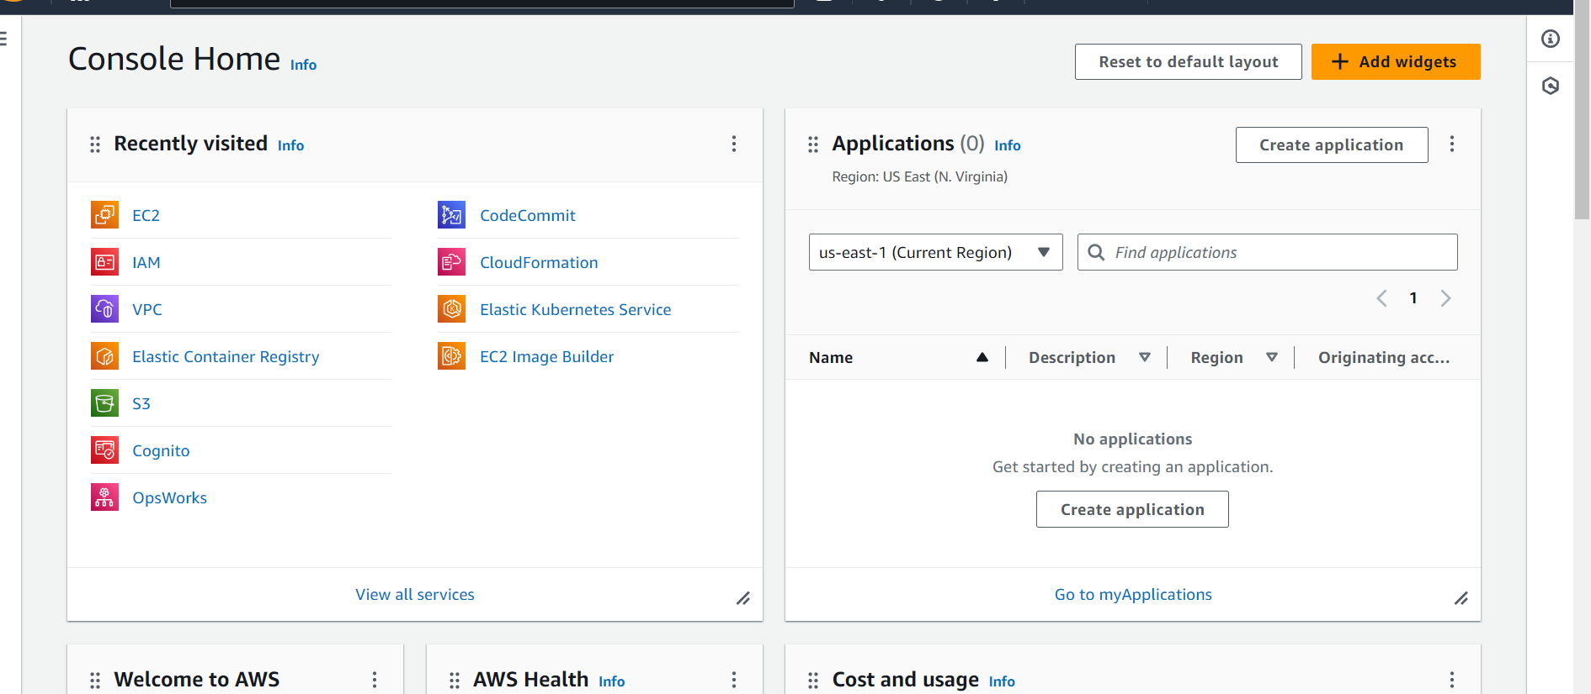

Click on launch instance

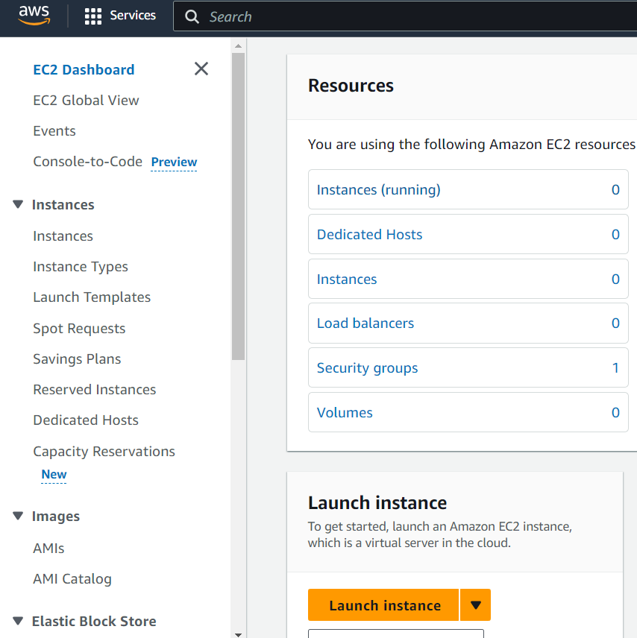

Give name as show below:

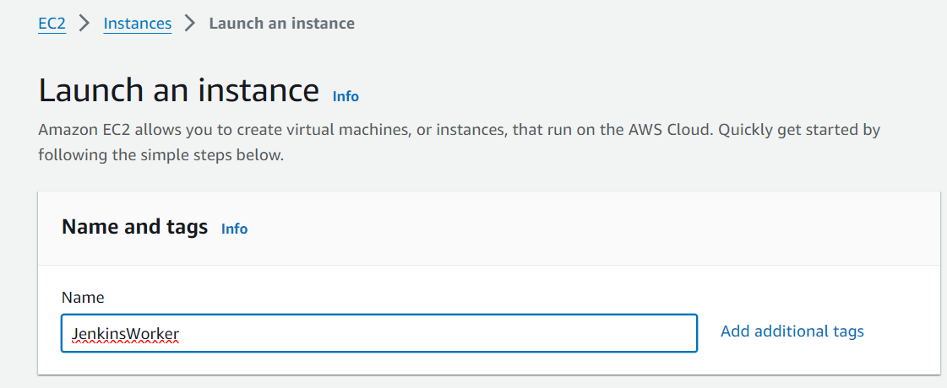

Select the AMI as shown below:

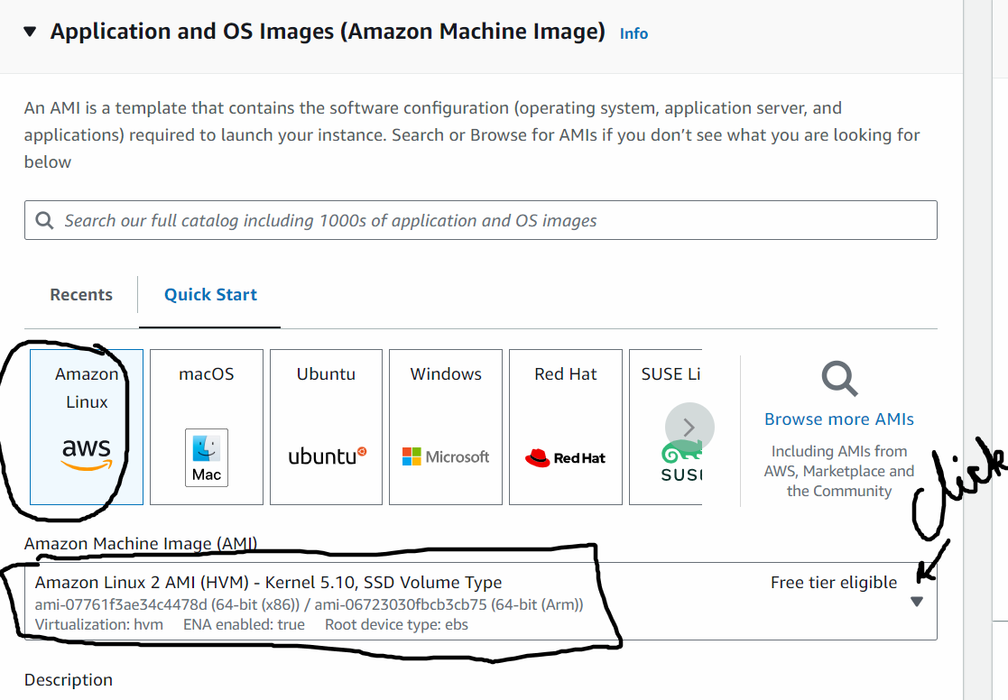

Select Instance_type as t2.micro

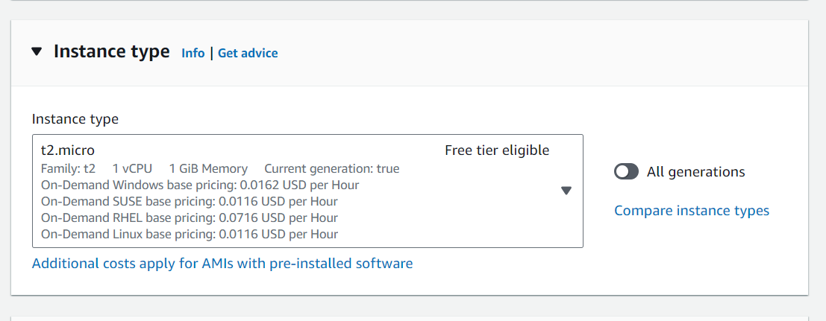

Create a new Key pair:

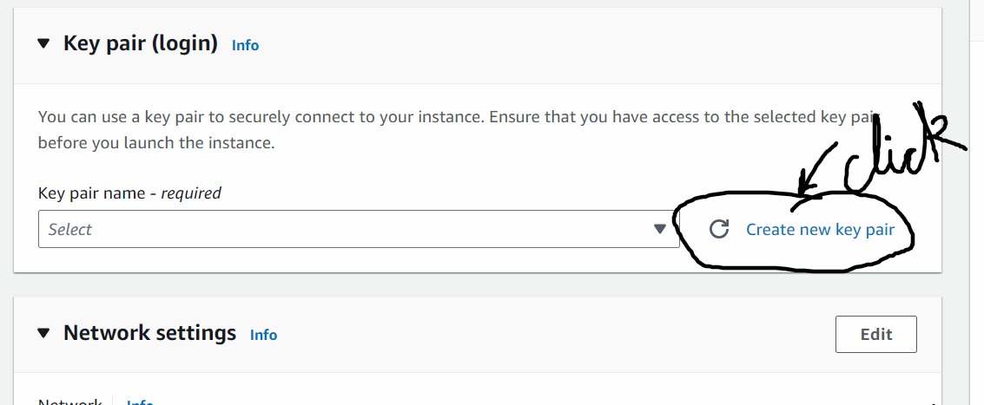

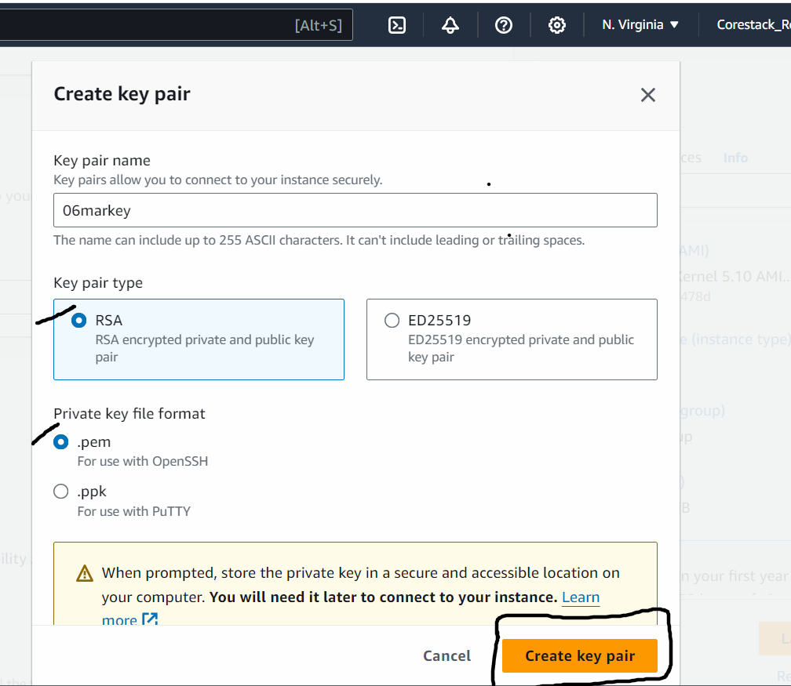

Make sure the select the key pair in the drop down

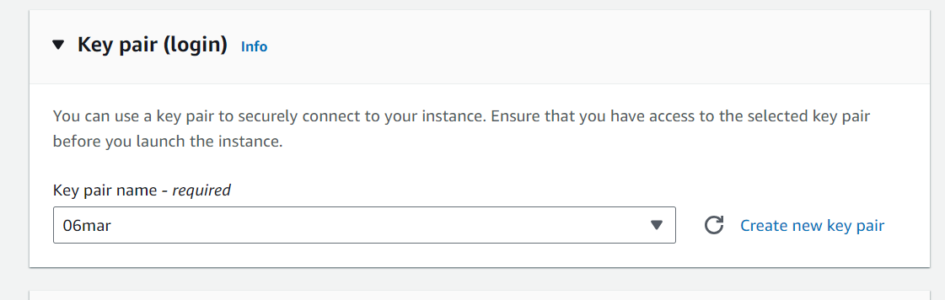

Add network Settings:

Click on Edit button and scroll down

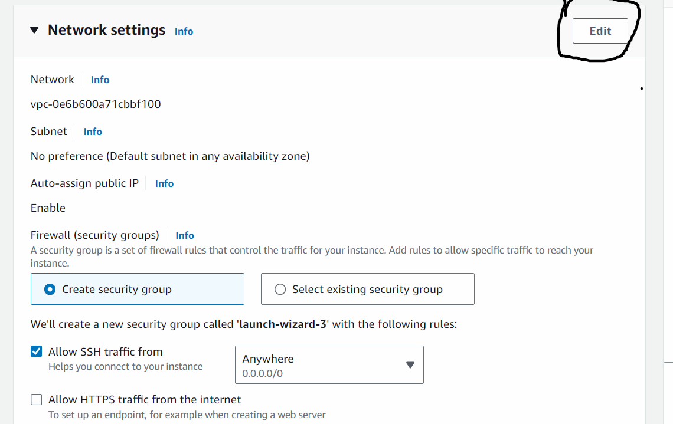

Click on Add security group rule

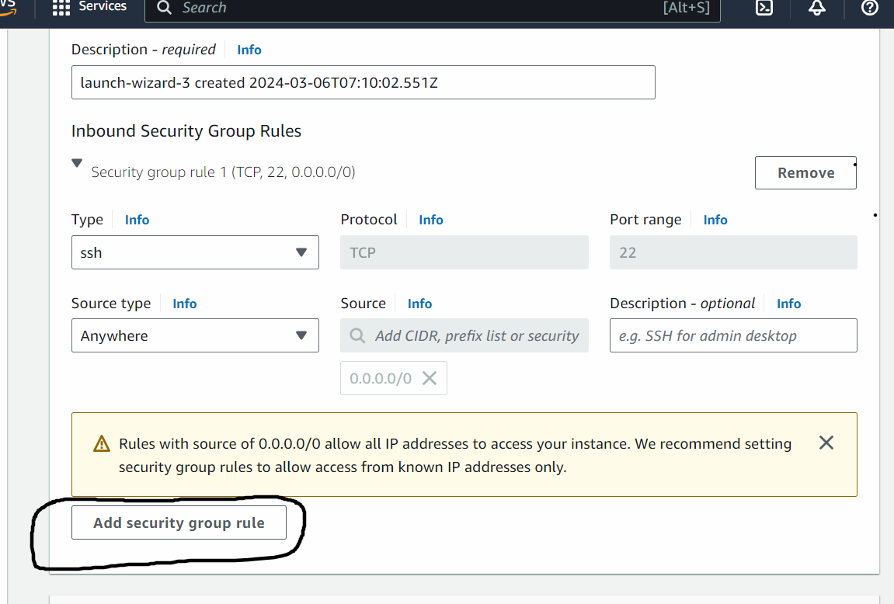

Add by selecting values from the drop down - as show below:

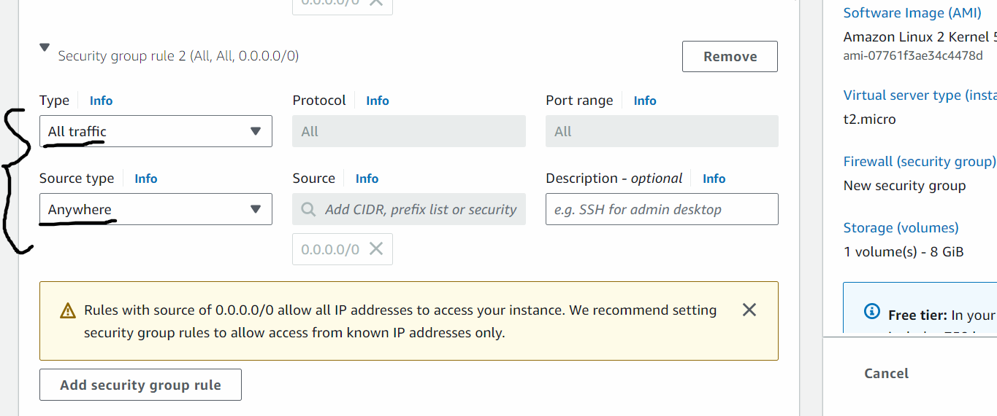

Scroll down and click on Advance settings

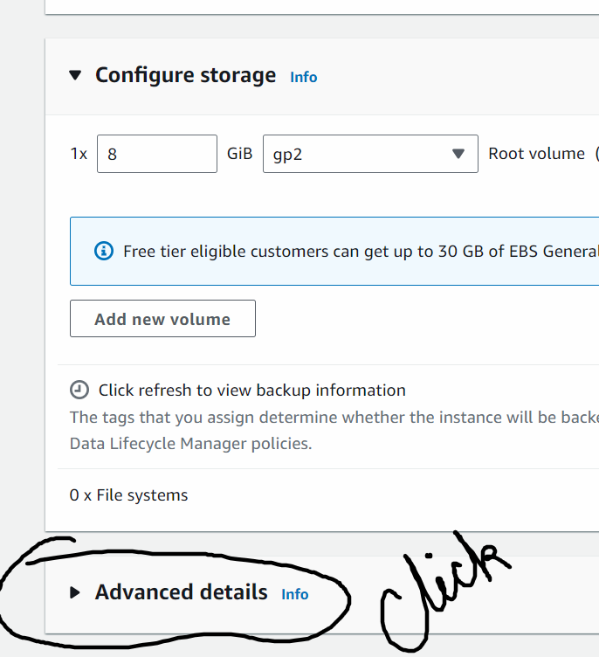

Scroll down to User data section and add below commands:

#!/bin/bash

sudo yum update -y

sudo yum install git -y

sudo amazon-linux-extras install java-openjdk11 -y

cd /tmp

mkdir jenkinsdir

chmod -R 777 /tmp/jenkinsdir

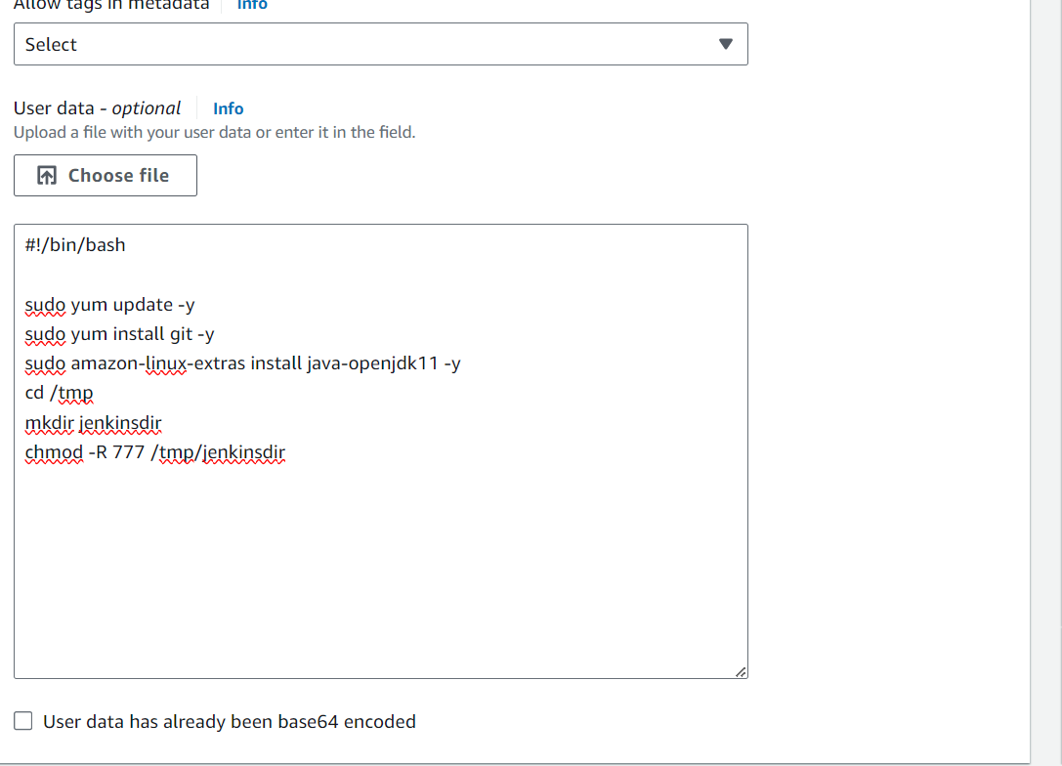

Now click on Launch instance

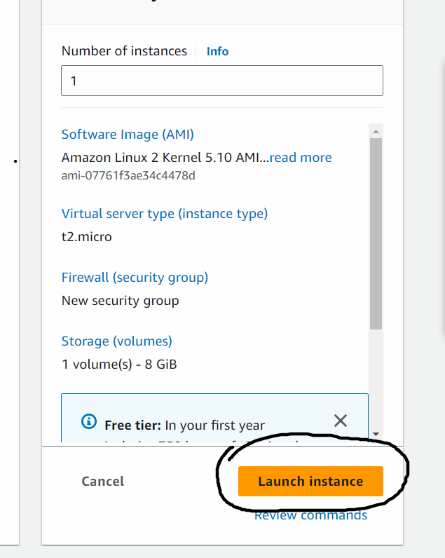

Connect to the instance:

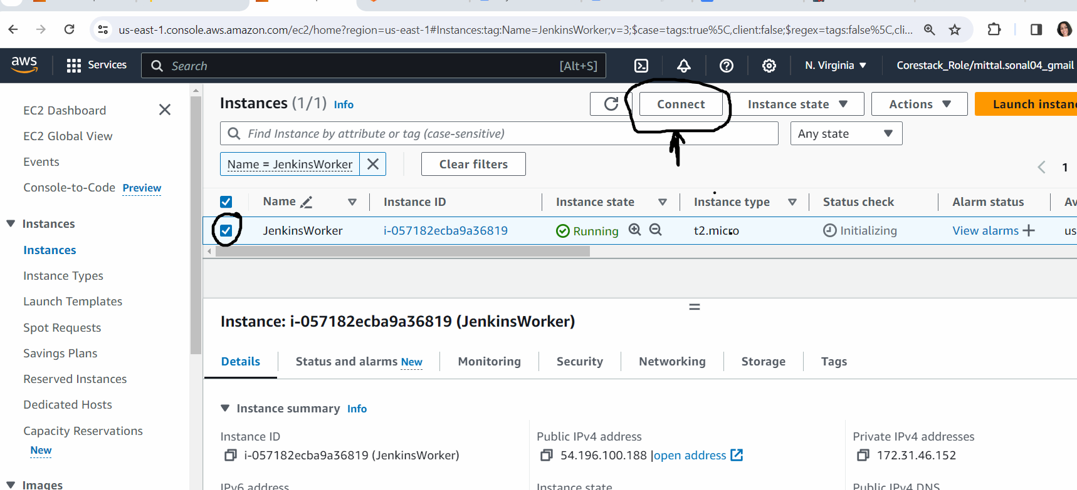

Go to Jenkins Server on the lab.

Go to Manage Jenkins 🡪Click on Security

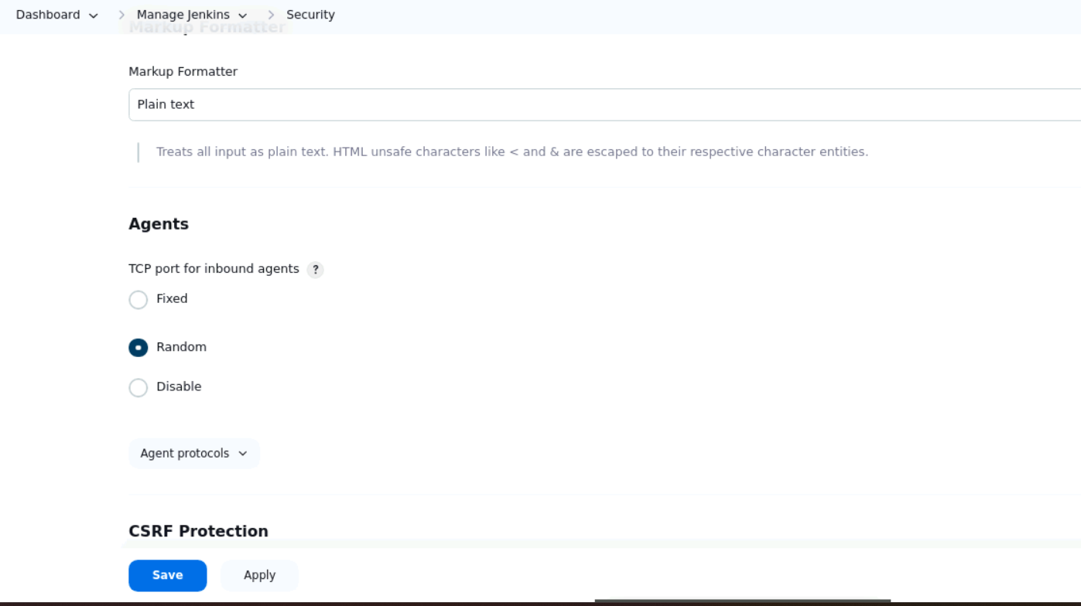

Click on Save button

Manage Jenkins – Manage nodes and Clouds

Click on + New node

Give node name: slave1

Select Permanent Agent

Click on create

Now give description : anything text

Number of executors: 1

Remote root directory: /tmp/jenkinsdir

Labels : linux_slave

Usage : select second option from dropdown

Launch method: launch agents via SSH

Host: public IP of agent node

Credentials: click on Add button > click on jenkins

Select Kind : SSH username and private key

username: ec2-user

Private key: you will get the private key of the agent node in your local laptop> downloads folder

got the downloads folder of laptop, search for the key(.pemfile)

open the file with notepad and copy the entire text

paste the text in jenkins > under private key

Now select the credials from the drop down.

step 7: Host Key Verification Strategy → select the 4th option->Non verifying Verification Strategy

Save the node details

On the dashboard you can see the node is now connected to master