Download VS code

https://code.visualstudio.com/download

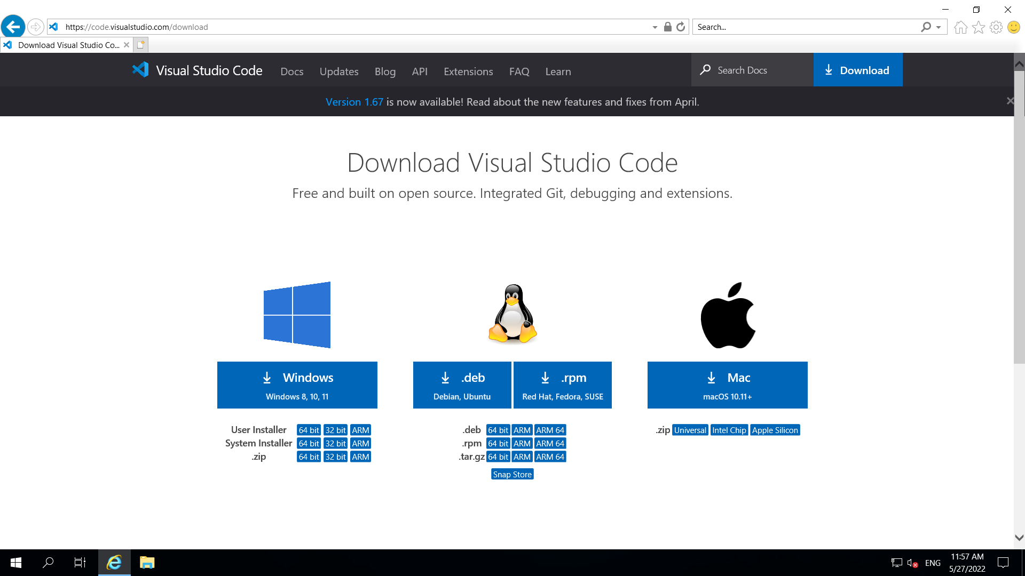

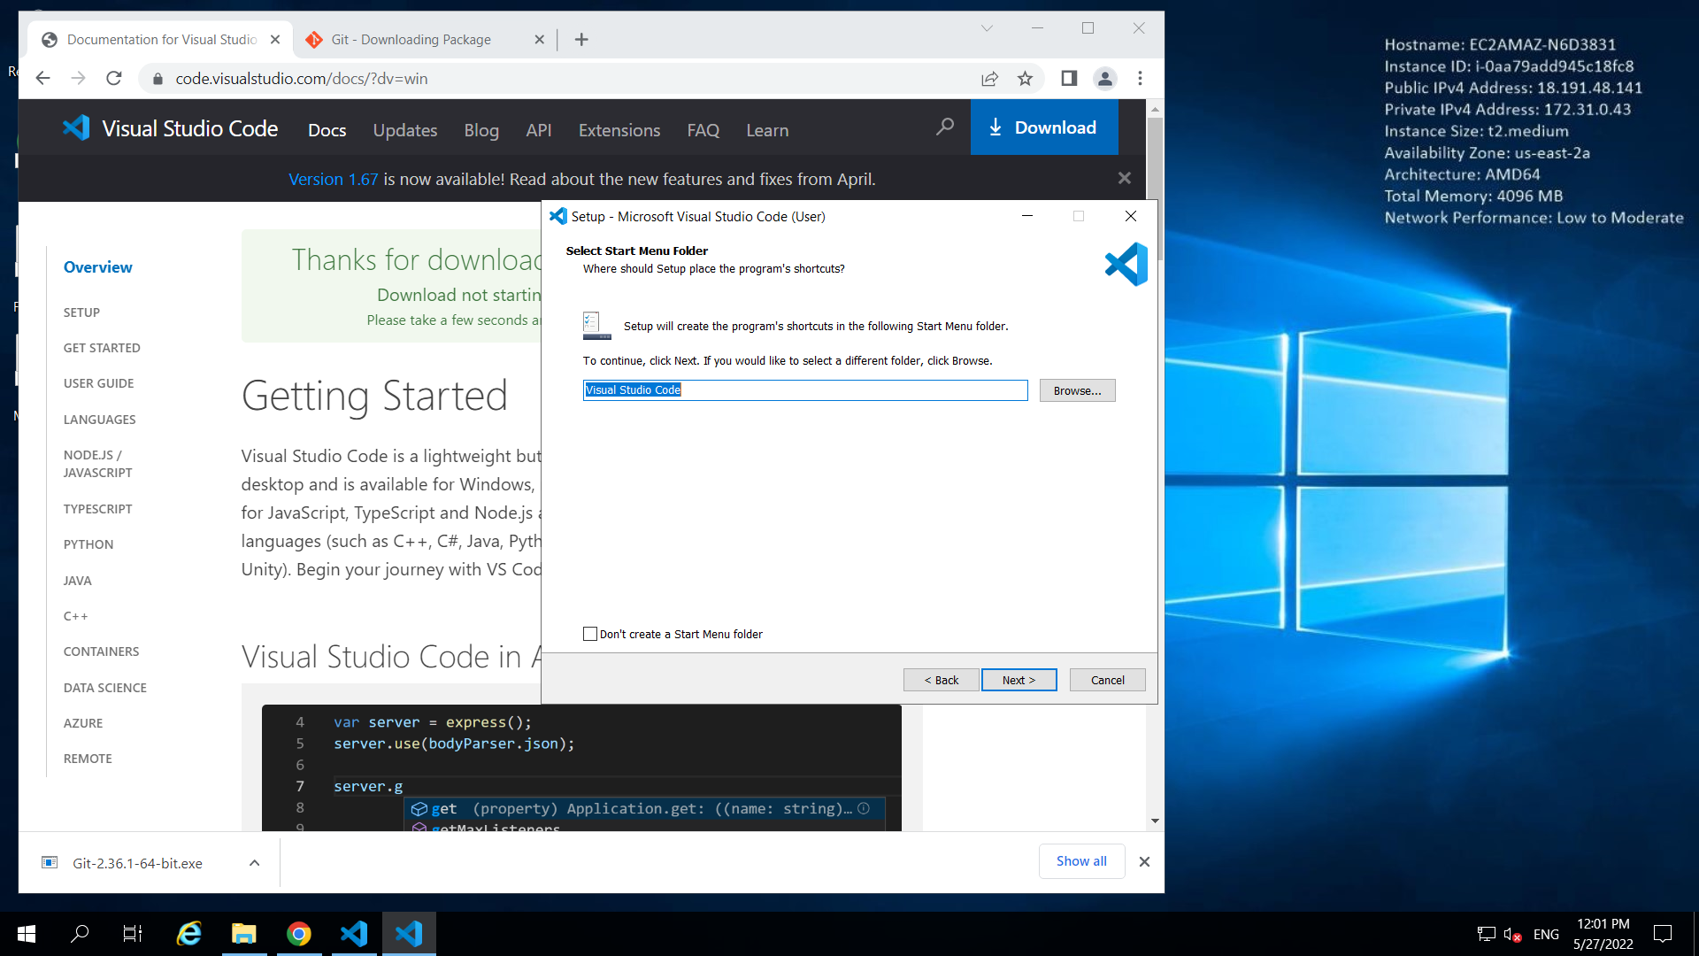

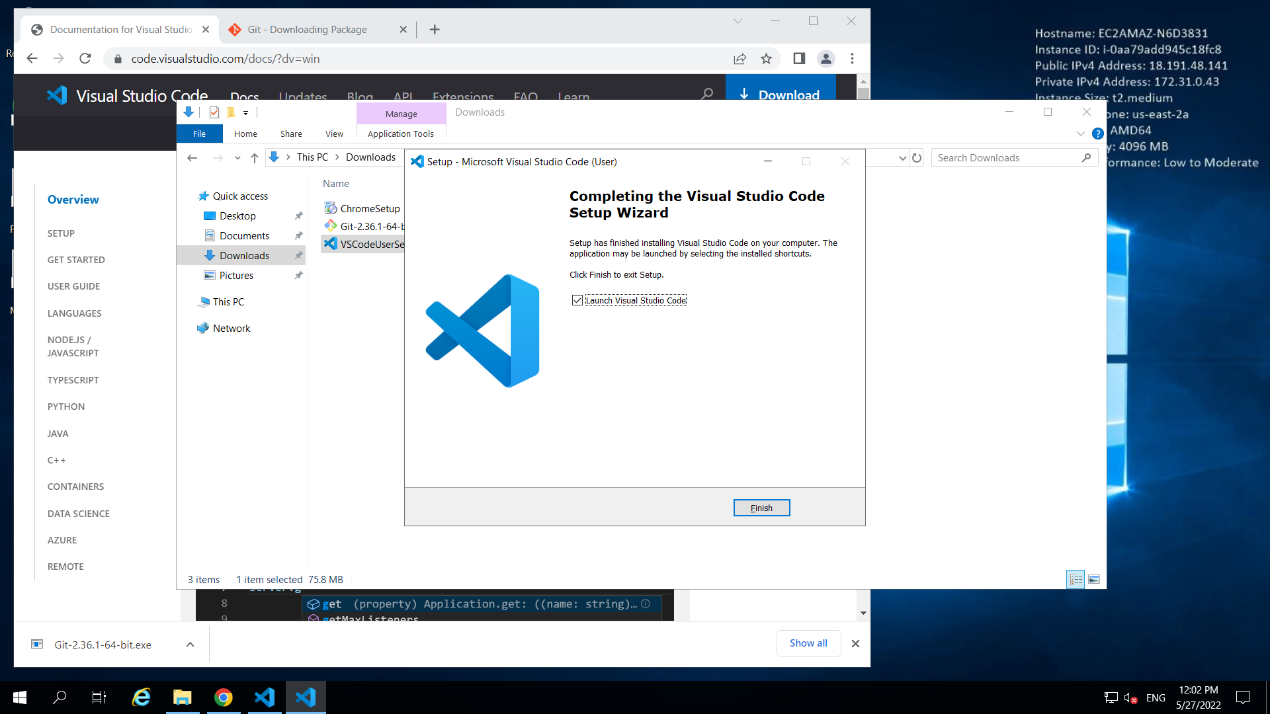

Install Git on windows.

Set the configurations on git

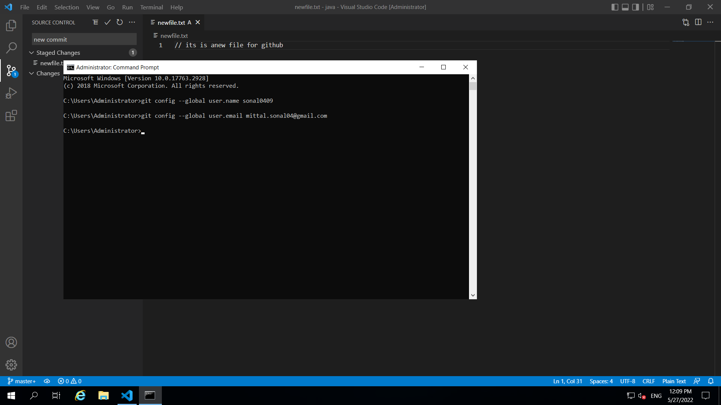

Now go VS Code to Clone a Repo

Click on Source Control 🡺 click on three dots …

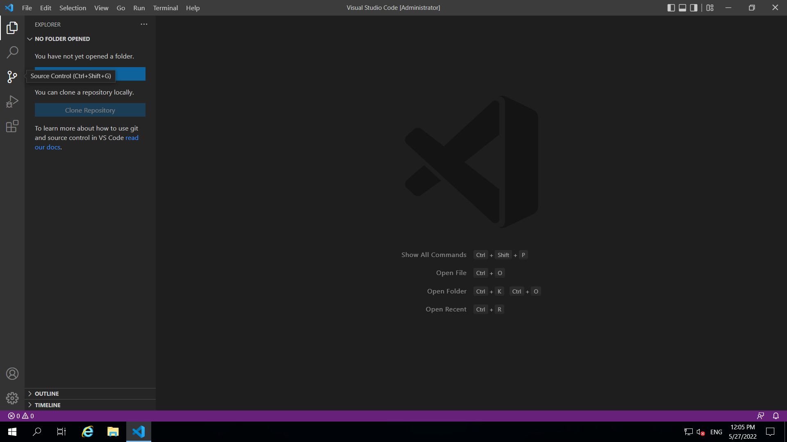

Click on Clone button

On the top give the repo path in https

<https://github.com/Sonal0409/VScodeDemo.git>

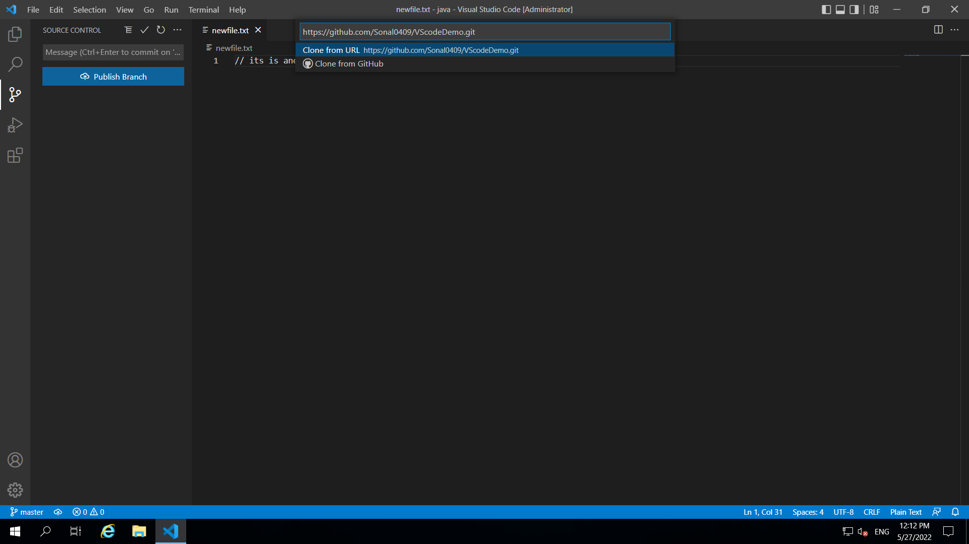

Select Repository Location 🡺 as Desktop

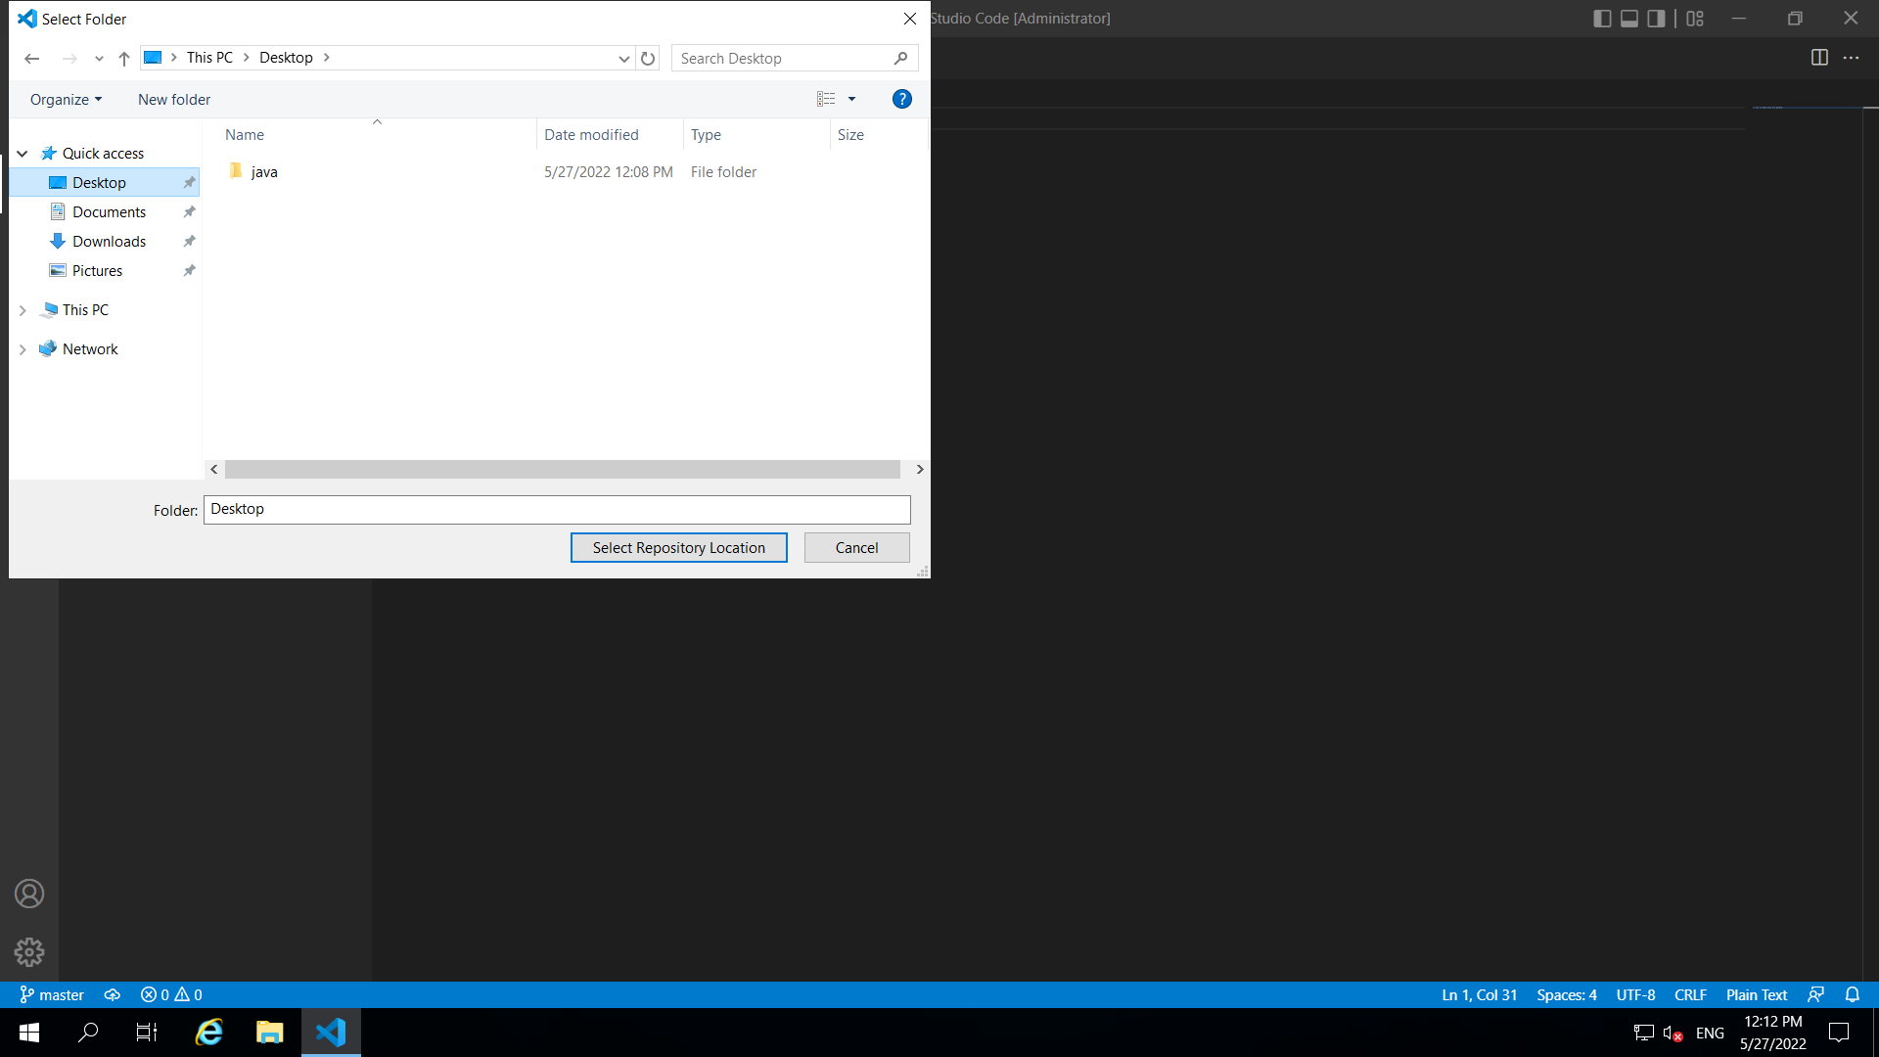

Clone will complete .. At the right side botton.. click on add to this workspace

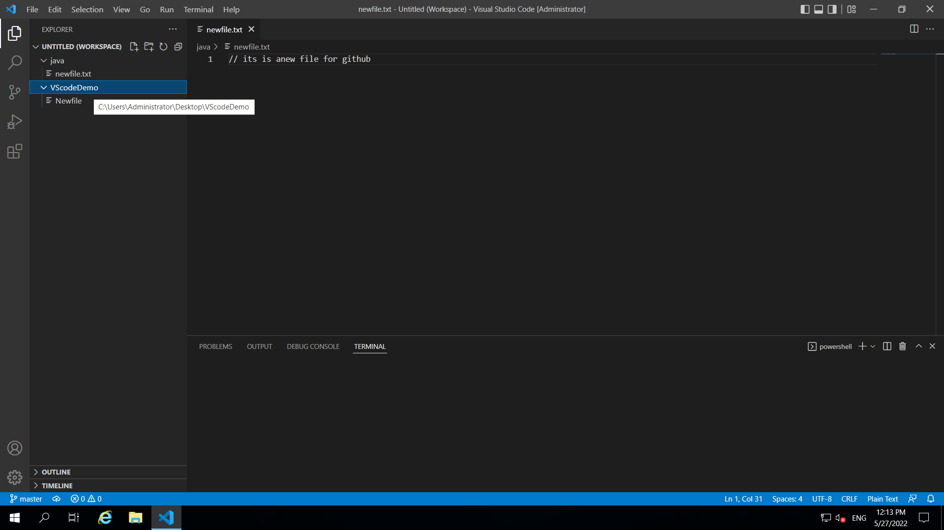

In source Control 🡺 for the project 🡺 click on 3 dots🡪 click on branch🡪 create branch

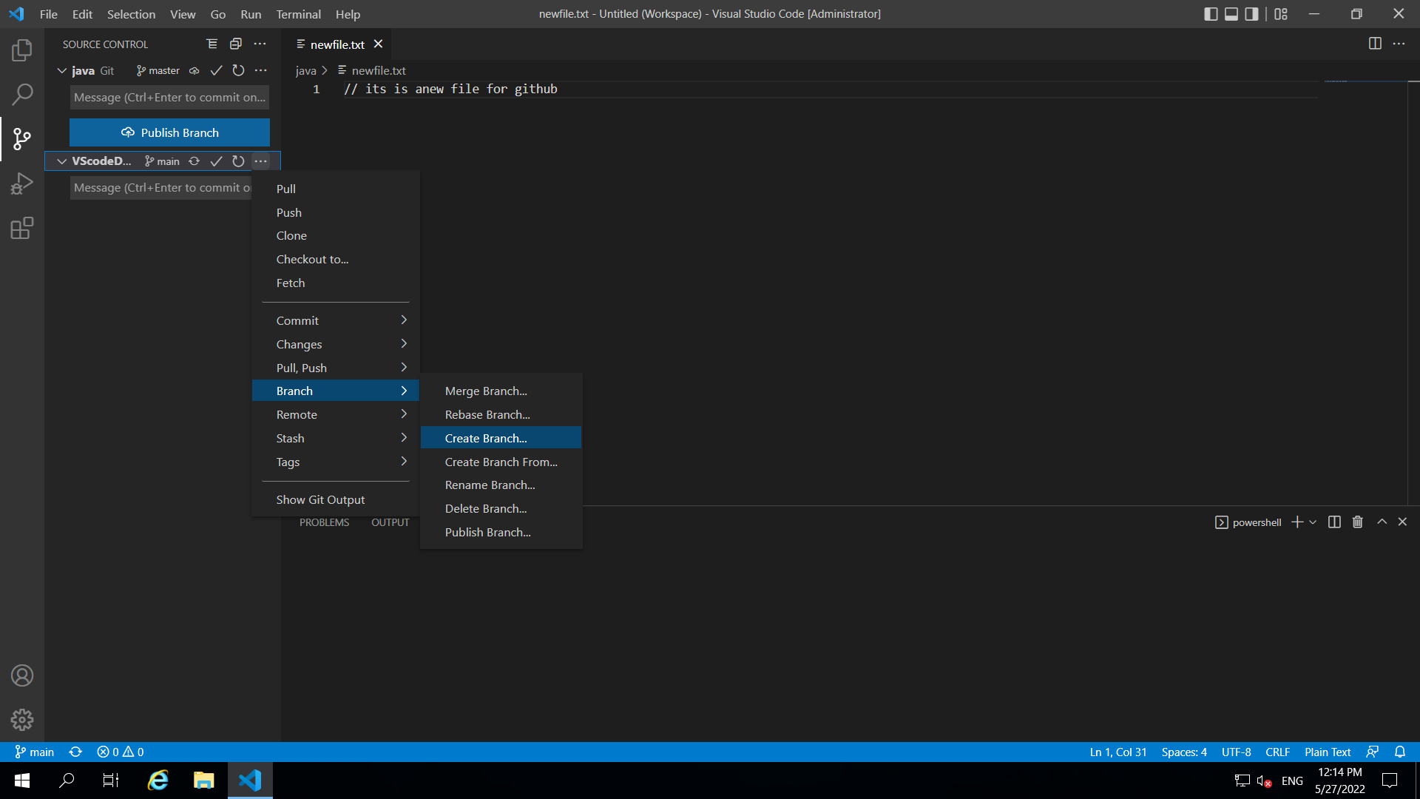

Give branch name as feature on the top and press enter

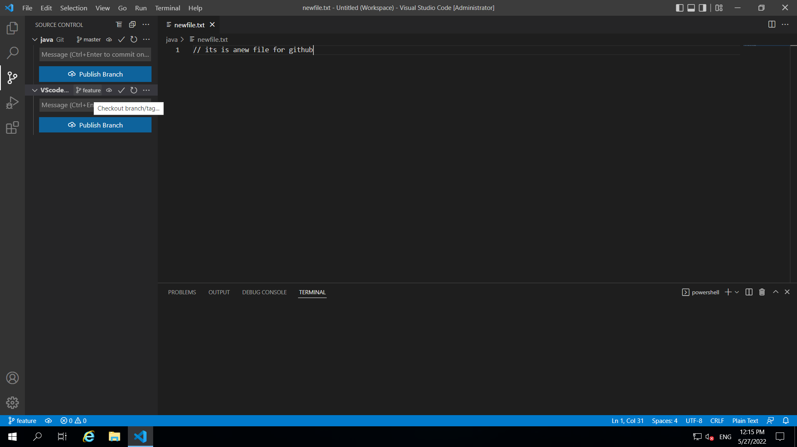

At bottom you can see the feature branch

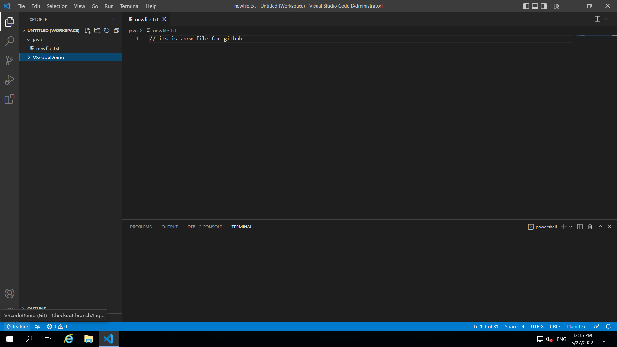

Add a new file in feature branch

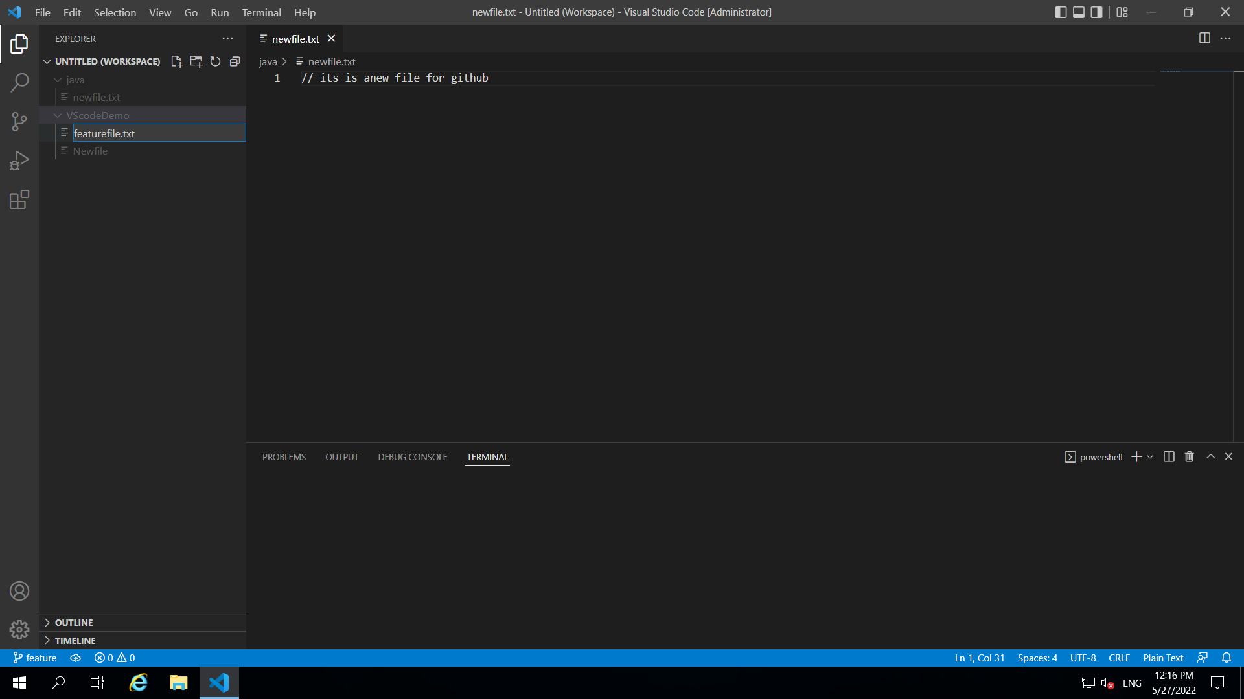

Go to source Control and Commit (tick mark and give message)

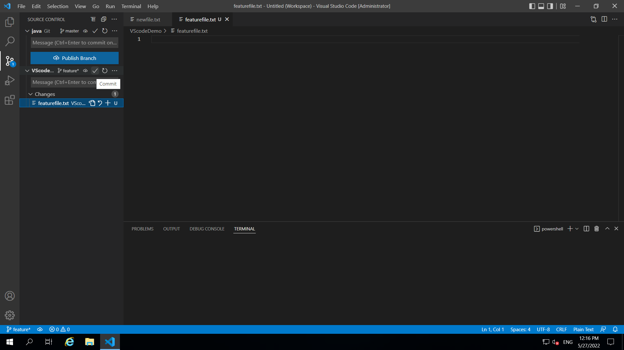

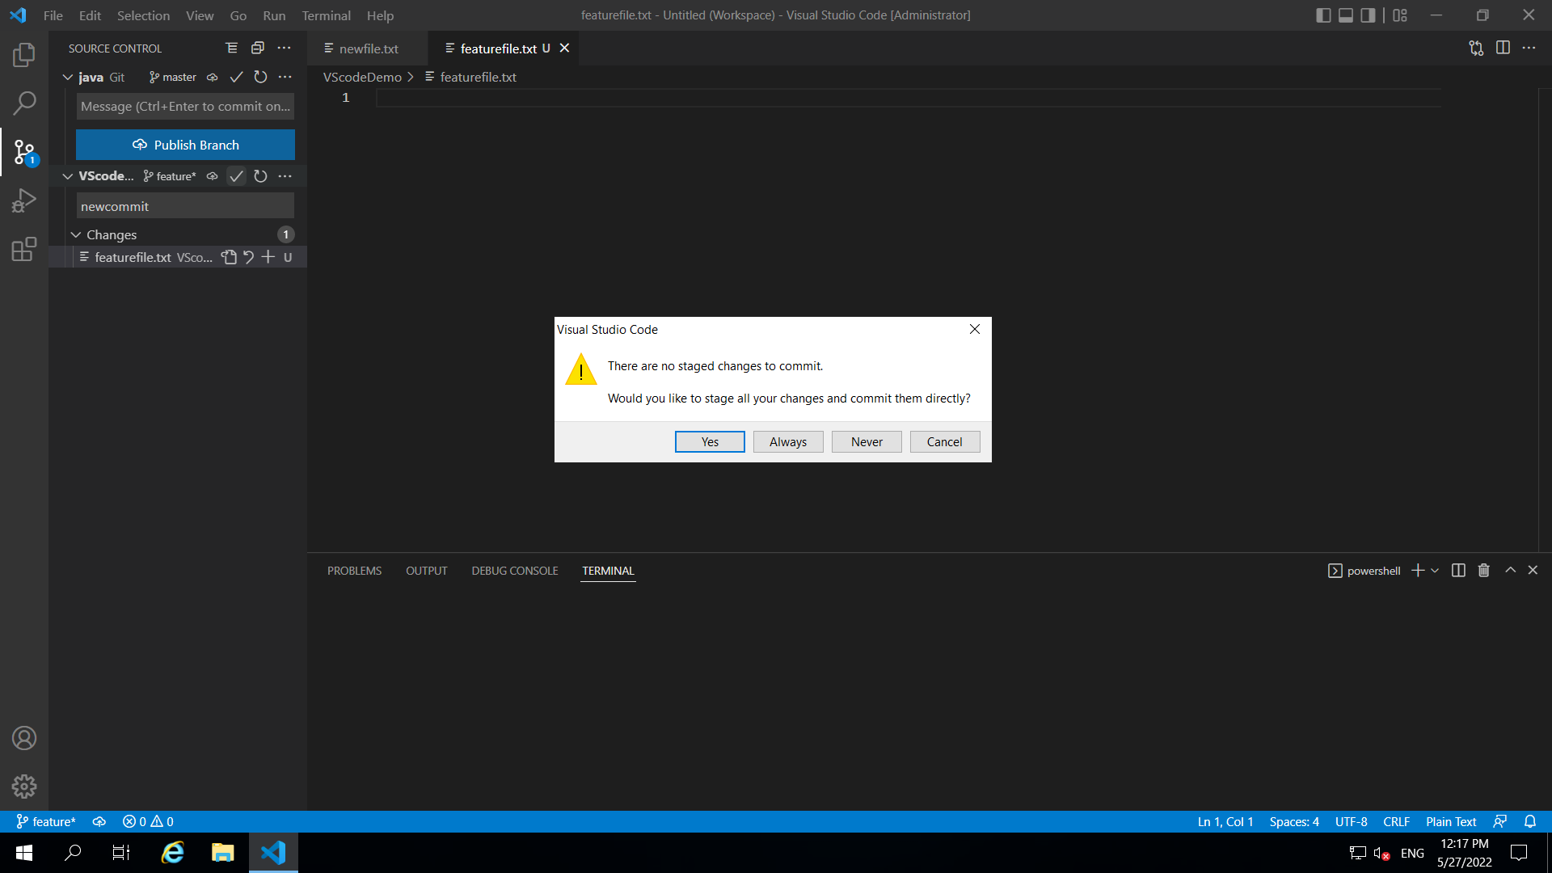

Now click on publish branch

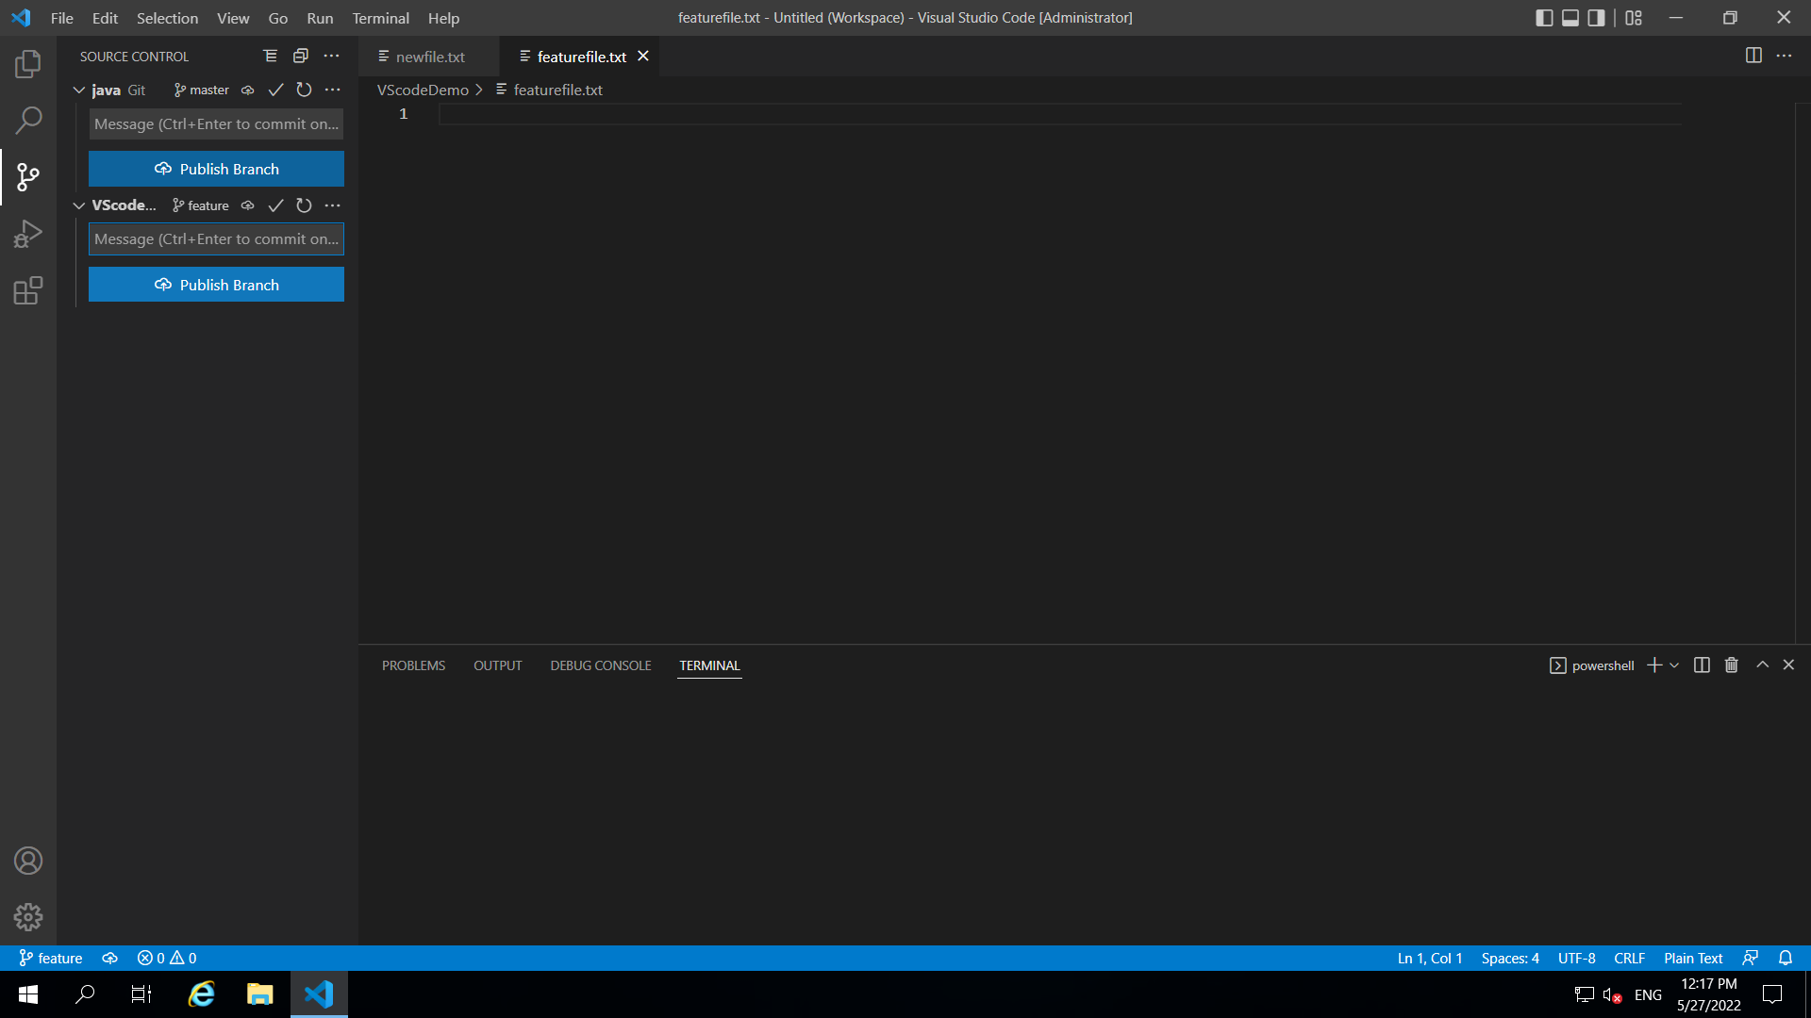

It will publish the branch

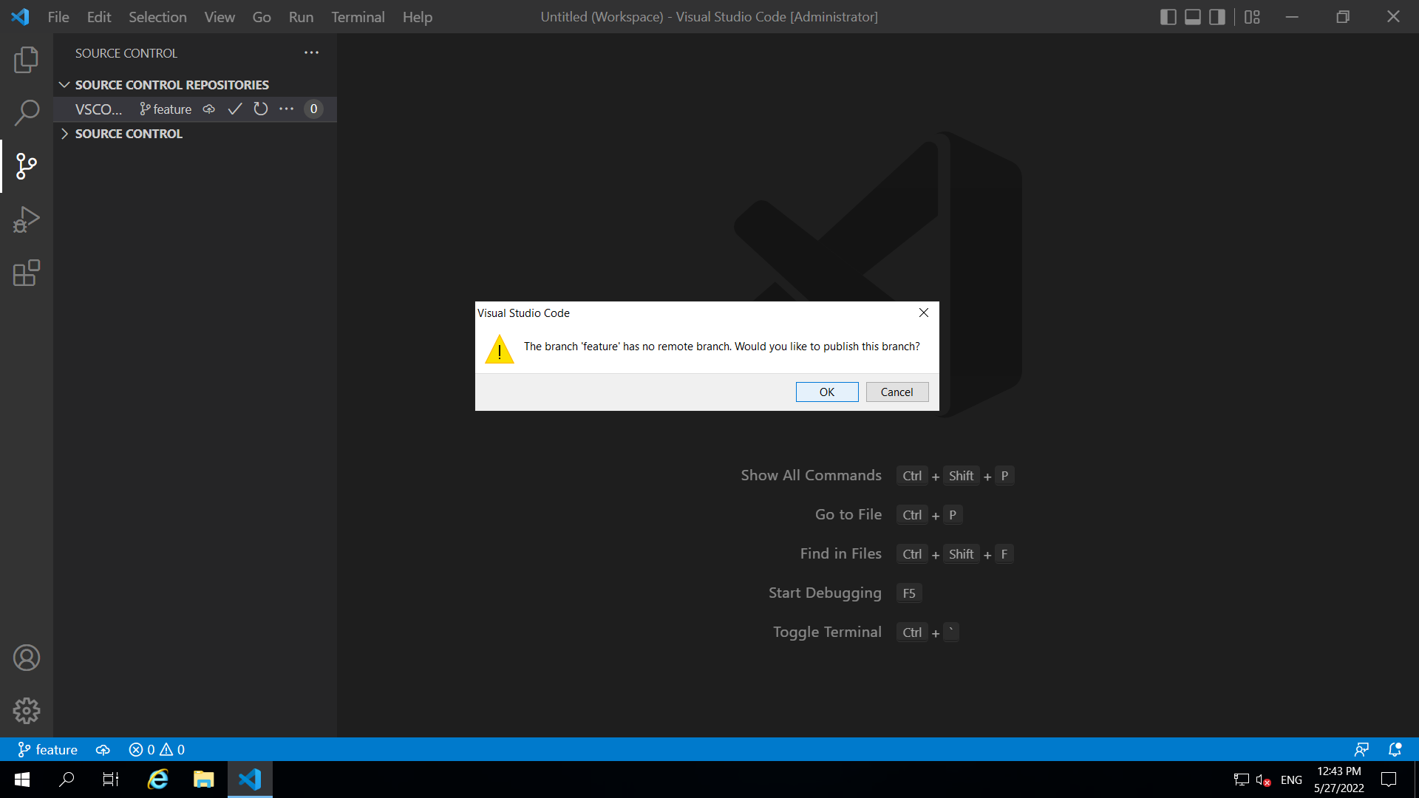

For authentication:

It will ask you to sign inot git hub for authentication

Minimise vs code to see the screen for authorization

