Click on this link to download eclipse:

<https://www.eclipse.org/downloads/packages/release/kepler/sr1/eclipse-ide-java-developers>

On the same page if you Scroll down 🡪 on the right side bottom you will find these options: You can download Eclipse version 2021-06 also.

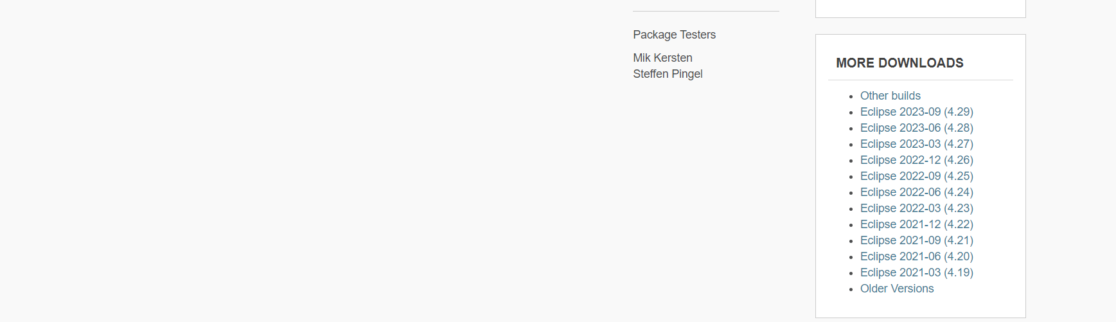

Download Eclipse using Eclipse Installer 🡪 Follow below steps:

As shown in screenshot below, click on Install button

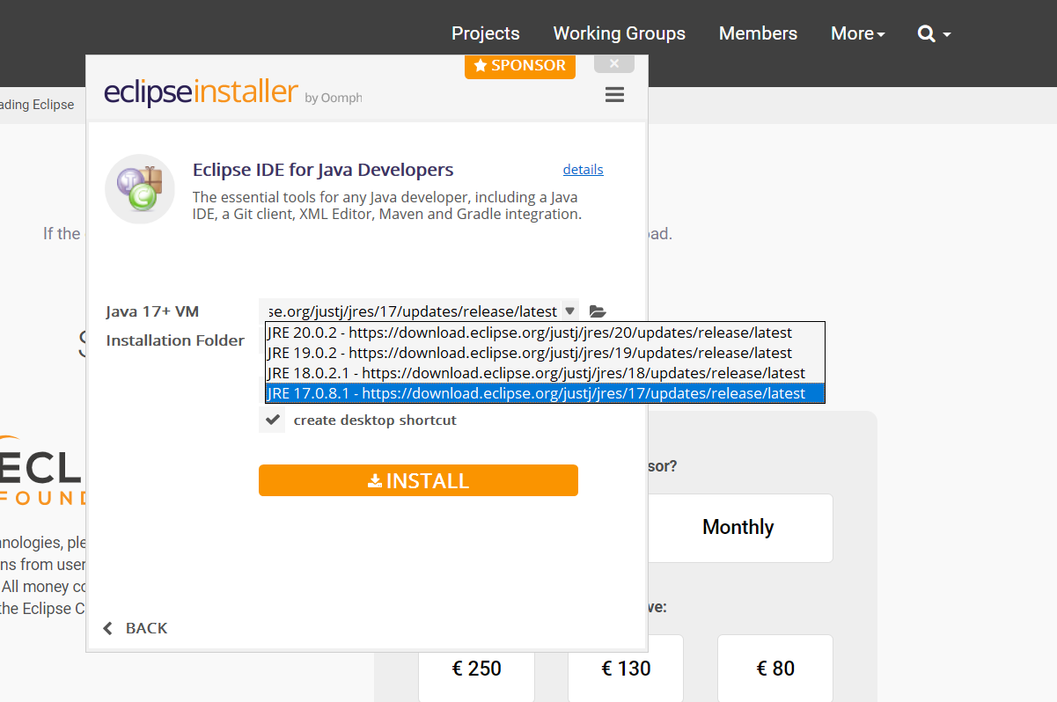

Select the Unassigned checkbox. Click on trusted Selected.

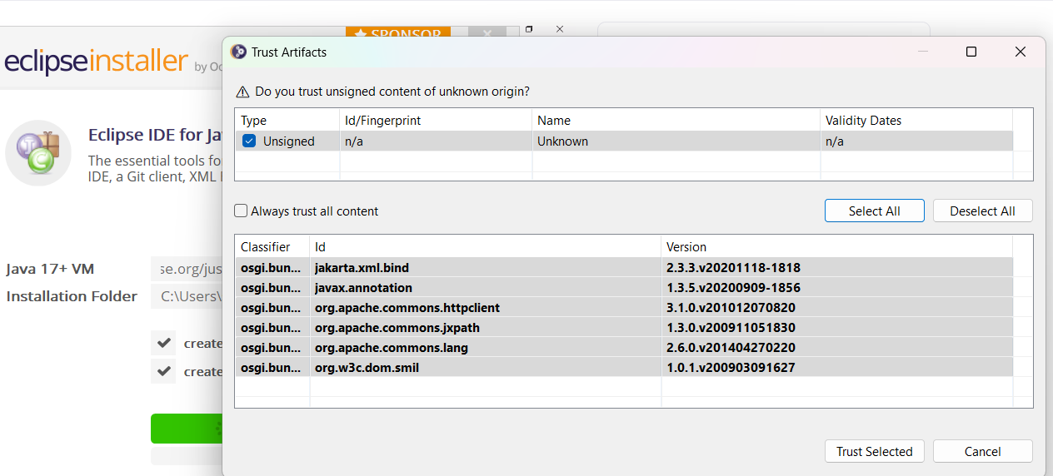

Click on Launch button

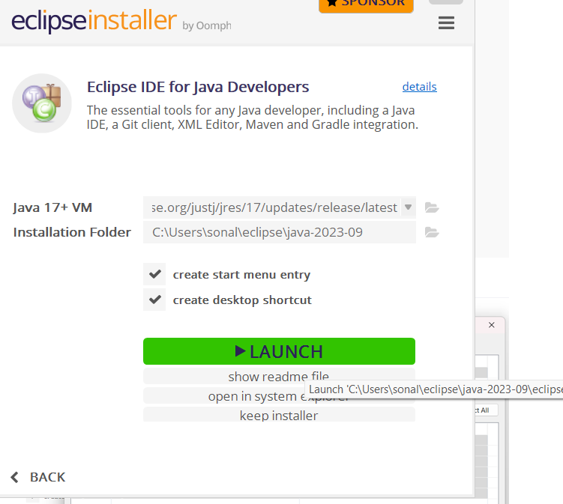

New Eclipse Editor will launch

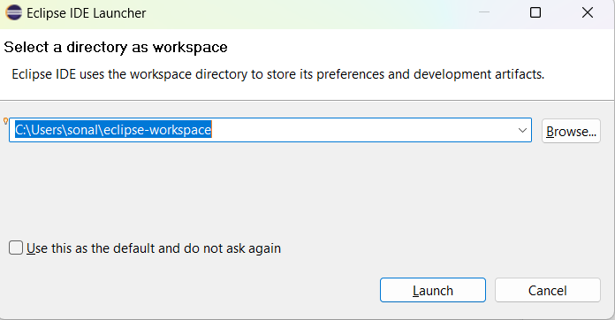

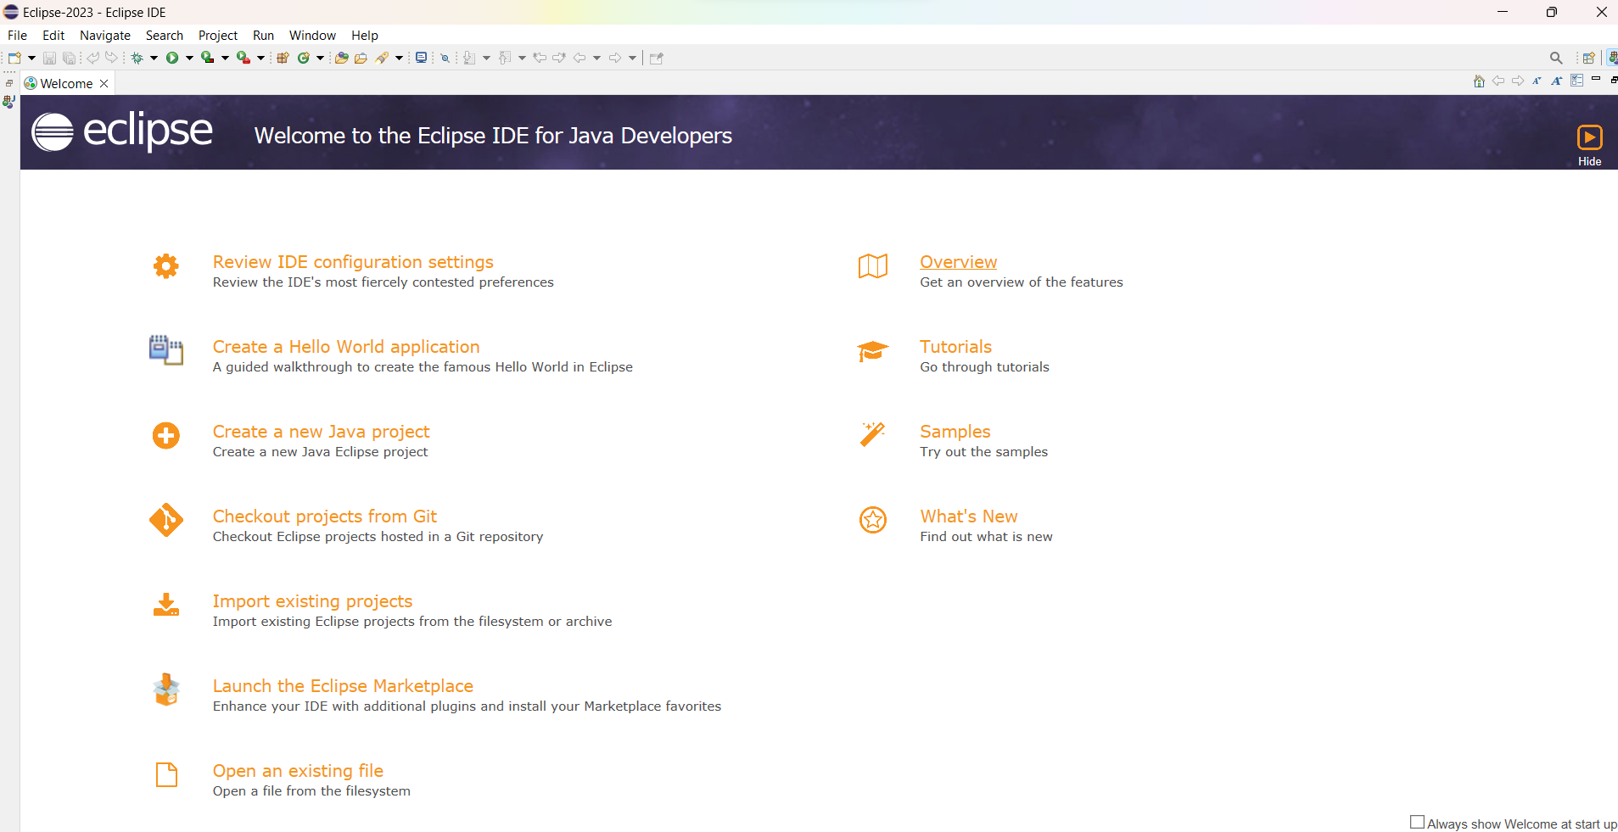

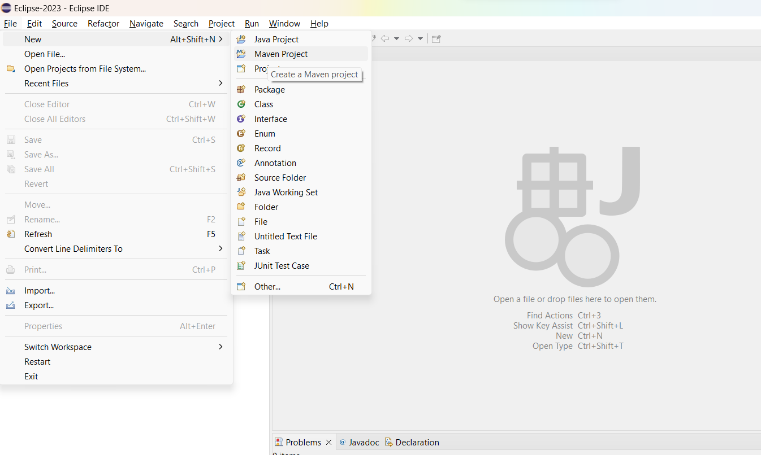

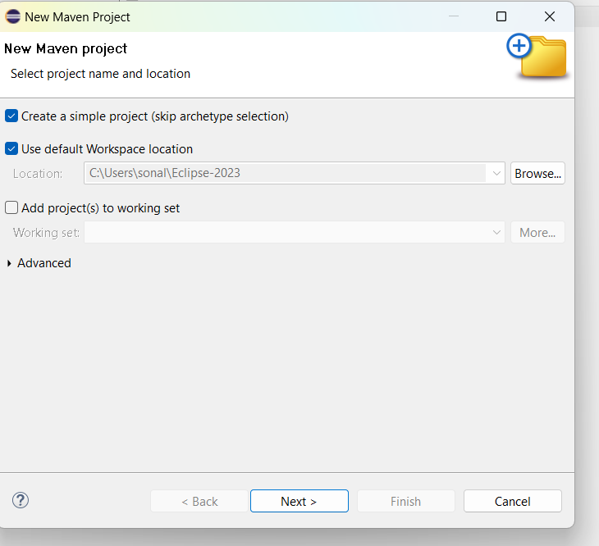

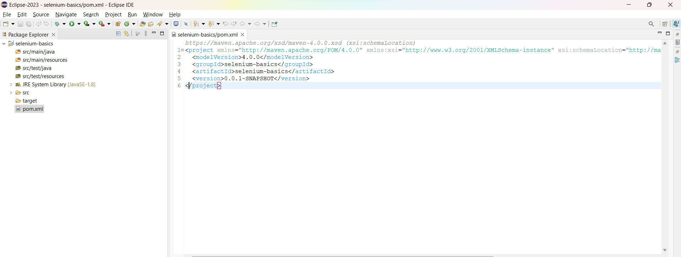

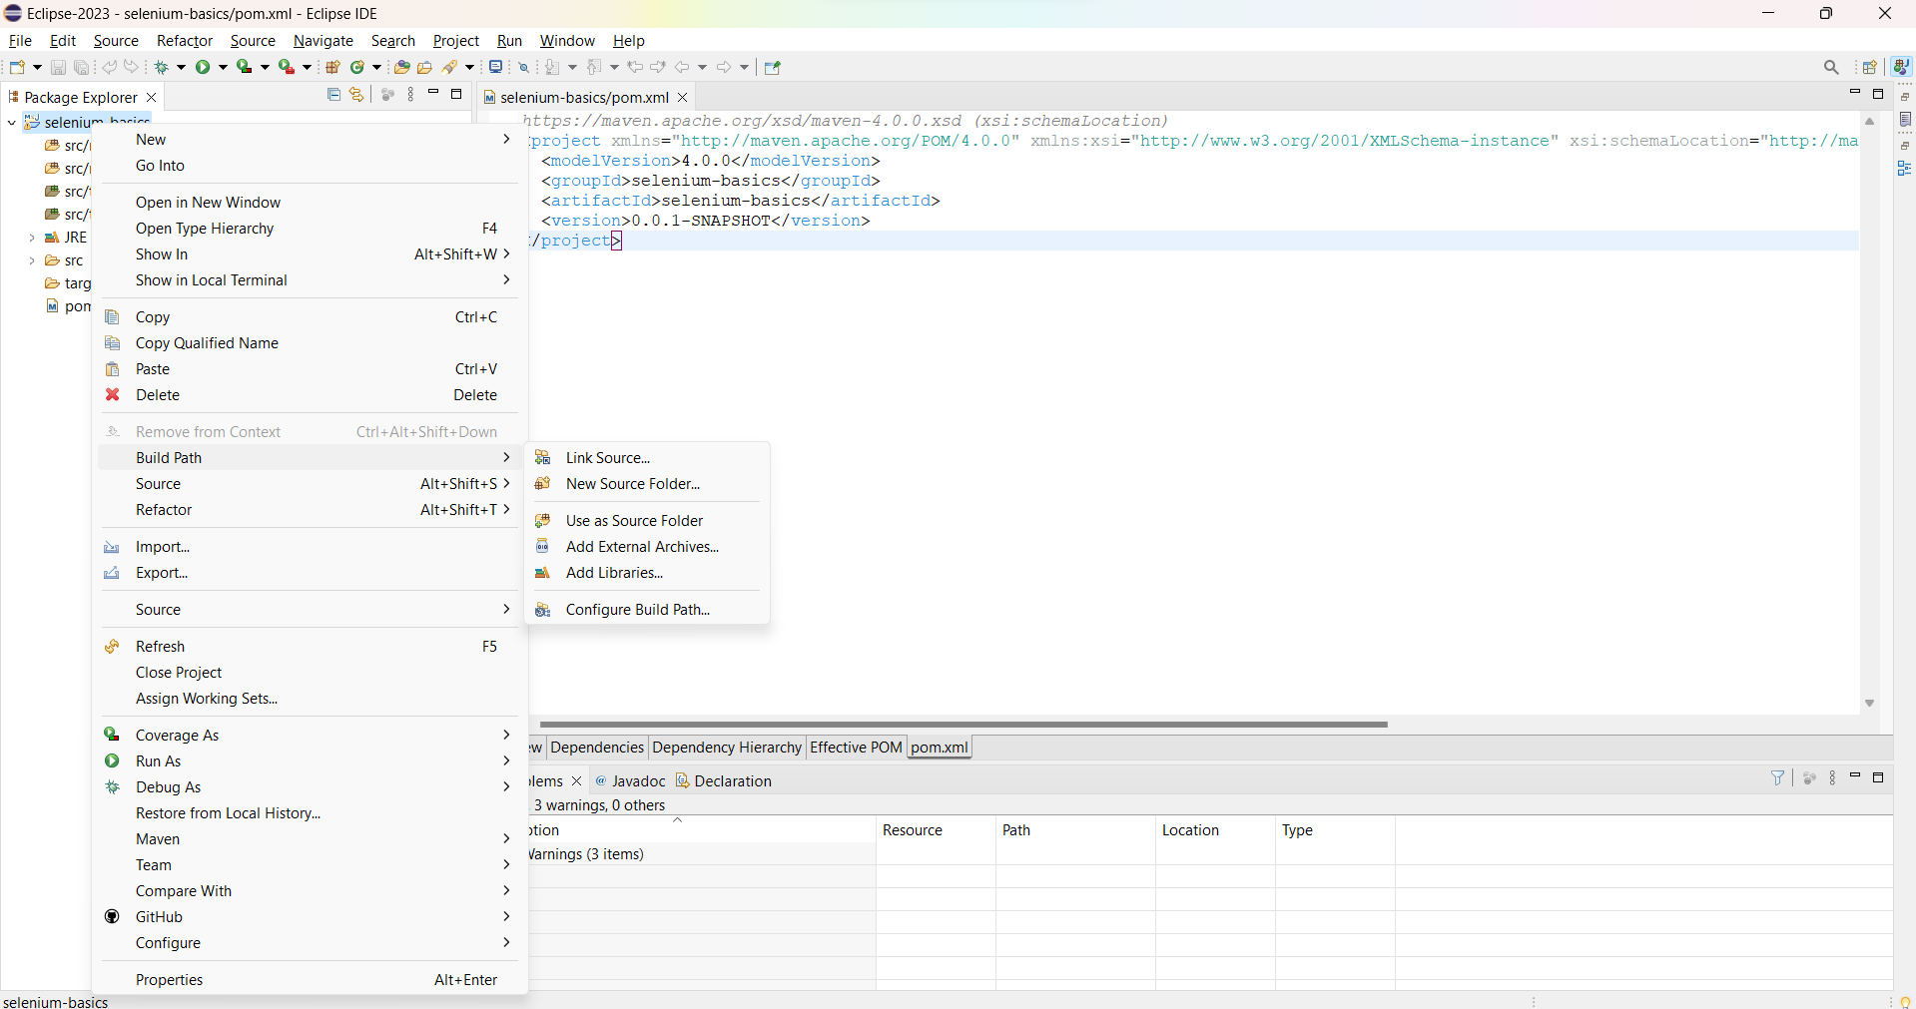

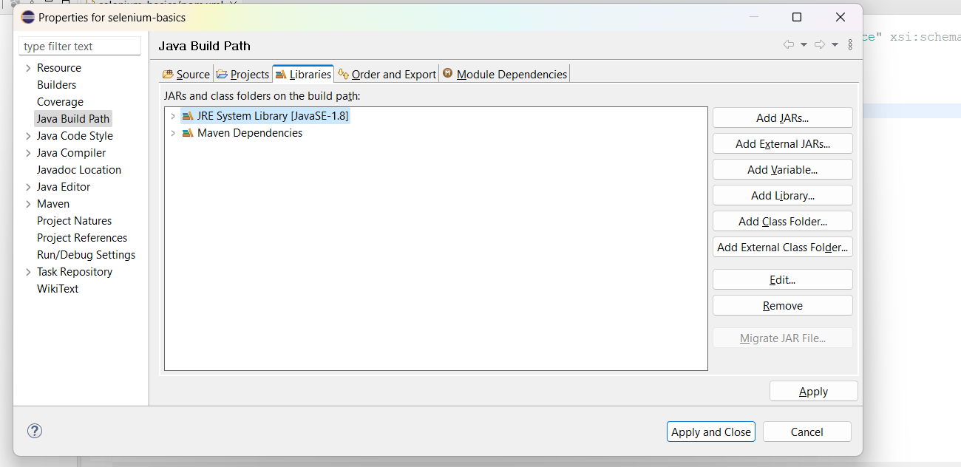

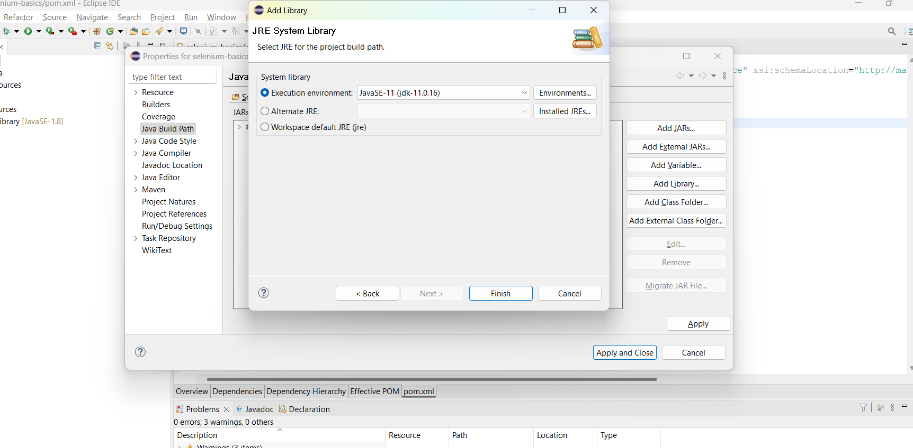

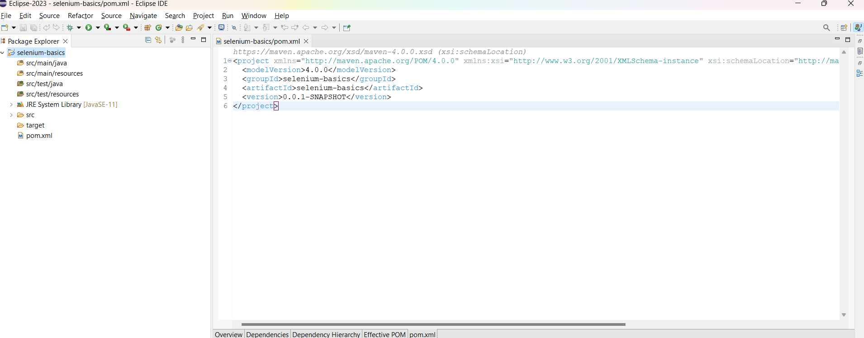

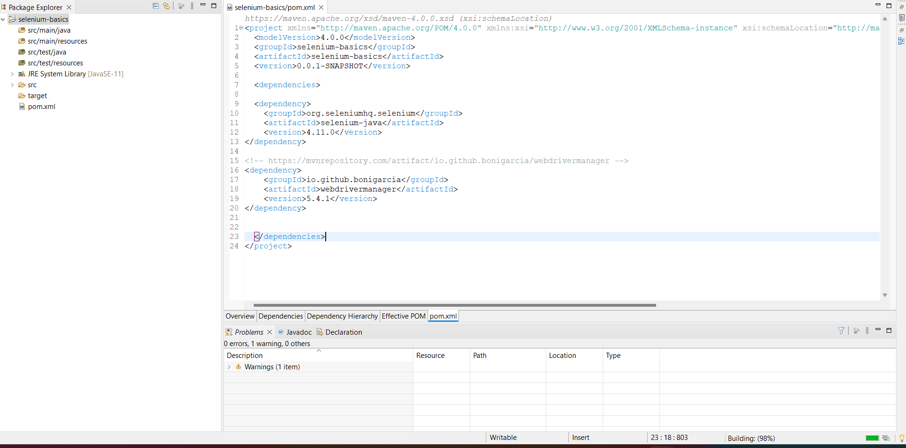

Error Screesnhot

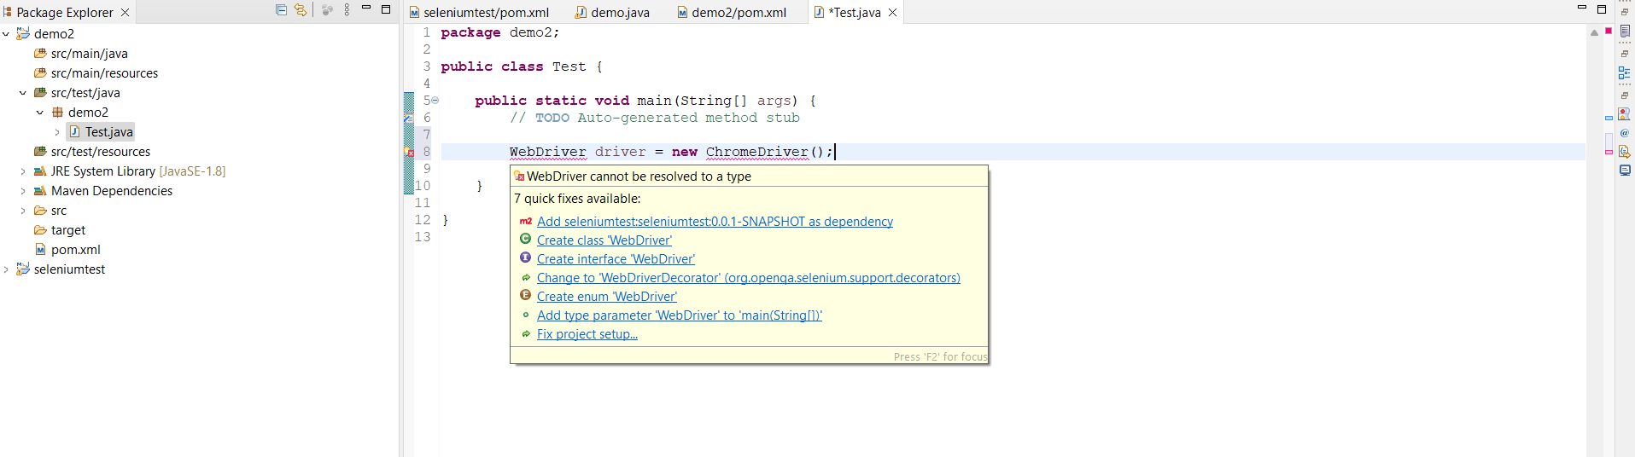

Manually copied the import statements and it worked.

