1Not following best practices
One of the first mistakes that many system administrators make when using Ansible is not following the best practices and guidelines that are recommended by the Ansible community and documentation. These include using consistent naming conventions, organizing your files and directories, writing modular and reusable code, using roles and collections, avoiding hard-coded values, and documenting your code. By following these best practices, you can ensure that your Ansible code is readable, maintainable, scalable, and secure.

Not testing your code
Another common mistake that can lead to errors and failures is not testing your Ansible code before running it on your production environment. Testing your code is essential to verify that it works as expected, that it does not have any bugs or syntax errors, and that it does not cause any unintended side effects or conflicts. You can use various tools and methods to test your Ansible code, such as Ansible Lint, Ansible Molecule, Ansible Check Mode, Ansible Vault, and Ansible Callback Plugins. By testing your code, you can avoid costly and time-consuming mistakes and ensure that your automation runs smoothly and reliably.

Not using idempotence
Idempotence is a property of Ansible that ensures that your code can be run multiple times without changing the state of your system or producing different outcomes. Idempotence is important for automation because it allows you to run your code repeatedly without worrying about breaking or duplicating anything. However, some system administrators may not use idempotence properly or consistently, which can result in errors and inconsistencies. For example, some Ansible modules or commands may not be idempotent by default, such as the shell or command modules, which may execute commands regardless of the system state. To avoid this, you should always use idempotent modules or commands whenever possible, such as the file or package modules, which check the system state before making any changes. You should also use conditionals, handlers, and facts to control the flow and execution of your code based on the system state.

Not handling errors and failures
Even if you follow the best practices, test your code, and use idempotence, you may still encounter errors and failures when running your Ansible code. These could be caused by various factors, such as network issues, permission issues, configuration issues, or unexpected changes in the system. Therefore, you need to be prepared to handle these errors and failures gracefully and efficiently. You can use various techniques and features in Ansible to handle errors and failures, such as the ignore_errors, failed_when, rescue, and retry parameters, which allow you to ignore, customize, recover, or retry from errors and failures. You can also use the debug module or the ansible-playbook --verbose option to troubleshoot and identify the root cause of the errors and failures.
Not optimizing your performance
The last common mistake that we will discuss is not optimizing your performance when using Ansible. Performance is a key factor for automation, as it affects the speed, efficiency, and reliability of your code. However, some system administrators may not pay enough attention to the performance aspects of their Ansible code, which can result in slow or unstable automation. You can optimize your performance in Ansible by using various tips and tricks, such as reducing the number of tasks, using parallel execution, using async and poll, using pipelining and SSH multiplexing, using strategy plugins, and using cache plugins. By optimizing your performance, you can improve your automation experience and results.

Run early, run often
You probably already heard about the “run early, run often” rule in some non-Ansible context, but it also applies in the Ansible world. When writing Ansible Playbooks, we highly suggest running them after each task you add. Why? Because when we mess things up, Ansible lets us know that right away. And since Ansible errors can get quite lengthy and dense, having a single source of bugs is a must.
Once all you can see are OK and changed statuses in the Ansible output, you can be sure your newly added playbook task does not have typos and other obvious errors.
It is true that once things grow a bit bigger, playbook executions start to take longer and longer, but here’s an idea: see this as an opportunity to optimize your playbook. For example, making sure you do not download things repeatedly if you don’t have to can massively improve runtimes. And future us will be glad we did this

Run it again
You might be thinking we’ve lost it, suggesting running paybooks twice in a row, but hear us out. The idea of this second run is to make sure Ansible changes nothing when rerunning the playbook. Why is this important? Because it forces us to think about the desired state of the target system. Ansible Playbooks that enforce a particular state are way more versatile and robust compared to their action-executing counterparts.
For example, we can just rerun the whole playbook if one task fails because of intermittent network problems. But if our playbook is executing state-unaware actions, we would most probably need to comment out already-executed parts of the playbook to avoid making things even worse. Or use the --start-at-task Ansible command-line switch, which is not much better.
Check it
So, what is next? Well, to run Ansible once again, of course! But this time, we will spice things up a bit and run Ansible in check mode. And we swear that this is the last Ansible run we will add to the workflow. The main idea behind this new run is to make sure no tasks fail in check mode. Why? Because this opens a lot of new opportunities for playbook reuse. For example, we can run such playbooks in check mode once per day, and if any of the runs report back a changed task, we know someone or something was messing with our system.
This configuration drift detection mechanism performs exceptionally well if the modules we use support diff mode. In that case, we can actually see the changes that were made. Use ansible-playbook --check --diff to use this feature.
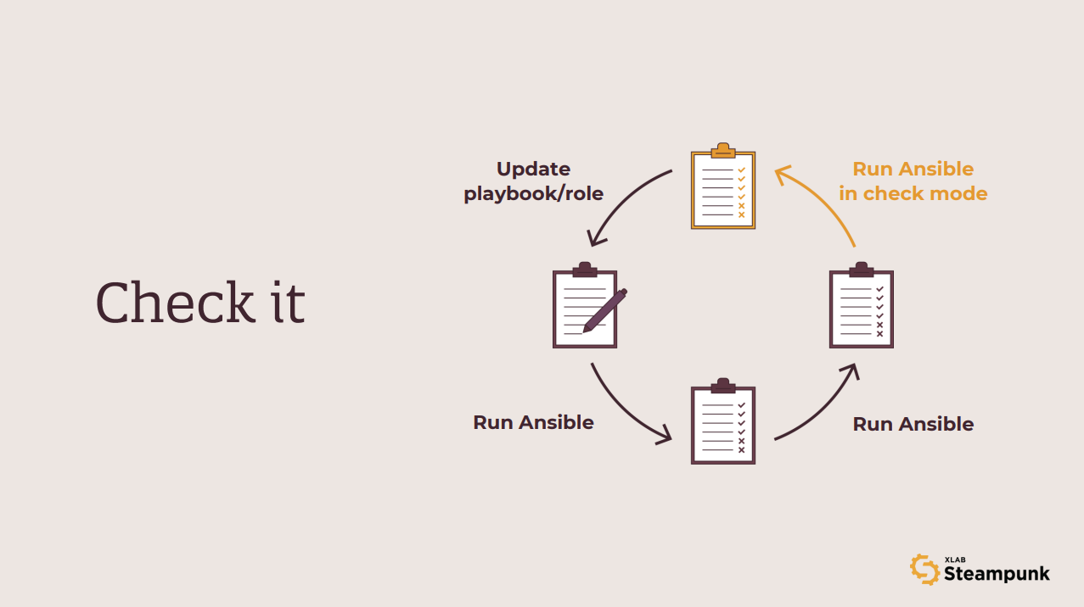
Starting over is hard
One thing we have ignored so far is the host that we run our playbooks and roles against. We assumed that the host was always available and would tolerate all the abuse from our playbooks. But of course, this is not what happens in reality. It takes just one poorly constructed task to make the test host unusable.
And while recreating a VM or a container from time to time is not too big of a deal, it has the potential to become a significant time sink once we start expanding our testing efforts. For example, if our playbook or role is expected to work on three different operating systems, we must suddenly maintain three separate hosts to test against. And host lifecycle management is what Molecule knows how to do best.
Once we describe our test environment, we can use Molecule to create test hosts, run our playbooks and roles on created hosts, and destroy the hosts once the test run is over. Find out how to write tests that won’t slow you down here !
But we don’t have to always execute all steps. In fact, Molecule is smart enough to skip some of the steps if they are not needed. For example, if we run the converge command twice in a row, only the first execution will create new hosts. The second converge run will reuse the existing hosts if they still exist.
Following the steps above assures our automation will perform reliably. But there is nothing in our workflow that would help us adopt best practices that crystalized in the Ansible community over the years. And this is what we will tackle next.
Linting
Ansible Lint is, at its core, a collection of rules that playbooks should follow. And yes, some rules are made to be broken. For example, Ansible Lint will warn you if your Jinja expressions do not have spaces before and after, and if you feel having things styled your own way, you can always ignore such warnings. Though even if stylistic deviations do not make a difference in the playbook’s functionality, having a consistent style in the codebase never hurts.
But there are other rules that we should never ever ignore. The risky file permissions warning is one such example that reminds us that we should pay attention to security when using modules like copy or template.
And this is it. We did all we could, our playbooks and roles are flawless, and Padme is happy. Right? Well … you’ve might have guessed it; things still aren’t that simple. Even all the running and rerunning and checking doesn’t guarantee catching all potential errors. But don’t be discouraged, as said, we’re here to help.
Scan it
Because we know how frustrating it can be to follow all the procedures, guidelines, and still end up with a playbook that just won’t do what you want it to do, we developed our Steampunk Spotter , an assisted automation writing tool that analyzes and offers recommendations for your Ansible Playbooks to help you reduce risks and speed up your automation. Unlike other similar tools, Spotter goes beyond simple syntax checks and understands the context of Ansible Playbooks and Ansible Collections, which means it knows what you want to achieve and helps you get there faster and safer.
With Spotter, you can structure your playbooks for readability, collaboration and ease of use, check for fully qualified names, ensure you are using certified modules, quickly identify invalid configurations, and more . Go ahead, start Spotting!
