**CICD Implementation with Jenkins and Ansible**

**=======================================================**

**# vim install_packages.yml**

- name: Install maven and docker on the worker node

  hosts: webserver

  become: true

  tasks:

  - name: Install CICD tools on worker node

    package: name={{item}} state=present

    loop:

     - git

     - maven

     - docker

  - name: Start Docker Service

    service: name=docker state=started

  - name: Clone the source code repo on the worker node

    git: repo=https://github.com/Sonal0409/DevOpsCodeDemo.git dest=/tmp/code-repo1

**# ansible-playbook install_packages.yml**

**# vim CICD-playbook.yml**

- name: CI and CD tasks

  hosts: webserver

  become: true

  tasks:

  - name: Build the Source code into an artifact

    command: chdir=/tmp/code-repo1 mvn package

  - name: Copy the war file from target folder to current directory

    copy: src=/tmp/code-repo1/target/addressbook.war dest=/tmp/code-repo1 remote_src=yes

  - name: Build the dockerfile into an image

    command: chdir=/tmp/code-repo1 docker build -t ansiblemaven .

  - name: Run the image to deploy app on container

    command: docker run -d -P ansiblemaven

**Save the file**

**# ansible-playbook CICD-playbook.yml**

**Integrating Ansible with Jenkins**

**===========================================**

**Install jenkins on the master server:**

**====================================**

**Step 1: On the Master node:**

**# become the root user**

**# sudo su -**

**Install java**

**# sudo apt install default-jre -y**

**Install jenkins on the master node**

**sudo wget -O /usr/share/keyrings/jenkins-keyring.asc https://pkg.jenkins.io/debian-stable/jenkins.io-2023.key**

**echo "deb [signed-by=/usr/share/keyrings/jenkins-keyring.asc]" https://pkg.jenkins.io/debian-stable binary/ | sudo tee /etc/apt/sources.list.d/jenkins.list > /dev/null**

**sudo apt-get update**

**sudo apt-get install jenkins**

**systemctl start jenkins**

**Steps to setup Jenkisn dashboard:**

**=======================**

**Set up ansible plugin:**

**manage Jenkins → manage Plugins→ Available plugins → install Ansible**

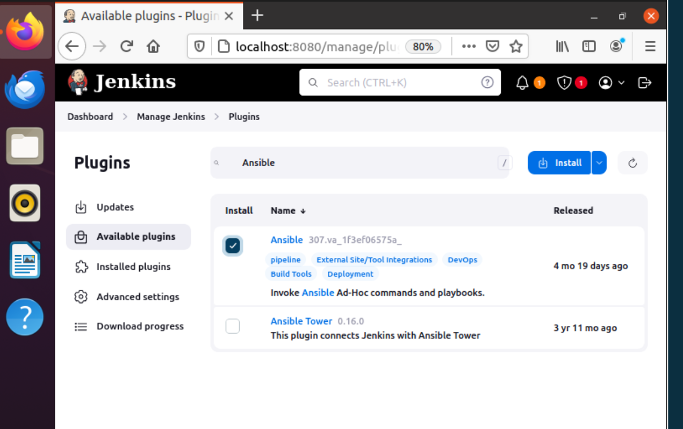

**Configure Ansible path in Jenkins**

**=======================================**

**Manage Jenkins → tools → Scroll to the bottom → Click on Ansible Installation → add below details**

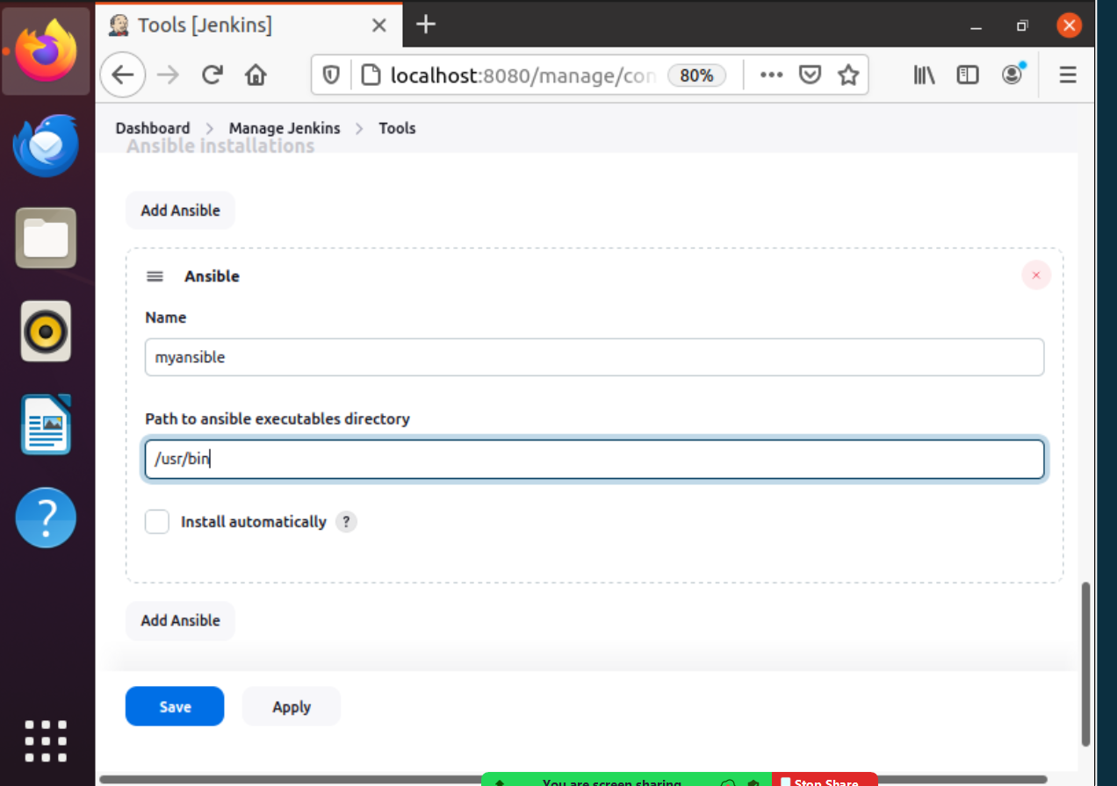

**Pipeline JOb**

**pipeline{**

**agent any**

**stages{**

**stage('clone repo')**

**{**

**steps{**

**git branch: 'main', url: 'https://github.com/Sonal0409/CEP1-Ansible-Jenkins_project-may.git'**

**}**

**}**

**stage('Execute playbook for installtion')**

**{**

**steps{**

**ansiblePlaybook credentialsId: 'ansibleremote', disableHostKeyChecking: true, installation: 'myansible', inventory: 'dev.inv', playbook: 'playbookInstall.yml', vaultTmpPath: ''**

**}**

**}**

**stage('execute the deployment playbook')**

**{**

**steps{**

**ansiblePlaybook credentialsId: 'ansibleremote', disableHostKeyChecking: true, installation: 'myansible', inventory: 'dev.inv', playbook: 'playbookDeploy.yml', vaultTmpPath: ''**

**}**

**}**

**}**

**}**



